# INTERNSHIP ALLOCATION FOR DEPARTMENT OF COMPUTER ENGINEERING

## Group 7 – E/18/098 – E/18/100 – E/18/155

### Conceptual Model

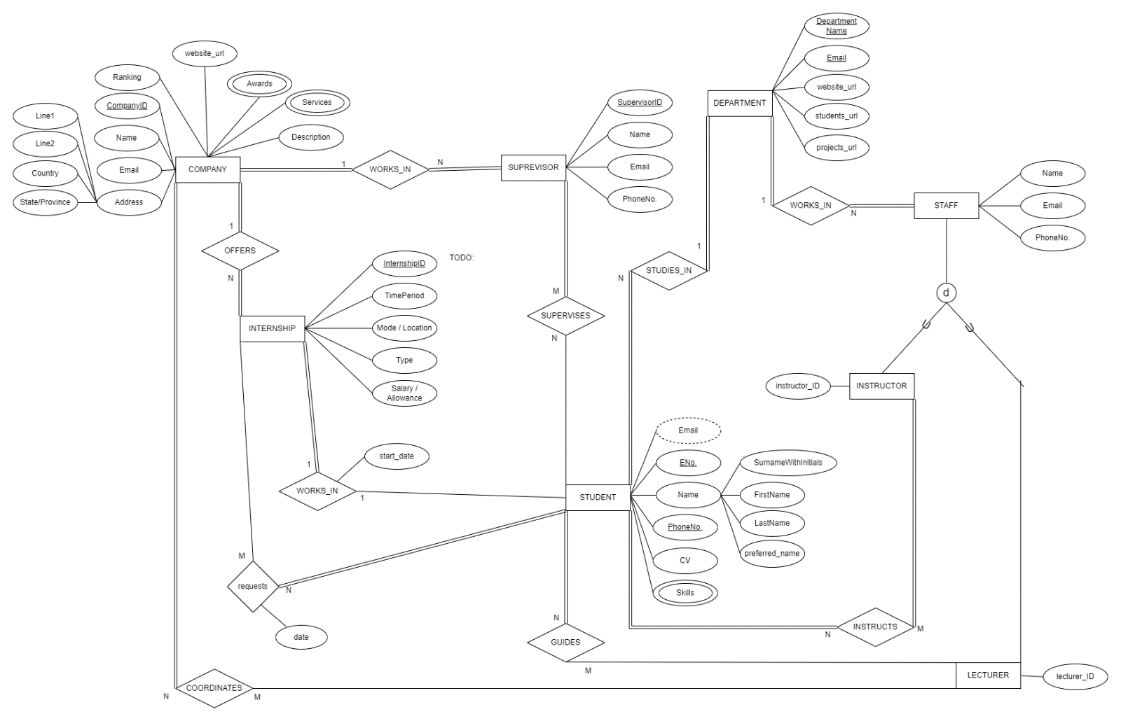

### Logical Model

