**RAJIV GANDHI COLLEGE OF ENGINEERING, RESEARCH AND TECHNOLOGY, CHANDRAPUR (M.H.)**

**Synopsis**

**Title: Online Retail Application**

*CTP Group no 3*

*SUBMITTED BY*

MIS.NEHA KAMBLE

MIS.POOJA KSHIRSAGAR

MR.ISHAN HIRANI

**INTRODUCTION**

The Online Retail Application is a project developed using Python. This project is a GUI application which stores different data in the form of records. Also, this app is capable of adding, removing, and updating data information. This project is an interesting project that uses CRUD operations.

**OBJECTIVE**

The Online Retail Application is a project developed using Python. This project is a GUI application which stores different data in the form of records. Also, this application is capable of adding Customer record of bill of purchased product also Application will use MYSQL database to fire SQL Queries.

* A customer can register to purchase an item
* The customer will provide bank account number and bank name (Can have multiple account number)
* After registration, each customer will have a unique customer id, user id and password.
* A customer can purchase one and more item in different quantities.
* The items can be of different categories.
* On the purchase of item, the bill will be generated.
* The bank account number is required to settle the bill
* The item can be ordered to one or more supplier.

**COMPATIBILITY**

* Computers and laptops

Operating system supports

* Windows
* Linux
* mac.

**Front End:-**Python

* A customer can register to purchase an item
* The customer will provide bank account number and bank name (Can have multiple account number)
* After registration, each customer will have a unique customer id, user id and password.
* A customer can purchase one and more item in different quantities.
* The items can be of different categories.
* On the purchase of item, the bill will be generated.
* The bank account number is required to settle the bill
* The item can be ordered to one or more supplier.

**Back End :-**MYSQL

**MODULES**

* **LOGIN**

This module is used for managing the user of system. This feature employee by the customer to login into system. A customer must login to get with his username and password to the system after registration. If they are invalid, the user not allowed entering the system. User login to the system valid user id and password.

**Entity Relationship diagram for database**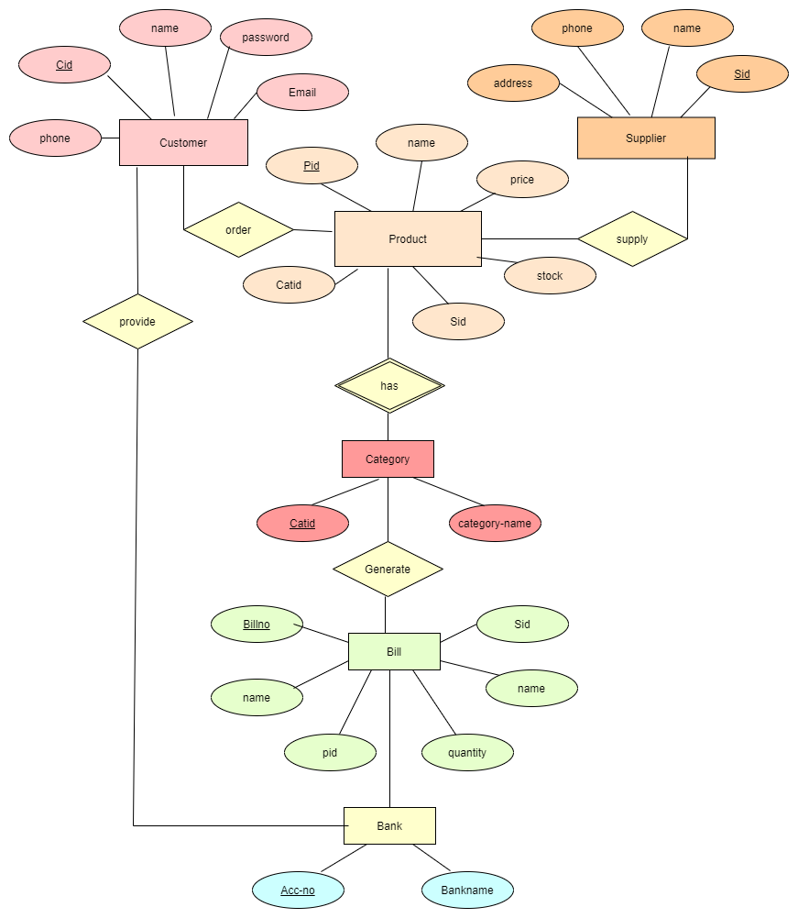

* **Panel for shopping and billing**

After successful login customer can purchase item from here and after shopping customer will need to enter bank details like account number and bank name to generate bill.

* **Registration**

If customer is new in the system then it is mandatory to register by providing information like phone number, email and name.