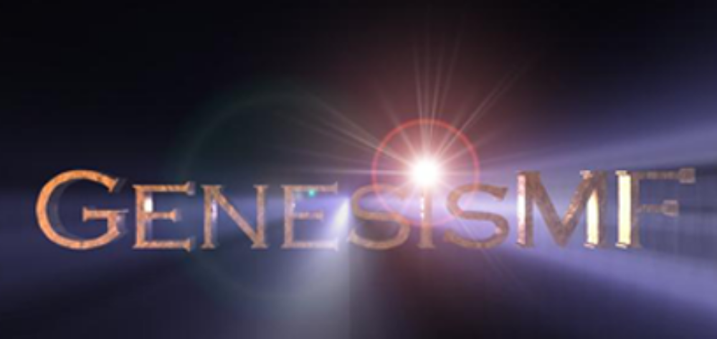
©1997 Andrew Cross for POSITRON

What does this plugin do?
GenesisMF (Genesis MINI FLARE) is a free plugin designed for creating lens flares with 3D Studio MAX. It’s designed to create a visual simulation of the artifacts light causes as it passes through a lens. Based upon a very restricted version of the full GenesisVFX effects rendering technology, GenesisMF renders eight different lens flares.

If you’re looking for an all-in-one special effects package with capabilities in addition to lens flares, we recommend downloading the full GenesisVFX demo. GenesisVFX produces stunning space effects, lightning, gas clouds, electricity, smoke, glows, and even psychedelic images. Elements can be animated individually, colorized, combined in any way and even morphed. GenesisVFX gives you the capability of creating effects that have never been seen before.

A Photoshop/PC version of GenesisVFX is available now allowing users to save and render files identically between the two programs. Versions for NewTek™’s LightWave 3D™ and Adobe® Premiere® will ship this summer.

If you require camera focus effects, you may be interested in “The Fields Of Depth” plugin that gives a user a degree of control that many commercial packages don't offer at just $10! (More information on “The Fields Of Depth” plugin can be found on http://max3d.com/~deadline/).

Order the full version of GenesisVFX and you’ll receive hundreds of pre-set .gfx files which can be combined for creating innumerable effects. If you don’t have time to create one yourself, there is effect for almost any application. Additionally, you’ll receive “The Fields of Depth” plugin FREE! To order or get more information on the revolutionary GenesisVFX package, e-mail mars@3dgraphics.com.

How do I Install and GenesisMF?
Installation:
- Unzip the files and place the .flt file in your MAX/ plugins/ directory.

Use:
- Run 3D Studio MAX
- Load or create a scene that you want to apply the effect to.
- In the Render menu select “Video Post”
- Click “add a scene event” and select the view that you wish to render. Click OK.
- Click “add an image filter event” and select “GenesisMF Mini Flare v1.00” from the list of filters.
6) Within the dialog box, select the flare style you want, click "Set Link..." and select the object that you would like to lock it onto in the scene, this can be any MAX object including lights, particles, dummies and geometry.
7) Click Render

Features
This plugin will render Lens Flares of different types, locked onto any kind of object within the MAX scene. If you lock onto Particle objects, a flare is rendered for every particle. Full alpha channel processing is used.

In keeping with all new plugins in the GenesisVFX product line, GenesisMF is implemented in a fault tolerant way. If, for any reason this plugin crashes, it will merely exit the plugin without crashing MAX, giving you the ability to continue your work (and save it, if you've forgotten to do so). Don't you wish all plugins had this capability?

What can it do?
This plugin will render Lens Flares of different types, locked onto any kind of object within the MAX scene. If you lock onto Particle objects, a flare is rendered for every particle. Video Post queue masks are supported. Field rendering is supported. Full alpha channel processing is used.

What are its limitations?
This plugin is intended primarily for non-professional users; and as such it has been made with ease of use considered above features. It does not offer the user any flexibility over the flares generated. If you require control over lens flares, or want a package with more features than just lens flares, we strongly suggest that you consider GenesisVFX.

What is GenesisVFX?
GenesisVFX is a very high-end special effects package that gives professional users a completely new way of working with special effects. GenesisVFX is not simply for producing flares, rather, it produces any kind of effect ranging from fire, smoke, lighting to gas clouds, glows and particles. GenesisVFX’ takes an entirely different approach to special effects creation by giving the user with a set of creative tools rather than parameters. In this way a user can craft effects that are defined not by the program, but the user’s imagination. GenesisVFX is without doubt the most powerful special effects creation tool available for MAX.

If you would like more information on the revolutionary GenesisVFX package, you may download a demo, and get comprehensive information at the URL: http://www.3dgraphics.com or contact Positron by email mars@3dgraphics.com.

Revisions
16/6/1997 Release of plugin v1.00

More information?
You can contact Andrew Cross on adjc@minster.york.ac.uk if you would like any more information about this plugin, suggestions comments, criticisms and bug reports are always welcome. I am always interested in any images you have created using this package (and any other of my plugins)!

You may contact Positron via mars@3dgraphics.com for information about Genesis^{vfx} or review information.

License Agreement and Conditions of Use
1) This plugin may be used FREELY by any user of 3D Studio MAX
2) No modification can be made to any form of the distribution
3) The files comprising this distribution may be distributed freely as long as they are modified in no way, and give details of a link to where the original files can be found. http://max3d.com/~deadline/Genesis/ or http://www.3dgraphics.com
- All code remains the property of Andrew Cross and Positron Publishing. Your license to use this product may be terminated at any time, without notice.

Huge thanks go to Nathalie, Ishani for some of the designing some of the marvelous effects in this plugin, Anton "C++ coder Extreme" for some really crafty pieces of code, Toby "The man behind the max3d.com", Brent for surviving my email barrage and all the other wonderful people at Positron.

