**SEMESTER PROJECT REPORT**

Analyze the dynamic Response of the Beam using MATLAB

Ishan Sharma

Graduate Student, Department of Mechanical Engineering

Clemson University

Index

* Introduction
* Summary
* Solution Procedure
* Implementation using MATLAB
* Observations & Results
* Conclusion

Introduction

In the given problem, we will analyze the dynamic response of a given cantilever beam for the specified load application. In the current problem, we are about to analyze how the cantilever beam responds to sudden load application. In the given study, we’ll be observing the aspects of dynamics in terms of displacement for a given instant of time over different time-steps.

Figure 1: Dimensions of Cantilever Beam

**Problem Description**

Beam type: Cantilever Beam (Fixed at One End and Free at Other End)

Cantilever Beam Dimensions:

Geometry:

* Length of the Beam: 20cm
* Breadth of the Beam: 0.5 cm
* Height of the Beam: 1cm

Mass Density:

Resultant volume of the beam: (L * B * H) =

Resultant Mass of the Beam: 2330 kg/m3

Moment of Inertia of the Beam: 1/12 * B * D3 =

Young’s Modulus of the Beam = 90GPa = 90 X 10 9 Pa = 9 X 10 10 Pa

Coefficients involved:

* Mass Coefficients:
* 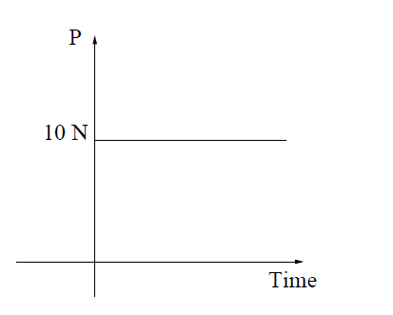Stiffness Coefficients:

Figure 2: Applied Load Profile

Load Profile:

* Applied Load: 10 N

Summary

Solution Procedure

Step – 1

Physical Understanding of the Problem

Step – II

Formulating the Mathematical Model for the above problem

In further analyzing a given problem, formulating a mathematical model is very integral and crucial. The dynamic analysis of a given system can be accomplished by multiple techniques, but we will be specifically hovering through the *Natural Frequencies and modes* and some elements of the *transient analysis*.

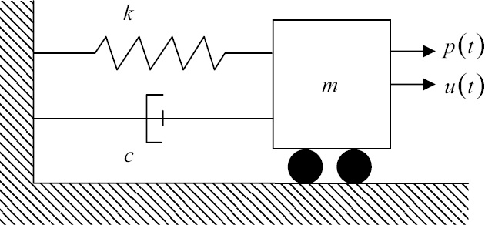We’ll start to deduce the governing equations involved by studying single degree of freedom models, these models are often coupled with two degree of freedom models to generate the governing equations for Automotive Structures and for their Side-Frame Geometry dynamics.

Figure: Single Degree of Freedom (Spring – Mass – Dashpot) Model

$$u\left(t\right):Displacement$$

$$f\left(t\right):Excitation Force (External Force Applied)$$

As per the Newton’s Law of Motion:

$$mass*Acceleration=Force$$

Or

$$m*\frac{d^{2}u}{dt^{2}}=f\left(t\right)-k*u-\frac{du}{dt}$$

*Now, as we know*

$$Acceleration :\frac{d^{2}u}{dt^{2}}$$

$$Velocity: \frac{du}{dt}$$

Now, we could have different cases of vibrations, Forced Vibrations and Free Vibration. In a Free Vibration model representation studied in Mechanical Vibrations has been used to work through the formulation of the mathematical model.

Assumptions:

* No inherent damping present across the system i.e. c=0

So, it can be written as -

$m*\frac{d^{2}u}{dt^{2}}= -k*u$*Eq 1*

Wherein the displacement, u can also be represented as for the above system

$u\left(t\right)=A*\sin\left(ω*t\right)$*Eq 2*

*Where,*

$ω:Angular Frequency$

* *A: Amplitude of Oscillations*

*Substituting the value of u from Equation 2 into Equation 1, We get –*

$-m*A*ω^{2}\sin\left(ω*t\right)+k*A*\sin\left(ω*t\right)$*= 0*

$$Taking \left(-ω^{2}*m+k\right) common from the above equation, We get-$$

$$\left(-ω^{2}*m+k\right)U=0$$

$$ω=\sqrt{\frac{k}{m}}$$

*Therefore, the above equation helps us to deduce the fundamental frequencies for a given system whose system stiffness and mass is known.*

*Frequency, thus, obtained from the above formulation will be Undamped Natural Frequency*

*(Cyclic Frequency)*

$f= \frac{ω}{2π}$

*Now, as for the free vibrational model, c is zero. If damping coefficient c is not zero and less than critical damping coefficient Cc*

*0 $0 <C<C_{c}$*

*Where, $damping ratio: \frac{Damping Coefficcent}{Critical Damping Coefficcent}$*

$$Critical Damping\left(C_{C}\right):2*\sqrt{k*m}=2*ω*m$$

*In most of the Engineering structures and its subcomponents is Damping Ratio is more than 0 and less than 0.15, which holds correct for our cantilever beam application for the given problem.*

*In continuum structures, equations are initially defined for infinitesimal small volume and the results are integrated over along the given domain*

*Now, Talking through the aspects of linear elasticity*

*Consider, the situation, where stress in three dimensions need to calculate. In a 3D Region Ω, with a linear elastic solid.*

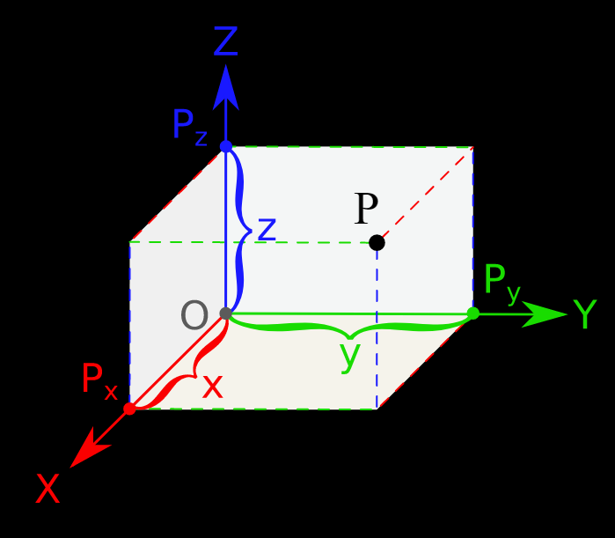

Ω

P (u, v, w)

The origin O (x, y, z), the displacement at point P with respect to origin, as per the right handed convention system has components (u,v,w) measured with respect to the global reference axis as defined in the above picture.

The entire domain boundary Ω is denoted by ℾ. ℾ is further categorized into two parts:

* ℾu: Domain where displacements are specified
* ℾt: Domain where surface traction is specified

Now, take a normal vector **n** normal to the boundary normal to Ω and has components (nx , ny, nz )with respect to the global system.

$$ℾ= ℾ_{u} U ℾ_{t}$$

Now, with the above system definition, we could define our set of differential equations of Equilibrium and Motion respectively for our given application using the principles of conservation of energy along the infinitesimal small volume of element. Where the force along its different faces is calculated.

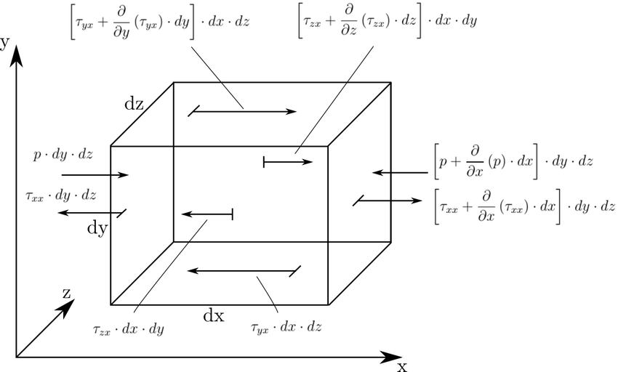

Figure: Force Balance on the infinitesimal element of domain Ω

Convention Utilized for Force Balance:

Force coming into the system

Step – III:

Weak Form

Method: Virtual Work

Final Weak Form

Step – IV

Discretization

Concept of Meshing

* Fine Mesh
* Coarse Mesh
* What is the difference?
* Computational Accuracy and Cost Aspects
* Nodes (Table)
* Elements (Table)

About the Code to generate nodes.dat and elements.dat

Step – V – X:

Setting up the Element Matrices and Element Vectors

Setting up the Solver Scheme:

Paragraph Pg. 487

* Newark Schemes

Solution for Global Equation of Motion:

Why do we need Newark Scheme?

* + Implicit Schemes
  + Explicit Schemes

Mass and Damping Matrices

Eq 9.91 Eq 9.92

Eq 9.99, Eq 9.100, Eq 9.101

Implementation using MATLAB

* Input Scheme
* Output Scheme
* Flow of the Implementation

Observations & Results

* Cases under consideration

Conclusion & Physical Understanding of the Results