Game Design Document

Fill up the Following document

1. Write the title of your project.

The Title is “Boycott China”

1. What is the goal of the game?

The Goal of The Game Is to Rescue the army officer who was caught by Chinese officer while killing the Chinese soldier who were going to attack in India.

1. Write a brief story of your game?

The Indian Officer is caught while fighting against the Chinese soldier wile Stoping the to come inside the India border. To rescue him India has sent a tank to fight

against China .You have to kill the China officer in first round but if your caught , you are send to rescue him through tank but Chinese player also have tank,

who will try to kill you.

1. Which are the playing characters of this game?

* Playing characters are the ones which respond to the user based on the input from the user
* Cars, monkeys, dinos, wizards etc, are the playing characters in the game.

|  |  |  |
| --- | --- | --- |
| Number | Character Name | What can this character do? |
| 1 | Indian army officer | He Can Shoot With “s” Key to Chinese army |
| 2 | Tank | Shot to Chinese tank with “a” key and move forward with right arrow |
| 3 |  |  |
| 4 |  |  |
| 5 |  |  |
| 6 |  |  |
| 7 |  |  |
| 8 |  |  |

1. Which are the Non Playing Characters of this game?

* Non Playing characters are the ones which don't have an action or a behaviour when the user interacts with the game.
* Hurdles, stones, bananas, coins, etc are non playing characters in the game.

|  |  |  |
| --- | --- | --- |
| Number | Character Name | What can this character do? |
| 1 | Chinese army officer | Catch Indian officer |
| 2 | Chines military tank | Defeat India Tank |
| 3 |  |  |
| 4 |  |  |
| 5 |  |  |
| 6 |  |  |
| 7 |  |  |
| 8 |  |  |

Draw your imagination of this game. What does this game look like?

* Draw the game either on your computer or on paper,
* Add images of scenes of the game to show each of the playing and non-playing characters at least once.

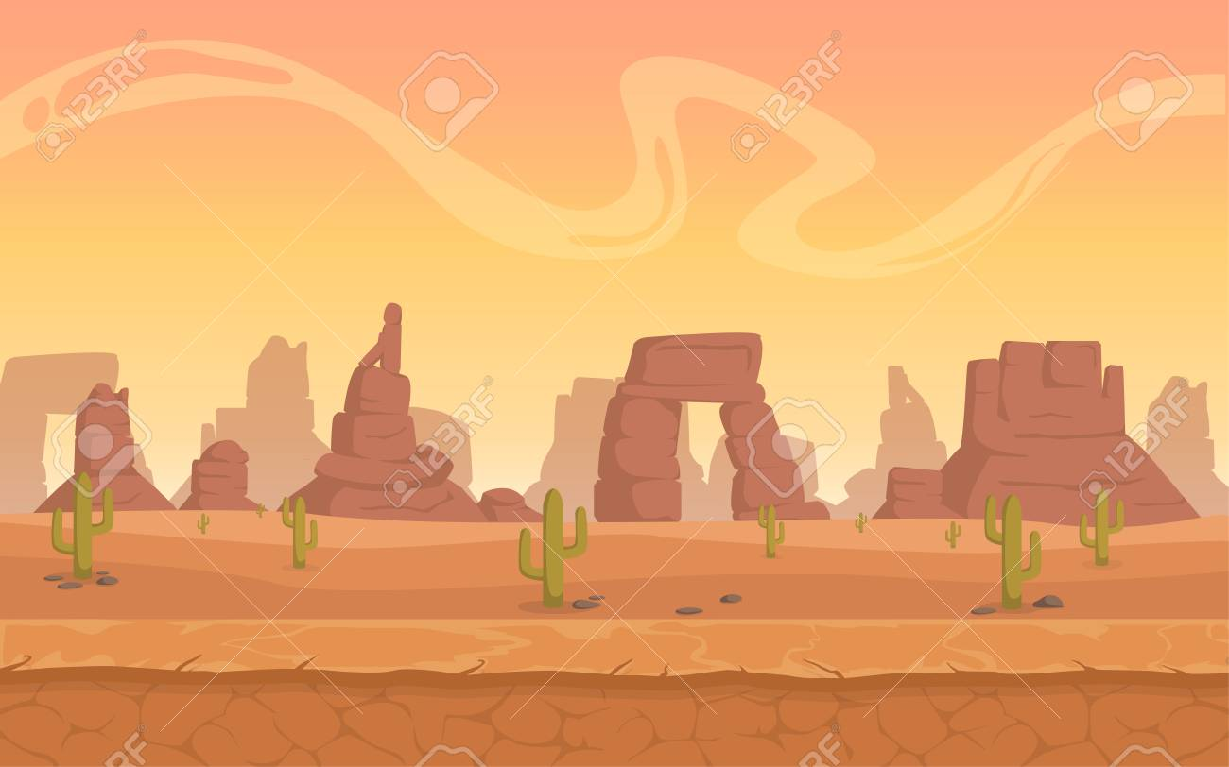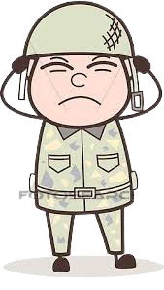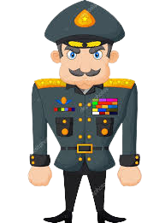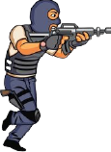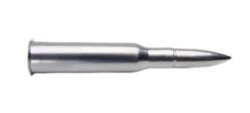

How do you plan to make your game engaging?

I will make my game interesting my adding level to it. In first level we can shoot and in the second level we can burst the Chinese tank Which a chinese people can also do.