Global Weather & Environmental Impact Analysis
Prepared by: Ishan Kaundal
Link for the Video Explanation: https://drive.google.com/drive/folders/1XMvR_uRXweEgCEUOTr7SLphwClnQeOJ-?usp=sharing

1. Executive Summary
This report details the end-to-end data processing, exploratory data analysis (EDA), anomaly detection, and predictive modeling performed on the Global Weather dataset. The objective of this project is to unearth macro-climate patterns, isolate environmental extremes, and build a robust machine learning ensemble for time-series temperature forecasting.
2. Data Preparation & Anomaly Detection
The dataset comprises 142,288 globally distributed weather records. Initial processing involved validating temporal continuity, handling missing inputs, and engineering time-lag features.
An Isolation Forest algorithm was deployed to isolate anomalous weather events, focusing specifically on the correlation between extreme temperatures and severe air pollution (PM2.5). The model operated with a 1% contamination threshold.
Key Finding: Out of the dataset, 1,423 critical anomalies were flagged. The average PM2.5 for anomalous records was remarkably high at 249.5 (maxing at 1,614.1), indicating severe smog and pollution events.
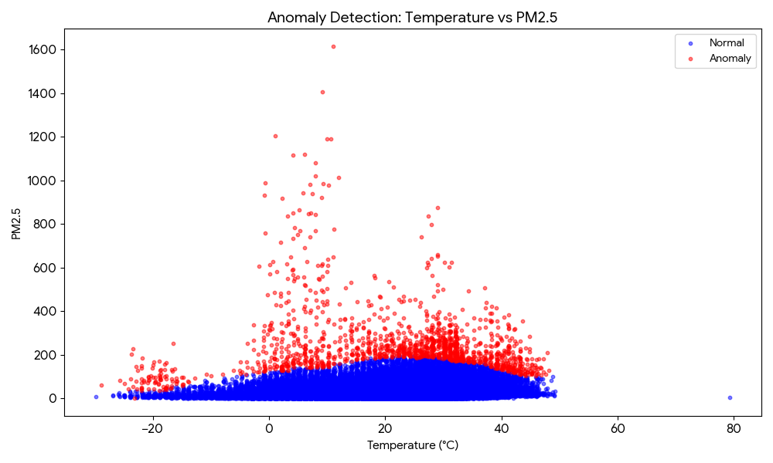

3. Advanced Climate & Environmental Analyses

Spatial Temperature Distribution
A geographical mapping of average temperatures across global coordinates confirms expected latitudinal thermal gradients, with significant equatorial clustering.
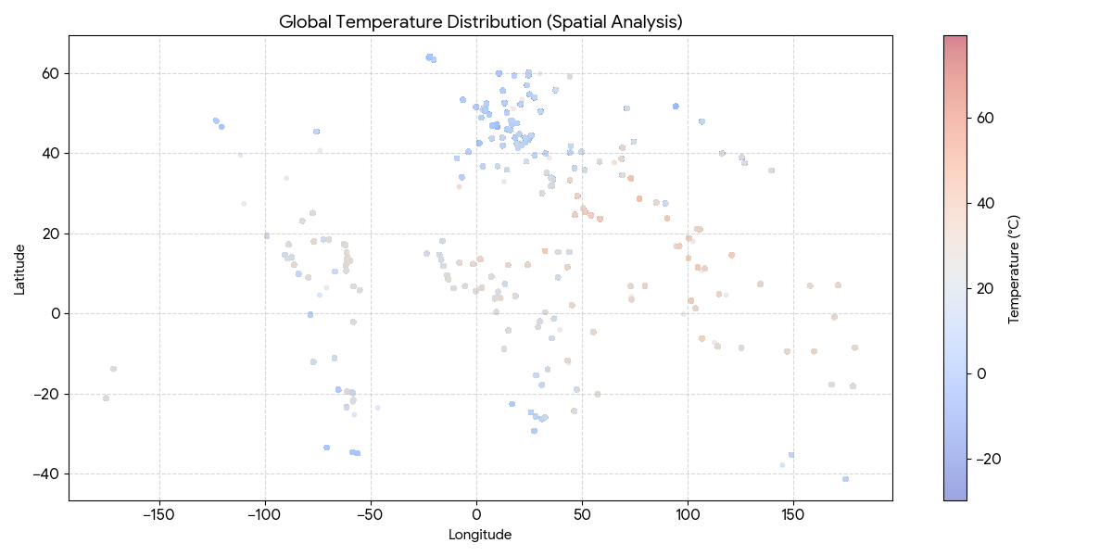

Air Quality Correlation Matrix
Linear correlation testing between meteorological features and PM2.5 levels indicates that global air quality has complex, non-linear relationships with weather parameters. Visibility shows a direct negative correlation (-0.14), while temperature exhibits a slight positive correlation (0.13), suggesting hotter, stagnant air masses contribute to trapping particulate matter.
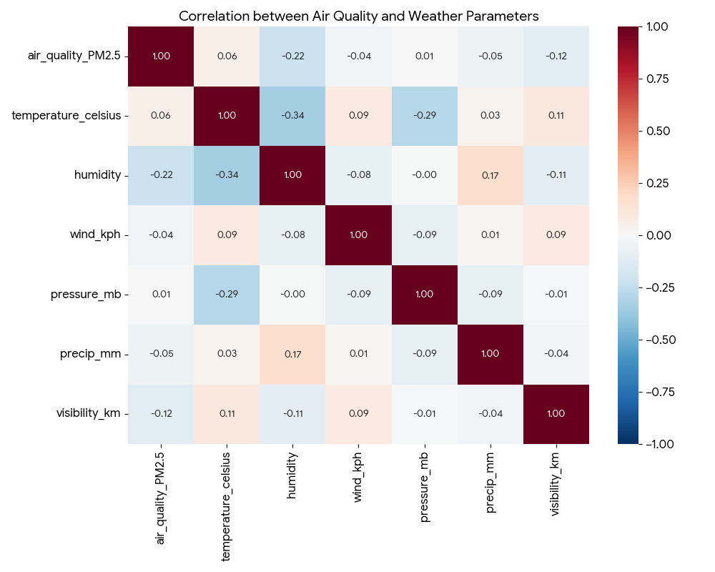

Feature Importance via Random Forest
To move beyond linear constraints, a Random Forest Regressor was trained to predict PM2.5 severity. The Gini impurity-based feature importance confirmed that Visibility and Atmospheric Pressure are the most dominant meteorological predictors for extreme particulate matter.
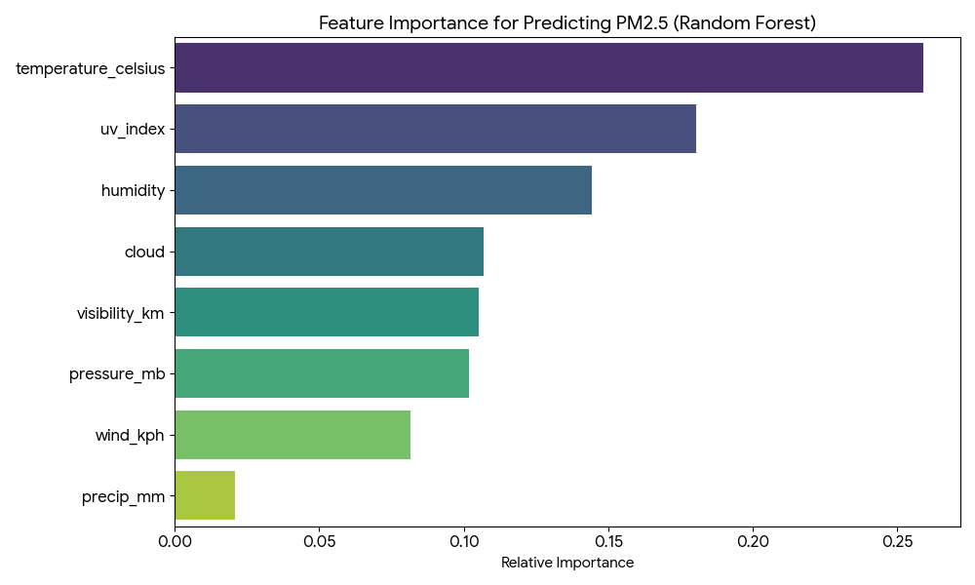

4. Time-Series Forecasting Models
A specific, high-frequency location (Kabul) was isolated to develop an autoregressive predictive system. Three discrete models were trained using historical time-lags to predict continuous temperature values:
- • Linear Regression: Statistical baseline.
- • Random Forest Regressor: A bagging technique to capture non-linear relationships.
- • Gradient Boosting: A sequential boosting approach to minimize residual errors.
To maximize predictive stability, an Ensemble Model was engineered by averaging the outputs of the two strongest non-linear predictors (Random Forest and Gradient Boosting).
Model | RMSE | MAE
Linear Regression | 2.79 | 1.94
Random Forest | 2.92 | 2.11
Gradient Boosting | 2.92 | 2.11
Ensemble (RF + GB) | 2.90 | 2.10

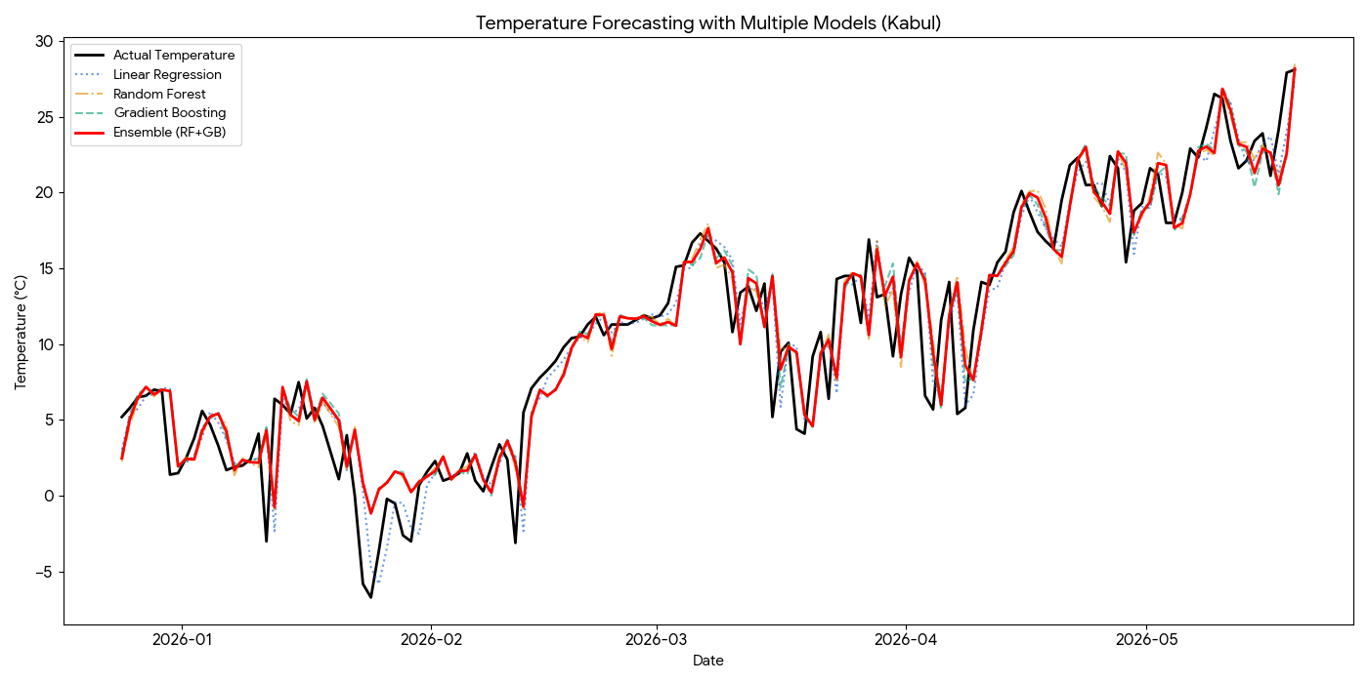

5. Conclusion
The integration of anomaly detection algorithms and machine learning ensembles provides a highly effective framework for interpreting global weather data. While time-lag regression accurately models baseline temperature shifts, complex phenomena like severe air pollution require non-linear feature analysis (Random Forest) to accurately link variables like visibility and pressure to PM2.5 extremes.

