Intelligent Refrigerator
(Cuisine Analyzer)

Ishank Aggarwal Sarthak Joshi Osheen Singh Udit Goel
JIIT Noida-62 JIIT Noida-62 JIIT Noida-62 JIIT Noida-62
ishankagarwal62@gmail.com sarthakjoshi2496@gmail.com singh.osheen@gmail.com uditgoel002@gmail.com

Abstract—In this paper, we explore the formation of different patterns and combinations that are resulted when we apply various machine learning models to the given Yummly dataset of wide variety of cuisines. These models provide range of accuracies and the best one is used for each purpose according to the moto “survival of the fittest”.
Keywords—Multinomial Naïve Bayes; Logistic Regression; Random Forest Classifier; K-Nearest Neighbours Classifier; K-Fold cross validation; Sentiment Classifier; TF-IDF; Linear Regression; Multiple Regression; Gradient Descent; Polynomial Regression; Ridge Regression; L2 penalty

Introduction
Food is integral part of one’s life besides clothing and shelter, no matter whether the person is young or old but the intakes or the right amount of servings largely varies from person to person depending on his or her health condition, biological clock and choices. Many a times, we waste time in deciding what to cook so that it fits our appetite and fulfills our taste buds. This choice making can take a lot of time and moreover, it depends on the ingredients we have at the moment. So reduce the time and overhead of choice making, various machine learning algorithms come into play.
To test the efficiency and usefulness of these algorithms, we have used Yummly dataset throughout our research work. Yummly is a mobile app and website that provides recipe recommendations personalized to the individual's tastes, semantic recipe search, a digital recipe box, shopping list and one-hour grocery delivery. It contains a huge dataset of almost 8339 recipes with each recipe mentioned against its list of ingredients. Throughout the research work, this dataset proved immensely important in calculations while using different machine learning models. The dataset contains most popular and widely used cuisines in the American world. We have played around with the dataset and exploited it to its extremities to measure the accuracies relative to each major purpose we are trying to accomplish through our project, for instance, being able to predict the most suitable recipe for a person keeping in mind of his dietary levels such as calorie count.

Datasets Related Work

Dataset Information
There are several companies with proprietary APIs and databases acquired through scraping these recipe websites. These companies then sell licenses to developers. These APIs vary in their quality, database size, and fees:
BigOven: 350,000 recipes; REST JSON and XML output
Yummly: 1 million recipes, ratings, ingredients; REST JSON output; Academic plan available with 30,000 lifetime calls
Food2Fork: 250,000 recipes; JSON output; Free plan with 500 calls per day
Spoonacular: 350,000 recipes; UNIREST JSON output; Free plan for hackathons and academic purposes
Edamam: 1.5 million recipes; Free Trial with up to 1000 lifetime calls
Initially, the two API’s were selected as the choices for the predictive analysis namely Spoonacular API and Yummly API but While Spoonacular's API had more bells and whistles and advanced features, Yummly's database of recipes was generally of higher quality than Spoonacular's. It also had access to over 1 million recipes compared to Spoonacular's, and had better-formatted ingredients for each recipe. So, finally, Yummly API was chosen to carry out the task of prediction. Yummly's API is accessed by querying an API endpoint and returns JSON-encoded recipe data. JSON data was translated to Pandas dataframe structures using the Requests package and Pandas. Initially, cuisine data was written into 25 separate CSVs before assembling them into cuisines_data.csv
For each recipe, the recipe name, rating, cooking time, course, cuisine, and ingredients is stored against it. In total, there are 25 cuisines for 8339 recipes.
Cuisine dataset basic stats:
- 8037 recipes
- 25 cuisines: Asian is the most well-represented, with 1400 recipes. English the least, with just 32 recipes.
- Ratings: overwhelmingly 4-star (62.1% of the 8339), some 3-star (18.9%) and 5-star (17.2%), very few 0, 1, or 2 stars (1.8%)
- Cooking Time: mean of 65 minutes, max of 1970 minutes (33 hours), min of 1 minute, median of 40 minutes
- Ingredients per recipe: mean of 10.1, max of 35 (Thai chicken tacos), min of 1, median of 9
- 3958 unique ingredients:
  - Most common ingredients: Salt (3325 occurences, 0.41 frequency), garlic (0.22), onions (0.20), olive oil (0.18)
  - Least common ingredients: 1401 unique ingredients are only used in one recipe throughout the dataset. Examples: chocolate candy, melon seeds, canned tuna, vegan yogurt, tarragon vinegar, unsalted almonds
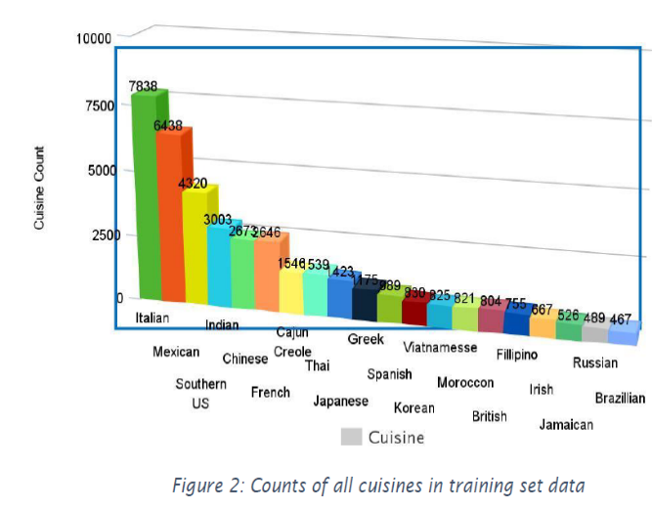
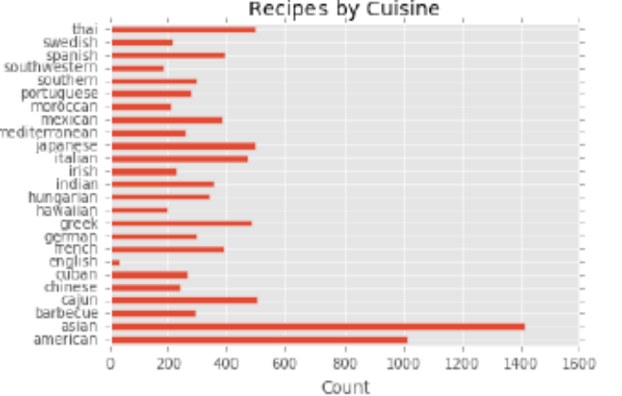
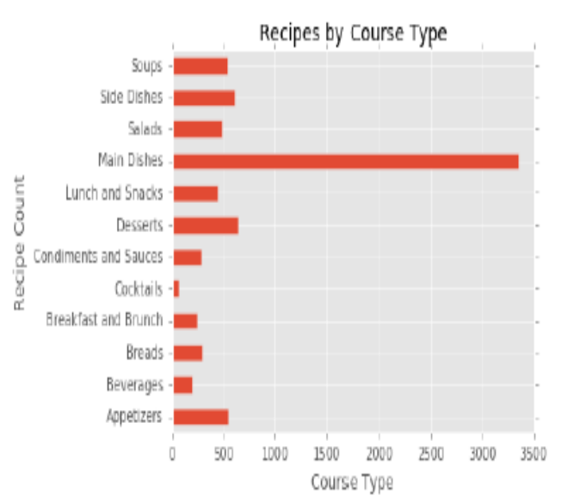Unique Ingredient Analysis is done by calculating the ingredient frequency which is obtained by dividing the instances by the number of recipes in the dataset, and appended as a new column "frequency".
Next, we identified which recipes within a given dataset are the most 'unique' in terms of their ingredients on the basis of relative scoring using two recipe uniqueness formulas. The first method of scoring is to take the mean of each recipe's ingredient frequencies (e.g. (0.3+0.1+0.2) / 3). For each recipe's ingredients, the sum the ingredients' unique ingredient frequency score is calculated as above, and then divided by the number of ingredients in the recipe so as to not bias the scoring towards recipes with dozens of ingredients. This score is assigned to a column named "uniq_score1". The second method of scoring is to take the product of each recipe's ingredient frequencies (e.g. 0.3 * 0.1 * 0.2). This score is assigned to a column named "uniq_score2". The product tends to 'reward' recipes with extremely rare ingredients whereas the mean method 'rewards' these recipes to far lower extent.

Data Pre-Processing
Several processing steps are conducted on the master cuisine data CSV file.

- Ingredient Parsing:
Each recipe's ingredients were encoded as a single, unseparated string, including brackets: "[ingredient 1, ingredient 2, ingredient 3]". So, in order to examine the ingredient separately, brackets from each ingredient string are dropped while traversing through [1:-1]. Next, the list of the ingredient string is returned separated by commas. This code treats essentially similar ingredients as unique, for instance, ‘pasta’, ‘Giorgino pasto’ and ‘fresh pasta’ are considered as separate ingredients.

- Ingredient Counts:
After parsing the ingredients from a single string to a list of strings, the number of ingredients in each recipe is computed by creating a new column named "ingredCount" and setting each value to len(ingredients).

- Time Conversion:
Each recipe's cooking time is converted from seconds to minutes by dividing it by 60 and populating it in a column named "timeMins".

- Munging:
To make sure that data is sufficiently clean for analysis, some measures are taken.
- The rows of cuisines data that had an empty “cuisine” value are dropped. Yummly's "Search by Cuisine" API call returns recipes that have "Chinese" in the recipe in some shape or form-- even in the ingredients! So a sandwich recipe that employs "French bread" or an "English muffin" might have a cuisine value of "French" or "English". To avoid these ambiguities, the empty recipes without an explicit cuisine are dropped. This greatly reduced the number of recipes for some cuisines like English.
- Empty course values are filled with "Unknown" rather than dropping these recipes.
- Finally, duplicate recipes from the dataset are dropped.

III. Methodology
1) Logistic regression is a statistical method for analyzing a dataset in which there are one or more independent variables that determine an outcome. The outcome is measured with a dichotomous variable (in which there are only two possible outcomes).
In logistic regression, the dependent variable is binary or dichotomous, i.e. it only contains data coded as 1 (TRUE, success, pregnant, etc.) or 0 (FALSE, failure, non-pregnant, etc.).
The goal of logistic regression is to find the best fitting (yet biologically reasonable) model to describe the relationship between the dichotomous characteristic of interest (dependent variable = response or outcome variable) and a set of independent (predictor or explanatory) variables. Logistic regression generates the coefficients (and its standard errors and significance levels) of a formula to predict a logit transformation of the probability of presence of the characteristic of interest:
where p is the probability of presence of the characteristic of interest. The logit transformation is defined as the logged odds:

2) The Naive Bayes algorithm is based on conditional probabilities. It uses Bayes' Theorem, a formula that calculates a probability by counting the frequency of values and combinations of values in the historical data.
Bayes' Theorem finds the probability of an event occurring given the probability of another event that has already occurred. If B represents the dependent event and A represents the prior event, Bayes' theorem can be stated as follows.

Conditional Probabilities in Bayes' Theorem
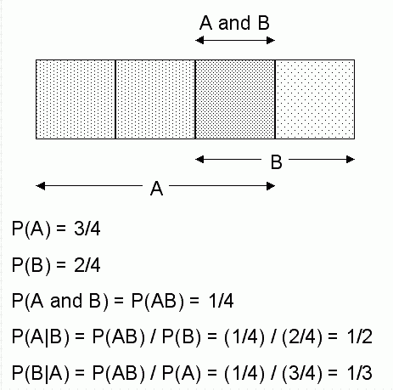

3) Random forests or random decision forests are an ensemble learning method for classification, regression and other tasks, that operate by constructing a multitude of decision trees at training time and outputting the class that is the mode of the classes (classification) or mean prediction (regression) of the individual trees. Random decision forests correct for decision trees' habit of overfitting to their training set.
The first algorithm for random decision forests was created by Tin Kam Ho using the random subspace method, which, in Ho's formulation, is a way to implement the "stochastic discrimination" approach to classification proposed by Eugene Kleinberg.
An extension of the algorithm was developed by Leo Breiman and Adele Cutler, and "Random Forests" is their trademark. The extension combines Breiman's "bagging" idea and random selection of features, introduced first by Ho and later independently by Amit and Geman in order to construct a collection of decision trees with controlled variance.

4) K-fold cross validation
“k- fold cross validation” is easy to follow and implement. Here are the quick steps:
- Randomly split your entire dataset into k”folds”.
- For each k folds in your dataset, build your model on k – 1 folds of the data set. Then, test the model to check the effectiveness for kth fold.
- Record the error you see on each of the predictions.
- Repeat this until each of the k folds has served as the test set.
- The average of your k recorded errors is called the cross-validation error and will serve as your performance metric for the model.
“How to choose right value of k?”
Always remember, lower value of K is more biased and hence undesirable. On the other hand, higher value of K is less biased, but can suffer from large variability. It is good to know that, smaller value of k always takes us towards validation set approach, where as higher value of k leads to LOOCV approach. Hence, it is often suggested to use k=10.



5) K-Nearest Neighbours (KNN)
- It can be used for both classification and regression problems. However, it is more widely used in classification problems in the industry. K nearest neighbors is a simple algorithm that stores all available cases and classifies new cases by a majority vote of its k neighbors. The case being assigned to the class is most common amongst its K nearest neighbors measured by a distance function.
- These distance functions can be Euclidean, Manhattan, Minkowski and Hamming distance. First three functions are used for continuous function and fourth one (Hamming) for categorical variables. If K = 1, then the case is simply assigned to the class of its nearest neighbor. At times, choosing K turns out to be a challenge while performing KNN modeling.
- KNN can easily be mapped to our real lives. If you want to learn about a person, of whom you have no information, you might like to find out about his close friends and the circles he moves in and gain access to his/her information!
- Things to consider before selecting KNN:
- KNN is computationally expensive
- Variables should be normalized else higher range variables can bias it
- Works on pre-processing stage more before going for KNN like outlier, noise removal.

Logistic Regresion
Logistic regression is named for the function used at the core of the method, the logistic function. The logistic function, also called the sigmoid function was developed by statisticians to describe properties of population growth in ecology, rising quickly and maxing out at the carrying capacity of the environment. It’s an S-shaped curve that can take any real-valued number and map it into a value between 0 and 1, but never exactly at those limits. 1 / (1 + e^-value) Where e is the base of the natural logarithms (Euler’s number or the EXP() function in your spreadsheet) and value is the actual numerical value that you want to transform. Below is a plot of the numbers between -5 and 5 transformed into the range 0 and 1 using the logistic function.
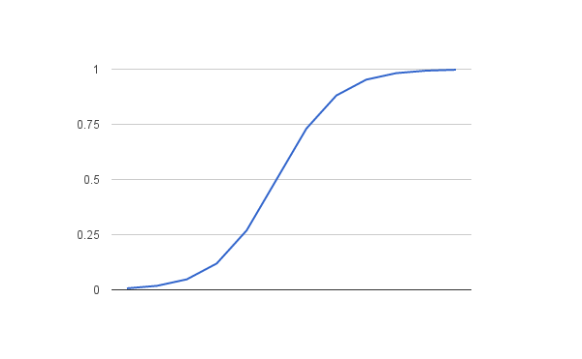
Logistic Function

- Polynomial Regression
This function fits a polynomial regression model to powers of a single predictor by the method of linear least squares. Interpolation and calculation of areas under the curve are also given.
If a polynomial model is appropriate for your study then you may use this function to fit a k order/degree polynomial to your data:-
where Y caret is the predicted outcome value for the polynomial model with regression coefficients b₁ to k for each degree and Y intercept b₀. The model is simply a general linear regression model with k predictors raised to the power of i where i=1 to k. A second order (k=2) polynomial forms a quadratic expression (parabolic curve), a third order (k=3) polynomial forms a cubic expression and a fourth order (k=4) polynomial forms a quartic expression
Some general principles:
- the fitted model is more reliable when it is built on large numbers of observations.
- do not extrapolate beyond the limits of observed values.
- choose values for the predictor (x) that are not too large as they will cause overflow with higher degree polynomials; scale x down if necessary.
- do not draw false confidence from low P values, use these to support your model only if the plot looks reasonable.
- Ridge Regression
Ridge is a powerful technique generally used for creating parsimonious models in presence of a ‘large’ number of features. Here ‘large’ can typically mean either of two things:
- Large enough to enhance the tendency of a model to overfit (as low as 10 variables might cause overfitting)
- Large enough to cause computational challenges. With modern systems, this situation might arise in case of millions or billions of features
Though Ridge and Lasso might appear to work towards a common goal, the inherent properties and practical use cases differ substantially. If you’ve heard of them before, you must know that they work by penalizing the magnitude of coefficients of features along with minimizing the error between predicted and actual observations.These are called ‘regularization’ techniques. The key difference is in how they assign penalty to the coefficients: Performs L2 regularization, i.e. adds penalty equivalent to square of the magnitude of coefficients
Minimization objective = LS Obj + α * (sum of square of coefficients)

Gradient Descent
Gradient descent is an optimization algorithm used to find the values of parameters (coefficients) of a function (f) that minimizes a cost function (cost). Best used when the parameters cannot be calculated analytically (e.g. using linear algebra) and must be searched for by an optimization algorithm.

Intuition for Gradient Descent:
Think of a large bowl like what you would eat cereal out of or store fruit in. This bowl is a plot of the cost function (f).A random position on the surface of the bowl is the cost of the current values of the coefficients (cost).The bottom of the bowl is the cost of the best set of coefficients, the minimum of the function.The goal is to continue to try different values for the coefficients, evaluate their cost and select new coefficients that have a slightly better (lower) cost. Repeating this process enough times will lead to the bottom of the bowl and you will know the values of the coefficients that result in the minimum cost.

- Decision Trees
A decision tree is a flowchart-like structure in which each internal node represents a "test" on an attribute (e.g. whether a coin flip comes up heads or tails), each branch represents the outcome of the test, and each leaf node represents a class label (decision taken after computing all attributes). The paths from root to leaf represent classification rules.
In decision analysis, a decision tree and the closely related influence diagram are used as a visual and analytical decision support tool, where the expected values (or expected utility) of competing alternatives are calculated. A decision tree consists of three types of nodes:
- Decision nodes– typically represented by squares
- Chance nodes – typically represented by circles
- End nodes – typically represented by triangles

- Ensemble Methods
In statistics and machinelearning, ensemble methods use multiple learning algorithms to obtain better predictive performance than could be obtained from any of the constituent learning algorithms alone.Unlike a statistical ensemble in statistical mechanics, which is usually infinite, a machine learning ensemble consists of only a concrete finite set of alternative models, but typically allows for much more flexible structure to exist among those alternatives.
An ensemble is itself a supervised learning algorithm, because it can be trained and then used to make predictions. The trained ensemble, therefore, represents a single hypothesis. This hypothesis, however, is not necessarily contained within the hypothesis space of the models from which it is built. Thus, ensembles can be shown to have more flexibility in the functions they can represent. This flexibility can, in theory, enable them to over-fit the training data more than a single model would, but in practice, some ensemble techniques (especially bagging) tend to reduce problems related to over-fitting of the training data.

- Gradient Boosting
Gradient boosting is a machine learning technique for regression and classification problems, which produces a prediction model in the form of an ensemble of weak prediction models, typically decision trees. It builds the model in a stage-wise fashion like other boosting methods do, and it generalizes them by allowing optimization of an arbitrary differentiable loss function.

IV. Features And Results

- The research done by Conway Yao included predefined ML models namely Logistic Regression and Multinomial Naïve Bayes with accuracies of 44% and 54% respectively.
- To improve the accuracy, we chose to apply Random Forest Classifier with predefined ensemble scikit-learn library and we achieved accuracy of 52%.
- Then, we applied K-Nearest Neighbours Classifier with number of neighbours ranging from 1-13 and we achieved maximum accuracy of 44%.
- We observed that the recipe names are too diverse from each other and training on some part of the data and leaving the other for testing will prevent us from learning the whole data. Henceforth, we applied K-Fold Cross Validations which trains and tests on the whole data with no. of folds equal to 100 and achieved an improved accuracy of 56%.
- Now, we built a model to find recipes that we can make given a set of supplies in the pantry. To implement this, we chose first 100 most frequent ingredients used in most recipes worldwide. So, we got 114 recipes as the result.
- Now, we observed that there was no relationship between the recommended cuisines we obtained from the above model, so, we built a Sentiment Classifier based on the ratings and probability of presence of particular ingredient. The no. of recipes obtained were 100.
- Now, we aim to predict similar dishes for a particular dish like pizza. So, we applied tf-idf algorithm to increase the weights of unique ingredients of dishes and thus by applying nearest neighbor model, we found 10 similar dishes closest to “grilled buffalo chicken pizza”.
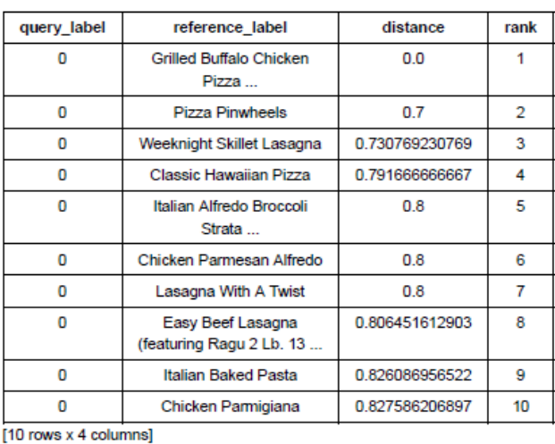
- We visualized the distribution of recipes by rating,
cuisine vs no. of recipes, cooking time & rating vs ingredient count, rating vs cooking time.
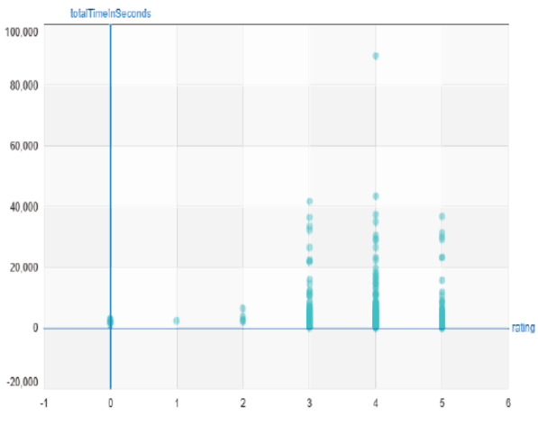
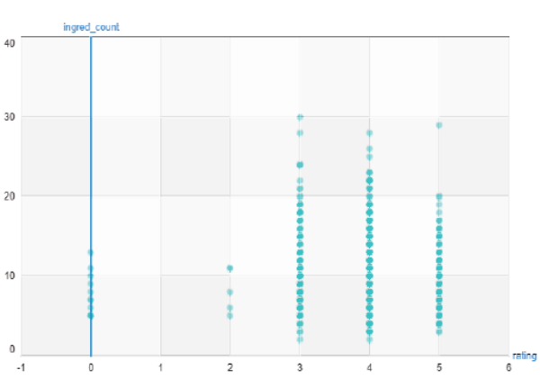
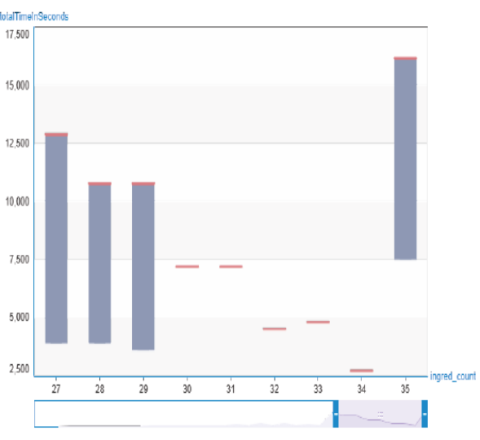
- Now, we built a generic simple linear regression function. Using the above model, we predicted cuisines for random ingredient lists (e.g.127). Then we evaluated our model using RSS (Residual Sum of Squares), a function which was built by us.
- Initially, we were directly predicting cuisines from ingredients in the pantry using issubset function. But since, there are lots of new cuisines emerging in the modern world today, we now aim to predict those using the ingredients we have by making regression model efficient by fitting it using different degree polynomials.
- Now, we compared different regression models in order to assess which model fits best and we used polynomial regression as a means to examine the same. To implement this, we created a polynomial SFrame function to create an SFrame consisting of powers of an SArray upto a specific degree.
- We created different degree polynomials ranging from 1 to 15 to predict cuisines and then plotted the predicted plot and found out the difference between their respective standard errors. (paste graphs)
- To make the plots more clean to visualize, we divided the data into 4 subsets of roughly equal size and estimated a 15th degree polynomial model on all 4 subsets and plotted the resulting fit.
- At this stage, we were not totally clear which degree polynomial fits the best. So, we applied a well known way to select parameters like degree by splitting the dataset into training, testing and validation set. Using these to compute the RSS on validation data for degree polynomials ranging from 1 to 15. Thus, we obtained the degree polynomial which gives minimum RSS amongst all 15, and that is degree 2 polynomial.
- Now, we ran ridge regression (Ridge regression aims to balance the bias-variance tradeoff
- Large tuning parameter(lambda) corresponds high bias, low variance
- Small tuning parameter(lambda) corresponds low bias, high variance
Thus, tuning parameter controls model complexity.
) multiple times with different L2 penalties to see which one produces best fit.
We have so many features and so few data points, the solution can become highly numerically unstable which can sometimes lead to strange unpredictable results. Thus, rather than using no regularization, we will introduce a tiny amount of regularization, (L2 penalty=1e-5) to make the solution numerically stable.
- Recall that the polynomial fit of degree 15 changed wildly whenever the data changed. So, we splitted the data into 4 subsets and fit the model of degree 15 and the result came out to be very different for each subset. The model had high variance. Now, we will see that Ridge Regression reduces such variance. Now, we used Ridge Regression with small test L2 penalty upon the 4 datasets and visualized their plots.
- Since variance still came to be high, ridge regression aims to address this issue by penalizing large weights and choosing L2 penalty=1e5 on all 15th order polynomial. Now visualizing the plots of 4 different datasets, variance significantly decreased.. So, these curves vary a lot less, now that we have applied a high degree of regularization (regularization aims to minimize total cost to fit function which is equal to measure of fit+ measure of magnitude of coefficients).
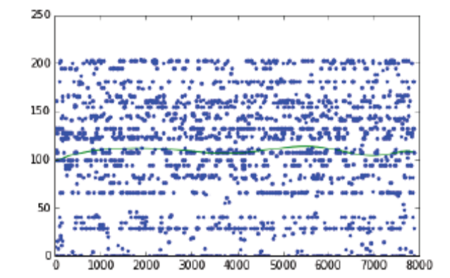
- Just like we implemented K-Fold Cross Validation before, we implement it again by creating a K-Cross Function via polynomial regression using L2 penalty as parameter because we don’t want to leave any observations for training data.
- Now, we built a function to compute the average validation error for the above model and wrote a loop to find the model that minimizes the average validation error. The loop does the following:
- Fit a 15th order polynomial model
- For L2 penalty in [10^1, 10^1.5, 10^2, 10^2.5,….,10^7]
- Run 10 Fold Cross Validation with L2 penalty
- Report which L2 penalty produce lowest average validation error
So, we found that L2 penalty=10^1 produces minimum RSS value.

- Now, we compute the derivate of regression cost function. Cost function is the sum over the data points of the squared difference between an observed output and a predicted output + L2 penalty term.
Cost(w)=SUM[(prediction-output)^2]
Derivative=2*SUM[error[feature_i]]

- Next, we write a function that performs gradient descent algorithm in our Ridge Regression Model.
- We visualized effect of L2 penalty and see how large weights get penalized. To do this, first we make a model considering no regularization and calculating the weights, then, considering high regularization, we make a model to get weights. Now, we plot the two learned models and compare both using the weights obtained before. So, we observed that, working with high regularization produced less RSS value as compared to the model with no regularization.(RSS is equal to summation of square of differences between real value and predicted value).
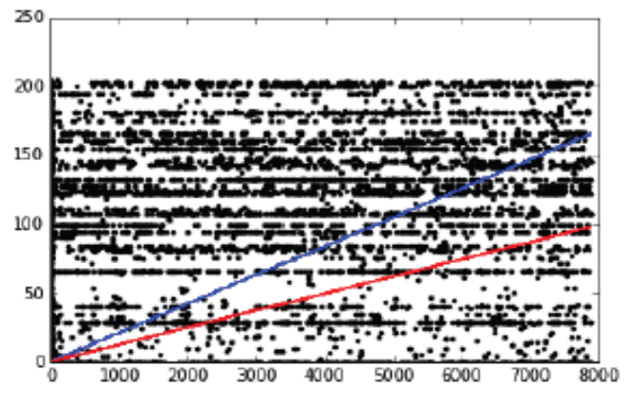
- For predicting similar cuisines for a particular cuisine of interest, in computing distances, it is crucial to normalize features otherwise eg. the cooking time feature (typically on the order of 1000s) would exert a much larger influence on distance than the ingredients feature (typically on the order of 1s). To calculate this, we define Euclidean distance and we use this in our nearest neighbor regression model to compute the distance between our query cuisine and all cuisines in our training set.
- We built a function to find K-nearest neighbours on our own and now made another function to take the average of the cuisines of the K-nearest neighbours in the training set. This function returns a predicted value of the query cuisine.
- In order to make multiple predictions, we made a function to predict the most similar dish corresponding to each and every dish in the dataset .
- Choosing the best value of k using validation set, we take values of k ranging from 1 to 15 and compute the RSS for predictions of these values and report which k value produce the lowest RSS on validation set. We found out that k=14 gives minimum RSS value on validation set. Now, to visualize the performance of the above model as a function of k, we plot RSS on validation set for each considered k value.
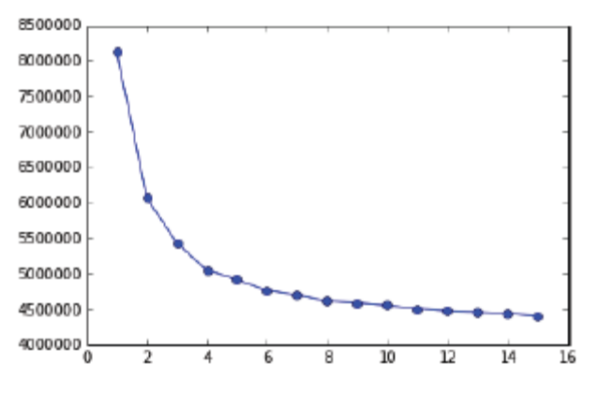
- We have crawled calorie count and appended it to our dataset. Usually, young adults who are in early 20’s normally require 1500 calories to be taken everyday in order to have a balanced diet. (This much amount of calorie value is generally taken from a renowned health website www.livestrong.com). Since we normally take 3 meals per day, this implies almost 500 calories per meal. So, taking 500 calorie as a threshold in calories ranging from 50 to 999, we make a target column(healthy) in our dataset in which 1 signifies healthy meal and -1 signifies unhealthy. The no. of cuisines which came out to be healthy were 4423 i.e. 53.046% and unhealthy being 3915 which is 46.954%.
- Now, we make a new classification algorithm which features ingredients, cooking time, ingredient_count, rating and cuisines. Now, we make a decision tree model of depth 6 and also a small model of decision tree with depth 2 and visualize both the trees, finding that visualizing the small model is comparatively easily to gain some intuition.
- Next, we make some predictions taking two +ve and two –ve examples from the validation set and see what the decision tree model predicts. So, the percentage of predictions the decision tree model got correct was 0.5. The probability of a cuisine being classified as healthy was 52% for the above 4 examples.
- In the visualization of the decision tree, the values at the leaf nodes are not class predictions but scores of being healthy. If score>0, class +1 is predicted. Otherwise, if score<0, we predicted class -1.
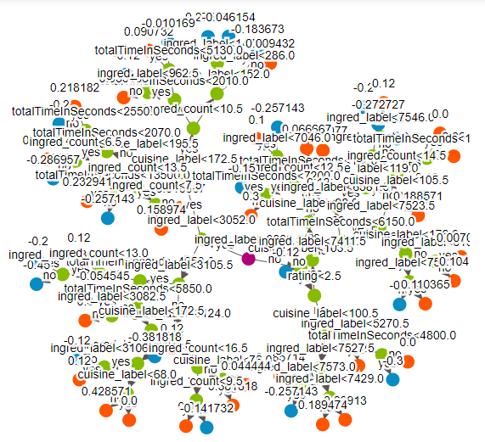
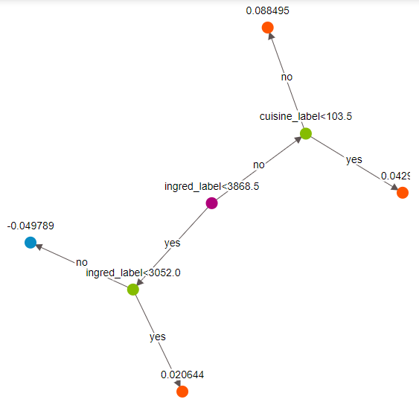
- The accuracy of the both the small (depth 2) and big(depth 6) were 54% and 57% respectively.
- Now, we evaluate the accuracy of complex decision tree model with max depth equal to 10 which came out to be 64% on trained data and 53% on validation data.
- Every mistake, the model makes costs money. We now try and quantify the cost of each mistake made by the model
- False –ves: Cuisines that were actually unhealthy were predicted to be unhealthy.
- False +ves: Cuisines that were actually unhealthy but predicted to be healthy.
Now, we plot a ROC curve of the model to visualize the variation of True +ve vs False +ve rate.
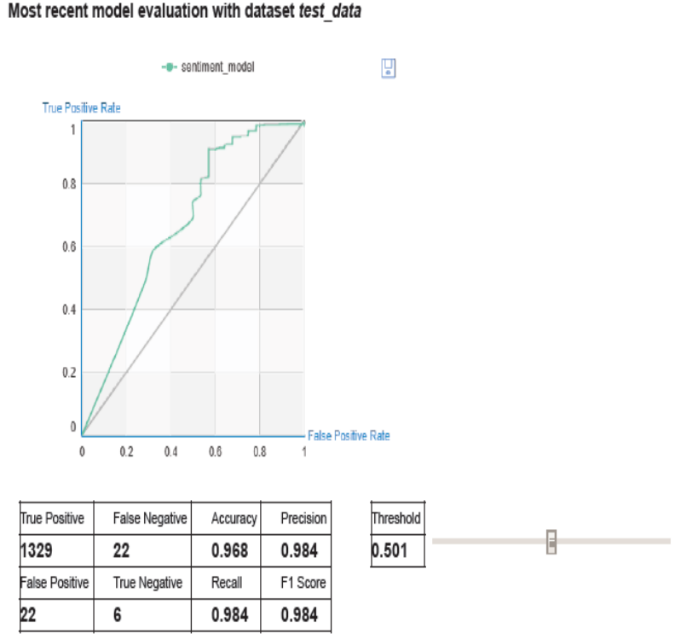

- The number of False +ve came out to be 663 whereas number of False –ves were 111.
- Assuming each mistake costs money, cost of $10,000 per False –ve, cost of $20,000 per False +ve ; the total cost obtained by decision tree model turned out to be 14.37 million.
- Ensemble methods : To further explore the use of boosting, we will use pre-implemented gradient boosting trees. To do this, we subsample the dataset to make sure the classes are balanced.
- We now train models to predict healthy cuisines with training and ensemble of 5 trees and we approached the data to predict healthy cuisines with the same technique as before by using two +ve and two –ve examples from the validation data and accuracy achieved is 52%.
- Confusion Matrix: True +ve(1,1)=415
True –ve(-1,-1)=404
False –ve (1,-1)=392
False +ve(-1,1)=387
- The benefit of extra 3% increase in accuracy in decision tree from cap 2 to cap 6.
- The cost of mistakes of the above ensemble model using false –ve and false +ve comes out to be 11.66 million which is 3.1 million less than the model without boosting.
- We find the cuisines that are most likely to be predicted healthy and for this we used an ensemble model with 5 trees and make probability predictions for all the cuisines and sort the data in decreasing order by probability predictions and found “southern cornbread dressing” as a result and also found out the top 5 cuisines with lowest probability of being predicted as a healthy cuisine.
- Now, we see the effect of adding more trees in the form of gradient boosted trees with 10, 50, 100, 200, 500 trees and calculated their respective accuracies in which the model with 100 trees came out to be the best.
- Finally, we plot the training and validation errors vs the no. of trees to get a sense of how these models are performing.
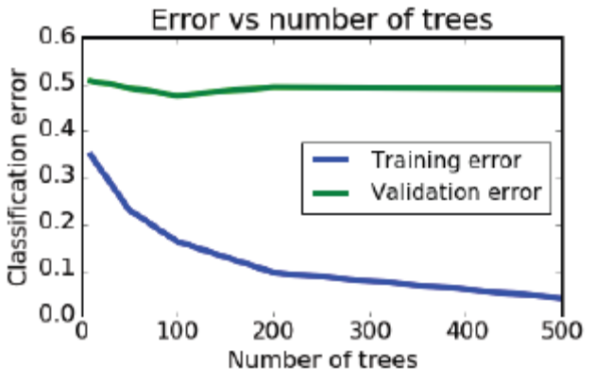

V. Conclusion
To conclude our project we assert that these important features and research objectives highlighted by us added something very important to the modern day Food-industry and also will help other researches in their research work as well. We aimed to build models that were efficient keeping in mind the various aspects related to humans like health by predicting healthy cuisines, mood by predicting similar dishes to a particular type of dish. Also assessing the popularity, Cooking times and ingredients counts were kept in mind while developing the models which seems to be our biggest achievement in our work. We also found relationships between many attributes and their dependence on each other like Cooking time and Rating of dishes increased with increase in no. of ingredients, also dishes with higher ratings had greater cooking times.

VI. Future Scope
In the future , we aim to deploy an app Intelligent Refrigerator which will use our predictive models to predict healthy cuisines based on the stock of ingredients the user has, and the mood of the user at that time. Also we would apply Deep Learning to capture the images of ingredients to directly sense what all ingredients the user has in stock, rather than typing them manually in the respective app.

VII. Acknowledgements

We would like to thank Prof Shikha Mehta and Prof Prashant Kaushik for their guidance and suggestions, especially for giving us the idea of trying and testing out different classification and clustering models in our dataset for improving the accuracy achieved. We would also like to extend our thanks to Prof Anuja Arora, who had been helpful in giving us the research idea suggestions.

References

- Yummly.com. (2017). Yummly: Personalized Recipe Recommendations and Search. [online] Available at: https://www.yummly.com/ [Accessed 28 Nov. 2017].
- Kaggle.com. (2017). Kaggle: Your Home for Data Science. [online] Available at: https://www.kaggle.com/ [Accessed 28 Nov. 2017].
- Rahul Venkatesh Kumar, R., Anand Kumar, M. and Soman, K. (2016). Cuisine Prediction based on Ingredients using Tree Boosting Algorithms. Indian Journal of Science and Technology, 9(45).
- Breiman, L. (2001). Random forests. Machine learning, 45(1), 5-32.
- Scikit-learn: Machine Learning in Python, Pedregosa et al., JMLR 12, pp. 2825-2830, 2011.
- McCallum, Andrew, and Kamal Nigam. "A comparison of event models for naive bayes text classification." AAAI-98 workshop on learning for text categorization. Vol. 752. 1998.
- Safreno, Doug, Deng, Yongxing. The Recipe Learner. Tech. N.p., 2013.
- Agarwal, Rahul, Jachowski, Daniel, Shengxi, David. RoboChef: Automatic Recipe Generation. Tech. N.p., 2009.
- D. Trudgian,Z. Yang, “Spam Classification Using Nearest Neighbour Techniques, ” Proceedings of the 5th international conference on intelligent data engineering and automated learning, pp.578–585.Revised
- L. Wang, Q. Li, N. Li, G. Dong, and Y. Yang. Substructure similarity measurement in chinese recipes. In Proceedings of the 17th international conference on World Wide Web, pages 979-988. ACM, 2

