Intelligent Refrigerator

Ishank Aggarwal Sarthak Joshi
JIIT,Noida-62,India JIIT Noida-62 ,India
ishankagarwal62@gmail.com sarthakjoshi2496@gmail.com

Abstract—In this research, we describe our models to predict “Cuisines from Ingredients”. Many applications like prediction of top 100 cuisines based on mood and keeping in mind the health of the user, predicting similar dishes to the query dish, and comparison between optimized models on the basis of money loss that they incur if the food intake is not right are covered in this research. We explore the formation of different patterns and combinations that are resulted when we apply various machine learning models to the given Yummly dataset of wide variety of cuisines. These models provide range of accuracies and the best one is used for each purpose according to the motto “survival of the fittest”.
Keywords—Multinomial Naïve Bayes; Logistic Regression; Random Forest Classifier; K-Nearest Neighbours Classifier; K-Fold cross validation; Sentiment Classifier; TF-IDF; Linear Regression; Multiple Regression; Gradient Descent; Polynomial Regression; Ridge Regression; L2 penalty

Introduction
Food is integral part of one’s life besides clothing and shelter, no matter whether the person is young or old but the intakes or the right amount of servings largely varies from person to person depending on his or her health condition, biological clock and choices. Many a times, we waste time in deciding what to cook so that it fits our appetite and fulfills our taste buds. This choice making can take a lot of time and moreover, it depends on the ingredients we have at the moment. So reduce the time and overhead of choice making, various machine learning algorithms come into play.
To test the efficiency and usefulness of these algorithms, we have used Yummly dataset throughout our research work. [5]. Yummly is a website and mobile app as well providing recipe recommendations with individual’s taste personalization, recipe search, digital recipe box, shopping list and one-hour grocery delivery. It contains a huge dataset of almost 8339 recipes with each recipe mentioned against its list of ingredients. Throughout the research work, this dataset proved immensely important in calculations while using different machine learning models. The dataset contains most popular and widely used cuisines in the American world. We have played around with the dataset and exploited it to its extremities to measure the accuracies relative to each major purpose we are trying to accomplish through our project, for instance, being able to predict the most suitable recipe for a person keeping in mind of his dietary levels such as calorie count.

Datasets Related Work

Dataset Information [5]
There are several companies with proprietary APIs and databases acquired through scraping these recipe websites. These companies then sell licenses to developers. These APIs vary in their quality, database size, and fees: [5]
BigOven: 350,000 recipes; REST JSON and XML output.
Yummly: 1 million recipes, ratings, ingredients; REST JSON output; Academic plan available with 30,000 lifetime calls.
Food2Fork: 250,000 recipes; JSON output; Free plan with 500 calls per day.
Spoonacular: 350,000 recipes; UNIREST JSON output; Free plan for hackathons and academic purposes
Edamam: 1.5 million recipes; Free Trial with up to 1000 lifetime calls
[5] Initially, the two API’s were selected as the choices for the predictive analysis namely Spoonacular API and Yummly API but While Spoonacular's API had more bells and whistles and advanced features, Yummly's database of recipes was generally of higher quality than Spoonacular's. It also had access to over 1 million recipes compared to Spoonacular's, and had better-formatted ingredients for each recipe. So, finally, Yummly API was chosen to carry out the task of prediction. Yummly's API is accessed by querying an API endpoint and returns JSON-encoded recipe data. JSON data was translated to Pandas dataframe structures using the Requests package and Pandas. Initially, cuisine data was written into 25 separate CSVs before assembling them into cuisines_data.csv. For each recipe, the recipe name, rating, cooking time, course, cuisine, and ingredients is stored against it. In total, there are 25 cuisines for 8339 recipes. Cuisine dataset basic stats: [5]
- 8037 recipes
- 25 cuisines: Asian is the most well-represented, with 1400 recipes. English the least, with just 32 recipes.
- Ratings: overwhelmingly 4-star (62.1% of the 8339), some 3-star (18.9%) and 5-star (17.2%), very few 0, 1, or 2 stars (1.8%)
- Cooking Time: mean of 65 minutes, max of 1970 minutes (33 hours), min of 1 minute, median of 40 minutes
- Ingredients per recipe: mean of 10.1, max of 35 (Thai chicken tacos), min of 1, median of 9
- 3958 unique ingredients:
  - Most common ingredients: Salt (3325 occurrences, 0.41 frequency), garlic (0.22), onions (0.20), olive oil (0.18)
  - Least common ingredients: 1401 unique ingredients are only used in one recipe throughout the dataset. Examples: chocolate candy, melon seeds, canned tuna, vegan yogurt, tarragon vinegar, unsalted almonds[5]
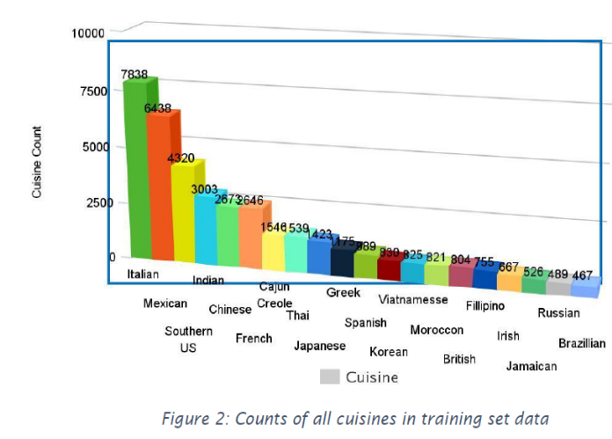Fig 1. Counts of all cuisines in training dataset
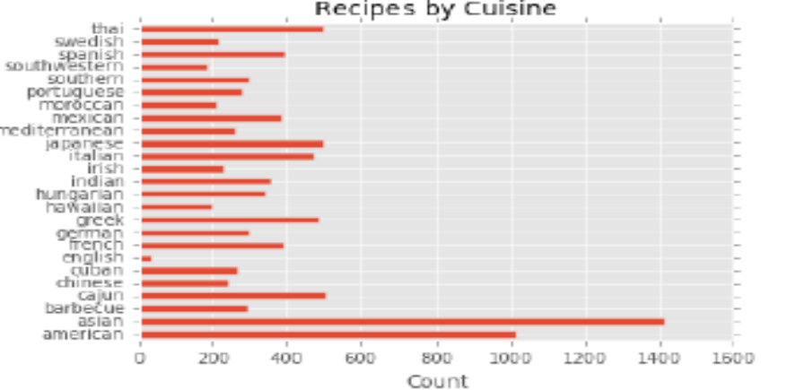Fig. 2. Graph showing distribution of no. of recipes vs cuisines.
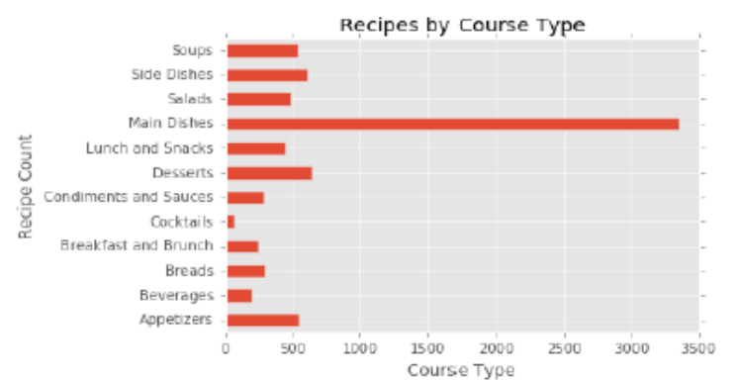Fig. 3 Graph showing distribution of no. of recipes vs course type.

Unique Ingredient Analysis is done by calculating the ingredient frequency which is obtained by dividing the instances by the number of recipes in the dataset, and appended as a new column "frequency".[5]
Next, we identified which recipes within a given dataset are the most 'unique' in terms of their ingredients on the basis of relative scoring using two recipe uniqueness formulas. The first method of scoring is to take the mean of each recipe's ingredient frequencies (e.g. (0.3+0.1+0.2) / 3). For each recipe's ingredients, the sum the ingredients' unique ingredient frequency score is calculated as above, and then divided by the number of ingredients in the recipe so as to not bias the scoring towards recipes with dozens of ingredients. This score is assigned to a column named "uniq_score1". The second method of scoring is to take the product of each recipe's ingredient frequencies (e.g. 0.3 * 0.1 * 0.2). This score is assigned to a column named "uniq_score2". The product tends to 'reward' recipes with extremely rare ingredients whereas the mean method 'rewards' these recipes to far lower extent. [5]

Data Pre-Processing
Several processing steps are conducted on the master cuisine data CSV file.

- Ingredient Parsing:
Each recipe's ingredients were encoded as a single, unseparated string, including brackets: "[ingredient 1, ingredient 2, ingredient 3]". So, in order to examine the ingredient separately, brackets from each ingredient string are dropped while traversing through [1:-1]. Next, the list of the ingredient string is returned separated by commas. This code treats essentially similar ingredients as unique, for instance, ‘pasta’, ‘Giorgino pasto’ and ‘fresh pasta’ are considered as separate ingredients.
- Ingredient Counts:
After parsing the ingredients from a single string to a list of strings, the number of ingredients in each recipe is computed by creating a new column named "ingredCount" and setting each value to len(ingredients).
- Time Conversion:
Each recipe's cooking time is converted from seconds to minutes by dividing it by 60 and populating it in a column named "timeMins".

- Munging:
To make sure that data is sufficiently clean for analysis, some measures are taken.
- The rows of cuisines data that had an empty “cuisine” value are dropped. Yummly's "Search by Cuisine" API call returns recipes that have "Chinese" in the recipe in some shape or form-- even in the ingredients! So a sandwich recipe that employs "French bread" or an "English muffin" might have a cuisine value of "French" or "English". To avoid these ambiguities, the empty recipes without an explicit cuisine are dropped. This greatly reduced the number of recipes for some cuisines like English.
- Empty course values are filled with "Unknown" rather than dropping these recipes.
- Finally, duplicate recipes from the dataset are dropped.

III. Methodology

Logistic regression
Logistic Regression is used for binary classification to estimate the probability of binary response based on predictors (independent variables) like features.
This algorithm makes use of predicting the logit transformation function based on characteristic of interest as”
Where p denotes the probability that characteristic of interest is present or not.
2) The Naive Bayes' Theorem : It works on conditional probability to find the probability of an event given that the another event has already occurred. It is a powerful algorithm which even works on millions of records with some attributes. [6]
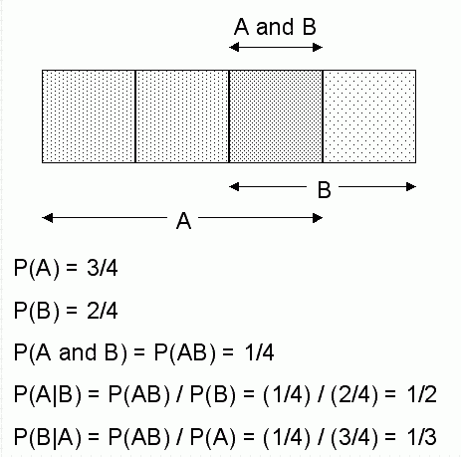
Fig 4. Conditional Probabilities in Bayes' Theorem
3) Random forests or random decision forests
Random Forest is ensemble learning method which constructs a multitude of trees to get more accurate and stable prediction. It can be used classification, regression , and other tasks in which it outputs the mode of the classes(classification) and mean prediction(regression) of the individual trees. It is also useful in dealing with the problems of over-fitting of the decision trees to their training set. [4]
4) K-fold cross validation : It is a type of Cross Validation and is a machine learning algorithm. It works as follows. First we do partioning of the dataset into k subsets, each one is called a fold. Out of the k folds, 1 fold is the validation set and the other k-1 folds are the cross validation sets. We train our model on the cross validation set and the predicted results are used to calculate the accuracy of the model with the validation set. Then the average of all the k accuracies of the model is the accuracy of the machine learning model.

Fig. 5. Figure showing how training subsets of dataset are trained by model.

5) K-Nearest Neighbours (KNN)

K nearest neighbors algorithm is used for classification and regression type of problems. In this algorithm a majority vote of the k neighbors classifies a new case from the stored cases. The case is chosen by the class that appears the most in the k neighbors using a distance function. There are many distance functions: Manhattan, Euclidean, Minkowski and Hamming distance. The first three functions are used for continuous variables and the Hamming distance measure is used for categorical variables. Value of K chosen is the topic of high importance which can be a challenge for better performance of the algorithm.

Linear Regression
Linear Regression is used to find relationship between continuous variables ie. Predictor or independent variable an response or dependent variable. We can get the idea that did the predictor correctly predict the outcome variable and which variables are significant predictors that impact the outcome variable.
- Polynomial Regression
Polynomial Regression function fits its model to the powers of predictor like features by linear least squares method. We can fit a k order/degree polynomial to data where Y is the predicted value of the model with regression coefficients b1 to k for each degree with intercept b. It is made up of linear regression models with k predictors raised to the power of i where i is equal to 1 to k.
- Ridge Regression
This algorithm is used in the problems which do not have a unique number of solutions, and provide additional information to the problem and thus, predicting the best solution. It is used to deal with multicollinearity(existence of near-linear relationship among independent variables) for multiple regression data. In this condition variances are so large so as to be far from the true value. By adding a degree bias to regression estimates, it reduces the errors.
- Gradient Descent
This algorithm is used to find the minimum of a function which is a first-order optimization algorithm which involves iterations. It finds the parameters (coefficients) for a function that minimizes the cost function. Steps proportional to the negative of the gradient are taken in order to get the local minimum at the current point. To get the local maximum one has to take step proportional to the positive gradient. This process is called gradient descent.
- Decision Trees
A decision tree is a tool for classification and prediction whose each node does a test on an attribute, whereas each branch corresponds to the result of the test, and leaf nodes have a class label. It involves recursive partitioning in which the tree is split up into subsets undergoing recursion. Usually decision tree classifier has good accuracy.
- Ensemble Methods
Ensemble method is a supervised learning algorithm where we use multiple algorithms instead of constituent algorithms alone which gives us better performance and accuracy. They have high flexibility like a single model would over-fit the training data but ensemble techniques (like bagging) can reduce such problems.

- Gradient Boosting
Gradient Boosting is a supervised learning model which produces a prediction model which consists of an ensemble of weak prediction models like decision trees. It has a loss function (MSE) which should be minimum, that means the sum of the residual values should be close to zero which means that the predicted values are almost the correct actual values. There are many other popular boosting algorithms like XGBoost, AdaBoost, GentleBoost etc.

IV. Features And Results
1) The research done by Conway Yao included predefined ML models namely Logistic Regression and Multinomial Naïve Bayes with accuracies of 44% and 54% respectively.
2) To improve the accuracy, we chose to apply Random Forest Classifier with predefined ensemble scikit-learn library and we achieved accuracy of 52%.
3) Then, we applied K-Nearest Neighbors Classifier with number of neighbors ranging from 1-13 and we achieved maximum accuracy of 44%.
4) We observed that the recipe names are too diverse from each other and training on some part of the data and leaving the other for testing will prevent us from learning the whole data. Henceforth, we applied K-Fold Cross Validations which trains and tests on the whole data with no. of folds equal to 100 and achieved an improved accuracy of 56%.
5) Now, we built a model to find recipes that we can make given a set of supplies in the pantry. To implement this, we chose first 100 most frequent ingredients used in most recipes worldwide. So, we got 114 recipes as the result.
6) Now, we observed that there was no relationship between the recommended cuisines we obtained from the above model, so, we built a Sentiment Classifier based on the ratings and probability of presence of particular ingredient. The no. of recipes obtained were 100.
7) Now, we aim to predict similar dishes for a particular dish like pizza. So, we applied tf-idf algorithm to increase the weights of unique ingredients of dishes and thus by applying nearest neighbor model, we found 9 similar dishes closest to “grilled buffalo chicken pizza”.
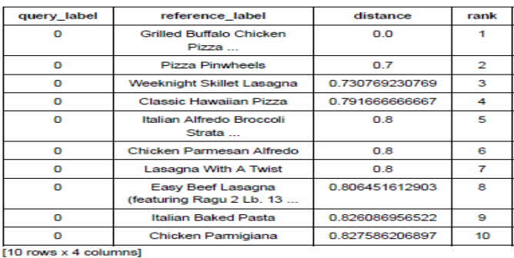Fig. 6. Table showing 9 nearest similar dishes to “Grilled Buffalo Chicken Pizza”.

8) We visualized the distribution of recipes by rating, cuisine vs no. of recipes, cooking time & rating vs ingredient count, rating vs cooking time.
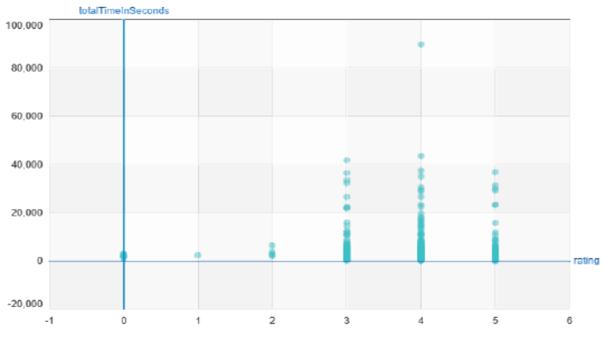
Fig. 7. Graph showing relationship of totalTimeInSeconds(cooking time) vs rating.
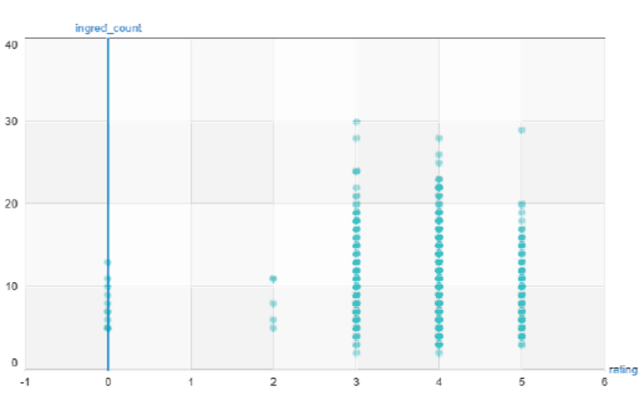
Fig. 8. Graph showing relationship of ingred_count(ingredient count) vs rating.

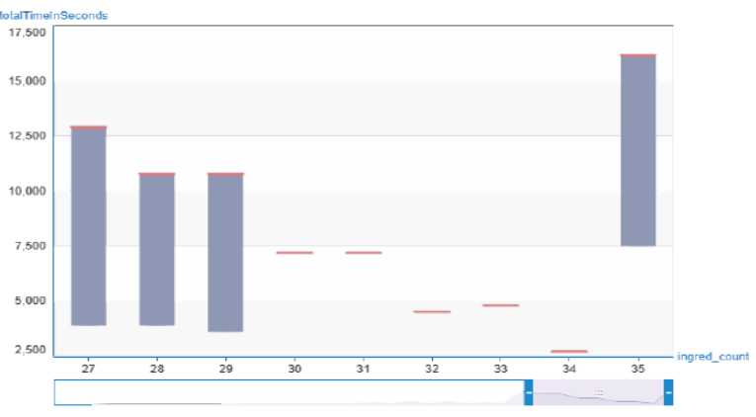
Fig. 9 Graph showing relationship of totalTimeInSeconds(cooking time) vs ingred_count(ingredient count).

9) Now, we built a generic simple linear regression function. Using the above model, we predicted cuisines for random ingredient lists (e.g.127). Then we evaluated our model using RSS (Residual Sum of Squares), a function which was built by us.
10) Initially, we were directly predicting cuisines from ingredients in the pantry using “issubset” function. But since, there are lots of new cuisines emerging in the modern world today, we now aim to predict those using the ingredients we have by making regression model efficient by fitting it using different degree polynomials.
11) Now, we compared different regression models in order to assess which model fits best and we used polynomial regression as a means to examine the same. To implement this, we created a polynomial SFrame function to create an SFrame consisting of powers of an SArray upto a specific degree.
12) We created different degree polynomials ranging from 1 to 15 to predict cuisines and then plotted the predicted plot and found out the difference between their respective standard errors. (paste graphs).
13) To make the plots more clean to visualize, we divided the data into 4 subsets of roughly equal size and estimated a 15th degree polynomial model on all 4 subsets and plotted the resulting fit.
14) At this stage, we were not totally clear which degree polynomial fits the best. So, we applied a well-known way to select parameters like degree by splitting the dataset into training, testing and validation set. Using these to compute the RSS on validation data for degree polynomials ranging from 1 to 15. Thus, we obtained the degree polynomial which gives minimum RSS amongst all 15, and that is degree 2 polynomial.
15) Now, we ran ridge regression (Ridge regression aims to balance the bias-variance tradeoff
- Large tuning parameter(lambda) corresponds high bias, low variance
- Small tuning parameter(lambda) corresponds low bias, high variance
Thus, tuning parameter controls model complexity.
) multiple times with different L2 penalties to see which one produces best fit.
We have so many features and so few data points, the solution can become highly numerically unstable which can sometimes lead to strange unpredictable results. Thus, rather than using no regularization, we will introduce a tiny amount of regularization, (L2 penalty=1e-5) to make the solution numerically stable.
16) Recall that the polynomial fit of degree 15 changed wildly whenever the data changed. So, we split the data into 4 subsets and fit the model of degree 15 and the result came out to be very different for each subset. The model had high variance. Now, we will see that Ridge Regression reduces such variance. Now, we used Ridge Regression with small test L2 penalty upon the 4 datasets and visualized their plots.
17) Since variance still came to be high, ridge regression aims to address this issue by penalizing large weights and choosing L2 penalty=1e5 on all 15th order polynomial. Now visualizing the plots of 4 different datasets, variance significantly decreased.. So, these curves vary a lot less, now that we have applied a high degree of regularization (regularization aims to minimize total cost to fit function which is equal to measure of fit + measure of magnitude of coefficients).
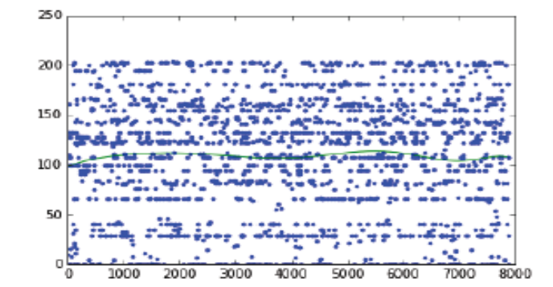
Fig. 10. Graph showing 15th order polynomial with L2 penalty= 1e5
18) Just like we implemented K-Fold Cross Validation before, we implement it again by creating a K-Cross Function via polynomial regression using L2 penalty as parameter because we don’t want to leave any observations for training data.
19) Now, we built a function to compute the average validation error for the above model and wrote a loop to find the model that minimizes the average validation error. The loop does the following:
- Fit a 15th order polynomial model
- For L2 penalty in [10^1, 10^1.5, 10^2, 10^2.5,….,10^7]
- Run 10 Fold Cross Validation with L2 penalty
- Report which L2 penalty produce lowest average validation error
So, we found that L2 penalty=10^1 produces minimum RSS value.
20) Now, we compute the derivate of regression cost function. Cost function is the sum over the data points of the squared difference between an observed output and a predicted output + L2 penalty term.
Cost(w)=SUM[(prediction-output)^2]
Derivative=2*SUM[error[feature_i]]
21) Next, we write a function that performs gradient descent algorithm in our Ridge Regression Model.
22) We visualized effect of L2 penalty and see how large weights get penalized. To do this, first we make a model considering no regularization and calculating the weights, then, considering high regularization, we make a model to get weights. Now, we plot the two learned models and compare both using the weights obtained before. So, we observed that, working with high regularization produced less RSS value as compared to the model with no regularization.(RSS is equal to summation of square of differences between real value and predicted value).
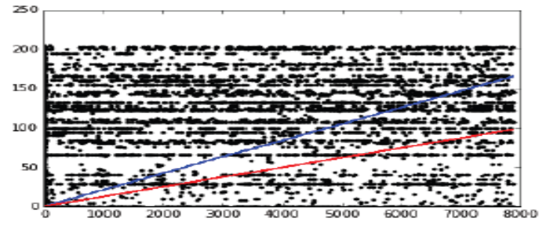
Fig. 11. Graph showing RSS comparison (Red: High regularization, Blue: Low regularization)

23) For predicting similar cuisines for a particular cuisine of interest, in computing distances, it is crucial to normalize features otherwise eg. the cooking time feature (typically on the order of 1000s) would exert a much larger influence on distance than the ingredients feature (typically on the order of 1s). To calculate this, we define Euclidean distance and we use this in our nearest neighbor regression model to compute the distance between our query cuisine and all cuisines in our training set.
24) We built a function to find K-nearest neighbors on our own and now made another function to take the average of the cuisines of the K-nearest neighbors in the training set. This function returns a predicted value of the query cuisine.
25) In order to make multiple predictions, we made a function to predict the most similar dish corresponding to each and every dish in the dataset .
26) Choosing the best value of k using validation set, we take values of k ranging from 1 to 15 and compute the RSS for predictions of these values and report which k value produce the lowest RSS on validation set. We found out that k=14 gives minimum RSS value on validation set. Now, to visualize the performance of the above model as a function of k, we plot RSS on validation set for each considered k value.
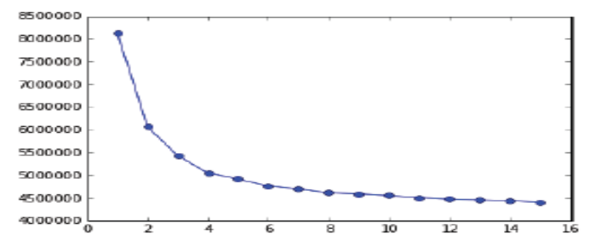
Fig. 12. Graph showing variation of RSS with different values of k.

27) We have crawled calorie count and appended it to our dataset. Usually, young adults who are in early 20’s normally require 1500 calories to be taken every day in order to have a balanced diet. (This much amount of calorie value is generally taken from a renowned health website www.livestrong.com). Since we normally take 3 meals per day, this implies almost 500 calories per meal. So, taking 500 calorie as a threshold in calories ranging from 50 to 999, we make a target column(healthy) in our dataset in which 1 signifies healthy meal and -1 signifies unhealthy. The no. of cuisines which came out to be healthy were 4423 i.e. 53.046% and unhealthy being 3915 which is 46.954%.
28) Now, we make a new classification algorithm which features ingredients, cooking time, ingredient_count, rating and cuisines. Now, we make a decision tree model of depth 6 and also a small model of decision tree with depth 2 and visualize both the trees, finding that visualizing the small model is comparatively easily to gain some intuition.
29) Next, we make some predictions taking two +ve and two –ve examples from the validation set and see what the decision tree model predicts. So, the percentage of predictions the decision tree model got correct was 0.5. The probability of a cuisine being classified as healthy was 52% for the above 4 examples.
30) In the visualization of the decision tree, the values at the leaf nodes are not class predictions but scores of being healthy. If score>0, class +1 is predicted. Otherwise, if score<0, we predicted class -1.
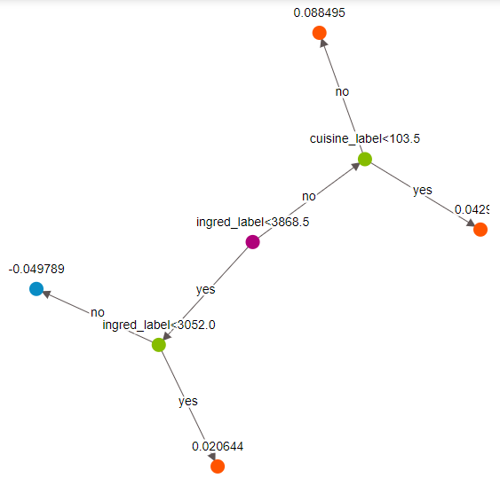
Fig. 13. Decision Tree capped to depth=2 for better visualization.
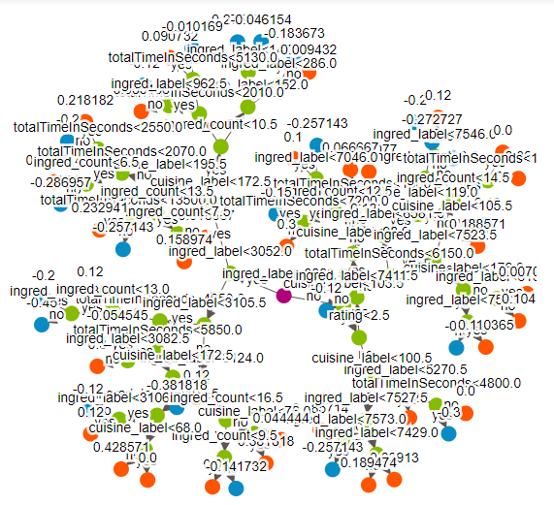
Fig. 14. Decision Tree visualization (depth=10).
31) The accuracy of the both the small (depth 2) and big(depth 6) were 54% and 57% respectively.
32) Now, we evaluate the accuracy of complex decision tree model with max depth equal to 10 which came out to be 64% on trained data and 53% on validation data.
33) Every mistake, the model makes costs money. We now try and quantify the cost of each mistake made by the model
- False –ves: Cuisines that were actually unhealthy were predicted to be unhealthy.
- False +ves: Cuisines that were actually unhealthy but predicted to be healthy.
Now, we plot a ROC curve of the model to visualize the variation of True +ve vs False +ve rate.
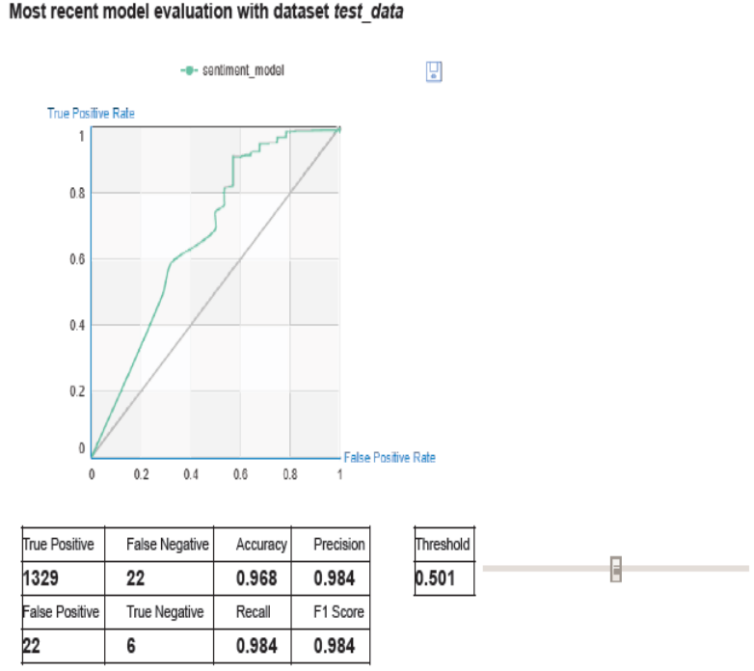
Fig. 15. Graph sowing false positives and negatives for quantification of mistakes.
34) The number of False +ve came out to be 663 whereas number of False –ve’s were 111.
35) Assuming each mistake costs money, cost of $10,000 per False –ve, cost of $20,000 per False +ve ; the total cost obtained by decision tree model turned out to be 14.37 million. Ensemble methods : To further explore the use of boosting, we will use pre-implemented gradient boosting trees. To do this, we subsample the dataset to make sure the classes are balanced.
36) We now train models to predict healthy cuisines with training and ensemble of 5 trees and we approached the data to predict healthy cuisines with the same technique as before by using two +ve and two –ve examples from the validation data and accuracy achieved is 52%.
37) Confusion Matrix: True +ve(1,1)=415
True –ve(-1,-1)=404
False –ve (1,-1)=392
False +ve(-1,1)=387
38) The benefit of extra 3% increase in accuracy in decision tree from cap 2 to cap 6.
39) The cost of mistakes of the above ensemble model using false –ve and false +ve comes out to be 11.66 million which is 3.1 million less than the model without boosting.
40) We find the cuisines that are most likely to be predicted healthy and for this we used an ensemble model with 5 trees and make probability predictions for all the cuisines and sort the data in decreasing order by probability predictions and found “southern cornbread dressing” as a result and also found out the top 5 cuisines with lowest probability of being predicted as a healthy cuisine.
41) Now, we see the effect of adding more trees in the form of gradient boosted trees with 10, 50, 100, 200, 500 trees and calculated their respective accuracies in which the model with 100 trees came out to be the best.
42) Finally, we plot the training and validation errors vs the no. of trees to get a sense of how these models are performing.

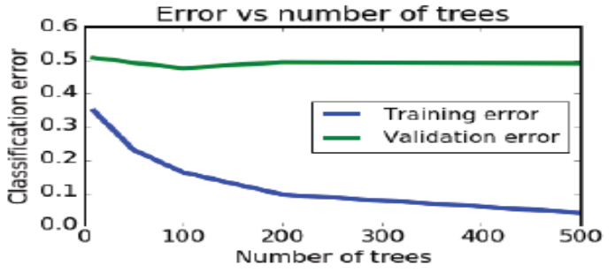
Fig. 16. Graph showing variation of RSS values vs No. of trees.

V. Conclusion
To conclude our research we assert that these important features and research objectives highlighted by us added something very important to the modern day Food-industry and also will help other researches in their research work as well. We aimed to build models that were efficient keeping in mind the various aspects related to humans like health by predicting healthy cuisines, mood by predicting similar dishes to a particular type of dish. Also assessing the popularity, Cooking times and ingredients counts were kept in mind while developing the models which seems to be our biggest achievement in our work. We also found relationships between many attributes and their dependence on each other like Cooking time and Rating of dishes increased with increase in no. of ingredients, also dishes with higher ratings had greater cooking times.

VI. Future Scope
In the future, we aim to deploy an app Intelligent Refrigerator which will use our predictive models to predict healthy cuisines based on the stock of ingredients the user has, and the mood of the user at that time. Also we would apply Deep Learning to capture the images of ingredients to directly sense what all ingredients the user has in stock, rather than typing them manually in the respective app.

VII. AKNOWLEDGEMENTS
We would like to show our gratitude to Prof. Shikha Mehta and Prof. Prashant Kaushik for sharing their pearls of wisdom with us during the course of this project, and we hope to receive their continuous insights till the deployment of the project.

VIII. References
- Yummly.com. (2017). Yummly: Personalized Recipe Recommendations and Search. [online] Available at: https://www.yummly.com/ [Accessed 28 Nov. 2017].
- Kaggle.com. (2017). Kaggle: Your Home for Data Science. [online] Available at: https://www.kaggle.com/ [Accessed 28 Nov. 2017].
- Rahul Venkatesh Kumar, R., Anand Kumar, M. and Soman, K. (2016). Cuisine Prediction based on Ingredients using Tree Boosting Algorithms. Indian Journal of Science and Technology, 9(45).
- Breiman, L. (2001). Random forests. Machine learning, 45(1), 5-32.
- https://github.com/conwayyao/Recipe-Analysis
- McCallum, Andrew, and Kamal Nigam. "A comparison of event models for naive bayes text classification." AAAI-98 workshop on learning for text categorization. Vol. 752. 1998.
- Safreno, Doug, Deng, Yongxing. The Recipe Learner. Tech. N.p., 2013.
- Agarwal, Rahul, Jachowski, Daniel, Shengxi, David. RoboChef: Automatic Recipe Generation. Tech. N.p., 2009.
- D. Trudgian,Z. Yang, “Spam Classification Using Nearest Neighbour Techniques, ” Proceedings of the 5th international conference on intelligent data engineering and automated learning, pp.578–585.Revised
- L. Wang, Q. Li, N. Li, G. Dong, and Y. Yang. Substructure similarity measurement in chinese recipes. In Proceedings of the 17th international conference on World Wide Web, pages 979-988. ACM, 2

