

**General Sir John Kotelawala Defence University**

Faculty of Engineering

Department of IT

**Smart Vehicle Parking Management System Enable with Infrared Technology**

**GGYU Gunasekara**

**ICT/12/0142**

**Abstract**

With the increase in vehicle production and world population, more and more parking spaces and facilities are required. The number of people using their own cars has increased exponentially in the past ten or fifteen years. Most of the parking areas today in Sri Lanka currently operate without or with a small computerized system using a small database. They usually require vehicle owners to walk around and manually check the occupancy of individual spots. The owners are concerned that they are not maximizing profit due the inefficient managements of parking slots. This study aims to examine the development of vehicle parking management system using infrared sensor technology to detect the entering and leaving of the vehicle. This system has been developed using ASP.NET for the development of web application and C language for the desktop application and also windows server 2012 for the development of database. This system has been tested in the shopping complex environment with vehicle owners. The feasibility of the proposed model has been analyzed through financial, technical and operational perspectives and it has been discovered that infrared sensor technology based solution has the possibility to rationalize the vehicle parking management.

**Chapter 01- Introduction**

* 1. **Prolegomena**

Software solution have introduced new way of handling real world problems. Software provides cost effective, accurate, user friendly and reusable solution for almost all applications. Among other software technologies programming, databases, web and multimedia have been the most widely used for development of software applications. Nowadays numerous software engineering tools are available for development of software applications. This thesis present our project to develop a software solution for the domain of vehicle parking management. In doing so this chapter outlines objectives, background and motivation for the project, problem in brief, hypothesis, proposed solution, resource requirements and overview of the structure of the rest of the thesis.

* 1. **Objectives**

With the aim to develop a web based vehicle parking management system, this project has identified the following objectives.

* To critically study the current practices in and issues in vehicle parking management solution
* To critically study the existing computer based solution for vehicle parking management
* To conduct detailed study of software engineering life cycle
* To do a detailed study of database, web, mobile and hardware technologies
* To develop an application which help customers to find a parking slot in an efficient manner
* To provide accurate results with the application to the users
* To provide the application with a user interactive and user friendly manner
* To provide backup, recovery and data integrity features to the database
* To provide authentic and authorized features to secure confidential data which can only be viewed by authorized user
* To deliver error free software application to the users
  1. **Background and Motivation**

Vehicle parking management has been one of the major concern in the modern world. There is an increasing demand in vehicle park management system in all the countries in the world. As quality of life increases, more and more people are dwelling cities. Urban life necessitates centralized public facilities. When visiting a new place for the first time or going to an event one must often deal with finding a car parking space. This can be a challenging and frustrating task for number of reasons. In most cases, location of parking spots is not known beforehand. Parking spaces can also have restrictions attached to them. Some parking lots are available only during certain hours of the day or it may only allow parking by people with permits. Without a proper vehicle park management vehicle parking will become an immense issue.

* 1. **Problem in Brief**

Parking problems are becoming ubiquitous and ever growing at an alarming rate in every major city. Time and cost are two important factors of human life, whether for an individual or a  
business. Offering safe and secure parking lots with a sufficient number of spaces can increase customer loyalty and attract customers to visit a shopping mall more frequently. With the increase in vehicle production and world population, more and more parking spaces and facilities are required. The number of people using their own cars has increased exponentially in the past ten or fifteen years. Therefore in order to provide parking spaces for the luxury of customers car parking has become an immense issue especially in big cities.

* 1. **Hypothesis**

Technology is now sinking in our lives and launch to remodel our standard way of living. From simple cellular phones to multimedia gadgets to super computers, that enables a person to make traditional processes become automate. Advances in technology such as the World Wide Web is one of the major media used by people nowadays to access information. Therefore web based solution with using infrared sensors can address the existing parking issues and it more helpful to do the work in an efficient and effective way. An infrared sensor is an electronic device that emits and/or detects infrared radiation in order to sense some aspect of its surroundings. Through this technology it has been possible to detect parking slots to increase the customer efficiency & satisfaction.

* 1. **Software Solution for Vehicle Parking Management**

In order to address this issue a new parking system called Smart Vehicle Parking Management System (SVPMS) is proposed to assist drivers to find vacant spaces in a car park within a shorter time. In the system, low-cost wireless sensors are deployed into a car park field, with each parking lot equipped with one sensor node, which detects and monitors the occupation of the parking lot. Features of SPS include vacant parking space detection, display of available parking spaces, payment facilities and different types of parking spaces (vacant, occupied and reserved) through the use of IR sensors. This system has been developed using ASP.net and windows server 2012 to run as web based system.

* 1. **Resource Requirement**

In order to execute the application in a successful manner the resources required in technical and human perspectives. Therefore as technical perspectives it requires hardware and software in order to establish the application. In human perspective, it requires the people who are aware of working with the IR sensor technology in order to get their assistance and the people who are having basic knowledge of working with a computer can be able to handle this application with the internet connection.

* 1. **Structure of the Thesis**

In context to the thesis this is an effort to represent the view of the entire research. In here these information related to the research is presented with seven separate chapters in order to get an easier understanding regarding the process. It includes the chapters as Introduction, Literature Review, Technology Adoption, Approach, Design, Analysis and Evaluation.

* 1. **Summary**

As discussed so far vehicle has become a necessity in our daily life making the vehicle quantity increase dramatically. Vehicle brings convenience to people, yet parking causes serious problems because of poor management at the same time. For drivers and managers, traditional parking management hasn’t met their needs in efficiency, security and performance. Therefore, the need for smart parking system with high efficiency, low cost and high security is indispensable for people in the modern society. This chapter determines the IR technology as a solution for the above mentioned problem.

**Chapter 02- State of the Art**

* 1. **State of the Art of Smart Vehicle Parking Management System**

Some of the features of the existing vehicle parking management systems has been documented in this section, together with the major and general types of vehicle parking management system. The chapter is also going to explore the product of the research conducted on existing vehicle parking systems. The scope of this chapter is basically to identify some vehicle parking management system and compare them, to produce the proposed new system.

* 1. **Introduction to Smart Vehicle Parking Management System**

Due to the technological innovations man is leading a comfortable life. But at the same moment these advancements have become hard at times. The number of people using their own vehicle has increased exponentially in the past ten or fifteen years with the growth of economy. Vehicle brings convenience to people yet parking has become an immense issue especially in large metropolises because of poor management at the same time. Traditional parking management hasn’t met their needs in efficiency, security and performance.

Hence an outline to vehicle parking management system, it is a system that is used to help managing vehicles in parking area to avoid congestion and arrange vehicles in an allocated position. The system also helps to track how many vehicles pass through the gate and the duration taken by each, and then it will calculate the amount of money a vehicle should pay when exiting. Vehicle parking management system is being used in many congested area or location where there are many meeting point of people like where there are more than one shopping complex near to each other or where there is megamall or stadium.

* 1. **Categories of Vehicle Parking Management System**

There are mainly three categories of vehicle parking management systems using different technologies:

* Wired Sensor-based Technology

Wired sensor-based system is using detection sensors such as ultrasonic sensors which are installed at each parking lot. These sensors are wired to a central control unit that store and manage the parking occupancy information. This information is then forward to display panels at intentional locations in the car park. The display panels provide information, direction and guide the drivers to vacant parking lots.

* Wireless Sensor-based Technology

With the advancement of wireless technologies, wireless based methods have been employed in parking management systems. Wireless sensors nodes are deployed and each parking lot is equipped with one node. The sensor board is equipped with the sensors of light, temperature, acoustic and a sounder. In using wireless technologies, disadvantage in employing sensor at each parking lot is still present and can be very costly as each sensing unit is usually attached with a processing unit and a transceiver.

* Image Processing and Character Recognition Technology

Image Processing involves the manipulation of the pixels of one image to form another image. An image can be obtained from some devices such as: scanners, sensors, etc. The parking management systems used image processing of recognizing number plates for operation of parking and billing system. License plate recognition applies image processing and character recognition technology to identify vehicles by automatically reading the license plates. Firstly the car image is captured. Then, the system should extract the number plate of the car alone for the segmentation of character purpose. Optical character recognition used to identify individual alpha numeric characters on a license plate. Character Segmentation separates each letter or number where it is subsequently processed by optical character recognition (OCR) algorithms. It translates the captured image into an alpha numeric text entry.

* 1. **Parallel Systems in World Context**

Vehicle parking management systems which are used in world context are described under this section.

* + 1. **Wired Sensor-Based Systems**
* Smart Parking System (SPS) Architecture Using Ultrasonic Detector

According to Kianpisheh et al.,(2012) a new parking system called Smart Parking System (SPS) is suggested to support drivers to find vacant spaces in a car park within a shorter time using ultrasonic sensors. Ultrasonic sensors detect car park occupancy or improper parking actions. Features of SPS include vacant parking space detection, detection of improper parking, display of available parking spaces, and directional indicators headed for vacant parking spaces, payment facilities and different types of parking spaces (vacant, occupied, reserved and handicapped) through the use of specific LEDs. The system used ultrasonic sensors, LED indicators, indoor display boards, outdoor display board(s), zone control unit (ZCU), central control unit (CCU), network switch, telephone cable and management software.

For each individual car park, one sensor is fixed in each parking space which is worked based on echo-location. The sensor transmits a sound, hits the car or ground and it is reflected back to the sensor. The time between the sent pulse and the returned echo is used to evaluate distance. The time among transmitted sound and reflection is lengthier in a vacant space than in an occupied space, hence the sensor can detect when a space is occupied. Figure 2.1 demonstrates how it works.

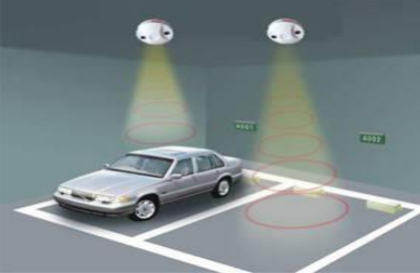

Figure 2.1: Ultrasonic Sensor Detection Area

Source: Kianpisheh et al. 2012, p.55

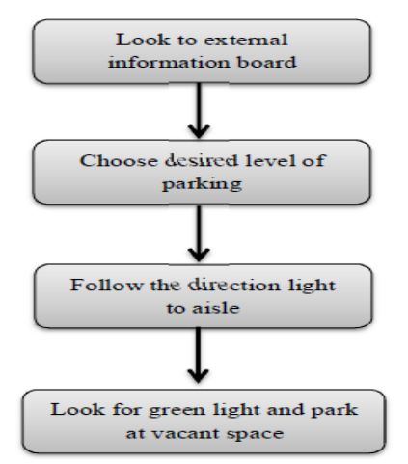

Figure 2.2: Overview of SPS Car Park Guidance System

Source: Kianpisheh et al. 2012, p.55

Figure 2.2 shows the four stages of utilizing a car park guidance system. Drivers look at an LED display board to find vacant spaces which displays how many and which type of vacant spaces are offered at each level at that time. After directing to the preferred parking level, drivers look at internal signs hanging from the ceiling at the end of each passage. Each internal sign shows the number of existing spaces and the direction (left, right or forward) of the path which has a vacant space. Each individual parking space is fixed out with LED lights in green, red, blue or yellow. Green color means the space is vacant, red means the space is occupied, blue indicates the space is assigned for handicapped drivers and yellow specifies it has been booked or is a VIP or reserved space for specific reasons. When a driver arrives to a vacant space, the green light changes to red. The LED and the sensor attach to each other through a phone cable.

Through the use of ultrasonic sensors it has several characteristics such as ultrasound waves can be produced with high directivity, they have a lower propagation speed than light or radio waves. However they also only detect objects directly behind or in front of the car, and may not work if the sensors are dirty or out of alignment. Ultrasonic parking sensors not be suitable for use with a tow bar. Besides that, temperature changes and extreme air turbulence affects the sensor performance.

* + 1. **Wireless Based Technology**
* RFID-Based Automatic Vehicle Parking System

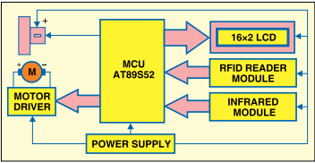

Figure 2.3: Block diagram of RFID-based automatic vehicle parking system

Source: Waraich 2012, p.118

Waraich (2012) proposed RFID-Based Automatic Vehicle Parking System as shown in the figure 3 diagram. The system consists of a vehicle counter, sensors, display board, gate controller, RFID tags and RFID reader. Firstly the vehicle owner has to register the vehicle and get the RFID tag. The RFID tag is located near the RFID reader, which is installed near the entry gate of the parking lot. When the RFID tag is read by the reader, the system automatically takes the specified amount from the RFID tag and the entry gate boomer opens to take the car inside to the parking area. Simultaneously, the parking counter increments by one. Likewise, the gate is opened at the exit and the parking counter decremented. The system also offers the facility to recharge the amount for each RFID tag. No manual processing is involved. In addition, the system provides security.

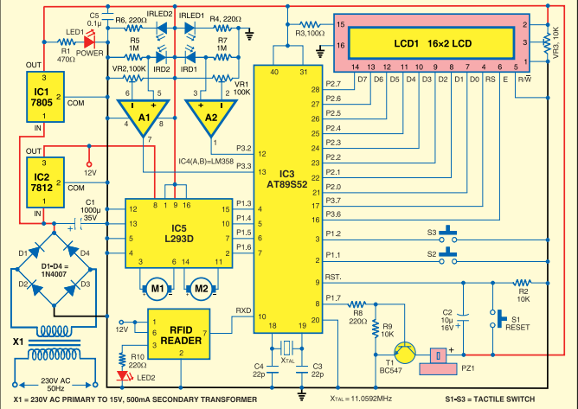

Figure 2.4: Circuit of the automatic RFID-based automatic vehicle parking system

Source: Waraich 2012, p.119

Figure 2.4 indicates the circuit of the RFID based automatic vehicle parking system. The circuit can be divided into different sections: Power supply, AT89S52 microcontroller, Connectors CON2 through CON4, L293D motor driver, LM358 op-amp, IR transmitter and receiver and LCD display.

Above declared automatic vehicle parking system is developed based on RFID technology which is an automatic identification method consisting of several components such as tags, tag readers, edge servers, middleware, and application software. RFID can store up to 1000 bytes of data and it is specific to each item. RFID system has the ability for data backup, recovery, and tags replacement. With the use of this RFID automatic vehicle parking system, time of searching a parking lot and manual effort will be reduced although parking lot utilization will be developed.

RFID technology has even now been applied effectively, it has certain technological barriers that still need to be overcome to optimize its application. These omissions are high investment, lack of security and privacy, and some related to the technology of RFID. The major drawback is the cost of the RFID tag therefore industrial leaders are concerned about the return on investment and net profit by investing the extra cost in the existing system. RFID can be interfered with other radio transmissions, metals, liquids, etc. There are many variations of RFID that operate at different frequencies and need different software and readers. Thus an agreement between the manufacturers, retailers and distributors is need to have interoperability upon one or group of frequencies.

* Intelligent Car Parking Management System On FPGA (ICPMS)

Khan et al. (2013) proposed ICPMS which is implemented using Field-Programmable Gate Array (FPGA) which provides widespread management for vehicles including parking facilities and security. ICPMS divided into several different modules such as car entering module, car exiting module, security module and invoice module.

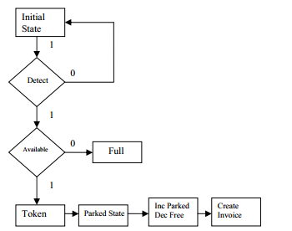

Figure 2.5: Flow Chart of the Entering Module

Source: Khan et al. 2013, p.174

As shown in figure 2.5 when the car enters to the lot, the IR sensor detects the arrival of the car. At that moment the capacity of the car park is checked, if there is a free slot in the parking lot, the car is allowed to enter the car park and a security token is allocated to it, or else it is shown that the park is full. After assigning the security token the car is allowed to park in specific location which is shown on the display. As intelligent car park system keeps track of all the parked cars, free locations and the location where the next car should be parked so when the car is parked the agreeing values are updated, the free locations or free slots are decremented by one and the chosen slots values are incremented by one. And if this was the last free location in the lot then it is displayed that the park is full. At the end a counter is started to create invoice for it.

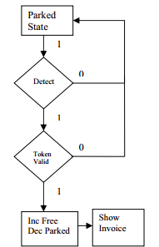

Figure 2.6: Flow chart of the Exit Module

Source: Khan et al. 2013, p.174

Figure 2.6 shows the flow chart of Exiting Module. When car exits, the sensor in the slot detects it. After that the assigned security token is checked. If it is found correct the car is allowed to go to the next state which is the invoice payment, otherwise it is not permitted to exit. The free locations or free slots are incremented by one and the selected slots values are decremented by one. The invoice is displayed to the car leaving the lot according to its stay in the parking system.

In Security Module, when the car enters the lot, it is assigned a security code. User will be only allowed to leave the parking lot, if the given code is correct. Each slot number should have its own security code to distinguish between the slots and this code generation should be random and tough to crack because this code is the basis of all the security of system is providing. In Invoice Module, as the car exits the lot, it is shown the invoice or the bill. In other words the payment details are displayed to the user, who leaves the car park. If a day was passed, then the invoice changes consequently.

* A Street Parking System Using Wireless Sensor Networks

Zhang et al. (2013) suggested Street Parking System (SPS) based on wireless sensor networks can monitor the state of every parking space by deploying a magnetic sensor node on the space. For accurately detecting a parking car, a vehicle detection algorithm is suggested. Sensor nodes are deployed along the roadside and each node is mounted on the center floor of a parking space. Each sensor node distinguishes the earth’s magnetic field periodically. When a node detected a car entering or leaving, it transmits a message to the router. The router forwards the packet to a base station that is one or more hops away. In the base station, information from different nodes will be combined, and parking guidance information will be transferred to LED board and remote server.

When deploying the sensor nodes the resistant issue and the protection over rainwater through node shell in bad weathers were some of the problems faced by the system.

* + 1. **Image Processing and Character Recognition Technology**
* Automatic Parking Management System and Parking Fee Collection Based on Number Plate Recognition

Rashid et al. (2012) discussed on automatic parking system and electronic parking fee collection based on vehicle number plate recognition. The system used image processing of recognizing number plates for operation of parking and billing system. At the entry, the vehicle will stop before the entry barrier and its existence is detected by loop sensor. The loop sensor will initiate the camera to capture a picture of the vehicle and the License Plate Recognition module (LPR) will analyze the captured picture to recognize the number. The captured picture together with the recognized number and entry date & time will be kept for parking fee calculation later. At that moment the entry barrier will open to allow the vehicle to enter and park. Another loop sensor after the barrier will close the barrier. The entry station is used to interface with the loop sensors and automatic barriers. When the leaving vehicle reach the exit booth, it will stop before the barrier and its presence is detected by a loop sensor. This sensor will initiate a picture to be taken and the license plate to be read by the LPR module. The LPR module will match the recognized vehicle number with its own file for the entry time for this particular vehicle. Once the exit and entry record are matched, the system will calculate and display the parking fee. When the transaction is complete, the exit barrier will open and the vehicle will leave. For barrier control there is another loop sensor is implemented.

Above mentioned automatic parking system based on image processing the number plate is differed by color, size and type from country to country. Therefore different algorithm has to be applied for different type of number plates. As a result of that this system cannot be used for different number plates which is varied from the number plate that is recognized in the system.

* 1. **Parallel Systems in Sri Lankan Context**

Automated car park management system which is developed by the Honeywell Company in Germany is used by the World Trade Center which ensures smooth and efficient traffic flow within a 550 vehicle capacity. There is convenient access to the office towers too, via a covered drop-off point through a private driveway. Magnetic sensors are deployed in the entry and exit gates. When a sensor detected a car entering or leaving, the gate is automatically opened. Customer gets a proximity card including a barcode number at the entry point and the system keep the record of entry time. At the exit point the system will calculate and display the parking fee. When the transaction is complete, the exit barrier will open and the vehicle will leave. The system calculates the total number of vehicles that has been parked in each day.

* 1. **An Approach to the Proposed Vehicle Parking Management System**

According to the above technologies if ultrasonic sensor is not positioned correctly, there could be a signal interference and the detector reading could be inaccurate. Reflecting surface also need to be flat so as to produce an accurate ultrasonic reading. Another limitation related to the use of this technique is the interference. If there is any interference there could be an impact on the strength of the echo that the ultrasonic transmitter received. And also RFID technology is more expensive and a complex technology. Exact details about standards and regulations of RFID may vary from one country to another. Installation of magnetic sensors requires pavement cut, coring, or boring under the roadway and thus requires lane closure during installation. Magnetic detectors cannot generally detect stopped vehicles. Also, some models have small detection zones. The other technology called image processing, the utilization of video image processor provides the ease of management and implementation as it is readily available in most car park facilities with basic surveillance systems (Kastrinaki et al., 2003). However the CCTV cameras which uses to capture images of vehicle may reduce the performance due to the inclement weather, shadows, and day-to-night transition etc. camera motions due to strong winds might also affect some models. The height and layout of the car park facility might also pose a problem as blocking can occur at certain locations.

By considering these technologies the proposed solution is the IR sensor technology to detect the vehicle parking lot. IR detectors can detect infrared light from far distances over a large area, much like the human eye is capable of detecting visible light. IR detectors operate in real-time and detect movement, making them ideal for security purposes. IR sensors are cost effective and can be practically implementable but the sensitivity of the sensor is reduced in heavy rain, snow etc. Key benefits of infrared sensors include low power requirements, simple circuitry, and their portable feature.

* 1. **Conclusion**

As a conclusion this document elaborates the technologies which are used to develop vehicle parking management system under four categories such as Wired Sensor-based Technology, Wireless Sensor-based Technology, Image Processing and Character Recognition Technology and Counter-based Technology. These technologies are described in world context as well as in Sri Lankan context. Through those technologies IR sensor technology has been selected for the proposed vehicle parking management system.

**Chapter 03- Technology Adoption**

**3.1 Introduction**

In the chapter 2 it discussed the details about the literature of the project. In there it was discussed the phenomena of the entire project and the background. Thus in this chapter it has been discussed about the technology perspective of the entire software development of SVPMS.

**3.2 Program Development- Technology Considerations**

To cope with the ever growing problem of parking management this chapter further defines an advance solution for managing and monitoring parking spaces. With the advancement of wireless technologies, wireless based methods have been employed in parking management systems. Monitoring parking lot vacancy and monitoring detection technology can be used to estimate the number of remaining vacant spaces for the entire parking lot by counting incoming and outgoing vehicles. And also it monitors the status of each individual space.

To detect the status of an individual parking space this proposed system used an Infrared sensors which placed at each space. Infrared (IR) radiation is electromagnetic radiation with wavelength longer than that of visible light but shorter than that of radio waves. Common systems for traffic surveillance use IR ranging from 100 to 105 GHz.

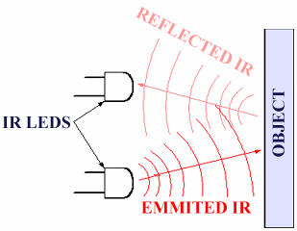

Figure 3.1: Working Principle of IR Sensor

Source: http://www.ikalogic.com/infra-red-proximity-sensor-part-1/

The active IR system emits low-energy radiation from light-emitting diodes or high energy one by laser diodes. The time difference between transmit and receive of the reflected signal from the detection zone is measured. A shorter return time represent the presence of a vehicle. Speed estimate is obtained by transmitting two or more IR signals onto different positions in the detection zone. Figure 3.1 shows a simple setup for such a system. Key benefits of Infrared sensors include low power requirements, simple circuitry and their portable feature.

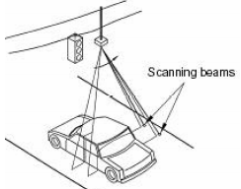

Figure3.2: Active Infrared Vehicle Detection

Source: http://www.civil.iitb.ac.in/tvm/1111_nptel/526_AutoVideo/plain/plain.html

The proposed system be made of hardware architecture and software architecture. The hardware architecture consists of set of infrared emitters and infrared receivers. The signal is generated when the vehicle is entered to particular slot and the signal is transmitted to the arduino 2560. Arduino 2560 is a microcontroller board based on the ATmega2560 as shown in the figure 3.3. It simply connect to the computer via USB cable. Arduino Ethernet shield connects the arduino to the Internet via RJ45 cable. In the vehicle park, LCD display can used to represent the availability of the vehicle park on site. Keypad can be used to enter customer PIN number to confirm his arrival.

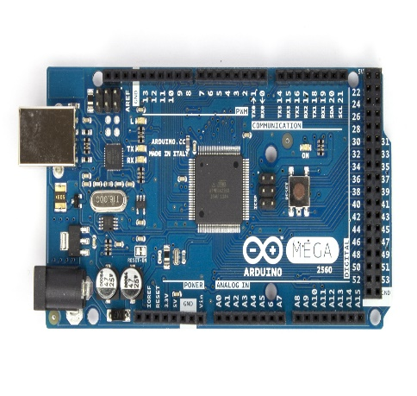

Figure 3.3: Arduino Mega 2560 R3 Front

Source: Arduino.cc

**3.3 Language & Tools Selection**

Overall system architecture is based on the three layers namely presentation layer, data link layer and application layer. ASP.Net has been used as the programming language which provides an easier and stable environment to create great web applications.

**3.4Database Selection**

Database which is most important aspect of the overall system which handles all the relevant details related to parking environment. In order to fulfill the need of database operation this system has been used SQL Server Management Studio which enables to access and manage the database engine. Management Studio brings graphical tools for database management together with a rich development environment. Database is maintained at the server.

**3.5** **Technical requirements**

Technical requirements for the development of system are as follows.

* The system has been developed using Microsoft Visual Studio 2012 platform using ASP.net language.
* Microsoft Windows Server 2012 has been used as the database to store the data
* IR sensor technology and arduino has been used to develop the hardware implementation.
* The application package has been developed as it is compatible for any computer which runs on windows platform such as Windows 2000, XP, 2007 and 2008

**3.6 Usability Requirements**

Following are the usability requirements of the SVPMS.

* Gather information about the different user access levels and how to personalize the user interfaces for each access levels
* System shall be able to provide user friendly interfaces to the users
* Design the interfaces according to gathered user requirements
* System should be adopt in web based environments
* Gather requirements using various fact gathering techniques such as interviews, questionnaires, observations, document review etc. to have a broad idea about the system
* If the users are not up to the standards to use the system in an effective way, system developers should conduct training sessions to develop knowledge to use the system without having any trouble

**3.7 Summary**

Technology is a one of the essential criteria when developing a software project. Through this chapter it has been described about the IR sensor technology for the proposed software solution. This chapter further described the technical and usability requirements when developing the proposed solution.

**Line eka cross unama thamai senxe karanne**

**Chapter 04-Approach to SVPMS**

* 1. **Introduction**

Chapter 1 already defined the research problem and the technology to be used for devising a solution for the problem. In chapter 2 it discussed the related works of others regarding the vehicle parking management & chapter 3 discussed the technology that is going to use for solving the problem identified in chapter 1. And also chapter 3 further elaborates the Infrared sensor technology, SQL server, ASP.Net as the technologies for developing the smart vehicle parking management system.

* 1. **Hypothesis**

Technology is now sinking in our lives and launch to remodel our standard way of living. From simple cellular phones to multimedia gadgets to super computers, that enables a person to make traditional processes become automate. Advances in technology such as the World Wide Web is one of the major media used by people nowadays to access information. Therefore web based solution with using infrared sensors can address the existing parking issues and it more helpful to do the work in an efficient and effective way. An infrared sensor is an electronic device that emits and/or detects infrared radiation in order to sense some aspect of its surroundings. Through this technology it will be possible to detect parking slots to increase the customer efficiency & satisfaction.

* 1. **Users**

This system is mainly targeted for customers & it can be also accessed by system administrators and other technical staff for updating the system. There are two kind of customers namely registered customer and walk-in customer. The registered customer will be required to provide username and password to login to the system. Walk-in customer can reserve a parking spot after entering to the car park. And also other users of the system are system operators and administrators. Administrator should be able to view registered customer’s profiles. Operator should also be able to set the parking fee prices within the reserved period and new parking slots to the parking area under the confirmation from the administrator.

* 1. **Functional Requirements**

This section contains the functional requirements required by the SVPMS. The requirements in this section specify the functions that each module must be capable of performing.

* Module-1: User Interaction

This module supports the registration of new customers. There are two types of customers.

* Registered Customers
* The SVPMS shall be able to create customer profiles by filling customer details such as first name, last name, date of birth, phone number, company details etc. To log into an account, the user must be able to provide his or her username and password.
* User should be able to edit or delete an account.
* Unregistered Customers (walk-in customers) - Do not have an online account.
* Module-2: Parking Space Monitoring

Each parking spot has a record of its current state in the database: “vacant”, “reserved,” or “occupied.”

* The SVPMS shall be able to detect when and if each individual parking space is occupied (in 30 second increments) and be able to report this information to the main entrance.
* The SVPMS shall be able to detect when and if each individual parking space is vacant (in 30 second increments) and be able to report this information to the main entrance.
* The SVPMS shall be able to detect when and if each individual parking space is reserved (in 30 second increments) and be able to report this information to the main entrance.
* Module-3: Payments
* The system shall process payments based on length of parking time.
* Periodically (e.g., once a month), the system examines the list of transactions for all customers and generates the monthly statement.
* Module-4: System Administration
* The system shall be able to view the registered customers’ profiles and customer statistics.
* The system shall be able to set the various prices and rates for the different services provided.
* Module 5: Statistical Data Collection (Reporting)
* The SVPMS shall be able to display and print reports of the data stored on the network based on user specified criteria.
* The SVPMS should be able to view various statistical charts about parking occupancy over different periods (day, week, month, etc.)
  1. **Non-Functional Requirements**

This section point out the non-functional requirements required by the SVPMS.

* Performance requirements

This section specifies the performance requirements that the SVPMS must adhere to.

* The SVPMS shall be able to perform under any condition
* The SVPMS shall be able to provide continuous updating of every parking space monitored on a 30 second cycle
* The SVPMS shall be able to provide the user with the information that contains the most recent updates of the parking spaces
* Reliability

This section specifies the reliability requirements imposed upon the SVPMS.

* Reliability is defined as providing the user up to date, correct information when they need it. Information is considered correct when the parking spaces are accurately reported and the information is no more than 30 seconds old

# Maintainability

This section specifies the maintainability requirements imposed upon the SVPMS.

* The SVPMS shall not need more than 3 hours of weekly maintenance
* The SVPMS shall not need more than 7 days of annual maintenance (system maintenance different from weekly maintenance)
* Safety

This section specifies the safety requirements imposed upon the SVPMS.

* The SVPMS shall be able to provide data backup in case of system crash
* Security

This section states the security requirements that the SVPMS must adhere to.

* The SVPMS shall not be able to provide access to the unregistered persons
* The SVPMS should not be easily breakable

# Eco-friendly

This section specifies the environmental requirements imposed upon the SVPMS.

* The SVPMS shall not cause physical harm to users and non-users
* The SVPMS shall not cause interference to external systems
  1. **Input**

Registered customer should be able to insert relevant details such as name, address, phone number etc. and create a profile. Once he successfully created his own profile by providing a username & password he will be able to make parking reservations. Through a successful reservation registered customer gets a PIN and walk-in customer gets a temporary ID number as inputs to enter to the parking.

* 1. **Output**

Through the application IR sensors will be detect the vehicle park occupancy. When a vehicle is entered to the parking slot IR sensors will be detected that and give a signal to the main entrance by indicating ‘Occupied’ and When exiting from the parking slot IR sensors will be detected that and give a signal to the main entrance by indicating ‘Vacant’.

And also after successfully completing the reservation reserved slots are stored in the application. Various statistical reports will be generated daily, weekly, monthly etc. basis.

* 1. **Process**

Through the web application registered customer can reserve a parking slot before he gets into the parking area by using his or her username and password after successfully creating the user profile. The registered customer should be able to check the parking space availability by specifying the desired date and time interval, using a web browser. If the system responds stating that there are available spots, the customer should be able to make the parking reservation. Upon successful reservation, the registered customer is issued a personal identification number (PIN) via an email notification. After the reservation temporary identity number (ID) is issued to the walk-in customer. When he arrives to the parking area he enters the PIN or Temporary ID number to confirm his arrival. At that time entering time is recorded. At the departure exit time is recorded. After that the total time that he parked is calculated. Once he enters to the parking slot IR sensor detects the vehicle by emitting IR radiation. Subsequently state of the parking slot changed from reserved to occupy. When leaving the parking slot IR sensor changes the state from occupy to vacant. In the data link layer all the relevant data such as reservation details, payment details etc. are stored in the database.

* 1. **Features**

Features of this system include vacant parking space detection, display of available parking spaces, payment facilities and different types of parking spaces namely vacant, occupied and reserved. System should be able to update the information in a timely manner. Low cost infrared sensors are deployed in each parking slot to detect vehicles. Customer can easily access the system through internet connection.

* 1. **Summary**

In this chapter it explained the approach to an automated solution for vehicle parking management by describing its input, output, process & features etc. It also highlighted the uniqueness of the solution with respect to technology/input/users. Following the approach the next chapter will describe the design of SVPMS.

**References**

Kianpisheh, A, Mustaffa, N, Limtrairut, P, Keikhosrokiani, P, 2012, Smart Parking System (SPS) Architecture Using Ultrasonic Detector,vol.6, no.3, University Sains Malaysia.

Waraich, B, 2012, ‘RFID-Based Automatic Vehicle Parking System’,

<http://www.efymag.com>

Khan, R, Shah, Y, Khan, Z, Ahmed, K, Manzoor M, Ali, A, 2013, Intelligent Car Parking Management System On FPGA, Vol. 10, Issue 1, no.3, Sarhad University of Science and IT, Peshawar, Pakistan, Institute of Business & Management Sciences, AU, Peshawar, Pakistan, UET, Peshawar, Pakistan

Zhang, Z, Li, X, Yuan, H, Yu, F, 2013, A Street Parking System Using Wireless Sensor Networks, vol.2013, Dongguan University of Technology, China,

<http://www.hindawi.com/journals/ijdsn/2013/107975/>

Rashid, M, Nusa, A, Rahman, A, Farahana, N, Farhana, A, 2012, Automatic Parking Management System and Parking Fee Collection Based on Number Plate Recognition, International Journal of Machine Learning and Computing, Vol. 2, No. 2

Kastrinaki, V, Zervakis, M, Kalaitzakis, K, 2003, A survey of video processing techniques for traffic applications. Image Vision Comput., 21: 359-381,

<http://www.barcodesinc.com/articles/barcode-technology.htm>

**Bibliography**

Bong, D,Ting, K, Rajaee, N, 2006, Car-park occupancy information system. Third Real-Time Technology and Applications Symposium, RENTAS 2006, Serdang, Selangor, December 2006.

<http://www.cs.ieeemalaysia.org/RENTAS2006/papers/Car-Park-Occupancy.pdf>

Funck, S, Mohler, N, Oertel, W, 2004, Determining car-park occupancy from single images. Proceedings of the Intelligent Vehicles Symposium, June 14-17, 2004, Dresden, Germany, pp: 325-328.

Idris, M,Yong, Tamil, L, Haron, Z, 2008, Parking guidance system using RFID and image processing techniques in WSN environment. Proceedings of the 4th International Colloquium on Signal Processing and its Applications, March 7-9, 2008, Royale Bintang Hotel, Kuala Lumpur, pp: 1-6.

Lee, S., Yoon, D, Ghosh, A, 2008, Intelligent parking lot application using wireless sensor networks. Proceedings of the International Symposium on Collaborative Technologies and Systems, May 19-23, 2008, Irvine, CA., pp: 48-57.

Benson, J, O'Donovan, T, O'Sullivan, P, Roedig, U, Sreenan, C *et al*., 2006. Car park management using wireless sensor networks. Proceedings of the 31st Conference on Local Computer Networks, November 14-16, 2006, Tampa, FL., USA., pp: 588-595,

<http://ieeexplore.ieee.org/xpl/login.jsp?tp=&arnumber=4116625&url=http%3A%2F%2Fieeexplore.ieee.org%2Fxpls%2Fabs_all.jsp%3Farnumber%3D4116625>

Chen, M, Chang, T, “A Parking guidance & Information system based on Wireless Sensor Networks”, IEEE International Conference on information & Automation Shenzhen, China, June 2011,

<http://www.ijetae.com/files/Volume4Issue2/IJETAE_0214_95.pdf>

Cheung, Y, Varaiya, P, “Traffic surveillance by wireless sensor networks: final report,” Tech. Rep., California PATH, University of California, Berkeley, Calif, USA, 2007,

<http://www.its.berkeley.edu/publications/UCB/.../UCB-ITS-PRR-2007-4.pdf>

Srikanth, V, Pramod, P, Dileep, K, Tapas, S, Patil, M, “Design & Implementation of a Prototype Smart Parking(SPARK) System using Wireless Sensor Networks” International Conference on Advanced Information Networking & Applications workshops, 978-0-7695-3639-2/09, 2009 IEEE,

<http://ieeexplore.ieee.org/xpl/login.jsp?tp=&arnumber=5136681&url=http%3A%2F%2Fieeexplore.ieee.org%2Fiel5%2F5136571%2F5136572%2F05136681.pdf%3Farnumber%3D5136681>