

**General Sir John Kotelawala Defence University**

Faculty of Computing

Department of IT

**Tablet PC based Motor Vehicle Insurance Claiming Solution**

Software Engineering Project undertaken in partial fulfillment of the Requirements for the Bachelor of ICT Degree program

**By**

**WMIL Wasalage**

**(ICT/12/0121)**

**Under the Supervision of**

**Mr. Nandana Pathirage**

**Abstract**

In motor vehicle claim settlement procedure, the preliminary assessment depends solely on the discretion of the insurance agent. He uses his experience and knowledge to assess the damage. Typically, customers are not satisfied with the assessment of the damage and there are no prescribed criteria or template on which the assessment is based. In most instances assessments are inadequate and customers are left with no choice but to bear the loss. In order to overcome of above mentioned problems this paper discuss a software solution to develop a smartphone based motor vehicle insurance claiming solution (SBMVCS) in order to enhance the information communication between the office and the field agents to minimize the loopholes in the current procedure. The solution consists of 2 main components as the online web application for the use of ground office staff and the smartphone application for the use of field agents to assist with the assessment process. The proposed software solution is stored in a web application server providing access to the system through a standard web browser. As for the mobile application, it access the system and the database via mobile networks through a web service. Overall system is divided in to three layers names as application layer, data layer and presentation layer. Thus the solution will allow the agents to provide real time updates and maintain the end to end connectivity with the company database.

Keywords— Smart Devices, insurance claiming, web services

**Table of Contents**

**Chapter 01- Introduction** **6**

1.1 Prolegomena 6

1.2 Objectives 6

1.3 Background and Motivation 7

1.4 Presenting Problem 7

1.5 Hypothesis8

1.6 Software Solution for Motor Vehicle Claim Settlement8

1.7 Resource Requirement 8

1.8 Structure of Thesis 9

1.9 Summary 9

**Chapter 02- Analysis of Existing Literature** **10**

2.1 Introduction 10

2.2 Motor Vehicle Insurance Industry: An Overview 10

2.3 Smartphones in the Age of Mobility and Smart Devices: An Overview 11

2.4 Mobile Network Penetration and Trends of Usage of Smartphones in Sri Lanka 13

2.5 An overview on Web Services 16

2.6 Examination of Past Research18

2.7 Summary 19

**Chapter 03- Technology Adoption** **21**

3.1 Introduction 22

3.2 Software Development- Technology Considerations 22

3.3 Language and Tools Selection 22

3.4 Database Selection 23

3.5 Technical Requirements 24

3.6 Usability Requirements 24

3.7 Summary 25

**Chapter 04- Approach to TBMVCS** **26**

4.1 Introduction 26

4.2 Hypothesis 26

4.3 Users 26

4.4 Functional Requirements 26

4.5 Non-Functional and Performance Requirements 27

4.6 Input 28

4.7 Output 28

4.8 Process 28

4.9 Features 29

4.10 Summary 29

**Table of Figures**

Figure 1.0 Loss Ratio-Non Life 10

Figure 2.0 Smartphones Becoming More Powerful 12

Figure 3.0 Increase of Mobile Subscription in Sri Lanka 14

Figure 4.0 How Internet Usually Accessed14

Figure 5.0 Mobitel GSM Coverage 15

Figure 6.0 Dialog GSM Coverage 15

Figure 7.0 Web Services Architecture 17

**Introduction 01**

# **Prolegomena**

In the modern world people have introduced software solutions as a major way of handling real world problems. Software solutions can be used to enhance the accuracy, efficiency, cost effectiveness, reusability and many more feature of a manual process. With the emergence concepts such as Internet of Things and advancements in networking people are connected with each other more than ever. Among other software technologies programming, databases, web and multimedia have been the most widely used for development of software applications in order to present solutions to various industries. Nowadays numerous software engineering technologies, tools, platforms are available for development of software applications for enterprises. This thesis presents a project to develop a software solution for the domain of motor vehicle insurance claiming procedure. In doing so, this chapter outlines background and motivation for the project, problem in brief, hypothesis, proposed solution, resource requirement and overview of the structure of the rest of the thesis.

# **Objectives**

With the aim to develop a smartphone based software solution to streamline the extant motor vehicle claim assessment and settlement procedure in order to benefit both the insurer and the client followings are the key milestones which needed to be achieved successfully during the project.

* To identify the weaknesses in phases of existing motor vehicle claim settlement procedures.
* To investigate similar researches and projects steered to mitigate identified weaknesses with the aid of technological advancements.
* To develop the web application linked with a central database and host in a server such that employees can access the system through a standard web browser.
* To develop and host a web service along with web system in order to allow any platform smartphones to connect to the system.
* To develop smartphone application to access the main system as well as the database through the hosted web service.
* To provide means to make assessments of damages more effectively and efficiently through access to an online central database.
* To improve customer satisfaction by the reduction of misjudged claims.

# **Background and Motivation**

Over past years, the use of automobiles have become more common with the increasing complexity of human lives. In Sir Lanka for any vehicle, it is must to have a motor vehicle insurance before using the vehicle. The growth in the automobiles usage in the country has led to the establishment of several insurance companies and it has become a competitive market segment in the industry where there is constant cash flows. In any motor vehicle insurance company, one of the key process is the claim settlement of their customers in case of an accident. It can be seen that cost savings and efficient process improvements in claims management business processes have a great impact on the key performance indicators of insurers.

When a motor vehicle meets with an accident, in the past the traditional way was to wait till the police produce a report of the accident which may take usually more than 2 weeks. Therefore sometimes vehicle owners have to bear the cost of repair on his own before getting the insurance money. As a solution the ‘on the spot’ policy was introduced. In the on the spot claim settlement process, after an accident has happened a field agent from the insurance company has to go to the accident location and do the preliminary assessment depends solely on the discretion of the insurance agent to complete the claim settlement. Whether it is a on the spot or not an assessment should be done on the accident location. Agents should use his experience and knowledge to assess the damage. There are problems arisen with this scenario which will be discussed in the next section.

# **Presenting Problem**

Insurance companies has become a major revenue generator in the business sector over the past years. Their main business is handling life and general insurance policies and under the general insurance solutions insurers usually provide motor, fire, marine, personal, engineering, medical, title, and miscellaneous insurance solutions. The growth in the automobiles usage in the country has led to the establishment of several motor insurance departments in these companies and it has become a competitive market segment in the industry where there is constant cash flows.

Even though there is several companies competing in the industry, they are confronted with a gradual decrease of motor policy renewals which has caused a decline in revenue. This has caused due to the inherent loopholes in the vehicle claiming procedure. In the current procedure of claim settlement, on the scene of an accident, an insurance agent does a preliminary assessment of the damage to the vehicle. This preliminary assessment depends solely on the discretion of the insurance agent. He uses his experience and knowledge to assess the damage. Typically, customers are not satisfied with the assessment of the damage and there are no prescribed criteria or template on which the assessment is based. In most instances assessments are inadequate and customers are left with no choice but to bear the loss.

Furthermore, the process of doing a preliminary assessment, verifying the documents and photographs in the scene of accident and the process of approving the claim and reprocessing the documents in the branch/head office to settle the claim causes hefty delays. These loopholes caused clients to leave the company effecting a decline of motor policy renewals.

To insurance companies, issues regarding the vehicle claim procedure is of utmost importance as motor policies are their top income earner and responsible for their considerable market share. As a solution for the delays ‘On the spot’ motor vehicle claiming procedure was introduced. In this methodology also several loopholes were seen similar to the earlier process due to the fact, the agent had limited access to the company database or any other resources. Hence, the need to re-engineer the existing motor vehicle claim management process using newer technologies is made apparent.

# **Hypothesis**

Technology is integrating with our lives more and more with the advancements in the technology. Today’s world, even hand held mobile devices has dominant processing power cable of running applications smoothly. With these powerful hardware capabilities and software solutions combined using networks to convert traditional processes to automate processes. Therefore it is suggested that web based solution with an integrated mobile application can address the issues arisen in the claim settlement of a motor vehicle accident and hence, it will benefit both the customers and insurance company.

# **Software solution for Motor Vehicle Claim Settlement**

In view of above mentioned problems the proposed solution is to develop a Tablet PC based motor vehicle insurance claiming solution (TBMVCS) in order to enhance the information communication between the office and the field agents to minimize the loopholes in the current procedure. The solution will consist of 2 main components as the online web application for the use of ground office staff and the tablet pc application for the use of field agents to assist with the assessment process. Thus the solution will allow the agents to provide real time updates and maintain the end to end connectivity with the company database.

# **Resource Requirement**

In order to execute the application in a successful manner the resources are required in technical and human perspectives. Therefore as for the technical perspectives it requires hardware and software in order to establish the application. It requires a tablet pc to run the application while central web host location to host the system and database. Apart from that for ground staff will need computers and an internet connection to connect to the system. In human perspective, it requires the people who are aware of working with the smart devices and the people who are having basic knowledge of working with a computer will be able to handle the application with the internet connection.

# **Structure of Thesis**

In context to the thesis this is an effort to represent the view of the entire research. In here these information related to the research is presented with separate chapters in order to get an easier understanding regarding the process. It includes the chapters as Introduction, Literature Review, Technology Adoption, Approach, Design, Analysis, Testing and Evaluation.

# **1.9 Summary**

As deliberated so far vehicle has become a necessity in our daily life making the vehicle important too in our live. Every vehicle need a motor vehicle insurance thus, insurance companies has become a major revenue generator in the business sector over the past years. In the traditional insurance claiming it was discovered that there were many loopholes. But with the help modern of powerful hardware and software, there is a need for a computerized claiming solution for motor vehicle insurance industry which will improve the efficiency, accuracy, cost effectiveness of the traditional procedure. In the next chapter it will be discussed about similar researches done on this subject.

Analysis of Existing Literature 02

2.1 Introduction

This chapter is dedicated to scrutinizing literatures which investigate similar problem domains in the hope of identifying and analyzing basic concepts embedded within that body of research. Hence, first it is discussed about the motor vehicle insurance niche in the insurance field. It is followed by a discussion on smartphone technologies, usage of smartphones in Sri Lanka and an overall discussion about the emerging web technologies in the technical world.

In the next section, the feasibility of mobile technologies to the insurance industry is examined through studying past researches conducted on the similar subject by various researchers.

2.2 Motor Vehicle Insurance Industry: An overview

Over past years, the use of automobiles have become more common with the increasing complexity of human lives. In Sir Lanka for any vehicle, it is must to have a motor vehicle insurance before using the vehicle. The growth in the automobiles usage in the country has led to the establishment of insurance companies and it has become a competitive market segment in the industry. In the Fitch ratings it is stated that “Intense pricing competition in the motor segment is likely to hold the combined ratios in non-life above 100%”. Due to fall in imports with increased customs duty and unfavorable exchange rate movements, growth in the motor sector has dropped to 16.49 % in 2012 (2011: 29.56%). Yet, the influence of the motor segment in non-life remained high at 63.64% and will remain the major GWP contributor in non-life (Fitch ratings, 2014).

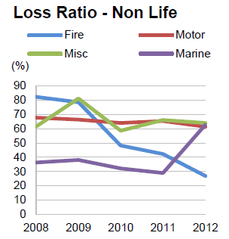

Figure 1.0: Loss Ratio - Non Life

Source: FitchRatings (2014)

Motor vehicle industry can be considered as an industry where there is a constant financial flow in-and-out with respect to a company. It is argued that cost savings and efficient process improvements in claims management business processes have a great impact on the key performance indicators of insurers(Baecker and Bereuter, 2010). The main reasons why cost savings are hard to achieve include the late involvement of insurers after car accidents, the limited integration of business partners such as repair shops, and improper information about the case circumstances (Kaeslin and El Hage 2008). As indicated by Capegemini 2013, Mobility has been acknowledged as a growing phenomenon in the insurance industry.

Since motor vehicle insurances is a fast growing area, it can be seen that with the help of latest technologies average claim life-cycle from set-up to close can be shortened as well as decrease the average costs per case since in contrast current motor vehicle insurance claiming procedure drags on for weeks to complete.

2.3 Smartphones in the Age of Mobility and Smart Devices: An Overview

A smartphone can be simply considered as a mobile phone with highly advanced features. Beal (n.d.) has described smartphones as a handheld device that integrates mobile phone capabilities with the more common features of a handheld computer or PDA. A smartphone is expected to have a more powerful CPU, more storage space, more RAM, greater connectivity options and larger screen. Smartphones are more powerful than regular cellular phones and PDAs in almost every aspects such as efficiency, reliability, user friendly and etc. A typical smartphone now a days generally has a high-resolution touch screen display, Wi-Fi connectivity, Web browsing capabilities, and the ability to accept sophisticated applications. The most popular mobile operating systems at the time being are Android, iOS and Windows Mobile.

The fine integration of these powerful hardware and software has paved a way to introduce sophisticated mobile devices with number of different services all in just one device. Those provided features along with the rapid developments in the internet technologies have amplified the usage of smartphone in the society. According to Gartner, a leading information technology research and advisory company, smartphones accounted for 53.6 percent of the overall mobile phone sales in 2013, which exceeded the annual sales of feature phones. Gartner revealed the global sales of smartphones to end users reached 968 million units during 2013, which is an increase of 42.3 percentage points from 2012's figure of 680 million.

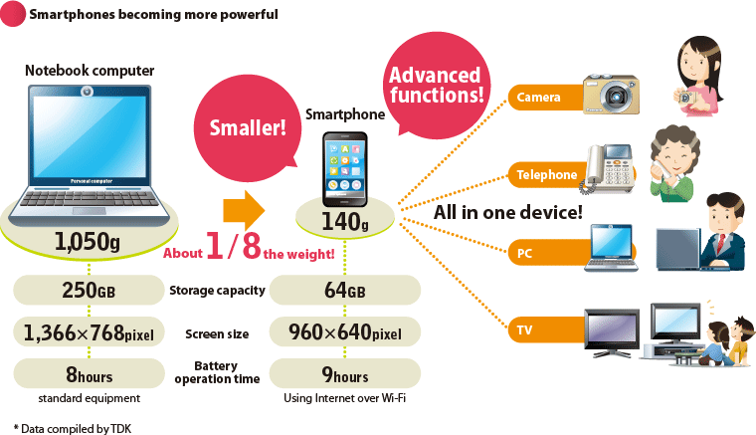

Figure 2.0: Smartphones Becoming More Powerful

Source: [www.global.tdk](http://www.global.tdk) (2012)

The above figure illustrate how smartphones are becoming more powerful day by day with the improvements in the technology field. Some of the common uses of smartphones are GPS to find your way, access your business data at any time, you will be able to conduct last minute researches, schedule keeping, managing the social collaborations and maintaining your schedules.

These trends make clear that these handheld devices and their technologies have become common currency in popular usage. Furthermore, they have penetrated every aspect of human existence. The widespread use of handheld devices in almost all major industries and sectors including financial services is a testimony for the ubiquitous applicability and popularity of mobile technologies.

Susan, a VP in Business Development at Scisbo Business Solutions states some applications of smartphone technologies which can be seen in the society. She mentions that medical doctors are able to monitor patients' health with heartbeat monitors, sleep monitors, and pedometers that connect to the cloud via a smartphone and send an alert when there’s a problem. People with chronic conditions such as diabetes can use a smartphone to monitor their blood sugar, making fewer trips to the clinic.

Furthermore she describes that smartphone docks in cars are valuable for more than just phone calls and entertainment. Now, they can be used for monitoring and diagnostics for the car itself or to track driving patterns for pay-as-you-drive insurance programs. Apart from that she also states that small size business reduce the energy use in commercial buildings by installing intelligent thermostats and heating controllers that can be programmed and monitored with apps and also smartphones can control door locks remotely or even control and monitor a whole security camera network.

It is the latest trend to develop smartphone applications which will communicate with your main server with the aid of a web service. Smartphone apps have been created to solve a problem, increase productivity, offer an intrinsic benefit, or for pure entertainment. Apple's IPhone store alone has more than 150,000 apps available for download and users have downloaded more than 3 billion apps. A custom application for your business can be developed to suit your need with minimum cost.

These results further strengthen the notion that use of handheld devices can greatly enhance the productivity of the business process and the productivity of employees. With the real time access to crucial business statistics, employees are given the opportunity to make informed decisions that greatly contribute to the overall productivity of business operations.

Considering breath of its features, it is clear to the researcher that smartphones have the capacity to be utilized in many areas of work as it is frequently seen that some government institutions and business organizations extensively use web services bases smartphone applications to enhance their customer interaction, productivity of the business and provide a strategic value to their businesses.

2.4 Mobile Network Penetration and Trends of Usage of Smartphones in Sri Lanka

Accidents can happen anywhere inside this Small Island, it can be a remote location or an urban location. Because of that it is very important study the mobile network penetration inside Sri Lanka. Not only that it is of pivotal importance to study the level of mobile literacy of Sri Lankans to determine whether the insurance filed agents will be comfortable in using such smartphone based solution.

There has being a significant increase in the mobile subscriptions in Sri Lanka over the last decade. It is stated in tradingeconomics (2014) that in the year 2008 up to 95% of population is covered by mobile cellular network in Sri Lanka. The following chart extracted from Trading Economics website illustrate the increase of mobile subscription in Sri Lanka from 2001 to 2013.

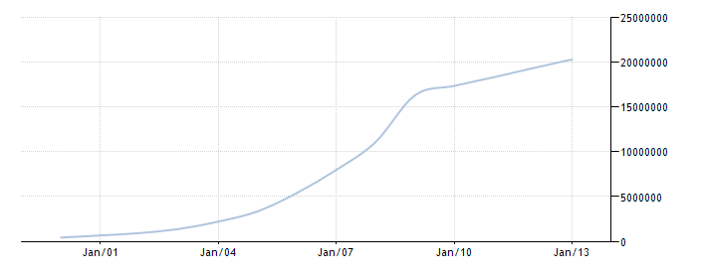

Figure 3.0: increase of mobile subscription in Sri Lanka

Source: Trading Economics (2014)

It is clear that Sri Lanka enjoys a high mobile literacy and considering the statistics of last ten years it is evident that emerging market trends in the mobile usage are seen in Sri Lanka. Apart from that, in Sri Lanka there are approximately over 4 million internet users. According to Nielsen’s “2013 Sri Lanka review” report further emphasizes this trend which highlights 57% of the internet users in Sri Lanka do access internet through a mobile device.

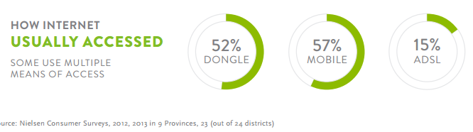

Figure 4.0: How Internet Usually Accessed

Source: Nielsen (2014)

In the present scenario there are five mobile network operators in Sri Lanka namely Dialog, Mobitel, Etisalat, Hutch and Airtel which provides mobile connections to consumers. Dialog offers a wide coverage and undisturbed service whereas Mobitel also have good coverage and specially a good 3G coverage. However if you are not traveling frequently Etisalat or Airtel would be good options. They offer lower call rates. Some youths opt to Hutch as they can easily obtain a connection and easily switch for a new one.

When considering the mobile network coverage available in Sri Lanka, it was obvious to researcher that Sri Lanka enjoys an Island wide mobile coverage encompassing almost 4/5th of the Island. This coverage is facilitated through different network types such as, CDMA, WCDMA, HSDPA, 3G, GSM, and GPRS mostly. Along with that 4G networks are also starting to emerge near major cities. Hence, this tendency to move ahead with latest next generation networks and the breadth of coverage testifies to the existence of positive trends in terms of mobile technological usage. The following figures shows the network coverage of two major service providers.

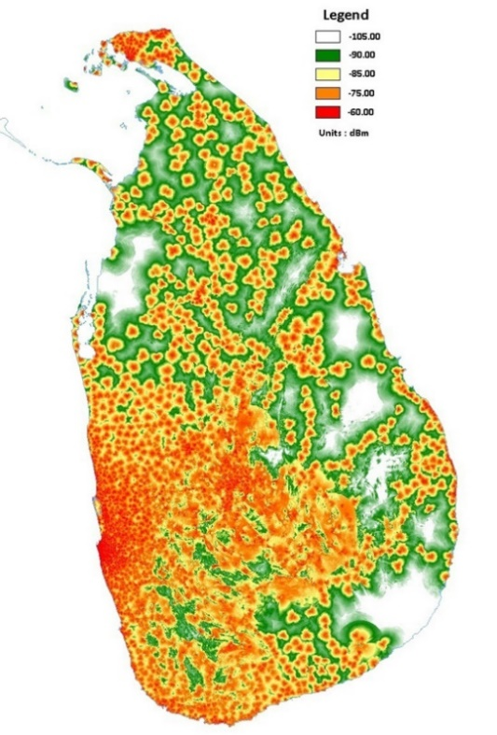

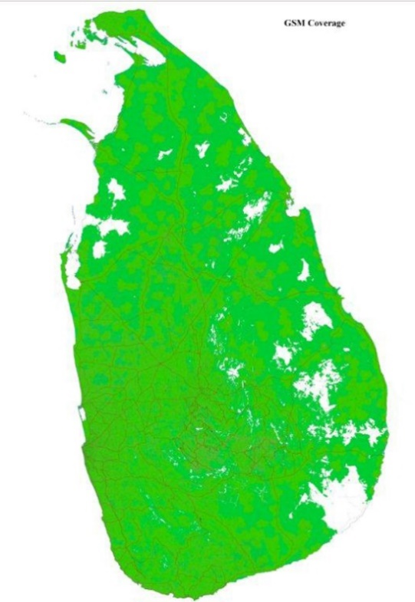

Figure 5.0: Mobitel GSM Coverage

Source: Mobitel (2014)

Figure 6.0: Dialog GSM Coverage

Source: Dialog (2014)

Although mobile and internet usage is widespread in the country it is also important to take a look at the usage of smartphones also. Couple of years back smartphones were not much popular on the market since they were perceived as high end devices which are considered to be expensive also. But now it’s not the case it has become widely affordable and available across the island, you can buy a decent smart phone for a very reasonable price. This results in more people buying smartphones and more people using internet through their device.

By taking into consideration the above facts it is evident that mobile literacy in Sri Lankans is in a healthy condition and all the indications are towards positive growth. Moreover, expanded and expanding nature of mobile network coverage in Sri Lanka shows the emerging trends in mobile technologies and services. Hence, it can be said that Sri Lanka is in the threshold of an adorning mobile era which would facilitates life styles and cooperate habits shaped by mobile technologies which indicates for the researcher that use of mobile technologies in the solution is a timely approach.

2.5 An Overview on Web Services

In the development of the proposed solution web services technologies will be used to connect the main system with the smartphone application. Web services can be identified as application components which communicate using open protocols (XML, SOAP, WSDL and UDDI) over an Internet protocol backbone. Web services are self-contained and self-describing. They can be discovered using UDDI and can be used by other applications (w3schools, 2014). It runs totally without any intelligence or input by a human being. One of the main ideas in developing such systems is that the human involvement is to a minimum and the human error is dealt to a nullity.

When the claiming agent conduct the assessment, the data has to be retrieved and also synchronized with the main database. This happens through the web server. Extensible Markup Language (XML) which is derived from Standard Generalized Markup Language (SGML) is a simple, flexible text format which is used for the development of the web server. There are no pre-defined tags in XML, user has to design their own tags. Document type definitions or XML Schema files are used by XML in order to describe data. XML works as a message carrier in web services.

Following figure demonstrate the overall architecture of a web service.

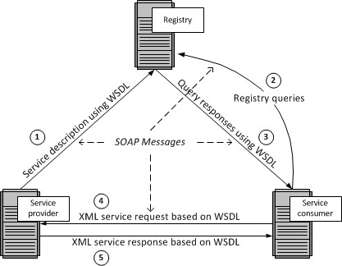

Figure 7.0: Web Services Architecture

Author: Barry DK (n.d)

Service provider host a web service and upload the service description using Web Service Description Language (WSDL) to a registry containing a list of WDL files. WSDL is an XML based language used to describe capabilities and locations of services or in simply how to work with the web service. WSDL uses Simple Object Access Protocol (SOAP) as its communication protocol. SOAP is a framework which support exchange XML based information in a network environment. SOAP is a wrapper class which encapsulates XML based information within HTTP packets in order to send through internet.

Service consumers will search the registry for available web services. Registry is a list of web services from different service providers. It uses the UDDI technology for maintaining the registry. UDDI stands for Universal Description, Discovery and Integration. This provides a platform independent, XML- based registry mechanism between the server and client in order to situate each other. SOAP is used as the communication protocol used by the UDDI.

AS the diagram indicates the once the relevant web service is found, registry will respond with the necessary WSDL files. Using the information in those files service consumer will be able to use the services provided by the provider.

The main advantage of using web services is it allow different applications from different sources to communicate with each other without time-consuming custom coding. Web services do not depend on any one operating system or programming language. They are platform independent because all communication is done using XML. Apart from that using web services help to tighten the security of your data and system since when accessing through a web service, external parties do not have the direct access to companies system or database.

By using the web services in the proposed solution it will enhance the security on cooperate data while providing real time access for the field agents. Apart from that, smartphone solution can be developed on any platform such as Android, Windows or Apple IOS because the smartphone application connect through the web service.

2.6 Examination of Past Research

This section presents past research conducted by academia and industry with regard to use of mobile technologies in claim settlement procedure of motor insurance industry.

In a research conducted by Baecker and Bereuter (2010), they have presented an analysis of claims management processes in motor insurance, and identified several areas for technology-based process improvements. They have categorized the areas such as Mobile loss report, Partner management, Status notification and Customer feedback. In order to establish the technical foundation for identifies areas, they have designed and implemented a service-oriented architecture and has used it to develop a demonstrator, which illustrates the identified process improvements. The demonstrator they have developed incorporates three major components namely Mobile phone application, Service-oriented integration architecture and Claims management enterprise system.

Furthermore they have discussed in the paper about the benefits of a mobile claims assistance application for customers involved in a car accident as well as for insurance companies. In addition, with the aid of demonstrator they have demonstrated that mobile phones are technically capable of reporting claims into commercial claims management enterprise systems.

In 2008, Kaeslin and El Hage conducted a research with the aim of identifying the possible cost reductions for claims management in motor insurance sector. As a result it was observed that the delays in claim settlement can largely be averted by automating the process. In addition to that it states that, it is vital to have proactive contacts between the all the relevant parties throughout the claim settlement process. Kaeslin and El Hage also argues that one of the major challenges that insurance companies have to address in order to improve control over the claims management processes is the lack of adequate IT solutions in the process.

In another research conducted by Lee and colleagues (2007), they have studied about possible strategies and applications for M-commerce in the insurance industry. After conducting a survey among insurance agents in order to explore mobile solutions which are applicable in the business process and to identify the possible benefits for the agents’ tasks, researchers concluded that personal digital assistant (PDA) technology is appropriate for the insurance industry and highlighted the potential for improvements of customer care and claims management.

Although in that era PDA was the popular mobile device which could fit into business solutions, in today’s world smartphone are much more powerful than PDAs and can be much more helpful than PDAs. Since, the entire business world moving towards a virtual market place, the integration of M-strategies with insurance tasks will definitely hold the key for insurance industry in future.

Moreover, IBM (2009) conducted a similar study on process automation in claiming sector. The research investigated the potential effects of automating some steps in a claiming procedure on the quality of customer service. The research concluded that 60% of claiming time can be reduced by the automation which eliminated “low- to no-touch management” in several phases.

It is stated by Want (2009) that while the applications such as eCall are currently deployed in motor vehicles, similar applications will become available for mobile phones as their computational power increases, additional sensor technology becomes available, and the necessity to integrate mobile phones with enterprise wide systems will rise.

As the above researches indicates the interest of academics of the possibilities of integrating smartphone technologies to enhance claim management processes and shows the necessity for further research in this area considering the competitive nature of the motor insurance industry which demands the integration of such mobile technologies.

2.7 Summary

This chapter was dedicated to conduct a survey regarding to problem domain, technologies available for the solution and also to examine past researched conducted on the similar area of research. As the first step it is discussed about the motor vehicle insurance industry niche of insurance sector. It was pointed out that better coordination and management of claiming process will lead to gaining more profits.

Next it is reflected an overview about the smartphones in this era of mobility and smart devices. It is briefly explained about what is a smartphone device and about the powerful hardware and software combination that smartphones are made up of. Along with that as the next step mobile network penetration and smartphone usage in Sri Lanka is examined. Since the smartphone prices are gradually decreasing but with day by day advancements in the devices, people have showed positive responses to the use of smartphones. Mobile networks in Sri Lanka also covers large areas around all most all the major cities and day by day it is growing with new technologies such as 4G. By considering networks and smartphone technologies it can be deduced that in the present smartphone based approach for the solution is the most suitable option.

As the proposed solution includes web technologies, in the chapter it is also discussed about web services and other related components such as WSDL, UDDI and SOAP. By using the web services in the proposed solution it will enhance the security on cooperate data while providing real time access for the field agents. Apart from that, smartphone solution can be developed on any platform such as Android, Windows or Apple IOS because the smartphone application connect through the web service.

Finally this chapter presents an evaluation on past researches conducted by professional on the subject of use of mobile technologies in the motor vehicle insurance sector. It show that there is a great potential towards research for mobile integrated solution for insurance companies as well as for the clients also.

# **Technology Adoption 03**

# **3.1 Introduction**

This chapter is dedicated to discuss the software development of tablet pc based motor vehicle claiming solution from the technological perspective. It is discussed about the technologies considered when developing the solution and the factors considered when choosing the technologies. Furthermore technical and usability requirements are also mentioned in this chapter.

# **3.2 Software Development-Technology Considerations**

In order to develop a successful system which meets the end user expectations, it is very important to use appropriate tools in the development process. Use of any inappropriate tools will only leads to develop a system with unnecessary errors and faults and it can affect the user expectations in efficiency and reliability of the solution. It is very vital to use appropriate computer language and any other necessary tools in order to develop a successful system. So these technologies and tools will help to develop the system within a minimum development time. The main objective of TBMVCS is to do a fast, easy, accurate claiming process via tablet pc. And this is done by connecting to the company database via web service with the use of mobile networks. So it is very important to consider some factors such as platform supportiveness and the efficiency of the system. And in order to meet above mention factors we must use the most appropriate tools available in the market to develop the system.

Technological considerations - followed during the development of the system

* Efficiency and Performance
* Re-usability and flexibility
* Object oriented development support

# **3.3 Language and Tools Selection**

In modern programming field there are many programming languages and many more are introducing day by day. Core function of the system is vehicle claiming through the tablet pc, researchers have been done on many software development languages in order to recognize the appropriate language that helps efficient data retrieval and updating from the company database via web service. Since the entire solution has a 3 main components namely the ground office system, web service and tablet application it was vital to select a language that will support all these three feature so that it will reduce the learning time of different languages. Several aspects such as build powerful web based applications, powerful, flexible, Simplified Data Access, platform dependency, build fast mobile applications were considered.

For the development of ground office system main technology considerations were ASP.net platform, java platform and PHP platform. Java and asp.net provide greater object oriented programming feasibility while PHP work as a fast backend server scripting language. Visual Studio IDE provide ASP.NET development environment with rich inbuilt functionalities for faster programming. As for the web service it was considered about coding a Visual studio web service, PHP web service and also WCF web service. WCF was considered to be a far better option than other web service types Microsoft has provided.

Another key part of the solution was the development of tablet applications. Main platform considerations were android, windows and IOS. In order to develop an IOS app it requires to learn Objective C language and it also need a Mac computer which are far more expensive than the others. Android is an open source platform with free available tools. There are lot of resources available for android development as well. Windows tablet pc was feasible to build on the same environment which was used to build the ground office system and the time taken for the learning curve was fairly less than android. Visual studio provides an in built emulator for testing purposed as well.

After considering several options ASP.Net was selected as the main programming platform to develop the ground office system since ASP.Net provides an easier and stable environment to create great web applications and it supports object oriented development greatly. Although it has to be purchased for commercial use, it can be purchased for free for university students from Dream spark. Bootstrap, a free CSS library was use to design the interfaces. C# programming language was used to implement the business logics in the backend of the system.

As for the initial step tablet application was developed for windows surface tab. It is using XAML for interface development and C# for backend coding. To connect the Tab application and the web system, WCF web service technology was selected since it can be developed using the same tools which are used to develop the system. Visual Studio 2013 was selected as the main tool for developing the solution while using open source text editors such as brackets were used wherever necessary.

# **3.4 Database Selection**

Database which is most important aspect of the overall system which handles all the relevant details related to insurance as well as claims. In order to fulfill the need of database operation this system has been used SQL Server Management Studio which enables to access and manage the database engine. Another reason for using this was it was free to purchase using Dreamspark account. Management Studio brings graphical tools for database management together with a rich development environment. Database is maintained at a central cloud server such that it can be accessed from wherever necessary.

# **3.5 Technical Requirements**

Technical requirements for the development of system are as follows.

* The ground office system was developed using Visual Studio 2012 using ASP.net platform. Bootstrap, an open source CSS library was used for interface designing while backend coding was done using c# language.
* Web service was implemented as a WCF web service which is available in C# language platform. JSON parser has being used for transferring data.
* Tab application was developed for Windows platform using Visual Studio 2013 Express version. It uses XAML for interfaces and C# as backend coding.
* The application package has been developed as it is compatible for any computer which runs on windows platform such as Windows Vista, Windows 7, Windows 8 and Windows 8.1.
* Tab application is available for devices which runs Windows 8 and windows 8.1.

# **3.6 Usability Requirements**

As the usability requirements it was expected the following standards from the developed system. Effectiveness, Efficiency, Safety Utility, Learnability and Memorability are factors which will be taken in discussion. Consistency and Standard Visibility of system, status Flexibility and efficiency of use, User control and freedom Match between system and the real world will be taken into consideration too.

Requirements that ensure that there is a good match between the system and its users. In most cases usability is expressed in terms of measurable objectives. The usability of the TBMVCS is to be considered with the education of the claiming staff members, how well they are conversant with technology and a tablet pc and such conditions. If the users are not up to the standards to use the system in an effective way, system developers should conduct training sessions to develop knowledge to use the system without having any trouble.

The tab application is going to be on a small screen compared to a desktop. Also since the claiming agent would be using it under direct sunlight the visibility of the screen would be an important aspect that needs to look at. The wisest option is to have the interface with dark black letters for more clarity. The use of colors might lessen the visibility of the claiming staff member to input data on to the device. Anyhow windows tabs come with option to choose dark and light themes which user can easily swap between them according to the situation.

Interfaces of the system components shall be designed with appropriate fonts, font sizes, colors and menus in way such that users are more comfortable to work with. Solutions software components shall be designed with simplicity but covering all necessary aspects ideally with the principle “Recognition rather than recall in mind.”

# **3.7 Summary**

Technology is a one of the essential criteria when developing a software project. Through this chapter it has been described about the various technology options for the proposed software solution. Furthermore this chapter discussed the technical aspects that need to be considered for the developed solution as well as the usability requirements that needs to be considered. Next chapter is dedicated for describing the approach which was used to develop the tablet pc based motor vehicle claiming solution.

# **Approach to TBMVCS 04**

# **4.1 Introduction**

This chapter is dedicated for describing the approach for the development of TBMVCS. With the hypothesis is stated this chapter will give a brief idea about the users of the system. And most importantly this chapter will describe the functional and non-functional requirements for the solution. It is vital to identify the input, process and the output of any solution. It is described in this section and at the end some of the key features are stated in this chapter.

# **4.2 Hypothesis**

Technology is integrating with our lives more and more with the advancements in the technology. Today’s world, even hand held mobile devices has dominant processing power cable of running applications smoothly. With these powerful hardware capabilities and software solutions combined using networks to convert traditional processes to automate processes. Therefore it is suggested that web based solution with an integrated mobile application can address the issues arisen in the claim settlement of a motor vehicle accident and hence, it will benefit both the customers and insurance company.

# **4.3 Users**

The main users of the web system will be the ground office staff. They are able to add new records, edit records, and obtain reports through the web interface. Adding new records will include records such as new policies, garage details, tow truck services and vehicle spare part details as well. All details are kept updated in the database by the ground office users. Other users’ type is the claiming field agent who will access the customer details through the tab application. They can conduct the whole claiming procedure on the spot of the accident and submit it to company database. They will be able to access all the updated, necessary customer, vehicle and spare part data through the tab application easily and in a fast manner.

# **4.4 Functional Requirements**

This section contains the functional requirements required for the tablet pc based solution for vehicle insurance claim settlement procedure. In the solution there are 2 main components namely the online web application and tablet pc application. The requirements in this section specify the functions that each component must be capable of performing.

Online web application component is designed for the use of operating staff at the ground office. When a client need to buy an insurance, operating agents needs to register new customer and create account acquiring the relevant information. It will involve the following key functions.

* The users shall be able to create, view and update customer profiles by filling customer details such as first name, last name, date of birth, phone number, company details etc.
* The users shall be able to add, view and update insurance vehicle details such as model, manufacturer, engine number etc. as per the customers’ vehicle.
* The users shall be able to add, edit and view insurance policies in to the system database.
* The system shall be able to add, view and update spare parts details relative to various manufactures and vehicle models.
* The system shall be able to produce reports regarding the customers, insurance policies and etc.

The other component is the tablet pc application which will aid the field agent with the assessment process. When an accident happens, once the agents goes to the location, the person can access the following key functions using the tablet pc application.

* The user shall be accessed to the insurance policy details of the customer from the database.
* The user shall be able to access the insurance vehicle details and the details of the clients on the system database.
* The user shall be able to access and assess the drivers’ insurance history.
* The user shall be able to complete the assessment of the accident by entering the details such as drivers’ details of the caused accident, accident location details, cause of accident and damages to the vehicle.
* The users shall be able to attach photos and videos to the record using tablet pc camera.
* The system shall be able to complete the assessment by calculating the damage by involving the database and the web server.

# **4.5 Non-Functional and Performance Requirements**

In the below discussed are the non-functional and performance requirements to be considered when implementing the motor vehicle claim settlement solution.

When considering the performance, this would depend on factors such as the network connection involved. As the field agents should move to the accident location, the network data transfer speeds will depend on the signal strength received to the particular location with the network provider.

In today’s smart devices market, there are several major OS platform which the devices work on. Since initial mobile application is developed for the Windows platform, Mobile application will require a smart device running on Windows OS platform. In considering the smart devices, another important factor which should be considered is the hardiness of the device. It is important to remember that this will be used outdoors and taken in the Sri Lankan tropical climate necessary precaution should be taken to protect the device.

System will be tested for identifying and reducing bugs to the minimum. If any bug may appear they will be debugged using demo test. Finally reliable software system will be introduced to provide real time information. The hours need for the maintenance of the system will be kept at a minimum by conducting testing thoroughly. The company database should also be updated with the current vehicle component values in the market and there should be constant updating done on the part of the head office.

The system will have its own security to prevent unauthorized write/ read/delete access along with its authentication module. Authentication module will include a module for encryption and decryption of authorization data. Apart from that necessary steps would be taken to back up the database periodically.

# **4.6 Input**

Ground office staff employees who will interact will be added to the system with valid authentication details. Then they will be able to log into the system with their credentials. Then they will be able to create new insurance records and enter customer details, vehicle details, policy information, vehicle spare part information updates and so on. These data input will be very vital for the assessment of the accidents when conducting a claiming procedure.

# **4.7 Output**

Accidents can happen anywhere in the country. Once an accident happened claim agent have to go to particular location to do the assessment. Agent will be equipped with a tablet pc installed with claim assistant application. He will be able to get all the necessary details such as customer information, vehicle information, policy information, spare part prices and so on. He will be able to conduct the assessment at that moment itself and attach photos to the claim record whenever necessary and finally submit them to insurance database. Apart from that he will be able to access the nearest company approved garages and tow truck service within a matter of minutes.

# **4.8 Process**

When a customer needs to insurance his vehicle, ground office staff can register the user on the system adding necessary details such as customer profile, vehicle information which is going to be insured and the policy information such as amount of the insurance, what covers are needed by the customers and so on. Once the registration is complete company can issue a document with the insurance record id which is auto generated from the system. Once they are in the system claim assessment can be done via the tab application.

When an accident happens claim agent will go to the location and do the assessment via tab application. First agent needs to log into the tab application using valid credentials. Once he is logged on to the application, he can request the policy id from the customer and enter it in the tab application. Application will retrieve all the necessary data from the company database through the web system via a web system. If all the details are in order agent can proceed with the claim assessment by filling the necessary data forms, attaching photos if necessary, add the necessary costs and get the total cost and submit the data into the company data base through the web system via web service. It can be seen that the manual process is minimized to a process with only few click using this approach.

# **4.9 Features**

Features of the complete solution include maintaining all the insurance records in a central cloud database and access them from a standard browser from any location in the country. The main feature is to conduct the claim assessment through a tab application minimizing the loopholes present in the traditional claiming process. Claiming agent have the accesses to all the necessary data in his tablet pc which will help him to do the assessment in a speedy but accurate manner. Since the data is passed as JSON string format even with a slow network connection tab application will be able to retrieve data through the web service. As an added feature security will be ensured using https when hosting and enabling encryption and decryption when comes to authorization aspects.

# **4.10 Summary**

In this chapter, it is described about the one of the key area which is functional and non-functional requirements for the solution. Apart from that there is a brief description about the users of the solution and a description of the system from an input, process output perspective. It also includes a brief description of features included in the system such as central database security wise and also access to the system. In the next chapter it will be discussed about the design of the system in depth.

References

Baecker, O., & Bereuter, A. (2010), *Technology-Based Industrialization of Claims Management in Motor Insurance,* Institute of Technology Management, University of St. Gallen.

Retrieved September 10th 2014, from the University of St. Gallen i-lab website: <http://www.i-lab.ch/docs/04_technology> based_industrialization_of_claims_management_in_motor_insurance.pdf

Baecker O., Fleisch E., Ackermann W., Ackermann L 2010, Mobile Claims Management: Smartphone Apps in Motor Insurance, Trendmonitor 4 . 2010

Barry D., K. n.d*, Web Services Explained,* Viewed 9th December 2014

<http://www.service-architecture.com/articles/web-services/web_services_explained.html>

Capegemini 2013, Mobile Solutions for Claims Management, Viewed 10th October 2014

http://www.capgemini.com/resource-file-access/resource/pdf/mobile_solutions_for_claims_management_0.pdf.

Dialog Axiata 2014, *Coverage Map,* Viewed 26th November 2014

<http://www.dialog.lk/support/mobile/coverage-service-points/coverage-map/>

Flitch Ratings 2013, *2014 Outlook: Sri Lanka Insurance Sector,* Outlook Report.

Retrieved September 17th 2014 from [www.fitchratings.lk/download-article-216.pdf](http://www.fitchratings.lk/download-article-216.pdf)

‘Gartner’ 2014, *Gartner Says Annual Smartphone Sales Surpassed Sales of Feature Phones for the First Time in 2013,* Viewed 29th October 2014

<http://www.gartner.com/newsroom/id/2665715>

IBM 2009, Fast path claims from IBM. Viewed 10th October 2014

http://www-03.ibm.com/industries/financialservices/doc/content/solution/1231013103.html.

Iqbal I. 2014*, Rapid Growth of Mobile Internet Usage in Sri Lanka,* Viewed 25th November 2014

<http://infasiqbal.com/rapid-growth-of-mobile-internet-usage-in-sri-lanka/>

Lee C, Cheng H., K., Cheng H. 2007, an empirical study of mobile commerce in insurance industry: Task-technology fit and individual differences, Decision Support Systems.

Mobitel 2104, *Mobitel GSM and 3G Coverage,* Viewed 26th November 2014

<http://www.mobitel.lk/images/English/common/Srilanka_GSM_Coverage%2030112013.jpg>

Nielsen 2013, Sri Lanka 2013 review and opportunities in 2014, Viewed 10th October 2014

http://www.nielsen.com/lk/en/insights/reports/2014/sri-lanka-2013-in-review-and-opportunities-in-2014.html

Susan W. 2013, Widespread *Adoption of Tablets and Smartphones Is Driving Growth in the Internet of Things,* Viewed 29th October 2014

<https://www.scisbo.com/web/business-solutions/blog/-/blogs/widespread-adoption-of-tablets-and-smartphones-is-driving-growth-in-the-internet-of-things>

TDK Global 2012*, Devising Total Solution for Condensing a Multitude of Function within a Limited Space,* Viewed 29th October 2014

<http://www.global.tdk.com/ir/ir_library/annual/2012/html/strategy/str01.htm>

Trading Economics 2014, *Mobile cellular subscriptions in Sri Lanka*, Viewed 29th November 2014

<http://www.tradingeconomics.com/sri-lanka/mobile-cellular-subscriptions-wb-data.html>

w3schools 2104, *Introduction to Web Services*, Viewed 9th December 2014

<http://www.w3schools.com/webservices/ws_intro.asp>

Want R 2009, When Cell Phones Become Computers, IEEE Pervasive Computing.