
TRIBHUVAN UNIVERSITY
Institute of Science and Technology

A PROJECT REPORT
ON
“PulseMailer: A Flask-Based Mail Application with Machine Learning
Spam filter and Content Moderation”

Submitted to
Department of Computer Science and Information Technology
National College of Computer Studies
Paknajol, Kathmandu

In partial fulfillment of the requirements for the bachelor’s in computer science and
Information technology

Submitted by
Shankar Adhikari

Under the supervision of
Nabaraj Bahadur Negi

National College of Computer Studies
Paknajol, Kathmandu

SUPERVISOR RECOMMENDATION
This is to certify that the project work entitled "PulseMailer: A Flask-Based Mail Application with Machine Learning spam filer and Content Moderation" submitted by Shankar Adhikari is a genuine work carried out under my supervision in partial fulfillment of the requirements for the degree of Bachelor in Computer Science and Information Technology at the Department of Computer Science and Information Technology, NCCS College, Institute of Science and Technology, Tribhuvan University.

Supervisor:
Nabaraj Bahadur Negi
Date: _______________


TRIBHUVAN UNIVERSITY

Faculty of Bachelor of Science in Computer Science and Information Technology
NCCS College
Paknajol, Kathmandu

LETTER OF APPROVAL

This is to certify that this project prepared by Shankar Adhikari entitled “PulseMailer: A Flask-Based Mail Application with Machine Learning Spam filter and Content Moderation”, in partial fulfillment of the requirements for the degree of Bachelor of Science in Computer Science and Information Technology has been well studied. In our opinion, it is satisfactory in the scope and qualify as a project for the required degree.
Evaluation Committee

--------------------------- ------------------------------ --------------------------
Mr. Nabaraj Bahadur Negi External Examiner Mr. Rajan Poudel
Supervisor Head of Department
NCCS College NCCS College
Paknajol, Kathmandu Paknajol, Kathmandu

ACKNOWLEDGEMENT
I would like to express my sincere gratitude to everyone who supported me in completing my project titled “PulseMailer: A Flask-Based Mail Application with Machine Learning Spam filter and Content Moderation”. First and foremost, I would like to extend my heartfelt thanks to my respected supervisor, Mr. Nabaraj Bahadur Negi, for his continuous guidance, valuable suggestions, and encouragement throughout the entire development of this project. His support, constructive feedback, and technical insights played a crucial role in shaping the direction and successful completion of this work.
I would also like to thank NCCS College for providing a supportive academic environment, necessary resources, and technical facilities that helped me carry out this project effectively. The knowledge and skills I gained during my academic journey greatly contributed to building this system.
Furthermore, I am grateful to the academic and research community whose published materials, research papers, and online resources helped me understand machine learning concepts, particularly the Naive Bayes algorithm, and implement them practically in this project.
Finally, I would like to express my appreciation to everyone who directly or indirectly supported me during this journey. Their encouragement and motivation have been invaluable.

With respect,
Shankar Adhikari
Department of Computer Science and Information Technology
NCCS College. Paknajol, Kathmandu

ABSTRACT
PulseMailer is a web-based messaging application developed using Flask and SQLite that aims to make digital communication safer and more organized by detecting spam and abusive messages intelligently. Unlike many modern systems that depend heavily on external APIs or simple keyword filtering, PulseMailer uses two machine learning classifiers built completely from scratch in Python. The first is a Naive Bayes spam filter trained on the SMS Spam Collection dataset, which analyzes messages and calculates probability scores using log-sum-exp normalization. Messages with a spam probability above the configurable threshold of 0.70 are automatically moved to the spam folder. The second classifier, called the VulgarClassifier, is designed to detect offensive and disguised profanity such as “bi*ch” or “@ss.” It combines word level features with character n-grams of lengths 3, 4, and 5, along with a normalization process that handles character substitutions commonly used to avoid detection. To reduce false positives, the classifier uses a high confidence threshold of 0.90. Both classifiers work together in a unified moderation pipeline where vulgar messages are blocked completely, spam messages are filtered silently, and clean messages are delivered normally. In addition to intelligent moderation, PulseMailer includes features such as secure user authentication with PBKDF2-SHA256 password hashing, message threading, mailbox management, search functionality, bulk actions, and a responsive interface. Overall, the project demonstrates how lightweight and interpretable machine learning models can be effectively integrated into a real-world messaging system without relying on third party moderation services.
Keywords: Flask, SQLite, Naive Bayes, spam filtering, vulgar content detection, character n-grams, machine learning, web application security, content moderation.

Table of Contents
SUPERVISOR RECOMMENDATION ii
LETTER OF APPROVAL iii
ACKNOWLEDGEMENT iv
ABSTRACT v
LIST OF FIGURES viii
LIST OF TABLES ix
LIST OF ABBREVIATIONS x
CHAPTER 1 INTRODUCTION 1
1.1 Introduction 1
1.2 Problem Statement 2
1.3 Objectives 2
1.4 Scope and Limitation 2
1.4.1 Scope 2
1.4.2 Limitations 3
1.5 Development Methodology 3
1.6 Report Organization 4
CHAPTER 2 BACKGROUND STUDY AND LITERATURE REVIEW 5
2.1 Background Study 5
2.2 Literature Review 5
CHAPTER 3 SYSTEM ANALYSIS 8
3.1 System Analysis 8
3.1.1 Requirement Analysis 8
3.1.2 Feasibility Analysis 11
3.1.3 Analysis 14
CHAPTER 4 SYSTEM DESIGN 20
4.1 Design 20
4.2 Algorithm Details 30
CHAPTER 5 IMPLEMENTATION AND TESTING 33
5.1 Implementation 33
5.1.1 Tools and Technology used 33
5.1.2 Implementation details of Modules 34
5.2 Testing 37
5.2.1 Test Cases for Unit Testing 38
5.2.2 Test Cases for System Testing 42
5.3 Result Analysis 43
CHAPTER 6 CONCLUSION AND FUTURE RECOMMENDATIONS 46
6.1 Conclusion 46
6.2 Future Enhancements 47
References 48
Appendices 50

LIST OF FIGURES
Figure 3.1 Use Case Diagram for PulseMailer system 10
Figure 3.2 Gnatt chart 13
Figure 3.3 Class diagram for PulseMailer system 14
Figure 3.4 Sequence diagram for PulseMailer system 15
Figure 3.5 Activity diagram for login process 16
Figure 3.6 Activity diagram for Sending message 18
Figure 4.1 System architecture for PulseMailer system 21
Figure 4.2 High level of the PulseMailer system 22
Figure 4.3 Component diagram for PulseMailer system 23
Figure 4.4 Refined class diagram for PulseMailer system 25
Figure 4.5 Refined Sequence diagram for PulseMailer system 26
Figure 4.6 Refined Activity diagram for PulseMailer system 28
Figure 4.7 State diagram for PulseMailer system 29
Figure 5.1 Tokenization of message 35
Figure 5.2 Training the classifier 35
Figure 5.3 Laplace Smoothing 35
Figure 5.4 Computing log probabilities 36
Figure 5.5 Prediction 36
Figure 5.6 Probability normalization 36
Figure 5.7 Setting threshold 37
Figure 5.8 Confidence calculation 37
Figure 5.9 Duplicate registration validity 39
Figure 5.10 Invalid credentials Validity 39
Figure 5.11 Search Feature Validity 40
Figure 5.12 Non-existent user validity 41

LIST OF TABLES
Table 3.1 Functional Requirements 8
Table 3.2 Non-functional requirements 10
Table 3.3 Technical feasibility 11
Table 5.1 Technology used 33
Table 5.2 Authentication Testing 38
Table 5.3 Message Testing 40
Table 5.4 Machine Learning Algorithms testing 41
Table 5.5 System Testing 42

LIST OF ABBREVIATIONS
Abbreviation | Full Form
API | Application Programming Interface
CSS | Cascading Style Sheets
DB | Database
DFD | Data Flow Diagram
ER | Entity-Relationship
HTML | HyperText Markup Language
HTTP | HyperText Transfer Protocol
JS | JavaScript
ML | Machine Learning
MNB | Multinomial Naive Bayes
NB | Naive Bayes
NLP | Natural Language Processing
PBKDF2 | Password-Based Key Derivation Function 2
REST | Representational State Transfer
SHA | Secure Hash Algorithm
SQL | Structured Query Language
SQLite | Self-Contained SQL Database Engine
UI | User Interface
UML | Unified Modelling Language
URL | Uniform Resource Locator
UX | User Experience
WSGI | Web Server Gateway Interface

CHAPTER 1
INTRODUCTION

Introduction
The internet has completely transformed the way people communicate. Among all digital communication methods, email remains one of the most important and widely used platforms for personal, academic, and professional interaction. Despite its popularity and usefulness, email systems continue to face major challenges such as spam and abusive language. Spam messages clutter inboxes, waste users’ time, and may even contain phishing attempts or malicious links. Similarly, vulgar or offensive content negatively affects the user experience and can create an uncomfortable communication environment.
Large commercial email providers solve these problems using advanced machine learning systems trained on massive amounts of data. However, building such large-scale systems is often unnecessary and impractical for smaller applications. Instead, there is a need for a lightweight, understandable, and easy to maintain solution that can work independently without depending on external APIs or third-party services.
PulseMailer was developed with this goal in mind. It is a full-stack web-based messaging application built using the Flask framework and SQLite database. Along with standard messaging features such as composing and sending messages, folder management (Inbox, Sent, Spam, and Trash), message threading, search functionality, and pagination, the system also includes two custom machine learning classifiers for content moderation. The first is a Naive Bayes spam detector trained on the SMS Spam Collection dataset [1]. The second is a vulgar content classifier designed to detect offensive language, including intentionally disguised words such as “f!ck” or “@ss,” using character n-grams and word-level features [2].
Together, these classifiers form a layered moderation system where vulgar messages are blocked completely, spam messages are automatically filtered into the spam folder, and legitimate messages are delivered normally. In addition, the system stores probability scores and moderation decisions in the database, making the filtering process transparent, interpretable, and easy to analyze.

Problem Statement
Despite the availability of modern spam filtering systems, many messaging and webmail applications used in educational institutions or small organizations still lack effective content moderation. In many cases, these systems either do not provide filtering at all or depend on simple keyword blacklists that can easily be bypassed. This project focuses on solving two major problems:
- Spam messages exchanged between registered users within a messaging platform may remain undetected, causing inbox clutter and creating opportunities for misuse of the communication system.
- Vulgar or abusive content, especially messages containing disguised words through character substitution such as “bi*ch” or “@ss,” can bypass traditional keyword-based filters and reach users without any moderation.
Most existing open-source Flask-based messaging applications mainly focus on basic communication features and do not include intelligent machine learning-based moderation systems. PulseMailer addresses this limitation by developing a moderation system from scratch that directly integrates probabilistic machine learning classification into the message-sending process. The system also stores confidence scores and moderation results in the database to improve transparency and interpretability, while carefully selected thresholds help reduce false-positive detections and maintain reliable filtering performance [3].

Objectives
The primary objectives of the MailApp include:
- To develop a full-stack web-based messaging application with secure and efficient communication features using Flask and SQLite.
- To develop and integrate machine learning models for detecting spam and vulgar content in messages to improve content moderation accuracy and user safety.

Scope and Limitation
The various scope and limitations of PulseMailer

1.4.1 Scope
The scope of the PulseMailer system are:
- The project develops PulseMailer Supports core messaging features such as composing, sending, threading, and folder-based organization (Inbox, Sent, Spam, Trash).
- Integrates machine learning-based spam and vulgar content detection using custom Python implementations.
- Offers basic REST API endpoints for user search and retrieving message folder statistics.

1.4.2 Limitations
The limitations of the system are:
- Does not support external email protocols such as SMTP or IMAP; it functions only as an internal messaging system for registered users.
- Uses SQLite, which is suitable for small-scale use but not ideal for large-scale or high-concurrency deployments.

Development Methodology
This project followed a Waterfall Model approach, where development was carried out in a structured, sequential manner, with each phase completed before moving to the next:
- Phase 1 - Requirement Analysis & System Design:
Defined system requirements, designed the database schema, and planned the overall architecture of the PulseMailer application, including user roles and messaging flow.
- Phase 2 - Core Application Development:
Implemented the foundational features such as user registration, login/logout functionality, secure session handling, and basic message sending and receiving.
- Phase 3 - Mailbox & Feature Implementation:
Developed advanced mailbox functionalities including Inbox, Sent, Spam, and Trash folders, along with pagination, search, message starring, and bulk actions.
- Phase 4 - Machine Learning Model Integration:
Trained and integrated the Naive Bayes spam classifier using the SMS Spam Collection dataset and developed the VulgarClassifier using character n-grams and a custom dataset.
- Phase 5 - System Integration & Testing:
Combined all modules into a unified system, integrated both classifiers into the message pipeline, stored ML metadata in the database, and performed thorough testing at both unit and system levels to ensure stability and correctness [4].

Report Organization
The rest of this report is organized as follows:
- Chapter 2 covers the background study and a review of related work in spam detection and content moderation.
- Chapter 3 presents the system analysis including requirements, feasibility study, and system modeling with UML and ER diagrams.
- Chapter 4 describes the detailed system design including database design, component diagram, deployment architecture, and key algorithms.
- Chapter 5 discusses implementation details, the tools and technologies used, and the results of unit and system testing.
- Chapter 6 concludes the report with lessons learned and directions for future improvement.

CHAPTER 2
BACKGROUND STUDY AND LITERATURE REVIEW

2.1 Background Study
2.1.1 The Naive Bayes Algorithm for Text Classification
Naive Bayes is a probabilistic classifier based on Bayes' theorem with the assumption that all features are conditionally independent given the class label. Despite this simplification, Naive Bayes classifiers have consistently performed well on text classification tasks and remain one of the preferred baselines for spam detection.
In this project, the Multinomial Naive Bayes variant is used. Given a message with words w1, w2, ..., wn, the classifier computes the log-posterior probability for each class (spam/ham or vulgar/clean) using: log P(class | message) = log P(class) + sum of log P(wi | class) for all tokens. Laplace smoothing is applied to handle unseen words. For the spam classifier, a threshold of 0.70 on the probability (obtained via log-sum-exp normalization) is used rather than a simple majority vote, which reduces borderline false positives.
2.1.2 Character N-Grams for Obfuscation Detection
A major weakness of word-level classifiers is their inability to handle deliberate character substitution used to bypass filters. Character n-grams (substrings of n consecutive characters) are more robust to such obfuscation because they capture partial patterns even when individual characters are replaced.
In the VulgarClassifier, character n-grams of lengths 3, 4, and 5 are extracted from the normalized text alongside standard word tokens. A normalizer (vulgar_normalizer.py) first converts common substitutions — such as '@' to 'a', '$' to 's', and '3' to 'e' — before feature extraction, further improving recall on obfuscated variants.

2.2 Literature Review
Spam detection has been widely studied since the early 2000s, with Naive Bayes emerging as one of the earliest and most dependable baseline approaches. Sahami et al. [4] introduced a probabilistic framework for spam filtering that became the foundation for many later machine learning-based systems. The SMS Spam Collection dataset used in this project was introduced by Almeida et al. [1] and has since become a standard benchmark for SMS spam classification, containing 5,572 labeled messages with a strong imbalance between ham and spam.
Over time, researchers have explored a variety of models beyond Naive Bayes. Kowsari et al. [5] highlight that although modern deep learning methods can outperform traditional approaches on large-scale datasets, simpler models like Naive Bayes still perform remarkably well in short-text scenarios such as SMS classification, especially when computational resources are limited. Similarly, Roy et al. [6] compared multiple machine learning algorithms and observed that while models like SVM and Random Forest can slightly outperform Naive Bayes in accuracy, they are significantly slower. This trade-off makes Naive Bayes more practical for real-time systems such as PulseMailer, where speed and efficiency matter just as much as accuracy.
Spam detection research has also expanded into ensemble and hybrid models. Alsubari et al. [7] proposed a hybrid email spam detection system combining TF-IDF vectorization with stacked classifiers such as Logistic Regression, SVM, and Multinomial Naive Bayes. Their system achieved very high accuracy (around 99.1%) on the Enron dataset, showing that combining models can improve robustness. However, they also noted that such ensemble systems reduce interpretability and increase inference cost. Similarly, Gómez Hidalgo et al. [8] explored transformer-based models like BERT for spam detection, achieving even higher accuracy (around 99.4%), but at the cost of requiring GPU-level computation, making them less suitable for lightweight or real-time web applications.
In addition to spam filtering, toxic and abusive language detection has become an important area of NLP research due to the rise of online harassment. Zampieri et al. [9] introduced the OLID dataset and SemEval shared task, showing that transformer-based models perform very well in detecting offensive content. However, earlier work by Nobata et al. [11] emphasized that character n-gram features are particularly effective for abusive language detection, especially when dealing with obfuscated or intentionally altered words. This insight strongly influenced the design of the vulgar content detection module in PulseMailer.
Further research has also highlighted the limitations of modern deep learning models in adversarial settings. Grndahl et al. [10] demonstrated that even strong models like BERT can be fooled by simple character-level manipulations such as leet-speak, extra spacing, or inserted symbols. Interestingly, they found that character-level representations are more resilient to such attacks compared to word-level or subword tokenization approaches. This directly supports the use of character n-grams in robust text filtering systems.
Pavlopoulos et al. [12] further explored transformer-based approaches like BERT and RoBERTa for abusive language detection and showed that while these models achieve state-of-the-art performance, they remain sensitive to noisy or obfuscated inputs unless augmented with character-level features. This reinforces the importance of combining traditional feature engineering with modern NLP approaches when designing practical systems.
Earlier foundational work also continues to remain relevant. Joachims [13] demonstrated the effectiveness of Support Vector Machines in text classification tasks, achieving strong accuracy across multiple datasets. However, SVMs require additional mechanisms for probability estimation and are generally more computationally expensive compared to Naive Bayes, especially in lightweight systems.
Deep learning methods have also been widely explored. Kim [14] introduced CNN-based text classification models using word embeddings, which significantly improved performance by capturing contextual patterns in text. Later studies such as Bhavani and Devi [15] applied similar deep learning architectures to spam detection and confirmed their high accuracy. However, these models come with increased complexity and higher resource requirements, which can limit their use in real-time or resource-constrained environments.
Finally, ensemble-based techniques such as Random Forest and gradient boosting methods like XGBoost and LightGBM have also shown strong performance in spam detection tasks [6,7]. These models are particularly good at capturing feature interactions, but they tend to be heavier and less suitable for fast, lightweight systems like PulseMailer, where quick inference is critical.

CHAPTER 3
SYSTEM ANALYSIS

3.1 System Analysis
The requirement analysis for PulseMailer involves a clear breakdown of both functional and non-functional requirements to guide the design and development of the system. These requirements ensure that the final application effectively supports secure messaging and intelligent content moderation within an internal communication environment.

3.1.1 Requirement Analysis
i. Functional Requirements
The system focuses on providing core messaging functionalities such as user registration, authentication, message composition, delivery, and mailbox management. In addition, it integrates machine learning based spam and vulgar content detection to automatically moderate messages and improve user safety. Functional requirements also include file attachment handling, search functionality, message threading, and REST API support for basic operations. They are grouped by module:
Table 3.1 Functional Requirements
Req. ID | Module | Requirement Description
FR-01 | Authentication | Users shall be able to register with a unique username and email.
FR-02 | Authentication | Users shall be able to log in with username and password.
FR-03 | Authentication | Sessions shall be terminated on logout.
FR-04 | Messaging | Authenticated users shall compose and send messages to other registered users.
FR-05 | Messaging | Users shall be able to attach files (PDF, images, documents) up to 5 MB.
FR-06 | Messaging | Users shall be able to view Inbox, Sent, Spam, and Trash folders.
FR-07 | Messaging | Users shall be able to reply to messages, maintaining thread context.
FR-08 | Messaging | Users shall be able to star, mark as read/unread, and delete messages.
FR-09 | Messaging | Users shall be able to search messages by subject or body text.
FR-10 | Messaging | Inbox shall be paginated (20 messages per page).
FR-11 | ML Pipeline | The system shall classify outgoing messages as spam or ham using the NB model.
FR-12 | ML Pipeline | The system shall classify messages for vulgar content using the VulgarClassifier.
FR-13 | ML Pipeline | Vulgar messages shall be blocked and not delivered to the recipient.
FR-14 | ML Pipeline | Spam messages shall be routed to the recipient's Spam folder.
FR-15 | API | The system shall expose a JSON API for username autocomplete and folder counts.
FR-16 | Profile | Users shall be able to update their display name and avatar color.

Use case diagram of PulseMailer system:
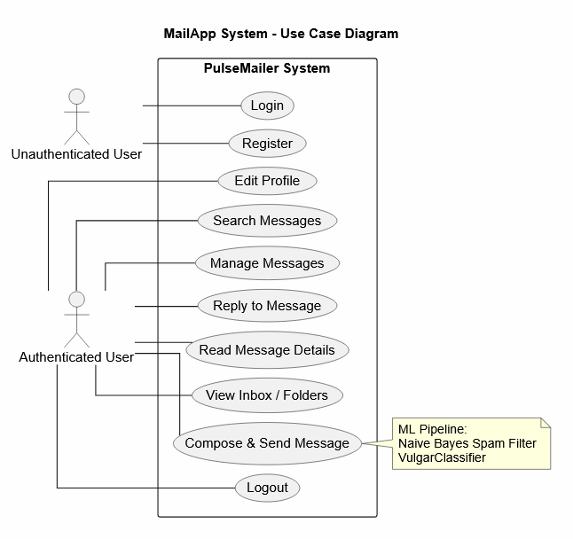
Figure 3.1 Use Case Diagram for PulseMailer system
ii. Non-Functional Requirement
The system should provide following non-functional requirements:
Table 3.2 Non-functional requirements
Req. ID | Category | Requirement
NFR-01 | Security | Passwords must be stored as PBKDF2-SHA256 hashes, never plaintext.
NFR-02 | Security | All database queries must use parameterized statements to prevent SQL injection.
NFR-03 | Security | Session cookies must be HttpOnly and SameSite=Lax.
NFR-04 | Performance | Page load time for the inbox should not exceed 2 seconds for up to 20 messages.
NFR-05 | Usability | The UI must be responsive and usable on mobile screens (min width 320px).
NFR-06 | Reliability | The application should handle invalid file types gracefully with user-friendly errors.
NFR-07 | Maintainability | ML thresholds must be configurable without retraining the models.
NFR-08 | Scalability | The database design must support migration to PostgreSQL or MySQL with minimal code changes.

3.1.2 Feasibility Analysis
A feasibility study is conducted to determine whether a proposed system is practical, achievable, and capable of meeting its intended objectives. It analyzes the system from different perspectives to evaluate whether the project can be successfully developed and implemented within available resources and constraints. For PulseMailer, the feasibility study helps assess the viability of developing a secure web-based messaging system integrated with machine learning-based spam and vulgar content detection.
i. Technical feasibility
All technologies required for this project are freely available and well-documented. Python 3.9+ is available on all major operating systems. Flask is a mature, widely-used framework. SQLite is included in Python's standard library. The Naive Bayes implementation relies only on Python’s standard libraries, including math, re, and collections, and does not require any external machine learning frameworks. The system was developed and tested on the Windows platform.
Table 3.3 Technical feasibility
Component | Technology | Availability | Verdict
Web Framework | Flask 3.x | Free, open-source | Feasible
Database | SQLite3 | Bundled with Python | Feasible
ML: Spam Classifier | Custom Naive Bayes (stdlib) | No dependencies | Feasible
ML: Vulgar Classifier | Custom MNB + n-grams (stdlib) | No dependencies | Feasible
Frontend | HTML5, CSS3, Vanilla JS | No build tools needed | Feasible
Password Hashing | werkzeug.security | Included with Flask | Feasible

ii. Operational Feasibility
The application is straight forward to operate. After installing requirements with pip and running python app.py, the system initializes the database automatically and starts serving on localhost:5000. No database administrator is required. The UI is intuitive for non-technical users. From an administrative perspective, spam thresholds can be adjusted by editing config.py without retraining or modifying source code.
iii. Economic Feasibility
This project is economically feasible because it was developed using open-source technologies such as Flask, SQLite, and Python, which do not require any licensing cost. The system can be developed and tested using a personal laptop without the need for expensive hardware or software. Since the project does not rely on paid APIs or external machine learning frameworks, the overall development and maintenance cost remains low, making the system cost-effective and economically feasible.
iv. Schedule Feasibility
We have a proper development schedule and sufficient time to complete the PulseMailer project successfully. The project was planned and implemented in different phases, including system design, core feature development, machine learning integration, testing, and final deployment. Since each module was developed according to the planned timeline, the project is considered schedule feasible. The overall development process and task distribution are illustrated in the following Gantt chart.
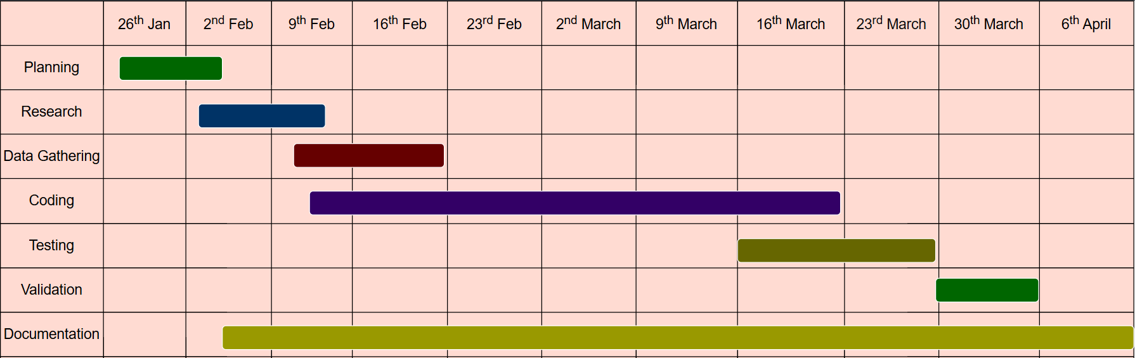
Figure 3.2 Gnatt chart

3.1.3 Analysis
Object modeling using class diagram
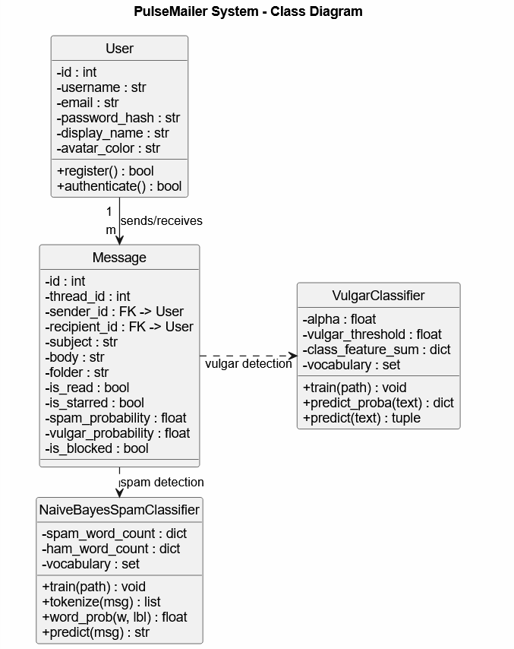
Figure 3.3 Class diagram for PulseMailer system
In the PulseMailer system, there are four main components: User Interface, Messaging System, Machine Learning Moderation System, and Decision Module.
User Interface handles user interaction, including registration, login, message composition, inbox management, and profile settings.
Messaging System manages core functionalities such as sending, receiving, threading, searching, and organizing messages into different folders.
Machine Learning Moderation System consists of the Naive Bayes spam classifier and VulgarClassifier, which analyze message content to detect spam and abusive language.
Decision Module combines the outputs of both classifiers and determines the final action for each message, such as allowing delivery, moving to spam, or blocking the message.

Dynamic modeling using sequence diagram:
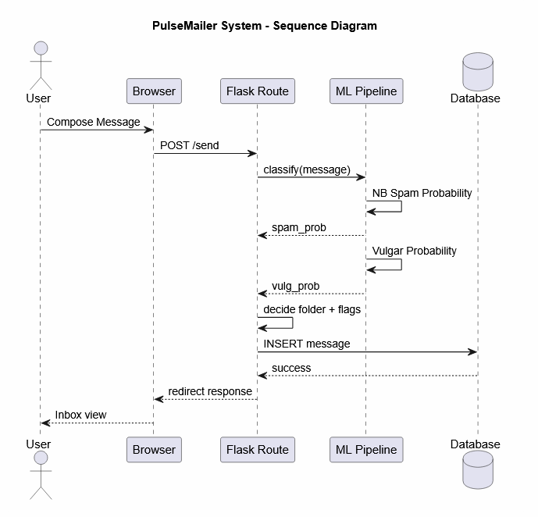
Figure 3.4 Sequence diagram for PulseMailer system
In the context of the PulseMailer system, the sequence diagram (Figure 3.4) represents the workflow involved in sending and moderating a message within the application. The process begins when a user composes a message and submits it through the browser interface. The request is then sent to the Flask backend route responsible for message processing.
After receiving the request, the system forwards the message content to the Machine Learning Pipeline for analysis. The pipeline applies both the Naive Bayes spam classifier and the VulgarClassifier to evaluate the message. It calculates spam probability and detects any presence of abusive or vulgar content using trained models.
Based on the computed probabilities and classification results, the system determines the appropriate action for the message, such as allowing it to be delivered to the inbox, redirecting it to the spam folder, or blocking it if necessary. Finally, the decision along with message status is stored in the database, and the user is redirected to the updated mailbox view reflecting the outcome of the process.
Process Modeling using Activity Diagram
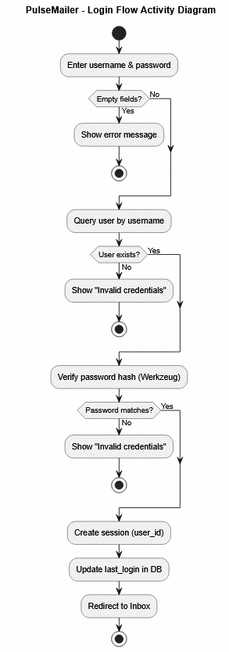
Figure 3.5 Activity diagram for login process
This activity diagram provides a high-level overview of the login workflow in the PulseMailer system. The process begins when the user enters their username and password through the login interface. The system first checks whether the input fields are empty and displays an error message if any required information is missing. If the input is valid, the system proceeds to query the database to verify whether the user exists. If the user is not found, an “Invalid credentials” message is shown and the process is terminated.
If the user exists, the system then verifies the entered password using Werkzeug’s password hashing mechanism. If the password does not match, the system again returns an “Invalid credentials” response. When the credentials are successfully validated, a user session is created, and the last login timestamp is updated in the database. Finally, the user is redirected to the Inbox page, completing the login process.
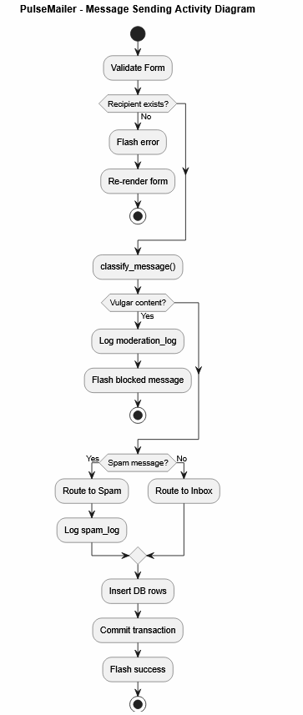
Figure 3.6 Activity diagram for Sending message
This activity diagram gives a simple overview of how messages are handled in the PulseMailer system. It starts when a user writes and submits a message through the form. Before doing anything else, the system checks if the form data is valid and whether the recipient actually exists in the database. If the recipient is not found, the system immediately shows an error message and asks the user to try again.
If everything is correct, the message is passed into the classification process, where the machine learning models analyze its content. First, the system checks if the message contains any vulgar or abusive language. If it does, the message is blocked and the event is recorded in the moderation log.
If the message is clean, it is then checked for spam. Spam messages are not delivered to the inbox instead, they are moved to the spam folder and logged for record keeping. If the message is neither spam nor abusive, it is considered normal and is delivered directly to the recipient’s inbox.
Finally, the system saves all related data in the database, completes the transaction, and shows a success message to the user confirming that the message has been sent successfully.

CHAPTER 4
SYSTEM DESIGN

4.1 Design
System design is the process of planning and organizing the structure, components, modules, interfaces, and data flow of a system so that it can meet the required objectives effectively. In PulseMailer, the system design phase converts the requirements and analysis from Chapter 3 into a detailed structure that guides the actual development of the project. Since the system follows an object-oriented approach, the design phase includes refining UML diagrams such as class diagrams, sequence diagrams, and activity diagrams, along with introducing component and deployment views. This chapter explains the overall architecture of the PulseMailer system, the improved UML designs, and the algorithms used for spam filtering and vulgar content detection.
The architecture of PulseMailer follows a layered design pattern that separates the system into different layers, including the presentation layer, application logic layer, machine learning layer, and database layer. As illustrated in Figure 4.1, the Flask framework acts as the core of the system by connecting the user interface with the backend processing modules. This design allows each component to function independently while still communicating through clearly defined interfaces, making the system easier to maintain, manage, and extend in the future.

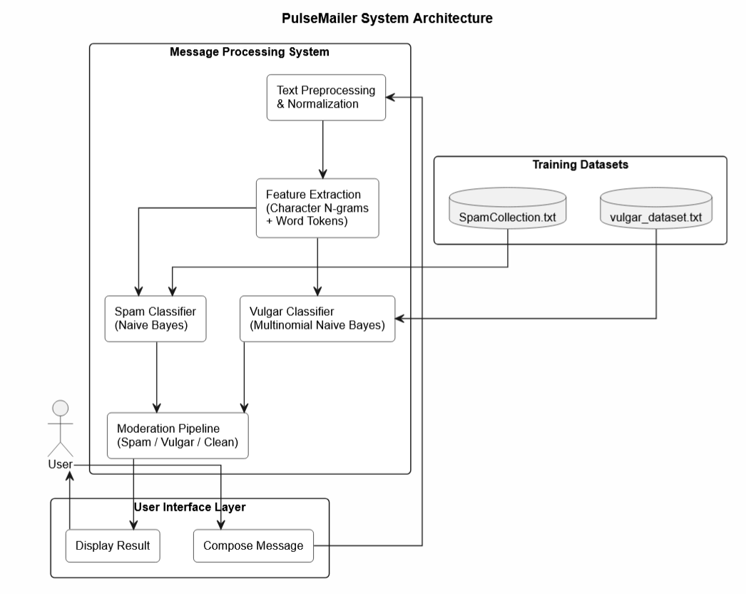
Figure 4.1 System architecture for PulseMailer system
As shown in Figure 4.1, the PulseMailer system is built using several connected modules that work together to manage user communication and message security. Users interact with the system through web pages created using Flask and Jinja2 templates. User requests are handled through Flask Blueprints, which direct them to modules such as authentication (auth.py), messaging (mail.py), and statistics (stats.py). The messaging module is connected to the machine learning pipeline, which includes the spam filter and vulgar content classifier. These classifiers analyze message text and generate probability-based results to identify spam or inappropriate content. All system data is securely stored and managed through the SQLite database layer using database.py.
Figure 4.2 illustrates the high-level design of PulseMailer by showing how messages move through the system from composition to final delivery or blocking. It highlights the complete message processing workflow, including moderation, spam detection, and inbox delivery, providing a clear overview of how the proposed system operates.

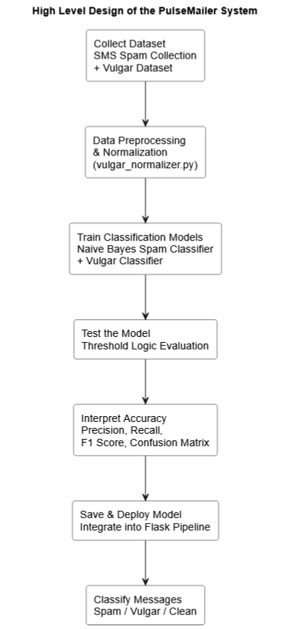
Figure 4.2 High level of the PulseMailer system
The high-level design of PulseMailer follows a three-stage message processing pipeline to ensure secure and reliable communication. In the first stage, the user creates a message through the web interface by entering the recipient, subject, and message content. In the second stage, the message is analyzed by the machine learning moderation pipeline, where the text passes through several processes including text normalization, feature extraction, vulgar content detection, and spam classification. Each classifier generates a probability score along with a classification result to determine whether the message contains harmful or unwanted content. In the final stage, the decision module processes these results using a priority-based approach. Messages containing vulgar or offensive content are completely blocked and recorded in the moderation log, spam messages are automatically moved to the recipient’s spam folder, and clean messages are successfully delivered to the inbox. This layered workflow helps the system identify and handle serious content violations before normal message delivery takes place.
4.1.1 Component diagram
A component diagram is a UML structural diagram that shows how different parts of a software system are organized and connected. It provides a high-level overview of the system architecture by illustrating the relationships and dependencies between major modules and components. In the PulseMailer system, the component diagram represents the interaction between the Flask application server, authentication module, messaging module, machine learning classifiers, database layer, and frontend templates. It demonstrates how each component works together to support the system’s functionality, including user authentication, message handling, spam detection, and data management. The diagram also helps developers better understand the system structure, making the application easier to maintain, manage, and expand in the future.
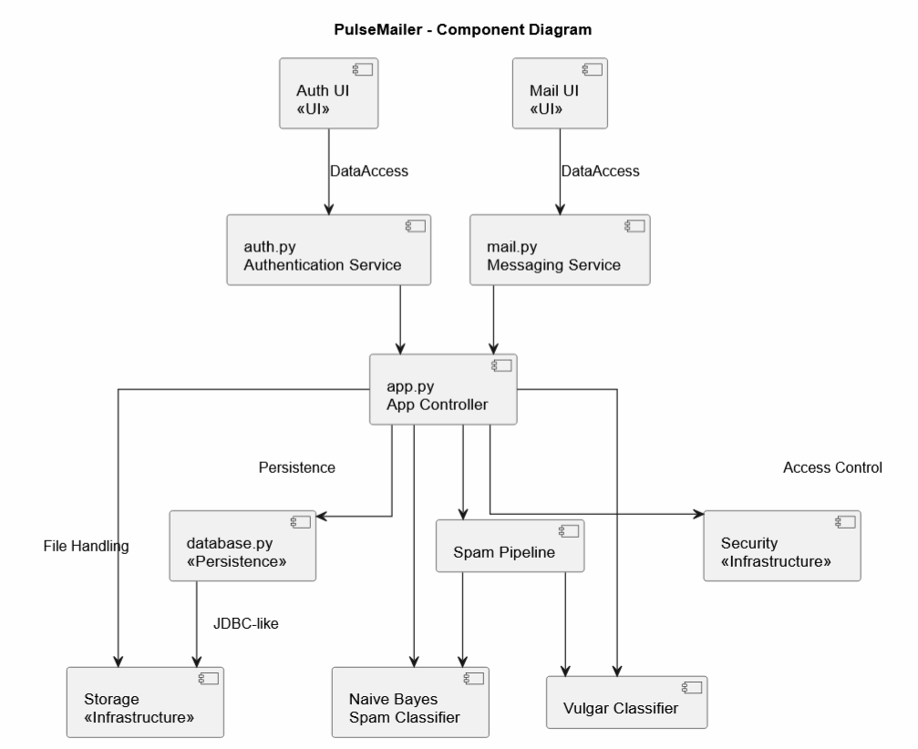
Figure 4.3 Component diagram for PulseMailer system
As shown in Figure 4.3, the PulseMailer system is built around five main components that work together to provide secure messaging, spam detection, and content moderation features. At the center of the system is the Flask Application component, which acts as the main controller by starting the application, managing configurations, and connecting all other modules through blueprint registration.
The Authentication Component (auth.py) is responsible for handling user-related operations such as registration, login, logout, and session management. This ensures that only authorized users can access the system securely. The Messaging Component (mail.py) manages the core email functionalities of the system. It allows users to compose and send messages, organize them into folders, search messages, and handle inbox operations efficiently.
The ML Pipeline Component contains the NaiveBayesSpamClassifier and VulgarClassifier, along with supporting modules for text preprocessing, feature extraction, and normalization. This component automatically analyzes message content to detect spam and inappropriate language before delivery.
Finally, the Database Component provides the data storage layer using SQLite. It manages important tables such as users, messages, spam_log, and moderation_log, ensuring that all application data is stored and retrieved efficiently.
All these components communicate through clearly defined Python interfaces, while the blueprint architecture helps keep the system modular and loosely coupled. This design makes the application easier to maintain, extend, and manage in the future.

4.1.2 Refinement of Class Diagram:
The refined class diagram gives a clear structural view of PulseMailer’s object-oriented design, showing the main classes along with their attributes, methods, and relationships. It improves on the initial diagram from Chapter 3 by adding implementation details from the design phase, including how the machine learning classifiers connect with the system and how the database structure is mapped.
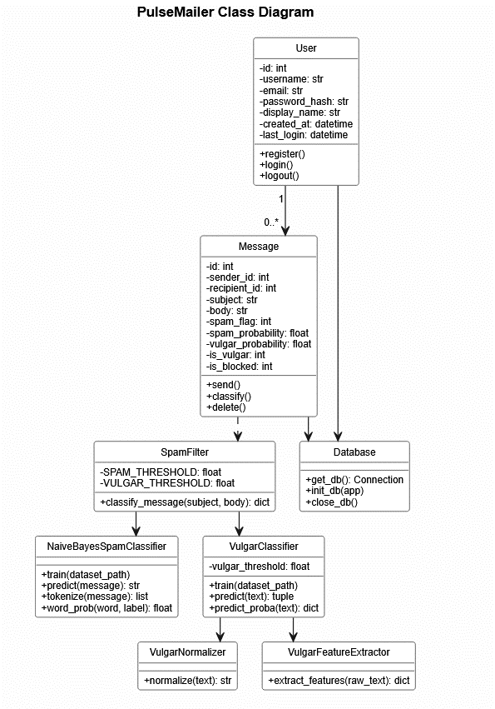
Figure 4.4 Refined class diagram for PulseMailer system
The refined class diagram in Figure 4.4 presents the main structure of the PulseMailer system through six core classes. The User class stores basic account details like username, email, password hash, display name, avatar color, and activity timestamps. The Message class represents each email and includes information such as subject, body, thread ID, folder type, read status, attachments, and moderation results like spam and vulgarity probabilities. The NaiveBayesSpamClassifier handles spam detection by maintaining word counts and vocabulary, with methods for training and prediction. The VulgarClassifier works similarly by evaluating inappropriate content using trained feature weights. The SpamFilter acts as a bridge between both classifiers to produce final decisions on messages. The ModerationLog keeps records of blocked messages along with sender/receiver details, scores, and timestamps. Overall, the relationships show that a user can send many messages, each message is analyzed by the ML models, and any blocked content is stored in the moderation log.
4.1.3 Refinement of Sequence Diagram
A refined sequence diagram shows how different parts of the system interact with each other over time, highlighting the order in which messages are exchanged between objects. In PulseMailer, this diagram represents the full process of composing, sending, and moderating a message, showing how each component works together step by step to complete the workflow.
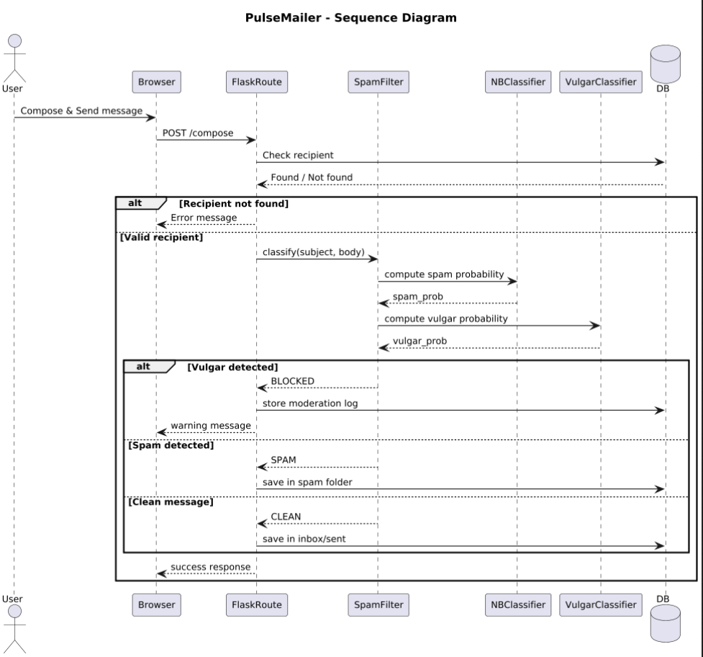
Figure 4.5 Refined Sequence diagram for PulseMailer system
As shown in Figure 4.5, the refined sequence diagram illustrates how a message moves through the PulseMailer system using seven main components: The User, Browser (UI), Flask Server, Authentication Module, Messaging Module, ML Pipeline, and Database. The process starts when a user writes a message and sends it through the browser, which forwards the request to the Flask server. The server then directs it to the messaging module for processing. The system first checks whether the recipient exists by verifying it with the database. Once confirmed, the message is sent to the ML pipeline for content analysis. Here, the text is first cleaned by the vulgar normalizer, then processed using feature extraction techniques like word tokens and character patterns. The vulgar classifier checks for inappropriate content, and if the score is too high, the message is blocked immediately. If it passes this step, the spam classifier evaluates whether the message is spam. Based on the results, the system decides what to do next: blocked messages are logged only in the moderation record, spam messages are stored in the spam folder, and clean messages are delivered to the inbox. Finally, the system sends a response back to the browser, which updates the user interface accordingly.
4.1.4 Refinement of Activity Diagram
The refined activity diagram gives a clear overview of how different activities flow within the PulseMailer message processing system. It shows the step-by-step process, including key decision points, parallel actions, and branching paths that determine how each message is analyzed, classified, and finally routed to its appropriate destination.
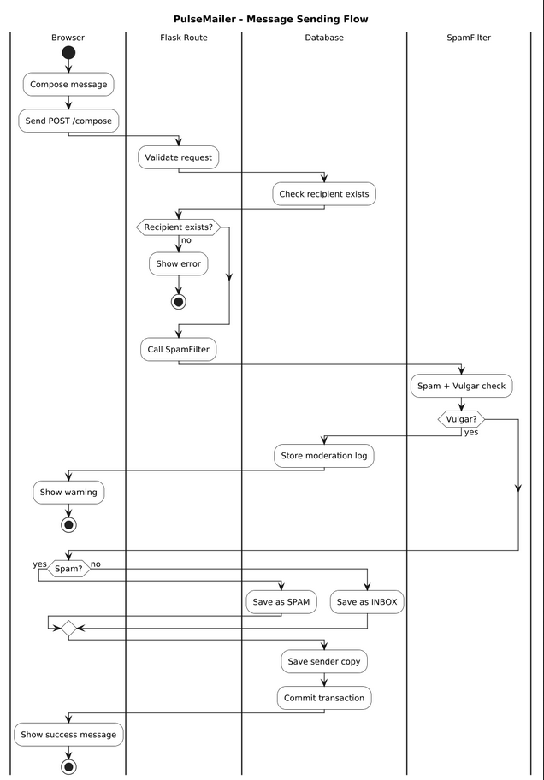
Figure 4.6 Refined Activity diagram for PulseMailer system
Figure 4.6 shows the refined activity flow of how messages are processed in PulseMailer. The process starts when a user composes a message by entering the recipient, subject, and body. The system first checks whether all required fields are filled and whether the recipient exists in the database. If anything is missing or incorrect, the user gets an error message. If validation is successful, the message moves into the moderation pipeline.
At this stage, the text is first normalized to clean up any modified or disguised characters. Then, features such as word tokens, character patterns, and special symbols are extracted from the text. The vulgarity classifier evaluates the message for offensive content, and if the score is too high, the message is immediately blocked and saved in the moderation log. If it passes this check, the spam classifier analyzes it using the Naive Bayes model to determine whether it is spam or not. Based on the results, spam messages are moved to the spam folder, while clean messages are delivered to the inbox. In all cases, the system stores the necessary records in the database and sends a final response back to the user.
4.1.5 State diagram
The state diagram shows how a message changes from one stage to another during its lifecycle in the PulseMailer system. It focuses on the dynamic behavior of messages by illustrating the different states they go through based on user actions and system conditions, from creation to final delivery, spam handling, or blocking.
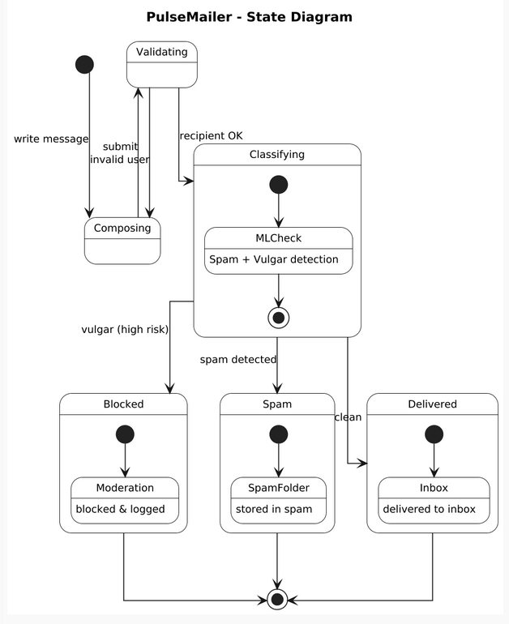
Figure 4.7 State diagram for PulseMailer system
As illustrated in Figure 4.7, a message in PulseMailer goes through several states during its lifecycle. It starts in the Composing state when the user is writing the message, and then moves to Submitted once it is sent. After submission, it enters the Analyzing state, where the ML pipeline evaluates its content. Based on the results, the message is then classified into one of three outcomes: Blocked if vulgar content is detected (probability ≥ 0.90), Spam Flagged if it is identified as spam (probability ≥ 0.70), or Clean if it passes both checks. Blocked messages are stored in the moderation log and are not delivered, while spam messages are sent to the recipient’s spam folder with relevant details. Clean messages go directly to the inbox. Once delivered, messages can still change state as users interact with them, such as marking them as read, starring them, or moving them to trash. This diagram clearly shows the full journey of a message from creation to its final outcome.

4.2 Algorithm Details
This section describes the detailed algorithms used in the PulseMailer system for spam detection and vulgar content classification. The system implements two separate machine learning models, both based on the Multinomial Naive Bayes framework, but customized for different classification tasks.
4.2.1 Naive Bayes Spam Classification Algorithm
The spam detection module is implemented in naive_bayes.py and uses the Multinomial Naive Bayes algorithm, a probabilistic classifier based on Bayes’ theorem with the assumption that words in a message are conditionally independent given the class label.
Training Phase:
The model is trained using the SpamCollection.txt dataset, which contains 5,585 labeled SMS messages (spam and ham). During preprocessing, each message is converted to lowercase, punctuation is removed using a regular expression, and the text is split into tokens. Common stop words are also filtered out. During training, the classifier maintains the following structures: spam_word_count: frequency of words in spam messages, ham_word_count: frequency of words in ham messages, total_spam_words and total_ham_words: total word counts per class, vocabulary: set of all unique words in the dataset, spam_messages and ham_messages: total message counts per class. The class prior probabilities are computed as P(spam) = spam_messages / total_messages and P(ham) = ham_messages / total_messages.
Prediction Phase
During prediction, the model computes log probabilities to avoid numerical underflow. For a message containing words w₁, w₂, ..., wₙ, the log-posterior is calculated as:
log P(c | message) = log P(c) + Σ log P(wᵢ | c)
where likelihood is computed using Laplace smoothing:
P (word | class) = (count(word, class) + 1) / (total_words_in_class + |vocabulary|)
The smoothing constant ensures that unseen words are still assigned a non-zero probability. A message is classified as spam if log P(spam | message) > log P(ham | message)

Probability Estimation and Thresholding
The spam_filter.py module converts log scores into probabilities using the log-sum-exp method
P(spam) = exp(log_spam - max_log) / (exp(log_spam - max_log) + exp(log_ham - max_log))
A threshold of 0.70 is applied, meaning a message is marked as spam only if P(spam) ≥ 0.70. This higher threshold reduces false positives by ensuring strong model confidence. A confidence score is also calculated as |P(spam) - P(ham)| which represents the certainty of the prediction.
4.2.2 Vulgar Content Detection Algorithm
The vulgar content detection module is implemented in vulgar_classifier.py, vulgar_features.py, and vulgar_normalizer.py. It also uses a Multinomial Naive Bayes classifier, but it relies on character-level features instead of word-level features. This makes it more effective in detecting obfuscated or masked offensive words such as “@ss”, “f!ck”, or “bi*ch”.
Text Normalization
Before feature extraction, input text is normalized using character substitution rules defined in vulgar_normalizer.py: @ → a, $ → s, ! → i, 1 → i, 3 → e, 0 → o, *→ (removed), #→ (removed). This step ensures that obfuscated variations are converted into a standard form before analysis.
Feature Extraction
The feature extraction module generates a combination of lexical and statistical features, including Character trigrams (n=3), Character four-grams (n=4), Word-level tokens (after normalization and stop-word removal), Special character-based features special_char_freq (ratio of non-alphanumeric characters), symbol_to_letter ratio, avg_word_length. Unlike TF-IDF, the model uses raw feature counts and numeric ratios directly for classification.

Classification
The VulgarClassifier applies the Multinomial Naive Bayes algorithm with Laplace smoothing (alpha = 2.0 in implementation). For each class (vulgar or clean), the log-posterior is computed as:
log P(c | features) = log P(c) + Σ vᵢ × log P(fᵢ | c)
where vᵢ represents the feature value and P(fᵢ | c) is the smoothed likelihood. The probabilities are normalized using the log-sum-exp method for numerical stability. A message is classified as vulgar if P(vulgar) ≥ 0.90. This strict threshold ensures that only highly confident cases are blocked.
Priority-Based Decision Pipeline
The final classification logic is implemented in classify_message() inside spam_filter.py. The system follows a strict priority order:
- Vulgarity Check (Highest Priority)
If P(vulgar) ≥ 0.90 → message is immediately blocked and the message is stored in the moderation_log table
- Spam Detection
If the message is not vulgar, spam probability is evaluated. If P(spam) ≥ 0.70, message is marked as spam and moved to the spam folder
- Clean Message Handling
If neither condition is met then the message is delivered to the inbox
This priority-based pipeline ensures that offensive or harmful content is always blocked first, followed by spam filtering, resulting in a robust multi-layer moderation system.

CHAPTER 5
IMPLEMENTATION AND TESTING

5.1 Implementation

5.1.1 Tools and Technology used
Table 5.1 Technology used
Category | Technology/Tool | Version | Purpose
Language | Python | 3.12 | Primary backend language
Web Framework | Flask | 3.0.x | HTTP routing, templating, sessions
Database | SQLite3 | Built-in | Relational data storage
Password Hashing | werkzeug.security | Bundled | PBKDF2-SHA256 hashing
File Upload Safety | werkzeug.utils | Bundled | secure_filename() for uploads
ML: Spam Classifier | Custom (stdlib) | — | Naive Bayes spam classifier
ML: Vulgar Classifier | Custom (stdlib) | — | Character n-gram vulgar classifier
Templating | Jinja2 | Bundled with Flask | Server-side HTML rendering
Frontend | HTML5 / CSS3 / Vanilla JS | — | Dark-themed responsive UI
Version Control | Git | — | Source code management

5.1.2 Implementation details of Modules
Authentication Module(routes/auth.py)
The authentication module manages three main routes: /register/login, and /logout. During registration, it first checks that both the username and email are unique before saving the user. Passwords are securely stored using a PBKDF2-SHA256 hash.
For login, the system fetches the user record using a case insensitive lookup on the username, and then verifies the password using Werkzeug’s check_password_hash() function. If the credentials are correct, the user’s ID is saved in Flask’s session to keep them logged in.
To maintain security, all database queries use parameterized placeholders, which helps protect the application from SQL injection attacks.
Messaging Module(routes/mail.py)
This is the largest module in the system. The /send route handles the POST request from the message form. It first verifies that the recipient exists, then processes the message content by passing it through classify_message() from spam_filter.py to determine whether it is spam or not.
After classification, the system inserts two records into the messages table: one for the sender (with folder='sent') and another for the recipient, where the folder is set based on the output of the ML pipeline (such as inbox or spam).
The /inbox route is used to display received messages. It retrieves messages using pagination and joins the users table so that sender IDs are replaced with readable display names, making the inbox more user-friendly and easier to navigate.
a. Naïve Bayes Spam Classifier(naïve_bayes.py)
Step 1: Tokenization and Preprocessing
The tokenizer converts messages into lowercase text and removes punctuation and unnecessary symbols. This improves consistency during training and prediction.
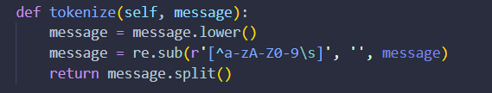
Figure 5.1 Tokenization of message
Step 2: Training the Classifier
The training process reads labeled datasets containing spam and ham messages. In this step the classifier Counts spam and ham words, Stores vocabulary, and Tracks message frequencies.
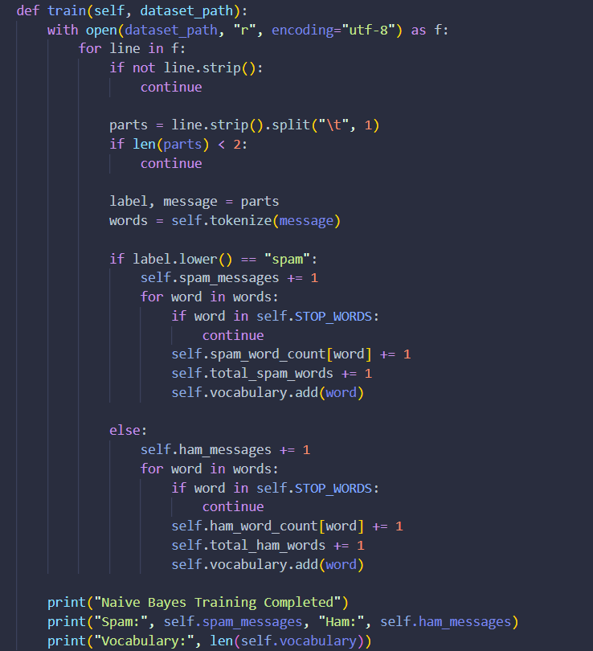
Figure 5.2 Training the classifier
Step 3: Laplace smoothing:
Laplace smoothing prevents zero probability problems for unseen words.
Probability formula:
P (word ∣ class) = count(word) + 1 / total words + |vocabulary∣
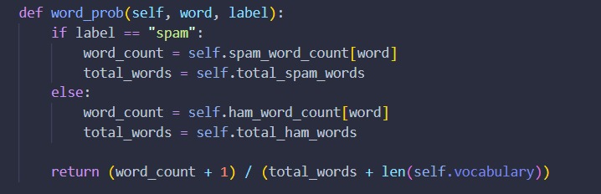
Figure 5.3 Laplace Smoothing
Step 4: Computing log probabilities:
The classifier computes logarithmic probabilities for spam and ham classes. Using logarithms prevents numerical underflow during multiplication of very small probabilities.
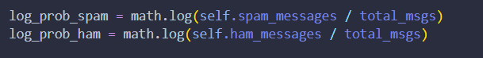
Figure 5.4 Computing log probabilities
Step 5: Predicting message class
The prediction function compares spam and ham probabilities and returns the class with the higher probability.
Figure 5.5 Prediction
b. Enhanced Probability-Based Spam Filtering Module
The enhanced spam filter improves the original Naive Bayes implementation by introducing probability extraction and threshold-based classification. Unlike the original binary classifier, the enhanced model computes Spam probability, Ham probability, Confidence score.
Step 1: Computing spam probability
The system converts log probabilities into normalized probabilities using exponential normalization.
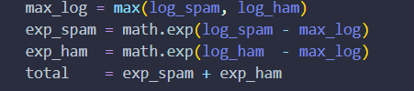
Figure 5.6 Probability normalization

Step 2: Threshold-Based Spam Detection
The system introduces a configurable threshold to reduce false positives.
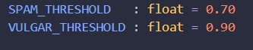
Figure 5.7 Setting threshold
Step 3: Confidence score calculation
The confidence score measures the certainty of classification.
Figure 5.8 Confidence calculation

Vulgar Content Classifier (vulgar_classifier.py + vulgar_features.py + vulgar_normalizer.py)
This is the novel contribution of the project. The VulgarClassifier is trained on a custom dataset containing 11,066 lines of data. It uses an extract_features() function that converts each message into a weighted feature representation, including both word tokens and character n-grams.
During training, these weighted features are aggregated into class wise feature sums, allowing the model to learn patterns specific to each category. For prediction, it computes log posteriors using a weighted sum of log likelihoods with Laplace smoothing, where alpha = 2.0 is used to maintain a more conservative prior and improve stability.
Before feature extraction, the input text is passed through a vulgar_normalizer, which standardizes common character substitutions (such as leetspeak or intentionally obfuscated words). This helps the system detect distorted or masked vulgar expressions more reliably.

5.2 Testing
During the development of this project, the system was tested continuously at different stages to identify and fix errors early. Since the project includes authentication, message handling, and machine learning-based classification, each component was tested separately as well as in integration to ensure smooth functionality across the system.

5.2.1 Test Cases for Unit Testing
i. Authentication Module
Table 5.2 Authentication Testing
Test ID | Test Case | Input | Expected Output | Result
UT-01 | Register with valid data | email='alice@mail.com'  Password=’shankar’ | Redirect to login, user created in DB | PASS
UT-02 | Duplicate username registration | username='shankar' (existing) | Flash 'Username already taken' | PASS
UT-03 | Login with correct credentials | username='shankar', password='shankar' | Redirect to inbox, session set | PASS
UT-04 | Login with wrong password | username='shankar', password='wrong' | Flash 'Invalid credentials' | PASS
UT-05 | Access inbox without login | GET /inbox (no session) | Redirect to /login | PASS
UT-06 | Logout clears session | POST /logout with active session | Session cleared, redirect to /login | PASS

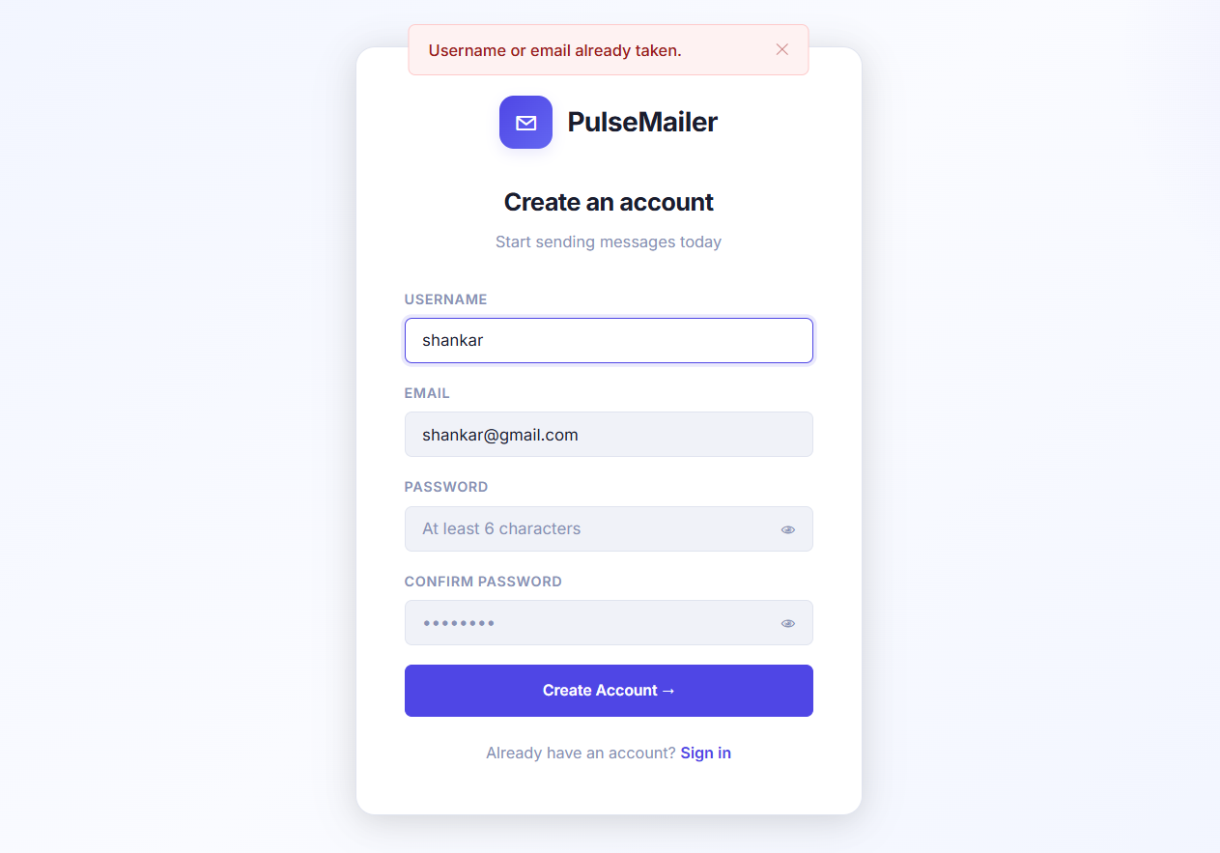
Figure 5.9 Duplicate registration validity
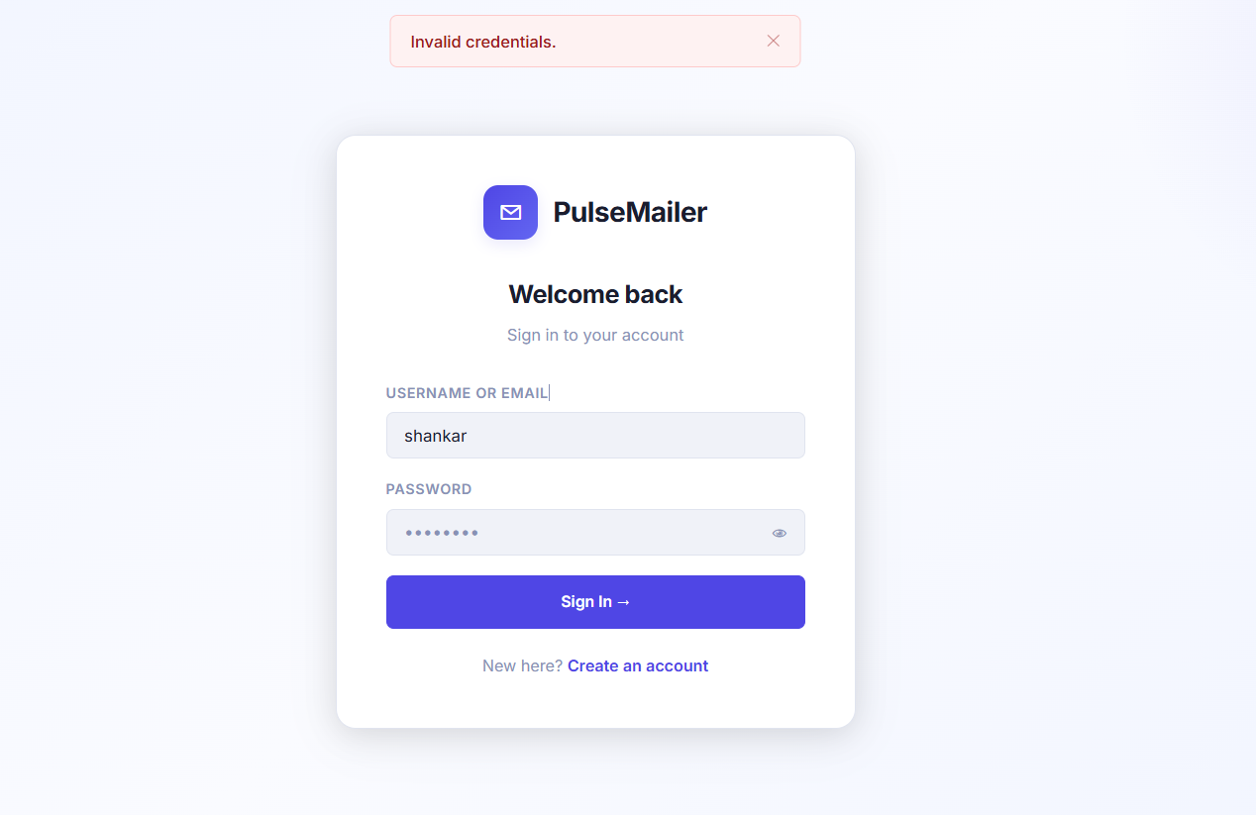
Figure 5.10 Invalid credentials Validity

ii. Messaging Module
Table 5.3 Message Testing
Test ID | Test Case | Input | Expected Output | Result
UT-07 | Send to valid user | recipient='bob', body='Hello' | 2 rows in messages (sent + inbox) | PASS
UT-08 | Send to non-existent user | recipient='nobody' | Flash 'Recipient not found' | PASS
UT-9 | Reply links thread_id | Reply to message id=5 | New message: thread_id=5 | PASS
UT-10 | Star / unstar message | POST /star/5 | is_starred toggles in DB | PASS
UT-11 | Delete moves to Trash | POST /delete/5 | folder='trash', deleted_at set | PASS
UT-12 | Search finds matching msg | GET /search?q=hello | Returns messages with 'hello' in subject/body | PASS

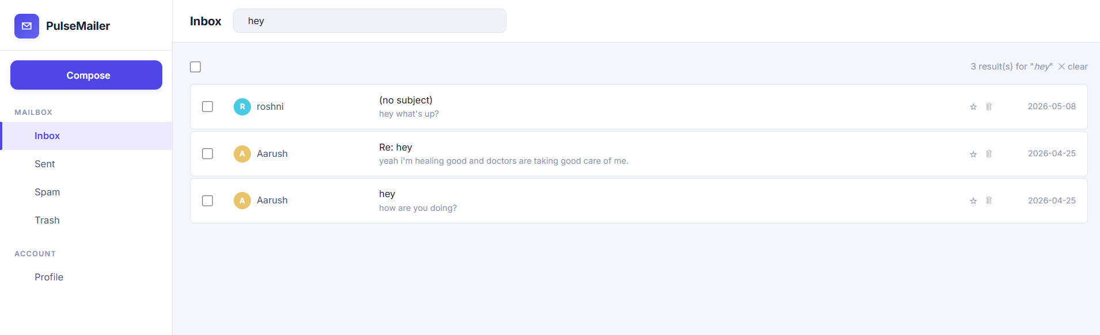
Figure 5.11 Search Feature Validity

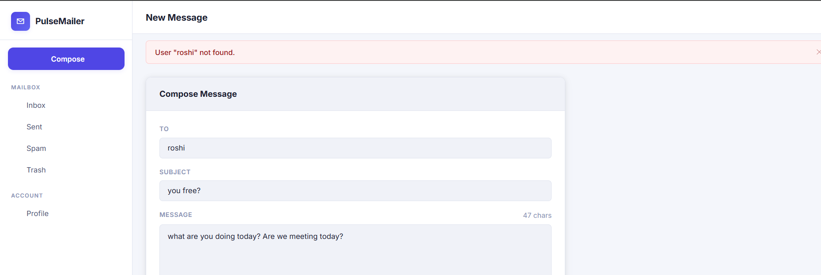
Figure 5.12 Non-existent user validity

iii. ML Classifier Module
Table 5.4 Machine Learning Algorithms testing
Test ID | Test Case | Input Text | Expected Result | Result
ML-01 | Clear spam message | 'WIN FREE MONEY!!! Click now!!!' | is_spam=True, spam_prob >= 0.70 | PASS
ML-02 | Normal clean message | 'Hey, are we meeting at 3pm tomorrow?' | is_spam=False, folder=inbox | PASS
ML-03 | Vulgar message (plain) | 'You are such an asshole' | is_vulgar=True, blocked=True | PASS
ML-04 | Obfuscated vulgar text | 'You @ssh0le!!!' | is_vulgar=True, blocked=True | PASS
ML-05 | Borderline spam | 'Get this free offer today' | Decision at 0.70 threshold | PASS
ML-06 | Vulgar + spam combined | 'FREE MONEY bi*ch win now!!!' | Priority=VULGAR, blocked=True | PASS

5.2.2 Test Cases for System Testing
In this project, system testing focuses on verifying the interaction between different components such as authentication, message handling, database operations, and the machine learning-based classification modules. It checks whether the system performs all required tasks as intended when all parts are combined.
Table 5.5 System Testing
Test ID | Scenario | Steps | Expected Outcome | Result
ST-01 | End-to-end spam flow | User A sends spam to User B; User B checks inbox | Message in User B's Spam folder | PASS
ST-02 | End-to-end vulgar block | User A sends vulgar message to User B | No delivery, message in moderation folder | PASS
ST-03 | Session expiry on restart | Server restarts; User A tries inbox access | Redirect to /login (session cleared) | PASS
ST-04 | SQL injection attempt | Username: ' OR '1'='1 | No data returned; query parameterized safely | PASS
ST-05 | Folder count via API | User with 5 unread messages loads inbox | Sidebar shows correct counts | PASS

5.3 Result Analysis
i. Evaluating Spam Classification
We tested the system using a series of small and controlled inputs, and overall it performed well according to the intended design. The project successfully achieved its main objective of classifying and filtering messages using a dual-layer machine learning pipeline. However, like any system, there is still room for improvement through additional data, feature enhancements, and real-world user feedback.
In this project, the performance of the spam classifier is evaluated using standard classification metrics commonly used in machine learning:
Accuracy: Accuracy measures the overall correctness of the model’s predictions. It represents the proportion of correctly classified messages (both spam and ham) out of all predictions made. In this system, the model achieves a very high accuracy of 99.23%, indicating strong overall performance.
Precision: Precision measures how many of the messages predicted as spam are actually spam. It helps reduce the number of false alarms.
Formula:
Precision = True Positives / (True Positives + False Positives)
In this project, the precision is 98.62%, meaning the model is highly reliable when it flags a message as spam.
Recall (Sensitivity): Recall measures how many actual spam messages are correctly identified by the model. It focuses on the model’s ability to catch spam effectively.
Formula:
Recall = True Positives / (True Positives + False Negatives)
The system achieves a recall of 95.6%, showing that it successfully detects most spam messages while missing very few.
F1 Score: The F1 score is the harmonic mean of precision and recall. It provides a balanced measure between both metrics, especially useful when there is class imbalance.
Formula:
F1 Score = 2 × (Precision × Recall) / (Precision + Recall)
The model achieves an F1 score of 97.09%, indicating a strong balance between precision and recall.
Confusion Matrix: A confusion matrix is used to visually represent the performance of the classification model by comparing actual and predicted values. It consists of four components:
True Positives (TP): Correctly identified spam messages
False Positives (FP): Ham messages incorrectly marked as spam
True Negatives (TN): Correctly identified ham messages
False Negatives (FN): Spam messages incorrectly marked as ham
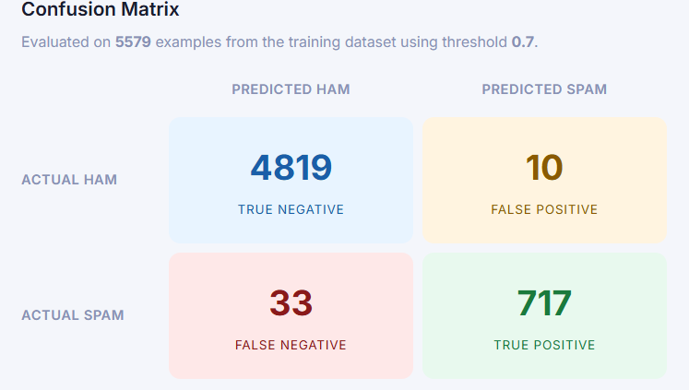

ii. Evaluating Vulgar Classification:
The vulgar content classifier is designed to detect offensive, abusive, or inappropriate language in messages. Similar evaluation metrics were used to measure the performance of this classifier.
Accuracy: The vulgar content classifier achieved an accuracy of 99.93%, which indicates extremely high overall correctness in identifying vulgar and clean messages.
Precision: The classifier achieved a precision of 99.96%, meaning almost every message flagged as vulgar was actually vulgar. This demonstrates excellent reliability and minimizes false warnings.
Recall: The vulgar detection model achieved a recall of 99.89%, showing that the system successfully detects nearly all vulgar content with very few missed cases.
F1 score: The vulgar classifier achieved an F1 Score of 99.92%, indicating an excellent balance between identifying vulgar messages correctly and avoiding incorrect classifications.
Confusion matrix:
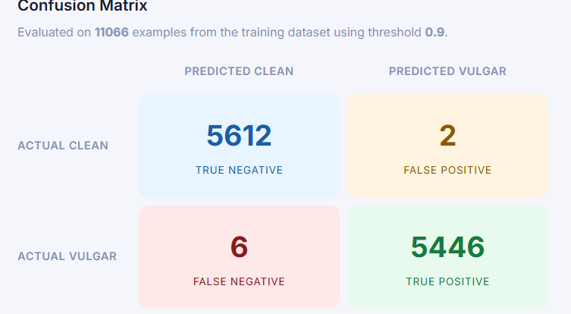

CHAPTER 6
CONCLUSION AND FUTURE RECOMMENDATIONS

6.1 Conclusion
This project shows that it is possible to build a full-stack web messaging application with integrated machine learning based content moderation using lightweight and dependency minimal tools, without compromising on practicality or clarity.
The system, PulseMailer, includes standard messaging features such as multi folder mailbox management, message search, pagination, file attachments, and message threading. Alongside these, it introduces a two-stage moderation pipeline that classifies messages into vulgar, spam, or clean categories using custom built Naive Bayes models.
The key technical contribution of the project is the VulgarClassifier. It combines character n-grams with a normalization step to detect obfuscated or intentionally altered profanity that simple keyword-based filters would miss. By using Laplace smoothing (alpha = 2.0) and a high confidence threshold of 0.90, the classifier is designed to reduce false positives while still reliably detecting clear cases of abusive content.
Both classifiers are integrated through a unified moderation pipeline in spam_filter.py, which applies a clear priority order for decisions and stores probability scores in the database for transparency and future auditing. The design is also flexible, allowing either classifier to be replaced or upgraded without affecting the rest of the system.
From a software engineering perspective, the project follows the Waterfall model as its development approach, with clearly defined and sequential phases including requirements analysis, system design, implementation, testing, and deployment. Each phase was completed before moving on to the next, ensuring a structured and well-documented development process.
The system also follows good engineering practices such as a modular architecture using Flask Blueprints, secure password hashing, and parameterized database queries to prevent SQL injection. In addition, the moderation system uses configurable thresholds that can be adjusted without retraining the models.

6.2 Future Enhancements
- Add real-time messaging support using Flask-SocketIO or Server-Sent Events so that users receive new messages instantly without needing to refresh the page.
- Migrate the database to PostgreSQL for production use, especially to handle multiple concurrent users more efficiently.
- Explore an alternative machine learning approach by using TF-IDF vectorization combined with a Support Vector Machine (SVM) model, which could potentially perform better on ambiguous or borderline messages.
- Add a “Report as spam” or “Report as inappropriate” feature that allows users to flag messages, with the data feeding back into the training pipeline for continuous model improvement.
- Implement end-to-end encryption for message content using a library like PyNaCl, ensuring that even system administrators cannot directly read user messages.

References
[1] T. A. Almeida, J. M. G. Hidalgo, and A. Yamakami, “Contributions to the Study of SMS Spam Filtering: New Collection and Results,” in Proceedings of the 11th ACM Symposium on Document Engineering (DocEng ’11), Mountain View, California, USA, Sep. 2011, pp. 259–262.
[2] M. Uzan and Y. HaCohen-Kerner, “Offensive Language Detection in Tweets using Preprocessing Methods, Character and Word N-grams,” in Proceedings of the 14th International Workshop on Semantic Evaluation (SemEval-2020), Barcelona, Spain, Dec. 2020, pp. 1183–1188.
[3] E. W. Pamungkas, V. Basile, and V. Patti, “Investigating the Role of Swear Words in Abusive Language Detection Tasks,” Language Resources and Evaluation, vol. 57, no. 1, pp. 155–188, Mar. 2023.
[4] M. Sahami, S. Dumais, D. Heckerman, and E. Horvitz, "A Bayesian Approach to Filtering Junk E-Mail," AAAI Workshop on Learning for Text Categorization, 1998.
[5] K. Kowsari, K. J. Meimandi, M. Heidarysafa, S. Mendu, L. Barnes, and D. Brown, "Text Classification Algorithms: A Survey," Information, vol. 10, no. 4, p. 150, 2019, doi: 10.3390/info10040150.
[6] P. Roy, R. Bhatt, and A. Kumar, "A Comparative Study of Machine Learning Methods for SMS Spam Detection," Int. J. Adv. Comput. Sci. Appl., vol. 11, no. 1, pp. 97–106, 2020.
[7] S. K. Alsubari, S. N. Deshmukh, A. A. Alqarni, N. Alsharif, I. Dhabbah, and R. K. Alotaibi, "Data Analytics for the Identification of Fake Reviews Using Supervised Learning," Computers, Materials & Continua, vol. 70, no. 2, pp. 3013–3028, 2022.
[8] J. M. Gómez Hidalgo, M. J. Martín-Abreu, and J. Riquelme, "Combining BERT Features and Transfer Learning for Spam Detection," Applied Sciences, vol. 11, no. 13, p. 6048, 2021, doi: 10.3390/app11136048.
[9] M. Zampieri, S. Malmasi, P. Nakov, S. Rosenthal, N. Farra, and R. Kumar, "Predicting the Type and Target of Offensive Posts in Social Media," in Proc. NAACL 2019, pp. 1415–1420, 2019.
[10] T. Grndahl, L. Pajola, M. Juuti, M. Conti, and N. Asokan, "All You Need is 'Love': Evading Hate-Speech Detection," in Proc. 11th ACM Workshop AISec, pp. 2–12, 2018.
[11] C. Nobata, J. Tetreault, A. Thomas, Y. Mehdad, and Y. Chang, "Abusive Language Detection in Online User Content," in Proc. 25th Int. Conf. World Wide Web, 2016.
[12] J. Pavlopoulos, J. Androutsopoulos, and A. Pitler, "Toxicity Detection: Does Context Really Matter?" in Proc. ACL 2020, pp. 4296–4305, 2020.
[13] T. Joachims, "Text Categorization with Support Vector Machines: Learning with Many Relevant Features," in Proc. ECML, 1998, pp. 137–142.
[14] Y. Kim, "Convolutional Neural Networks for Sentence Classification," in Proc. EMNLP 2014, pp. 1746–1751.
[15] B. Bhavani and S. Devi, "Deep Learning Based Spam Filtering Model for Short Message Service (SMS)," Wireless Pers. Commun., vol. 120, pp. 1039–1054, 2021, doi: 10.1007/s11277-021-08496-8.

Appendices
1. Inbox Page
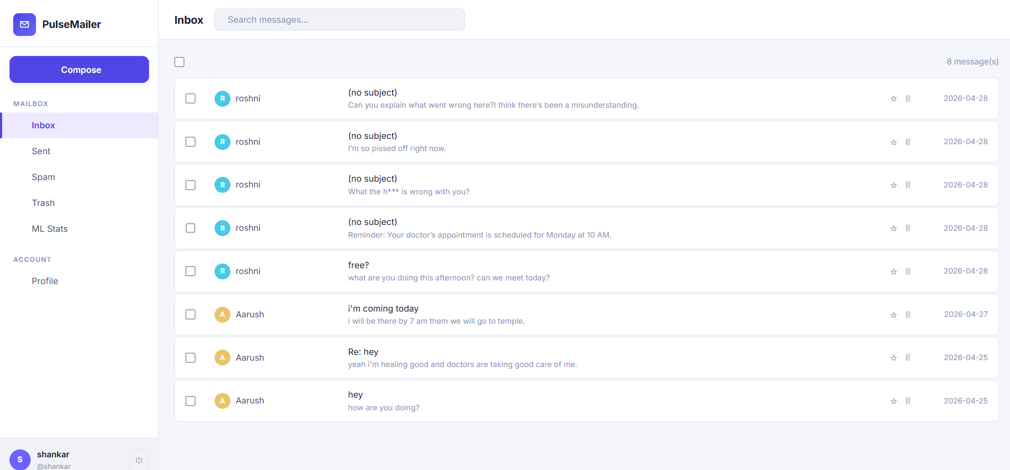
2. Spam Page
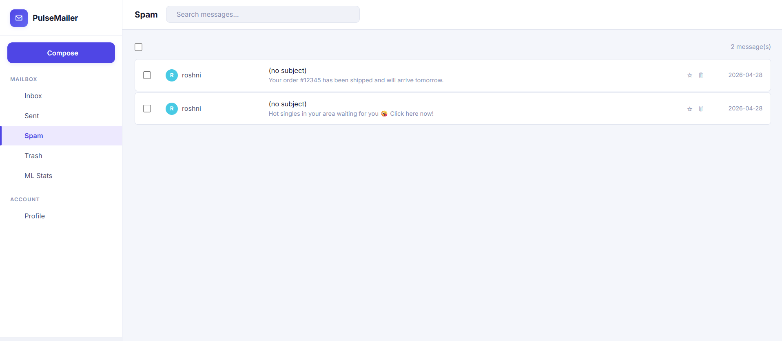

3. Compose Page
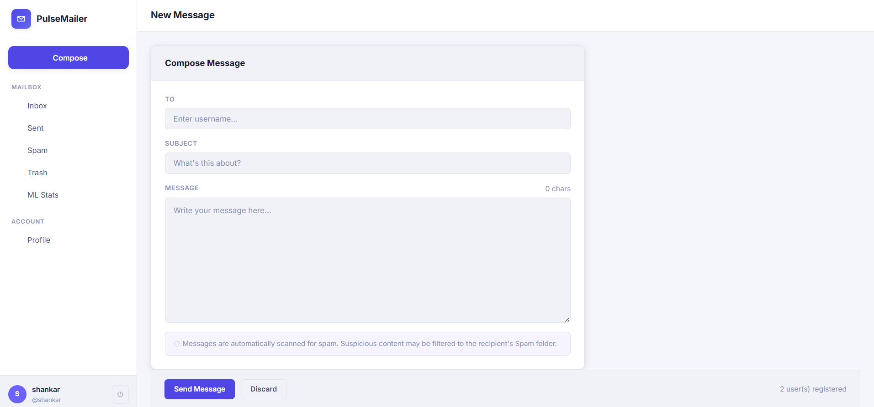
4. ML statistics
