Number: 100782184 Version: B.1

Released: 04-Dec-2022

Name: Franchise 2D Direct Marking Design Procedure (Shared)

|  |  |  |  |
| --- | --- | --- | --- |
| **Windchill Signature History Report** | | | |
| **Signature** | **Role** | **Event Date** | **Vote** |

Revision History for 100782184

|  |  |
| --- | --- |
| Summary of Changes | |
| Revision No. | Description of Change |
| 2 | * Replaced “Codman” with “Cerenovus” |
| 1 | * New document |

# Purpose

This work instruction defines how reusable medical devices (including reusable instruments and capital equipment that’s classified as a medical device) are to be marked with human readable interpretation (HRI) and 2D DataMatrix for Unique Device Identification (UDI) purposes for both FDA and MDR across the Johnson & Johnson (J&J) medical device companies.

This work instruction establishes guidelines regarding the placement of markings, marking with regards to regulatory compliance, and general-purpose markings; taking into account materials, marking processes and technical aspects.

# Scope

This work instruction is applicable to all reusable medical devices, instruments and capital equipment developed and manufactured by or for, and marketed by, Johnson & Johnson (J&J) medical device companies as the legal manufacturer. This also includes all external manufacturers (suppliers) that provide applicable product types to any of the J&J medical device companies listed in the table below, or are otherwise marketed by J&J.

Compliance to this Work Instruction shall be implemented for affected devices by the below MDR Compliance Dates for direct marking:

* Class III – May 26, 2023
* Class IIA, Class II B – May 26, 2025
* Class I (all) – May 26, 2027

Individual product groups can implement these requirements before the MDR compliance dates. Additionally, individual product groups, supplementary requirements may be established but must adhere to this work instruction.

|  |  |
| --- | --- |
| **Operating Companies in Scope** | |
| Ethicon (Includes Mentor) | All Sites |
| Ethicon Endo Surgery (EES)  *(includes both Inc and LLC)* | All Sites |
| Biosense Webster (BWI) | All Sites |
| NeuWave | All Sites |
| Megadyne | All Sites |
| Cerenovus | All Sites |
| DePuy | All Sites |
| Synthes | All Sites |
| Omrix | All Sites |

# Definitions, Acronyms and Abbreviations

|  |  |
| --- | --- |
| Term | Meaning |
| # | Symbol/Acronym for Number |
| AI | Application Identifier = Code which defines format and type of the content of a GS1 data element; e.g. the AI code for Lot # is 10. |
| AIDC | Automatic Information and Data Capture refers to the output of data from a barcode when scanned. |
| CE Mark | A physical “CE” mark on a product that indicates conformity  declaration as per regulation MDR 2017/745 Medical Device Regulation for EU replacing MDD 93/42/EEC, Annex XII |
| DHF | Design History File = Compilation of records that describe the design history of a finished medical device and includes the design activities used to develop the device, accessories, major  components, labeling, packaging, and production processes. |
| DI | Device Identifier = A mandatory, fixed portion of a UDI that identifies the specific version or model of a device and the labeler  of that device. The GS1 standard name for a DI is the Global Trade Item Number (GTIN). |
| DM | Direct Marking (also referred to as Direct Part Marking) = Requirement for directly marking product with a globally unique ID. |
| DQE | Design Quality Engineering = A J&J medical device operating company’s Design Quality Engineering department/function. |
| EMEA / AP / LAT | Refers to the market regions of Europe, Middle East, Africa / Asian Pacific / Latin America |
| FS | Font Size = Absolute height of a capital character or a stand-alone symbol in an etch. |
| GS1 | Global Nonprofit Organization which owns, manages and provides the GS1 System for worldwide unique product identification;  Successor organization of UCC and EAN. |
| GS1 2D DataMatrix | Dot DataMatrix of square or rectangular shape and compliant to GS1 and ECC 200 standardization. The alphanumeric code contained in the matrix uniquely identifies articles on a lot or single item level. |
| GS1 Human  Readable Interpretation | Human Readable Interpretation refers to the characters printed below, beside or above a barcode. It’s the representation of data from the barcode. Also referred to as HRI and easily readable plain  text. |
| GTIN | Global Trade Item Number = Globally unique product and manufacturer identifying number, which is part of the GS1 system. |
| IFU/e-IFU | Instructions For Use / electronic Instructions For Use |
| Lot # | Lot Number = Unique production ID # for products produced in the same production lot. |
| N/A | Not Applicable |
| PD | A J&J medical device operating company’s Product Development department/function. |
| PI | Production Identifier Identifies the production information of a specific device with variable production information that is reflected on the product or packaging labels. The PI can be in the form of lot or batch number, serial number, expiration date, date of  manufacture etc. |
| PM | A J&J medical device operating company’s Product Management department/function. |

|  |  |
| --- | --- |
| R&D | A J&J medical device operating company’s Research & Development department/function. |
| RA | A J&J medical device operating company’s Regulatory Affairs  department/function. |
| Serial # | Serial Number = Unique Production Identifier for a single product unit. |
| TF | Technical File – document(s) that describes a product and provides proof the product was designed according to the requirements of a quality management system. |
| UDI | Unique Device Identification  System intended to assign a unique identifier to medical devices that generally consists of the following: Device Identifier (DI) a mandatory fixed portion of a UDI that identifies the label and the specific version or model of a device and Production Identifier (PI) a conditional, variable portion of a UDI that identifies one or more of the following:   * Lot or Batch number * Serial number * Expiration or manufacturing date |

1. **Roles and Responsibilities**

The following divisions should be consulted to provide input and decision making regarding the marking of content for specific products:

* R&D (Research and Development / Product Development)
* DQE (Design Quality Engineering)
* SQE (Supplier/Source Quality Engineering)
* ME (Manufacturing Engineering)
* RA (Regulatory Affairs)
* Purchasing/Source

|  |  |
| --- | --- |
| Role | Responsibility |
| R&D | Propose content, layout and process for marking.  Dissemination of the proposed marking requirements to all affected parties. |
| DQE | Review and approve the proposed marking content. |
| SQE | Review and approve the proposed marking content, layout, and make, from a manufacturing point of view. |
| ME | Review and approve layout from a manufacturing point of view. |
| RA | Review and approve the proposed marking content from a regulatory point of view. |
| Purchasing | Dissemination of the finalized marking requirements to all affected parties. |

Refer to your local operating procedures with regards to department naming conventions, as these may be different, for example Purchasing may be referred to as Supply Chain/SRM team

All decisions made must be documented in the Design History Files (DHF), Technical File (TF), or equivalent design quality document for the affected products.

1. **Process Map**

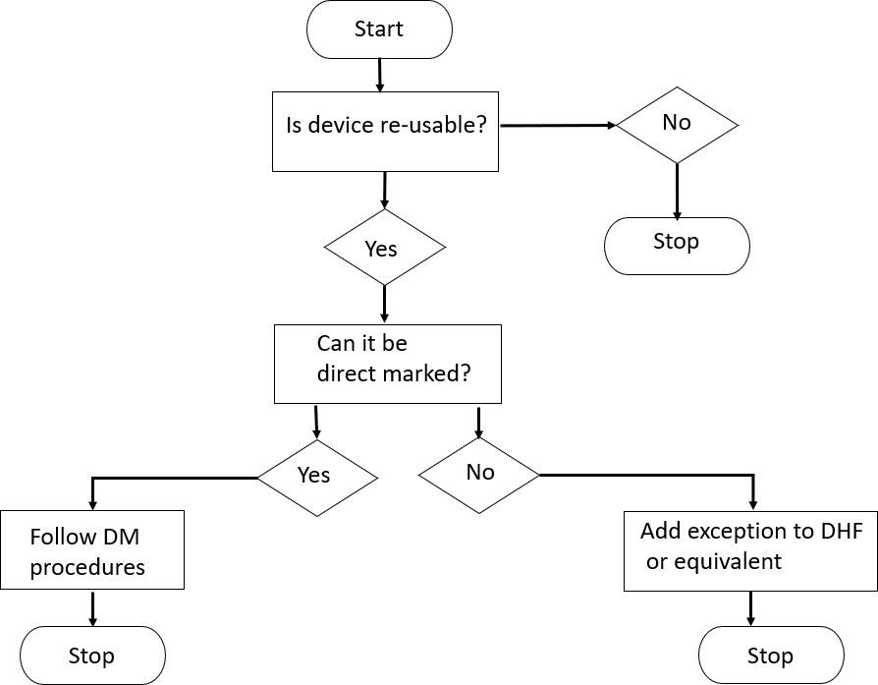

1. **Procedure**
   1. **General Requirements**

Products are marked with symbols and text for clear identification. Marking requirements may differ depending on the market country or region. The type of marking required may be machine readable (e.g. barcodes) and/or human readable interpretation plain text that can be read by a user with and without the use of reading aids. When possible, it is recommended that the entire identification mark be placed on a single surface location.

Direct Marking of product includes, but is not limited to the following elements (please review local procedures if applicable):

* + - UDI DM compliant marking:
      * Global Trade Item Number (GTIN) as well as Lot #, and/or Serial # as content of a 2D DataMatrix of type GS1 or as part of a GS1 compatible alphanumeric HRI.
    - CE Marking
    - Lot Number, and/or Serial Number
    - Date of manufacture (Production Date)
    - Expiration date
    - Article Number
    - Material Type (implants only)
    - Logo (Manufacturer)
    - (Product) System Information (e.g. DHS, PFN, UFN, UniLOCK, Click’X, USS, etc.)
    - Information of functional relevance for the user (e.g. pictograms, dimensions, etc.)

Marking of products shall be consistent with respect to the direct marking requirements for products regardless of their manufacturing location or manufacturer.

Whenever possible, marked content should be selected to fulfill the requirements of one global market – cumulative requirements of the USA and EMEA / AP / LAT markets. When this is not possible, single market specific marking would apply.

Additional marking requirements from local authorities shall be followed and added to the basic requirements. The use of characters of local language specific character fonts also comes under the heading additional marking requirements. The result thereof is always a product destined for one single specific market.

Exceptions:

The following are acceptable US FDA, EUMDR, US Customs and CE Notified Bodies exception reasons for not applying DM or CE Marking on a device:

|  |
| --- |
| Reason |
| Interfere with the Safety of the device |
| Technologically not feasible |
| The device has been previously marked (FDA only) |

The omission of UDI DM marking elements, and CE marks (with or without notified body ID), must be justified and documented in a Technical Review Protocol or Design History File (DHF) or Technical File. In the case of a family of parts, the justification must address each individual part.

# Direct Marking (DM) requirements US and EU:

Excerpts from the Direct Marking (DM) requirements from U.S. FDA and EU MDR regulations:

# Per 21 CFR. 801.45 Devices that must be directly marked with a unique device identifier:

1. *In general.* A device that must bear a unique device identifier (UDI) on its label must also bear a permanent marking providing the UDI on the device itself if the device is intended to be used more than once and intended to be reprocessed before each use.
2. *UDI for direct marking.* The UDI provided through a direct marking on a device may be:
   1. Identical to the UDI that appears on the label of the device, or
   2. A different UDI used to distinguish the unpackaged device from any device package containing the device.
3. *Form of a UDI when provided as a direct marking.* When a device must bear a UDI as a direct marking, the UDI may be provided through either or both of the following:
   1. Easily readable plain-text;
   2. Automatic identification and data capture (AIDC) technology, or any alternative technology, that will provide the UDI of the device on demand.
4. *Exceptions.* The requirement of paragraph (a) of this section shall not apply to any device that meets any of the following criteria:
   1. Any type of direct marking would interfere with the safety or effectiveness of the device;
   2. The device cannot be directly marked because it is not technologically feasible;
   3. The device is a single-use device and is subjected to additional processing and manufacturing for the purpose of an additional single use.
   4. The device has been previously marked under paragraph (a) of this section.
5. *Exception to be noted in design history file.* A labeler that decides to make use of an exception under paragraph (d of this section) must document the basis of that decision in the design history file required by 820.30(j)

# Per Office Journal of the European Union Regulation (EU) 2017/745, Annex VI Part C The UDI System:

4.10 Devices that are reusable shall bear a UDI carrier**\*** on the device itself. The UDI carrier for reusable devices that require cleaning, disinfection, sterilization or refurbishing between patient uses shall be permanent and readable after each process performed to make the device ready for the subsequent use throughout the intended lifetime of the device. The requirement of this Section shall not apply to devices in the following circumstances:

1. any type of direct marking would interfere with the safety or performance of the device
2. the device cannot be directly marked because it is not technologically feasible.

4.11 The UDI carrier shall be readable during normal use and throughout the intended lifetime of the device.

* 1. Reusable devices requiring cleaning, disinfection, sterilization, or refurbishing between uses.
     1. The UDI of such devices shall be placed on the device and be readable after each procedure to make the device ready for the next use

**\*** UDI carrier encompasses AIDC and HRI information

# Placement of Marking

The markings must be placed so as not to interfere with the effectiveness or safety of the device or any other product risk on the device. It is the responsibility of product development to evaluate the effect of the markings on the device substrate with regards to mechanical use/material/design etc. and to document their findings, see 6.11 – Direct Marking Elements for UDI.

Per the GS1 Guidelines: “It is recommended to have Human Readable Interpretation of the Application Identifiers (AIs) and their associated data near the GS1 DataMatrix Symbol in which they are encoded. The precise location and font used for the Human Readable Interpretation

are determined by the specific application guidelines. Typical conventions place the primary information, such as the Global Trade Item Number (GTIN), in the human readable data underneath the barcode. The characters, however, should be clearly legible and must be obviously associated with the symbol.”

# CE Marking

Whilst the CE Mark isn’t a UDI requirement, the following table outlines the CE Marking requirements (Refer to your local operating procedures regarding size and location of CE marking and Notified Bodies).

|  |  |  |  |  |
| --- | --- | --- | --- | --- |
| **MDD**  **Class** | **MDR**  **Class** | **CE Mark** | | **Product** |
| **CE**  **Symbol** | **Notified Body ID Number** |
| (e.g. 0123) |
| **I** | **I** | ● | **-** | trays, cases incl. modules |
| **I** | **I** | ● | **-** | Instruments |
| **I** | **I r** | ● | ●* | reusable instruments |
| **I s** | **I s** | ● | ● | sterile instruments |
| **I m** | **I m** | ● | ● | Instruments with scaling/measuring function |
| **II a** | **II a** | ● | ● | power tools, attachments and power tool operated instruments |
| **II b** | **II b** | ● | ● | Implants |
| **III** | **III** | ● | ● | e.g. bio-resorbable product |

* Per EU Regulation 2017/745 (MDR), class I r (reusable devices) must consist of both the CE mark and the notified body ID number.

# Marking Process

Identification marking of product is typically done through acid etching, engraving, printing, coloring, laser marking or etching or other suitable processes. All processes used for markings are subject to current local operating company specific process and work instructions. The processes used must not have a negative impact on product safety and must be proven by risk management as acceptable.

# Specifications

The appropriate process for applying marked symbols and identifications is determined with regards to legibility, durability, material and surface area properties. In certain cases, the final determination of the procedure can only be made after successful completion of special tests (e.g. clinical reprocessing, etc.). Direct Marking of reusable devices for UDI purposes is expected to last throughout the service life of the device. The following end of life indicators will assist the user in determining whether the device can no longer function as intended: visual, functional or performance criteria. Additional information can be found in Section 6.18 Service Life Requirements for 2D DataMatrix.

# Font

To maximize legibility, it is recommended to use serif-free (sans-serif) font types.

Helvetica is one of five font types defined by DIN 1451-1 and DIN 30640. The five DIN font types are copyright protected and are therefore only supported in a limited fashion by CNC software for milling and laser etching. If none of the licensed font types are available, the following font types may also be used:

* Linear-Antiqua,
* OCR B or F
* Arial or Arial Narrow
* Frutiger (45 / light, 65 / bold),
* Helvmed, 1451B (Trumpf) and D1451 (Rofin) as machine manufacturer specific copies of the font Helvetica per DIN 1451.

Whenever possible, include, at a minimum a single line width of white space between characters.

The use of a font type not listed above must be approved by Product Development (PD/R&D) prior to its use.

In addition to the font type, a line weight is designated i.e. normal or bold. Normal is the default line weight, unless otherwise specified.

# Readability

HRI easily readable plain text is defined as a text that a person with normal or corrected eyesight without additional magnification can read at distances between 20cm and 40cm (7.5” and 15.5”). The minimum plain text height of the UDI marking on a medical device shall be 1mm (0.0393”). To improve readability, a 3mm (0.118”) font height should be targeted.

Local operating companies may have work instructions that contain information regarding legibility requirements for HRI easily readable plain text, company logos, and special characters. In these cases the local work instructions should be consulted and they are the governing source for readability requirements.

# Orientation of Marking on Round Parts

In the absence of local work instructions or procedures for Direct Marking, the following guidance should be used:

1. Longitudinal markings should be centered and located along the longitudinal axis of the part, in single or multiple lines. The font height on the longitudinal axis should not exceed 50% of the diameter.
2. Circumferential markings should be placed symmetrically around the longitudinal axis.
3. Place the markings on the largest diameter of cylindrical parts, unless functional constraints dictate otherwise.
4. For limitations when marking 2D DataMatrix, see section 6.16 Placement of Matrix. See Fig.1 for examples of cylindrical markings

**Fig.1**

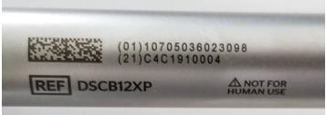

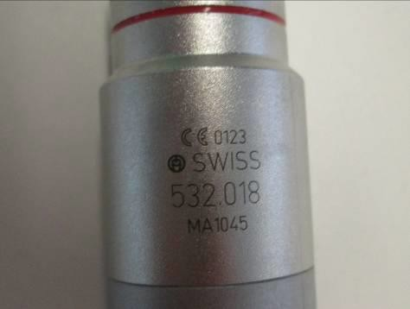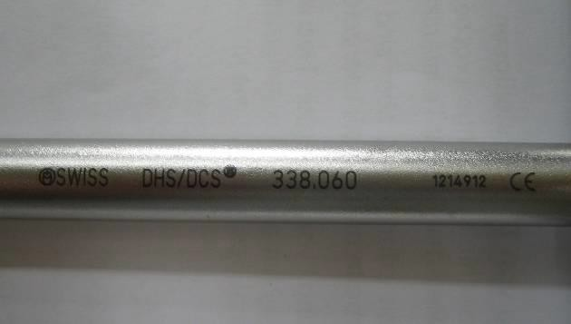

# Orientation of Marking in General

In the absence of local work instructions or procedures for Direct Marking, the following guidance should be used.

The identification marks or text must be legible when the device is held in the right hand in such a way that the device is pointing to the left (i.e. the “right hand rule”).

No allowance is required for holding the part in the left hand, with regard to orientation of marking (implants such as left and right hip replacements for example may not follow this rule).

For examples of the “right hand rule”, see **Fig. 2**

## Fig. 2

|  |  |  |
| --- | --- | --- |
| TiefenmesserHand |  | ZangeHand |

The marking on the top of a screw head must be legible from the outside to the center. See **Fig. 3.**

## Fig. 3

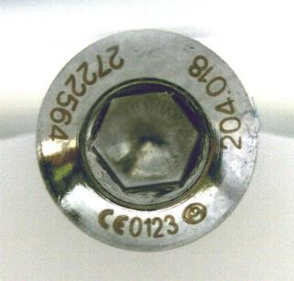

If your local operating company has work instructions that contain information regarding placement and orientation of markings, they should be consulted.

# Direct Marking Elements for UDI

The FDA and MDR require UDI information on all medical device products that are intended for sale on the US and EU markets, respectively, for those medical devices that are re-usable, the UDI information must be marked directly on the product itself, by Direct Marking (DM).

The addition of DM information to implants is recommended, but not mandatory. Implants are exempt from DM, but nevertheless they must be identifiable at the point of implantation.

For FDA requirements, the UDI information must be applied in AIDC format, either in the form of a GS1 ECC200 compatible 2D DataMatrix, RFID, or in the form of a GS1 compatible Human Readable Interpretation text.

For MDR requirements, all reusable devices within the scope section of this work instruction must include the AIDC format in the form of a GS1 ECC200 compatible 2D DataMatrix and GS1 compatible Human Readable Interpretation text.

The UDI information consists of the following data elements: Device Identifier (DI) GTIN (Global Trade Item Number) and Production Identifier (PI) Lot # and/or Serial #. The individual elements are identifiable through a leading Application Identifier (AI) in parenthesis.

The field contents of the data elements (AIs) comes from the production order (router or purchasing order).

|  |  |  |
| --- | --- | --- |
| **Product Class** | **Data Elements** | |
| **Minimum for DM** | **Recommendation for Best Practice** |
| I | GTIN (FDA)  GTIN + Lot # or Serial # (MDR) | GTIN + Lot # or Serial # |
| II, IIa and IIb | GTIN + Lot # or Serial # | GTIN + Lot # or Serial # |
| III | GTIN + Lot # or Serial # | GTIN + Lot # or Serial # |

**Note:** FDA product classification does not necessarily match MDR product classification. All MDR instrument classifications require a DI and PI.

|  |  |  |
| --- | --- | --- |
| **Application Identifier (AI)** | **Data Definition / Type** | **Number of Characters of Data Content*3** |
| 01 | GTIN (DI) | 14 1*) |
| 10 | Lot # (PI) | max.10 2*) |
| 21 | Serial # (PI) | max.10 2*) |

1* Purely numeric

2* Alphanumeric with a maximum of 3 alpha characters (capital characters only) when maximum number of characters reached.

3* Matrix sizes 12x26 & 18x18 may have capacity issues when utilizing larger LOT or Serial number sequences.

Refer to GS1 General specifications for special characters.

# GS1 2D DataMatrix

Terminology used for 2D DataMatrix

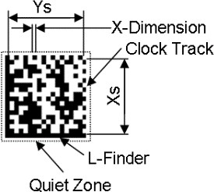

|  |  |
| --- | --- |
| Term | Description |
| Matrix Size | The size of the Matrix as a multiple of a Module and consisting of the Data Region including L-Finder and Clock Track width. |
| Data Region | Area within a Matrix which effectively contains the coded data; the area is described by its run length in number of Modules in X and Y direction – XsxYs. |
| Module | The smallest geometric entity/element within a Matrix; a Module may have a square or a round shape; a dark module represents a binary 1 and a white one a binary 0. The size of a module is defined by the X-Dimension. |
| X-Dimension (X-Module) | Edge length of a square or diameter of a round Module. |
| L-Finder | Defines the size of the Data Region; the width of the L-Finder is 1 Module. |
| Clock Track | Defines the Module density of the Data Region; the width of the Clock Track is 1 Module. |
| Quiet Zone | Area all around the 2D DataMatrix element which must be free of any visually disruptive elements; the width of the Quiet Zone must be at least 1 Module. |
| ECC 200  Identifier | A Zero Module (empty or white Module) in the right upper edge of the Matrix. |
| FNC1  Character | Per ECC 200, 2D DataMatrix must have a leading FNC1 character in the code to indicate that the Matrix is a GS1 compatible one. FNC1 is a special, non- printable, character. Depending on the system, a two-byte control character from an extended ASCII character set (Double Byte Character Set or DBCS) is used for that purpose – Microsoft or IBM systems. |

For additional information regarding the 2D DataMatrix, refer to the latest version of GS1 general specifications and GS1 DataMatrix Guidelines.

# Matrix Sizes Used

|  |  |  |  |  |  |  |
| --- | --- | --- | --- | --- | --- | --- |
| **Type** | | **Matrix Size**  (XxY) | **Data Region**  (Data Area Size)  (XsxYs) | **Maximum Data Capacity** | | **X-Dimension Range**  (Module Size Range) |
| Num. | Alpha- num. |
|  |  | **18x18** 4*) | D16x16 | 36 | 25 | 0.1 – 0.3 |
| Square |  | 20x20 | D18x18 | 44 | 31 |
|  |  | 22x22 | D20x20 | 60 | 43 |

|  |  |  |  |  |  |  |
| --- | --- | --- | --- | --- | --- | --- |
|  |  | **12x26** 4*) | D10x24 | 32 | 22 |  |
| Rectangular |  | 12x36 | D10x32 3*) | 44 | 31 |
|  |  | 14x36 | D12x32 3*) | 64 | 46 |
| (Shape) | | [ModulexModule] 5*) | [ModulexModule] | [Digit] 1*); 5*) | | [mm] 2*) |

Additional information for matrix sizes can be found in Appendix 2.

## Notes:

1*) The maximum number of digits the code can consist of; the requirements per numeric character are 1 digit and per alpha character 2 digits.

2*) The X-dimension may be used in 0.05mm increments.

3*) Split into two data areas.

4*) Minimum matrix sizes which can handle the data required by UDI DM minimum requirements in most cases; Exception: The matrix size 12x26 will reach maximum capacity if the LOT or Serial numbers are more than 10 characters including one alpha numeric (each alpha numeric counts as 2)

5*) Where the current data capacity no longer meets the demand (e.g. because an additional data element is needed) refer to GS1 General Specifications from [www.GS1.Org.](http://www.GS1.Org/)

# Space Requirements

|  |  |  |  |  |  |  |
| --- | --- | --- | --- | --- | --- | --- |
|  | **Matrix Size**  (XxY) | **Minimum Required Space for Matrix Types per Module Size** (= X-Dimension in mm)  **and including Quiet Zone**  (XmxYm) | | | | |
| **X-Dimension**  2*) |  | 0.3 | 0.25 | 0.2 | 0.15 | 0.1 3*) |
| **Square Type** | **18x18**  **1*)** | 6mmx6mm (0.236”x0.236”) | 5mmx5mm (0.196”x0.196”) | 4mmx4mm (0.157”x0.157”) | 3mmx3mm (0.118”x0.118”) | 2mmx2mm (0.0787”x0.0787”) |
| 20x20 | 6.6mmx6.6mm (0.259”x0.259”) | 5.5mmx5.5mm (0.216”x0.216”) | 4.4mmx4.4mm (0.173”x0.173”) | 3.3mmx3.3mm (0.129”x0.129”) | 2.2mmx2.2mm (0.0866”x0.0866”) |
| 22x22 | 7.2mmx7.2mm (0.283”x0.283”) | 6mmx6mm (0.236”x0.236”) | 4.8mmx4.8mm (0.188”x0.188”) | 3.6mmx3.6mm (0.141”x0.141”) | 2.4mmx2.4mm (0.0944”x0.0944”) |
| **Rectangular Type** | **12x26**  **1*)** | 4.2mmx8.4mm (0.165”x0.330”) | 3.5mmx7mm (0.137”x0.275”) | 2.8mmx5.6mm (0.110”x0.220”) | 2.1mmx4.2mm (0.0826”x0.165”) | 1.4mmx2.8mm (0.0551”x0.110”) |
| 12x36 | 4.2mmx11.4mm (0.165”x0.448”) | 3.5mmx9.5mm (0.137”x0.374”) | 2.8mmx7.6mm (0.110”x0.299”) | 2.1mmx5.7mm (0.082”x0.224”) | 1.4mmx3.8mm (0.0551”x0.149”) |
| 14x36 | 4.8mmx11.4mm (0.188”x0.448”) | 4mmx9.5mm (0.157”x0.374”) | 3.2mmx7.6mm (0.125”x0.299”) | 2.4mmx5.7mm (0.0944”x0.224”) | 1.6mmx3.8mm (0.0629”x0.149”) |

## Notes:

1*) Preferred sizes

2*) Wherever possible, always go for the biggest module size

3*) Use in special situations, only

# GS1 Size Requirements for 2D DataMatrix

Johnson & Johnson will follow the direct marking size requirements specified in the most current revision of the GS1 General Specification – Direct Part Marking. The size of the X-dimension for 2D bar codes will be from 0.100mm (0.0039”) to 0.300mm (0.0118”) for all medical devices such as small medical/surgical instruments.

In the situation where only the 0.1mm (0.0039”) X-dimension barcode size will work, it is recommended to evaluate the capability of the barcode verifier, scanner equipment and laser technology on a case by case basis to ensure they will be readable by end users and write an exception based on technological feasibility if necessary.

**Note:** See Appendix 1 and 2 for additional information regarding size requirements

# Placement of Matrix:

Determine the biggest suitable area for the application of the 2D DataMatrix while considering criteria such as flatness, finish, possible stress concentration zones, already defined “no etching permitted” zones and existing or placed marking elements.

Except for information of functional relevance, already placed marking elements may be relocated.

Where possible and if space is available, align 2D DataMatrix to other elements of marking.

A possible curvature of the area of placement must meet both the requirements of the marking process as well as the one of the reading process.

When marking a curved surface, the DataMatrix should be limited in size to approximately 1/6 of the diameter of the curvature. A rectangular DataMatrix is most suited to this type of application. If the surface can be treated to have matte or textured finish, which reduces the reflectivity of the surface being marked, it is possible to further increase the size of the DataMatrix being marked. For example, the matte or textured finish diminishes the effect of the intense light bar apparent in the illustration below which the rectangular DataMatrix is designed to sit within, thus ensuring a consistent contrast across the complete surface of the DataMatrix.



Rectangular DataMatrix within 1/6 of the diameter of curvature

# Reading and Grading Requirements for 2D DataMatrix

Johnson & Johnson will follow the grading requirements specified in the most current revision of GS1 General Specification, which also references ISO/IEC 15415 and ISO/IEC 29158.

Per GS1, there are 4 general categories for grading bar codes, 0, 1, 2 and 3. The following guideline may be used to help determine which category a particular device may belong.

**Category 0** – A printed label. Any general bar code scanner should be sufficient to read category 0 bar codes.

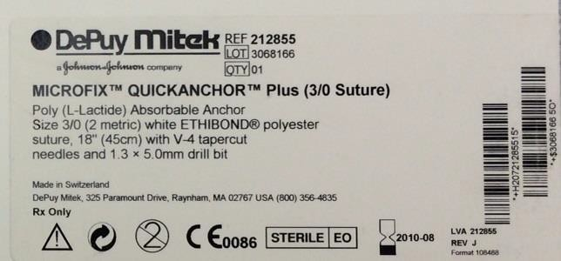

**Category 1** – Devices which are considered easy to read in the field of a healthcare setting using a normal or typical standard scanner. The devices may require some orientation to scan and would include a mix of environment labels and DM. These would typically be a DM quality scanner.

Examples may include name plates on capital equipment and flat non-reflective reusable instruments with larger size X-dimensions.

|  |
| --- |
|  |
| image001 |

**Category 2** – Devices which require special lighting such as in a repair facility because of curved surfaces, very low contrast, highly textured, etc.

These types of devices are not normally expected to be read in the field and are expected to require reorientation to read.

Examples may include DM on curved reflective surfaces and small size bar codes that may not be easy to identify on products.



**Category 3** – This includes parts which cannot pass the grading specification because the marking method and substrate cannot be modified to pass, for example a highly reflective

surface on a trauma plate is considered a difficult surface for an extreme environment and would require access to special lighting to be able to read.

Due to the level of difficulty to read category 3 devices in a normal scanning environment such as central processing or an operating room, devices considered to be category 3 shall be considered not technologically feasible and the justification of a device determined to be category 3 should be documented in the device DHF and/or TF as applicable and is out of scope for direct part marking.



Additional information with regards to verification and grading of 2D barcodes can be found in the 2D DM technical specification.

# Service Life Requirements for 2D DataMatrix

Due to FDA and MDR requirements, when the 2D barcode can no longer be scanned and read (the AIDC portion of the direct mark is no longer readable), the device will be considered at the end of its service life.

Refer to J&J franchise level work instructions and local operating company work instructions for how to determine service life for products and how to test 2D barcodes to ensure proper service life of the devices.

The following end of life indicators will assist the user in determining whether the device can no longer function as intended: Visual, functional or performance criteria. If the product has an IFU or e-IFU, these may also contain end of life indicators.

Products which utilize nameplates with UDI information including a 2D DataMatrix barcode and are only subject to wipe down cleaning between cases vs. cleaning and sterilization in central processing, are exempt from life cycle testing since they will not be subjected to processes such as high pH cleaning solutions and steam autoclave.

# Customer Requirements for Scanning of 2D Bar Codes

To date, many hospitals are not well equipped to scan and read direct marked devices. Many of the hospital scanners are designed primarily to read paper labels, prescription drug bottles and patient identification bracelets.

Healthcare providers should only use DM quality (direct mark quality) barcode scanners to read 2D barcodes on reusable instruments.

By verifying the barcodes and achieving an acceptable grade in accordance with GS1 and ISO/ IEC 29158 standards, J&J meets the requirements for Direct Marking.

# GS1 Human Readable Plain Readable Text Code Element

FDA allows the HRI text of the UDI information to be applied on a product in place of, or in addition to a 2D DataMatrix. EU requires both 2D and HRI.

In HRI easily readable plain text form, the data elements are shown in single or multiple lines and with leading Application Identifiers (AI’s) in parenthesis. The data elements belonging to HRI must be placed next to each other, one after the other or one below the other.

If the marking of the Device Identifier (DI) and Production Identifier (PI) onto a reusable device as HRI plain text cannot be grouped, their spatial separation is allowed. If, due to spatial constraints, the DI cannot precede the PI, their sequence can be inverted.

Below are the recommended, preferred allowed and acceptable allowed illustrative examples of HRI marking types:

|  |  |  |
| --- | --- | --- |
| ***Recommended*** | ***Preferred Allowed*** | ***Acceptable allowed (if recommended/preferred allowed not possible)*** |
| Default Linear | Default Stacked | Separated |
| (01)12345678901234(10)1234567 | (01)12345678901234  (10)1234567 | (01)12345678901234  (10)1234567 |

The following illustrative examples of human readable marking types are **not** allowed.

|  |  |
| --- | --- |
| ***Not Allowed*** | ***Not Allowed*** |
| Linear | Stacked |
| (10)1234567(01)12345678901234 | (01)12345678901  234(10)1234567 |

## 2D DataMatrix Symbols and Plain Text Options

|  |  |  |
| --- | --- | --- |
| **2D DataMatrix** | **Encoded format1** | **Plain-Readable Text 2** |
|  | ]d201107053712345221ABCD1234 | (01)1070537123452 (21)ABCD1234 |
|  | ]d201107053712345221ABCD1234 | (01)1070537123452(21)ABCD1234 |

**Notes:**

1. Barcode verification output of the transmitted data string. Rectangular and square GS1 DataMatrix symbols with identical UDI have identical encoded data.
2. The parentheses displayed in plain readable text form are used to separate the Application Identifier value from the data. Parentheses must NEVER be encoded in the barcode.

# Direct Marking of Product Produced by Non-J&J Manufacturers

For products where J&J functions only as distributor, the responsibility to meet FDA’s and EU MDR requirements regarding UDI remains with their legal manufacturer.

1. **Reference Documents**

|  |  |
| --- | --- |
|  | |
| Number | Title |
| External Standard and/or Shared Document(s) | |
| 100782225 | J&J 2D Direct Marking Technical Procedure shared |
| TV-QTS-00020 | J&J UDI Policy |
| 21 CFR | Code of federal regulations, title 21 |
| DIN 1451-1 | Lettering; Linear Antiqua without Serifs - General |
| MDR 2017/745 | Medical Device Regulation for EU replacing MDD 93/42/EEC |
| GS1 General Specifications | [www.gs1.org](http://www.gs1.org/) (use latest version) |
| GS1 DataMatrix Guidelines | [www.gs1.org](http://www.gs1.org/) (use latest version) |
| ISO/IEC 15415 | Automatic Identification and Data Capture techniques – Bar code symbol print quality test specification – 2 dimensional symbols |
| ISO/IEC 29158 | Automatic Identification and Data Capture techniques – Direct Part Mark (DPM) quality guideline |
| EN 980 | Graphical Symbols for the use in Labeling of Medical Devices |
| EN ISO 14971 | Medical Device – Application of Risk Management to Medical Devices |
| WI-3226 | DEPUY SPINE - DRAFTING/DESIGN STANDARDS |
| 103107449 | DPM-UDI – Direct Part marking Requirement for Reusable Devices and Instruments |
| SE_037727 | Marking of Products |
| Quality System: Ethicon | |
| Not Applicable | Not Applicable |
| Quality System: Ethicon Endo Surgery (LLC / INC) | |
| Not Applicable | Not Applicable |
| Quality System: Biosense Webster (BWI) | |
| Not Applicable | Not Applicable |
| Quality System: Megadyne | |

|  |  |
| --- | --- |
| Not Applicable | Not Applicable |
| Quality System: NeuWave | |
| Not Applicable | Not Applicable |
| Quality System: Cerenovus | |
| Not Applicable | Not Applicable |
| Quality System: DePuy | |
| Not Applicable | Not Applicable |
| Quality System: Synthes | |
| Not Applicable | Not Applicable |
| Quality System: Omrix | |
| Not Applicable | Not Applicable |

1. **Appendices**

|  |  |
| --- | --- |
| Appendix Number | Appendix Title |
| 1. | Additional information for size requirements |
| 2. | Matrix size options for marking square and round parts |

1. **Additional information for size requirements**

**Below table taken from GS1 General Specifications V20. Jan 2020, later versions maybe available.**

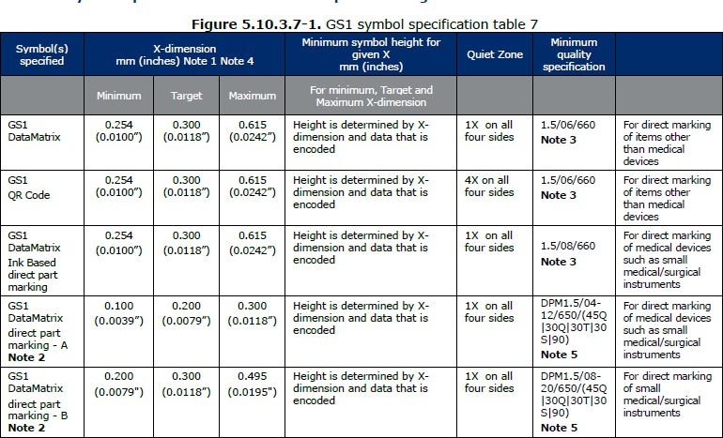

**Note:** The largest X-dimension in a given range that will allow a symbol with the needed data content to fit within the available marking area should be used to maximise marking and reading performance (depth of field, tolerance to curvature, etc.).

The angle is an additional parameter defining the angle of incidence (relative to the plane of the symbol) of the illumination for direct part marking verification. It SHALL be included in the overall symbol grade when the angle of incidence is other than 45 degrees. Its absence indicates that the angle of incidence is 45 degrees. See ISO/IEC 15415 and ISO/IEC TR 29158 (AIM DPM).

In small instrument marking, mixed marking technologies used within the same scanning environment should be avoided to ensure highest reading performance. Laser etching is recommended for small instrument marking.

**Note 1:** Optical effects in the image capture process require that label based GS1 DataMatrix and GS1 QR Code symbols be printed at approximately 1.5 times the equivalent X-dimension allowed for linear symbols in the same application.

**Note 2:** There are two basic types of non ink based direct part marks, those with “connected modules” in the “L” shaped finder pattern (GS1 DataMatrix direct part marking – A) created by DPM marking technologies such as laser or chemical etching and those with “non connected modules” in the “L” shaped finder pattern (GS1 DataMatrix direct part marking – B) created by DPM marking technologies such as dot peen. Due to the marking technologies and characteristics of reading they each have varied ranges of X-dimensions and different quality criteria recommended and may require different reading equipment. GS1 DataMatrix – A is suggested for marking of medical devices such as small medical/surgical instruments. The Minimum X-dimension of 0.100mm is based upon the specific need for permanence in direct marking of small medical instruments which have limited marking area available on the instrument with a target useable area of 2.5mm x 2.5mm and a data content of GTIN (AI 01) plus serial number (AI 21).

**Note 3:** The effective aperture for GS1 DataMatrix and GS1 QR Code quality measurements SHOULD be taken at 80 percent of the minimum X-dimension allowed for the application. For direct part marking - A this would equate to an aperture of 3; for direct part marking – B this would equate to an aperture of 6 and for general healthcare label printing, an aperture of 8. See *ISO/IEC 15415* and *ISO/IEC TR 29158*.

**Note 4:** In practical application, where very small symbol sizes are needed, it may be necessary to work with GS1 DataMatrix module X-dimensions smaller than those suggested. Where dimensional restrictions prohibit the application of a full size code, reduced X-dimension AIDC marking is encouraged to facilitate information capture. It should be noted that these practices may limit the symbol effectiveness, including but not limited to:

* the effect of smaller X-dimensions on reading performance,
* the need for, and limited availability of, special scanners/imagers for reading,
* special processes for marking,
* the overall cost considerations.

These smaller X-dimensions should therefore only be used internally or by mutual agreement between trading partners.

**Note 5:** Any “GS1 DataMatrix direct part marking – A” mark that meets the grade requirements under the quality techniques specified in *ISO/IEC 15415* is considered acceptable. If the letters “DPM” precede the grade it indicates that the grade was obtained by following *ISO/IEC TR 29158 (AIM DPM)* and not *ISO/IEC 15415*, regardless whether it is GS1 DataMatrix direct part marking of type A or B.

1. **Matrix size options for marking square and rectangular parts**

|  |  |  |  |  |  |
| --- | --- | --- | --- | --- | --- |
| **Preferred Option** | **Dot Size** | **Matrix** | **Shape** | **Size of 2D** | **Selection Condition** |
| 1 | 0.2mm (0.0078”) | 18x18 | Square | 4mmx4mm (0.157”x0.157”) | Most preferred option if space permits.  For surface selection in a part for 2D DM, following is the preferred order. Flat > Curved-Cylindrical > Curved-Spherical > Curved-Others.  [Note: For curved surface, the diameter of curvature should be greater than **24mm (0.944”)** (6 times 2D size) |
| 2 | 0.2mm (0.0078”) | 12x26 | Rectangular | 2.8mmx5.6mm (0.110”x0.220”) | If Option 1 is not feasible due to space limitation or if the diameter of curvature is less than **24mm (0.944**”) but greater than **16.8mm (0.661”)** (6 times 2D size) |
| 3a | 0.15mm (0.0059”) | 18x18 | Square | 3mmx3mm (0.118”x0.118”) | If Option 1/2 is not feasible due to space limitation |
| 3b | 0.15mm (0.0059”) | 12x26 | Rectangular | 2.1mmx4.2mm (0.082”x0.165”) | If Option 1/2 is not feasible due to space limitation or if the diameter of curvature is less than **16.8mm (0.661”)** but greater than **12.6mm (0.496”)** (6 times 2D size) |
| 4a | 0.1mm (0.0039”) | 18x18 | Square | 2mmx2mm (0.078”x0.078”) | If Option 1/2/3a/3b is not feasible due to space limitation |
| 4b | 0.1mm (0.0039”) | 12x26 | Rectangular | 1.4mmx2.8mm (0.0551”x0.110”) | If Option 1/2/3a/3b is not feasible due to space limitation or if the diameter of curvature is less than **12.6mm (0.496”)** but greater than **8.4mm (0.330”)** (6 times 2D size) |