- Creating and Renaming Files/Directories
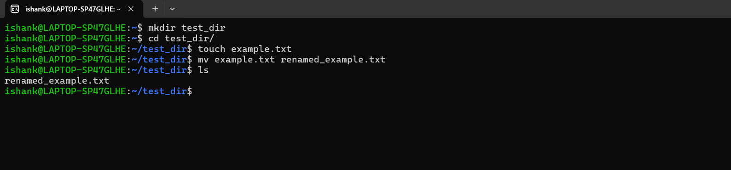
Explanation –
  - mkdir test_dir - create a new directory named test_dir.
  - cd test_dir - change working directory to test_dir.
  - touch example.txt - creates a new empty file called example.txt inside the current folder.
  - mv example.txt renamed_example.txt - rename the file: example.txt → renamed_example.txt mv command is used for moving files, and it can also rename files.

- Viewing File Contents
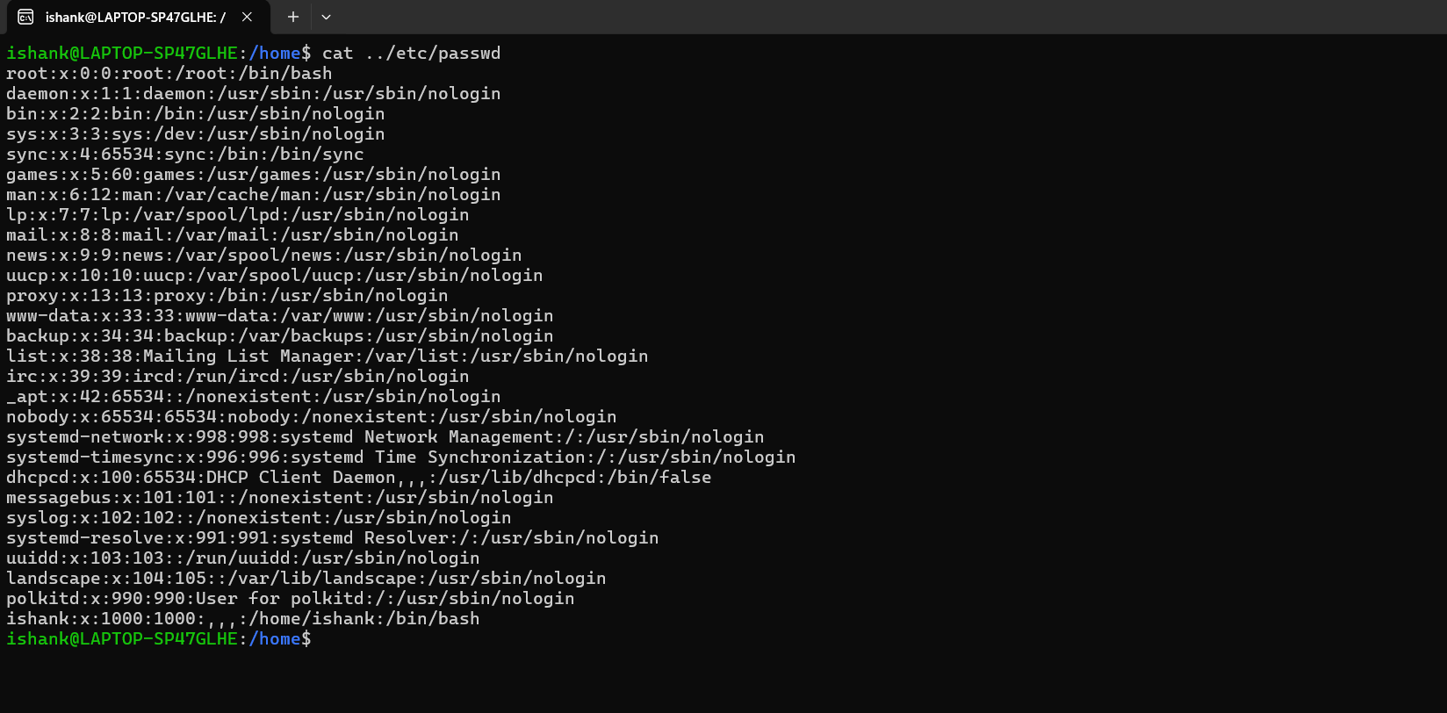
Explanation –
  - cat /etc/passwd - cat prints the entire contents of the file.
  - head -5 /etc/ passwd - show first 5 lines the file.
  - tail -5 /etc/shells - show last 5 lines the file.

- Searching for Patterns
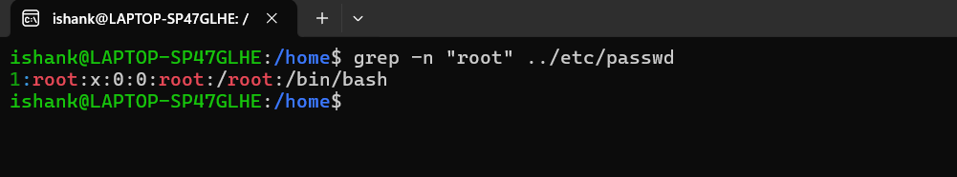
Explanation –
  - grep -n "root" /etc/passwd - is checking the file for the presence of "root" and show line numbers along with matching lines.

- Zipping and Unzipping
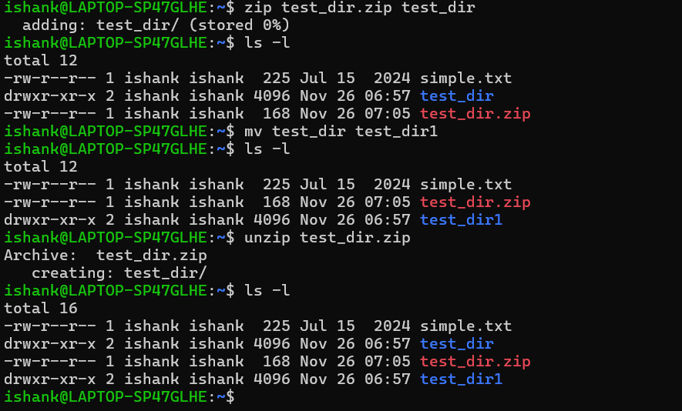
Explanation –
  - zip test_dir.zip test_dir - Creates a file named test_dir.zip
  - unzip test_dir.zip - restores the original directory name contained inside the ZIP.

- Downloading Files
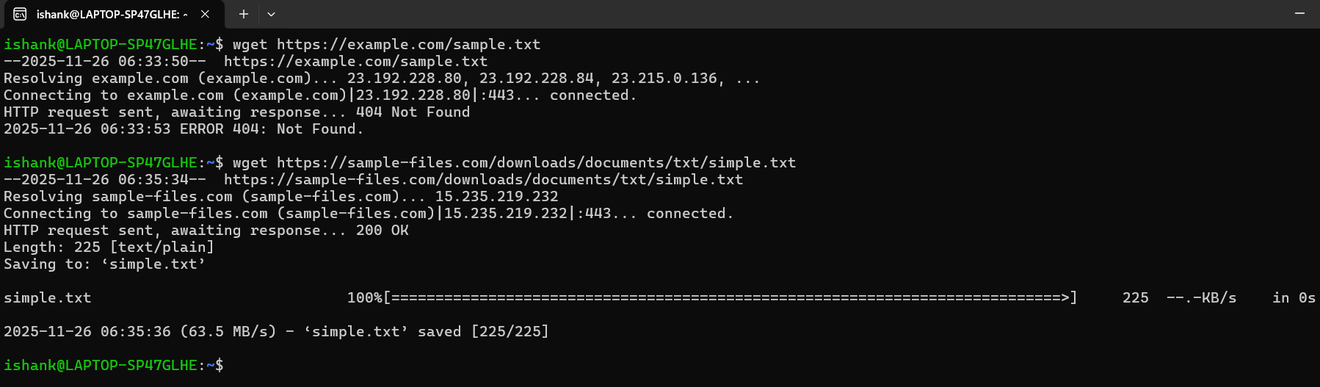
Explanation –
  - wget https://sample-files.com/downloads/documents/txt/simple.txt - tried to download sample.txt from https://sample-files.com/downloads/documents/txt/, Connection to the server succeeded and File exists and is downloaded.

- Changing Permissions
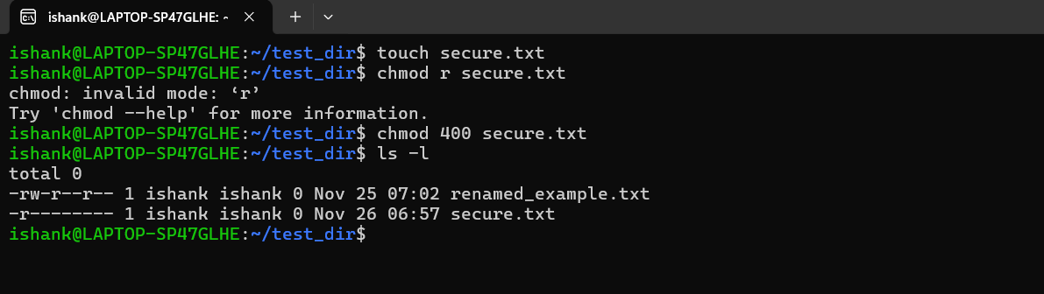
Explanation –
  - touch secure.txt & chmod 400 secure.txt - created an empty file named secure.txt in the current directory, sets permission mode 400 on secure.txt i.e. read only.

- Working with Environment Variables
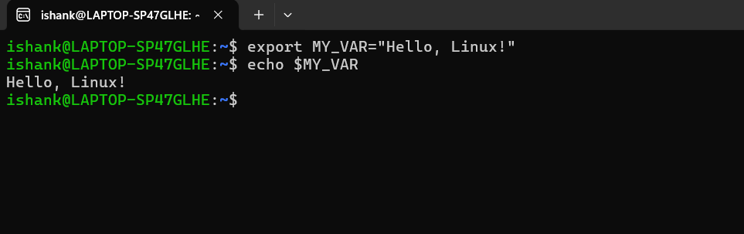
Explanation –
  - export MY_VAR="Hello, Linux!" - creates an environment variable and available to all child processesnamed MY_VAR and sets its value to "Hello, Linux!"
  - echo $MY_VAR - print the value stored in the variable MY_VAR.

