- Create a new GitHub repository.
- Clone the repository to your local machine using SSH (generate an SSH key if needed, add the public key to your GitHub account).
- Create a new branch named after your username (e.g., Tutedude).
- Add your Flask project files to this branch.
- Commit the changes and merge the branch into the main branch.

Adding SSH keys to the Github
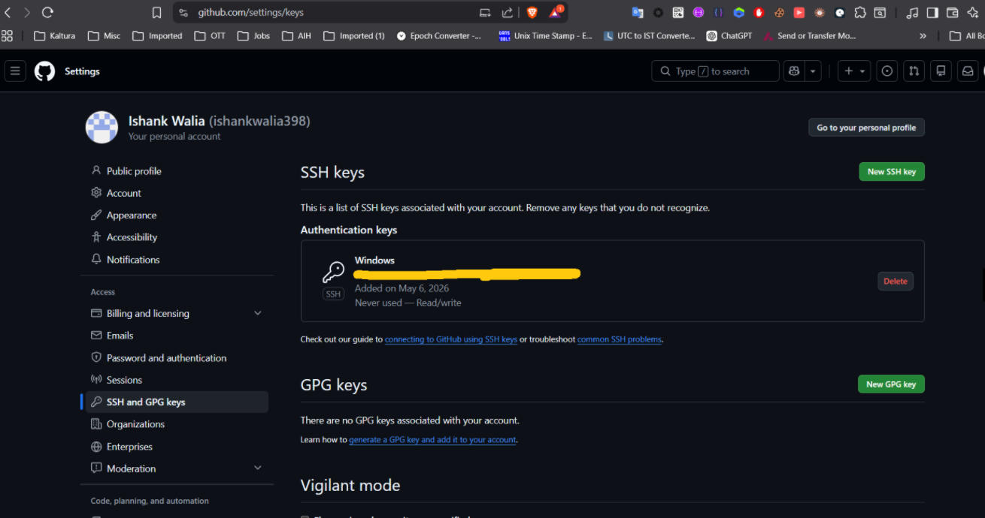

Cloning the repository to local machine
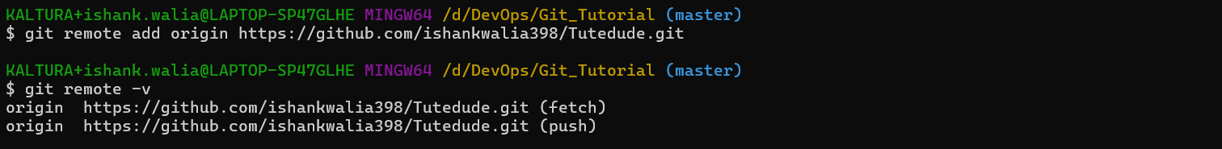

Created a new branch and switch to new branch
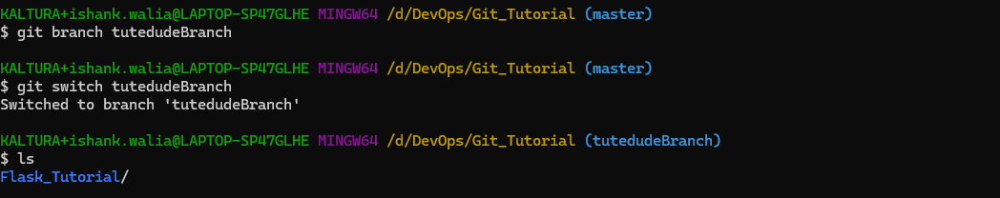
Added the flask project files to this branch and commit
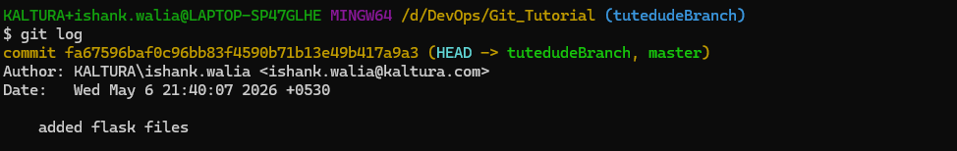
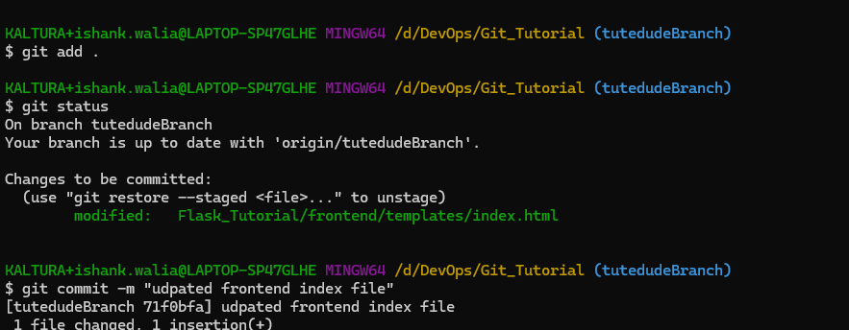

Merging the branch into the main branch
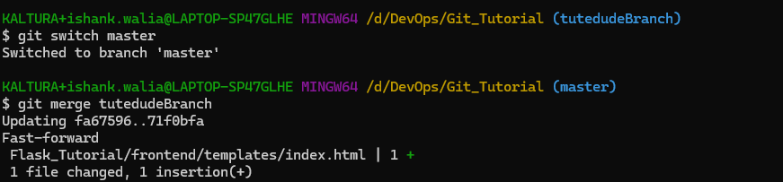

2. Create a new branch named <your_name>_new (e.g., Tutedude_new).
- Update the content of the JSON file used for the /api route in this branch.
- Merge the <your_name>_new branch into the main branch.
- If there are conflicts during the merge, resolve them by accepting the changes from the <your_name>_new branch.
- Add the resolved changes to the staging area, commit them, and push the updates to the remote repository.

Created a new branch and switch to new branch
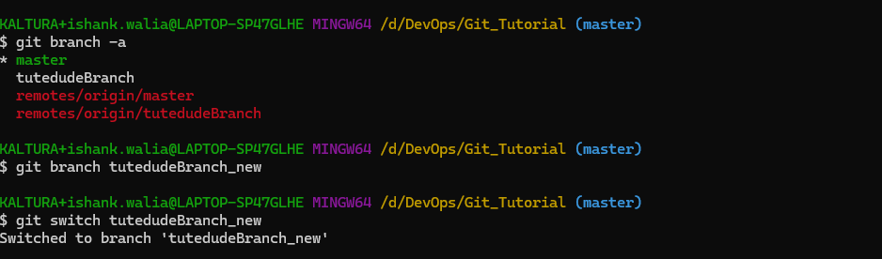

Updated the content in the frontend app.py file (added the print line)
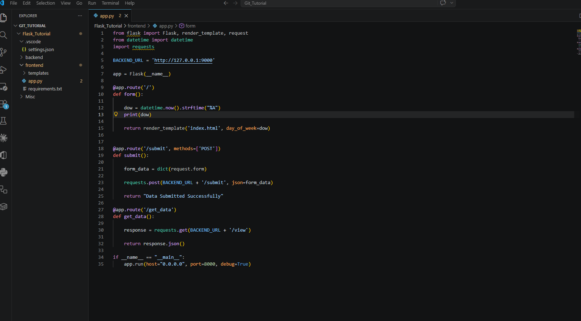

Merging the new branch into the main branch
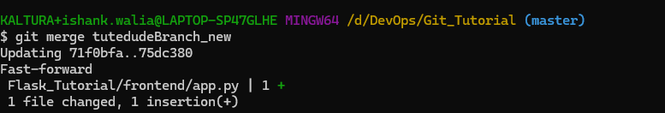

Staging the changes done, then committing and finally pushing the updates to the remote repository
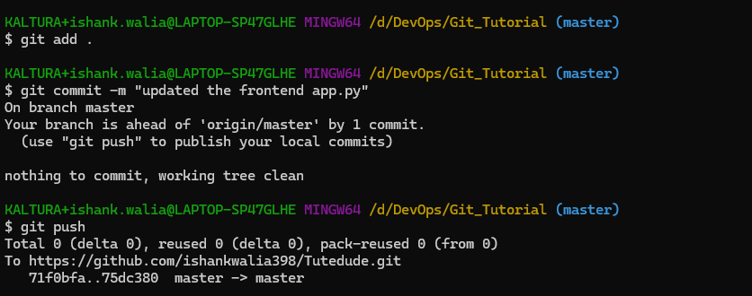

3. Branch Creation:
- Create two branches: master_1 and master_2 from the main branch.
- Feature Development in master_1:
- In the master_1 branch, create a To-Do Page in the frontend.
  - The page should contain a form with the following fields:
    - Item Name
    - Item Description
- Backend API in master_2:
- In the master_2 branch, create a backend route named /submittodoitem.
- This route will:
  - Accept itemName and itemDescription via a POST request.
  - Store these details in a MongoDB database.
- Merging Changes:
- Merge the changes from both master_1 and master_2 into the main branch.

Created 2 new branches (master_1 & master_2)
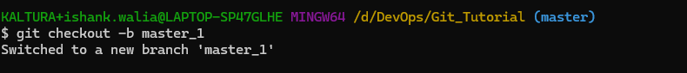
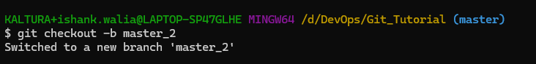

Added the To Do page in master_1
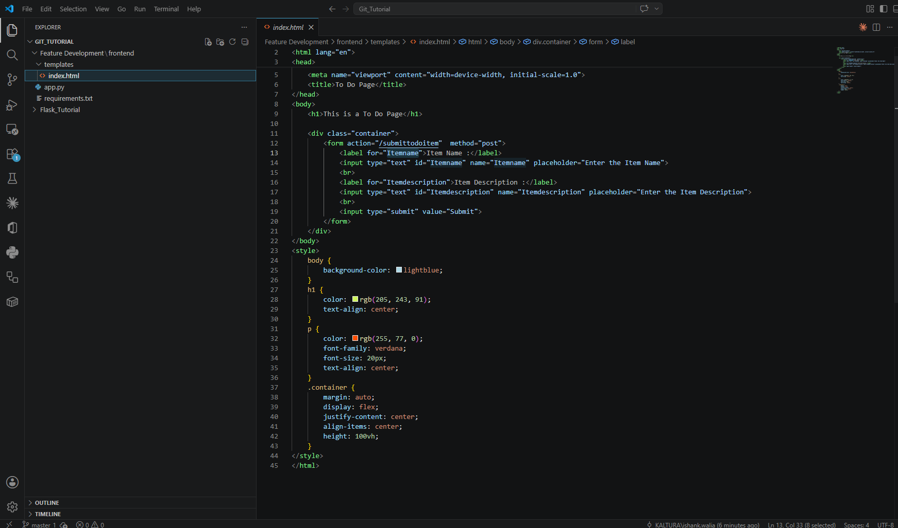
Stage and then commit the changes
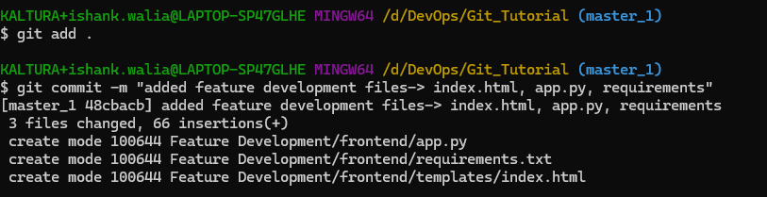
Added the backend API in master_2
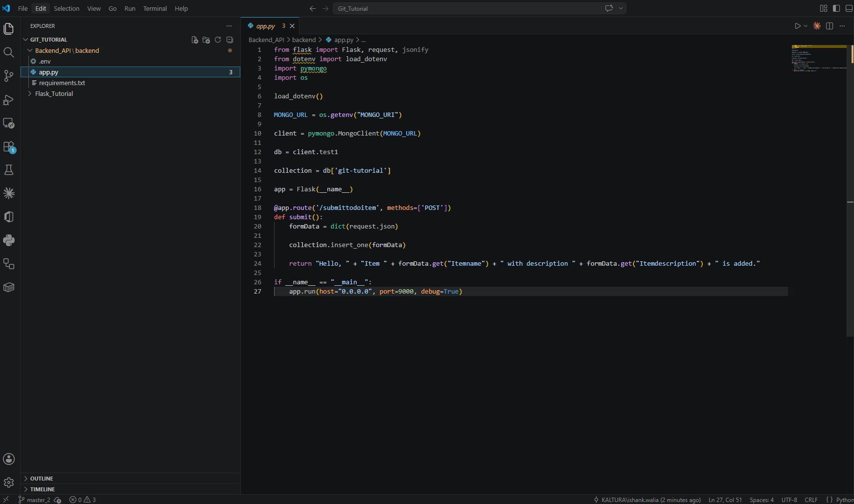

Stage and then commit the changes
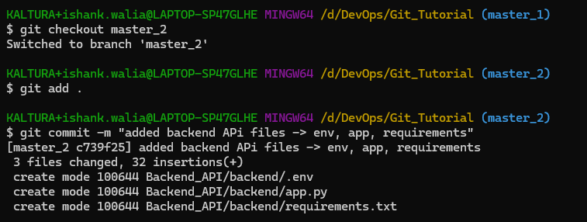

Merging the changes of both the branches to master
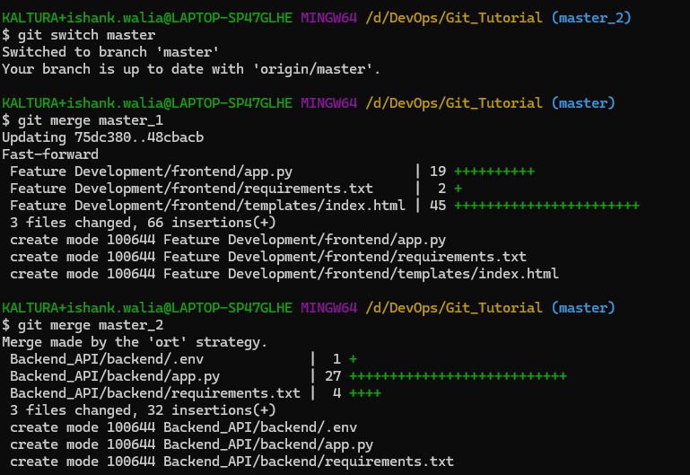

4. Enhancing the To-Do Form in master_1:
- In the master_1 branch, add the following fields to the To-Do form:
  - Item ID
  - Item UUID
  - Item Hash
- Committing in Sequence:
- Add and commit each field separately in the following order:
  - First commit: Add Item ID field.
  - Second commit: Add Item UUID field.
  - Third commit: Add Item Hash field.
- Merging to main:
- Merge the master_1 branch into the main branch.
- Git Reset and Commit Deletion:
- In the main branch, use Git Reset to roll back to the commit where only the Item ID field was added.
- Use git reset --soft to ensure changes remain staged.
- Re-commit this state to the main branch.
- Merge this updated state to the main branch.
- Rebasing Changes:
- Rebase the updated changes in the main branch to the master_1 branch.
Clarification:
  - During rebasing, preserve individual commits to maintain the commit history for each change (i.e., do not squash commits).
  - Use git rebase main master_1 to integrate changes from the main branch back into the master_1 branch.

Enhancing To Do Form (added new fields and did the commit 1 by 1)
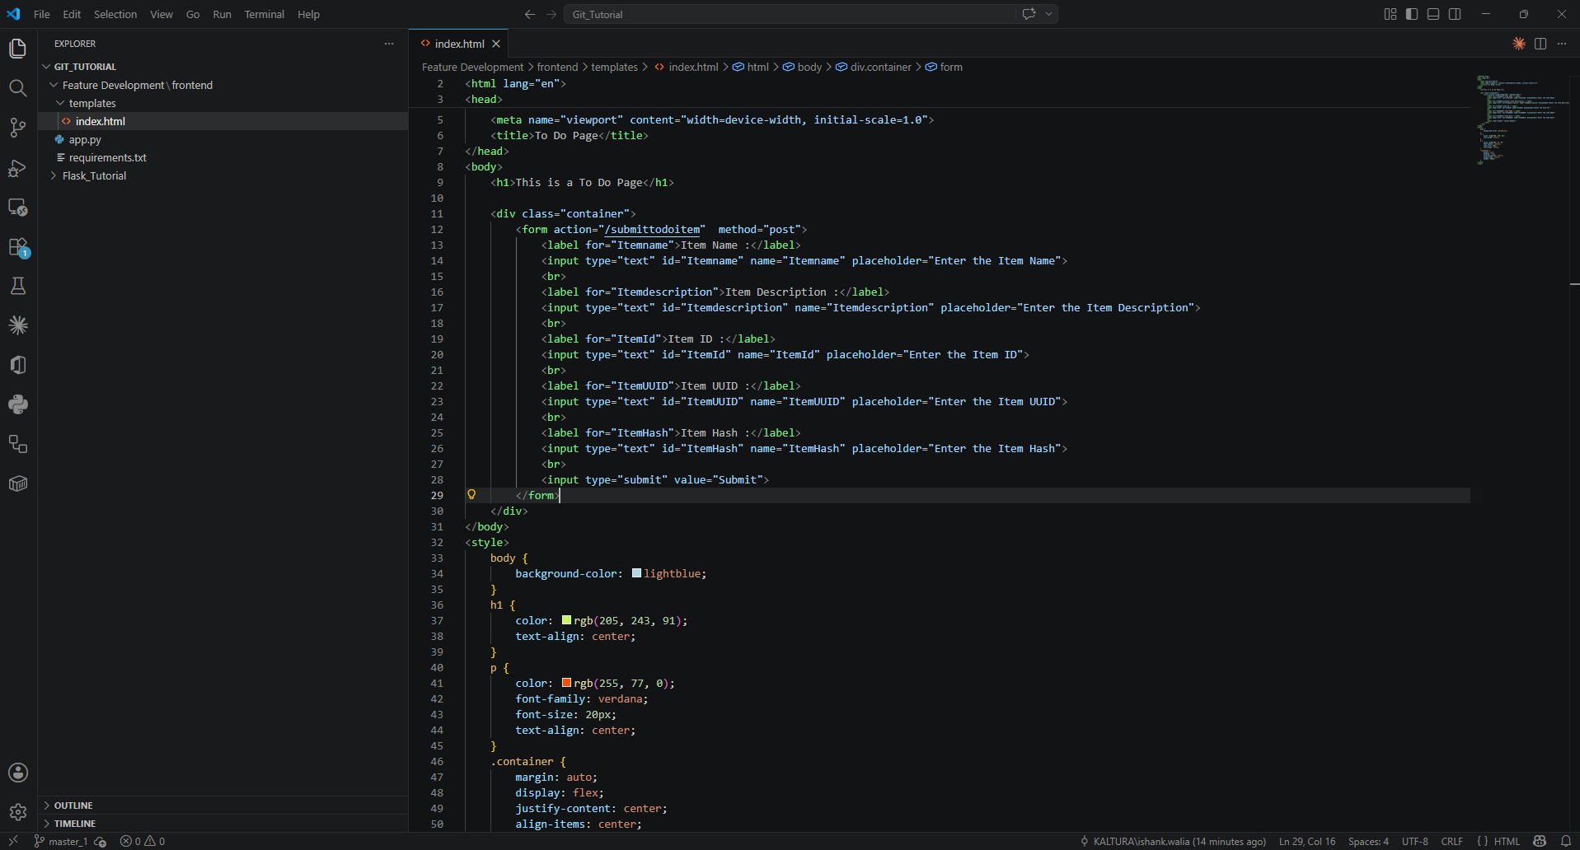
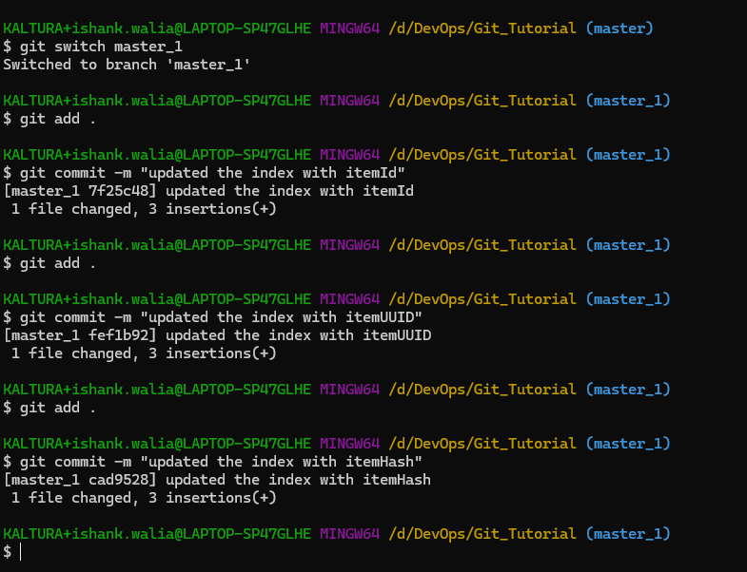

Merge to master branch
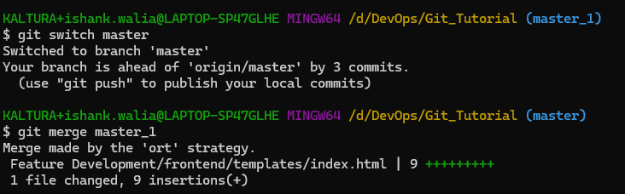

Resetting to the commit where only ItemId is added
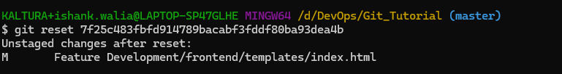
Recommitting
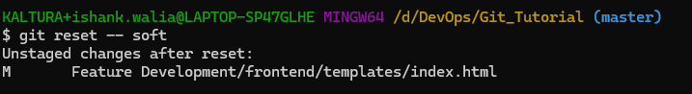
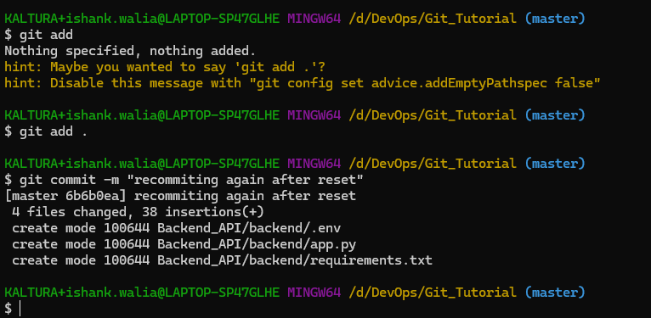

Rebasing
