- Create a Flask application with an /api route. When this route is accessed, it should return a JSON list. The data should be stored in a backend file, read from it, and sent as a response.
Code
app.py
from flask import Flask, request, render_template
from datetime import datetime
app = Flask(__name__)
@app.route('/api')
def form():
firstName = request.values.get("fname")
lastName = request.values.get("lname")
dow = datetime.now().strftime("%A")
return render_template('index.html', firstName = firstName, lastName = lastName, day_of_week=dow)
if __name__ == "__main__":
app.run(debug=True)

Explanation
- from flask import Flask, request, render_template & from datetime import datetime -> pulls specific components from the Flask framework
  - Flask – main class to create application
  - request – for incoming http request and to access query params
  - render_template – to return an HTML file and to work with jinja2
  - datetime – class from python built in datetime module
- Flask(__name__) -> creates web application instance
- @app.route('/api ‘) -> defines a URL endpoint
- def form(): -> defines a function named as form
- request.values collects data sent from the client
  - It tries to fetch:
    - "fname" → stored in firstName
    - "lname" → stored in lastName
- dow = datetime.now().strftime("%A")-> returns current day of the week and store it in dow
- return render_template('index.html', firstName = firstName, lastName = lastName, day_of_week=dow)->
  - renders an HTML file called index.html
  - passes variables into the template:
    - firstName
    - lastName
    - day_of_week
- app.run -> Runs the app
- debug=True ->
  - Auto reload on code changes
  - Shows detailed error logs

index.html
<!DOCTYPE html>
<html lang="en">
<head>
<meta charset="UTF-8">
<meta name="viewport" content="width=device-width, initial-scale=1.0">
<title>Flask Tutorial Sign Up Form</title>
</head>
<body>
<h1>Hello {{ firstName }} {{ lastName }}</h1>
<p>This is a Flask Tutorial sign up form</p>
<p>Today is {{ day_of_week }}</p>
</body>
<style>
body {
background-color: lightblue;
}
h1 {
color: rgb(205, 243, 91);
text-align: center;
}
p {
color: rgb(255, 77, 0);
font-family: verdana;
font-size: 20px;
text-align: center;
}
</style>
</html>

Explanation
- <body> <h1>Hello {{ firstName }} {{ lastName }}</h1> <p>This is a Flask Tutorial sign up form</p> <p>Today is {{ day_of_week }}</p> </body> -> Is a Jinja2 templating syntax (used by Flask).
  - {{ firstName }} → replaced with value from backend
  - {{ lastName }} → replaced with value from backend
  - {{ day_of_week }} → replaced with current day
- Create a Flask application with an /api route. When this route is accessed, it should return a JSON list. The data should be stored in a backend file, read from it, and sent as a response.
Code
app.py
from flask import Flask, request, render_template
from datetime import datetime
from dotenv import load_dotenv
import pymongo
import os

load_dotenv()

MONGO_URL = os.getenv("MONGO_URI")
client = pymongo.MongoClient(MONGO_URL)
db = client.test
collection = db['flask-tutorial']
app = Flask(__name__)

@app.route('/api')
def form():
dow = datetime.now().strftime("%A")
return render_template('index.html', day_of_week=dow)

@app.route('/submit', methods=['POST'])
def submit():
formData = dict(request.form)
collection.insert_one(formData)
return "Hello, " + formData.get("name") + "!" + " You have successfully submitted the form!" + " Your email is " + formData.get("email") + "."

if __name__ == "__main__":
app.run(debug=True)
Explanation
- from flask import Flask, request, render_template, from datetime import datetime , from dotenv import load_dotenv, import pymongo & import os-> pulls specific components from the Flask framework
  - Flask – main class to create application
  - request – for incoming http request and to access query params
  - render_template – to return an HTML file and to work with jinja2
  - datetime – class from python built in datetime module
  - python-dotenv – loads .env file
  - PyMongo – connects to MongoDB
  - os – reads environment variables
- load_dotenv()-> Loads variables from a .env file
- MONGO_URL = os.getenv("MONGO_URI") -> Reads MONGO_URI (database connection string)
- client = pymongo.MongoClient(MONGO_URL)-> Connects to MongoDB server
- db = client.test-> Create database: test
- collection = db['flask-tutorial']-> Create collection: flask-tutorial
- app = Flask(__name__)-> Initializes application
- @app.route('/api ‘) -> defines a URL endpoint
- def form(): -> defines a function named as form
- dow = datetime.now().strftime("%A")-> returns current day of the week and store it in dow
- return render_template('index.html', day_of_week=dow)->
  - renders an HTML file called index.html
  - passes variable into the template:
    - day_of_week
- @app.route('/submit', methods=['POST'])-> defines a URL endpoint and this route only accepts POST requests
- def submit():-> defines a function named as submit
- formData = dict(request.form)-> contains submitted form fields and converted into a dictionary
- collection.insert_one(formData)-> Inserts the form data into MongoDB and each submission becomes a document
- return "Hello, " + formData.get("name") + "!" + \
" You have successfully submitted the form!" + \
" Your email is " + formData.get("email") + "." -> Sends a plain text response back to the user
- app.run -> Runs the app
- debug=True ->
  - Auto reload on code changes
  - Shows detailed error logs

index.html
<!DOCTYPE html>
<html lang="en">
<head>
<meta charset="UTF-8">
<meta name="viewport" content="width=device-width, initial-scale=1.0">
<title>Flask Tutorial Sign Up Form</title>
</head>
<body>
<h1>This is a Flask Tutorial sign up form</h1>
<p>Today is {{ day_of_week }}</p>
<div class="container"> <form action="/submit" method="post">
<label for="name">Name :</label>
<input type="text" id="name" name="name" placeholder="Enter Your name"> <br>
<label for="email">Email :</label>
<input type="email" id="email" name="email" placeholder="Enter Your email"> <br>
<label for="password">Password :</label>
<input type="password" id="password" name="password" placeholder="Enter Your password"> <br>
<input type="submit" value="Submit">
</form> </div>
</body>
<style>
body {
background-color: lightblue;
}
h1 {
color: rgb(205, 243, 91);
text-align: center;
}
p {
color: rgb(255, 77, 0);
font-family: verdana;
font-size: 20px;
text-align: center;
}
.container {
margin: auto;
display: flex;
justify-content: center;
align-items: center;
height: 100vh;
}
</style>
</html>

Explanation
- <body> <h1>Hello {{ firstName }} {{ lastName }}</h1> <p>This is a Flask Tutorial sign up form</p> <p>Today is {{ day_of_week }}</p> </body> -> Is a Jinja2 templating syntax (used by Flask).
  - {{ day_of_week }} → replaced with current day
- <form action="/submit" method="post"> -> When the user clicks submit, data is sent to the /submit route (the Flask route)
- Then we have some label and input fields like – Name, Email, Password to take the input.
- <input type="submit" value="Submit"> -> When clicked:
  - Collects all input values
  - Sends POST request to /submit

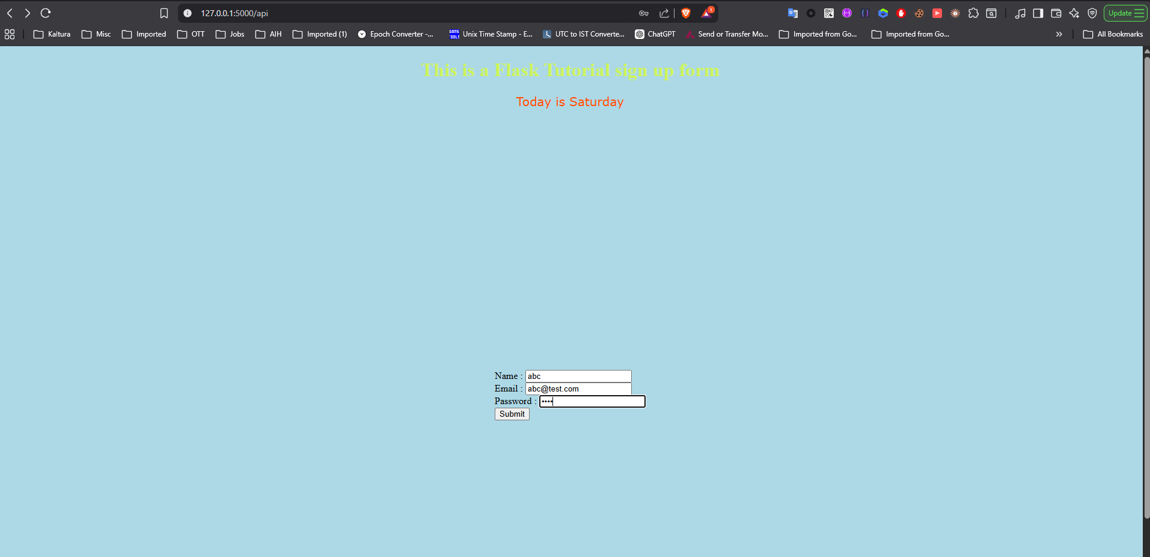
Form is opened then the input values are given and then clicked on submit
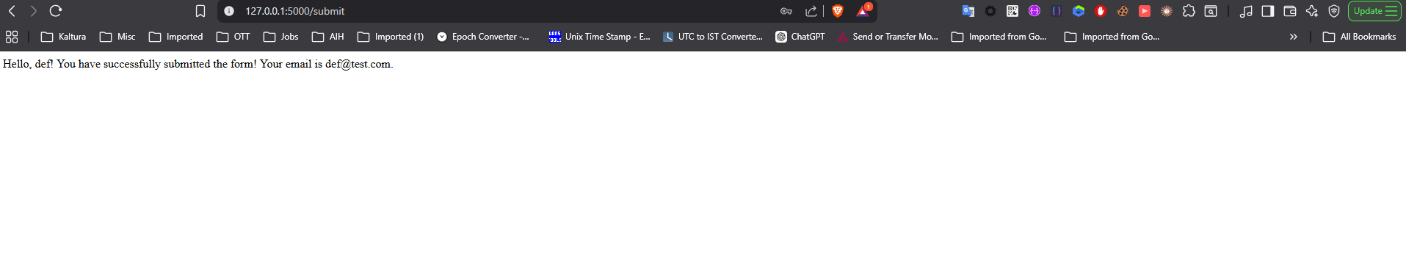
After successful submission it is redirected to submit page where is shows the message as above
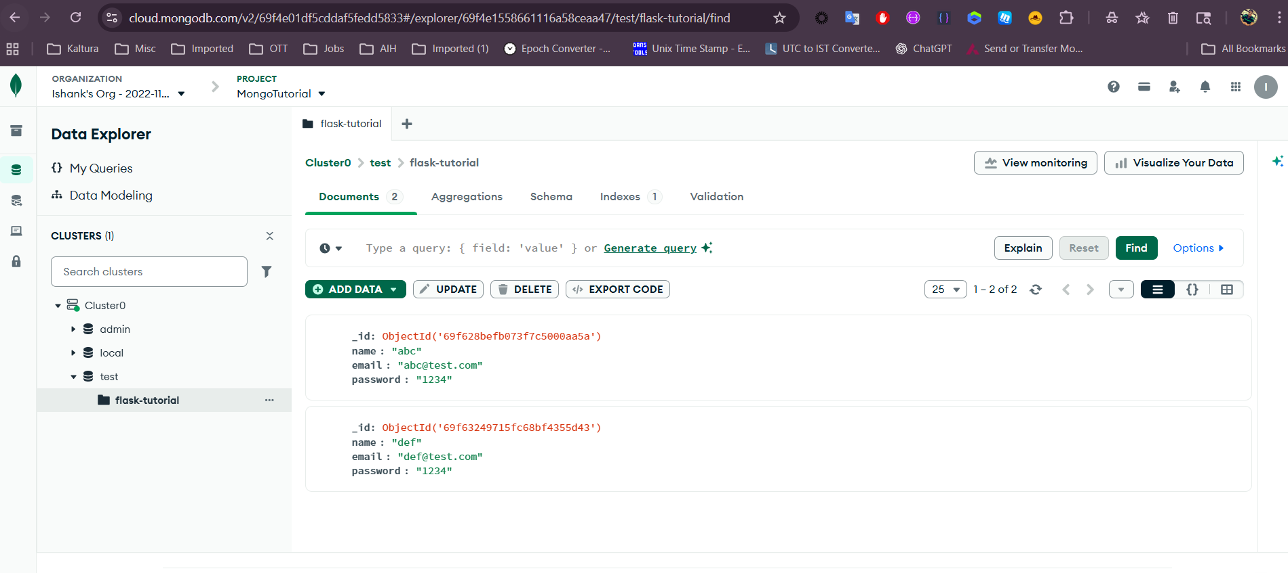
Data is added to the Mongo

When error returned on submitting page
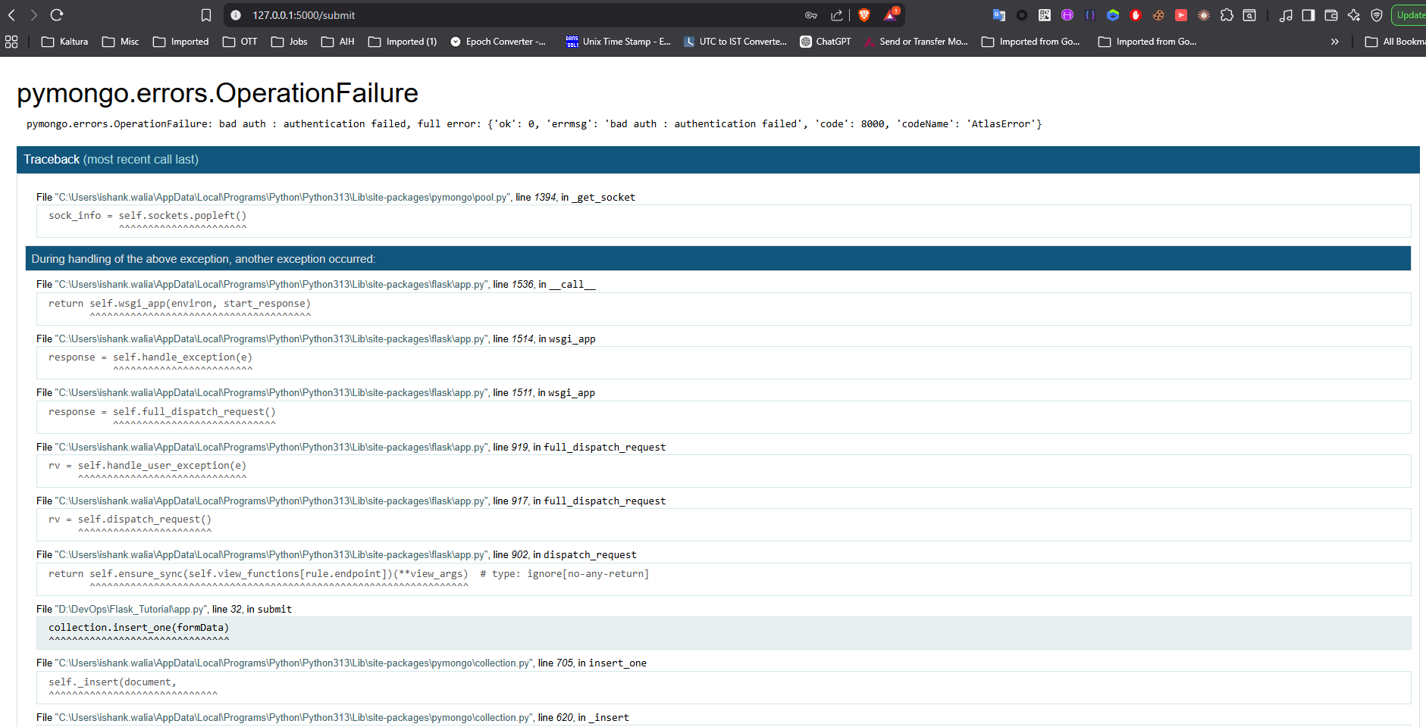
In case any error is there, no data is entered in mongo
