SELENIUM MINI ASSIGNMENT FOR HU Batch

Problem 1 – Write down the locators for below web elements.
Write 1 relative xpath, and 1 CSS selector and 1 locator from id / classname / name / tagname / link text for Below Web elements

Website URL: https://www.flipkart.com/
Web elements:
- Flipkart logo
- Login
- Cart
- Travel
- One way trip
- Search button
- From
- To
- Depart On
- Return On

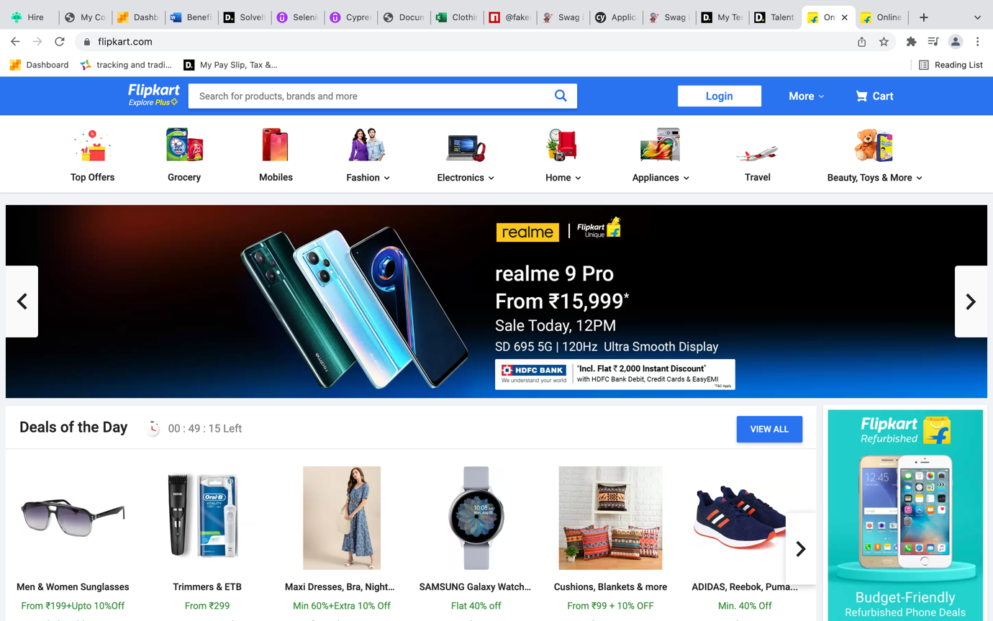
https://www.flipkart.com/

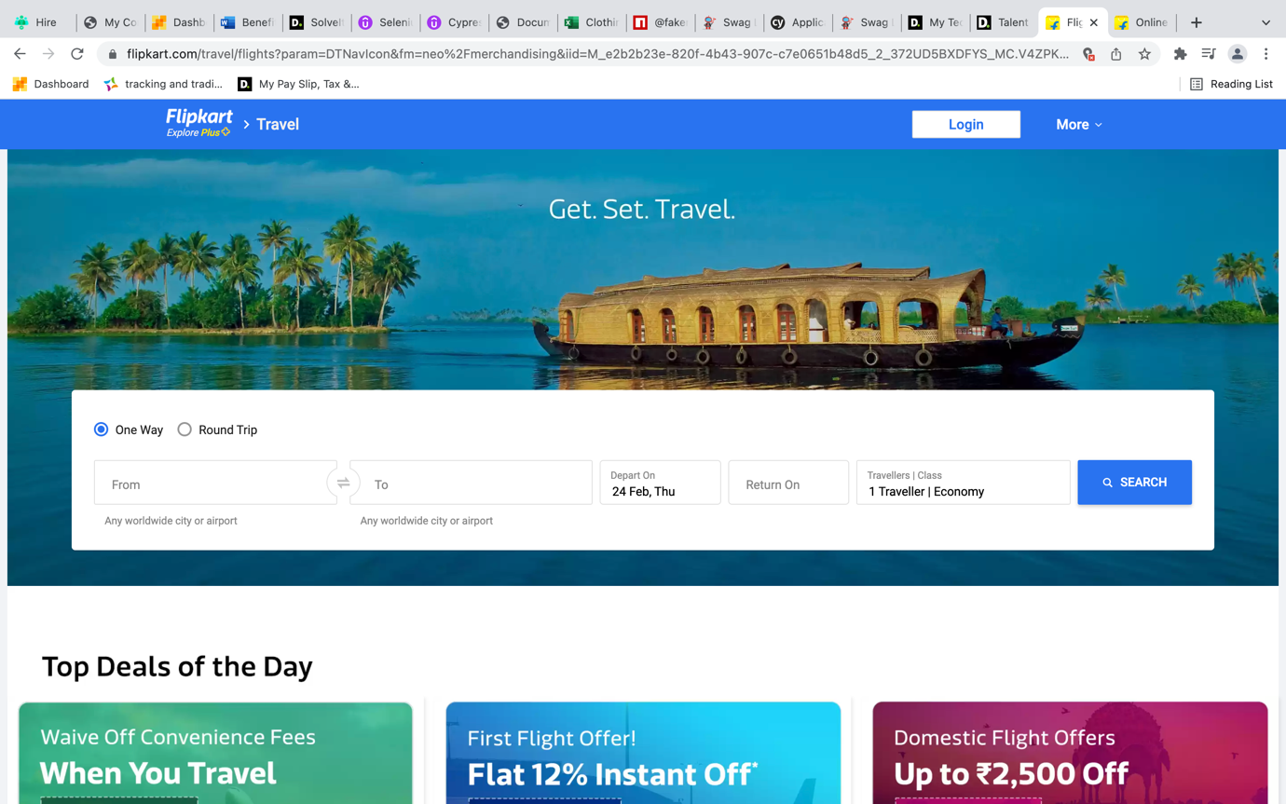
ANSWERS

Flipkart logo
Driver.findElement_By.xpath(“//*[@id="container"]/div/div[1]/div[1]/div[2]/div[1]/div/a[1]/img”))
Driver.find_element_css path(“#container > div > div._1kfTjk > div._1rH5Jn > div._2Xfa2_ > div._3_C9Hx > div > a:nth-child(1) > img”)
Driver.find_Element_By_id(‘container’)

Login
Driver.find_Element_By_xpath (“//*[@id="container"]/div/div[1]/div[1]/div[2]/div[3]/div/div/div/a”)
Driver.find_element_css path (“#container > div > div._1kfTjk > div._1rH5Jn > div._2Xfa2_ > div.go_DOp._2errNR > div > div > div > a”)
Driver.find_Element_By_class name (“_1_3w1N”)

Cart
Driver.find_Element_By_xpath( “//*[@id="container"]/div/div[2]/div/div/div/div/div[2]/div”)
Driver.find_element_css path (“#container > div > div._1Er18h > div > div > div > div > div._1AtVbE.col-12-12 > div”)
Driver.find_element_class name(“ Vy94J0”)

Travel
Driver.find_Element_By_xpath(“//*[@id="container"]/div/div[2]/div/div/div[8]/a/div[2]”)
Driver.find_element_css path (“#container > div > div._331-kn._2tvxW > div > div > div:nth-child(8) > a > div.xtXmba”)
Driver.find_element_class name (“xtXmba”)

One way trip
Driver.find_Element_By_xpath(“//*[@id="container"]/div/div[2]/div[1]/div/div[2]/div/div[1]/div/div/label[1]/div[2]/div”)
Driver.find_element_css path (“#container > div > div._2I_P4n._6t1WkM._3HqJxg > div:nth-child(1) > div > div._3XCEEm > div > div._3--Dt3 > div > div > label._2Fn-Ln._3L7Pww > div._2jIO64._3Y-Z5B > div”)
Driver.find_element_class name (“_2jIO64 _3Y-Z5B”)

Search button:
Driver.find_Element_By_xpath(“//*[@id="container"]/div/div[2]/div[1]/div/div[2]/div/div[2]/form/div/button”)
Driver.find_element_css path (“#container > div > div._2I_P4n._6t1WkM._3HqJxg > div:nth-child(1) > div > div._3XCEEm > div > div._2ffI1H > form > div > button”)
Driver.find_element_class name (“_2KpZ6l _1QYQF8 _3dESVI”)

From
Driver.find_Element_By_xpath(“//*[@id="container"]/div/div[2]/div[1]/div/div[2]/div/div[2]/form/div/div[1]/div[1]/div[1]/div[1]/input”)
Driver.find_element_css path (“#container > div > div._2I_P4n._6t1WkM._3HqJxg > div:nth-child(1) > div > div._3XCEEm > div > div._2ffI1H > form > div > div._3REAgv > div:nth-child(1) > div.GTbXbG > div._3qBKP_._1Jqgld > input”)
Driver.find_element_class name (“_1w3ZZo _1YBGQV _110Trj _2EjOJB lZd1T6 _2vegSu _2mFmU7”)

To
Driver.find_Element_By_xpath(“//*[@id="container"]/div/div[2]/div[1]/div/div[2]/div/div[2]/form/div/div[1]/div[3]/div[1]/div[1]/input”)
Driver.find_element_css path (“#container > div > div._2I_P4n._6t1WkM._3HqJxg > div:nth-child(1) > div > div._3XCEEm > div > div._2ffI1H > form > div > div._3REAgv > div:nth-child(3) > div.GTbXbG > div._3qBKP_._1Jqgld > input”)
Driver.find_element_class name (“_1w3ZZo _1YBGQV _110Trj _2EjOJB lZd1T6 _2dqBfU _2mFmU7”)

Depart on
Driver.find_Element_By_xpath(“//*[@id="container"]/div/div[2]/div[1]/div/div[2]/div/div[2]/form/div/div[3]/div[2]/div/input”)
Driver.find_element_css path (“#container > div > div._2I_P4n._6t1WkM._3HqJxg > div:nth-child(1) > div > div._3XCEEm > div > div._2ffI1H > form > div > div._1SzMWX._1Bv2QP > div:nth-child(2) > div > input”)
Driver.find_element_class name (“_1w3ZZo _2gKfhi _1WPSB8 _2mFmU7”)

Return on
Driver.find_Element_By_xpath(“//*[@id="container"]/div/div[2]/div[1]/div/div[2]/div/div[2]/form/div/div[3]/div[3]/div[1]/input”)
Driver.find_element_css path (“ #container > div > div._2I_P4n._6t1WkM._3HqJxg > div:nth-child(1) > div > div._3XCEEm > div > div._2ffI1H > form > div > div._1SzMWX._1Bv2QP > div:nth-child(3) > div.zzPDhz._1Jqgld > input”)
Driver.find_element_class name (“_1w3ZZo _2gKfhi _1WPSB8 _2mFmU7”)

