PROJECTS:

-EN20IT301052 ISHAN RAI

1. **Guess the number in C:**

**CODE:**

#include <stdio.h>

#include <stdlib.h>

#include <time.h>

int main()

{

int number, nguesses = 1, guess;

srand(time(0));

number = rand() % 500 + 1;

do

{

printf("guess the number between 1 to 500\n");

scanf("%d", &guess);

if (guess > number)

{

printf("lower number please:)\n");

}

else if (number > guess)

{

printf("higher number please :)\n");

}

else

{

printf("you guessed it in %d attempts\n", nguesses);

}

nguesses++;

} while (guess != number);

return 0;

}

OUTPUT:

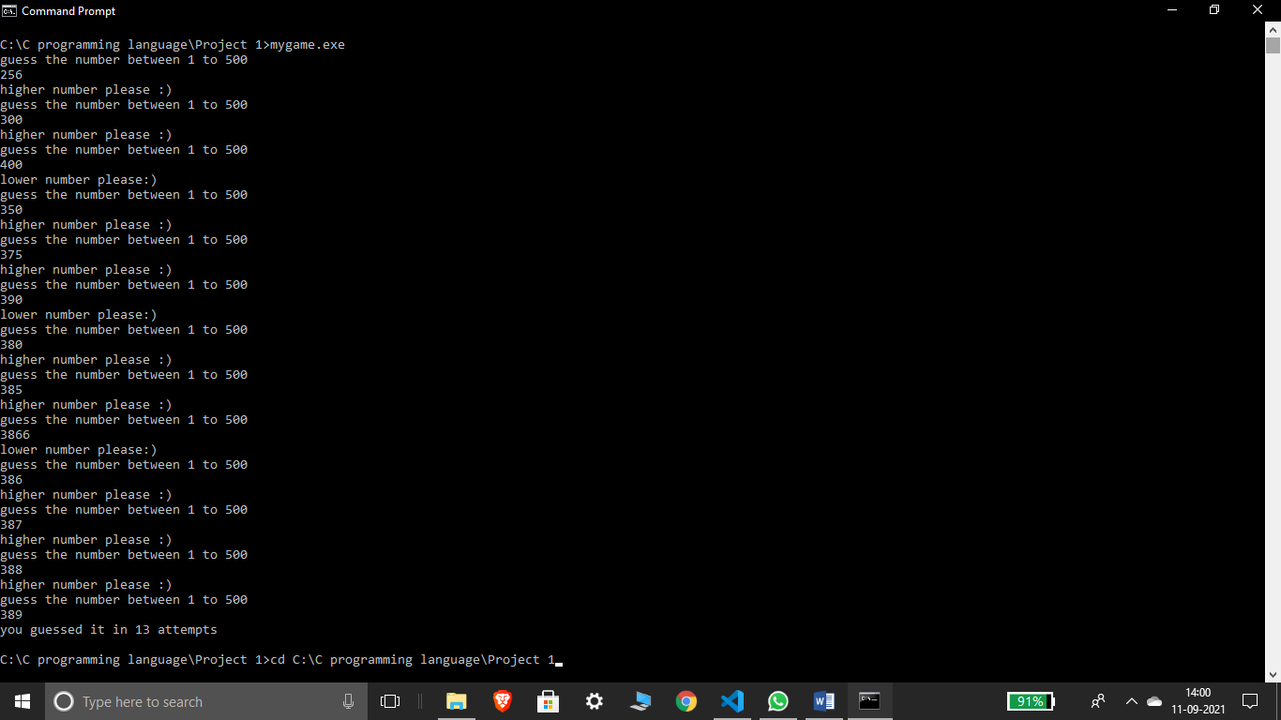

1. **Snake water gun or stone paper scissor in C**

**CODE:**

#include<stdio.h>

#include<stdlib.h>

#include<time.h>

*int* snakeWaterGun(*char* *you*, *char* *comp*){

    // returns 1 if you win, -1 if you lose and 0 if draw

    if(*you* == *comp*){

        return 0;

    }

    if(*you*=='s' && *comp*=='g'){

        return -1;

    }

    else if(*you*=='g' && *comp*=='s'){

        return 1;

    }

    if(*you*=='s' && *comp*=='w'){

        return 1;

    }

    else if(*you*=='w' && *comp*=='s'){

        return -1;

    }

    if(*you*=='g' && *comp*=='w'){

        return -1;

    }

    else if(*you*=='w' && *comp*=='g'){

        return 1;

    }

}

*int* main(){

*char* you, comp;

    srand(time(0));

*int* number = rand()%100 + 1;

    if(number<33){

        comp = 's';

    }

    else if(number>33 && number<66){

        comp='w';

    }

    else{

        comp='g';

    }

    printf("Enter 's' for snake, 'w' for water and 'g' for gun\n");

    scanf("%c", &you);

*int* result = snakeWaterGun(you, comp);

    if(result ==0){

        printf("Game draw!\n");

    }

    else if(result==1){

        printf("You win!\n");

    }

    else{

        printf("You Lose!\n");

    }

    printf("You chose %c and computer chose %c. ", you, comp);

    return 0;

}

OUTPUT:

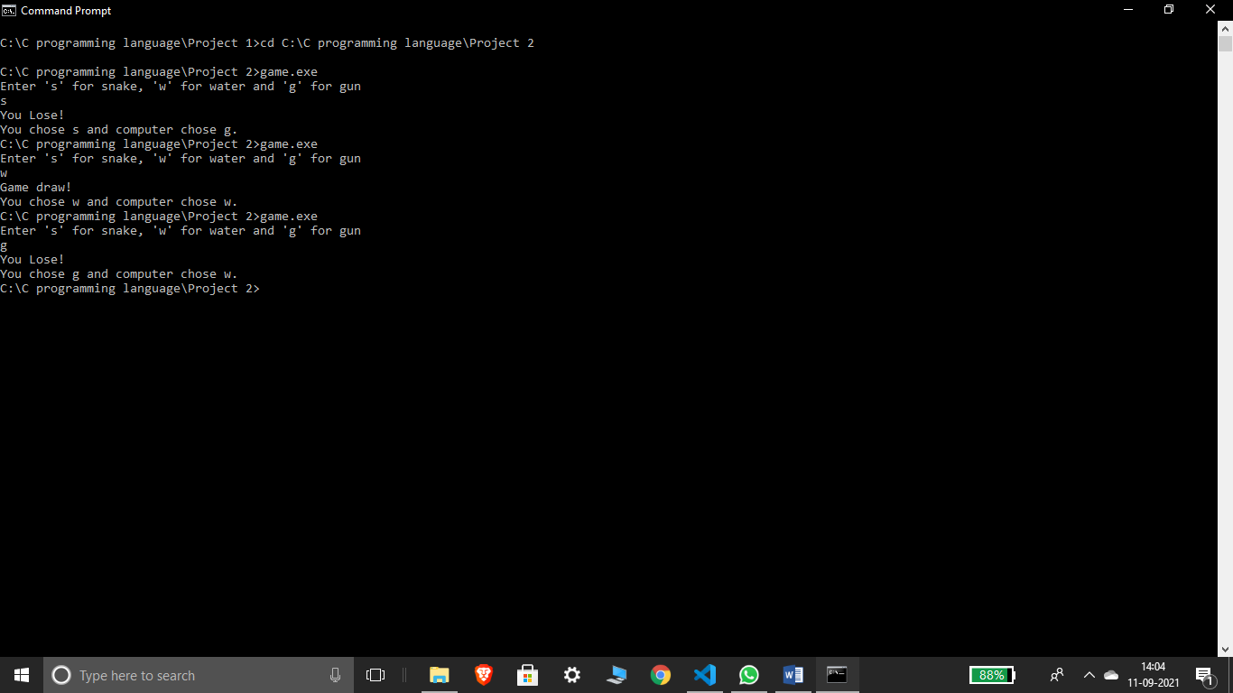

1. LIBRARY MANAGEMENT SYSTEM IN PYTHON

CODE:

*class* Library:

*def* __init__(*self*, *list_of_books*):

        self.books = list_of_books

*def* display_available_books(*self*):

        print("Books present in this library are:\n")

        for book in self.books:

            print(" # "+book)

*def* issue_book(*self*, *book_name*):

        if book_name in self.books:

            print(

*f*"{book_name} has been issued on your name, keep it safe and return within a MONTH!")

            self.books.remove(book_name)

            return True

        else:

            print("Sorry, this book is issued to someone else")

            return False

*def* return_book(*self*, *book_name*):

        self.books.append(book_name)

        print("Thanks for returning this book")

*class* Student:

*def* __init__(*self*,):

        pass

*def* request_book(*self*):

        self.book = input("Enter the name of book you want to issue: ")

        return self.book

*def* return_book(*self*):

        self.book = input("Enter the name of book you want to return or add: ")

        return self.book

# main

if __name__ == "__main__":

    Central_library = Library(["How to win friends and influence people",

                              "The Alchemist", "Da Vinci Code", "7 Habits of highly effective people"])

    Central_library.display_available_books()

    student_obj = Student()

    while(True):

        Welcome_message = '''

        *****Welcome to Central Library*****

            Choose one of the following options:

            1.Display list of available books

            2.Issue a book

            3.Return/Add a books

            4.Exit the library

            '''

        print(Welcome_message)

        try:

            a = *int*(input("Enter your choice: "))

            if a == 1:

                Central_library.display_available_books()

            elif a == 2:

                Central_library.issue_book(student_obj.request_book())

            elif a == 3:

                Central_library.return_book(student_obj.return_book())

            elif a == 4:

                print("Thank you for choosing Central library keep reading :)")

                exit()

            else:

                print("Invalid Choice")

        except *Exception* as e:

            print("Enter Number corresponding to choice ")

OUTPUT:  
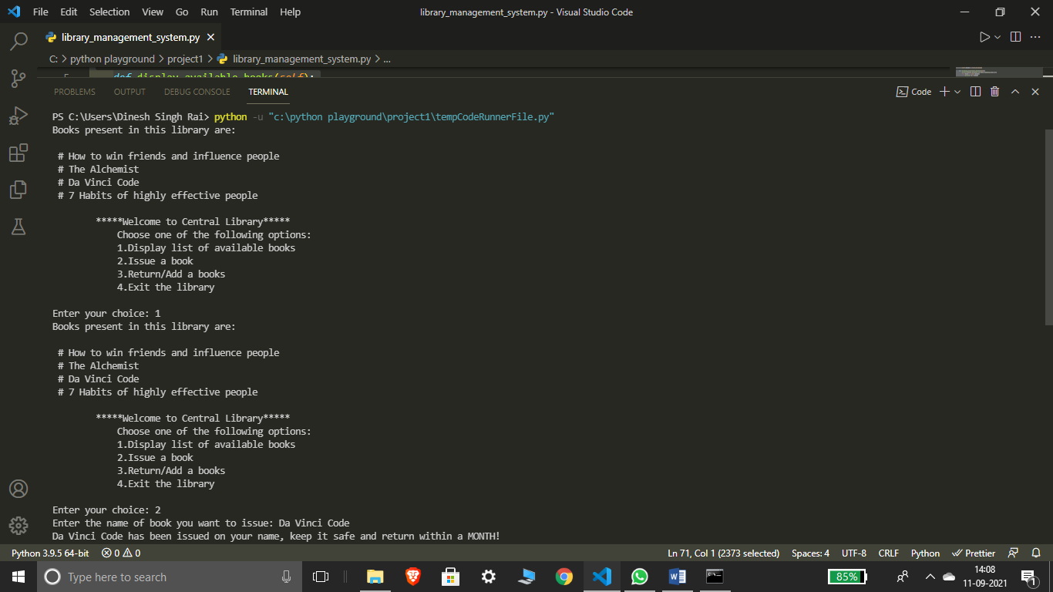

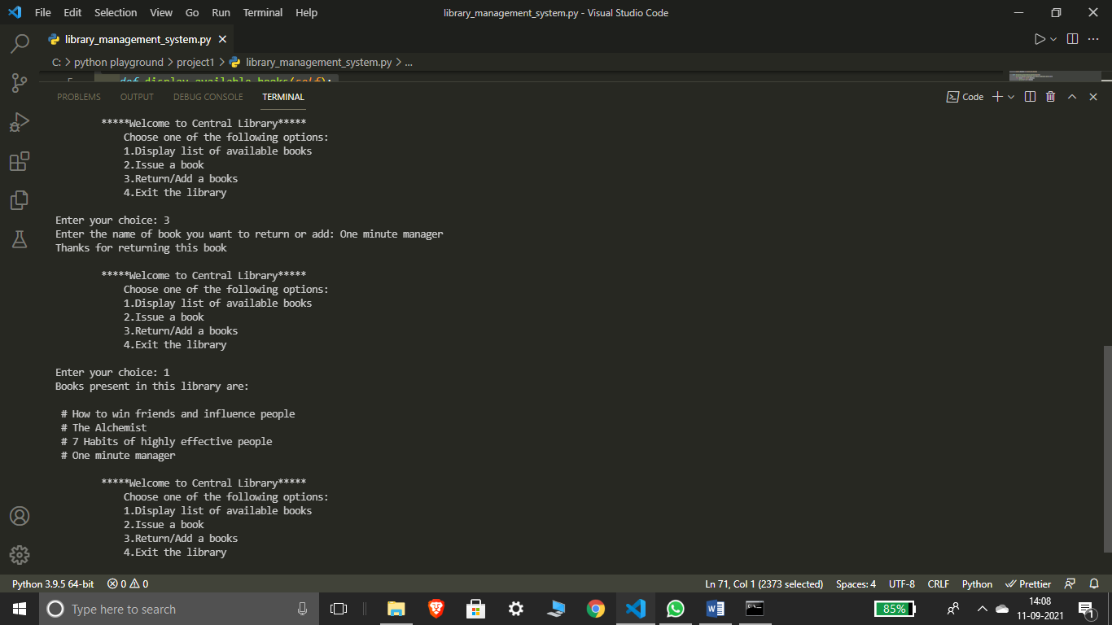

4.)Dekstop assistant in python:

CODE:

import pyttsx3 #pip install pyttsx3

import speech_recognition as sr

import datetime

import wikipedia

import webbrowser

import os

import smtplib

engine = pyttsx3.init('sapi5')

voices = engine.getProperty('voices')

# print(voices[1].id)

engine.setProperty('voice', voices[1].id)

*def* speak(*audio*):

    engine.say(*audio*)

    engine.runAndWait()

*def* wish_me():

    hour = int(datetime.datetime.now().hour)

    if hour >= 0 and hour < 12:

        speak("Good morning Sir")

    elif hour >= 12 and hour <= 18:

        speak("Good afternoon sir")

    else:

        speak("Good evening sir")

    speak("Jarvis at your service, how may i help you")

*def* take_command():

    pass

    r= sr.Recognizer()

    with sr.Microphone() as source:

        print("Listening....")

        r.pause_threshold=1

        audio=r.listen(source)

    try:

        print("Recognizing...")

        query=r.recognize_google(audio,*language*='en-in')

        print("User said: ", query,"\n")

    except Exception as e:

        print("Couldn't recognize your voice")

        return "None"

    return query

if __name__ == '__main__':

    wish_me()

    take_command()