

Sri Lanka Institute of Information Technology

SE3010 – Software Engineering Process & Quality Management

Semester 1–Year 3

Test management is the activity of managing some tests. A test management tool is [software](http://en.wikipedia.org/wiki/Software) used to manage [tests](http://en.wikipedia.org/wiki/Test_case) (automated or manual) that have been previously specified. It is often associated with [automation](http://en.wikipedia.org/wiki/Automation) software. Test management tools often include [requirement](http://en.wikipedia.org/wiki/Requirement) and/or [specification](http://en.wikipedia.org/wiki/Specification_(technical_standard)) management modules that allow automatic generate a [requirement test matrix](http://en.wikipedia.org/wiki/Traceability_matrix) (RTM), which is one of the main metrics to indicate functional coverage of a [system under test](http://en.wikipedia.org/wiki/System_under_test) (SUT).

## Learning objectives

1. Understanding the importance of test management
2. Practicing the tool

## Creating the company and users

Hierarchies, working groups and teams can be easily managed in XStudio by creating a structure of folders hosting users.

|  |  |
| --- | --- |
| http://www.xqual.com/documentation/user_guide/images/3.1%20-%20User%20Tree.jpg | 1. create your own company  1. creating working groups and teams in the company   http://www.xqual.com/documentation/user_guide/images/3.1.2%20-%20Create%20Folder%20button.jpg   1. create some users  1. Try to login with the new user IDs 2. Enter some absenceshttp://www.xqual.com/documentation/user_guide/images/3.1.4%20-%20Submit%20a%20new%20absence%202%20-%20button.jpg |

## **Creating** a SUT

System under test (SUT) refers **to a** [**system**](http://en.wikipedia.org/wiki/System) that is being tested for correct operation. A SUT should be uniquely defined through its name and version

|  |  |
| --- | --- |
| http://www.xqual.com/documentation/user_guide/images/3.2%20-%20SUT%20Tree%201.jpg | 1. Create different folders 2. Create SUThttp://www.xqual.com/documentation/user_guide/images/3.2.1%20-%20Create%20a%20SUT%20-%20button.jpg   (enter the name and the version)   1. Create a SUT Inheriting requirements   Select the Requirements tab  click the Preset import from SUT settings button http://www.xqual.com/documentation/user_guide/images/3.2.2%20-%20Create%20a%20SUT%20Inheriting%20requirements%20from%20another%20SUT%201%20-%20button.jpg |

## Create requirements

|  |  |
| --- | --- |
| http://www.xqual.com/documentation/user_guide/images/3.4%20-%20Requirement%20Tree%202.jpg | 1. Create a category 2. Create folder 3. create requirement http://www.xqual.com/documentation/user_guide/images/3.4.2%20-%20Create%20a%20requirement%201%20-%20button.jpg |

|  |  |
| --- | --- |
| Status | Represents |
| New | New requirement |
| Ack | The requirement is being reviewed by the person who is supposed to sign it off |
| Approved | The requirement has been approved |

*** *******Create the SUT by inheriting the requirements*************

## Creating the Agent tree

All hosts on the network that will have XStudio installed on MUST be included in the tree.

|  |  |
| --- | --- |
| http://www.xqual.com/documentation/user_guide/images/3.3%20-%20Agent%20Tree.jpg | 1. Create a folder 2. Create agents |

## Creating specifications

|  |  |
| --- | --- |
| http://www.xqual.com/documentation/user_guide/images/3.5%20-%20Specification%20Tree.jpg | 1. Create a folder 2. Create a specification   http://www.xqual.com/documentation/user_guide/images/3.5.1%20-%20Create%20a%20specification%201%20-%20button.jpg |

|  |  |
| --- | --- |
| Status | Represents |
| New | New specification |
| Ack | The specification is being reviewed by the person who is supposed to sign it off |
| Approved | The specification has been approved |

*** Depending of the rights you can set the status of the specification

## Creating a project

A project must be created for any new “product” you want to deliver. A project is made of tasks. Most of the time, a task is the smaller entity that a developer can develop.

A sprint is the result of any iteration in a project. So, to deliver a product, you will deliver several intermediate releases, each corresponding to a sprint. A sprint is generally at most 2 or 3 weeks long. A number of tasks will be associated to each sprint.

|  |  |
| --- | --- |
| http://www.xqual.com/documentation/user_guide/images/3.6%20-%20Project%20Tree%202.jpg | ProjectCreate project http://www.xqual.com/documentation/user_guide/images/3.6.1%20-%20Create%20a%20project%20-%20button.jpg  1. Enter a focus ratio   **Task**   1. Create a folder belonging to a project 2. Create task http://www.xqual.com/documentation/user_guide/images/3.6.2%20-%20Create%20a%20task%20-%20button.jpg 3. Enter the priority of this task 4. Enter the estimated effort in mandays   **Sprint**   1. Select a project 2. Create sprint http://www.xqual.com/documentation/user_guide/images/3.6.3%20-%20Create%20a%20sprint%201%20-%20button.jpg |

|  |  |
| --- | --- |
| Status | Represents |
| Idle | Idle sprint |
| Running | The sprint is currently running |
| Finished | The sprint if finished |

## Allocating resources to a sprint: All the tasks associated to a sprint will be performed by a pool of resources. These resources are users (taken from the user tree).

1. Select the sprint
2. Select the Resources tab
3. Un-toggle the select filter button http://www.xqual.com/documentation/user_guide/images/3.6.5%20-%20Allocate%20some%20resources%20to%20a%20sprint%201%20-%20button.jpgto display the complete user tree
4. Select the users
5. Re-toggle the select filter button http://www.xqual.com/documentation/user_guide/images/3.6.5%20-%20Allocate%20some%20resources%20to%20a%20sprint%201%20-%20button.jpgto display only the selected users

## Associate some tasks to a sprint

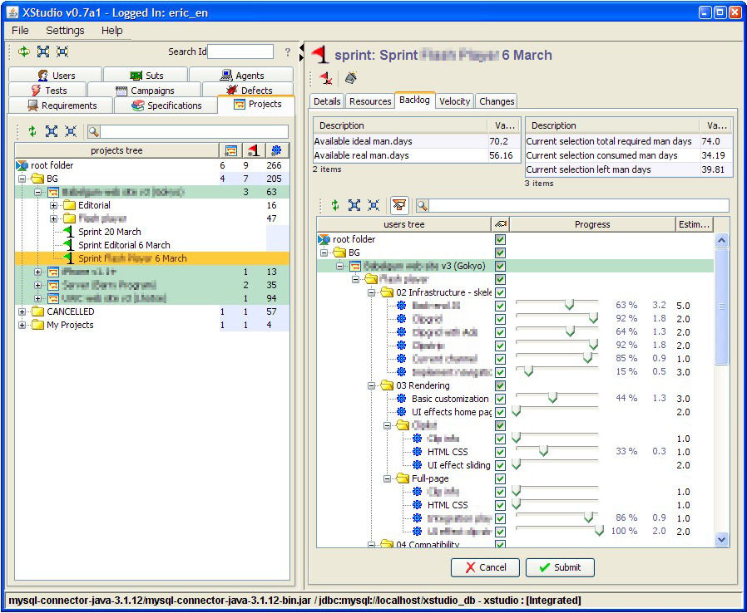

1. Select the sprint
2. on the right panel, select the Backlog
3. un-toggle the select filter button http://www.xqual.com/documentation/user_guide/images/3.6.5%20-%20Allocate%20some%20resources%20to%20a%20sprint%201%20-%20button.jpgto display the complete task tree
4. check the tasks that need to be associated to the current sprint
5. RE-toggle the select filter button http://www.xqual.com/documentation/user_guide/images/3.6.5%20-%20Allocate%20some%20resources%20to%20a%20sprint%201%20-%20button.jpgto display only the selected tasks
6. Daily update progress of the tasks of a sprint
7. Check the status of the sprint (**Velocity** tab)