Lab 5: Static Code Analysis - address_book.py
Repo: SETAPESU26/L5_27_address_book. Tools: Pylint, Bandit, Flake8.

Summary
Tool | Before | After
Pylint | 5.47/10 | 10.00/10
Bandit | 4 issues (1 High, 1 Medium, 2 Low) | 0 issues
Flake8 | 4 issues | 0 issues

BEFORE fixes

Before: Pylint
Score 5.47/10. Naming, missing docstrings, broad exception, unspecified encoding.
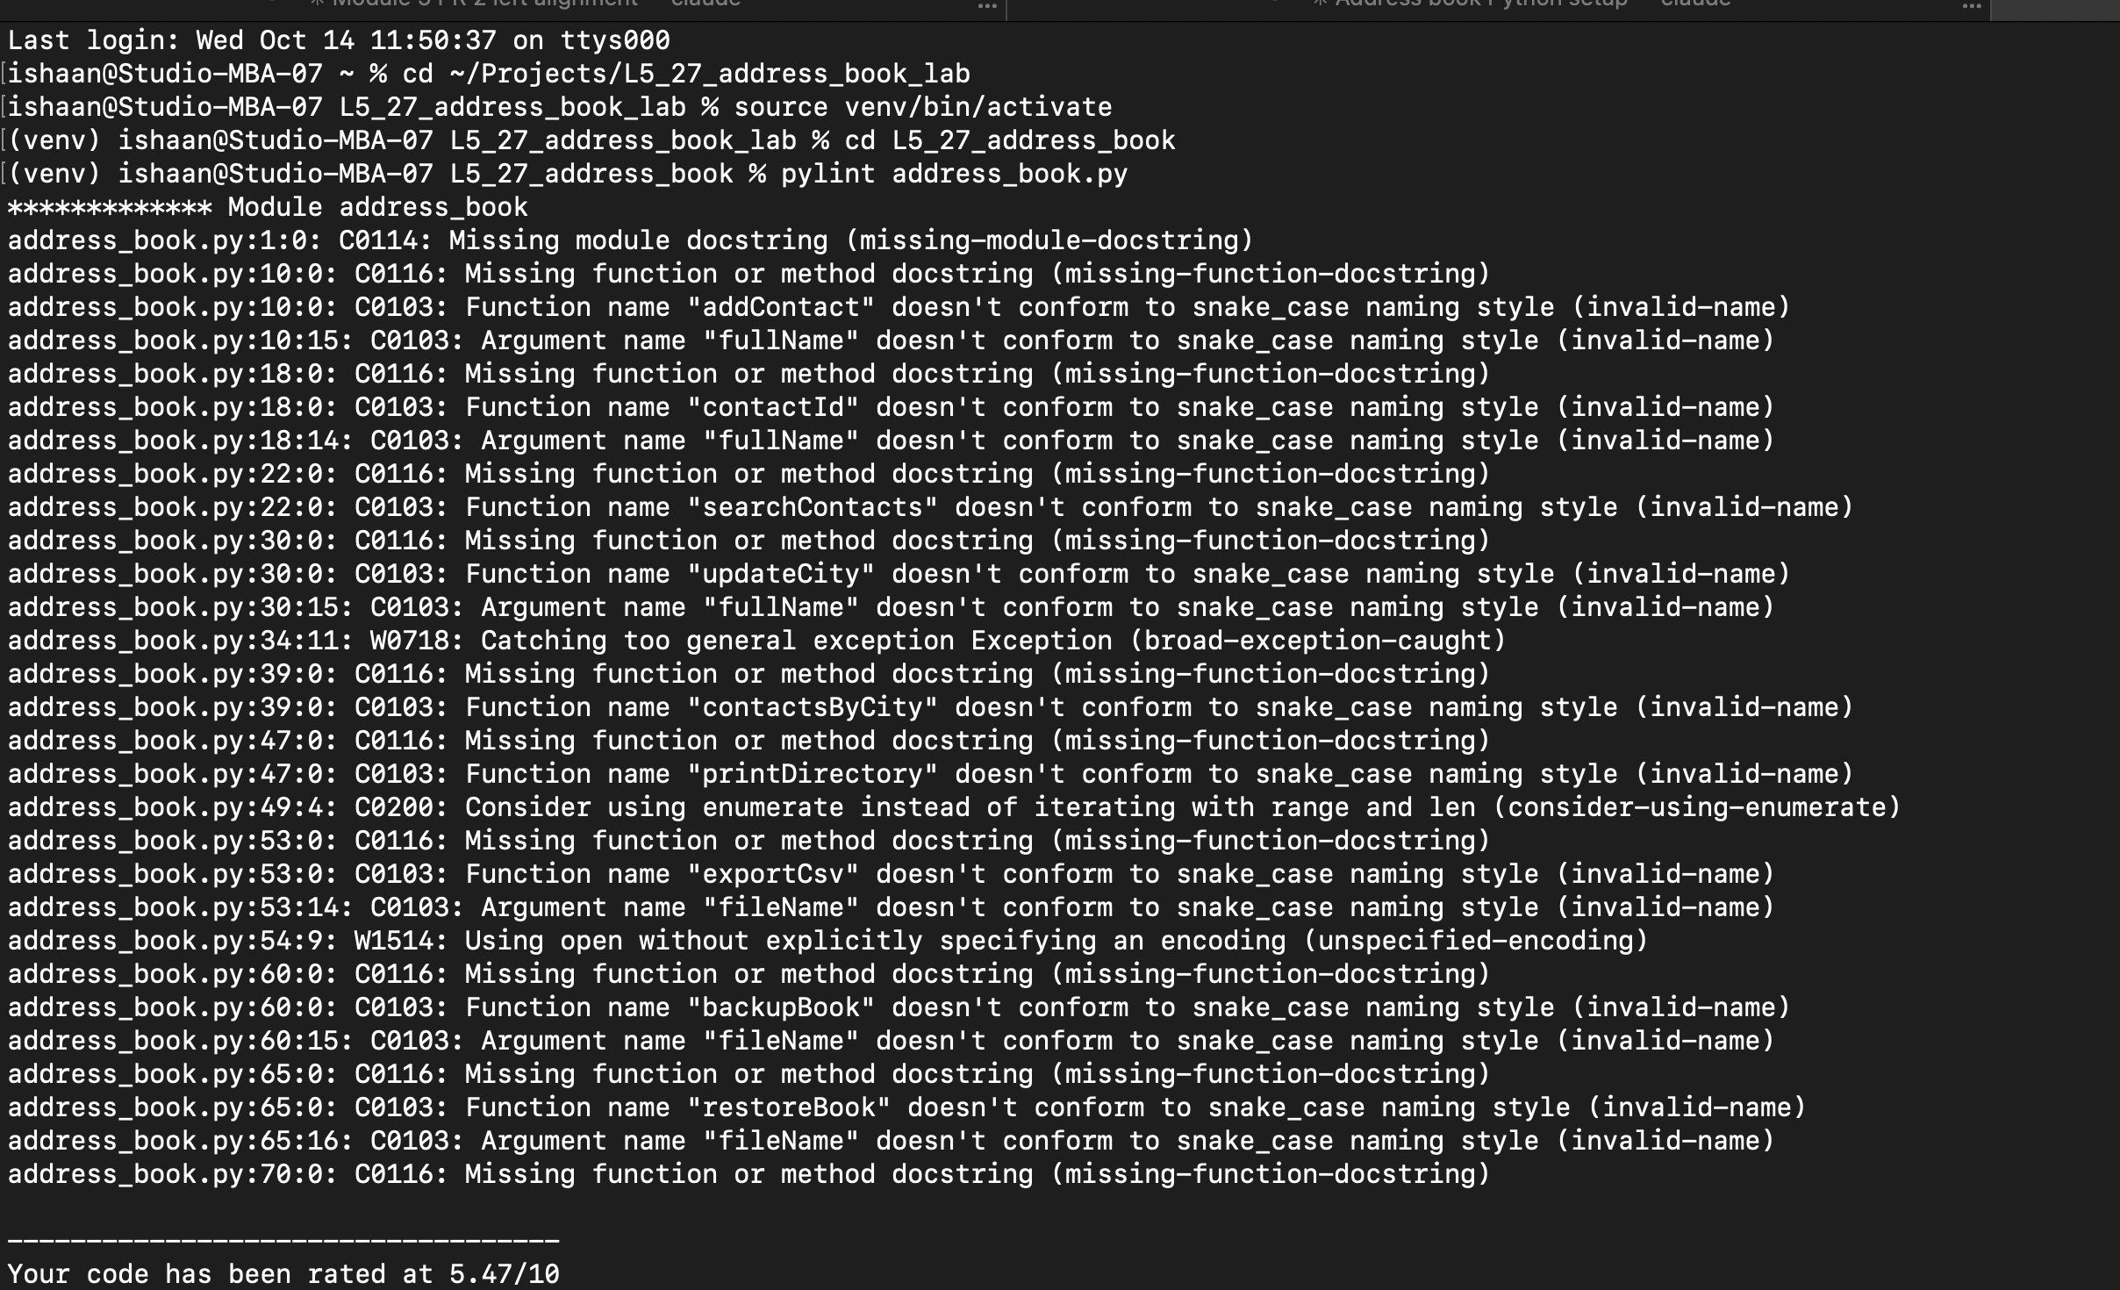

Before: Bandit
4 issues: MD5 (High), pickle.load (Medium), pickle import and hardcoded password (Low).
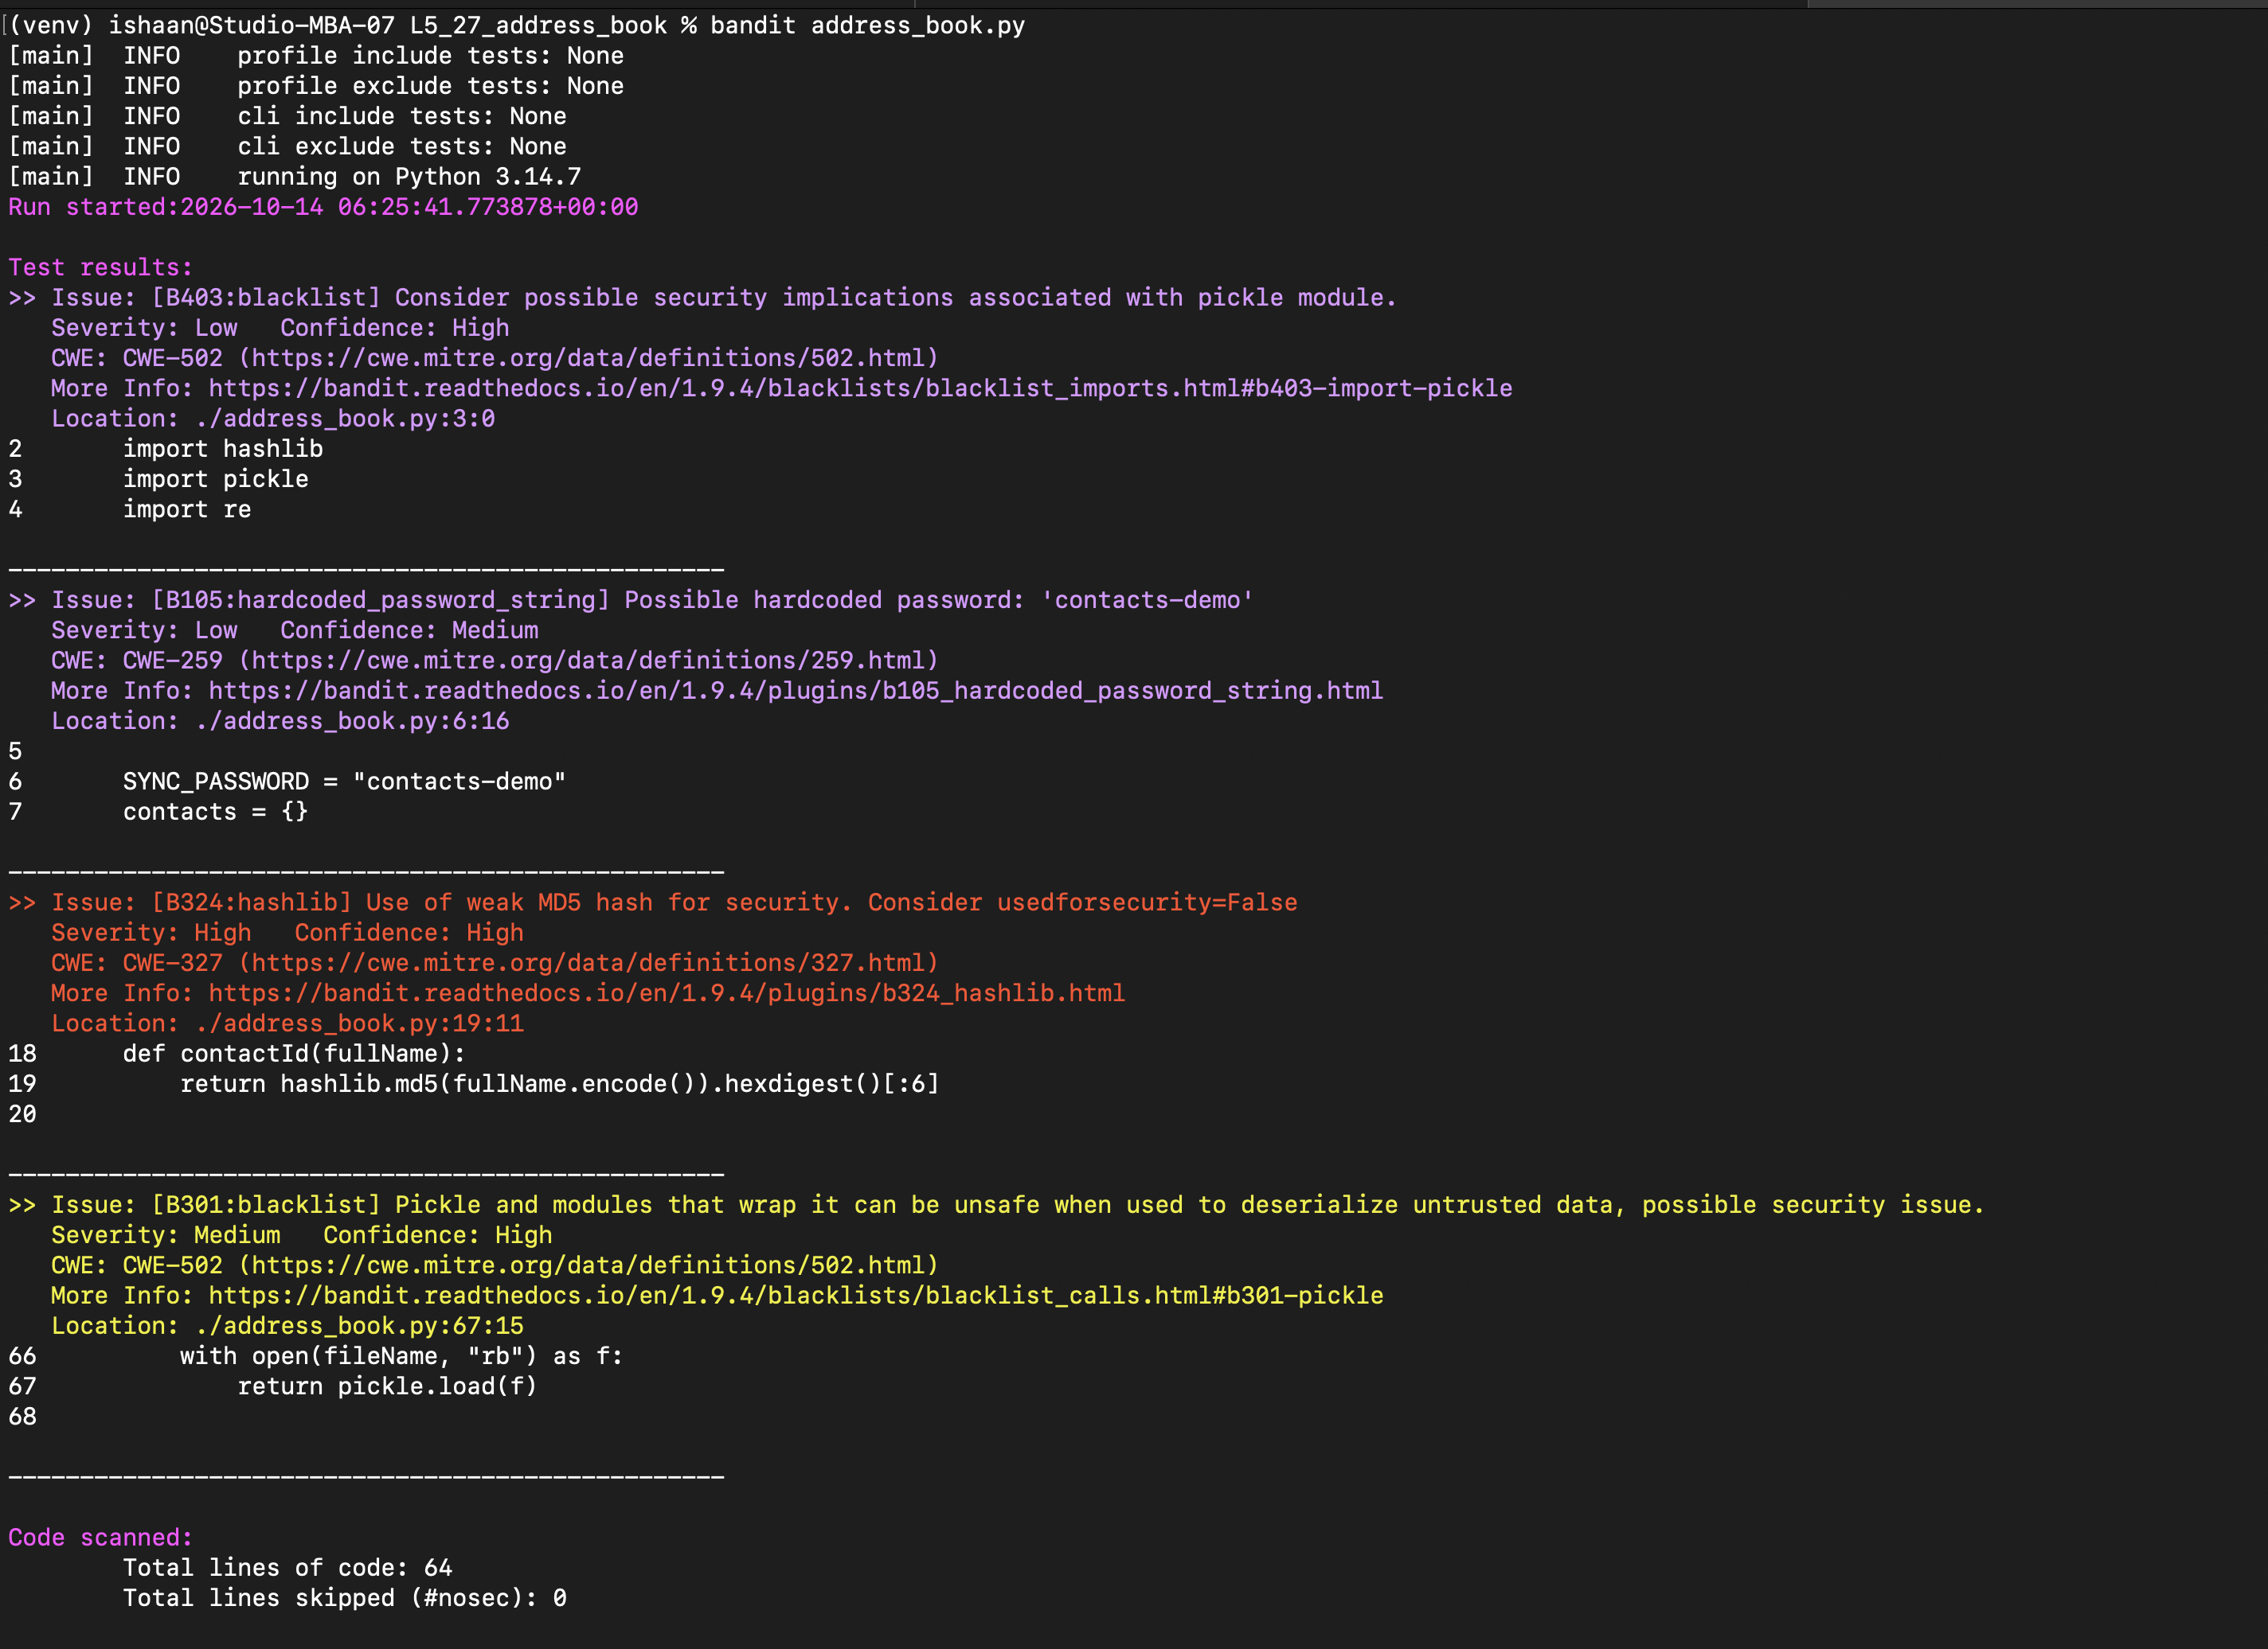

Before: Flake8
4 issues: E225, E303, E231, E501.
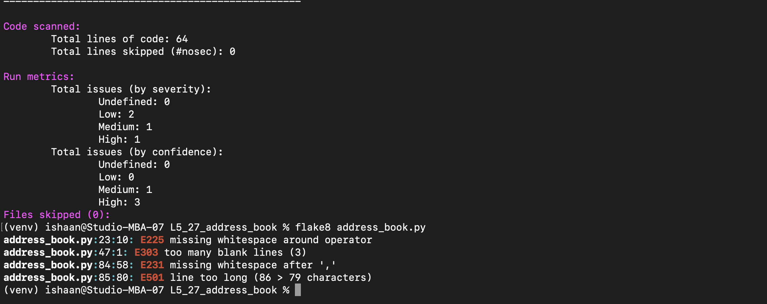

AFTER fixes

After: Flake8, Pylint, Bandit
Flake8 clean (no output), Pylint 10.00/10, Bandit: No issues identified.
