Novashyld Technologies Internship

TASK 1 Report – Foundations of Ethical Hacking & Penetration Testing
Submitted By: Ishant Jaiswal

1. Objective
Build a strong foundation in ethical hacking and penetration testing by understanding
the core methodology, legal boundaries, and essential technical basics.
2. Tools Used
- Oracle VM VirtualBox
- Kali Linux
- Metasploitable2
- Nmap
- Metasploit Framework
- Telnet
- FTP
- Netcat
- Web Browser

3. Lab Setup
A virtual lab was created using Oracle VM VirtualBox. Kali Linux was configured as the attacker machine and Metasploitable2 as the vulnerable target machine. NAT and Host-Only adapters were configured to establish isolated communication.
Assigned IPs:
- Kali Linux: 192.168.56.101
- Metasploitable2: 192.168.56.102

4. Practical Steps Performed
4.1 Connectivity Verification
ICMP ping test was performed successfully between Kali Linux and Metasploitable2 to confirm network communication.
4.2 Service Enumeration
Nmap service version detection scan was performed using:
nmap -sV 192.168.56.102
Multiple open ports and insecure services were identified including FTP, SSH, Telnet, HTTP, SMB, and SMTP.
4.3 Metasploit Initialization
Metasploit Framework was launched to understand the exploitation environment and vulnerability attack modules.
4.4 Weak Credential Exploitation
Unauthorized Telnet access was gained using default weak credentials (msfadmin/msfadmin), demonstrating insecure authentication.
4.5 Shell Verification
Commands like whoami, uname -a, and id were executed to verify shell access on the target machine.
4.6 FTP Access Testing
FTP login and directory listing were performed successfully, proving insecure file transfer configuration.
4.7 Web Service Exposure
The Metasploitable hosted vulnerable web applications were accessed via browser.
4.8 Banner Grabbing
Netcat was used to capture service banners from exposed FTP/Telnet services.
4.9 Vulnerability NSE Scan
Nmap NSE vulnerability scripts were executed to automatically detect vulnerable services.

5. Key Findings
- Multiple insecure services were publicly exposed.
- Default weak credentials allowed unauthorized access.
- Telnet and FTP services lacked proper hardening.
- Vulnerability scripts confirmed exploitable weaknesses.
- The target machine demonstrated a weak security posture.

6. Conclusion
Task 1 successfully demonstrated the practical implementation of the penetration testing lifecycle including lab setup, reconnaissance, scanning, weak credential exploitation, and vulnerability assessment. This task built a strong hands-on foundation in ethical hacking methodologies and cybersecurity basics.

7. GitHub Repository Link
Link : https://github.com/ishant-jaiswal30/NovaShyld-Task_1

Screenshots
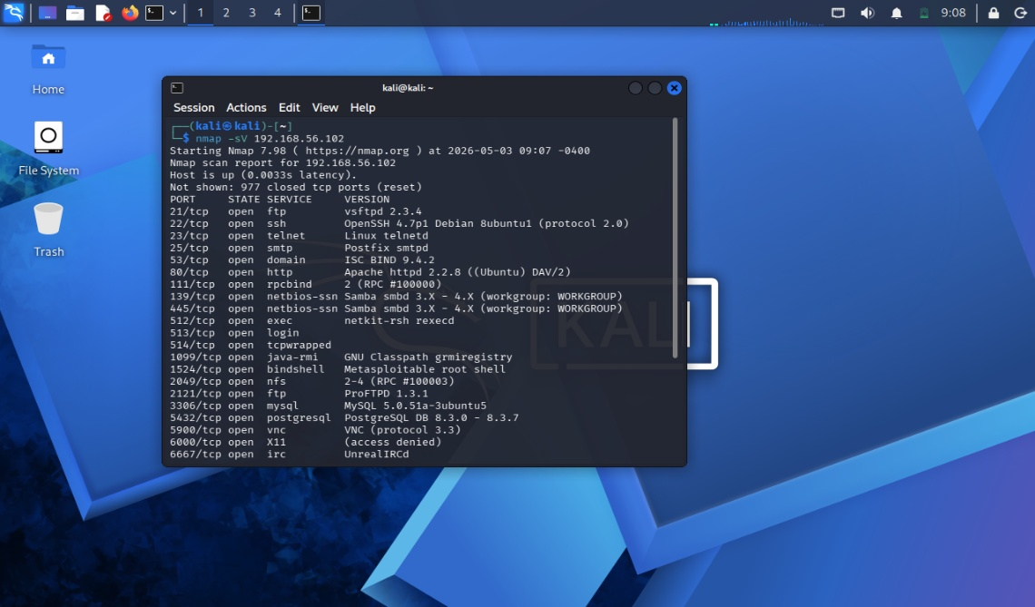
Fig.1. Nmap Scanning
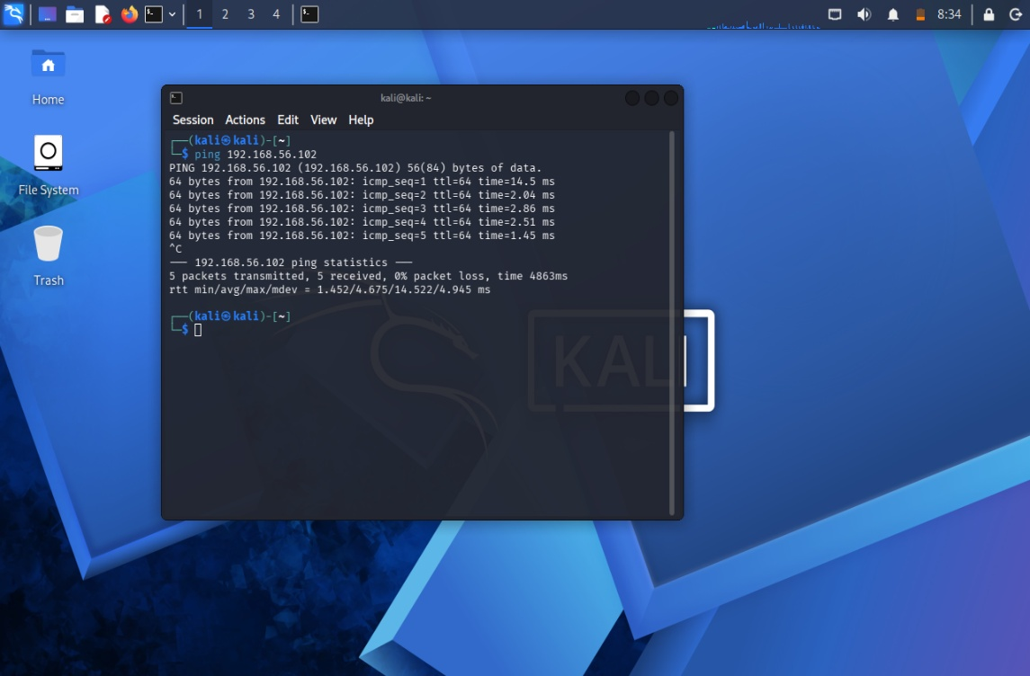
Fig.2. Ping Test
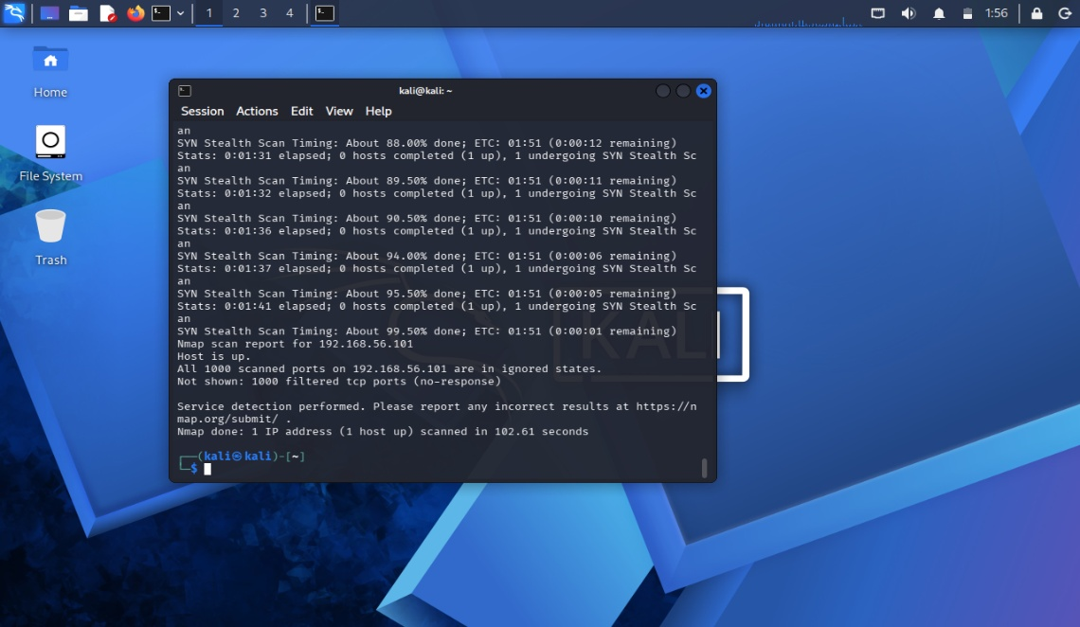
Fig.3. Vulnerability NSE Scan

