**ACTIVITY-5**

**My Local Network**

1. Record all the different network-attached devices in your home or classroom.
2. Investigate how each device connects to the network to send and receive information.
3. Create a diagram showing the topology of your network.
4. Label each device with its function within the network.
5. **Record all the different network-attached devices in your home or classroom.**

**The different network-attached devices in your home or classroom.**

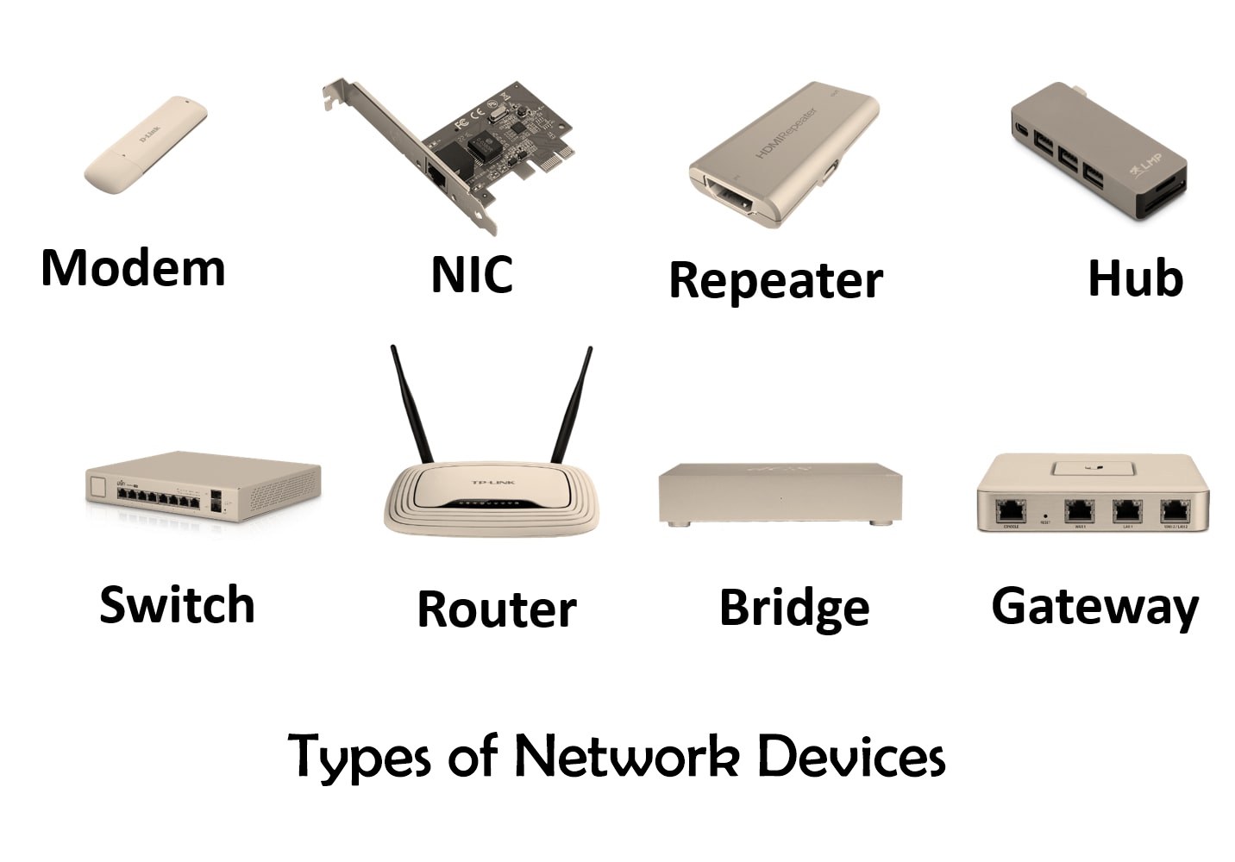

1. **Computers (laptops, desktops, all-in-ones):**

These are traditional computing devices used for various tasks, including work, entertainment, and more. They connect to the network for internet access, file sharing, and communication.

1. **Mobile devices (smartphones, tablets):**

Smartphones and tablets are portable computing devices that connect to the network via Wi-Fi or cellular data. They are used for web browsing, apps, messaging, and more.

1. **Gaming consoles:**

Devices like PlayStation, Xbox, and Nintendo Switch are used for gaming and often require an internet connection for online gaming, game downloads, and streaming services.

1. **Smart TVs:**

These televisions can connect to the internet and stream content from services like Netflix, Hulu, or YouTube. They may also have web browsers and apps.

1. **Streaming devices (Roku, Apple TV, Chromecast):**

These devices are used to stream online content to your TV. They connect to the internet and allow you to watch movies, shows, and more.

1. **Printers:**

Networked printers can be accessed by multiple devices on the same network. They allow wireless or wired printing from computers and mobile devices.

1. **Scanners:**

Networked scanners can scan documents or images and send them to computers or other devices on the network for storage or printing.

1. **Network-attached storage (NAS) devices:**

NAS devices are dedicated file storage servers that connect to the network. They are used for data backup, file sharing, and media streaming within a local network.

1. **Smart home devices (lights, thermostats, doorbells, cameras, etc.):**

These devices are part of the Internet of Things (IoT) and can be controlled and monitored via the internet. They include smart bulbs, thermostats, video doorbells, and security cameras.

1. **Voice assistants (Amazon Echo, Google Home, Apple HomePod):**

These devices use voice recognition to perform tasks like answering questions, controlling smart home devices, and playing music. They connect to the internet for voice recognition and to access information.

1. **Routers:**

Routers are the core of a home or office network. They manage network traffic, assign IP addresses, and provide internet connectivity to all devices in the network.

1. **Switches:**

Network switches are used to expand the number of wired network connections available. They connect multiple devices within a local network.

1. **Hubs:**

Hubs are similar to switches but less efficient. They connect multiple devices in a network but broadcast data to all devices, unlike switches, which send data only to the intended recipient.

Each of these devices plays a specific role in your network, providing a wide range of functionalities and services. Understanding the devices connected to your network is essential for managing and troubleshooting your network effectively.

1. **Investigate how each device connects to the network to send and receive information.**

**Certainly! Here's an investigation of how each of the listed devices typically connects to a network to send and receive information:**

1. **Computers (laptops, desktops, all-in-ones):**

These devices connect to the network using either Ethernet cables (wired) or Wi-Fi (wireless). They have network interface cards (NICs) that handle the connection.

1. **Mobile devices (smartphones, tablets):**

Mobile devices primarily connect to the network via Wi-Fi when in range of a wireless network. They can also use cellular data networks provided by mobile carriers when Wi-Fi is unavailable.

1. **Gaming consoles:**

Gaming consoles connect to the network via Ethernet cables for a more stable and faster connection. However, they can also connect wirelessly to Wi-Fi networks.

1. **Smart TVs:**

Smart TVs connect to the network through Wi-Fi or Ethernet, just like computers. They have built-in network adapters and Wi-Fi capabilities.

1. **Streaming devices (Roku, Apple TV, Chromecast):**

These devices connect to the network using Wi-Fi, allowing them to stream content from the internet and interact with other devices on the network.

1. **Printers:**

Networked printers can connect either via Wi-Fi or Ethernet. They have their own IP addresses and can be accessed by devices on the same network.

1. **Scanners:**

Networked scanners often connect via Wi-Fi or Ethernet, depending on the model. They allow documents to be scanned and transmitted to computers or storage locations on the network.

1. **Network-attached storage (NAS) devices:**

NAS devices connect to the network via Ethernet or Wi-Fi, depending on the model. They are dedicated file servers accessible by other devices on the same network.

1. **Smart home devices (lights, thermostats, doorbells, cameras, etc.):**

Smart home devices connect to the network through Wi-Fi or, in some cases, a specialized hub that connects to the router via Ethernet. They communicate with smartphones or other devices via an app or a central smart home platform.

1. **Voice assistants (Amazon Echo, Google Home, Apple HomePod):**

Voice assistants connect to the network via Wi-Fi. They listen for voice commands and transmit data to the cloud for processing.

1. **Routers:**

Routers connect to the internet through an Internet Service Provider (ISP) and distribute internet connectivity to all devices in the network via Ethernet cables and Wi-Fi.

1. **Switches:**

Switches create wired connections in a local network. Devices like computers and printers connect to a switch via Ethernet cables, and the switch efficiently routes data between them.

1. **Hubs:**

Hubs are similar to switches in connecting multiple devices via Ethernet cables, but they broadcast data to all devices, which can lead to network congestion and inefficiency.

Each of these devices uses different methods to connect to a network based on their design and intended use. Understanding how they connect is crucial for optimizing network performance and ensuring proper functionality.

1. **Create a diagram showing the topology of your network.**
2. **Label each device with its function within the network.**