The Agentic AI Grind!!! Road to Success.

Month 1: Fundamentals of AI System

Week 1:

- Traditional Vs AI Systems

Agentic AI represents an advanced evolution of AI systems, focusing on autonomy and goal-oriented behaviour, while traditional AI relies on predefined rules and human oversight for specific tasks.

Core Differences

Agentic AI operates independently, setting its own sub-goals, planning actions, and adapting to changes in real-time, unlike traditional AI's rigid, rule-based processing. Traditional systems excel at narrow tasks like classification or prediction but struggle with dynamic environments, whereas agentic AI uses reasoning loops—perceive, reason, act, learn—to handle complexity.

Aspect | Traditional AI | Agentic AI
Autonomy | Low; needs human input and prompts | High; self-directed with minimal oversight
Decision-Making | Rule-based, deterministic | Context-aware, probabilistic, adaptive
Adaptability | Limited to training data | Learns from feedback and environments
Use Cases | Routine predictions (e.g., Siri basics) | Multi-step workflows (e.g., autonomous planning)

Practical Implications

Agentic AI enables proactive problem-solving across tools and systems, such as dynamic customer segmentation or project automation, building on traditional AI's foundations but adding collaboration and long-term memory. This shift suits complex, real-world applications like enterprise workflows, though it requires robust guardrails for safety.

- Uncertainty in AI

Uncertainty in AI mainly shows up as non-determinism in LLMs, meaning the same input can produce different outputs each time. This happens because models like GPT-4 or LLaMA sample from probability distributions rather than following fixed rules. Factors like temperature, token sampling, and hidden randomness introduce variation, which is useful for creativity but risky for systems requiring consistency.

In an Agentic system, this uncertainty is handled using retry logic and validation loops. Instead of trusting a single response, the system checks if the output meets criteria (format, correctness, constraints). If it fails, the system retries—either with the same prompt, adjusted parameters (e.g., lower temperature), or a refined prompt. This makes the system more reliable without removing the flexibility of LLMs.

Example: Suppose an agent is generating JSON output for an API call. On the first attempt, the LLM returns malformed JSON. The system detects this using a parser, rejects it, and retries with a stricter prompt like “return valid JSON only.” On the second attempt, the output is valid, so the agent proceeds.

- Load Balancing for Inference - Techniques for distributing LLM API/Model requests

Load balancing for inference is about distributing incoming LLM requests across multiple model instances or APIs to reduce latency, avoid overload, and improve reliability. Since LLM calls (e.g., to GPT-4 or LLaMA) are compute-heavy and variable in duration, naive routing can cause bottlenecks, so smarter strategies are used.

Common techniques include round-robin and least-connections routing, where requests are evenly spread or sent to the least busy instance. More advanced setups use latency-aware routing, sending requests to the fastest responding node, or adaptive load balancing, which considers token usage, queue length, and GPU utilisation. In distributed setups, a request queue + worker pool pattern is common, and for high availability, systems use multi-region routing and failover across providers or clusters.

Example: An agent platform receives 100 LLM requests/sec. Instead of sending all to one endpoint, a load balancer distributes them across 5 model servers. If one server slows down due to heavy token generation, the system detects higher latency and shifts more traffic to faster nodes, keeping overall response time stable.

- Message Queues (Kafka) - Intro to Kafka in AI Pipelines for async processing

Message queues like Apache Kafka are used in AI pipelines to enable asynchronous, decoupled processing of tasks. Instead of calling an LLM or downstream service directly (blocking), a producer publishes a message (task/event) to a Kafka topic, and independent consumers process it when ready. This improves scalability, fault tolerance, and smooth handling of traffic spikes.

In Agentic systems, Kafka acts as a buffer between components—agents, retrievers, LLM workers—so failures or slowdowns in one part don’t break the entire flow. It also supports retries, replayability, and ordering guarantees, which are important for reliable AI workflows.

Example: A user submits a document for summarization. The frontend pushes a message to a Kafka topic “summarization_requests.” A pool of LLM workers consumes messages asynchronously, processes them, and publishes results to another topic “summarization_results.” Even if workers crash, Kafka retains the message, ensuring it gets processed later without losing the request.

- System Design Mock - Basic AI Chat System
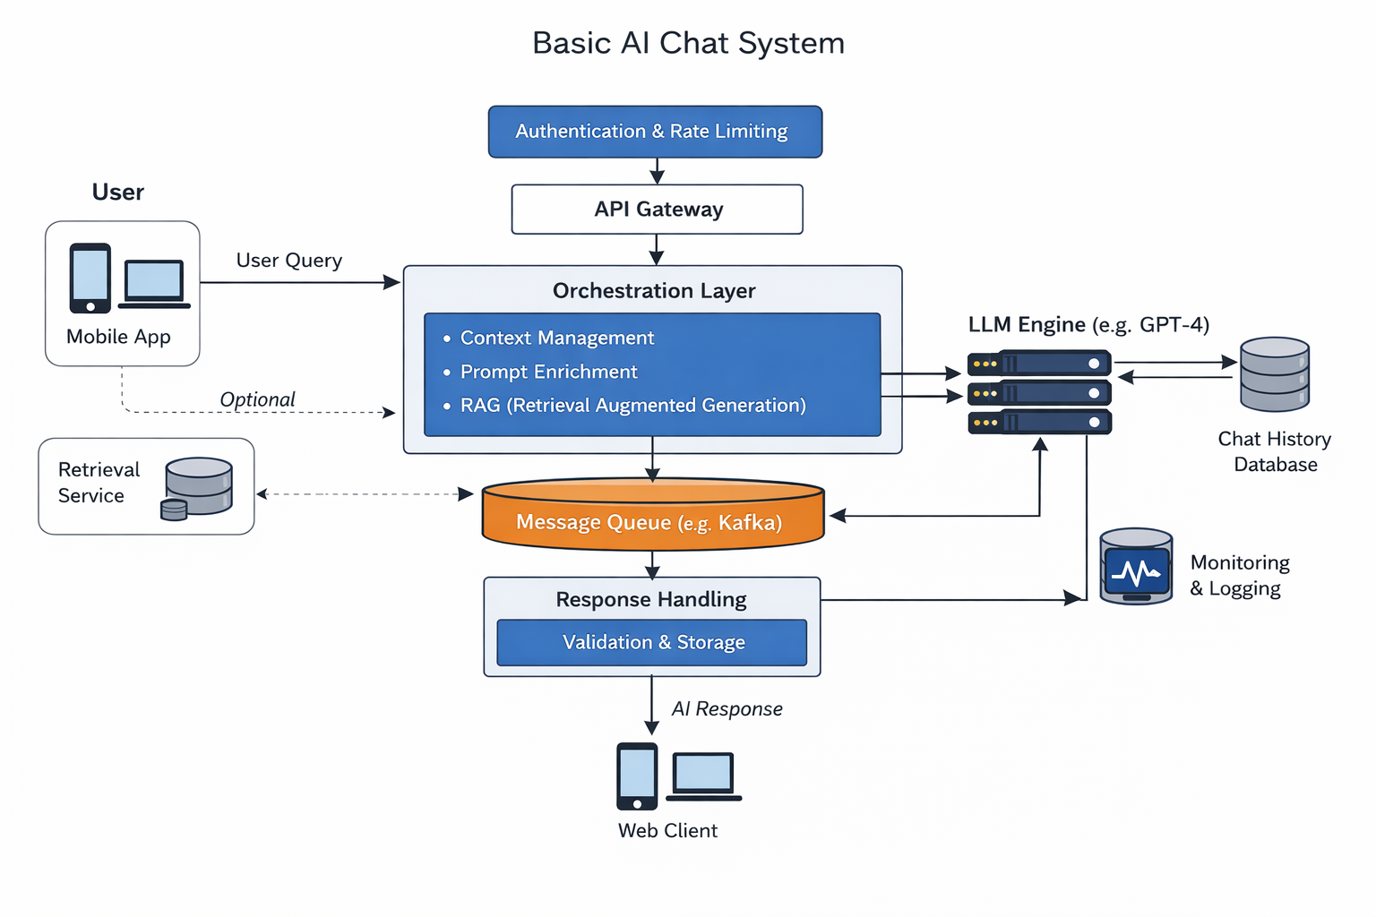
This diagram shows a typical end-to-end flow of a basic AI chat system, where each layer has a clear responsibility to keep the system scalable and reliable.

It starts with the user (mobile/web) sending a query. The request first goes through Authentication & Rate Limiting, ensuring only valid users can access the system and preventing overload. Then the API Gateway acts as the entry point, routing the request to the backend.

The core logic sits in the Orchestration Layer. Here, the system manages conversation context (past messages), enriches the prompt, and optionally fetches external data using retrieval (RAG). This prepared input is then sent to the LLM (like GPT-4), which generates the response.

Before reaching the LLM, requests may pass through a Message Queue (e.g., Apache Kafka). This enables async processing—if traffic spikes, requests are queued and handled by multiple workers, preventing system crashes.

Once the LLM generates a response, it goes to Response Handling, where the output is validated (format/safety) and stored in the Chat History Database. Finally, the response is sent back to the user.

Parallelly, Monitoring & Logging tracks system health, errors, and performance for debugging and scaling.

Example: When a user asks “Explain transformers,” the system fetches past context → builds a prompt → sends it via Kafka to an available LLM worker → gets the response → validates and stores it → returns the answer to the user.

- HTTP Status responses

HTTP response status codes indicate the result of an API request, helping systems decide whether to proceed, retry, or fail gracefully. They are grouped by categories based on the first digit.

1xx (Informational) means the request is received and processing is continuing, but these are rarely used in typical AI/API flows.

2xx (Success) indicates the request was successfully processed. The most common is 200 OK (successful response), 201 Created (resource created, e.g., new chat session), and 204 No Content (success but no response body). These are treated as successful paths in agents.

3xx (Redirection) means further action is needed, like 301 Moved Permanently or 302 Found, where the client should follow another URL. Not very common in LLM APIs but relevant in web flows.

4xx (Client Errors) indicate an issue with the request. 400 Bad Request means invalid input (e.g., malformed prompt), 401 Unauthorised means missing/invalid auth, 403 Forbidden means access denied, and 429 Too Many Requests is critical in AI systems—it signals rate limiting, where retry with backoff is needed.

5xx (Server Errors) means the server failed to process a valid request. 500 Internal Server Error is generic failure, 502 Bad Gateway and 503 Service Unavailable often happen in LLM APIs under load, and usually trigger retries.

Example: If an agent calls an LLM API and gets 200, it proceeds normally. If it gets 429, it waits and retries. If it gets 400, it stops and fixes the prompt instead of retrying.

- What is Agentic AI?

Agentic AI refers to systems where an LLM (like GPT-4) behaves as an autonomous agent that can plan tasks, take actions, use tools, and iterate toward a goal instead of giving a one-shot response.

In practice, an agent has a loop: think → act → observe → refine. It uses reasoning (chain-of-thought internally), tool usage (APIs, DBs), and memory (short/long-term context) to complete tasks. This makes it suitable for multi-step workflows like research, automation, or decision-making.

Example: A “travel planning agent” gets a request: “Plan a 3-day Tokyo trip under ₹1L.” The agent first breaks it into steps (flights, hotels, itinerary), calls APIs for pricing, adjusts based on budget, and iterates until a valid plan is generated—rather than answering in one shot.

Example: A “bug-fixing agent” receives a GitHub issue. It analyzes the error, reads code files, writes a fix, runs tests, and refines the solution if tests fail—looping until the issue is resolved instead of giving just a suggestion.

Popular frameworks help implement such agents. LangGraph is designed for building stateful, controllable agent workflows using graphs (great for production systems). CrewAI focuses on role-based multi-agent collaboration (e.g., planner, executor, reviewer). AutoGen enables agents that converse with each other to solve tasks. These frameworks abstract planning, memory, and tool usage, making agentic system design easier.

- Core Components of Agentic AI

A robust agent typically consists of four pillars:
The Brain (LLM):
The core controller that handles reasoning, planning, and decision-making.
Memory:
Short-term: The context window (chat history).
Long-term: Vector databases or SQL (to recall user preferences or past tasks).
Tools:
Interfaces that allow the agent to interact with the world (e.g., Calculators, APIs, Web Browsers, File Systems).
Planning:
The capability to decompose a complex user goal into smaller, manageable sub-steps (e.g., using ReAct or Plan-and-Solve patterns).
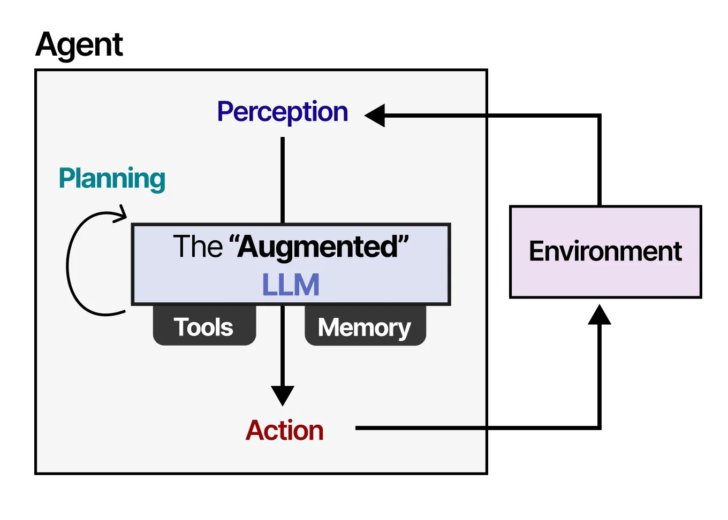
What is ReAct?
A ReAct agent is an AI agent that uses the “reasoning and acting” (ReAct) framework to combine chain of thought (CoT) reasoning with external tool use. The ReAct framework enhances the ability of a large language model (LLM) to handle complex tasks and decision-making in agentic workflows.

What is Plan and Solve Problems?
Plan-and-solve in agentic AI is an autonomous, multistep reasoning process where an agent breaks complex, high-level goals into smaller, actionable tasks before execution

- Simple Python Script which handles API Retries and Logging

This script wraps the LLM call in a retry loop. If the API fails (timeout, rate limit, etc.), it retries up to 3 times with a delay, while logging each attempt and failure.

Example: If the first call fails due to a rate limit, it logs the error, waits 2 seconds, retries, and succeeds on the second attempt without crashing the system.

import time
import logging
from langchain_openai import ChatOpenAI
from langchain.schema import HumanMessage

# Setup logging
logging.basicConfig(
level=logging.INFO,
format="%(asctime)s - %(levelname)s - %(message)s"
)

# Initialize LLM
llm = ChatOpenAI(
model="gpt-4",
temperature=0.7,
max_retries=0 # we handle retries manually
)

def call_llm_with_retry(prompt, retries=3, delay=2):
for attempt in range(1, retries + 1):
try:
logging.info(f"Attempt {attempt} - Calling LLM")

response = llm.invoke([HumanMessage(content=prompt)])

logging.info("LLM call successful")
return response.content

except Exception as e:
logging.error(f"Attempt {attempt} failed: {e}")

if attempt < retries:
time.sleep(delay)
else:
logging.critical("All retry attempts failed")
raise

# Example usage
if __name__ == "__main__":
prompt = "Explain what is an API in one sentence"

result = call_llm_with_retry(prompt)
print("Final Response:", result)

Week 2: Fundamentals of RAG (Retrieval Augmented Generation)

- Introduction to RAG

Retrieval augmented generation, or RAG, is an architecture for optimizing the performance of an artificial intelligence (AI) model by connecting it with external knowledge bases. RAG helps large language models (LLMs) deliver more relevant responses at a higher quality.

RAG allows generative AI models to access additional external knowledge bases, such as internal organizational data, scholarly journals and specialized datasets. By integrating relevant information into the generation process, chatbots and other natural language processing (NLP) tools can create more accurate domain-specific content without needing further training.

Working of RAG

RAG works by combining information retrieval models with generative AI models to produce more authoritative content. RAG systems query a knowledge base and add more context to a user prompt before generating a response.

Standard LLMs source information from their training datasets. RAG adds an information retrieval component to the AI workflow, gathering relevant information and feeding that to the generative AI model to enhance response quality and utility.
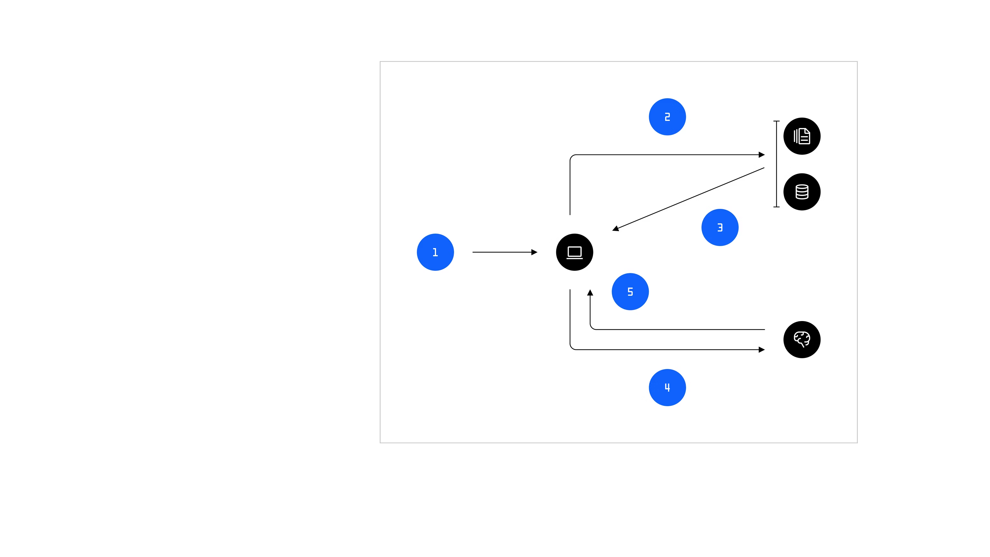
RAG systems follow a five-stage process:
1. The user submits a prompt.
2. The information retrieval model queries the knowledge base for relevant data.
3. Relevant information is returned from the knowledge base to the integration layer.
4. The RAG system engineers an augmented prompt to the LLM with enhanced context from the retrieved data.
5. The LLM generates an output and returns an output to the user.

This process showcases how RAG gets its name. The RAG system retrieves data from the knowledge base, augments the prompt with added context and generates a response.
Components of a RAG system

RAG systems contain four primary components:

1. The knowledge base: The external data repository for the system.
2.The retriever: An AI model that searches the knowledge base for relevant data.
3. The integration layer: The portion of the RAG architecture that coordinates its overall functioning.
4. The generator: A generative AI model that creates an output based on the user query and retrieved data.

Other components might include a ranker, which ranks retrieved data based on relevance, and an output handler, which formats the generated response for the user.

The knowledge base

The first stage in constructing a RAG system is creating a queryable knowledge base. The external data repository can contain data from countless sources: PDFs, documents, guides, websites, audio files and more. Much of this will be unstructured data, which means that it hasn’t yet been labeled.

RAG systems use a process called embedding to transform data into numerical representations called vectors. The embedding model vectorizes the data in a multidimensional mathematical space, arranging the data points by similarity. Data points judged to be closer in relevance to each other are placed closely together.

Knowledge bases must be continually updated to maintain the RAG system’s quality and relevance.

LLM inputs are limited to the context window of the model: the amount of data it can process without losing context. Chunking a document into smaller sizes helps ensure that the resulting embeddings will not overwhelm the context window of the LLM in the RAG system.

Chunk size is an important hyper-parameter for the RAG system. When chunks are too large, the data points can become too general and fail to correspond directly to potential user queries. But if chunks are too small, the data points can lose semantic coherency.

The retriever

Vectorizing the data prepares the knowledge base for semantic vector search, a technique that identifies points in the database that are similar to the user’s query. Semantic search machine learning algorithms can query massive databases and quickly identify relevant information, reducing latency as compared to traditional keyword searches.

The information retrieval model transforms the user’s query into an embedding and then searches the knowledge base for similar embeddings. Then, its findings are returned from the knowledge base.

The integration layer

The integration layer is the centre of the RAG architecture, coordinating the processes and passing data around the network. With the added data from the knowledge base, the RAG system creates a new prompt for the LLM component. This prompt consists of the original user query plus the enhanced context returned by the retrieval model.

RAG systems employ various prompt engineering techniques to automate effective prompt creation and help the LLM return the best possible response. Meanwhile, LLM orchestration frameworks such as the open source LangChain and LlamaIndex or IBM® watsonx Orchestrate™ govern the overall functioning of an AI system.

The generator

The generator creates an output based on the augmented prompt fed to it by the integration layer. The prompt synthesizes the user input with the retrieved data and instructs the generator to consider this data in its response. Generators are typically pretrained language models, such as GPT, Claude or Llama.

- Chunking Strategies - Fixed vs Semantic

Chunking is the process of splitting large documents into smaller pieces before feeding them into embedding models or LLM pipelines. The goal is to balance context preservation and retrieval accuracy.

Fixed-size chunking splits text into equal-length chunks (e.g., 500 tokens) regardless of meaning. It’s simple and fast but can break sentences or ideas mid-way, leading to loss of context. This works well when documents are structured or when speed is more important than precision.

Semantic chunking splits text based on meaning—like paragraphs, headings, or topic boundaries. It preserves context better, improving retrieval quality in RAG systems, but is slower and more complex to implement (often requires NLP heuristics or embeddings).

Example: Suppose you chunk a legal document. With fixed-size chunking, a clause might be split across two chunks, making retrieval incomplete. With semantic chunking, the entire clause stays in one chunk, so when queried, the system retrieves a coherent and complete answer.

- Hybrid Search - What is keyword search (BM25) and vector search? How to combine them?

Hybrid search combines keyword-based retrieval and vector (semantic) search to get both exact matches and contextual relevance.

Keyword search (BM25) is a traditional IR technique (used in systems like Elasticsearch). It ranks documents based on exact term matches, frequency, and document length. It’s strong for precise queries (e.g., error codes, names) but fails when wording differs (synonyms, paraphrases).

Vector search converts text into embeddings using models and finds semantically similar content via distance metrics (cosine similarity). It captures meaning even if exact words differ, but may miss exact keyword importance (e.g., specific IDs or rare terms).

Hybrid search combines both signals—typically by running both searches in parallel and merging scores. Common approaches include weighted scoring (BM25 + vector similarity), re-ranking (use vector search first, then refine with BM25 or vice versa), or using one as a filter and the other as a ranker.

Example: A user searches “fix login 500 error.” BM25 will strongly match documents containing “500 error,” while vector search may find docs about “server failure during authentication.” Hybrid search combines both, ensuring the result is both exact (500 error) and semantically relevant (login failure), improving retrieval quality.

- ReRanking - Cross Encoders (refining search results)

Re-ranking is a second-stage step in retrieval where you take the top N results (from BM25/vector search) and reorder them using a more accurate but slower model. This improves final relevance without searching the entire corpus again.

Cross-encoders are commonly used for this. Unlike bi-encoders (used in vector search) that embed query and documents separately, cross-encoders (e.g., BERT-based models) take query + document together as input and output a single relevance score. This allows deep interaction between query and text, leading to much higher ranking quality.

In practice, the pipeline is: retrieve top ~50 candidates using fast methods → pass each (query, doc) pair through the cross-encoder → sort by relevance score → return top results. This is widely used in RAG systems to reduce hallucinations and improve answer grounding.

Example: A query “best way to handle API retries” retrieves 20 docs via vector search. Some are loosely related. A cross-encoder evaluates each pair and ranks a document specifically about “retry logic with exponential backoff” higher than a generic “API best practices” doc, refining the final output quality.

- Query Expansion - Techniques like HyDE (Hypothetical Document Embeddings)

Query expansion improves retrieval by enhancing or reformulating the user query so the system can find more relevant documents, especially when the original query is short or ambiguous.

One advanced technique is HyDE (Hypothetical Document Embeddings). Instead of embedding the raw query, the system first uses an LLM (e.g., GPT-4) to generate a hypothetical answer/document for the query. This generated text is richer in context and vocabulary, and its embedding is then used to search the vector database. Since the hypothetical document resembles a real answer, retrieval quality improves significantly.

Other expansion methods include adding synonyms, paraphrasing the query, or generating multiple query variants and merging results.

Example: For the query “how to reduce API latency,” HyDE generates a paragraph about caching, load balancing, and async processing. This richer text is embedded and used for search, retrieving documents that might not explicitly mention “reduce latency” but discuss those techniques, leading to better results than the original short query alone.

- RAG Evaluation

RAG performance evaluation measures how well a Retrieval-Augmented Generation system retrieves relevant context and generates accurate, grounded answers. It is typically evaluated in two parts: retrieval quality and generation quality.
For retrieval, metrics focus on whether the right documents are fetched. Common ones include Recall@K (did the correct document appear in top K results?) and MRR (Mean Reciprocal Rank) (how high the correct document is ranked). Poor retrieval directly leads to hallucinations since the LLM lacks the right context.
For generation, evaluation checks if the answer is factually correct and grounded in retrieved context. This is often done using LLM-based evaluators (like GPT-4) or frameworks such as Ragas, which provide metrics like faithfulness (is answer supported by context?), answer relevancy, and context precision.
In practice, evaluation is done using a labeled dataset of queries + ground truth answers/docs, or via synthetic test sets. Both automated metrics and human evaluation are used for reliability.
Example: For a query “What is retry logic?”, if the system retrieves unrelated docs, Recall@K is low. If it retrieves correct docs but the LLM generates extra incorrect info, faithfulness is low. A good RAG system scores high on both retrieval and grounded generation.
- Vector DB Basics - Introduction to Pinecone, Weaviate and understanding vector embeddings

Vector databases are designed to store and search embeddings, which are numerical representations of text, images, etc. Embeddings capture semantic meaning, so similar content is close in vector space. In AI systems, text is converted into vectors using embedding models, and queries are matched using similarity (e.g., cosine similarity) instead of exact keywords.

Tools like Pinecone and Weaviate provide scalable infrastructure for storing and querying these vectors. Pinecone is fully managed and optimized for fast similarity search, while Weaviate also supports hybrid search (keyword + vector) and built-in modules. Both allow indexing, filtering, and metadata-based retrieval alongside vector search.

Example: A document “How to handle API retries” is converted into an embedding and stored. When a user queries “retry logic for APIs,” the system converts this query into a vector and finds the closest vectors in the DB, retrieving the relevant document even though exact words differ.

- HNSW (Hierarchical Navigable Small World)

HNSW (Hierarchical Navigable Small World) is an efficient indexing technique used in vector databases to perform approximate nearest neighbor (ANN) search. Instead of comparing a query vector with every stored vector (which is slow), HNSW organizes vectors into a multi-layer graph where nodes (vectors) are connected to their closest neighbors.

The structure is hierarchical: upper layers are sparse and help quickly navigate large distances, while lower layers are dense and refine the search locally. During a query, the algorithm starts at the top layer, greedily moves to closer nodes, and progressively descends layers to find the nearest neighbors. This makes search logarithmic in complexity, much faster than brute force, with minimal accuracy loss.

In systems like Pinecone or Weaviate, HNSW is commonly used under the hood to enable low-latency semantic search at scale.

Example: Suppose you have millions of document embeddings. Instead of scanning all, HNSW quickly “navigates” through the graph to a region of similar vectors and returns the closest matches, enabling fast retrieval for RAG systems.

- Metadata Filtering

Metadata filtering in vector databases allows you to narrow down the search space using structured attributes (like tags, dates, user IDs) before or alongside vector similarity search. This improves both relevance and performance, especially in multi-tenant or domain-specific systems.

Instead of searching across all vectors, the system first applies filters (e.g., department = finance, date > 2024) and then performs similarity search only on the filtered subset. Most vector DBs like Pinecone and Weaviate support this using key-value metadata attached to each vector.

There are two common approaches: pre-filtering (apply metadata filter first, then vector search) and post-filtering (do vector search first, then filter results). Pre-filtering is more efficient, while post-filtering is useful when filters are less strict.

Example: In a company knowledge base, each document has metadata like {team: "HR", region: "India"}. If a user from India HR searches a query, the system filters only HR + India documents and then performs vector search, avoiding irrelevant results from other teams or regions.

- Scaling Vector DBs - Sharding and replication in context of Vector Data

Scaling vector databases is about handling large volumes of embeddings and high query traffic while keeping latency low. Two key techniques are sharding and replication, adapted specifically for vector search workloads.

Sharding splits the dataset into smaller partitions (shards), each stored on different nodes. Queries are either broadcast to all shards or routed intelligently (e.g., based on metadata). Each shard performs ANN search (like HNSW) locally, and results are merged. This allows horizontal scaling as data grows, used in systems like Pinecone and Weaviate.

Replication creates multiple copies of the same shard across nodes. This improves availability and read throughput—if one node fails, another replica serves the request. It also enables load balancing for high QPS systems.

In practice, systems combine both: data is sharded for scale and each shard is replicated for reliability. Trade-offs include consistency (sync vs async replication) and increased storage cost.

Example: A vector DB with 100M embeddings is split into 10 shards across nodes. Each shard has 2 replicas. A query is sent to all shards, each returns top results, and the system merges them. If one node fails, its replica still serves queries without downtime.

- Inference Optimization - Semantic caching to reduce API costs

Semantic caching is an inference optimization technique where you store previous LLM responses along with their embeddings, and for every new query, you check if a semantically similar query has already been answered. Instead of exact string matching (traditional caching), it uses vector similarity (via embeddings in a vector DB) to reuse responses for “meaningfully similar” queries, reducing redundant LLM calls, latency, and API cost. A similarity threshold (e.g., cosine similarity > 0.9) decides whether to return a cached response or call the model again. This is especially useful in Agentic systems where users or agents often ask variations of the same question.

For example, if a user asks “What is the refund policy?” and later another asks “Can I get my money back after purchase?”, both queries generate similar embeddings. If the similarity crosses the threshold, the system returns the cached response instead of calling the LLM again. In an Agentic customer support system, this can significantly cut costs when handling repeated intent-level queries while maintaining fast responses.

- Rate Limiting - Client side rate limiting for LLM providers

Client-side rate limiting is a strategy where your application proactively controls how many requests it sends to an LLM provider (like OpenAI or Anthropic) to stay within API quotas and avoid throttling errors (e.g., 429). Instead of relying on server-side rejection, the client enforces limits using techniques like token bucket or leaky bucket algorithms, often combined with request queues and retries with exponential backoff. This ensures smoother throughput, predictable latency, and prevents cascading failures in Agentic systems where multiple agents may fire concurrent requests.

For example, suppose your system allows 60 requests per minute. If 100 agent actions trigger LLM calls at once, the client-side limiter queues or delays the extra 40 requests and releases them gradually. Without this, the provider would reject excess calls, causing retries, increased latency, and potential system instability.

- Streaming Strategies - Server sent events for llm responses

Server-Sent Events (SSE) is a streaming strategy where the server pushes partial LLM outputs to the client over a single long-lived HTTP connection, instead of waiting for the full response. As the model generates tokens, they are streamed incrementally, improving perceived latency and enabling real-time UX (typing effect, early rendering). SSE is unidirectional (server → client), lightweight (uses standard HTTP), and simpler than WebSockets for LLM streaming since the client doesn’t need to send continuous messages after the initial request.

For example, in an Agentic chatbot using an API from OpenAI, when a user asks a question, the backend forwards the request with streaming enabled. The server then emits tokens like “The… capital… of… France…” as they are generated, and the frontend appends them live to the UI. This allows users to start reading immediately instead of waiting for the full completion, reducing perceived latency and improving interactivity.

- Cost Management - Analyze token usage and optimize prompt lengths

Cost management in LLM systems mainly comes from controlling token usage, since providers like OpenAI charge per input + output tokens. The goal is to analyze where tokens are being spent (system prompt, history, retrieved context, output) and reduce unnecessary verbosity without hurting quality. Common optimizations include trimming conversation history, compressing retrieved documents (summarization), using structured prompts instead of verbose instructions, and setting output limits (max_tokens). In Agentic systems, this is critical because multiple tool calls and reasoning loops can quickly multiply token usage.

For example, instead of sending a full 10-message chat history (~2k tokens), you summarize it into a 200-token context and pass only the latest query + summary. If each request originally used 3k tokens and you reduce it to 1k tokens, at scale (say 10k requests/day), you cut costs by ~66% while maintaining similar response quality.

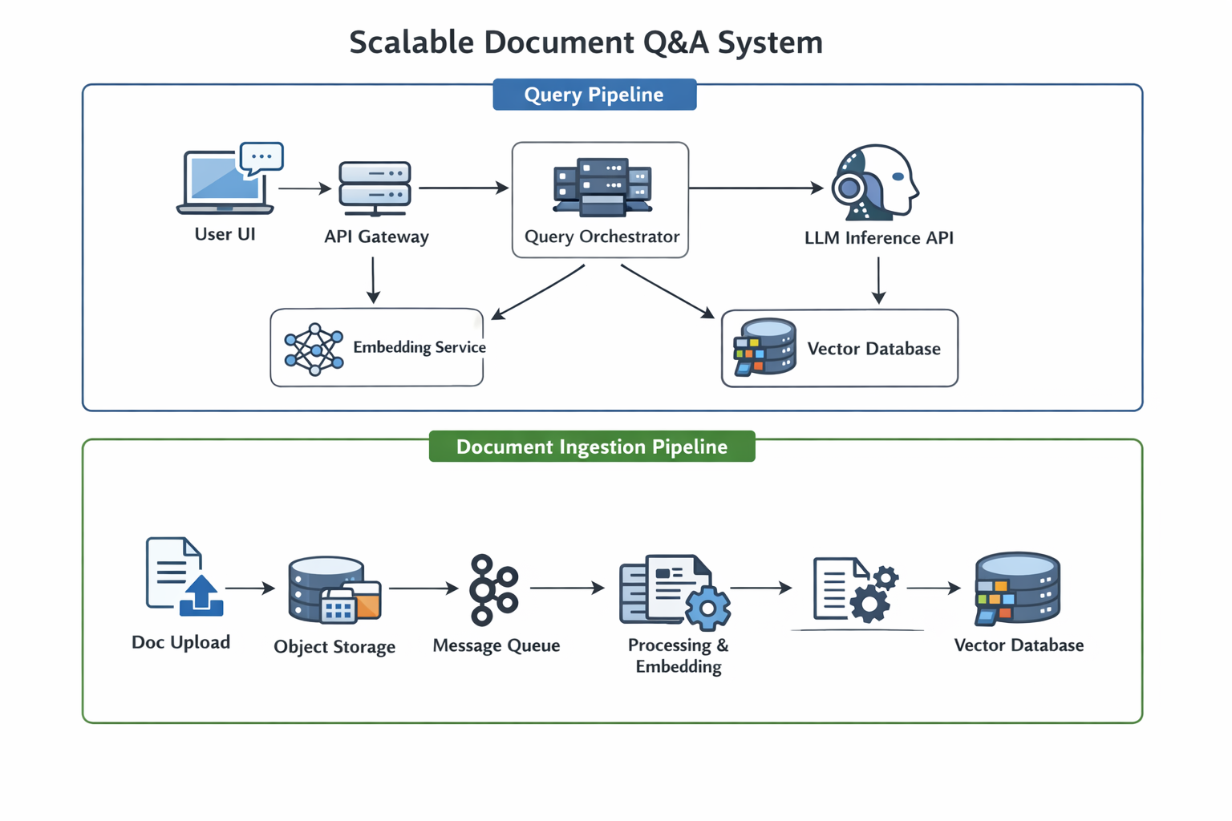
- Design a scalable doc q&a system

A scalable Document Q&A system is usually designed as an ingestion pipeline plus an online query pipeline. During ingestion, documents are uploaded to object storage, then a preprocessing service extracts text, chunks the content, generates embeddings, and stores them in a vector database. Metadata is stored separately for filtering. During query time, the user query goes through an API gateway to an orchestrator service, which embeds the query, retrieves relevant chunks from the vector DB, builds the prompt, and sends it to the LLM. To scale, ingestion workers run asynchronously through a message queue, vector DB is horizontally scalable, and the orchestrator is stateless behind a load balancer. Caching is often added for embeddings and repeated queries to reduce cost and latency.

For example, if 1,000 PDFs are uploaded, they are processed asynchronously by workers so ingestion doesn’t block user queries. When a user asks “What is the refund policy?”, the orchestrator embeds the question, retrieves the top relevant chunks from the vector DB, and sends them to the LLM for answer generation. This separation between offline ingestion and online retrieval makes the system scalable and efficient.

