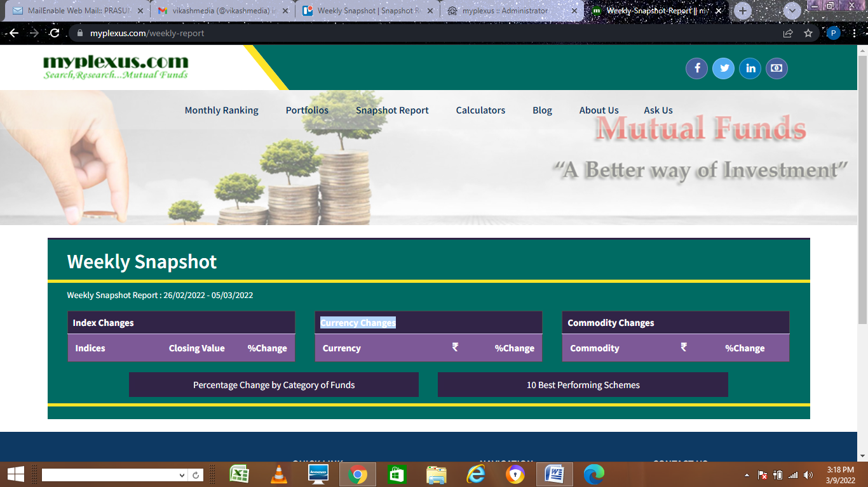
Weekly snapshot: https://www.myplexus.com/weekly-report
The data span in question is from the Sunday to Saturday Weekly Snapshot Report : 26/02/2022 - 05/03/2022
No matter when the viewer is looking up the data, it will ONLY be for the immediate past week and it will be automatically populate every Sunday morning… and keep on showing the same data for the next 7 days (till Saturday).
Of All the indices which are there we need to give the index name and the percentage change for the period mentioned for ONLY 6 indices. 3 of the best, 3 of the worst. So the names are dynamic. Yesterday I had sent the doc for calculating per cent changes. The same logic would be applicable.
Currency Changes this will have the currencies we track ----- dollar, pound, yen and the percentage change over the mentioned time period.
Commodity changes will be the percent change for gold, silver and crude over the mentioned time period.
Percentage Change by Category of Funds
Let us say we have a category called Open Ended Equity Flexi Cap Fund. The schemes which are flexi cap are to be found from the FUND MASTER TABLE. The funds will have a percent change over the mentioned time period (i.e. returns) The layout will mention all the categories one after the other and the table content will be orderable (scroll option) for each of the columns. Upon clicking the name of the classification, the fund names in the classification will be shown with their individual scheme changes and the percent section will be orderable (scroll option).
 | Percent change by category
Fund Classification | Average Change | Median Change
Open Ended Equity Flexi Cap Fund | 0.3 for example | 0.27 for example

https://www.myplexus.com/know-your-scheme?id=Open%20Ended%20Equity%20Flexi%20Cap%20Fund&flg=2

10 Best Performing Schemes these will be the 10 best performing schemes amongst all the schemes that we have (around 800 odd now) for the mentioned time period. Thus we are talking of percentage changes in NAV over the period of one week.

