**Overview**

This application is developed for TCI so that its customers can order the items. The sales order is directly created in the AX through this application.

Following are the Core functionality which we will discuss 1 by 1.

1)Registration, Account login and Forgot password.

2)Adding items into the cart, viewing the cart and confirming the order.

3)Enquiry – Viewing past sales orders and invoices by its number.

**Registration:**

Below is the registration page where a customer can enter its details and click on Register Button. Once a customer is registered, the AX team would create its account in AX and give the username password to the customer.

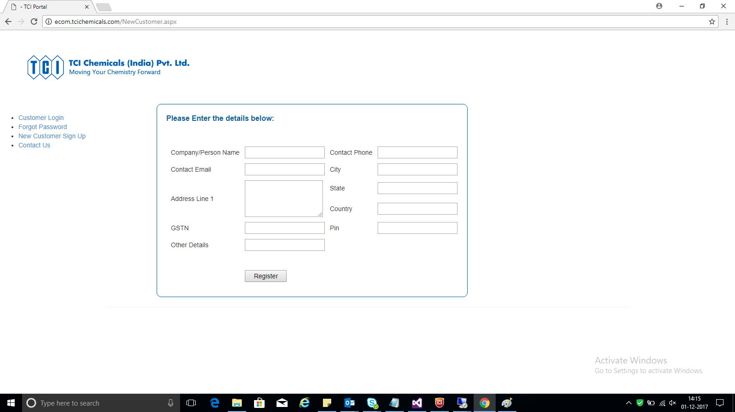

**Customer Login:**

A customer can enter the User Id and password and login to the system.

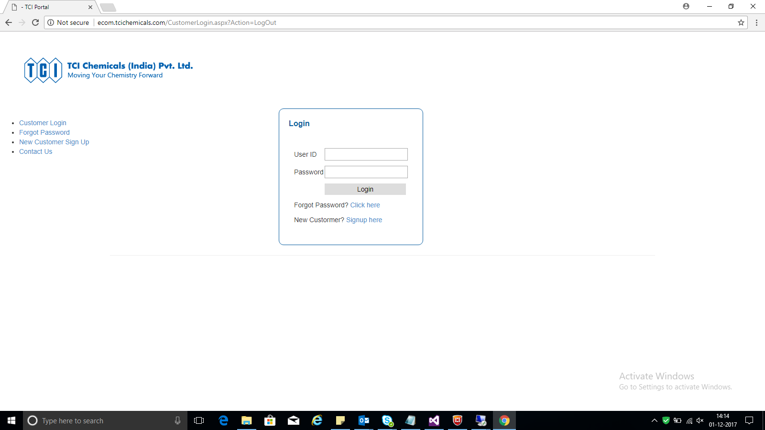

**Forgot Passwords:**

If a customer forgets the password, he can simply submit its User Id and email to the below page.

A link will be sent through email to reset the password.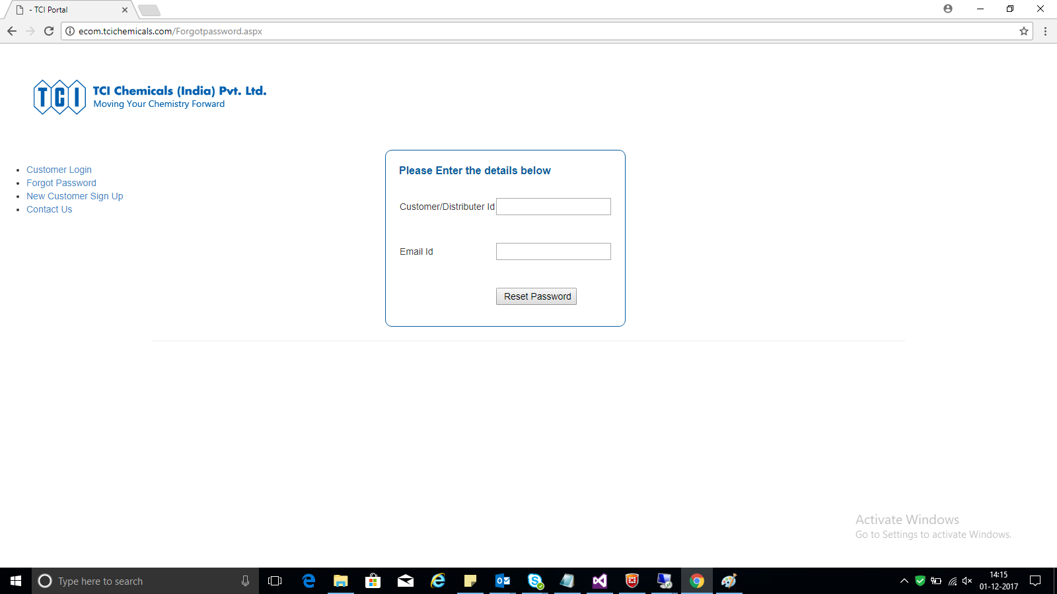

**Home Page:**

After the customer logins, he will be redirected to the homepage screen where he will be able to see the list of products. These products are coming from the AX database.

A customer can search the items which he needs to order as shown in the below screen.

In this screen a search has been processed on the item Code (B000). Also he can add the quantity of each item he wants to order and press add to cart button shown below the grid. These added items will be shown in the view cart page which we will be discussing in our next page.

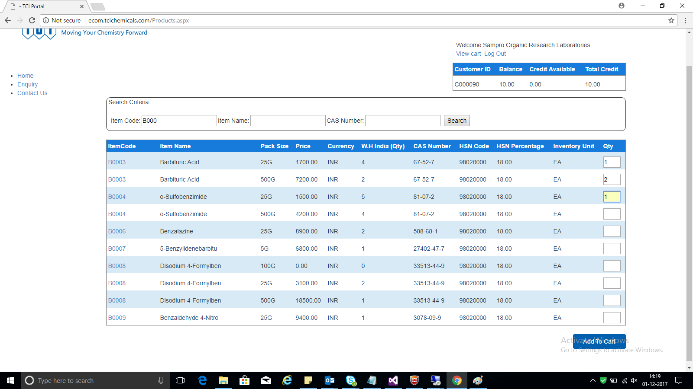

**View Cart:**

On clicking the view cart link from the home screen, the following page will be opened. It would contain all the items which were added from the home screen with the respective quantity.

Alternatively, a customer can add the items to the cart by uploading the excel as shown in the upload excel section.

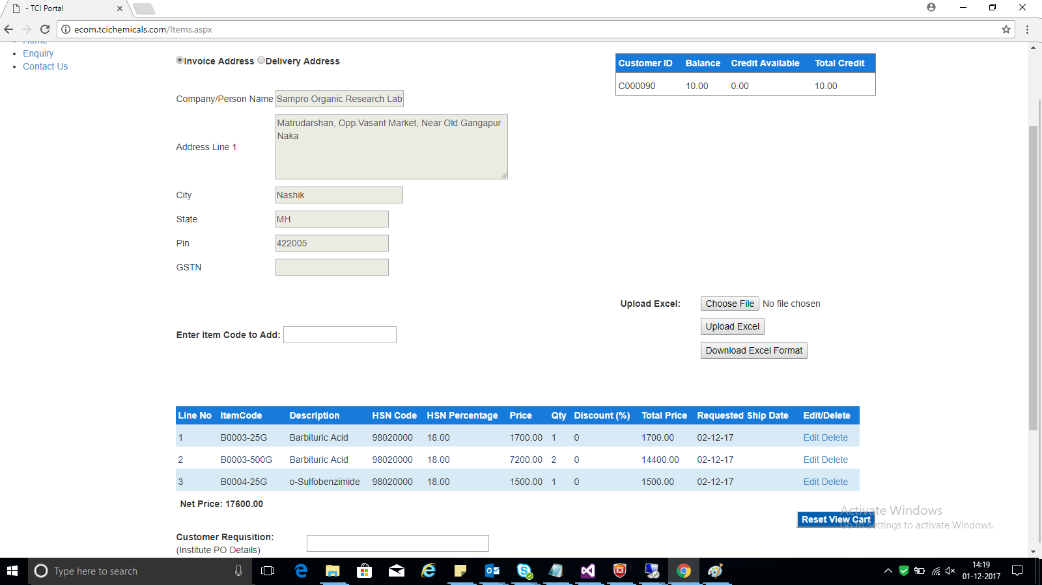

**View Cart Continued…**

After adding the items to the cart a customer has to give some basic information like Customer Requisition, Purchase Order, Remark and upload the document (Optional).

After entering these information, the customer is required to click on “Confirm Order” Button.

Once the customer clicks on “Confirm Order” all the data entered by customer along with the items in the view cart gets pushed into the AX system and a sales order number is returned to the application by the AX system.

