Issue 1:
Defect Log:
Application URL: http://13.200.185.1/c/ishan-9e7934/catalogue?q=dsdsds&category=
User: buyer1
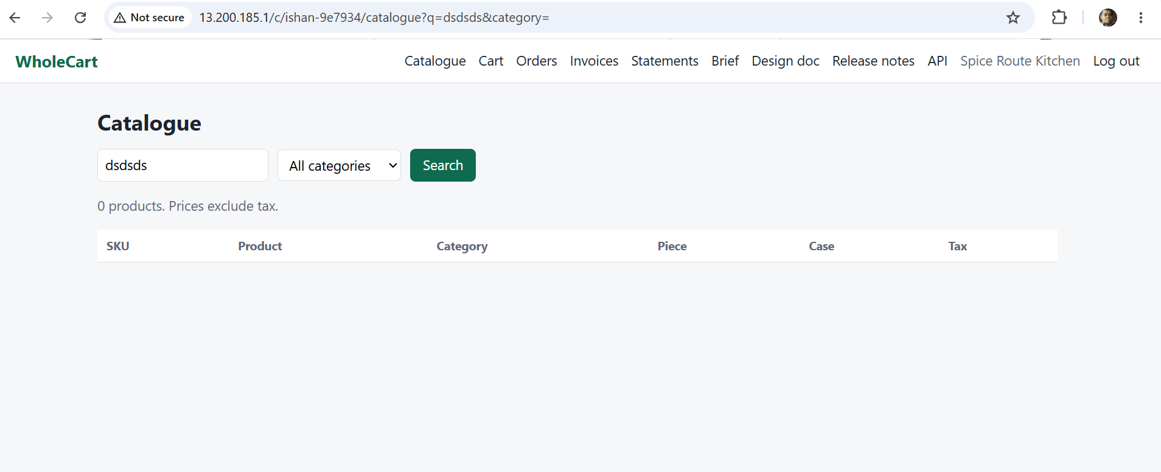
Steps:
1.Open the given URL
2.Search with random text
3.Validate the text message for no result found

Expected: Only “No Products found” to be displayed
Actual:It is showing “0 products. Prices exclude tax. “

Issue 2:
Defect Log:
Application URL: http://13.200.185.1/c/ishan-9e7934/catalogue?q=dsdsds&category=
User: buyer1
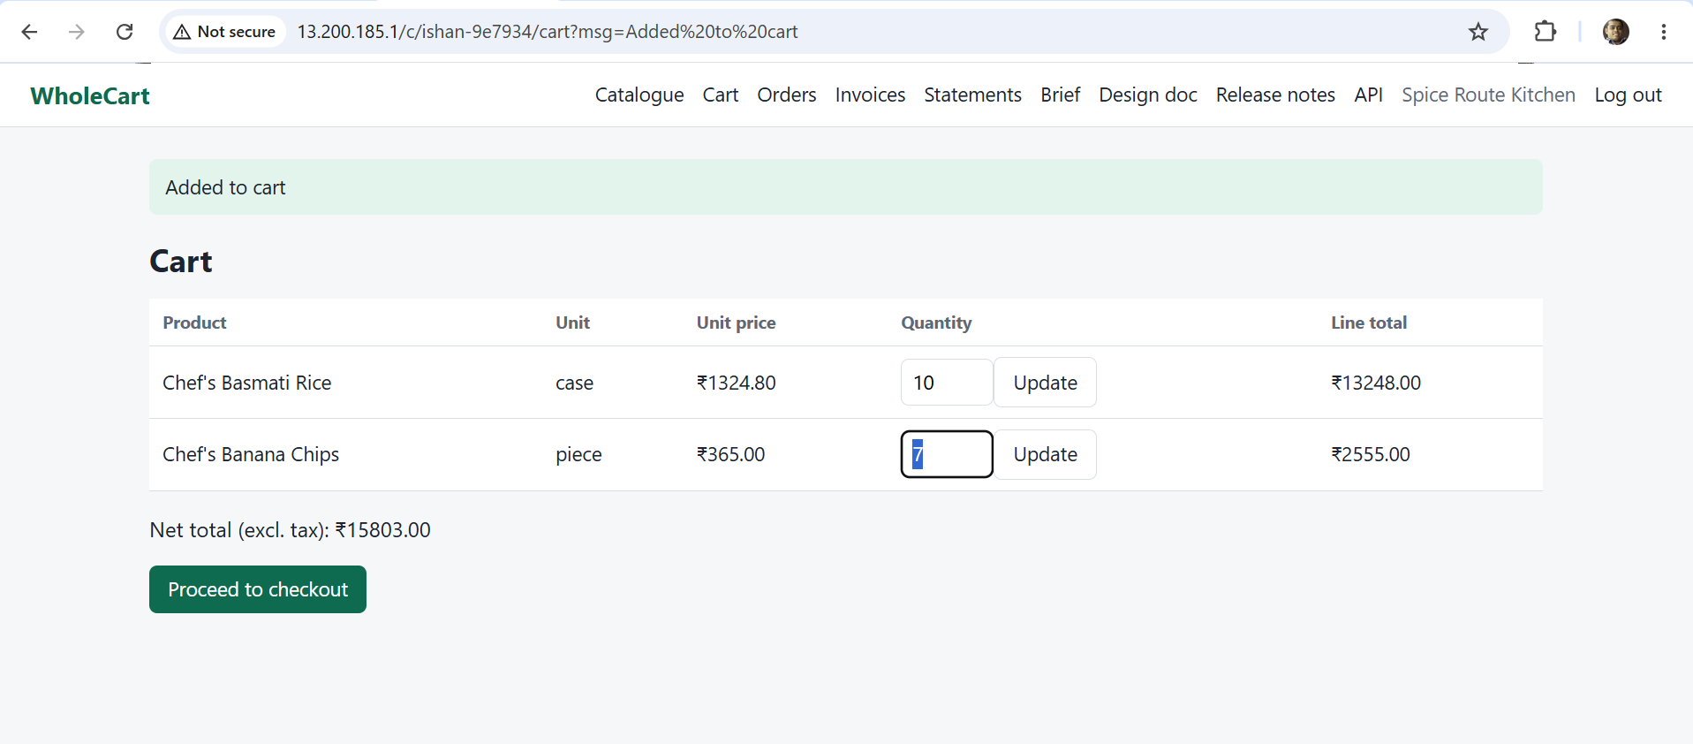
Steps:
1.Open the given URL
2.click on search
3.Click on any of the SKU and enter 10 as Case
4.Click on Add to cart
Expected: UI of the Update button should be proper
Actual: Update button UI is not proper

Issue 3:
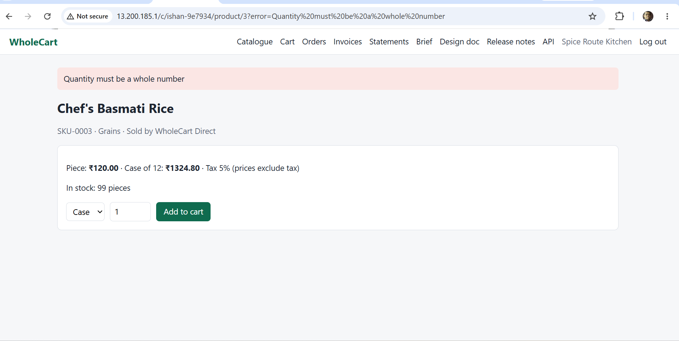
1.Open the given URL
2.click on search
3.Click on any of the SKU and enter 100 as Case
4.Click on Add to cart
Expected: The calculation of Case of 12 should be 1440
Actual: The calculation of case of 12 is showing 1324.80 which is incorrect

Issue 3 &4:
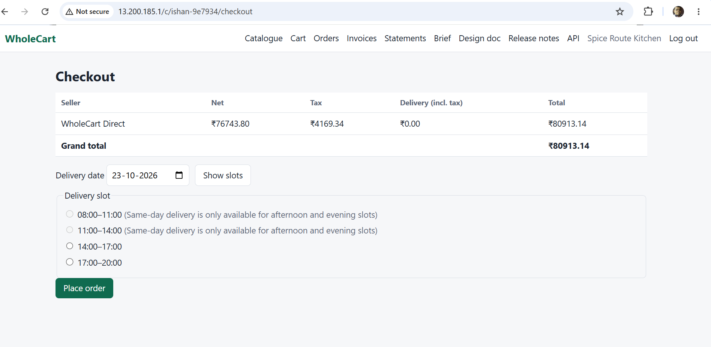
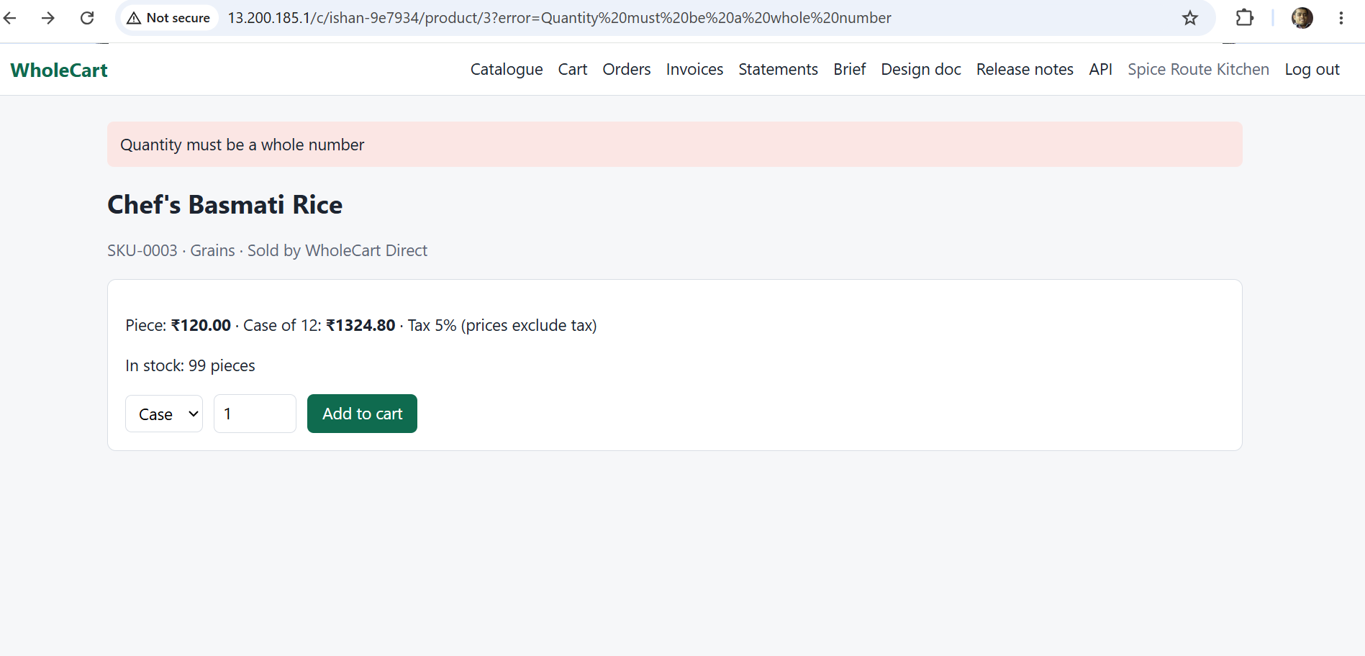
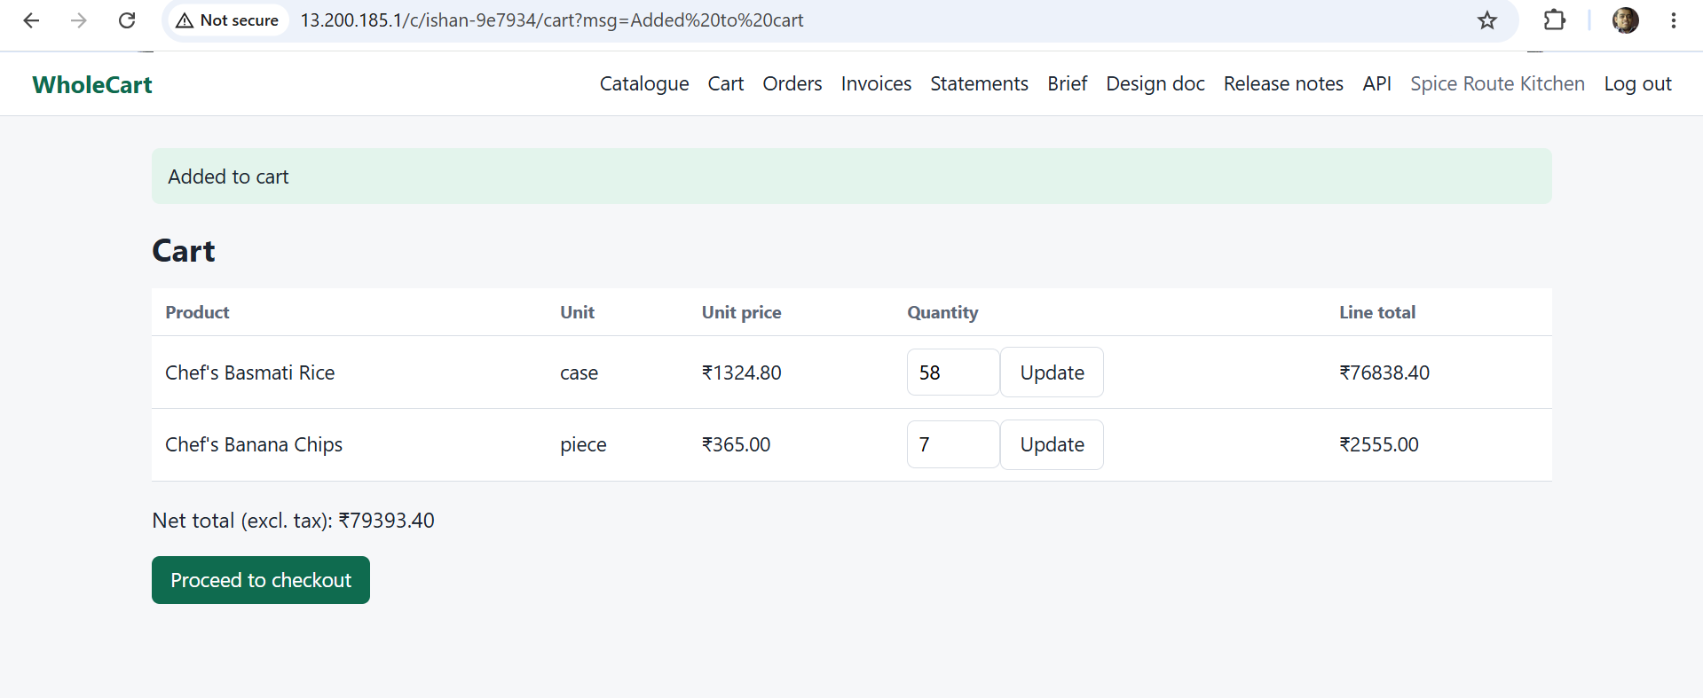

1.Open the given URL
2.click on search
3.Click on any of the SKU and enter 100 as Case
4.Click on Add to cart
Expected: Back button should be there and when change the quantity using back button then the updated price should be displayed
Actual: No back button is showing for the application and updated price is not showing

Issue 4:
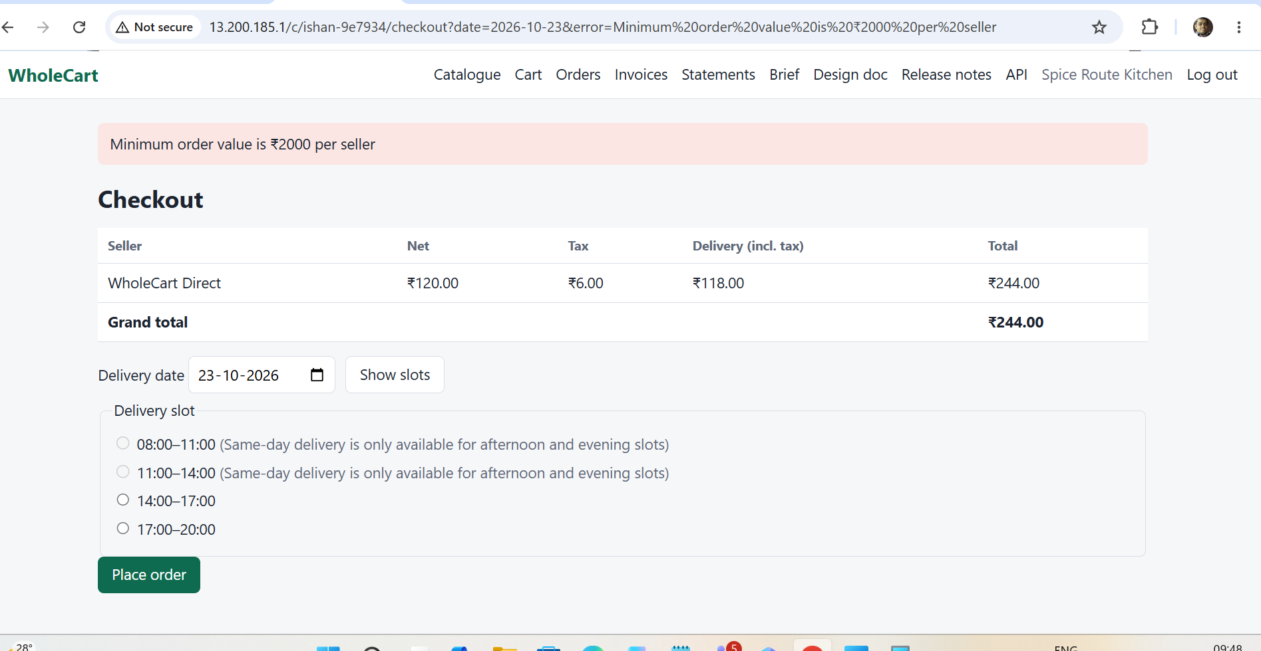

1.Open the given URL
2.click on search
3.Click on any of the SKU and enter 100 as Case
4.Click on Add to cart with quantity with piece that have sum of below 1500
Expected: there should be error message with minimum value of 1500
Actual: there is error message with minimum value of 1500

Issue 5&6:
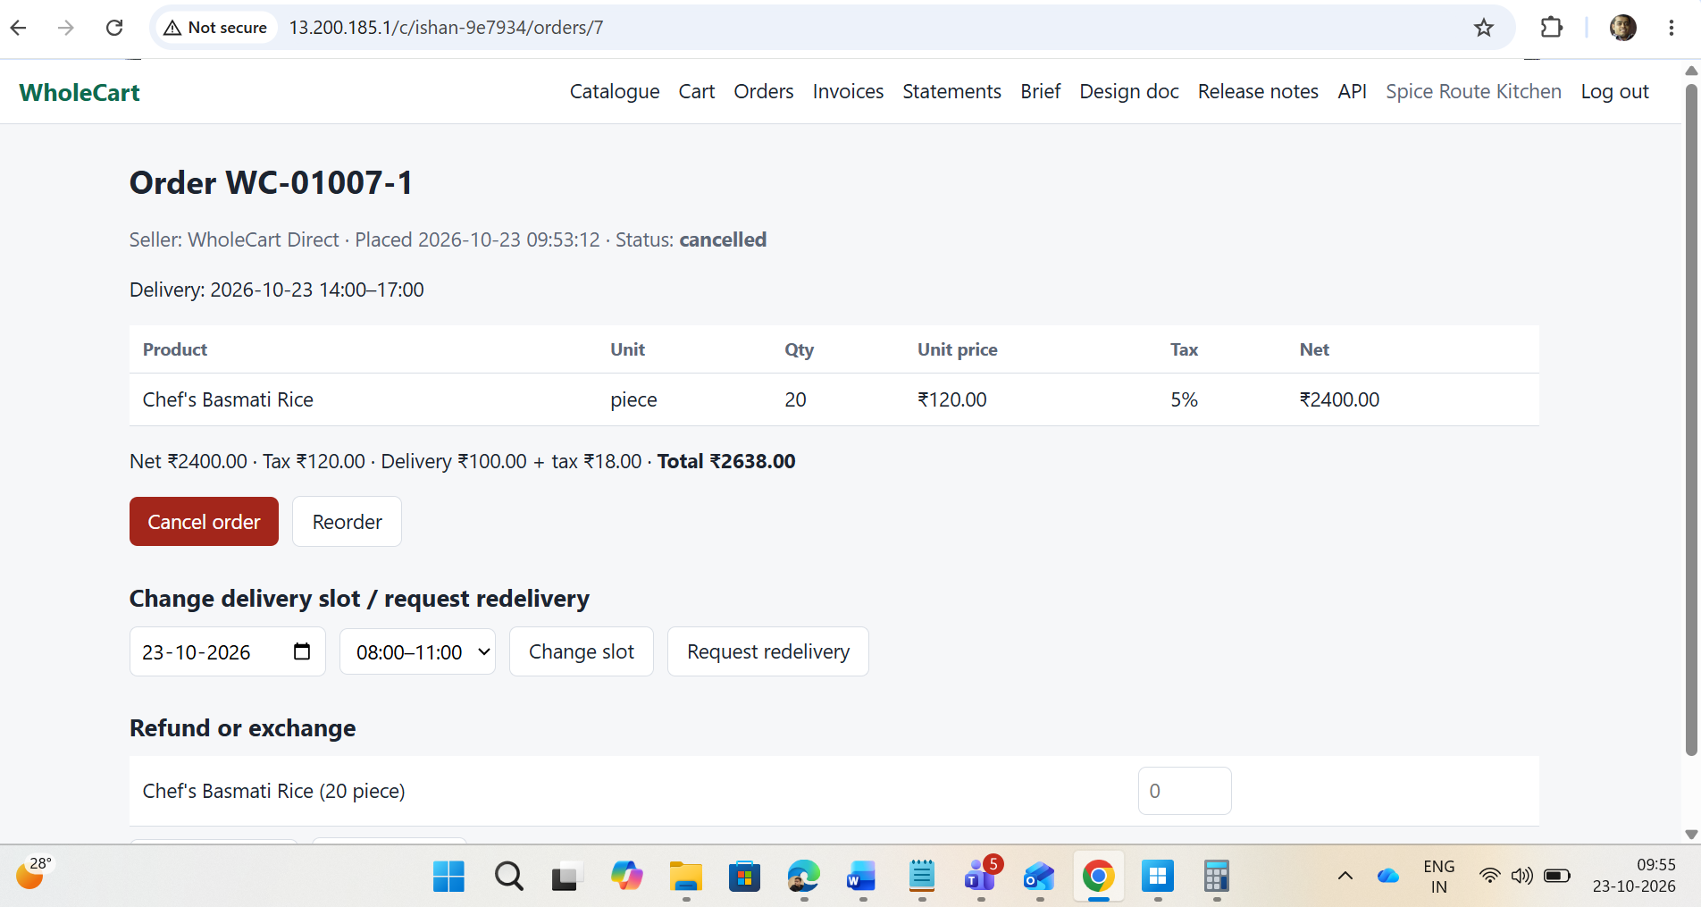
1.Open the given URL
2.click on search
3.Click on any of the SKU and enter 100 as Case
4.Click on Add to cart with quantity with piece that have sum of below 1500
5.Proceed to checkout and then cancel the order
Expected: Cancel order button should be disabled after cancellation of the order
Actual: Cancel order button is still displayed as it is after cancellation of the order and it is still showing the change delivery slot

Issue 7:
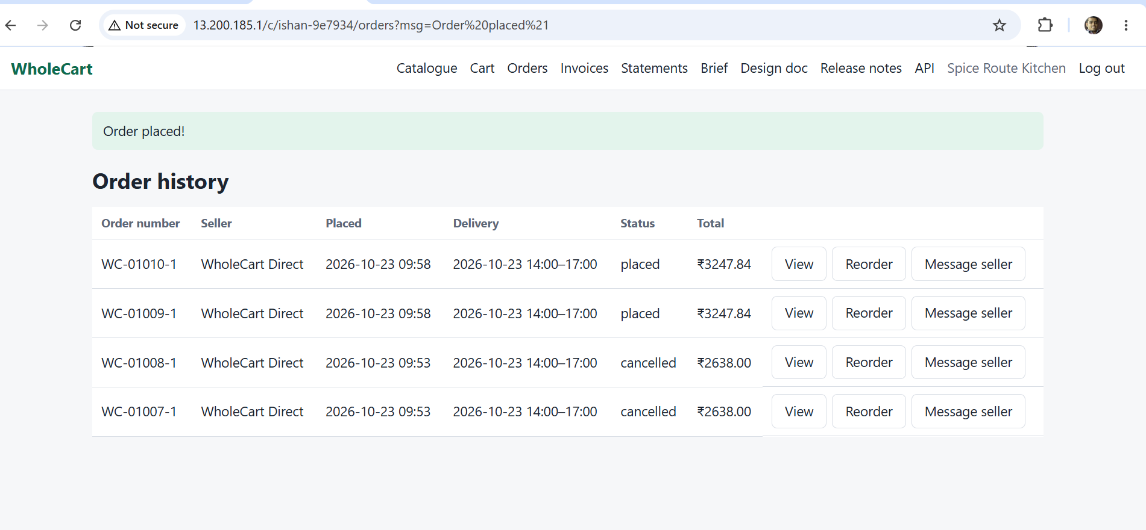
1.Open the given URL
2.click on search
3.Click on SKU for Chef’s Maida and enter 5 as Case
4.Click on Add to cart with quantity with piece that have sum of below 1500
5.Proceed to checkout with any available slot
Expected: There should be single order to be displayed
Actual: There are duplicated order showing

Issue 8:
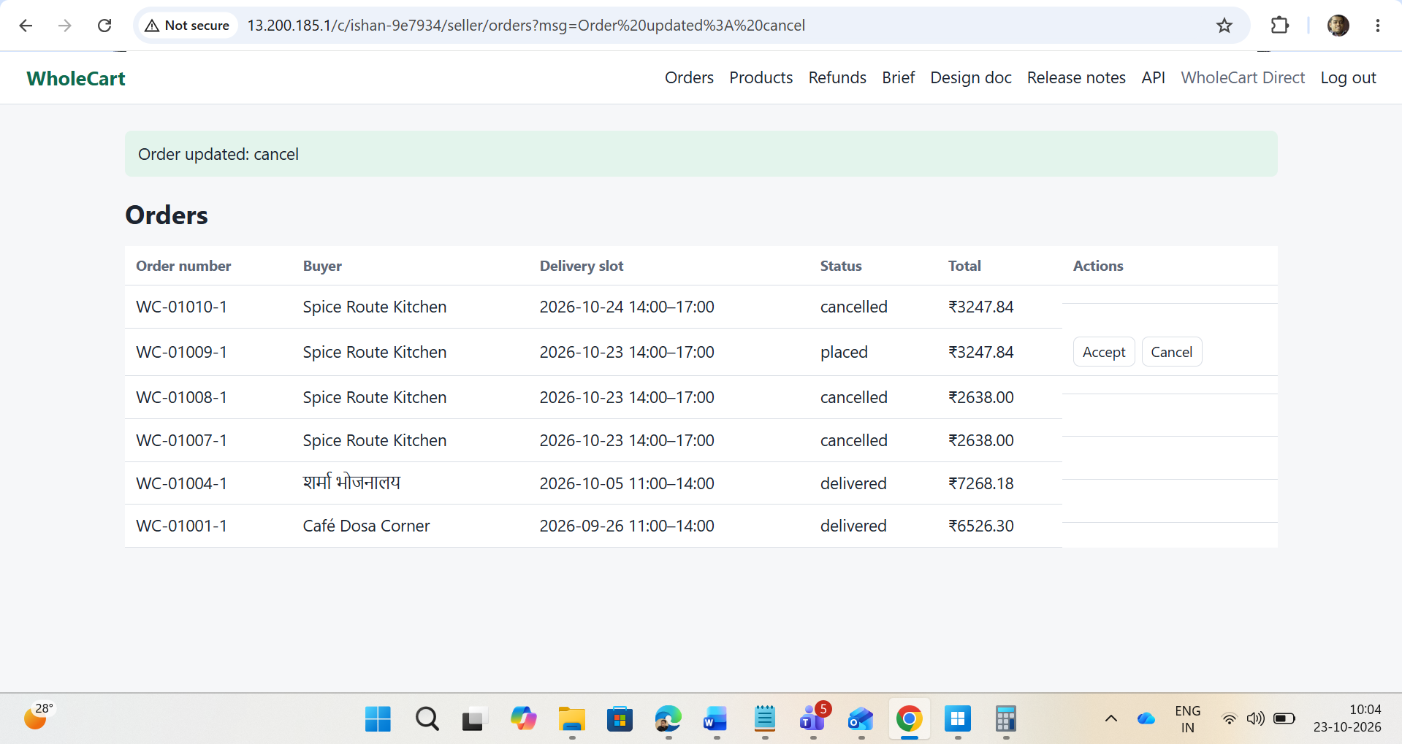

1.Open the given URL and login as seller
2.Click on cancel for any of the order
Expected: UI should be proper after cancellation of the order
Actual: UI is become distorted

Issue 9:
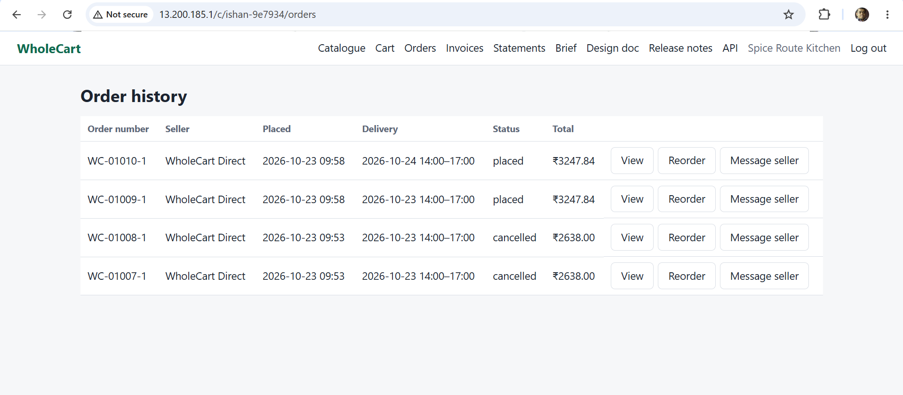

1.Open the given URL and login as seller
2.Click on cancel for any of the order
3.Again login with buyer
4. Go to orders
Expected: cancelled order should be displayed as cancelled
Actual: there is nothing is displayed cancelled

Issue 9:
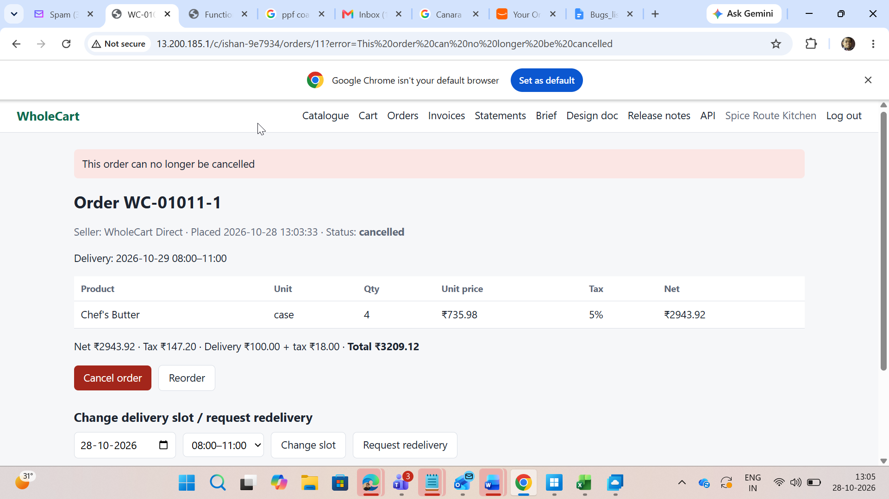
Cancel button should be disabled rather than message is showing

Issue 10:
After click on clear from calendar the date and slot should be reset where currently it is showing as it is and allow to place the order
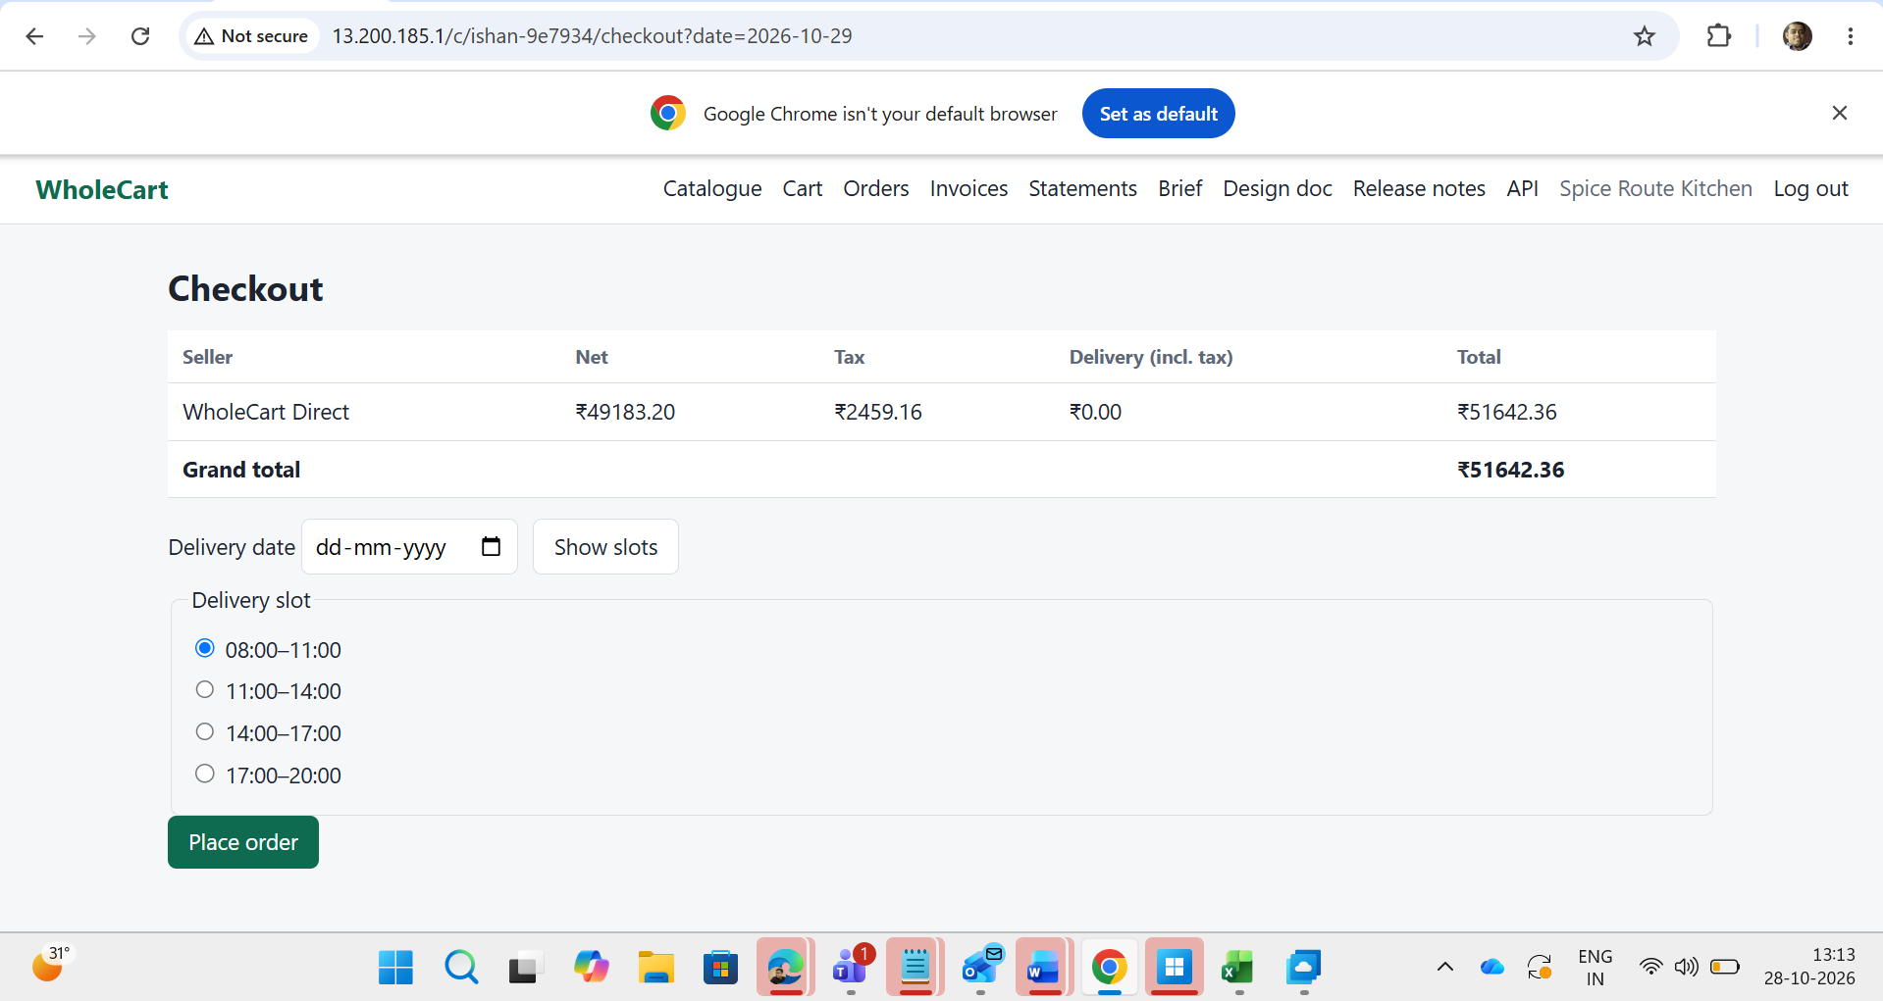
Issue 11:
The canceled order from seller shows still placed at buyer side
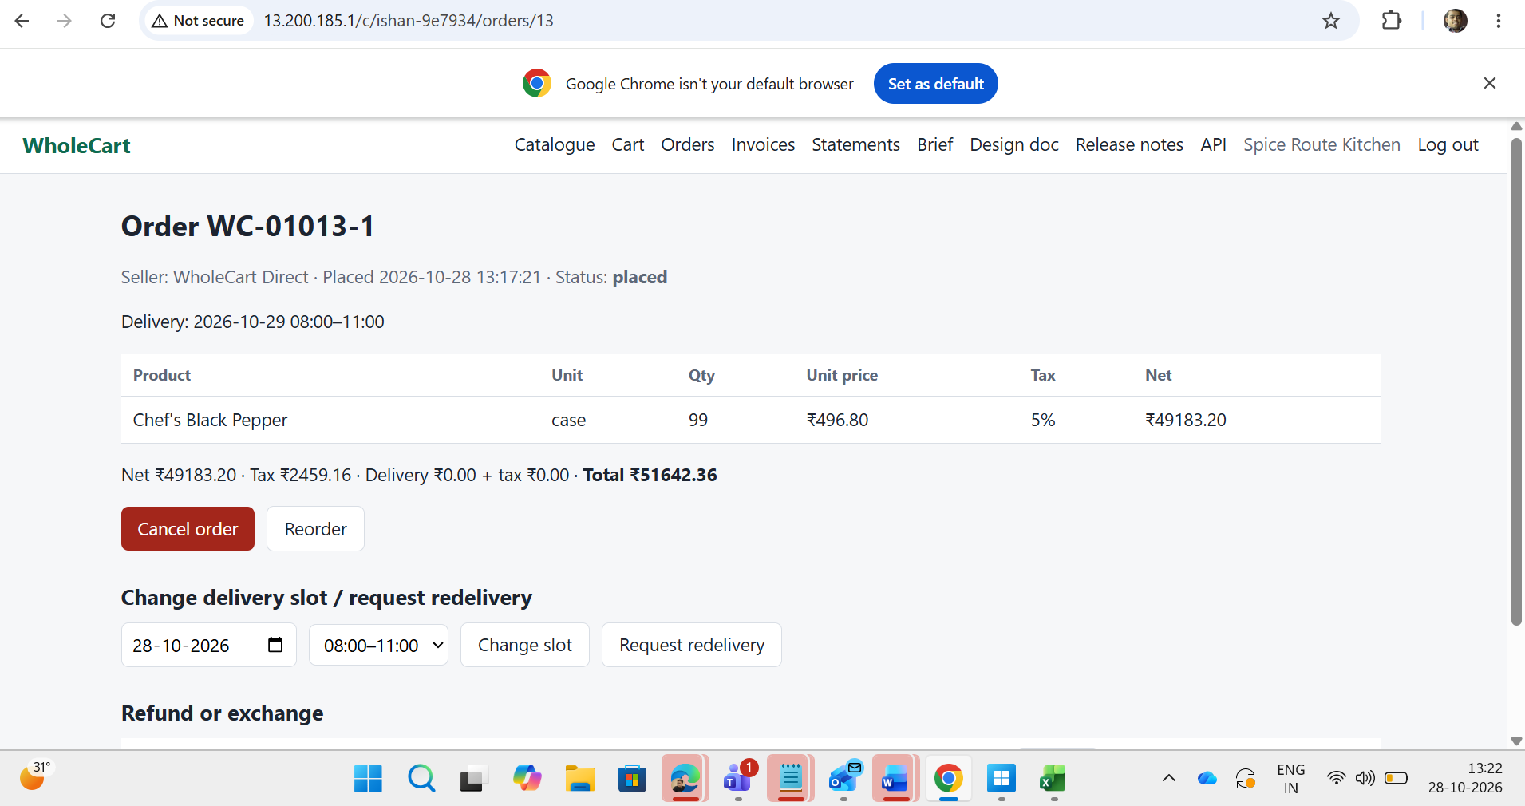
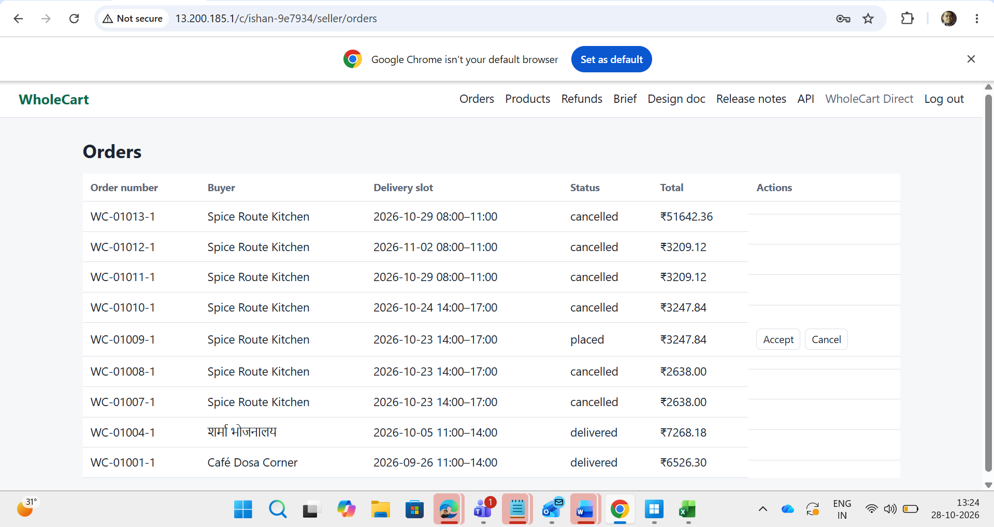

Issue 12:
By click on checkout 2 times it is showing place order 2 times
