**Class Diagram**

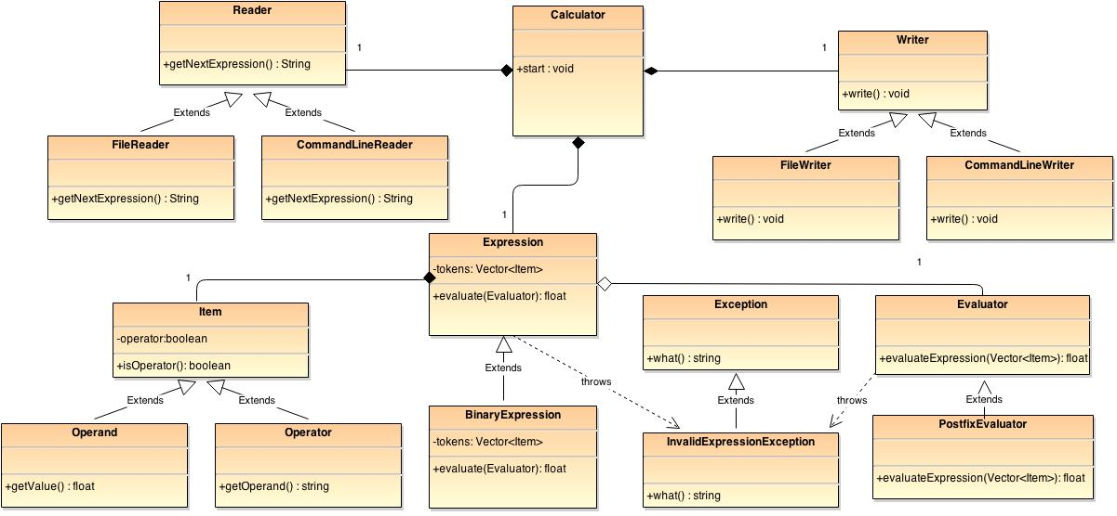

|  |  |
| --- | --- |
| Class | Purpose |
| Calculator | Provides access to calculator functionality. |
| Reader | Reads the user input and returns it as a string. |
| FileReader | Reads the user input from a file. |
| CommandLineReader | Reads the user input from the command line. |
| Writer | Writes the output of the calculation. |
| FileWriter | Writes the output of the calculation to a file. |
| CommandLineWriter | Writes the output of the calculation to the command line. |
| Expression | Holds the expression to be evaluated. |
| Evaluator | Evaluates a given expression. |
| PostfixEvaluator | Evaluates a given expression by converting the expression to the postfix notation. |
| Item | Holds individual segments of the given expression. |
| Operand | Holds an operand in the given expression |
| Operation | Holds an operation in the given expression |
| InvalidExpressionException | Gets thrown when a given expression is invalid. |

**Object Diagram**

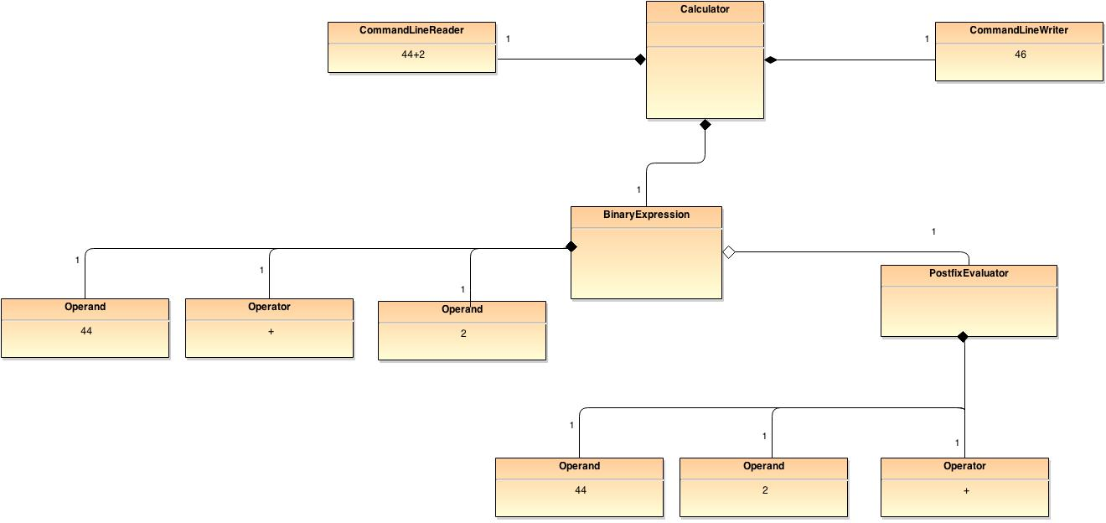

**Sequence Diagram**

