SCHOOL OF TECHNOLOGY | 

DATABASE MANAGEMENT SYSTEMS
PROJECT-BASED LEARNING (PBL) REPORT
Small Database Application Development using Java / Python
PROJECT TITLE
DESIGN AND IMPLEMENTATION OF A DATABASE MANAGEMENT SYSTEM FOR LEGAL CASE AND CLIENT MANAGEMENT SYSTEM

Program | B.Tech (Cybersecurity), Batch 2025 – 29
Section | AIML Rhinos4
Faculty | Prof. Sahithi
Date of Submission | Date of Submission
Academic Year | 2026 – 27
Submitted by
Roll Number | Student Name | Mobile | Email ID
25WU0102101 | Ishanth M | 8870785794 | ishanthm07@gmail.com

ACKNOWLEDGEMENT
I express my sincere gratitude to Woxsen University, School of Technology, for providing me with the opportunity to undertake this Project-Based Learning (PBL) activity as part of the Database Management Systems (DBMS) course.
I thank my course faculty, Prof. Sahithi, for the guidance, suggestions, and support throughout the design and development of this project. The guidance helped me understand the practical application of database concepts such as ER modelling, relational schema design, normalization, SQL, constraints, queries, and database application development.
This PBL activity has strengthened my understanding of DBMS concepts and provided valuable experience in applying them to a real-world problem.

UNDERTAKING
I hereby declare that the project entitled “Design and Implementation of a Database Management System for Legal Case and Client Management System”, submitted as part of the Project-Based Learning activity for the Database Management Systems (DBMS) course, is my individual work carried out under the guidance of the course faculty.
I undertake that the project report, database design, SQL scripts, application source code, results, and supporting materials submitted by me have been prepared for academic purposes. Wherever information, ideas, tools, datasets, or other resources have been referred to, appropriate acknowledgement has been provided.
I further undertake that I am responsible for the correctness and authenticity of the work submitted and that I have followed the academic and project guidelines prescribed by the University.
Signature
Date : Date of Submission  Place : Hyderabad | Name: Ishanth M  Roll Number: 25WU0102101  Program: B.Tech (Cybersecurity)

TABLE OF CONTENTS
Contents Page No.
Abstract 8
LIST OF TABLES 5
LIST OF FIGURES 6
LIST OF ACRONYMS 7
1. PROBLEM STATEMENT, SOLUTION STRATEGY AND ER DIAGRAM 9
1.1 Problem Statement 9
1.2 Objectives 9
1.3 Scope and Assumptions 9
1.4 Proposed Solution Strategy 10
1.5 Functional Requirements 10
1.6 Entity-Relationship Diagram (ERD) 11
1.7 Entity and Relationship Summary 12
2. LOGICAL DATABASE DESIGN 14
2.1 Relational Schema 14
2.2 Keys and Integrity Constraints 14
2.3 Functional Dependencies 16
2.4 Normalization up to Third Normal Form (3NF) 16
2.5 Data Dictionary 17
2.6 Implementation of Logical Design: DDL and Sample Data 19
3. APPLICATION DEVELOPMENT USING LOGICAL DATABASE DESIGN 22
3.1 Application Overview 22
3.2 Development Environment and Database Connectivity 22
3.3 Application Modules and Database Mapping 22
3.4 CRUD Operations 23
3.5 Business Rules, Validation and Error Handling 24
3.6 Reports and Database Operations 24
3.7 Application Screens 25
3.8 Testing and Results 29
4. CONCLUSION 32
4.1 Limitations and Future Enhancements 32
5. REFERENCES 33
6. APPENDICES 34

LIST OF TABLES
Table No. | Table Title | Page No.
Table 1 | Scope and Assumptions | 10
Table 2 | Proposed Solution Strategy | 10
Table 3 | Functional Requirements | 11
Table 4 | Entity and Relationship Summary | 12
Table 5 | Relational Schema | 14
Table 6 | Keys and Integrity Constraints | 14
Table 7 | Normalization Status up to 3NF | 17
Table 8 | Data Dictionary | 17
Table 9 | Database Implementation Environment | 19
Table 10 | Application Development Environment | 22
Table 11 | Application Module-to-Database Mapping | 23
Table 12 | CRUD Operations | 23
Table 13 | Business Rules, Validation and Error Handling | 24
Table 14 | Reports and Database Operations | 25
Table 15 | Test Cases | 29

LIST OF FIGURES
Figure No. | Figure Title | Page No.
Figure 1 | Entity-Relationship Diagram of the Proposed System | 12
Figure 2 | Login Screen with Role-Based Sign-in | 25
Figure 3 | Dashboard of the Administrator | 26
Figure 4 | Data Entry: Registering a New Case | 26
Figure 5 | Search and Display of Cases | 27
Figure 6 | Case Detail View Combining Hearings, Documents and Billing | 27
Figure 7 | Transaction Processing: Marking a Bill as Paid | 28
Figure 8 | Activity Log Written by the Application and the Trigger | 28
Figure 9 | Database-Computed Reports | 29
Figure 10 | Restricted View for the Lawyer Role | 29

LIST OF ACRONYMS
Acronym | Expansion
1NF | First Normal Form
2NF | Second Normal Form
3NF | Third Normal Form
API | Application Programming Interface
BCNF | Boyce-Codd Normal Form
CRUD | Create, Read, Update, Delete
CSV | Comma-Separated Values
DBMS | Database Management System
DDL | Data Definition Language
ERD | Entity-Relationship Diagram
FD | Functional Dependency
FK | Foreign Key
FR | Functional Requirement
HTTP | Hypertext Transfer Protocol
IEEE | Institute of Electrical and Electronics Engineers
JSON | JavaScript Object Notation
PBL | Project-Based Learning
PK | Primary Key
SQL | Structured Query Language
UI | User Interface
UQ | Unique (constraint)

ABSTRACT
Law firms often manage client details, case files, hearing dates and fee records through paper files and scattered spreadsheets, which leads to duplicated data, missed hearings and delayed billing. A relational database application can keep this information consistent, secure and searchable in one place. The objective of this project is to design and implement a database management system that tracks clients, lawyers, courts, cases, hearings, documents and fees for a small law firm. The design began with an entity-relationship model, which was converted into ten relational tables normalised to third normal form, with primary keys, foreign keys, unique, check and default constraints, two views and one trigger. The system is implemented in MySQL and accessed through a Python Flask web application that uses parameterised queries. The application provides role-based login for administrators, clerks, lawyers and clients, create, search, update and delete operations, a case detail view, fee payment tracking, reports computed by the database and an activity log. Testing confirmed that access rules and referential integrity are enforced both by the application and by the database. The completed system shows how a carefully designed schema supports a reliable and practical case management tool for a small legal practice.
KEYWORDS
Keywords: Legal Case Management, Relational Database, ER Diagram, Normalization, MySQL, Python Flask

CHAPTER 1
PROBLEM STATEMENT, SOLUTION STRATEGY AND ER DIAGRAM
This chapter presents the problem addressed by the project, the objectives, the scope, the proposed solution strategy, the functional requirements and the approved entity-relationship diagram for the legal case and client management system.

1.1 Problem Statement
Small and medium law firms handle a continuous flow of related information: client details, the cases filed on behalf of each client, the courts in which they are heard, the lawyers responsible, the hearing calendar, supporting documents and fee records. In many practices this information is still kept in paper files, spreadsheets and personal notes. As a result the same client details are copied into several places, a change made in one place is not reflected in another, and there is no single view of the current position of a case.
This manual process creates risks for the stakeholders, namely the administrators and clerks who maintain the records, the lawyers who argue the cases, and the clients who depend on timely information. Hearing dates can be missed because they are not tracked in one calendar. Documents and fee records are slow to retrieve, payments can be recorded twice or not at all, and every member of staff can see files that they do not need, which is a confidentiality concern in legal work. A relational database application is therefore needed that stores each fact once, enforces integrity rules automatically, controls who may see and change each record, and produces the reports that the firm needs.

1.2 Objectives
- Design a relational schema of ten tables, derived from an ER model and normalised to third normal form, for legal case and client management.
- Implement the schema in MySQL with primary key, foreign key, unique, check and default constraints, two views and one trigger.
- Develop a Python Flask web application that performs create, read, update and delete operations on the business tables using parameterised queries.
- Validate role-based access for four user roles, and generate four database-computed reports together with an activity log of user actions.

1.3 Scope and Assumptions
Table 1 summarises what the project covers, what it leaves out, and the assumptions made.
Table 1. Scope and Assumptions
Item | Description
In Scope | Client, lawyer and court records; case registration with one or more assigned lawyers; hearing schedule and outcomes; document register (details of each document); fee entries with payment status; role-based login for administrator, clerk, lawyer and client; reports; activity log.
Out of Scope / Exclusions | Online payment processing; storage of the document files themselves; electronic filing with courts; email or SMS reminders; operation for several firms on one system; a mobile application.
Assumptions | The system serves one law firm using one MySQL server. Each case belongs to exactly one client and one court, and may have several lawyers. Each user account is linked to at most one lawyer or one client. Amounts are in Indian rupees. All sample data is fictitious.

1.4 Proposed Solution Strategy
The solution follows the relational model [1]. The requirements were first captured as an entity-relationship model [2], which was then mapped to relations, normalised, implemented in MySQL and connected to a Python Flask web application. Table 2 describes the intended users, modules, workflow, key business rules and expected outputs.
Table 2. Proposed Solution Strategy
Solution Element | Project-Specific Description
Primary Users / Roles | Administrator (full control and user management); Clerk (day-to-day data entry for all records); Lawyer (views assigned cases, adds hearings and documents for them); Client (read-only view of own cases).
Major Application Modules | Authentication; Dashboard; Clients; Lawyers; Courts; Cases; Hearings; Documents; Billing; Reports; Users; Activity Log.
Proposed Workflow | A clerk registers the client and creates the case with its court and lawyers. Lawyers add hearings and documents as the case proceeds. The clerk raises fee entries and marks them paid when received. Clients and lawyers sign in to see the current position, while the administrator reviews reports and the activity log.
Important Business Rules | A case needs a client and a court. A client, court or lawyer cannot be deleted while cases refer to it. Amounts cannot be negative. Emails and bar numbers are unique. Lawyers may change hearings and documents only for their own cases. Clients can only read. Every change is logged, and a database trigger records each payment.
Expected Reports / Outputs | Upcoming hearings; pending fees by client; cases per lawyer; cases by status; billing by status; case summary view; activity log; CSV export of any table shown on screen.

1.5 Functional Requirements
The functional requirements derived from the problem statement are listed in Table 3.
Table 3. Functional Requirements
Req. ID | Functional Requirement | Remarks / Priority
FR-01 | Authenticate users by username and password and start a session. | High
FR-02 | Restrict menus, records and actions according to the role of the signed-in user. | High
FR-03 | Add, view, search, edit and delete clients, lawyers and courts. | High
FR-04 | Register a case with client, court, type, status, filing date and one or more lawyers. | High
FR-05 | Schedule hearings and record their outcome. | High
FR-06 | Register the documents that belong to a case. | Medium
FR-07 | Raise fee entries against a case and mark them as paid. | High
FR-08 | Show a case detail view combining hearings, documents and billing. | Medium
FR-09 | Show dashboard totals and upcoming hearings. | Medium
FR-10 | Generate reports computed by the database. | Medium
FR-11 | Let the administrator create, edit and delete user accounts. | Medium
FR-12 | Record every login, logout and data change in an activity log. | Medium
FR-13 | Export the table on screen to a CSV file. | Low

1.6 Entity-Relationship Diagram (ERD)
Figure 1 shows the approved ER diagram. LEGAL_CASE is the central entity. A bar at the end of a line means “one”, a crow’s foot means “many” and a small circle means that participation is optional. The two grey entities, APP_USER and ACTIVITY_LOG, support login and auditing, and are linked to the business entities through optional foreign keys.
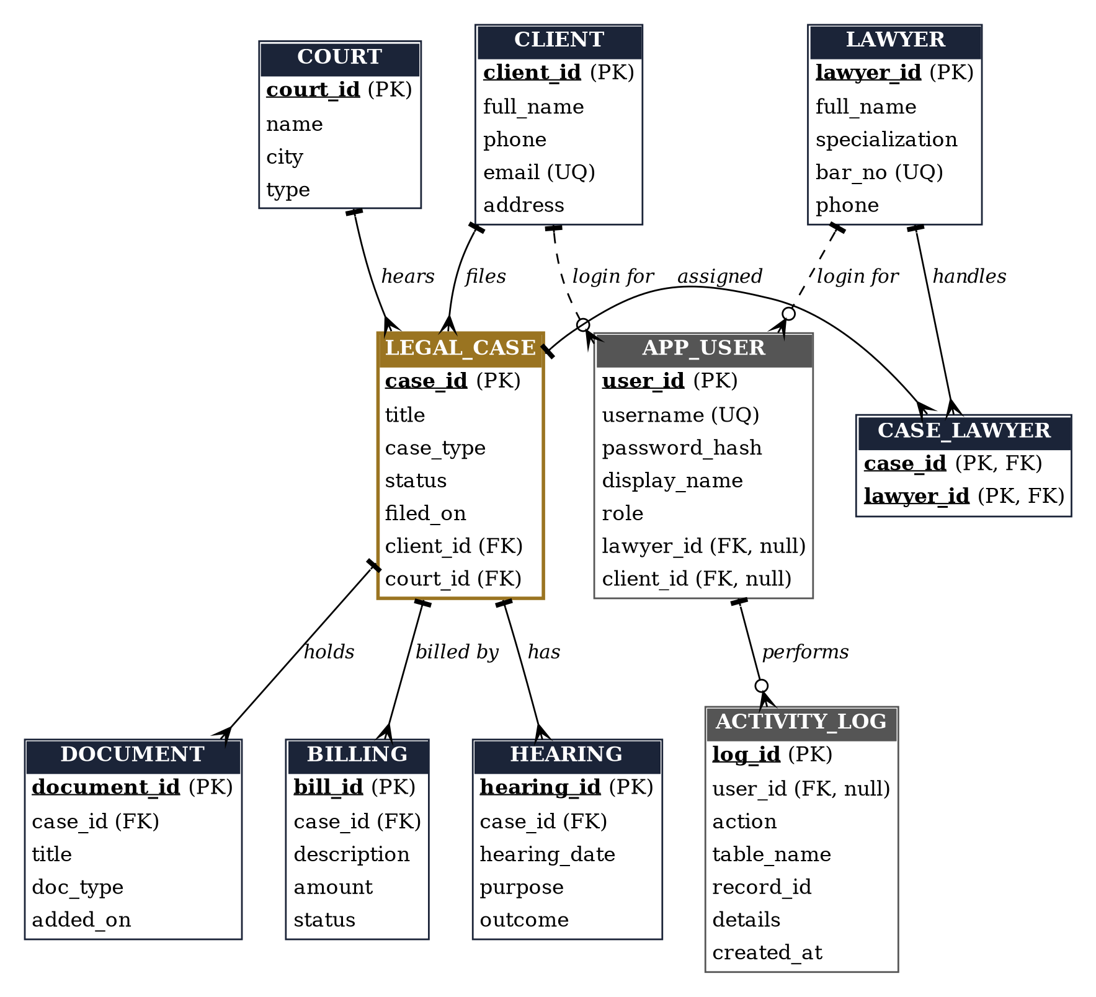
Figure 1. Entity-Relationship Diagram of the Proposed System

1.7 Entity and Relationship Summary
Table 4 summarises each entity and relationship in the ER diagram, together with its cardinality and the rule it represents.
Table 4. Entity and Relationship Summary
Entity / Relationship | Major Attributes / Cardinality | Purpose / Rule
CLIENT | client_id (PK), full_name, phone, email (UQ), address | Person or company that engages the firm.
LAWYER | lawyer_id (PK), full_name, specialization, bar_no (UQ), phone | Advocate working with the firm.
COURT | court_id (PK), name, city, type | Court or tribunal where cases are heard.
LEGAL_CASE | case_id (PK), title, case_type, status, filed_on, client_id (FK), court_id (FK) | Central entity: one legal matter.
CASE_LAWYER | (case_id, lawyer_id) composite PK, both FK | Resolves the many-to-many link between cases and lawyers.
HEARING | hearing_id (PK), case_id (FK), hearing_date, purpose, outcome | A scheduled court appearance for a case.
DOCUMENT | document_id (PK), case_id (FK), title, doc_type, added_on | Register of documents belonging to a case.
BILLING | bill_id (PK), case_id (FK), description, amount, status | Fee entry with Pending or Paid status.
APP_USER | user_id (PK), username (UQ), password_hash, display_name, role, lawyer_id (FK), client_id (FK) | Login account and role; linked to a lawyer or a client.
ACTIVITY_LOG | log_id (PK), user_id (FK), action, table_name, record_id, details, created_at | Audit trail of logins and changes.
CLIENT files LEGAL_CASE | 1 : N (mandatory on the case side) | Every case has exactly one client; a client may have many cases.
COURT hears LEGAL_CASE | 1 : N (mandatory on the case side) | Every case is heard in exactly one court.
LEGAL_CASE assigned LAWYER | M : N through CASE_LAWYER | A case can have several lawyers; a lawyer can handle many cases.
LEGAL_CASE has HEARING / DOCUMENT / BILLING | 1 : N for each | Child records are deleted with their case (cascade).
LAWYER / CLIENT login for APP_USER | 1 : N, optional | A login account may be linked to a lawyer or a client.
APP_USER performs ACTIVITY_LOG | 1 : N, optional | Entries written by the trigger have no user (NULL).

CHAPTER 2
LOGICAL DATABASE DESIGN
This chapter documents how the approved ER model was converted into a relational database design, how it was verified for normalization, and how it was implemented in MySQL as a working database prototype.

2.1 Relational Schema
The ER model was mapped to relations using three rules: every entity becomes a table with its primary key; every one-to-many relationship becomes a foreign key on the “many” side; and the many-to-many relationship between cases and lawyers becomes the junction table CASE_LAWYER. The case table is named legal_case because CASE is a reserved word in MySQL. Table 5 lists the ten relations.
Table 5. Relational Schema
S.No. | Table Name | Purpose
1 | client | Stores clients of the firm.
2 | lawyer | Stores lawyers and their bar council numbers.
3 | court | Stores courts and tribunals.
4 | legal_case | Stores cases with client and court references.
5 | case_lawyer | Junction table linking cases to the lawyers assigned.
6 | document | Stores the document register of each case.
7 | hearing | Stores hearing dates, purposes and outcomes.
8 | billing | Stores fee entries and their payment status.
9 | app_user | Stores login accounts with hashed passwords and roles.
10 | activity_log | Stores the audit trail of logins and changes.

2.2 Keys and Integrity Constraints
Table 6 lists the keys and integrity constraints, and the business rule that each one enforces. Foreign keys use ON DELETE RESTRICT where a parent record must not disappear while it is still in use, ON DELETE CASCADE where child records belong to the parent, and ON DELETE SET NULL for the audit trail. MySQL ENUM columns act as domain constraints for fixed sets of values.
Table 6. Keys and Integrity Constraints
Table Name | Key / Constraint | Attribute(s) | Business Rule Enforced
client | Primary Key | client_id | Each client is identified uniquely.
client | Not Null | full_name | A client must have a name.
client | Unique | email | The same email cannot be registered twice.
lawyer | Primary Key | lawyer_id | Each lawyer is identified uniquely.
lawyer | Not Null | full_name, bar_no | Name and bar number are mandatory.
lawyer | Unique | bar_no | A bar number belongs to one lawyer.
court | Primary Key | court_id | Each court is identified uniquely.
court | Not Null | name, type | Name and type are mandatory.
court | Domain (ENUM) | type | District, High Court, Supreme Court or Tribunal.
legal_case | Primary Key | case_id | Each case is identified uniquely.
legal_case | Foreign Key | client_id → client | Case must belong to an existing client; client cannot be deleted while cases exist (RESTRICT).
legal_case | Foreign Key | court_id → court | Case must be heard in an existing court (RESTRICT).
legal_case | Not Null | title, case_type, status, filed_on, client_id, court_id | Core case details are mandatory.
legal_case | Default | status | A new case starts as Open.
legal_case | Domain (ENUM) | case_type, status | Case type and status come from fixed lists.
case_lawyer | Primary Key | (case_id, lawyer_id) | The same lawyer cannot be assigned twice to a case.
case_lawyer | Foreign Key | case_id → legal_case | Assignments are removed with the case (CASCADE).
case_lawyer | Foreign Key | lawyer_id → lawyer | A lawyer with assigned cases cannot be deleted (RESTRICT).
document | Primary Key | document_id | Each document entry is unique.
document | Foreign Key | case_id → legal_case | Document belongs to a case; deleted with it (CASCADE).
document | Not Null | title, doc_type, added_on | Document details are mandatory.
document | Domain (ENUM) | doc_type | Petition, Affidavit, Evidence, Order or Contract.
hearing | Primary Key | hearing_id | Each hearing is unique.
hearing | Foreign Key | case_id → legal_case | Hearing belongs to a case; deleted with it (CASCADE).
hearing | Not Null | hearing_date | Every hearing has a date.
billing | Primary Key | bill_id | Each fee entry is unique.
billing | Foreign Key | case_id → legal_case | Fee belongs to a case; deleted with it (CASCADE).
billing | Not Null | description, amount | Fee details are mandatory.
billing | Check | amount >= 0 | Negative amounts are rejected.
billing | Default | status | A new fee entry is Pending.
billing | Domain (ENUM) | status | Pending or Paid.
app_user | Primary Key | user_id | Each account is unique.
app_user | Unique | username | Two accounts cannot share a username.
app_user | Not Null | username, password_hash, display_name, role | Account essentials are mandatory.
app_user | Domain (ENUM) | role | admin, clerk, lawyer or client.
app_user | Foreign Key | lawyer_id → lawyer | Optional link to a lawyer (RESTRICT).
app_user | Foreign Key | client_id → client | Optional link to a client (RESTRICT).
activity_log | Primary Key | log_id | Each log entry is unique.
activity_log | Foreign Key | user_id → app_user | Entries remain when a user is deleted (SET NULL).
activity_log | Not Null | action | Every entry names an action.
activity_log | Default | created_at | Time is set automatically (CURRENT_TIMESTAMP).

2.3 Functional Dependencies
A functional dependency (FD) X → Y states that the value of X determines the value of Y [3]. The important dependencies of the design are listed below. In every relation the determinant is a key, which is what makes the design free of partial and transitive dependencies.
- client: client_id → full_name, phone, email, address; email → client_id
- lawyer: lawyer_id → full_name, specialization, bar_no, phone; bar_no → lawyer_id
- court: court_id → name, city, type
- legal_case: case_id → title, case_type, status, filed_on, client_id, court_id
- case_lawyer: (case_id, lawyer_id) → no non-key attribute
- document: document_id → case_id, title, doc_type, added_on
- hearing: hearing_id → case_id, hearing_date, purpose, outcome
- billing: bill_id → case_id, description, amount, status
- app_user: user_id → username, password_hash, display_name, role, lawyer_id, client_id; username → user_id
- activity_log: log_id → user_id, action, table_name, record_id, details, created_at

2.4 Normalization up to Third Normal Form (3NF)
Normalization removes redundancy and update anomalies by decomposing relations until every non-key attribute depends on the key, the whole key, and nothing but the key [4]. The design started from a single flat case register with columns such as case title, client name, client phone, court name, lawyer names and hearing dates. That register breaks 1NF because several lawyers and hearings sit in one row, breaks 2NF and 3NF because client and court details depend on the client or court rather than on the case, and repeats data. It was decomposed into the ten relations of Table 7. Client and court details now appear once, and the multi-valued lawyer list is held in CASE_LAWYER. Every relation is also in BCNF because each determinant is a candidate key.
Table 7. Normalization Status up to 3NF
Relation Name | 1NF | 2NF | 3NF | BCNF | Remarks / Decomposition
client | Yes | Yes | Yes | Yes | Client details stored once; email is an alternate key.
lawyer | Yes | Yes | Yes | Yes | bar_no is an alternate key.
court | Yes | Yes | Yes | Yes | Court details separated from cases.
legal_case | Yes | Yes | Yes | Yes | Holds only foreign keys to client and court, not their details.
case_lawyer | Yes | Yes | Yes | Yes | Junction table that removes the repeating list of lawyers.
document | Yes | Yes | Yes | Yes | One row per document; depends only on document_id.
hearing | Yes | Yes | Yes | Yes | One row per hearing; multi-valued hearings separated from case.
billing | Yes | Yes | Yes | Yes | One row per fee entry; no derived totals are stored.
app_user | Yes | Yes | Yes | Yes | Username is an alternate key; password stored as a hash.
activity_log | Yes | Yes | Yes | Yes | One row per event; user_id may be NULL for system events.

2.5 Data Dictionary
Table 8 is the data dictionary for all ten tables, giving the data type, key or constraint, and meaning of every attribute.
Table 8. Data Dictionary
Table | Attribute | Data Type | Key / Constraint | Description
client | client_id | INT | PK, AUTO_INCREMENT | Unique client identifier
client | full_name | VARCHAR(100) | NOT NULL | Client name
client | phone | VARCHAR(20) | - | Contact number
client | email | VARCHAR(100) | UNIQUE | Contact email
client | address | VARCHAR(200) | - | Postal address
lawyer | lawyer_id | INT | PK, AUTO_INCREMENT | Unique lawyer identifier
lawyer | full_name | VARCHAR(100) | NOT NULL | Lawyer name
lawyer | specialization | VARCHAR(60) | - | Area of practice
lawyer | bar_no | VARCHAR(30) | NOT NULL, UNIQUE | Bar council number
lawyer | phone | VARCHAR(20) | - | Contact number
court | court_id | INT | PK, AUTO_INCREMENT | Unique court identifier
court | name | VARCHAR(120) | NOT NULL | Court name
court | city | VARCHAR(60) | - | City of the court
court | type | ENUM('District','High Court','Supreme Court','Tribunal') | NOT NULL | Level of court
legal_case | case_id | INT | PK, AUTO_INCREMENT | Unique case identifier
legal_case | title | VARCHAR(150) | NOT NULL | Case title
legal_case | case_type | ENUM('Civil','Criminal','Family','Corporate','Property') | NOT NULL | Category of case
legal_case | status | ENUM('Open','In hearing','Closed') | NOT NULL, DEFAULT 'Open' | Current stage
legal_case | filed_on | DATE | NOT NULL | Date of filing
legal_case | client_id | INT | FK, NOT NULL | Client who owns the case
legal_case | court_id | INT | FK, NOT NULL | Court hearing the case
case_lawyer | case_id | INT | PK, FK | Case being handled
case_lawyer | lawyer_id | INT | PK, FK | Lawyer assigned
document | document_id | INT | PK, AUTO_INCREMENT | Unique document identifier
document | case_id | INT | FK, NOT NULL | Case the document belongs to
document | title | VARCHAR(150) | NOT NULL | Document title
document | doc_type | ENUM('Petition','Affidavit','Evidence','Order','Contract') | NOT NULL | Kind of document
document | added_on | DATE | NOT NULL | Date added to the register
hearing | hearing_id | INT | PK, AUTO_INCREMENT | Unique hearing identifier
hearing | case_id | INT | FK, NOT NULL | Case being heard
hearing | hearing_date | DATE | NOT NULL | Date of hearing
hearing | purpose | VARCHAR(150) | - | Reason for the hearing
hearing | outcome | VARCHAR(150) | NULL until decided | Result of the hearing
billing | bill_id | INT | PK, AUTO_INCREMENT | Unique bill identifier
billing | case_id | INT | FK, NOT NULL | Case being billed
billing | description | VARCHAR(150) | NOT NULL | What the fee is for
billing | amount | DECIMAL(10,2) | NOT NULL, CHECK >= 0 | Fee amount in rupees
billing | status | ENUM('Pending','Paid') | NOT NULL, DEFAULT 'Pending' | Payment status
app_user | user_id | INT | PK, AUTO_INCREMENT | Unique account identifier
app_user | username | VARCHAR(40) | NOT NULL, UNIQUE | Login name
app_user | password_hash | VARCHAR(255) | NOT NULL | Salted password hash
app_user | display_name | VARCHAR(100) | NOT NULL | Name shown after login
app_user | role | ENUM('admin','clerk','lawyer','client') | NOT NULL | Access level
app_user | lawyer_id | INT | FK, NULL | Linked lawyer (lawyer role)
app_user | client_id | INT | FK, NULL | Linked client (client role)
activity_log | log_id | INT | PK, AUTO_INCREMENT | Unique log identifier
activity_log | user_id | INT | FK, NULL | User who acted (NULL for system)
activity_log | action | VARCHAR(30) | NOT NULL | LOGIN, CREATE, UPDATE, ...
activity_log | table_name | VARCHAR(30) | - | Table affected
activity_log | record_id | INT | - | Row affected
activity_log | details | VARCHAR(200) | - | Short description
activity_log | created_at | TIMESTAMP | DEFAULT CURRENT_TIMESTAMP | Time of the event

2.6 Implementation of Logical Design: DDL and Sample Data
The design was implemented in MySQL [5]. Table 9 gives the implementation environment. Representative CREATE TABLE statements, a view and the trigger are shown below, and the complete script is given in Appendix A.
Table 9. Database Implementation Environment
Item | Details
DBMS | MySQL
DBMS Version | MySQL version, from SELECT VERSION();
Number of Tables | 10 base tables, 2 views (v_case_summary, v_pending_fees) and 1 trigger (trg_bill_paid)
Sample Data | Initial data: 4 clients, 3 lawyers, 3 courts, 5 cases, 6 case-lawyer links, 7 hearings, 6 documents, 6 bills and 6 user accounts, all fictitious

CREATE TABLE legal_case (
case_id INT AUTO_INCREMENT PRIMARY KEY,
title VARCHAR(150) NOT NULL,
case_type ENUM('Civil','Criminal','Family',
'Corporate','Property') NOT NULL,
status ENUM('Open','In hearing','Closed')
NOT NULL DEFAULT 'Open',
filed_on DATE NOT NULL,
client_id INT NOT NULL,
court_id INT NOT NULL,
FOREIGN KEY (client_id) REFERENCES client(client_id)
ON DELETE RESTRICT,
FOREIGN KEY (court_id) REFERENCES court(court_id)
ON DELETE RESTRICT
);

CREATE TABLE case_lawyer (
case_id INT NOT NULL,
lawyer_id INT NOT NULL,
PRIMARY KEY (case_id, lawyer_id),
FOREIGN KEY (case_id) REFERENCES legal_case(case_id)
ON DELETE CASCADE,
FOREIGN KEY (lawyer_id) REFERENCES lawyer(lawyer_id)
ON DELETE RESTRICT
);

CREATE TABLE billing (
bill_id INT AUTO_INCREMENT PRIMARY KEY,
case_id INT NOT NULL,
description VARCHAR(150) NOT NULL,
amount DECIMAL(10,2) NOT NULL CHECK (amount >= 0),
status ENUM('Pending','Paid') NOT NULL
DEFAULT 'Pending',
FOREIGN KEY (case_id) REFERENCES legal_case(case_id)
ON DELETE CASCADE
);

CREATE TRIGGER trg_bill_paid AFTER UPDATE ON billing
FOR EACH ROW
INSERT INTO activity_log
(user_id, action, table_name, record_id, details)
SELECT NULL, 'PAYMENT_RECEIVED', 'billing', NEW.bill_id,
CONCAT('Bill paid: ', NEW.amount)
FROM DUAL WHERE NEW.status = 'Paid' AND OLD.status = 'Pending';

Representative sample records, as displayed by the MySQL command-line client, are shown below.
mysql> SELECT client_id, full_name, phone, email FROM client;
+-----------+---------------------------+---------------+--------------------------+
| client_id | full_name | phone | email |
+-----------+---------------------------+---------------+--------------------------+
| 1 | Anita Rao | 98480 11223 | anita.rao@example.com |
| 2 | Vikram Industries Pvt Ltd | 040 2345 6789 | legal@vikram.example |
| 3 | Suresh Kumar | 99890 33445 | suresh.k@example.com |
| 4 | Lakshmi Textiles | 040 2788 1100 | accounts@lakshmi.example |
+-----------+---------------------------+---------------+--------------------------+

mysql> SELECT case_id, title, case_type, status, client_id, court_id FROM legal_case;
+---------+------------------------------------+-----------+------------+-----------+----------+
| case_id | title | case_type | status | client_id | court_id |
+---------+------------------------------------+-----------+------------+-----------+----------+
| 1 | Rao vs Rao (custody) | Family | In hearing | 1 | 2 |
| 2 | Vikram Industries vs Sai Traders | Corporate | Open | 2 | 1 |
| 3 | State vs Suresh Kumar | Criminal | Open | 3 | 2 |
| 4 | Lakshmi Textiles vs Orion Exports | Corporate | In hearing | 4 | 3 |
| 5 | Rao property partition | Property | Closed | 1 | 2 |
| 6 | Lakshmi Textiles vs Metro Builders | Property | Open | 4 | 2 |
+---------+------------------------------------+-----------+------------+-----------+----------+

CHAPTER 3
APPLICATION DEVELOPMENT USING LOGICAL DATABASE DESIGN
This chapter shows how the approved logical design is used by the final Python application. The application reads and writes the MySQL database for every operation and holds no static data of its own.

3.1 Application Overview
The application, named Legal Desk, is a web application used by four kinds of users: the administrator, the clerk, lawyers and clients. After signing in, each user sees only the menus and records that the role allows. The pages let users register and search clients, lawyers, courts, cases, hearings, documents and bills, view a combined case page, mark bills as paid, and see reports and the activity log. Every page request is handled by a Flask server, which runs SQL statements on the MySQL database and returns the results as JSON data to the browser.

3.2 Development Environment and Database Connectivity
Table 10 describes the development environment. The Flask web framework [6] receives requests from the browser at HTTP endpoints under /api. Database settings (host, user, password and database name) are kept in a separate configuration file, and the function db() opens a connection through the MySQL connector for each request. Every statement is sent with %s placeholders, so user input is never joined into the SQL text.
Table 10. Application Development Environment
Item | Details
Programming Language | Python 3
DBMS | MySQL
IDE / Framework / GUI Toolkit | Flask web framework; HTML, CSS and JavaScript user interface (single page, served by Flask)
Database Connector / Driver | mysql-connector-python; Werkzeug security helpers for password hashing (PBKDF2-SHA256)
Operating Environment | Windows (development and demonstration); also runs on Linux and macOS
Repository Link | GitHub repository link

3.3 Application Modules and Database Mapping
Table 11 maps each application module to the tables it uses and the main database operations it performs.
Table 11. Application Module-to-Database Mapping
Module / Screen | Purpose | Tables Used | Main Operations
Login | Authenticate user and start session | app_user, activity_log | SELECT, INSERT
Dashboard | Totals and upcoming hearings | legal_case, hearing, billing | SELECT
Clients | Maintain client records | client | INSERT, SELECT, UPDATE, DELETE
Lawyers | Maintain lawyer records | lawyer | INSERT, SELECT, UPDATE, DELETE
Courts | Maintain court records | court | INSERT, SELECT, UPDATE, DELETE
Cases | Register cases and assign lawyers | legal_case, case_lawyer, client, court, lawyer | INSERT, SELECT, UPDATE, DELETE
Case Detail | Combined view of one case | legal_case, hearing, document, billing | SELECT
Hearings | Schedule hearings, record outcomes | hearing, legal_case | INSERT, SELECT, UPDATE, DELETE
Documents | Register case documents | document, legal_case | INSERT, SELECT, UPDATE, DELETE
Billing | Raise fees and mark them paid | billing, activity_log (trigger) | INSERT, SELECT, UPDATE, DELETE
Reports | Database-computed summaries | v_pending_fees, lawyer, case_lawyer, legal_case, billing | SELECT with JOIN, GROUP BY
Users | Create and manage accounts | app_user, lawyer, client | INSERT, SELECT, UPDATE, DELETE
Activity Log | Show the audit trail | activity_log, app_user | SELECT with JOIN

3.4 CRUD Operations
Table 12 shows where each CRUD operation is performed in the application and where the evidence can be found.
Table 12. CRUD Operations
Operation | Application Feature / Screen | Table(s) Affected | Evidence
Create | Add case form with client, court and lawyers | legal_case, case_lawyer, activity_log | Figure 4, Figure 8
Read / Search | Case list with search box; case detail view; reports | legal_case, client, court, hearing, document, billing | Figure 5, Figure 6, Figure 9
Update | Mark a bill as paid; edit forms for every table | billing, activity_log (trigger) | Figure 7, Figure 8
Delete / Controlled Removal | Delete button with confirmation; blocked when records are in use | Any table; RESTRICT and CASCADE rules | Table 15, TC-08 and TC-09

3.5 Business Rules, Validation and Error Handling
Invalid input and rule violations are stopped at three levels: the browser form, the Flask server and the MySQL database. All SQL uses parameterised queries. Each write runs in a transaction that is committed on success and rolled back when an error occurs, so a failed save never leaves partial data. Destructive actions ask for confirmation, and MySQL error numbers are translated into plain messages. Table 13 lists the main rules.
Table 13. Business Rules, Validation and Error Handling
Rule / Validation | How Implemented | Evidence / Message
Only signed-in users may use the data | Session check on every request; HTTP 401 if absent | Please sign in.
Passwords are never stored as text | PBKDF2-SHA256 hash with salt in app_user.password_hash | Wrong username or password.
Role permissions | Permission table per role checked on each request; HTTP 403 if not allowed | You do not have permission to do this.
Lawyers act only on own cases | Server checks case_lawyer before saving or deleting hearings and documents | You can only change records for your own cases.
Clients and lawyers see only their data | Row filter added to the SELECT for each role | Figure 10; TC-14, TC-17
Records in use cannot be deleted | Foreign keys with ON DELETE RESTRICT; MySQL error 1451 translated | This record is still used by other records.
No duplicate email, bar number or username | UNIQUE constraints; MySQL error 1062 translated | That value already exists.
Amounts cannot be negative | CHECK (amount >= 0) and a minimum of 0 in the form | A value is outside the allowed range.
Case, hearing, document and bill need an existing parent | Foreign keys; MySQL error 1452 translated; dropdown lists in the form | The selected client, court, case or lawyer does not exist.
Account must match its role | Server rejects a lawyer or client account without its linked record | Choose the lawyer this account belongs to.
Own account cannot be deleted | Server compares the target with the signed-in user | You cannot delete your own account.
Payments are always recorded | Trigger trg_bill_paid fires when a bill changes from Pending to Paid | PAYMENT_RECEIVED entry (Figure 8)

3.6 Reports and Database Operations
Table 14 lists the reports and database operations. The totals are calculated by the database and are never stored in the application. Figure 9 shows the Reports screen.
Table 14. Reports and Database Operations
Report / Operation | SQL / Database Concept Used | Application Output
Upcoming hearings | SELECT with date comparison and ORDER BY on hearing_date | Dashboard list (Figure 3)
Pending fees by client | View v_pending_fees: JOIN of billing, legal_case and client with GROUP BY and SUM | Reports screen (Figure 9)
Cases per lawyer | LEFT JOIN of lawyer and case_lawyer with GROUP BY and COUNT | Reports screen (Figure 9)
Cases by status | GROUP BY status with COUNT | Reports screen (Figure 9)
Billing by status | GROUP BY status with SUM | Reports screen (Figure 9)
Case summary | View v_case_summary using joins and correlated subqueries | Available in the MySQL terminal (Appendix C)
Activity log | LEFT JOIN of activity_log and app_user, newest first, with the trigger entries | Activity log screen (Figure 8)
Table export | Rows already read by SELECT are written to a CSV file in the browser | Export CSV button on each list

3.7 Application Screens
The screens below were produced by running the application on the database described in Chapter 2. Figure 2 shows the sign-in page, which offers the demonstration accounts of the four roles.
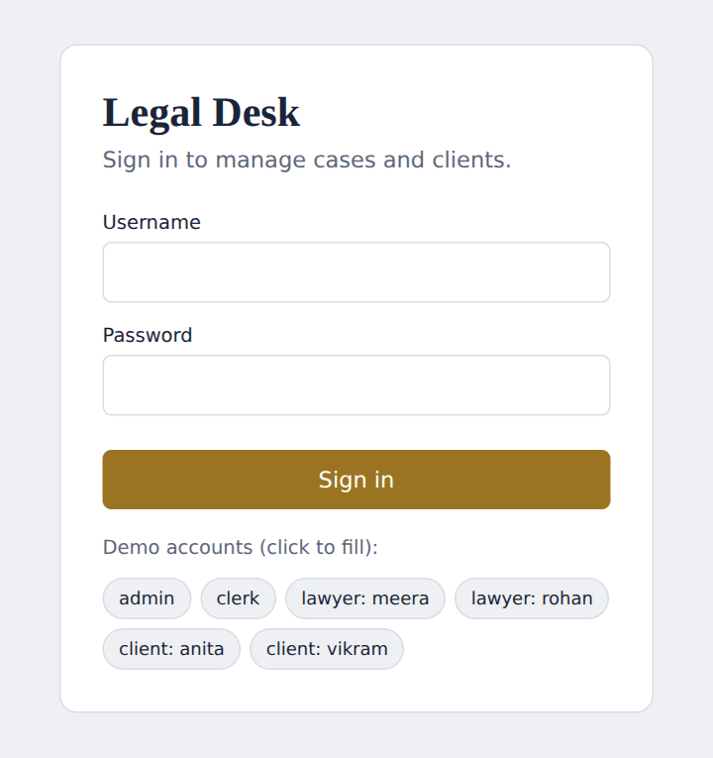
Figure 2. Login Screen with Role-Based Sign-in
Figure 3 shows the administrator’s dashboard, with totals and the upcoming hearings read from the database.
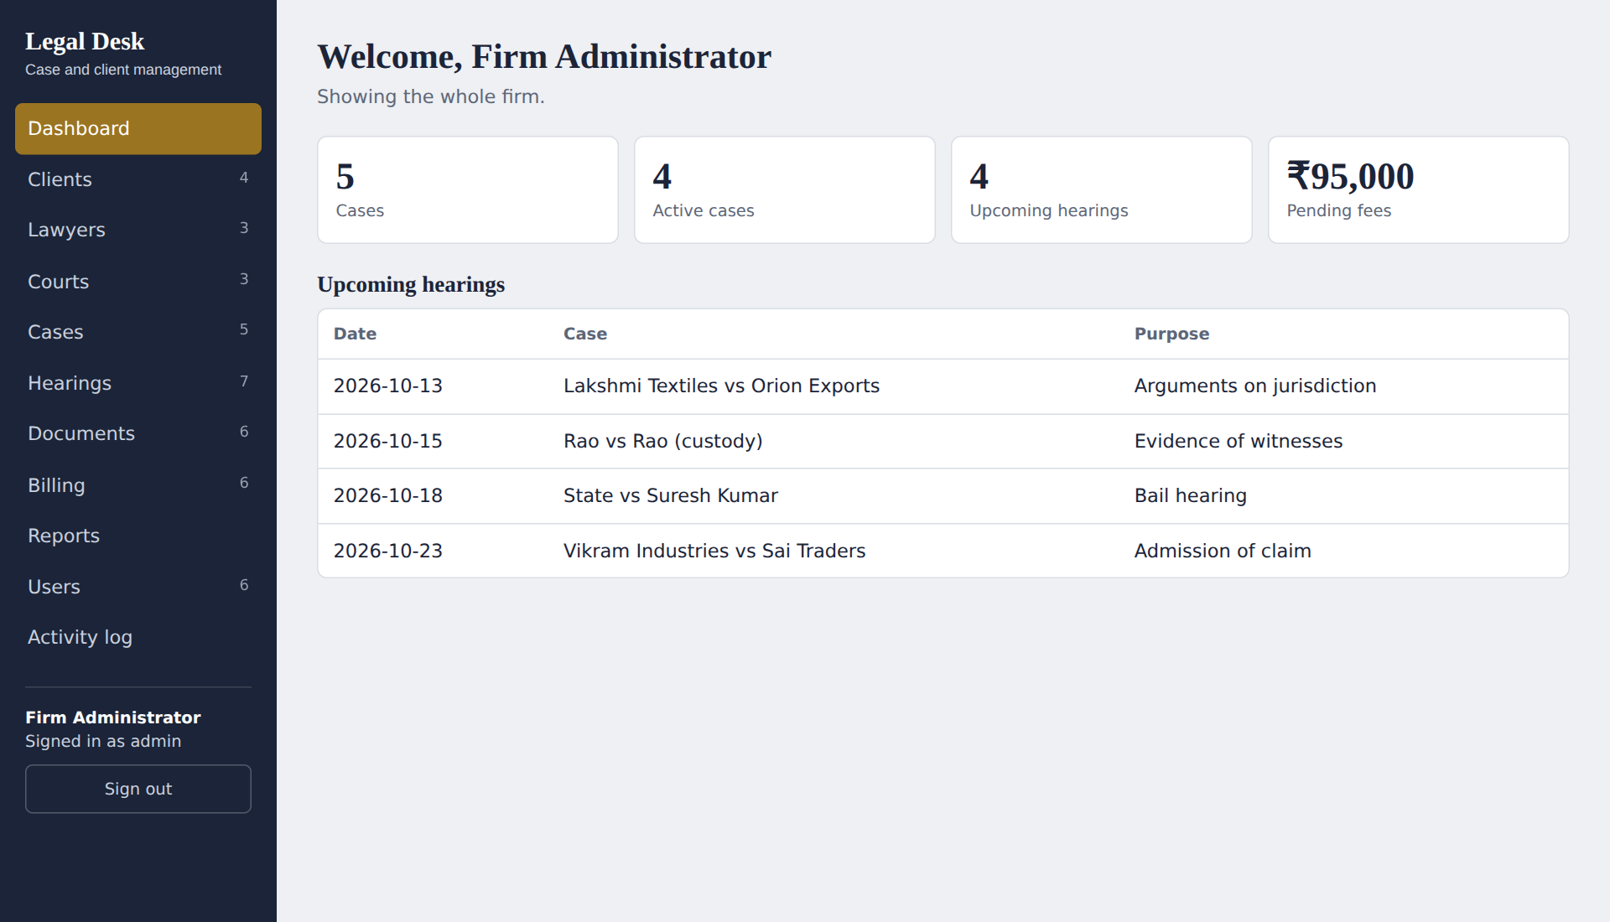
Figure 3. Dashboard of the Administrator
Figure 4 shows data entry. The client, court and lawyers are chosen from lists loaded from the database, so only existing records can be selected.
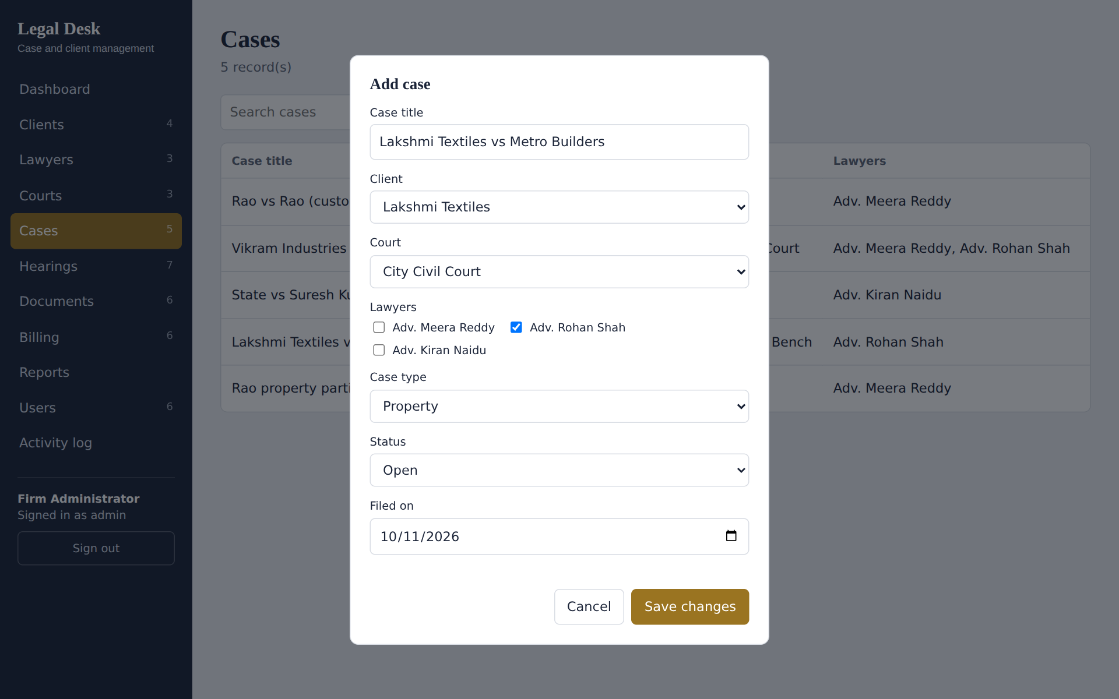
Figure 4. Data Entry: Registering a New Case
Figure 5 shows the search facility, and Figure 6 shows the case detail view that gathers data from four tables.
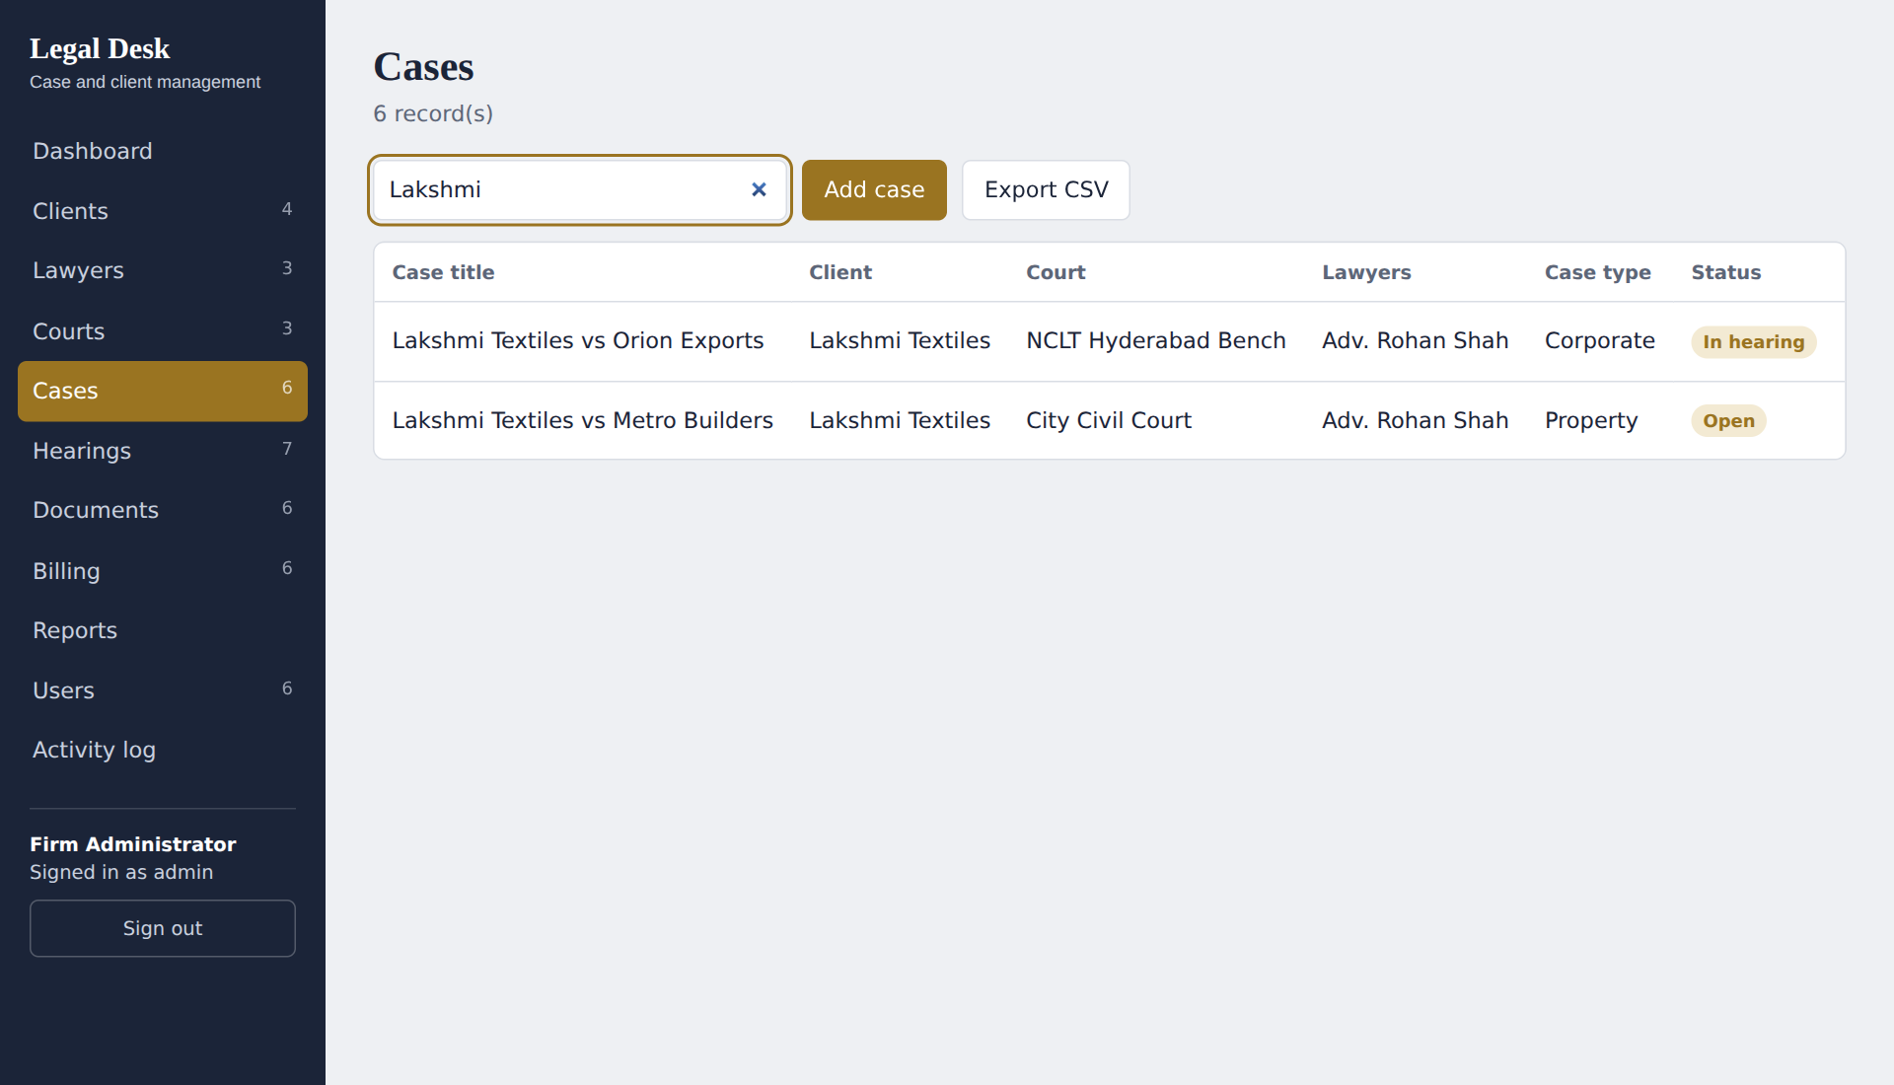
Figure 5. Search and Display of Cases
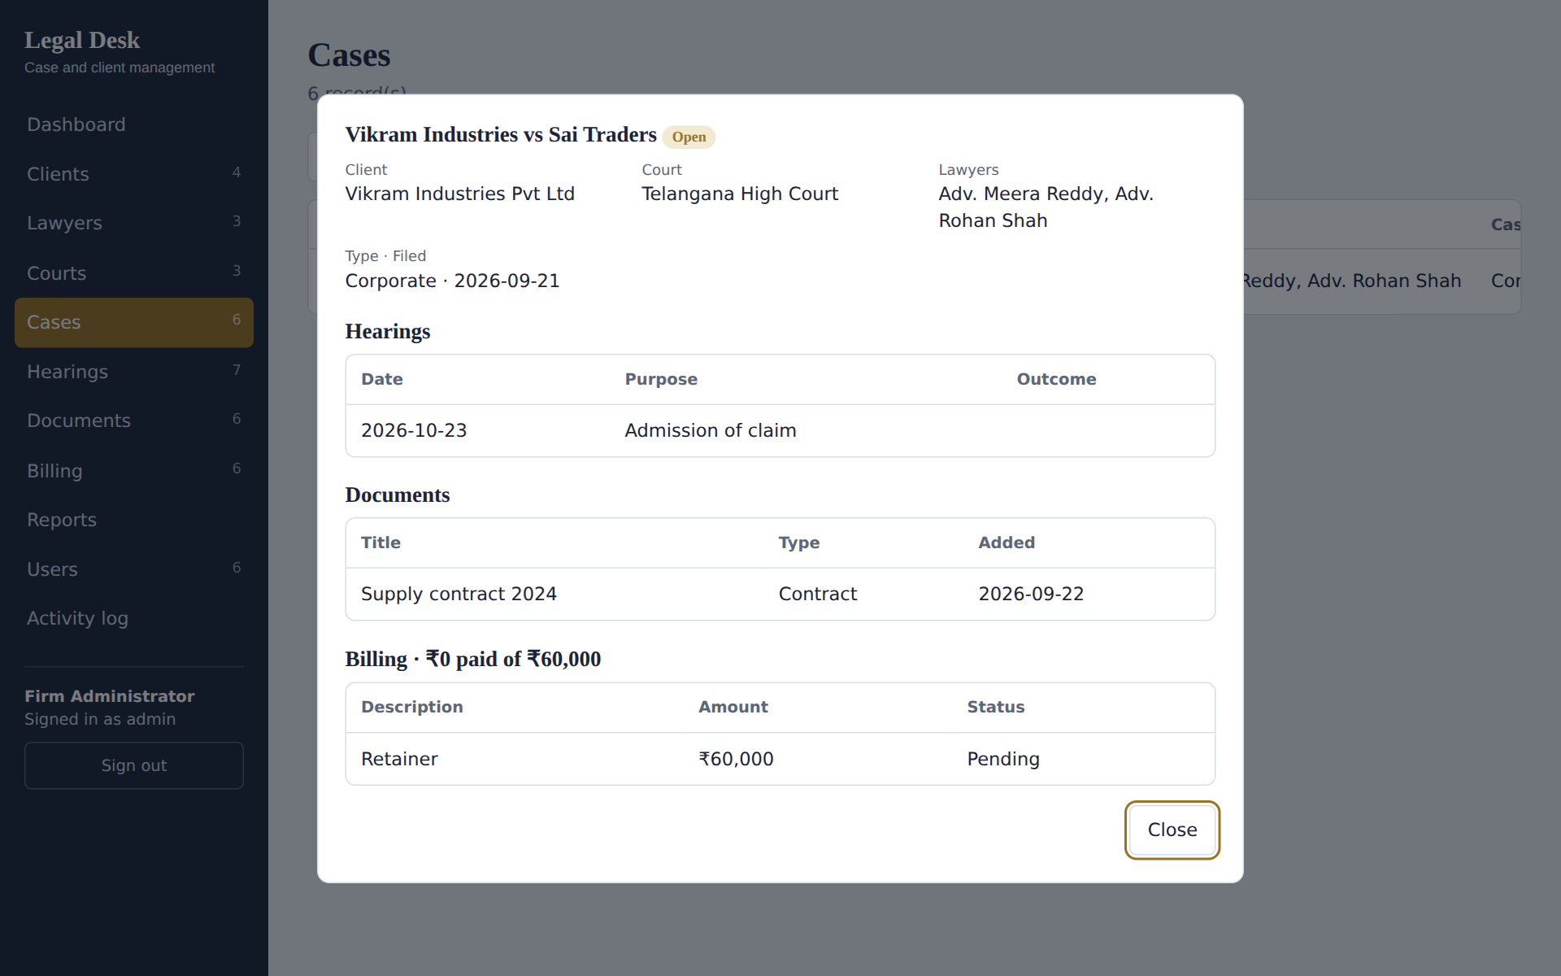
Figure 6. Case Detail View Combining Hearings, Documents and Billing
Figure 7 shows the project-specific transaction, marking a bill as paid. The database trigger then writes the PAYMENT_RECEIVED entry visible in Figure 8, next to the entries written by the application itself.
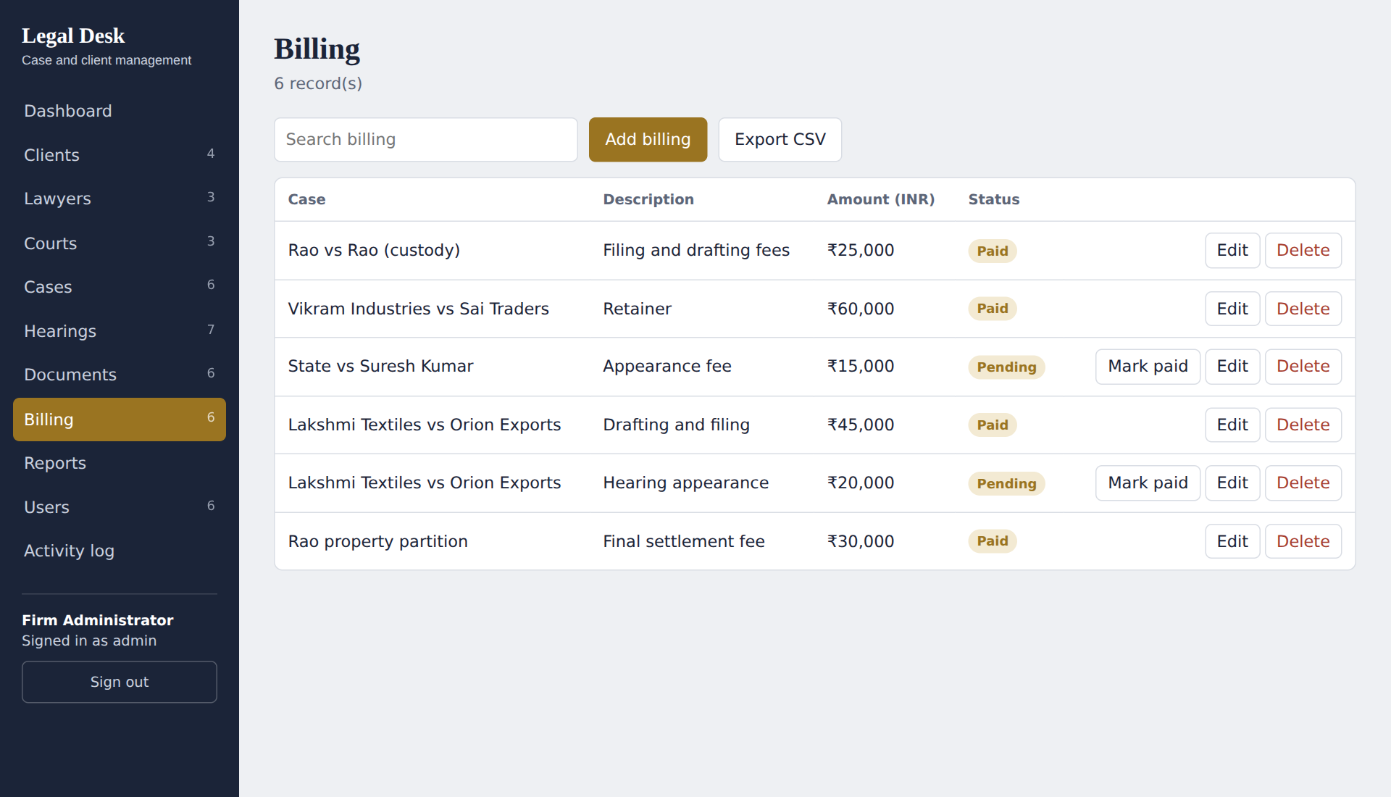
Figure 7. Transaction Processing: Marking a Bill as Paid
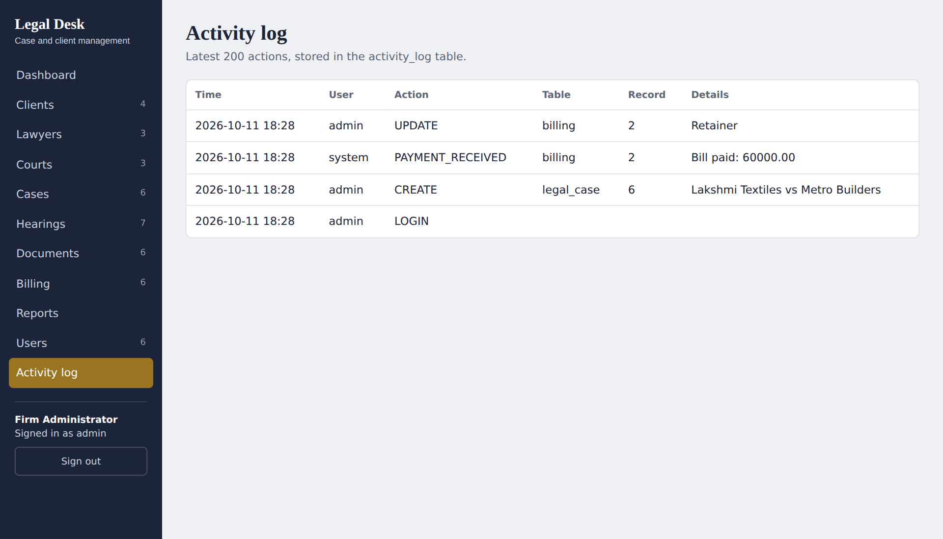
Figure 8. Activity Log Written by the Application and the Trigger
Figure 9 shows the reports calculated by the database, and Figure 10 shows how the same case list is restricted and made read-only when a lawyer signs in.
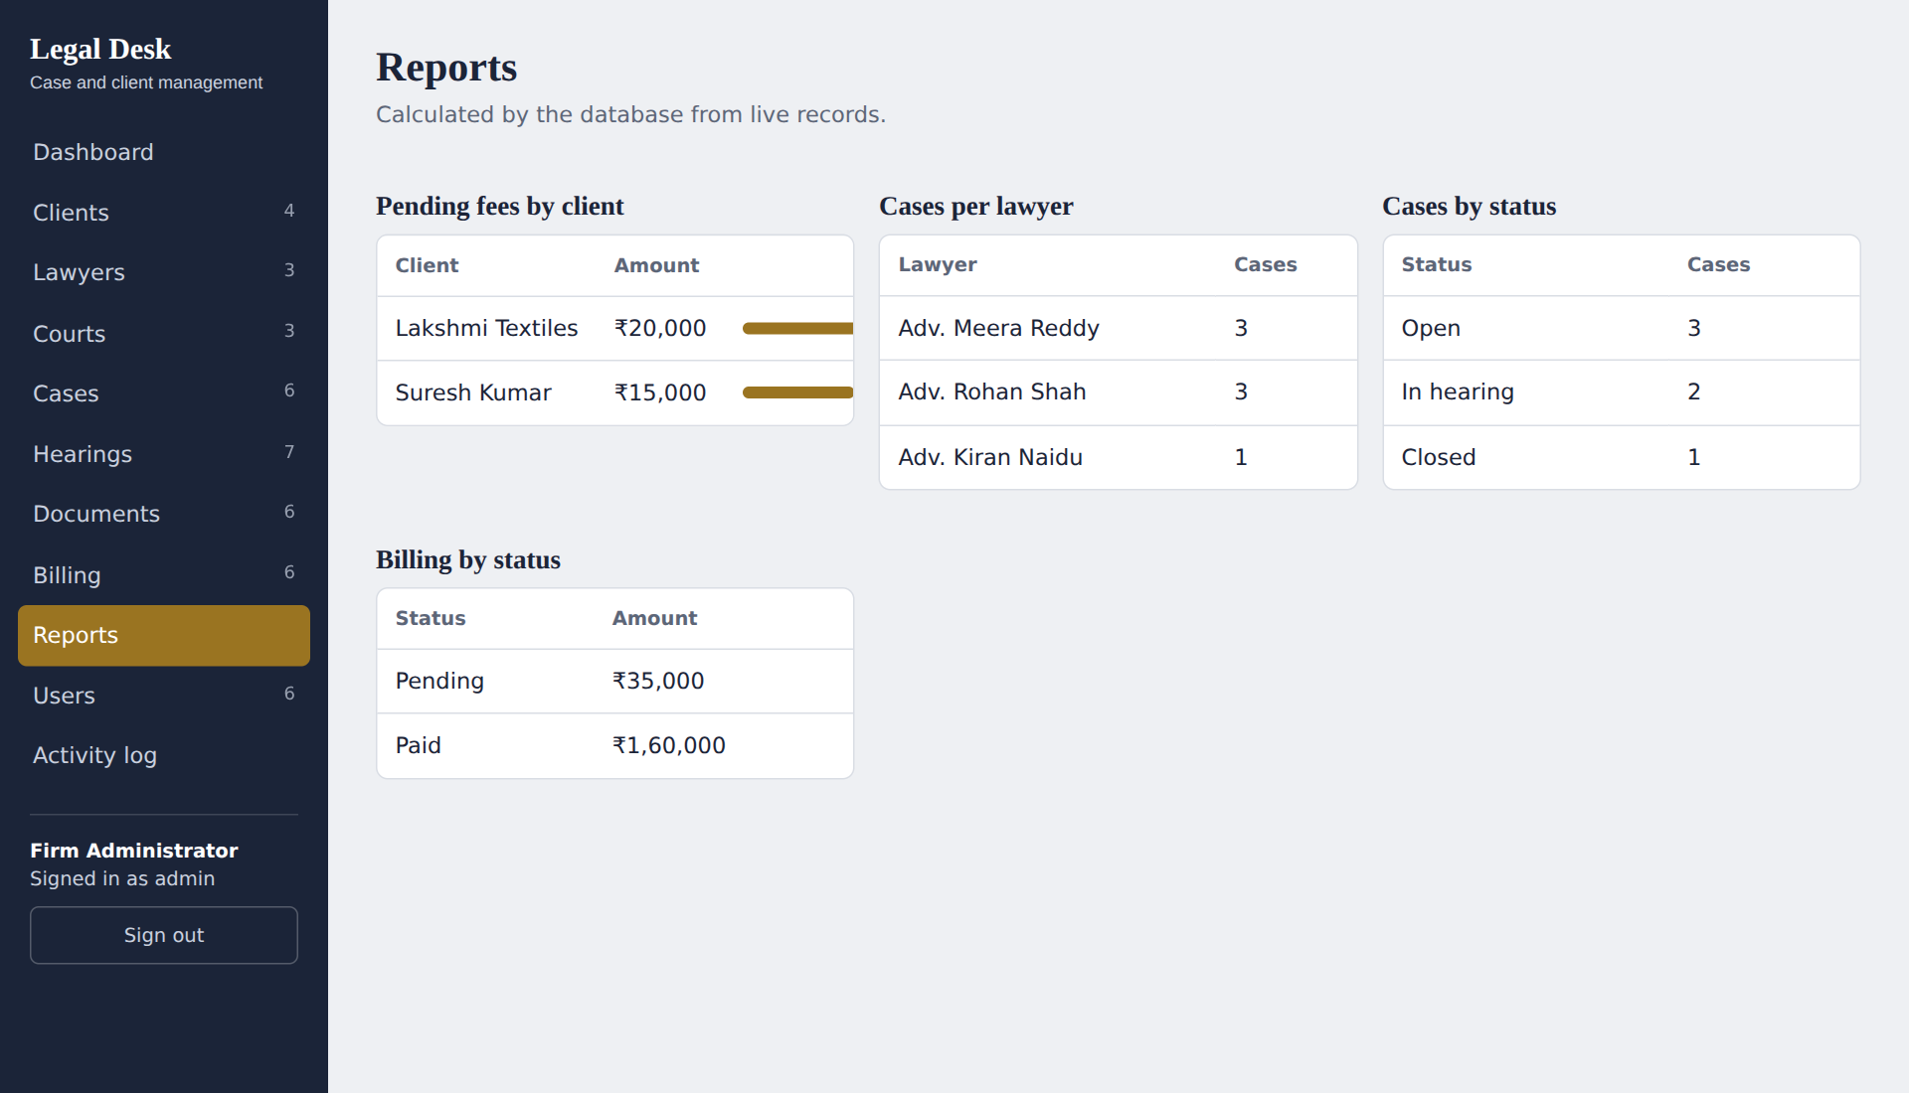
Figure 9. Database-Computed Reports
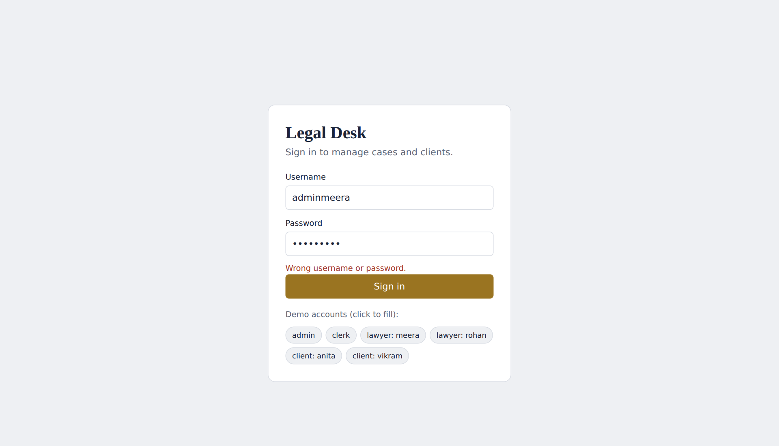
Figure 10. Restricted View for the Lawyer Role

3.8 Testing and Results
The test cases in Table 15 cover normal use and rule violations. Each test was run against the application and the database, and the actual result was recorded from what was observed.
Table 15. Test Cases
Test ID | Feature | Input / Action | Expected Result | Actual Result | Status
TC-01 | Login | User admin with the correct password | Dashboard opens; login recorded | Dashboard shown (Figure 3); LOGIN row added to activity_log | Pass
TC-02 | Login (negative) | admin with a wrong password | Access refused | HTTP 401: Wrong username or password. | Pass
TC-03 | Protected data | Request the case list without signing in | Request refused | HTTP 401: Please sign in. | Pass
TC-04 | Create case | Add a case with client, court and lawyer Rohan Shah | Rows in legal_case and case_lawyer; log entry | Case 6 saved and listed; CREATE legal_case entry logged (Figures 4, 8) | Pass
TC-05 | Search | Type “Lakshmi” in the case search box | Only matching cases shown | Two matching cases displayed (Figure 5) | Pass
TC-06 | Case detail | Open the Vikram Industries case | Hearings, documents and billing shown together | Combined details displayed (Figure 6) | Pass
TC-07 | Update / trigger | Mark the Retainer bill as paid | Status becomes Paid; trigger logs payment | Status Paid; PAYMENT_RECEIVED entry for 60000.00 (Figures 7, 8) | Pass
TC-08 | Referential integrity | Clerk deletes client Anita Rao, who has cases | Deletion refused | This record is still used by other records. Row kept. | Pass
TC-09 | Referential integrity | Admin deletes a court used by cases | Deletion refused | Same message; court row kept | Pass
TC-10 | CHECK constraint | Add a bill with amount -500 | Rejected | A value is outside the allowed range. | Pass
TC-11 | UNIQUE constraint | Add a client with an existing email; a lawyer with an existing bar number | Both rejected | That value already exists. (both cases) | Pass
TC-12 | Foreign key | Add a hearing for case number 999 | Rejected | The selected client, court, case or lawyer does not exist. | Pass
TC-13 | Role: client | Client Anita tries to add a hearing | Refused | HTTP 403: You do not have permission to do this. | Pass
TC-14 | Row-level view: client | Anita lists cases, bills and hearings | Only her own records | 2 cases, 2 bills and 3 hearings returned | Pass
TC-15 | Role: lawyer | Meera adds a hearing to her own case | Saved | Hearing saved | Pass
TC-16 | Role: lawyer | Meera adds a hearing to another lawyer’s case | Refused | You can only change records for your own cases. | Pass
TC-17 | Row-level view: lawyer | Meera opens Cases | Only assigned cases, read-only | 3 cases shown without Add or Edit buttons (Figure 10) | Pass
TC-18 | Role: lawyer | Meera tries to add a bill | Refused | HTTP 403: You do not have permission to do this. | Pass
TC-19 | Account rule | Admin creates a lawyer account without a linked lawyer | Rejected | Choose the lawyer this account belongs to. | Pass
TC-20 | Account rule | Admin deletes own account | Refused | You cannot delete your own account. | Pass

All twenty test cases gave the expected result. The results show that the application reads and writes the designed database for every operation, that referential integrity, uniqueness and range rules are enforced by the database itself, and that the role rules are enforced by the application on every request. The trigger recorded the payment without any extra application code, and the activity log shows which user made each change.

CHAPTER 4
CONCLUSION
This project addressed the problem of scattered, duplicated and unprotected records in a small law firm. An entity-relationship model was converted into ten relational tables in third normal form, with keys, constraints, two views and a trigger, and implemented in MySQL. A Python Flask web application was then built on this design to provide role-based login, record maintenance, a combined case view, fee tracking, reports and an activity log.
The work showed how much of the application’s correctness can be placed in the database: foreign keys, unique and check constraints and the trigger rejected or recorded events without extra code, while the application added role-based access and clear messages. The main learning outcome was seeing how normalization, constraints and SQL features such as joins, views and triggers support a real application.

4.1 Limitations and Future Enhancements
- The document module stores only the details of each document; uploading and storing the files themselves is a possible enhancement.
- The system serves one firm. Supporting several firms, and password reset by email, would need further tables and services.
- Hearing reminders by email or SMS and a calendar view would help lawyers avoid missed dates.
- Invoices could be generated as PDF files, and fee entries could be linked to online payment.
- The development server and demonstration accounts are for learning; a production server, HTTPS and stronger password rules would be needed for real use.

REFERENCES
[1] E. F. Codd, “A relational model of data for large shared data banks,” Commun. ACM, vol. 13, no. 6, pp. 377-387, Jun. 1970, doi: 10.1145/362384.362685.
[2] P. P. Chen, “The entity-relationship model—toward a unified view of data,” ACM Trans. Database Syst., vol. 1, no. 1, pp. 9-36, Mar. 1976, doi: 10.1145/320434.320440.
[3] R. Elmasri and S. B. Navathe, Fundamentals of Database Systems, 7th ed. Hoboken, NJ, USA: Pearson, 2016.
[4] A. Silberschatz, H. F. Korth, and S. Sudarshan, Database System Concepts, 7th ed. New York, NY, USA: McGraw-Hill, 2019.
[5] Oracle Corporation, MySQL 8.0 Reference Manual. Accessed: access date. [Online]. Available: https://dev.mysql.com/doc/refman/8.0/en/
[6] Pallets Projects, Flask Documentation. Accessed: access date. [Online]. Available: https://flask.palletsprojects.com/

APPENDICES

APPENDIX A - COMPLETE DATABASE SCRIPT
The complete database script is submitted as three files in the folder sql/ of the project: 01_schema.sql (creates the database, all tables, views and the trigger), 02_seed.sql (sample data and demonstration accounts) and 03_queries.sql (queries used for the reports and demonstration). The full text of 01_schema.sql is listed below, with line breaks adjusted to fit the page width.
-- Legal Desk: Legal Case and Client Management System (MySQL 8 / MariaDB)
DROP DATABASE IF EXISTS legal_desk;
CREATE DATABASE legal_desk CHARACTER SET utf8mb4;
USE legal_desk;

CREATE TABLE client (
client_id INT AUTO_INCREMENT PRIMARY KEY,
full_name VARCHAR(100) NOT NULL,
phone VARCHAR(20),
email VARCHAR(100) UNIQUE,
address VARCHAR(200)
);
CREATE TABLE lawyer (
lawyer_id INT AUTO_INCREMENT PRIMARY KEY,
full_name VARCHAR(100) NOT NULL,
specialization VARCHAR(60),
bar_no VARCHAR(30) NOT NULL UNIQUE,
phone VARCHAR(20)
);
CREATE TABLE court (
court_id INT AUTO_INCREMENT PRIMARY KEY,
name VARCHAR(120) NOT NULL,
city VARCHAR(60),
type ENUM('District','High Court','Supreme Court',
'Tribunal') NOT NULL
);
-- CASE is a reserved word in MySQL, so the table is named legal_case
CREATE TABLE legal_case (
case_id INT AUTO_INCREMENT PRIMARY KEY,
title VARCHAR(150) NOT NULL,
case_type ENUM('Civil','Criminal','Family','Corporate',
'Property') NOT NULL,
status ENUM('Open','In hearing','Closed') NOT NULL DEFAULT 'Open',
filed_on DATE NOT NULL,
client_id INT NOT NULL,
court_id INT NOT NULL,
FOREIGN KEY (client_id) REFERENCES client(client_id) ON DELETE RESTRICT,
FOREIGN KEY (court_id) REFERENCES court(court_id) ON DELETE RESTRICT
);
CREATE TABLE case_lawyer ( -- many-to-many
case_id INT NOT NULL,
lawyer_id INT NOT NULL,
PRIMARY KEY (case_id, lawyer_id),
FOREIGN KEY (case_id) REFERENCES legal_case(case_id)
ON DELETE CASCADE,
FOREIGN KEY (lawyer_id) REFERENCES lawyer(lawyer_id)
ON DELETE RESTRICT
);
CREATE TABLE document (
document_id INT AUTO_INCREMENT PRIMARY KEY,
case_id INT NOT NULL,
title VARCHAR(150) NOT NULL,
doc_type ENUM('Petition','Affidavit','Evidence','Order',
'Contract') NOT NULL,
added_on DATE NOT NULL,
FOREIGN KEY (case_id) REFERENCES legal_case(case_id) ON DELETE CASCADE
);
CREATE TABLE hearing (
hearing_id INT AUTO_INCREMENT PRIMARY KEY,
case_id INT NOT NULL,
hearing_date DATE NOT NULL,
purpose VARCHAR(150),
outcome VARCHAR(150),
FOREIGN KEY (case_id) REFERENCES legal_case(case_id) ON DELETE CASCADE
);
CREATE TABLE billing (
bill_id INT AUTO_INCREMENT PRIMARY KEY,
case_id INT NOT NULL,
description VARCHAR(150) NOT NULL,
amount DECIMAL(10,2) NOT NULL CHECK (amount >= 0),
status ENUM('Pending','Paid') NOT NULL DEFAULT 'Pending',
FOREIGN KEY (case_id) REFERENCES legal_case(case_id) ON DELETE CASCADE
);
-- Login accounts: each role sees different data.
-- Passwords are stored hashed.
CREATE TABLE app_user (
user_id INT AUTO_INCREMENT PRIMARY KEY,
username VARCHAR(40) NOT NULL UNIQUE,
password_hash VARCHAR(255) NOT NULL,
display_name VARCHAR(100) NOT NULL,
role ENUM('admin','clerk','lawyer','client') NOT NULL,
lawyer_id INT NULL,
client_id INT NULL,
FOREIGN KEY (lawyer_id) REFERENCES lawyer(lawyer_id) ON DELETE RESTRICT,
FOREIGN KEY (client_id) REFERENCES client(client_id) ON DELETE RESTRICT
);
CREATE TABLE activity_log (
log_id INT AUTO_INCREMENT PRIMARY KEY,
user_id INT NULL,
action VARCHAR(30) NOT NULL,
table_name VARCHAR(30),
record_id INT,
details VARCHAR(200),
created_at TIMESTAMP DEFAULT CURRENT_TIMESTAMP,
FOREIGN KEY (user_id) REFERENCES app_user(user_id) ON DELETE SET NULL
);
CREATE INDEX idx_case_client ON legal_case(client_id);
CREATE INDEX idx_hearing_date ON hearing(hearing_date);

CREATE VIEW v_case_summary AS
SELECT c.case_id, c.title, c.status, cl.full_name AS client,
co.name AS court,
(SELECT COUNT(*) FROM hearing h
WHERE h.case_id = c.case_id) AS hearings,
(SELECT COALESCE(SUM(amount),0) FROM billing b
WHERE b.case_id = c.case_id) AS billed
FROM legal_case c
JOIN client cl ON cl.client_id = c.client_id
JOIN court co ON co.court_id = c.court_id;

CREATE VIEW v_pending_fees AS
SELECT cl.client_id, cl.full_name, SUM(b.amount) AS pending_amount
FROM billing b
JOIN legal_case c ON c.case_id = b.case_id
JOIN client cl ON cl.client_id = c.client_id
WHERE b.status = 'Pending' GROUP BY cl.client_id, cl.full_name;

-- Trigger: log an entry whenever a bill changes from Pending to Paid
CREATE TRIGGER trg_bill_paid AFTER UPDATE ON billing FOR EACH ROW
INSERT INTO activity_log (user_id, action, table_name, record_id, details)
SELECT NULL, 'PAYMENT_RECEIVED', 'billing', NEW.bill_id,
CONCAT('Bill paid: ', NEW.amount)
FROM DUAL WHERE NEW.status = 'Paid' AND OLD.status = 'Pending';

APPENDIX B - APPLICATION SOURCE CODE
The source code is available at GitHub repository link. The project folder contains the following files.
File | Purpose
app.py | Flask server: login, permissions, row filters, CRUD endpoints, reports and activity log
static/index.html | Browser interface: login page, menus, tables, forms, case detail, reports
config.py | MySQL connection settings
setup_db.py | Creates the legal_desk database from the SQL files
sql/01_schema.sql, 02_seed.sql, 03_queries.sql | Database script, sample data and demonstration queries
requirements.txt | Python packages needed: flask and mysql-connector-python

APPENDIX C - ADDITIONAL TEST DATA AND OUTPUTS
The demonstration accounts are admin, clerk, meera, rohan, anita and vikram. The outputs below were taken from the MySQL command-line client after the test run described in Chapter 3.
mysql> SHOW FULL TABLES;
+----------------------+------------+
| Tables_in_legal_desk | Table_type |
+----------------------+------------+
| activity_log | BASE TABLE |
| app_user | BASE TABLE |
| billing | BASE TABLE |
| case_lawyer | BASE TABLE |
| client | BASE TABLE |
| court | BASE TABLE |
| document | BASE TABLE |
| hearing | BASE TABLE |
| lawyer | BASE TABLE |
| legal_case | BASE TABLE |
| v_case_summary | VIEW |
| v_pending_fees | VIEW |
+----------------------+------------+

mysql> SELECT user_id, username, display_name, role, lawyer_id, client_id FROM app_user;
+---------+----------+----------------------+--------+-----------+-----------+
| user_id | username | display_name | role | lawyer_id | client_id |
+---------+----------+----------------------+--------+-----------+-----------+
| 1 | admin | Firm Administrator | admin | NULL | NULL |
| 2 | clerk | Priya (Office Clerk) | clerk | NULL | NULL |
| 3 | meera | Adv. Meera Reddy | lawyer | 1 | NULL |
| 4 | rohan | Adv. Rohan Shah | lawyer | 2 | NULL |
| 5 | anita | Anita Rao | client | NULL | 1 |
| 6 | vikram | Vikram Industries | client | NULL | 2 |
+---------+----------+----------------------+--------+-----------+-----------+

mysql> SELECT * FROM v_case_summary;
+---------+------------------------------------+------------+---------------------------+----------------------+----------+----------+
| case_id | title | status | client | court | hearings | billed |
+---------+------------------------------------+------------+---------------------------+----------------------+----------+----------+
| 1 | Rao vs Rao (custody) | In hearing | Anita Rao | City Civil Court | 2 | 25000.00 |
| 2 | Vikram Industries vs Sai Traders | Open | Vikram Industries Pvt Ltd | Telangana High Court | 1 | 60000.00 |
| 3 | State vs Suresh Kumar | Open | Suresh Kumar | City Civil Court | 1 | 15000.00 |
| 4 | Lakshmi Textiles vs Orion Exports | In hearing | Lakshmi Textiles | NCLT Hyderabad Bench | 2 | 65000.00 |
| 5 | Rao property partition | Closed | Anita Rao | City Civil Court | 1 | 30000.00 |
| 6 | Lakshmi Textiles vs Metro Builders | Open | Lakshmi Textiles | City Civil Court | 0 | 0.00 |
+---------+------------------------------------+------------+---------------------------+----------------------+----------+----------+

mysql> SELECT * FROM v_pending_fees;
+-----------+------------------+----------------+
| client_id | full_name | pending_amount |
+-----------+------------------+----------------+
| 3 | Suresh Kumar | 15000.00 |
| 4 | Lakshmi Textiles | 20000.00 |
+-----------+------------------+----------------+

mysql> SELECT log_id, user_id, action, table_name, record_id, details FROM activity_log ORDER BY log_id DESC LIMIT 6;
+--------+---------+------------------+------------+-----------+------------------------------------+
| log_id | user_id | action | table_name | record_id | details |
+--------+---------+------------------+------------+-----------+------------------------------------+
| 5 | 1 | LOGOUT | NULL | NULL | NULL |
| 4 | 1 | UPDATE | billing | 2 | Retainer |
| 3 | NULL | PAYMENT_RECEIVED | billing | 2 | Bill paid: 60000.00 |
| 2 | 1 | CREATE | legal_case | 6 | Lakshmi Textiles vs Metro Builders |
| 1 | 1 | LOGIN | NULL | NULL | NULL |
+--------+---------+------------------+------------+-----------+------------------------------------+

