DBMS

The main function of database management system is C.R.U.D.
C- Create information
R- Read information
U- Update information
D- Delete information

There are 2 main types of database:
- Relational database(SQL) : Organize data into one or more tables
- Each table has columns and rows
- A unique key identifies each row
- Non-Relational database(no SQL/Not just SQL) : Organize data is anything but a traditional table(ex mongodb)
- Key-value stores
- Documents(JSON, XML, etc.)
- Graphs
- Flexible tables
RELATIONAL DATABASES (SQL)
- Relational Database Management System (RDBMS)
- Helps users create and maintain a relational database
Ex mySQL, Oracle, PostgreSQl, MariaDB, etc.
- Structures Query Language (SQL)
- Standardized language for interacting with RDBMS
- Used to perform CURD operations as well as other administrative tasks (user management, security, backup, etc.)
- Used to define tables and structures
- SQL code used on one RDBMS is not always portable to another without modification
NON-RELATIONAL DATABASES
- Non-Relational Databases Management Systems (NRDBMS)
- Helps users create and maintain a non-relational database
- mongoDB, DynamoDB, apache Cassandra, firebase, etc.
- Implementation Specific
- There is no set language standard
- Most NRDBMS will implement their own language for performing CRUD and administrative operations on the database
Database Queries
Queries are request made to the dbms for specific information
Ex . A google search is a query

Tables & Keys
- All tables have rows and column
- Column represent a single attribute
- Row represent an actual entry
Surrogate key is primary key that has no mapping in the real world
Natural key has a mapping in the real world
Foreign key is used to link 1 database table to another database table

Structured Query Language (SQL)
- SQL is a language used for interacting with RDBMS
- You can use SQL to get the RDBMS to do things for you
- CRUD
- Create and manage databases
- Design and create databases tables
- Perform Administration tasks (security, user management, import/export, etc.)
- SQL implementations vary between systems
- The concepts are the same but the implementation may vary
- SQL is actually a hybrid language, its basically 4 types of languages in one
- Data Query Language (DQL)
- Used to query the database for information
- Get information that is already stored there
- Data Definition Language (DDL)
- Used for defining database schemas
- Data Control Language (DCL)
- Used for controlling access to the data in the database
- User and permission management
- Data Manipulation Language (DML)
- Used for inserting updating and deleting data

Queries
- A query is a set of instructions given to the RDBMS (written in SQL) that tell the RDBMS what information you want it to retrieve for you
- Tons of data in a DB
- Often hidden in a complex Schema
- Goal is to only get the data you need
- SELECT employee.name, employee.age
- FROM employee
- WHERE employee.salary > 30000;

Basic Data Types :
- INTEGER
- DECIMAL(M,N) M-Total no of digits before the decimal
N- Total no of digits after the decimal
- VARCHAR(L) ---- String of txt of length L
- BLOB ---- Binary Large Object, Stores large data
- DATE ---- ‘YYYY-MM-DD’
- TIMESTAMP ---- ‘YYYY-MM-DD HH:MM:SS’ - used for recording

SYNTAX: CREATE TABLE student (
student_id INT ,
name VARCHAR(20) NOT NULL,
major VARCHAR(20) UNIQUE,
PRIMARY KEY(student_id)//Primary key is the main key
);

DESCRIBE student; //Describe

DROP TABLE student; //This deletes the table

ALTER TABLE student ADD gpa DECIMAL(3, 2);//ALTER TABLE helps to make changes in the table

ALTER TABLE student DROP COLUMN gpa;

//Insert into is used to add values into the table.
INSERT INTO student(student_id, name) VALUES(3, 'Jack');
INSERT INTO student VALUES(4, 'Claire', 'Biology');

//NOT NULL indicates the value cannot be NULL
//UNIQUE doesn’t allow 2 values to be same
//DEFAULT ‘value’ this gives them a default value
//AUTO_INCREMENT helps in creating the primary key automatically

UPDATE student //Used to update the existing value
SET major = 'Bio' //is used to set the new value
WHERE major = 'BIOLOGY' //indicates where to update the new value

UPDATE student
SET major = 'Biochemistry'
WHERE major = 'Bio' OR major = 'CHEMISTRY';

DELETE FROM student
WHERE student_id = 1;
SELECT * FROM student; // selects keywords tells the database that we want to get some information
SELECT student.name, student.major
ORDER BY name DESC; DESC stands for descending
FOREIGN KEY (key) REFERENCES table(key)

CREATE TABLE employee (
emp_id INT PRIMARY KEY,
first_name VARCHAR(40),
last_name VARCHAR(40),
birth_day DATE,
sex VARCHAR(1),
salary INT,
super_id INT,
branch_id INT
);

CREATE TABLE branch (
branch_id INT PRIMARY KEY,
branch_name VARCHAR(40),
mgr_id INT,
mgr_start_date DATE,
FOREIGN KEY(mgr_id) REFERENCES employee(emp_id) ON DELETE SET NULL
);

ALTER TABLE employee
ADD FOREIGN KEY(branch_id)
REFERENCES branch(branch_id)
ON DELETE SET NULL;

ALTER TABLE employee
ADD FOREIGN KEY(super_id)
REFERENCES employee(emp_id)
ON DELETE SET NULL;

CREATE TABLE client (
client_id INT PRIMARY KEY,
client_name VARCHAR(40),
branch_id INT,
FOREIGN KEY(branch_id) REFERENCES branch(branch_id) ON DELETE SET NULL
);

CREATE TABLE works_with (
emp_id INT,
client_id INT,
total_sales INT,
PRIMARY KEY(emp_id, client_id),
FOREIGN KEY(emp_id) REFERENCES employee(emp_id) ON DELETE CASCADE,
FOREIGN KEY(client_id) REFERENCES client(client_id) ON DELETE CASCADE
);

CREATE TABLE branch_supplier (
branch_id INT,
supplier_name VARCHAR(40),
supply_type VARCHAR(40),
PRIMARY KEY(branch_id, supplier_name),
FOREIGN KEY(branch_id) REFERENCES branch(branch_id) ON DELETE CASCADE
);

-- -----------------------------------------------------------------------------

-- Corporate
INSERT INTO employee VALUES(100, 'David', 'Wallace', '1967-11-17', 'M', 250000, NULL, NULL);

INSERT INTO branch VALUES(1, 'Corporate', 100, '2006-02-09');

UPDATE employee
SET branch_id = 1
WHERE emp_id = 100;

INSERT INTO employee VALUES(101, 'Jan', 'Levinson', '1961-05-11', 'F', 110000, 100, 1);

-- Scranton
INSERT INTO employee VALUES(102, 'Michael', 'Scott', '1964-03-15', 'M', 75000, 100, NULL);

INSERT INTO branch VALUES(2, 'Scranton', 102, '1992-04-06');

UPDATE employee
SET branch_id = 2
WHERE emp_id = 102;

INSERT INTO employee VALUES(103, 'Angela', 'Martin', '1971-06-25', 'F', 63000, 102, 2);
INSERT INTO employee VALUES(104, 'Kelly', 'Kapoor', '1980-02-05', 'F', 55000, 102, 2);
INSERT INTO employee VALUES(105, 'Stanley', 'Hudson', '1958-02-19', 'M', 69000, 102, 2);

-- Stamford
INSERT INTO employee VALUES(106, 'Josh', 'Porter', '1969-09-05', 'M', 78000, 100, NULL);

INSERT INTO branch VALUES(3, 'Stamford', 106, '1998-02-13');

UPDATE employee
SET branch_id = 3
WHERE emp_id = 106;

INSERT INTO employee VALUES(107, 'Andy', 'Bernard', '1973-07-22', 'M', 65000, 106, 3);
INSERT INTO employee VALUES(108, 'Jim', 'Halpert', '1978-10-01', 'M', 71000, 106, 3);

-- BRANCH SUPPLIER
INSERT INTO branch_supplier VALUES(2, 'Hammer Mill', 'Paper');
INSERT INTO branch_supplier VALUES(2, 'Uni-ball', 'Writing Utensils');
INSERT INTO branch_supplier VALUES(3, 'Patriot Paper', 'Paper');
INSERT INTO branch_supplier VALUES(2, 'J.T. Forms & Labels', 'Custom Forms');
INSERT INTO branch_supplier VALUES(3, 'Uni-ball', 'Writing Utensils');
INSERT INTO branch_supplier VALUES(3, 'Hammer Mill', 'Paper');
INSERT INTO branch_supplier VALUES(3, 'Stamford Lables', 'Custom Forms');

-- CLIENT
INSERT INTO client VALUES(400, 'Dunmore Highschool', 2);
INSERT INTO client VALUES(401, 'Lackawana Country', 2);
INSERT INTO client VALUES(402, 'FedEx', 3);
INSERT INTO client VALUES(403, 'John Daly Law, LLC', 3);
INSERT INTO client VALUES(404, 'Scranton Whitepages', 2);
INSERT INTO client VALUES(405, 'Times Newspaper', 3);
INSERT INTO client VALUES(406, 'FedEx', 2);

-- WORKS_WITH
INSERT INTO works_with VALUES(105, 400, 55000);
INSERT INTO works_with VALUES(102, 401, 267000);
INSERT INTO works_with VALUES(108, 402, 22500);
INSERT INTO works_with VALUES(107, 403, 5000);
INSERT INTO works_with VALUES(108, 403, 12000);
INSERT INTO works_with VALUES(105, 404, 33000);
INSERT INTO works_with VALUES(107, 405, 26000);
INSERT INTO works_with VALUES(102, 406, 15000);
INSERT INTO works_with VALUES(105, 406, 130000);

MORE BASIC QUERIES:-
-- Find all employees
SELECT *
FROM employee;

-- Find all clients
SELECT *
FROM clients;

-- Find all employees ordered by salary
SELECT *
from employee
ORDER BY salary ASC/DESC;

-- Find all employees ordered by sex then name
SELECT *
from employee
ORDER BY sex, name;

-- Find the first 5 employees in the table
SELECT *
from employee
LIMIT 5;

-- Find the first and last names of all employees
SELECT first_name, employee.last_name
FROM employee;

-- Find the forename and surnames names of all employees
SELECT first_name AS forename, employee.last_name AS surname
FROM employee;

-- Find out all the different genders
SELECT DISCINCT sex
FROM employee;

-- Find all male employees
SELECT *
FROM employee
WHERE sex = 'M';

-- Find all employees at branch 2
SELECT *
FROM employee
WHERE branch_id = 2;

-- Find all employee's id's and names who were born after 1969
SELECT emp_id, first_name, last_name
FROM employee
WHERE birth_day >= 1970-01-01;

-- Find all female employees at branch 2
SELECT *
FROM employee
WHERE branch_id = 2 AND sex = 'F';

-- Find all employees who are female & born after 1969 or who make over 80000
SELECT *
FROM employee
WHERE (birth_day >= '1970-01-01' AND sex = 'F') OR salary > 80000;

-- Find all employees born between 1970 and 1975
SELECT *
FROM employee
WHERE birth_day BETWEEN '1970-01-01' AND '1975-01-01';

-- Find all employees named Jim, Michael, Johnny or David
SELECT *
FROM employee
WHERE first_name IN ('Jim', 'Michael', 'Johnny', 'David');

FUNCTIONS
-- Find the number of employees
SELECT COUNT(super_id)
FROM employee;

-- Find the average of all employee's salaries
SELECT AVG(salary)
FROM employee;

-- Find the sum of all employee's salaries
SELECT SUM(salary)
FROM employee;

-- Find out how many males and females there are
SELECT COUNT(sex), sex
FROM employee
GROUP BY sex

-- Find the total sales of each salesman
SELECT SUM(total_sales), emp_id
FROM works_with
GROUP BY client_id;

-- Find the total amount of money spent by each client

SELECT SUM(total_sales), client_id
FROM works_with
GROUP BY client_id;
-- Find the number of female employees born after 1970
SELECT COUNT(emp_id)
FROM employee
WHERE sex = ‘F’ AND birth_date > ‘1970-01-01’;

WILDCARDS
-- % = any # characters, _ = one character

-- Find any client's who are an LLC
SELECT *
FROM client
WHERE client_name LIKE '%LLC';

-- Find any branch suppliers who are in the label business
SELECT *
FROM branch_supplier
WHERE supplier_name LIKE '% Label%';

-- Find any employee born on the 10th day of the month
SELECT *
FROM employee
WHERE birth_day LIKE '_____10%';

-- Find any clients who are schools
SELECT *
FROM client
WHERE client_name LIKE '%Highschool%';

UNION
-- Find a list of employee and branch names
SELECT employee.first_name AS Employee_Branch_Names
FROM employee
UNION
SELECT branch.branch_name
FROM branch;

-- Find a list of all clients & branch suppliers' names
SELECT client.client_name AS Non-Employee_Entities, client.branch_id AS Branch_ID
FROM client
UNION
SELECT branch_supplier.supplier_name, branch_supplier.branch_id
FROM branch_supplier;
JOINS
-- Add the extra branch
INSERT INTO branch VALUES(4, "Buffalo", NULL, NULL);

SELECT employee.emp_id, employee.first_name, branch.branch_name
FROM employee
JOIN branch -- LEFT JOIN, RIGHT JOIN
ON employee.emp_id = branch.mgr_id;

NESTED QUERIES
-- Find names of all employees who have sold over 50,000
SELECT employee.first_name, employee.last_name
FROM employee
WHERE employee.emp_id IN (SELECT works_with.emp_id
FROM works_with
WHERE works_with.total_sales > 50000);

-- Find all clients who are handles by the branch that Michael Scott manages
-- Assume you know Michael's ID
SELECT client.client_id, client.client_name
FROM client
WHERE client.branch_id = (SELECT branch.branch_id
FROM branch
WHERE branch.mgr_id = 102);

-- Find all clients who are handles by the branch that Michael Scott manages
-- Assume you DONT'T know Michael's ID
SELECT client.client_id, client.client_name
FROM client
WHERE client.branch_id = (SELECT branch.branch_id
FROM branch
WHERE branch.mgr_id = (SELECT employee.emp_id
FROM employee
WHERE employee.first_name = 'Michael' AND employee.last_name ='Scott'
LIMIT 1));

-- Find the names of employees who work with clients handled by the scranton branch
SELECT employee.first_name, employee.last_name
FROM employee
WHERE employee.emp_id IN (
SELECT works_with.emp_id
FROM works_with
)
AND employee.branch_id = 2;

-- Find the names of all clients who have spent more than 100,000 dollars
SELECT client.client_name
FROM client
WHERE client.client_id IN (
SELECT client_id
FROM (
SELECT SUM(works_with.total_sales) AS totals, client_id
FROM works_with
GROUP BY client_id) AS total_client_sales
WHERE totals > 100000
);

ON DELETE SET NULL
This helps us to delete an entry with foreign key
ON DELETE CASCADE
If one entry is deleted it deletes the entire row
TRIGGERS
-- CREATE
-- TRIGGER `event_name` BEFORE/AFTER INSERT/UPDATE/DELETE
-- ON `database`.`table`
-- FOR EACH ROW BEGIN
-- -- trigger body
-- -- this code is applied to every
-- -- inserted/updated/deleted row
-- END;

CREATE TABLE trigger_test (
message VARCHAR(100)
);

-- The dollar sign is used because you can use the same delimiter twice in the trigger
-- So you need to first make a new delimiter at the start of statement and then change the delimiter to a semicolon (;) at the end of the trigger statement

DELIMITER $$
CREATE
TRIGGER my_trigger BEFORE INSERT
ON employee
FOR EACH ROW BEGIN
INSERT INTO trigger_test VALUES('added new employee');
END$$
DELIMITER ;
INSERT INTO employee
VALUES(109, 'Oscar', 'Martinez', '1968-02-19', 'M', 69000, 106, 3);

DELIMITER $$
CREATE
TRIGGER my_trigger BEFORE INSERT
ON employee
FOR EACH ROW BEGIN
INSERT INTO trigger_test VALUES(NEW.first_name);
END$$
DELIMITER ;
INSERT INTO employee
VALUES(110, 'Kevin', 'Malone', '1978-02-19', 'M', 69000, 106, 3);

DELIMITER $$
CREATE
TRIGGER my_trigger BEFORE INSERT
ON employee
FOR EACH ROW BEGIN
IF NEW.sex = 'M' THEN
INSERT INTO trigger_test VALUES('added male employee');
ELSEIF NEW.sex = 'F' THEN
INSERT INTO trigger_test VALUES('added female');
ELSE
INSERT INTO trigger_test VALUES('added other employee');
END IF;
END$$
DELIMITER ;
INSERT INTO employee
VALUES(111, 'Pam', 'Beesly', '1988-02-19', 'F', 69000, 106, 3);

DROP TRIGGER my_trigger;

ER DIAGRAMS
E- Entity
R- Relationship
Entity- An object we want to model & store information about
Attributes- Specific pieces of information about the entity
Primary key – An attribute(s) that uniquely identify an entry in the database table
Composite attribute – An attribute that can be broken up into sub-attributes
Multi-valued attributes - An attribute than can have more than one value
Derived attributes -An attribute than can be derived from the other attributes
Multiple Entities – You can define more than one entity in the diagram
Relationship – Defines a relationship between two entities
Total participation – All members must participate in the relationship
Relationship Attribute – An attribute about relationship
Relationship Cardinality – The number of instances of an entity from a relation that can be associated with the relation
Weak Entity – An entity that cannot be uniquely identified by its attribute alone
Identifying relationship- A relationship that serves to uniquely identify the weak entity

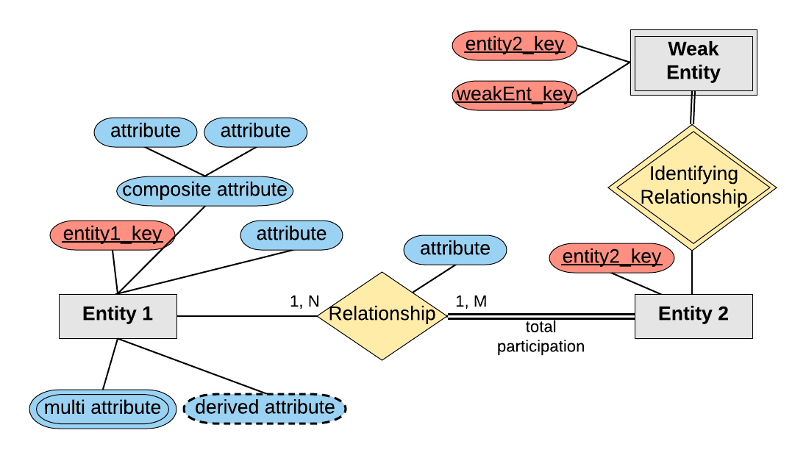
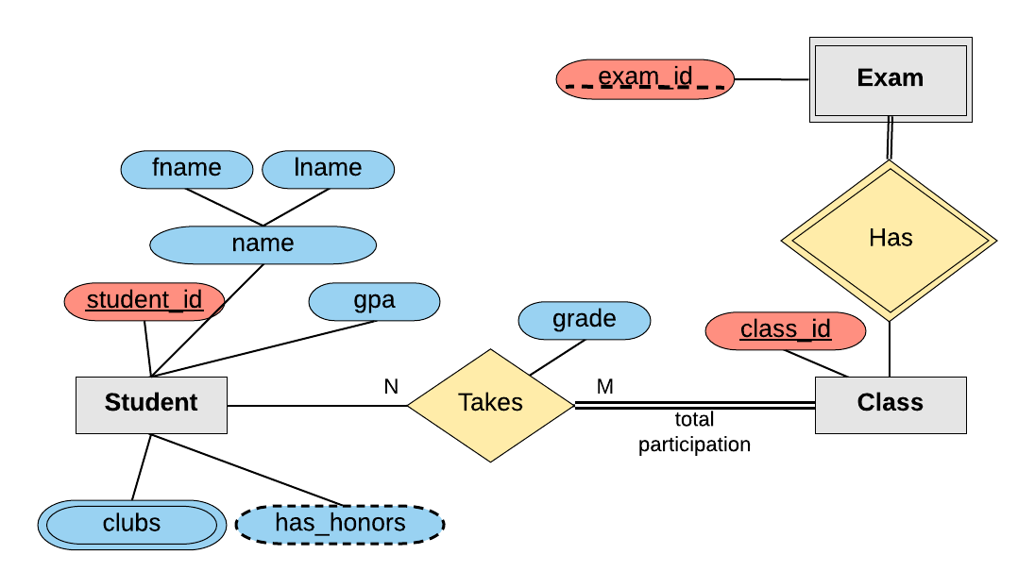

DESIGNING AN ER DIAGRAM
The company is organized into branches. Each branch has a unique number, a name, and a particular employee who manages it.
The company makes it’s money by selling to clients. Each client has a name and a unique number to identify it.
The foundation of the company is it’s employees. Each employee has a name, birthday, sex, salary and a unique number.
An employee can work for one branch at a time, and each branch will be managed by one of the employees that work there. We’ll also want to keep track of when the current manager started as manager.
An employee can act as a supervisor for other employees at the branch, an employee may also act as the supervisor for employees at other branches. An employee can have at most one supervisor.
A branch may handle a number of clients, with each client having a name and a unique number to identify it. A single client may only be handled by one branch at a time.
Employees can work with clients controlled by their branch to sell them stuff. If nescessary multiple employees can work with the same client. We’ll want to keep track of how many dollars worth of stuff each employee sells to each client they work with.
Many branches will need to work with suppliers to buy inventory. For each supplier we’ll keep track of their name and the type of product they’re selling the branch. A single supplier may supply products to multiple branches.

Company ER Diagram
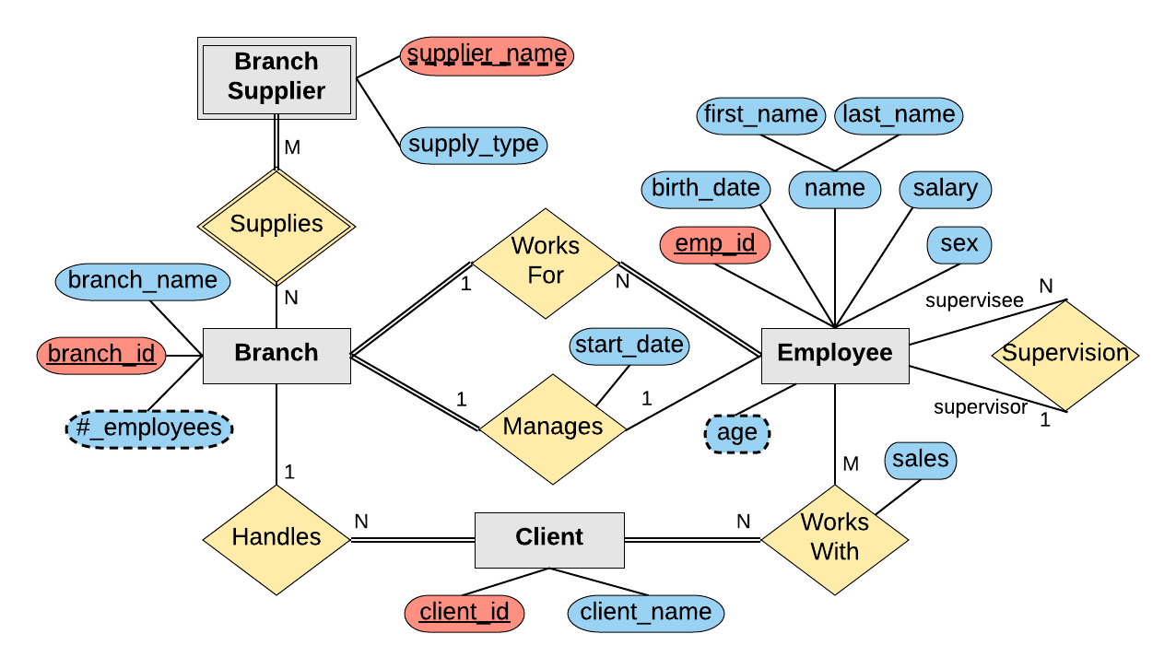

DOUBLE LINE – indicates full participation (Compulsory)
SINGLE LINE – indicates partial participation (Not compulsory)

CONERTING ER DIAGRAM TO SCHEMAS

STEP 1 : Mapping of regular entity types
STEP 2 : Mapping of weak entity types
STEP 3 : Mapping of Binary 1:1 relationship types
STEP 4 : Mapping of Binary 1:N relationship types
STEP 5 : Mapping of Binary M:N relationship types

