Machine Learning Operations (MLOps)
End-to-End Heart Disease Risk Prediction
Model development, CI/CD, containerised deployment and monitoring
Item | Detail
Course | AIMLCZG523 - Machine Learning Operations
Assignment | Assignment 01 (50 marks)
Student name | Ishant Tanwar
Student ID | 2025AE05871
Dataset | Heart Disease UCI - Cleveland subset (303 patients)
Repository | https://github.com/ishanttanwar/heart-disease-mlops
Submission date | 10 November 2026

1. Introduction and objective
This report covers a system I built to predict coronary heart disease from thirteen routine clinical measurements. The classifier itself is not the hard part. The dataset is small and well studied, and a decent model falls out of it quickly. The work that actually took the time was everything around the model: getting the data preparation reproducible, tracking the experiments properly, writing tests, packaging the thing so it runs the same way inside a container, deploying it, and then being able to see what it is doing once it is running.
I set one rule for myself at the start: anything in the repository has to be reproducible from a fresh clone. Clone it, install the pinned dependencies, and three commands should regenerate the cleaned data, the trained pipeline and every plot. That is easy to claim and easy to break, so the CI pipeline runs the same sequence on every push. If it stops being true, the build goes red.

1.1 Scope
- Data acquisition, cleaning and exploratory analysis of the UCI Cleveland dataset.
- A single scikit-learn Pipeline covering imputation, scaling, encoding and the classifier, so training and serving cannot diverge.
- Twelve tracked experiments across three model families and four preprocessing variants, logged to MLflow.
- A FastAPI service exposing prediction, health and metrics endpoints, packaged as a Docker image.
- A three-stage GitHub Actions pipeline: lint and test, build and run the container, deploy to a Kubernetes cluster.
- Prometheus scraping and a nine-panel Grafana dashboard, backed by structured request logs.

1.2 Clinical framing
The two kinds of mistake are not equally bad here. Missing a patient who has disease sends them home untreated. Flagging a healthy patient leads to more tests, which are mostly non-invasive. So recall on the disease class matters more than headline accuracy. I picked ROC-AUC as the selection metric because it judges the model across all operating points instead of locking in one cut-off, and I kept the decision threshold outside the model so it can be moved later without retraining. Section 5.4 goes into this.

2. Dataset acquisition and exploratory analysis

2.1 Acquisition
The Cleveland subset is downloaded directly from the UCI Machine Learning Repository by src/data_loader.py, with the ucimlrepo package as a fallback if the direct HTTP request fails. The raw file has no header row and encodes missing values as question marks, so the loader applies the documented column order and converts those markers to NaN.
python -m src.data_loader # downloads, cleans and saves the dataset
Two cleaning choices are worth calling out. The original target runs from 0 to 4 for disease severity, so I collapsed it to 0 against 1-4 as the problem statement asks. The second choice was less obvious: I left the six missing values as NaN in the cleaned CSV instead of filling them in. Filling them during cleaning would mean computing a median over the whole dataset, including rows that later end up in validation folds. Imputing inside the pipeline keeps those statistics on the training side of every split.

2.2 Dataset profile
Property | Value
Rows | 303 patients
Features | 13 (5 numeric, 8 categorical)
Target balance | 164 no disease (54.1%) vs 139 disease (45.9%)
Missing values | ca: 4, thal: 2 (about 1% each)
Duplicate rows | none
Age range | 29 to 77 years (mean 54.4)
Cholesterol range | 126 to 564 mg/dl (mean 246.7)
Max heart rate range | 71 to 202 bpm (mean 149.6)
The classes are close to balanced, so no resampling was applied and accuracy remains interpretable. Stratified splitting and stratified cross-validation preserve this ratio in every fold.

2.3 Findings
Seven figures are generated by src/eda.py and saved to screenshots/eda/. The strongest associations with the target, measured by Spearman correlation, are thal (0.52), ca (0.49), cp (0.47), exang (0.43), oldpeak (0.41) and thalach (-0.42). Patients with disease reach a markedly lower maximum heart rate and show higher exercise-induced ST depression.
- oldpeak is strongly right-skewed with a large mass at zero, which motivated testing a log transform as an engineered feature.
- chol and trestbps overlap heavily between classes and contribute little on their own; a few extreme values (cholesterol 564, blood pressure 200) are clinically plausible and were retained rather than clipped, with robust scaling tested as an alternative.
- fbs shows almost no separation between classes, and restecg category 1 contains only a handful of patients.
- The highest feature-to-feature correlation is slope with oldpeak at 0.59, so multicollinearity is moderate and regularised logistic regression handles it comfortably.
One caveat applies to these numbers: Spearman correlation on integer category codes implicitly treats those categories as ordered, so the values are a ranking guide rather than exact effect sizes.
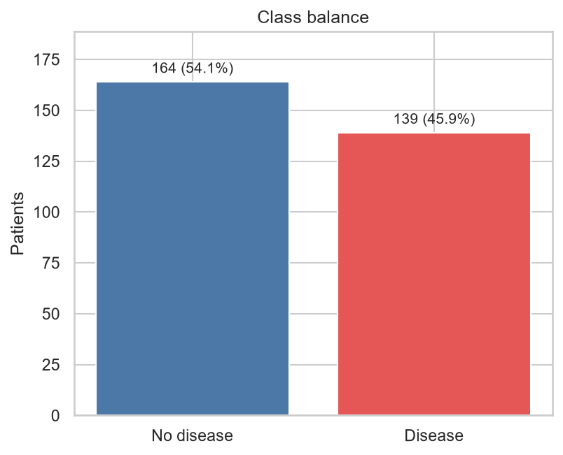
Figure 1: Class balance - 164 patients without disease against 139 with.
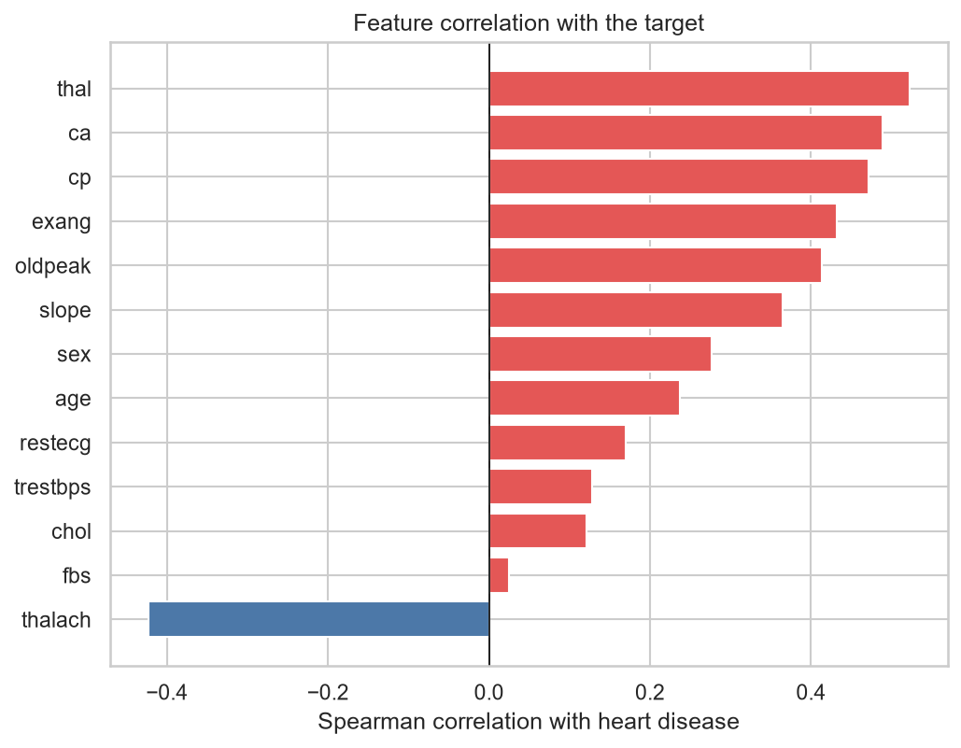
Figure 2: Spearman correlation of each feature with the diagnosis.
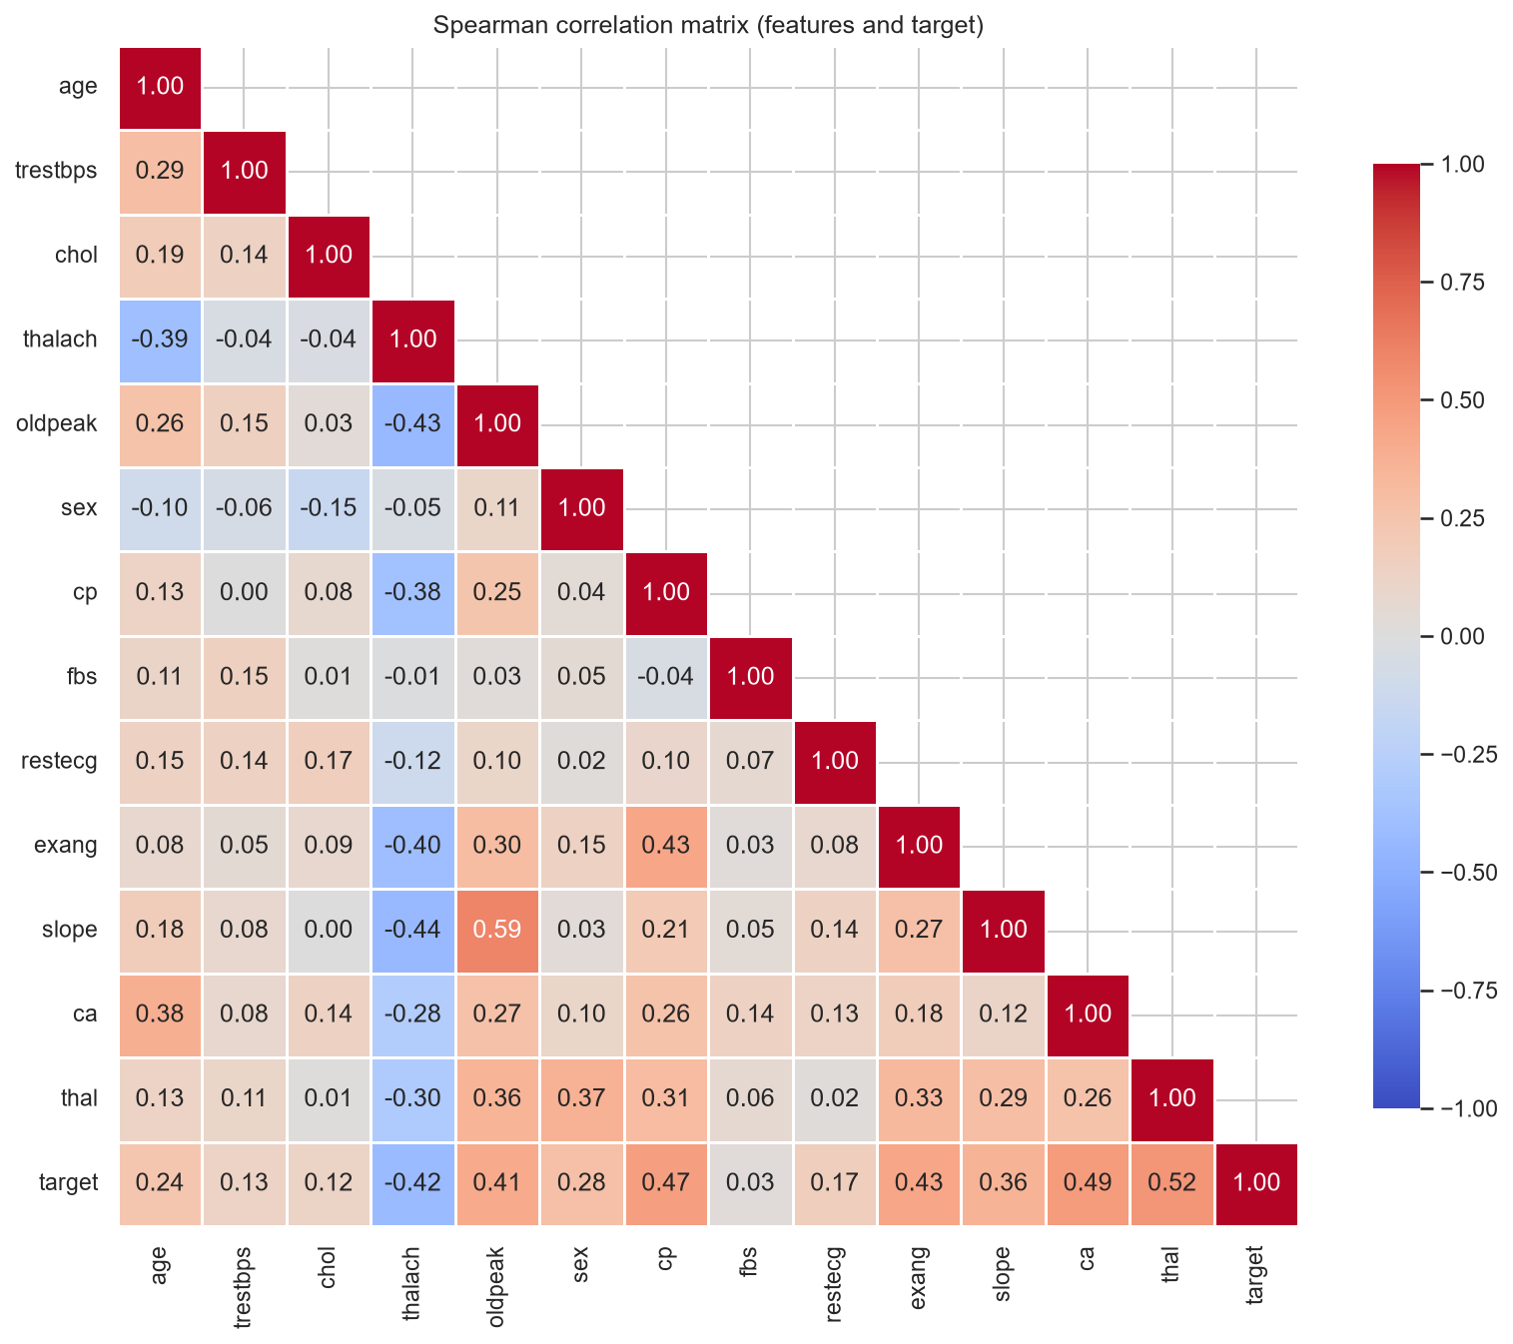
Figure 3: Correlation matrix across all features and the target.
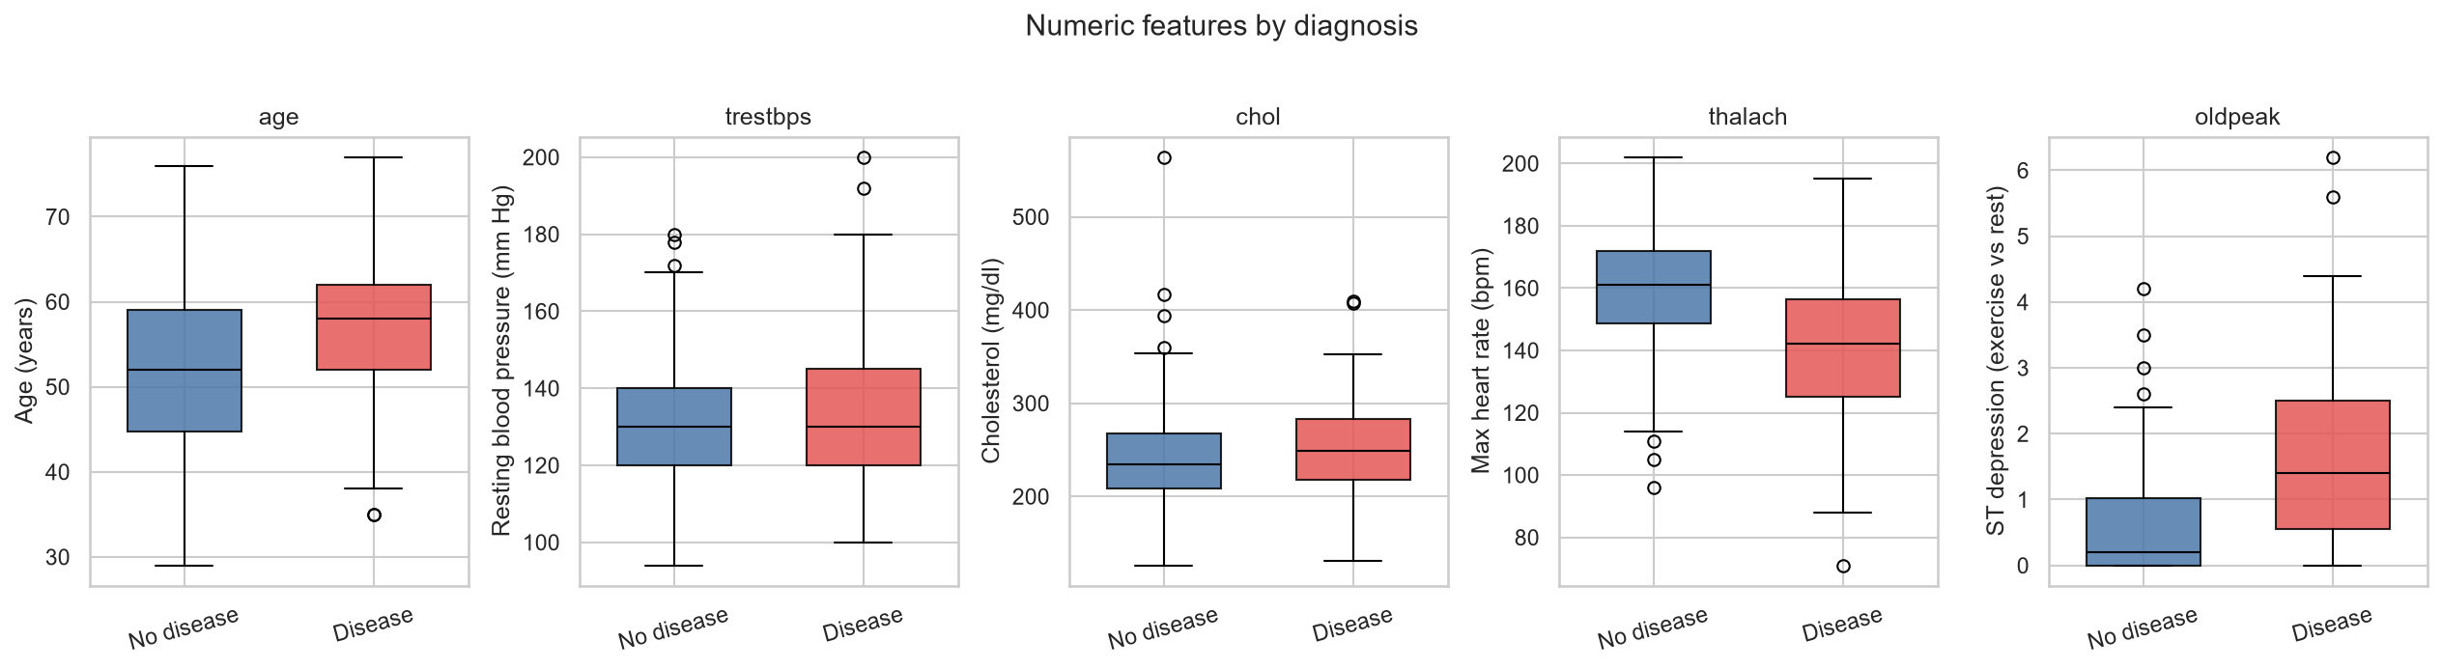
Figure 4: Numeric features split by diagnosis.
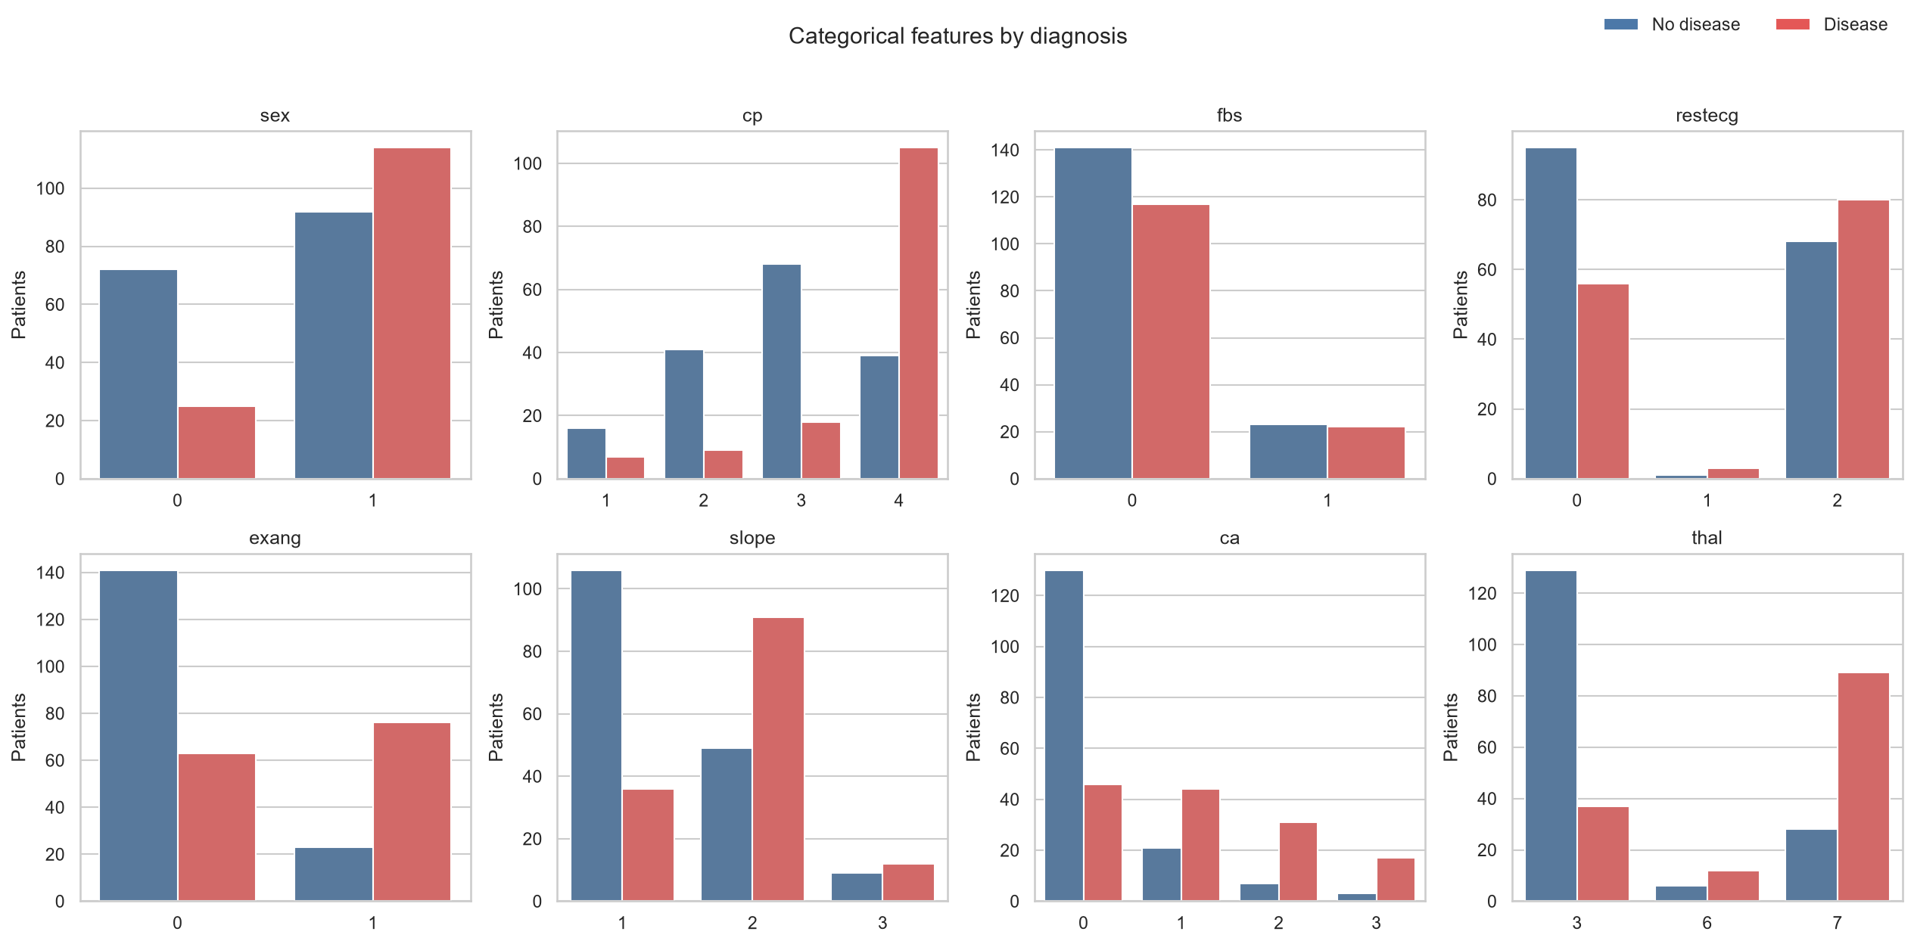
Figure 5: Categorical features split by diagnosis.

3. Feature engineering and preprocessing
All feature transformation lives inside one scikit-learn Pipeline, defined in src/preprocessing.py. This is the single most important design decision in the project: because the fitted preprocessor is saved together with the classifier, the API applies byte-identical transformations to a single incoming JSON record as were applied during training.

3.1 Pipeline structure
Stage | Applies to | Transformation
Feature engineering | optional | ClinicalFeatures adds two derived columns
Numeric branch | 5 columns | median imputation, then standard or robust scaling
Categorical branch | 8 columns | most-frequent imputation, then one-hot encoding
Unknown categories | all | handle_unknown='ignore' so serving never crashes
Treating ca as categorical rather than numeric was a judgement call. It is a count of major vessels from 0 to 3, so it could reasonably be modelled either way. It was treated as categorical because the relationship with the target is not monotonic in a strictly linear sense and one-hot encoding lets the model learn each level independently; with only four levels the cost in extra parameters is negligible.

3.2 Engineered features
I added two derived features, but built them as a switch that can be turned off, so I could measure whether they earned their place instead of assuming it:
- hr_reserve_pct = thalach / (220 - age). Maximum heart rate achieved expressed as a fraction of the age-predicted maximum. A 150 bpm result means something different for a 40-year-old than for a 70-year-old, and this ratio captures that.
- oldpeak_log = log(1 + oldpeak). Compresses the long right tail identified during EDA.
Section 5.3 reports how that turned out. The short version is that neither feature moved the result, which I have reported as-is rather than quietly keeping them and saying nothing.

3.3 Guarding against leakage
Imputation and scaling are fitted inside the pipeline, so when GridSearchCV refits on each fold, those statistics come from that fold's training portion alone. A dedicated unit test asserts this directly: it fits the preprocessor on a training split and checks that the imputer's learned medians equal the medians of the training rows, not of the full dataset.
test_imputation_statistics_come_from_training_data_only PASSED

4. Model development and tuning

4.1 Experiment design
Rather than comparing three models on one fixed preprocessing setup, the experiment grid crosses three model families with four preprocessing variants, giving twelve tracked runs. Each run performs its own hyperparameter search, so each model is compared at its own best configuration.
Dimension | Values
Model families | Logistic Regression, Random Forest, Gradient Boosting
Scaler | StandardScaler, RobustScaler
Engineered features | off, on
Cross-validation | 5-fold stratified, shuffled, seed 42
Search | GridSearchCV, refit on ROC-AUC
Metrics recorded | accuracy, precision, recall, F1, ROC-AUC (mean and std)
Logistic Regression was fitted with the saga solver and an elastic-net penalty, letting the search move continuously between ridge and lasso behaviour via l1_ratio. Random Forest used 300 trees with depth, leaf size and feature-sampling tuned. Gradient Boosting was chosen as the third family because it is a fundamentally different bias-variance trade-off from a bagged ensemble and needs no additional dependency.

4.2 Selection protocol
The winning run is chosen on the highest mean cross-validated ROC-AUC, with ties broken first by cross-validated recall and then by lower standard deviation. The held-out test set is never consulted during selection; it is scored once, afterwards, purely as a final sanity check. This matters here because the test set contains only 61 patients, so a handful of cases can move its metrics by several points.

5. Results

5.1 Comparison across all twelve runs
The table below is generated automatically by the training script and saved to screenshots/training/model_comparison.csv. Runs are ordered by the selection metric.
Run | CV ROC-AUC | CV Recall | CV Acc | Test ROC-AUC | Fit (s)
logistic_regression robust_eng | 0.9074 ± 0.012 | 0.793 | 0.839 | 0.958 | 5.0
logistic_regression standard | 0.9070 ± 0.011 | 0.783 | 0.835 | 0.959 | 14.7
logistic_regression robust | 0.9070 ± 0.011 | 0.793 | 0.839 | 0.958 | 5.0
logistic_regression standard_eng | 0.9064 ± 0.012 | 0.783 | 0.835 | 0.959 | 6.2
random_forest robust | 0.9023 ± 0.032 | 0.774 | 0.810 | 0.948 | 27.0
random_forest standard | 0.9023 ± 0.033 | 0.774 | 0.810 | 0.948 | 24.2
random_forest standard_eng | 0.8983 ± 0.025 | 0.756 | 0.810 | 0.962 | 26.6
random_forest robust_eng | 0.8983 ± 0.025 | 0.756 | 0.810 | 0.961 | 26.3
gradient_boosting robust | 0.8853 ± 0.029 | 0.756 | 0.818 | 0.960 | 13.0
gradient_boosting standard | 0.8850 ± 0.030 | 0.756 | 0.818 | 0.960 | 13.4
gradient_boosting robust_eng | 0.8842 ± 0.029 | 0.765 | 0.818 | 0.956 | 11.5
gradient_boosting standard_eng | 0.8838 ± 0.029 | 0.765 | 0.818 | 0.956 | 13.0
Table 1: All twelve tracked runs, ordered by mean cross-validated ROC-AUC.
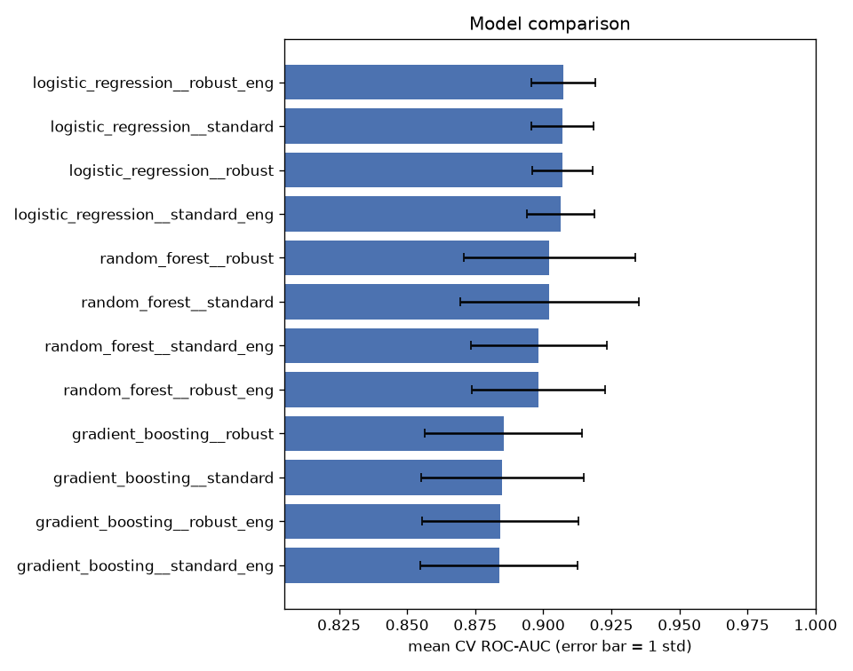
Figure 6: Mean cross-validated ROC-AUC with one standard deviation. The ensemble error bars are visibly wider.

5.2 The selected model
Logistic Regression with robust scaling and engineered features was selected, registered in the MLflow Model Registry as version 2, and saved to models/model.joblib.
Property | Value
Run name | logistic_regression__robust_eng
MLflow run id | d7f3665857a34d8a89049f77235ba0a1
Hyperparameters | C = 1.0, l1_ratio = 1.0 (pure lasso), class_weight = none
CV ROC-AUC | 0.9074 (std 0.012)
CV accuracy / precision / recall / F1 | 0.839 / 0.855 / 0.793 / 0.819
Test accuracy / precision / recall / F1 | 0.869 / 0.833 / 0.893 / 0.862
Test ROC-AUC | 0.9578
Decision threshold | 0.5
Environment | Python 3.12.10, scikit-learn 1.9.1
Three things stand out here.
I expected one of the ensembles to win, and neither did. With only 303 rows and predictors that mostly move in one direction with risk, logistic regression has about the right amount of capacity, while the trees have enough freedom to chase noise in individual folds. The spread backs that up: Random Forest varies by 0.032 across folds against 0.012 for the linear model. It is also the easier model to explain to a clinician, which counts for something here.
The grid settled on l1_ratio = 1.0, which is pure lasso. Nothing pushed it that way, so the search found a sparse solution on its own. That lines up with the EDA, where a few features, fbs especially, showed almost no separation between the classes.
Every model scores four to five points higher on the test set than in cross-validation, which looks good until you count the test set: 61 patients, so one case changing sides moves accuracy by 1.6 points. That gap is the test set being small, not the models generalising unusually well. If I quoted the test ROC-AUC of 0.958 as what to expect in production I would be overselling it. The cross-validated 0.907 is the number I would stand behind.

5.3 Did the engineered features help?
No. All four logistic regression variants land within 0.001 ROC-AUC of each other, which is nowhere near the 0.012 standard deviation across folds. The scaler made no difference either. The engineered-feature version is what got saved, but only because the tie-break rule preferred it on recall; on the evidence, the two are the same model. I am counting this as a useful result rather than a wasted afternoon. Had I not run the variants side by side, both the derived features and the robust scaler would have stayed in the pipeline on the strength of them sounding sensible.

5.4 Recall and the decision threshold
The number I am least happy with is cross-validated recall at 0.793. At the default 0.5 cut-off that means about one disease case in five goes undetected, and given what I said in section 1.2 about the cost of a miss, that is the first thing I would fix. The fix does not need a new model. The threshold lives in metadata.json rather than inside the pipeline, so lowering it trades precision for recall directly, and the API hands back the raw probability as well as the class so a caller can apply its own cut-off. Tuning it on a validation set is the first item in section 13.
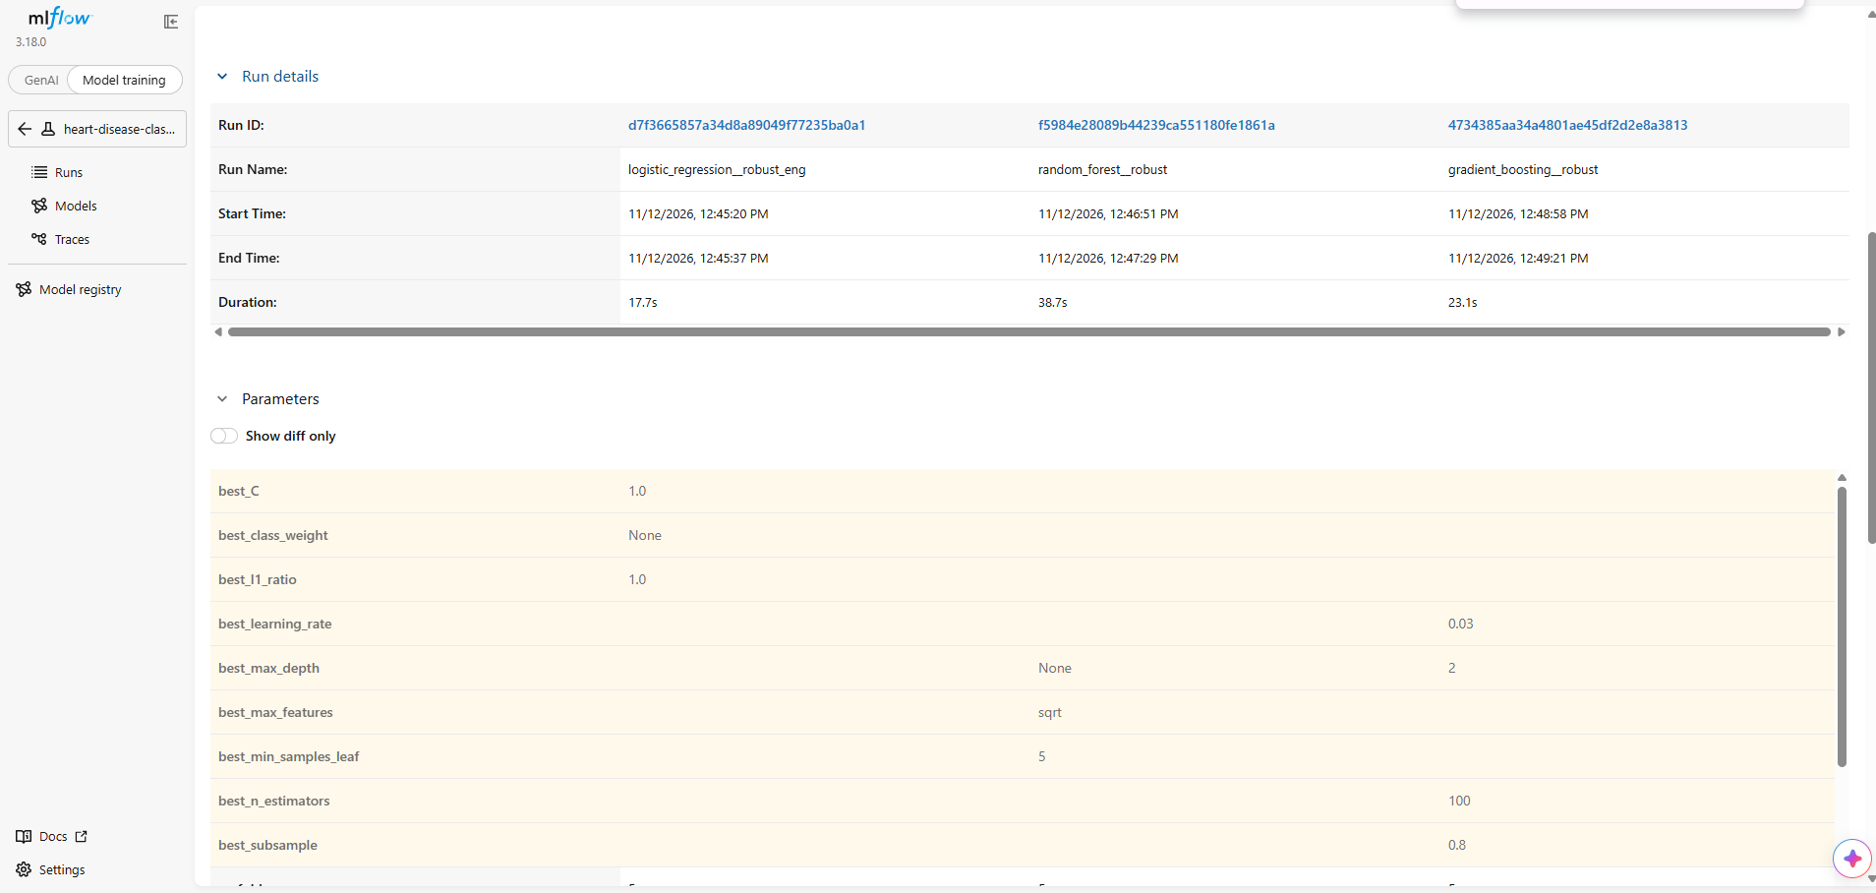
Figure 7: MLflow comparison of the best run from each model family.
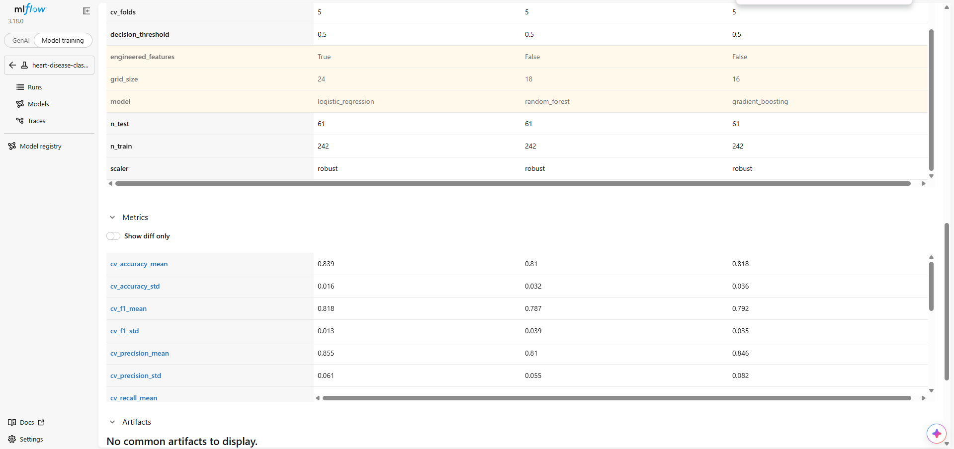
Figure 8: Parameters and cross-validated metrics side by side for the same three runs.

6. Experiment tracking
MLflow runs against a local SQLite backend with artefacts written to the mlruns directory. Fifteen runs are recorded in total: three from the fast smoke-test configuration and twelve from the full grid.

6.1 What each run records
- Parameters: model family, scaler, engineered-features flag, fold count, grid size, train and test sizes, decision threshold, and every tuned hyperparameter of the winning candidate.
- Metrics: mean and standard deviation of all five cross-validated metrics, the five held-out test metrics, and wall-clock fit time.
- Artefacts: ROC curve, confusion matrix, feature-importance plot, the full GridSearchCV results as CSV, and a per-class classification report.
- Model: the complete fitted pipeline with an inferred signature and a worked input example, so it can be loaded and served directly from the registry.
- Tags: model family, preprocessing variant and the selection metric, which make the runs filterable in the UI.
Feature importance is computed against the transformed feature names, using absolute coefficients for the linear model and impurity-based importances for the ensembles, so the plots are directly comparable across families.

6.2 Model registry
The winning run of each training invocation is registered under the name heart-disease-classifier. Version 1 came from the smoke-test run and version 2 from the full grid; version 2 is the model that is served. Registration is wrapped in a guard so that a registry failure logs a warning rather than failing an otherwise successful training run.
mlflow ui --backend-store-uri sqlite:///mlflow.db
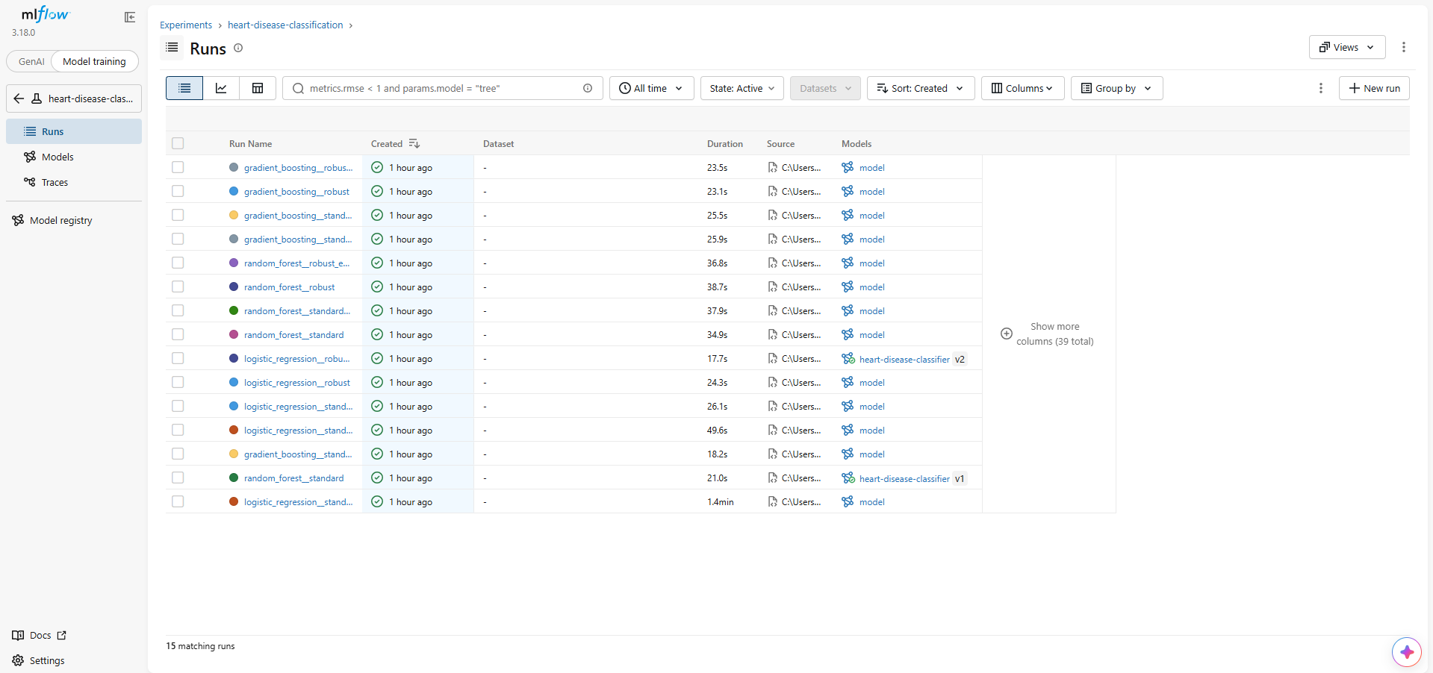
Figure 9: Experiment view listing all fifteen tracked runs.
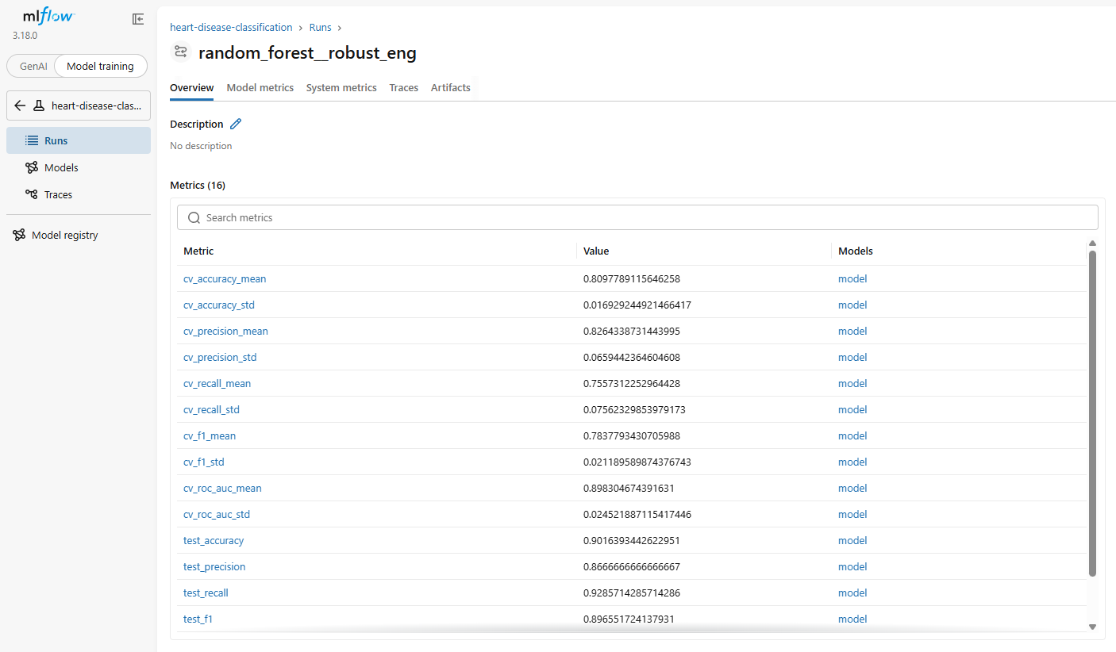
Figure 10: Parameters and metrics recorded for a single run.
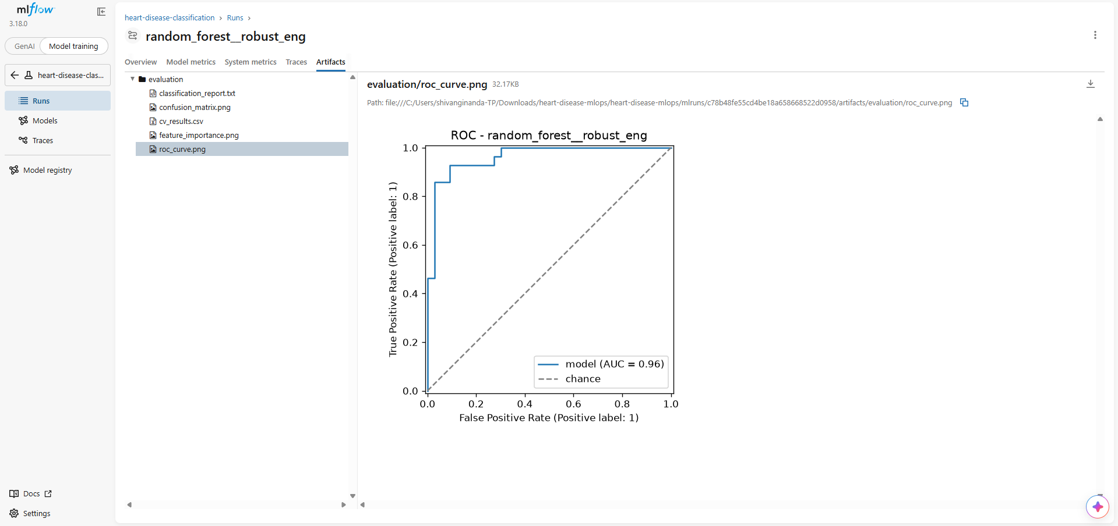
Figure 11: ROC curve logged as a run artefact, alongside the confusion matrix, feature importances and the full search results.
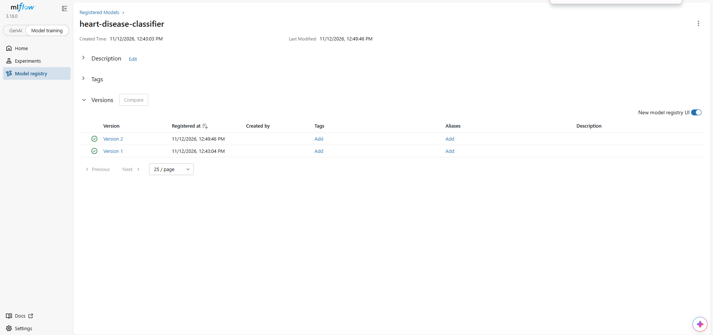
Figure 12: Registered model showing both versions.

7. Packaging and reproducibility
The final artefact is a single joblib file containing the preprocessing steps and the classifier as one object, accompanied by a metadata file that records how it was produced.
Artefact | Purpose
models/model.joblib | Complete fitted pipeline: imputation, scaling, encoding and classifier
models/metadata.json | Run id, hyperparameters, metrics, threshold, feature order, library versions
requirements.txt | Full development environment including MLflow, Jupyter and test tooling
requirements-serve.txt | Eight pinned packages needed only for serving
Two reproducibility details are worth drawing out. The metadata file records the exact scikit-learn version used to fit the pipeline, because a pickled estimator is only guaranteed to load under the version that wrote it; the serving requirements pin that same version. And because the pipeline references the custom ClinicalFeatures transformer by module path, the src package must be present wherever the model is loaded. The Docker image therefore copies src/ rather than the model file alone, which is a subtle failure mode that only surfaces at container runtime.

7.1 Clean-environment verification
The production-readiness requirement that every script runs from a clean setup is verified two ways. Locally, the repository was cloned into a fresh directory, a new virtual environment created, dependencies installed from requirements.txt alone, and the full test suite run. In CI the same sequence executes on an ephemeral runner on every push, so the guarantee cannot silently decay.
git clone <repo> && python -m venv .venv && pip install -r requirements.txt && pytest
44 passed

8. Serving API
The service is built with FastAPI and defined in src/api/app.py. The model is loaded once at application startup rather than per request, and the load result is recorded so the health endpoint can report it.
Endpoint | Method | Behaviour
/predict | POST | One patient as JSON; returns class, label, probability, confidence, risk band, model version and request id
/predict/batch | POST | Up to 100 patients in a single call
/health | GET | 200 when the model is loaded, 503 when it is not; used by the Kubernetes probes
/model | GET | Metadata of the served model
/metrics | GET | Prometheus exposition format
/docs | GET | Generated OpenAPI documentation

8.1 Input validation
A Pydantic schema validates every request before the model is reached. Continuous features carry clinically plausible bounds (age 18 to 100, resting blood pressure 70 to 250, maximum heart rate 60 to 220), categorical features are constrained to their valid codes, and unknown fields are rejected outright rather than silently ignored. The two features that are genuinely missing in the source data, ca and thal, accept null and are imputed by the pipeline. Invalid input returns HTTP 422 with a message naming the offending field.

8.2 Response design
The response deliberately carries more than a bare class label. The probability of disease is returned alongside the confidence in whichever class was predicted, which are different quantities and are easy to conflate. A coarse risk band (low, moderate, high) is derived from the probability for human readers. The model version and a request identifier are included so that any prediction can be traced back to the exact pipeline that produced it and to the corresponding log line.
{"prediction": 0, "label": "No disease", "probability_disease": 0.1725,
"confidence": 0.8275, "risk_level": "low",
"model_version": "logistic_regression__robust_eng@2026-11-12T07:19:45+00:00",
"request_id": "07203c6d77f8"}
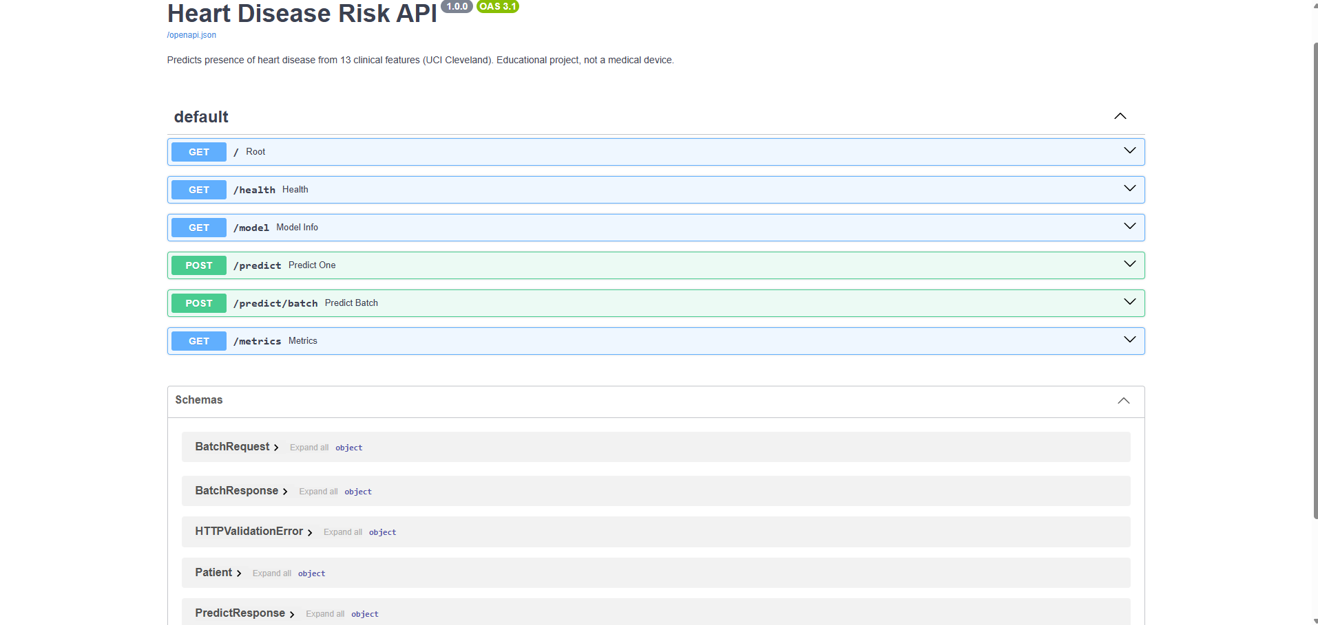
Figure 13: Generated OpenAPI documentation listing every endpoint and schema.
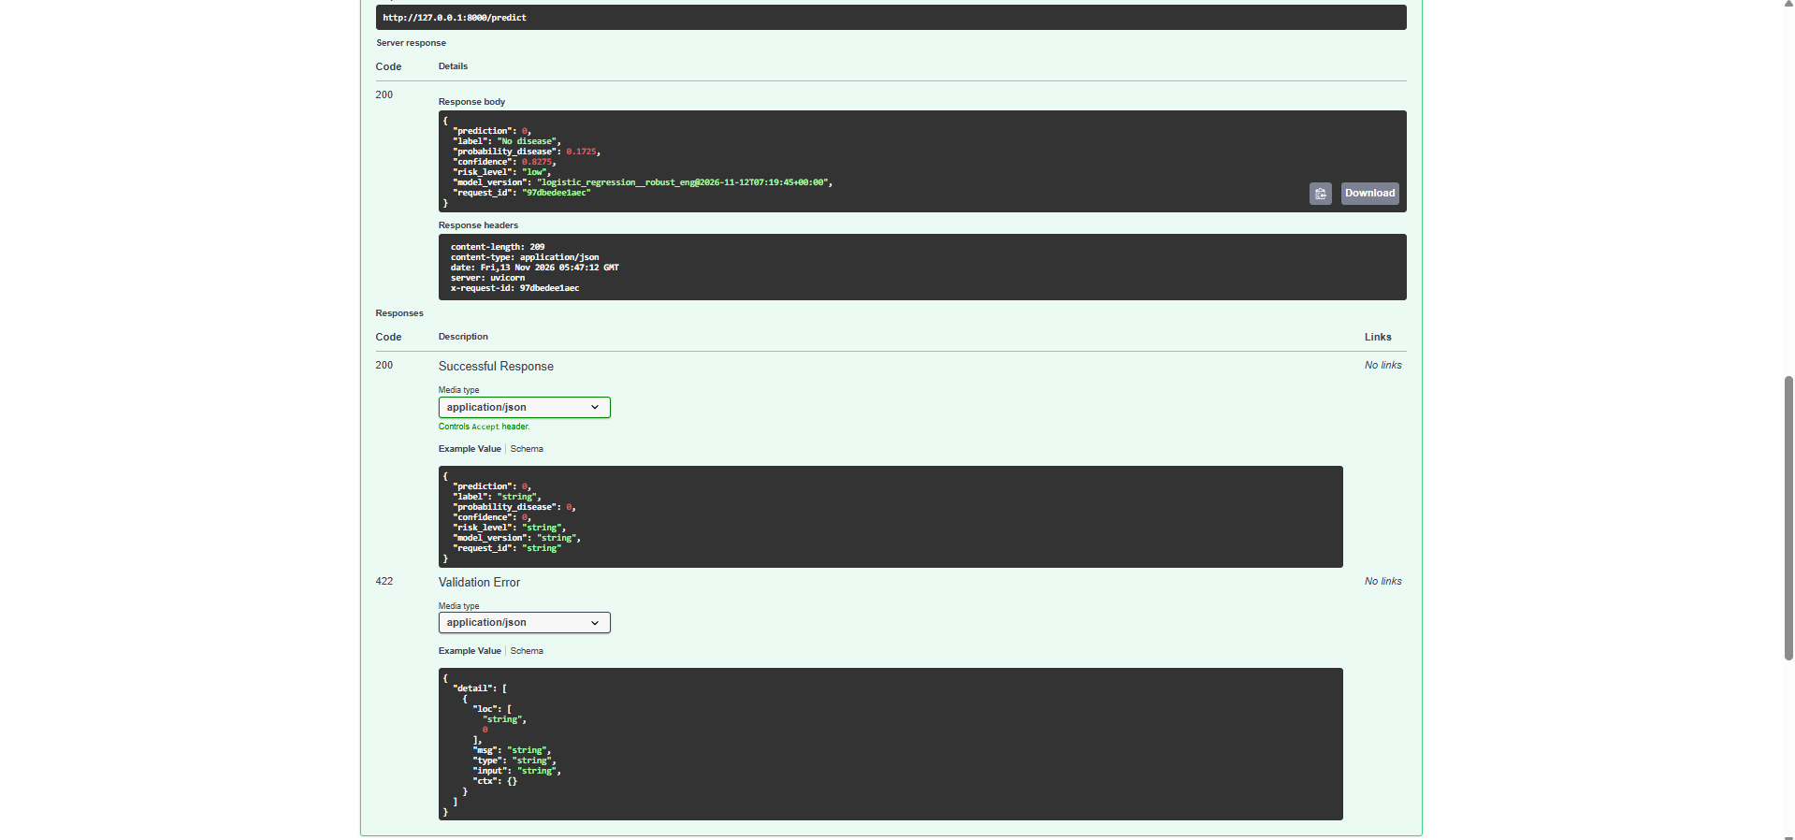
Figure 14: A live prediction returning class, probability, confidence, risk band, model version and request id.
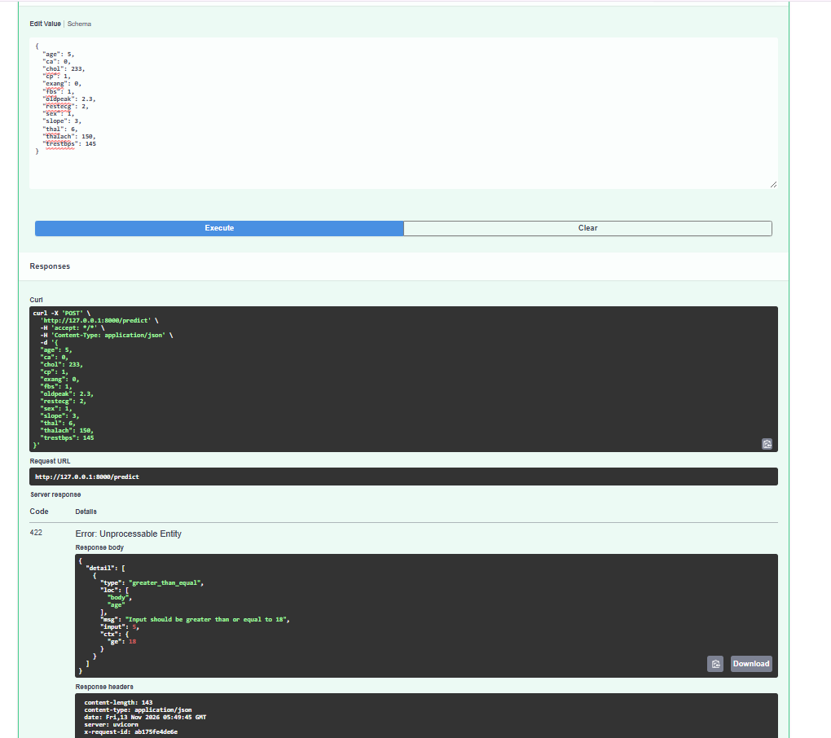
Figure 15: An age of 5 rejected with HTTP 422 before the model is reached.
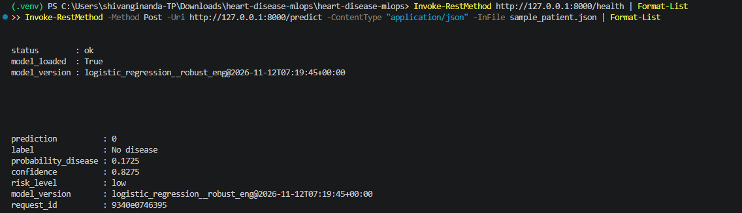
Figure 16: The same endpoints called from the command line.

9. Automation: testing, containerisation and deployment

9.1 Test suite
Forty-four tests run in roughly twenty seconds. They use synthetic data generated in fixtures rather than the real dataset, so they need no network access and behave identically on any machine.
Area | Tests | Representative assertions
Data loading | 9 | Target binarised correctly, question marks become NaN, duplicates dropped, malformed input rejected
Preprocessing | 13 | No NaN survives the pipeline, imputation fitted on training data only, unseen categories do not crash, saved pipeline reproduces predictions exactly
Training | 9 | Every family fits and returns valid probabilities, selection uses CV and not test scores, end-to-end run beats chance on planted signal
API | 13 | Valid request returns 200, confidence matches probability, four classes of invalid input return 422, metrics increment, missing model yields 503

9.2 Pipeline stages
The GitHub Actions workflow runs three dependent jobs; a failure in any one stops the rest.
Stage | Steps | Evidence produced
Lint, test and train | flake8, pytest with JUnit report, retrain, inference check | Model, metrics and test report uploaded as artefacts
Build and run container | docker build, docker run, smoke test against the live container | Container logs uploaded
Deploy to Kubernetes | kind cluster, load image, apply manifests, wait for rollout, verify service | Cluster state and pod logs uploaded
The requirement that the pipeline must fail on code or test errors was verified deliberately rather than assumed: a test assertion was broken, pushed, and the resulting red run captured, before the change was reverted. Both runs are preserved in the repository history.

9.3 Container
The image is built from python:3.12-slim. Dependencies are installed in their own layer ahead of the application code so that code changes rebuild in seconds. The container runs as an unprivileged user, declares a HEALTHCHECK that polls /health using only the standard library, and runs a single server process. The single-worker choice is deliberate: Prometheus counters live in process memory, so multiple workers would fragment the metrics. Horizontal scaling is handled by Kubernetes replicas instead.
The image is built and run on every push rather than once by hand. The second CI stage builds it, starts the container and runs scripts/smoke_test.py against the live service, checking the health endpoint, a valid prediction and a rejected request. The container logs from that run are uploaded as a workflow artefact, so the build-and-run evidence is regenerated on every commit.

9.4 Kubernetes
The Deployment runs two replicas behind a LoadBalancer Service. Readiness and liveness probes both poll /health, with the readiness probe ensuring no pod receives traffic until its model is loaded, and the liveness probe restarting a pod that stops responding. CPU and memory requests and limits are set, a rolling update strategy with maxUnavailable zero gives zero-downtime releases, and pod annotations allow Prometheus to discover the pods automatically. An Ingress manifest is included as an alternative to the LoadBalancer.
kubectl apply -f k8s/deployment.yaml -f k8s/service.yaml
kubectl rollout status deployment/heart-api
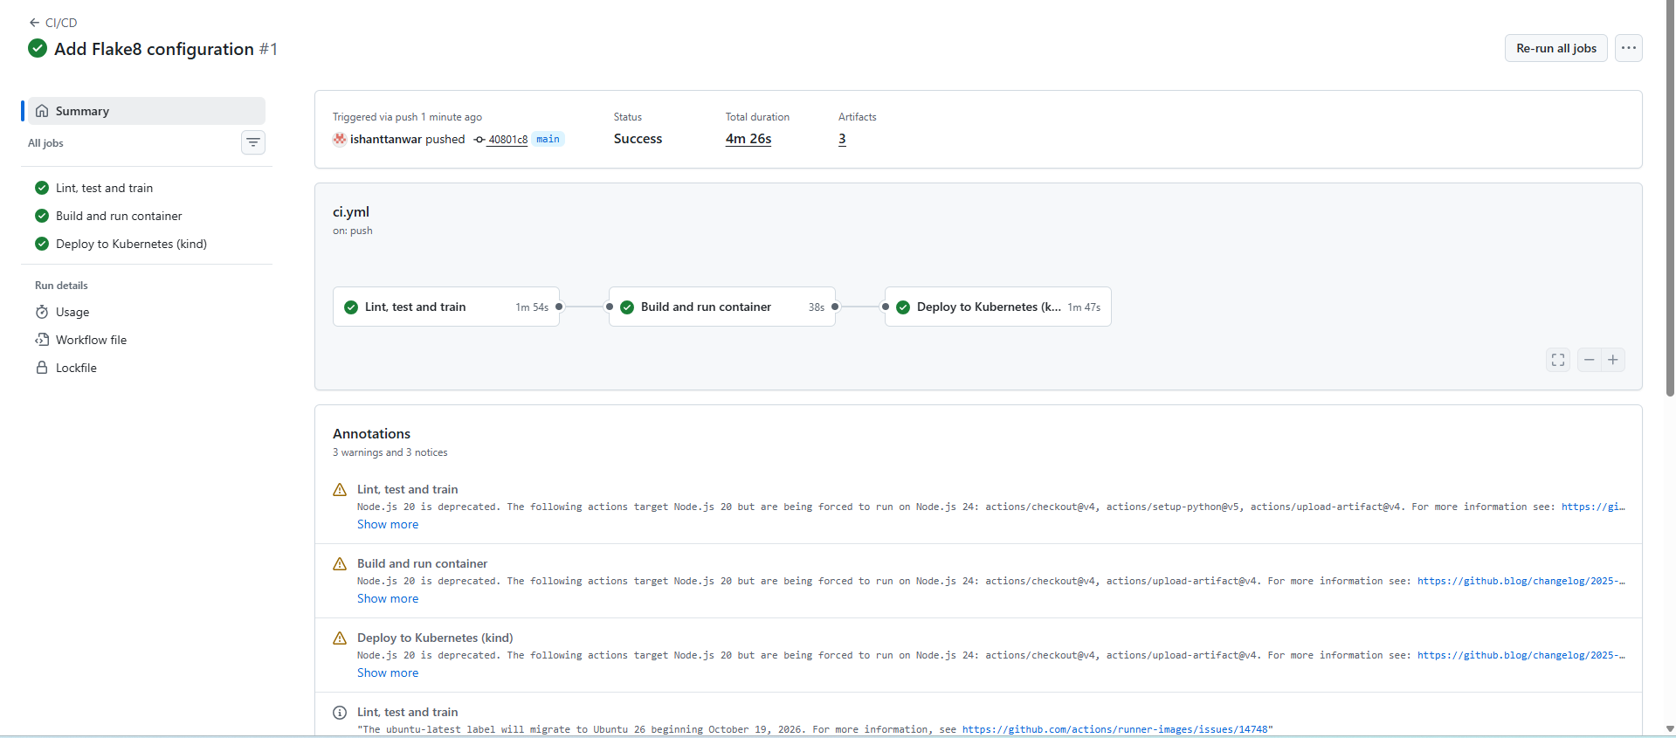
Figure 17: Pipeline run with all three stages passing.
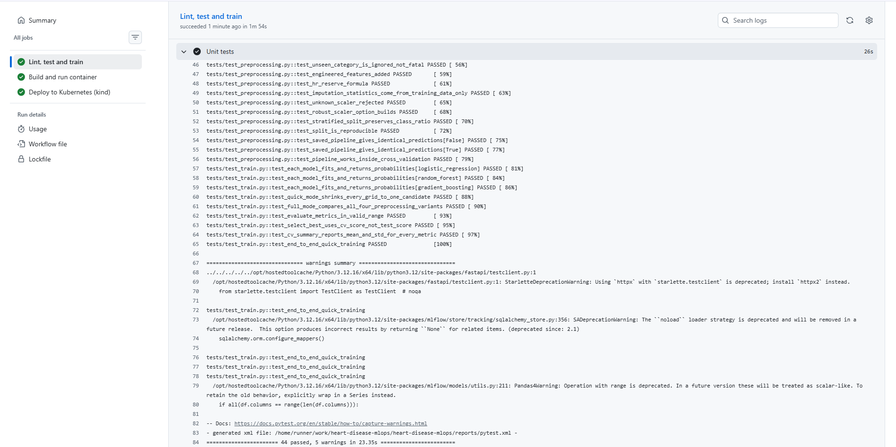
Figure 18: The test step, ending with 44 passed.
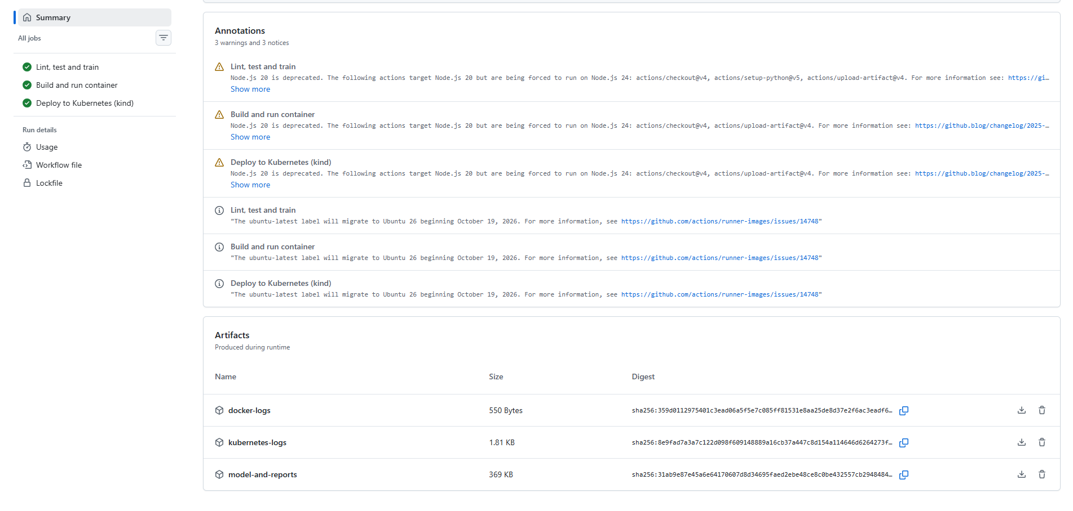
Figure 19: Artefacts uploaded by the run: container logs, Kubernetes logs, and the trained model with its reports.
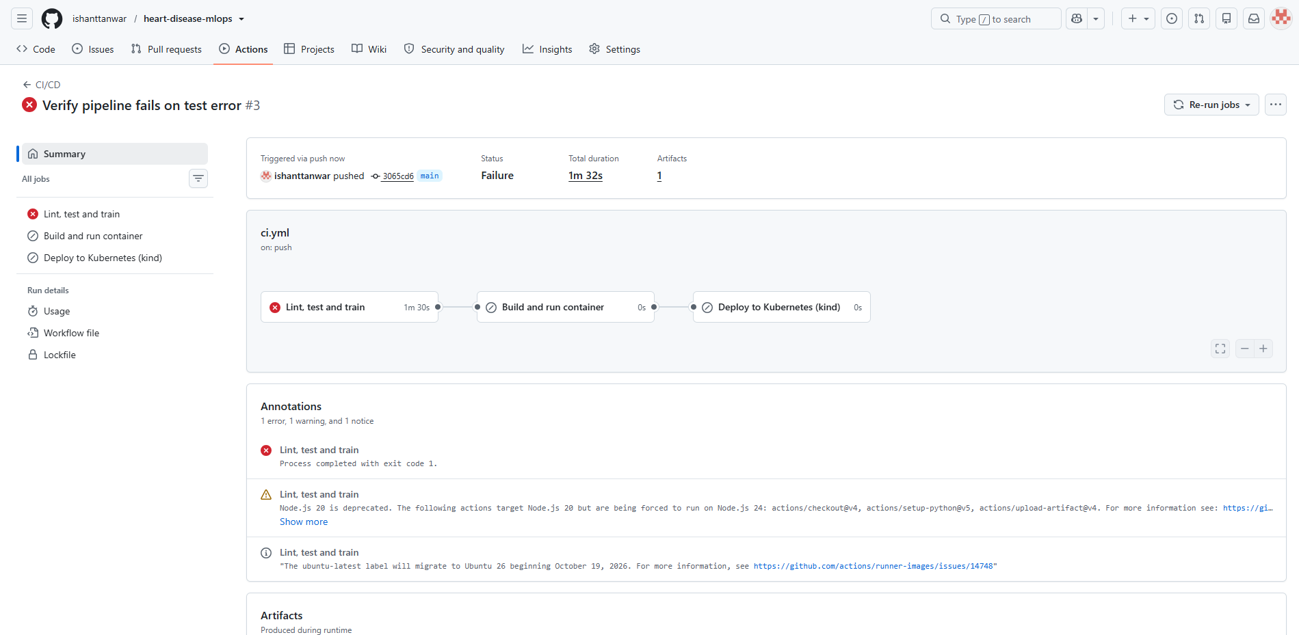
Figure 20: The pipeline failing on a deliberately broken test. The later stages never run.
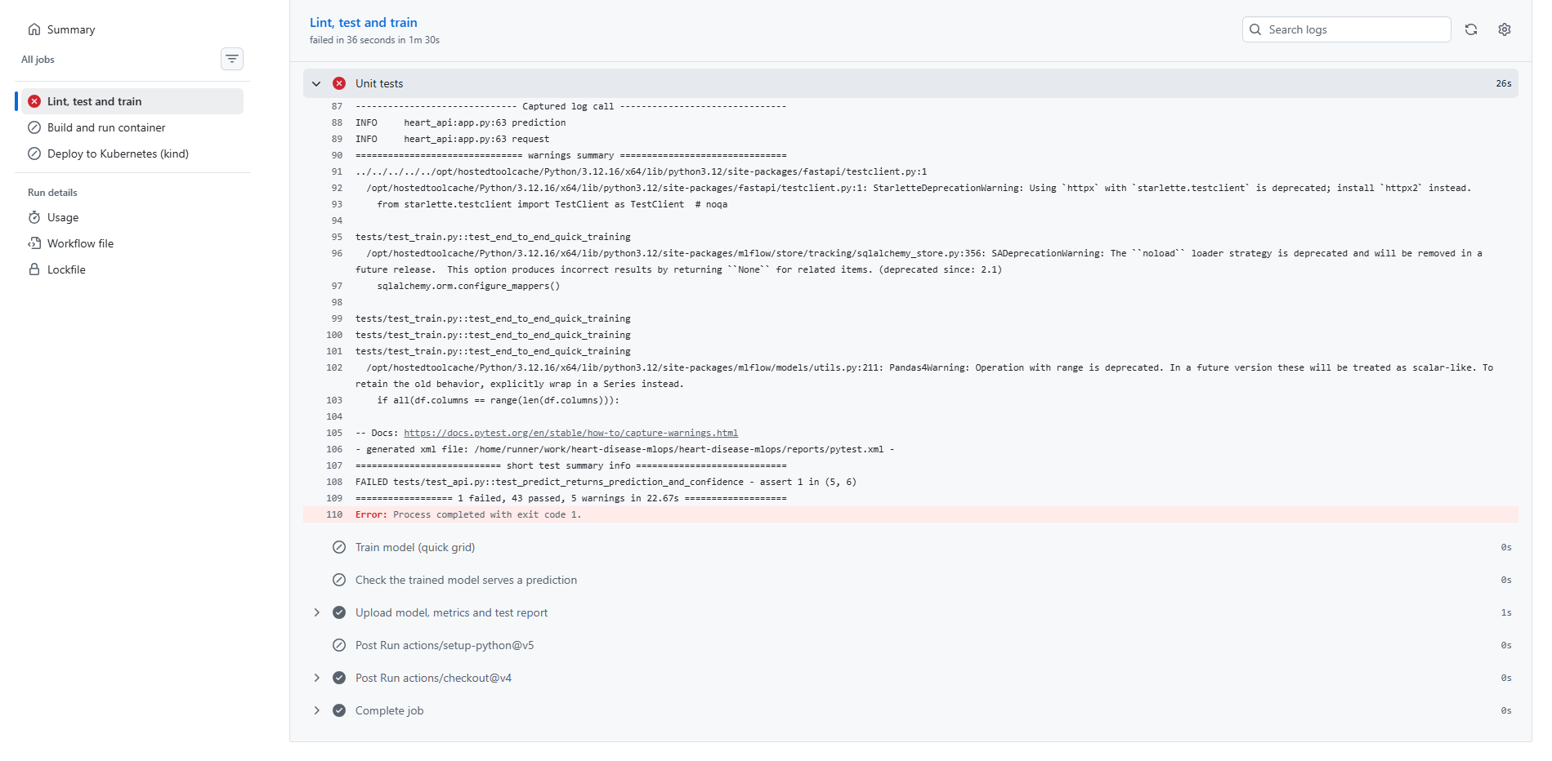
Figure 21: The failure log naming the test that failed and the non-zero exit code.
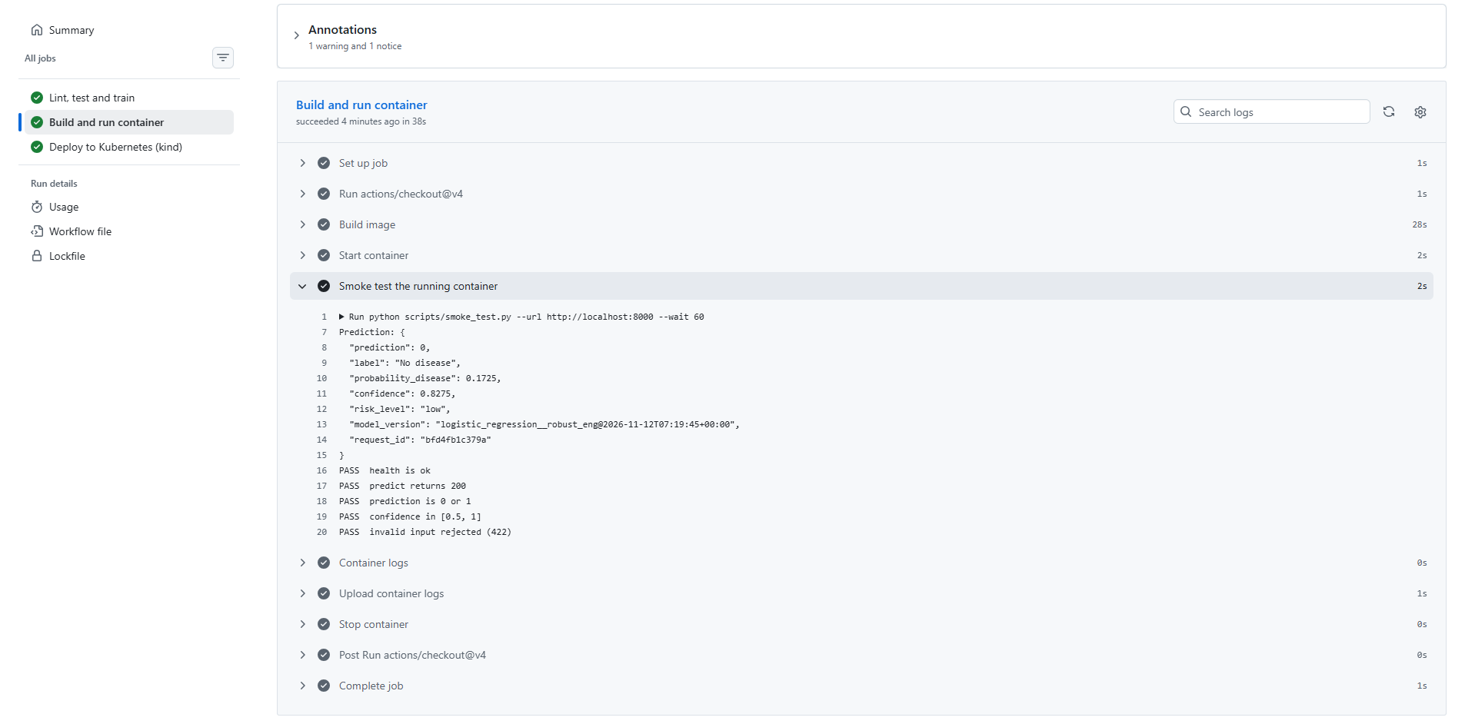
Figure 22: The container built, started and smoke-tested, with all five checks passing.
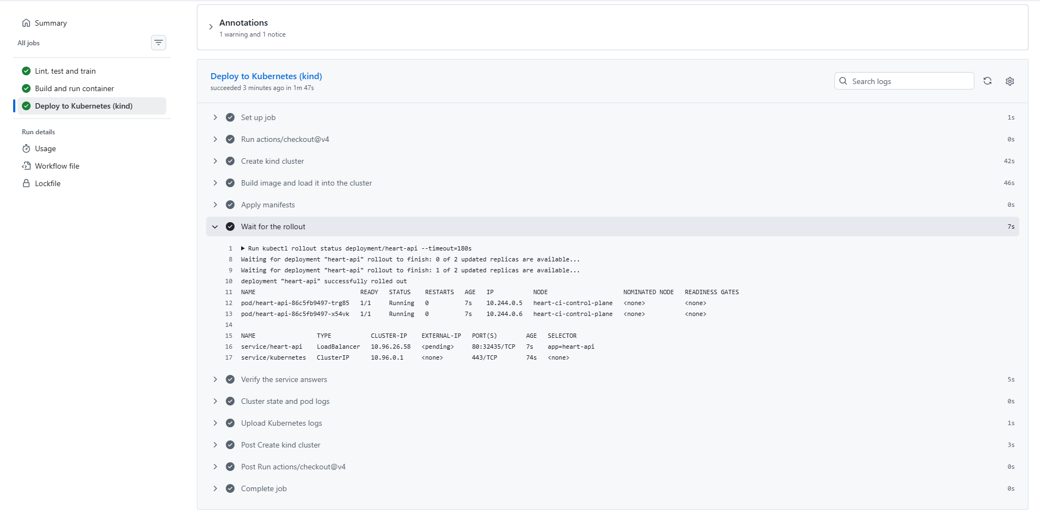
Figure 23: Two replicas running and the LoadBalancer service created.
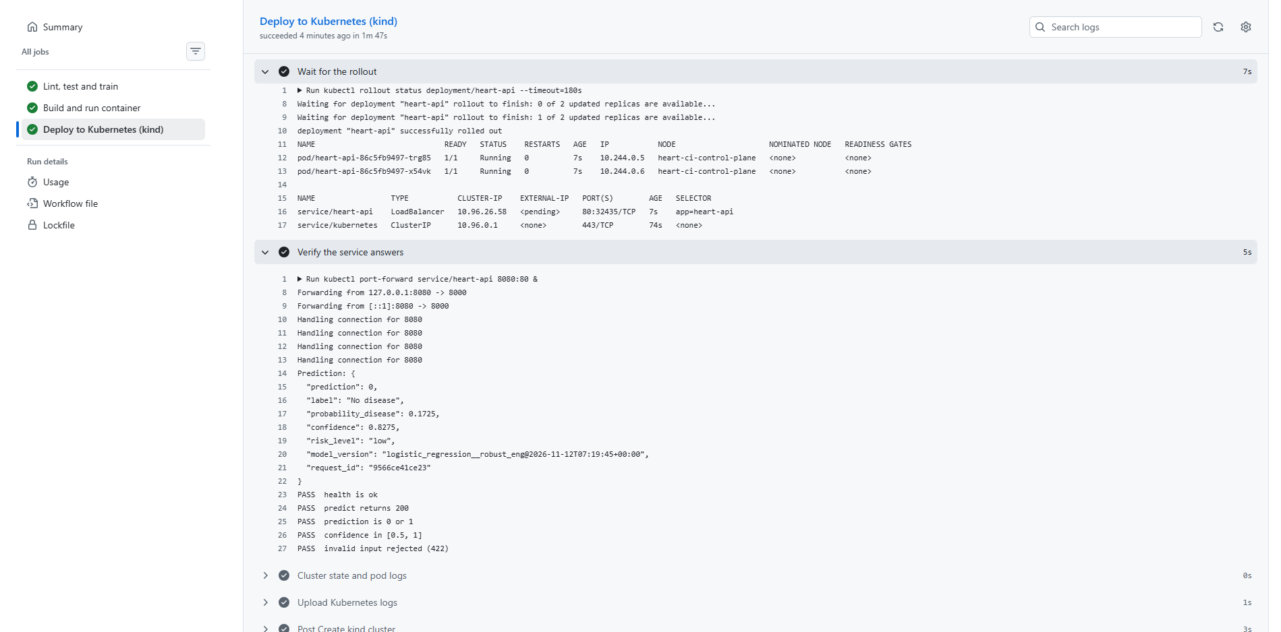
Figure 24: A prediction served through the Kubernetes service.

10. Monitoring and logging

10.1 Structured logging
Every request produces a single JSON log line carrying a request identifier, method, path, status code and latency in milliseconds. Prediction endpoints emit an additional line with the predicted class and probability. JSON was chosen over free text because the same lines can be shipped to a log aggregator without parsing rules, and the request identifier is echoed in both the response body and an x-request-id header, so a user-reported problem can be traced to its exact log entry.

10.2 Metrics
Metric | Type | Purpose
api_requests_total | Counter | Requests by method, endpoint and status code
api_request_latency_seconds | Histogram | Latency distribution per endpoint, supporting quantiles
model_predictions_total | Counter | Predictions by predicted class
model_prediction_probability | Histogram | Distribution of predicted probabilities
model_loaded | Gauge | Whether the pipeline loaded successfully
The last two are the ones I added deliberately. Request counts and latency tell you the service is alive; they say nothing about whether the model has quietly gone wrong. If the mean predicted probability drifts, or the split between the two classes wanders away from the roughly even mix seen in training, something about the incoming data has changed even though every request is still returning 200. It is a rough signal rather than real drift detection, since nothing here is compared against confirmed diagnoses. Section 13 covers that gap.

10.3 Dashboard and alerts
Prometheus scrapes the service every five seconds. A nine-panel Grafana dashboard covers service and model availability, cumulative predictions and rejections, request rate by endpoint, p50 and p95 latency, the prediction mix, the status-code breakdown and the mean predicted probability. Four alert rules are defined: service unreachable, model failed to load, error rate above five percent, and p95 latency above one second.
The dashboard surfaced one real characteristic of the service. The first request after startup shows a p95 latency of around 2.5 seconds, falling to single-digit milliseconds thereafter; this is one-off warm-up cost as the scientific libraries and the pipeline are first exercised. In Kubernetes the readiness probe absorbs this, because the pod does not receive traffic until it has answered a health check.
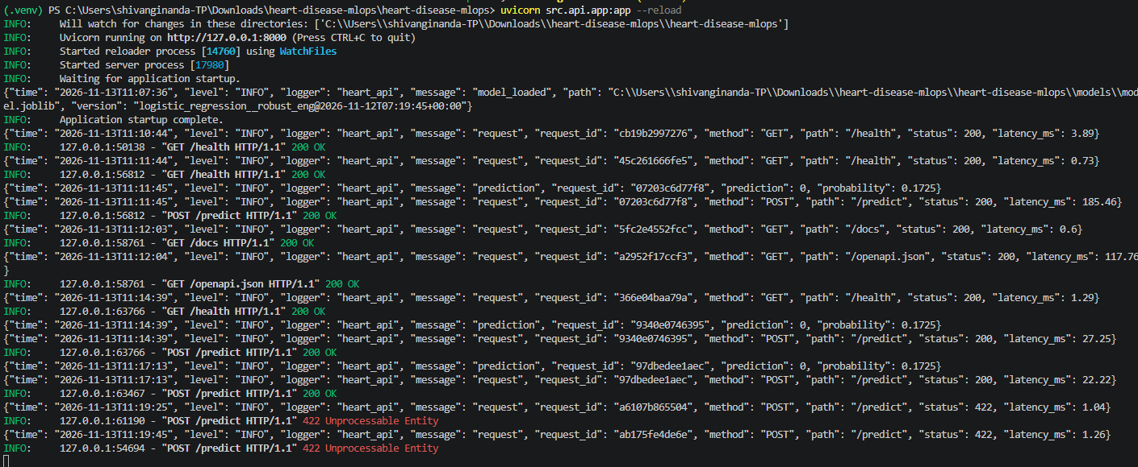
Figure 25: Structured request logs, one JSON line per request with its id, path, status and latency.
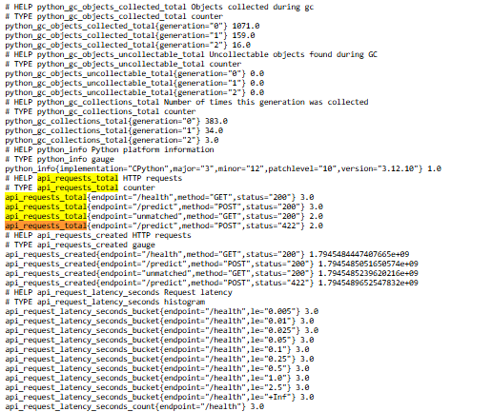
Figure 26: The /metrics endpoint in Prometheus exposition format.
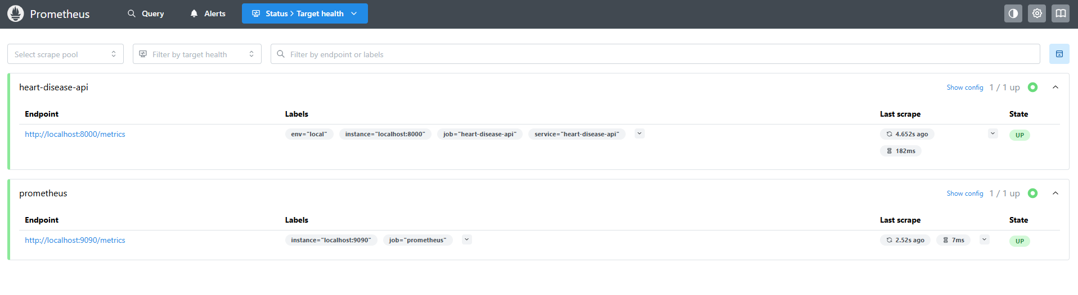
Figure 27: Prometheus scraping the service every five seconds.
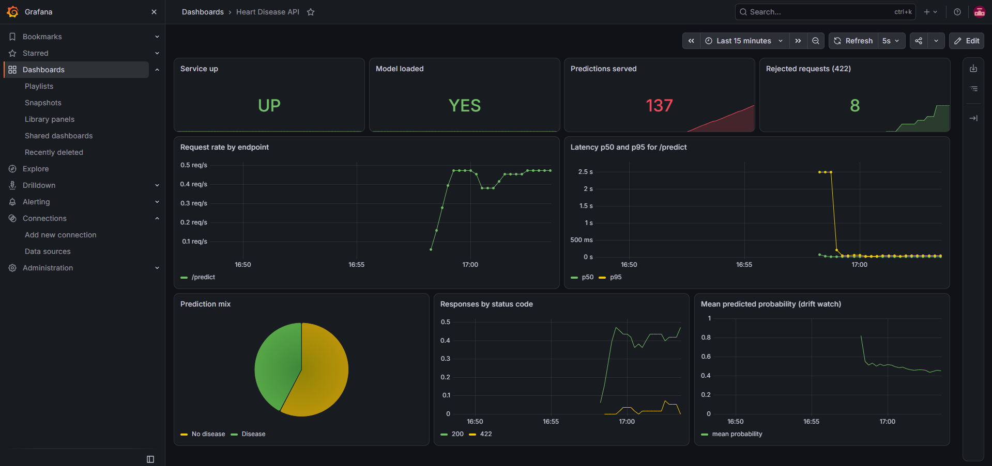
Figure 28: The nine-panel dashboard under generated load.
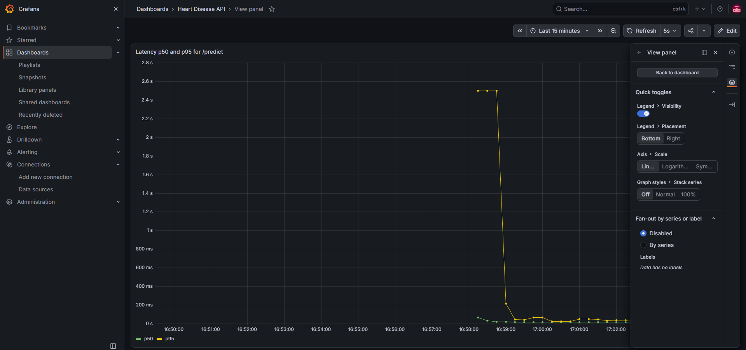
Figure 29: Latency panel showing the one-off warm-up cost on the first request.
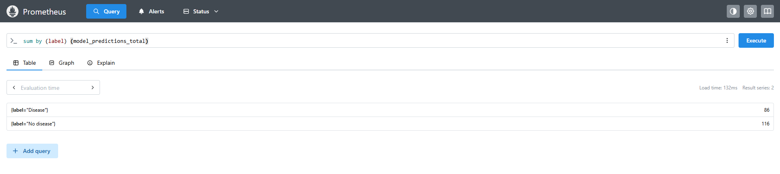
Figure 30: Prediction counts by class, queried directly in Prometheus.

11. System architecture
The diagram below traces a single flow from raw data to a monitored prediction. Development produces a tracked, registered model; continuous integration verifies and packages it; the serving layer runs it behind a validated HTTP interface; and the observability layer reports on what the running system is actually doing.
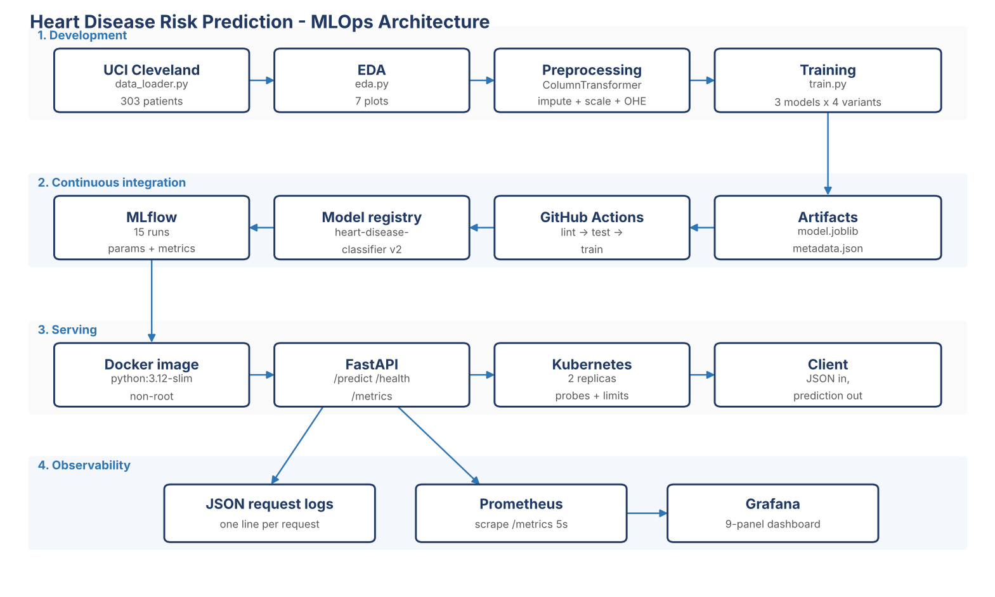
Figure 31: End-to-end architecture across development, CI, serving and observability.

12. Setup and reproduction

12.1 Local installation
git clone https://github.com/ishanttanwar/heart-disease-mlops.git
cd heart-disease-mlops
python -m venv .venv
.venv\Scripts\Activate.ps1 # Windows
source .venv/bin/activate # macOS or Linux
pip install -r requirements.txt

12.2 Reproducing the pipeline
python -m src.data_loader # download and clean the dataset
python -m src.eda # regenerate every EDA figure
python -m pytest # 44 tests
python -m src.train # full experiment grid, about 6 minutes
mlflow ui --backend-store-uri sqlite:///mlflow.db

12.3 Serving
uvicorn src.api.app:app --port 8000 # local
python scripts/smoke_test.py # verify

docker build -t heart-disease-api:1.0 . # container
docker run -d -p 8000:8000 --name heart-api heart-disease-api:1.0

kubectl apply -f k8s/ # Kubernetes
kubectl get pods,svc

12.4 Monitoring
prometheus --config.file=monitoring/prometheus.yml
grafana-server # import monitoring/grafana_dashboard.json
python scripts/generate_load.py --requests 300

12.5 Repository layout
Path | Contents
src/ | config, data_loader, eda, preprocessing, train, predict, api/app
tests/ | 44 tests across four modules
notebooks/ | EDA notebook with written observations
k8s/ | Deployment, Service and Ingress manifests
monitoring/ | Prometheus config, alert rules, Grafana dashboard
.github/workflows/ | Three-stage CI/CD pipeline
screenshots/ | Evidence for every stage
models/ | Serialised pipeline and metadata

13. Limitations and further work
A few things about this system are worth being upfront about. Several of them would need sorting out before it went anywhere near real patients.
- Dataset size. 303 patients from a single institution collected decades ago. The confidence interval around any reported metric is wide, and the model has not been validated on an external cohort.
- Recall at the default threshold. Roughly one in five disease cases is missed at a threshold of 0.5. Tuning the threshold on a validation set to maximise recall subject to an acceptable precision floor is the single highest-value next change, and the architecture already supports it without retraining.
- No ground-truth feedback loop. The monitoring detects shifts in input and output distributions, but nothing closes the loop with confirmed diagnoses, so genuine accuracy degradation would go unmeasured. A production system would need a labelling pipeline and scheduled retraining triggered by measured performance rather than by a calendar.
- Single-node deployment. The Kubernetes setup runs locally with a LoadBalancer service. A production deployment would add an ingress controller with TLS, autoscaling, a managed image registry, and authentication on the prediction endpoint, which is currently open.
- No calibration assessment. Probabilities are used both for the decision and for the drift metric, but calibration was never formally checked with a reliability curve. For a model whose output may inform clinical judgement, this should be verified.
- Fairness not assessed. The cohort is predominantly male, and no subgroup performance analysis was carried out. Reporting metrics by sex and age band would be a minimum requirement before any real use.

14. Conclusion
What I ended up with runs from a raw download of the UCI Cleveland file through to a monitored prediction service in a container, with every step automated and checkable from a clean clone. The model that won is a regularised logistic regression with robust scaling, at a cross-validated ROC-AUC of 0.907 and a standard deviation of 0.012 across folds. It beat both tree ensembles, held steadier across folds, and is easier to explain than either.
The finding that taught me the most was a negative one. I ran four preprocessing variants through the same tracked grid, and the engineered features and the scaler both turned out to make no measurable difference. Neither idea was unreasonable, which is exactly the problem: without running them side by side and logging the results, I would have shipped both and believed they helped. That is the part of MLOps that actually changed what I built rather than just how it was deployed.
The rest is engineering discipline. Saving preprocessing and classifier as one object means training and serving cannot drift apart. Forty-four tests catch regressions, including one that specifically checks for leakage in the imputer. The pipeline fails loudly rather than quietly. The monitoring reports on the model, not just the web server. Looking at what still separates this from something clinically usable, most of it is evidence rather than engineering: more data, external validation, calibration checks, subgroup analysis. That seems like the right way round for a problem of this kind.

