IT20217440-Covid 19 Vaccination Registration Management

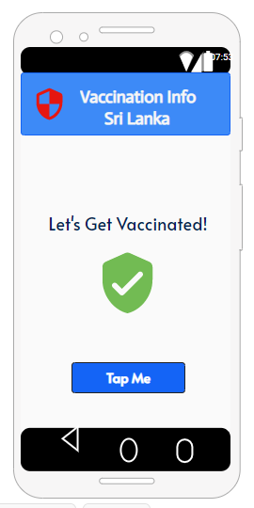

This is the main page of this section. This page opens up when you click the register button under the covid 19 registration on the home page of the app, this is like the welcome screen for this section, after clicking the “Tap Me” button it will load up the registration page.

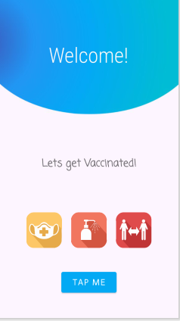

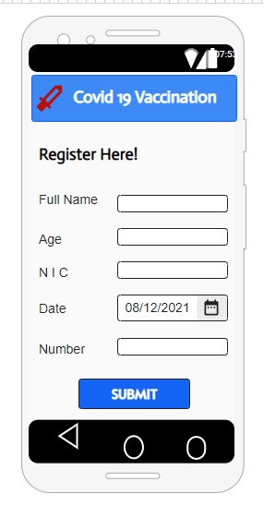

This is the main registration page for this section. Patient can enter their details here, and they can submit their details. After clicking the submit it will take to the next page.

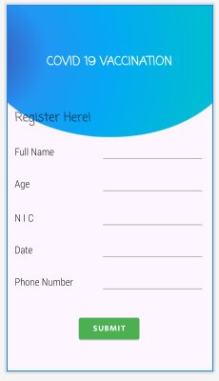

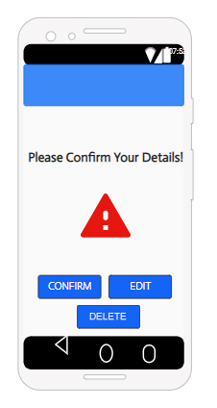

This page will warn the patient that they have submit their information correctly. By clicking the “Edit” button, this will take patient back to warning page and then they can edit their details, by clicking confirm button patient can save his information and it will take to the next page. Patient also can delete their registration by clicking delete button.

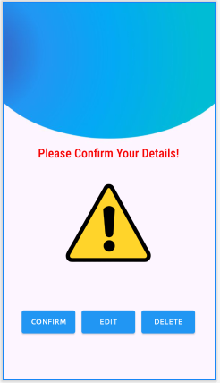

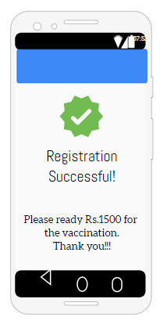

This is the end page , this informs patient to ready the fee for the vaccination , and it displays that registration is successful.

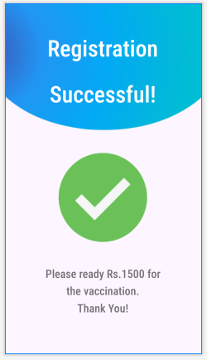

Usage of resource file

<resources>

<color name="purple_200">#FFBB86FC</color>

<color name="purple_500">#FF6200EE</color>

<color name="purple_700">#FF3700B3</color>

<color name="teal_200">#FF03DAC5</color>

<color name="teal_700">#FF018786</color>

<color name="black">#FF000000</color>

<color name="white">#FFFFFFFF</color>

</resources>

<resources>

<array name="preloaded_fonts" translatable="false">

<item>@font/secular_one</item>

</array>

</resources>

<resources>

<string name="app_name">MAD</string>

</resources>

<resources xmlns:tools="http://schemas.android.com/tools">

<!-- Base application theme. -->

<style name="Theme.MAD" parent="Theme.MaterialComponents.DayNight.DarkActionBar">

<!-- Primary brand color. -->

<item name="colorPrimary">@color/purple_500</item>

<item name="colorPrimaryVariant">@color/purple_700</item>

<item name="colorOnPrimary">@color/white</item>

<!-- Secondary brand color. -->

<item name="colorSecondary">@color/teal_200</item>

<item name="colorSecondaryVariant">@color/teal_700</item>

<item name="colorOnSecondary">@color/black</item>

<!-- Status bar color. -->

<item name="android:statusBarColor" tools:targetApi="l">?attr/colorPrimaryVariant</item>

<!-- Customize your theme here. -->

</style>

</resources>

<resources xmlns:tools="http://schemas.android.com/tools">

<!-- Base application theme. -->

<style name="Theme.MAD" parent="Theme.MaterialComponents.DayNight.DarkActionBar">

<!-- Primary brand color. -->

<item name="colorPrimary">@color/purple_200</item>

<item name="colorPrimaryVariant">@color/purple_700</item>

<item name="colorOnPrimary">@color/black</item>

<!-- Secondary brand color. -->

<item name="colorSecondary">@color/teal_200</item>

<item name="colorSecondaryVariant">@color/teal_200</item>

<item name="colorOnSecondary">@color/black</item>

<!-- Status bar color. -->

<item name="android:statusBarColor" tools:targetApi="l">?attr/colorPrimaryVariant</item>

<!-- Customize your theme here. -->

</style>

</resources>