IT20140052-COVID 19 Vaccination & PCR Test Appoint Registration Management

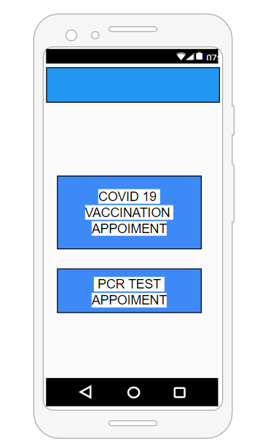

This is the main page of this section. This

Section. This page open up when you click and

Can you get a appoiment.

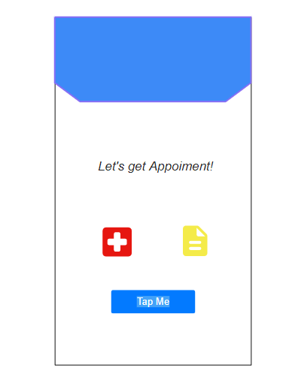

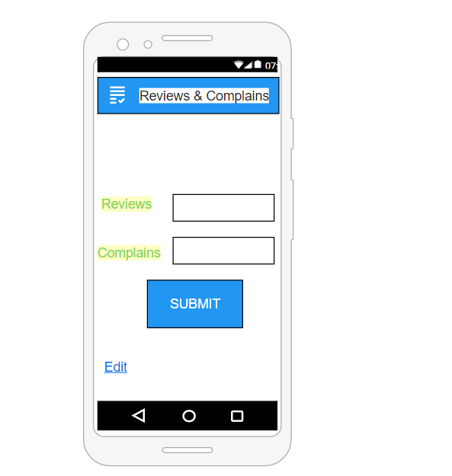

Patient can enter the reviews and complains details here, and they can submit their details.after clicking the submit it will takes to the next page.

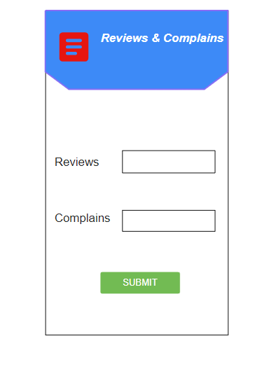

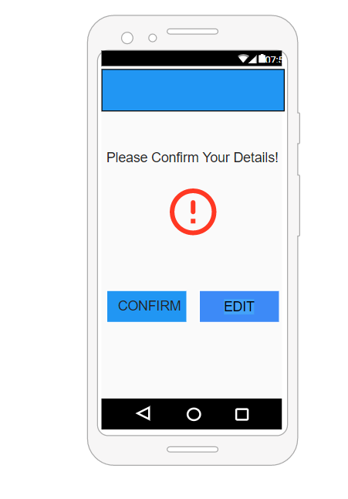This page will warn the patient that they have submit

Their information correctily. By the clicking the “ediot” button,this

will take patient back to warning page and then they can ediot

details. their

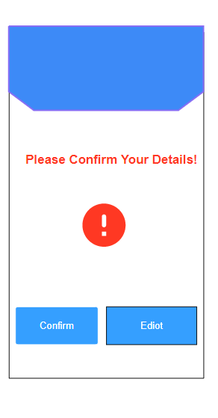

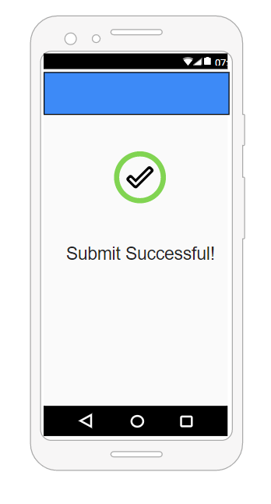

This is end page,this informs patient to ready

The fee for the vaccination,and it displays that

Registration is successful.

