Developing a Data Analysis and Machine Learning Workflow Using

WHO Sri Lanka Health Indicators

Focused indicator: Stunting prevalence among children under 5 years of age (% height-for-age < −2 SD), survey-based estimates

HND in Computer Science with Artificial Intelligence- NIBM KIC
Numerical Mathematics and Computing
Group Number 03
KIC-HNDCSAI-261P-002
KIC-HNDCSAI-261P-006
2026.10.20

1. Introduction
This project applies a data analysis and machine learning workflow to a real-world health dataset for Sri Lanka published through the World Health Organization (WHO) Global Health Observatory and made accessible through the Humanitarian Data Exchange (HDX). The selected indicator measures the prevalence of stunting among children under five years of age. Stunting is defined as a height-for-age measurement below −2 standard deviations from the median of the WHO Child Growth Standards.
The objectives are to clean and preprocess the dataset, perform exploratory data analysis (EDA), conduct selected statistical hypothesis tests, and compare two regression models using appropriate evaluation metrics.
The original dataset contains 30,912 records and 17 variables. Filtering for the selected survey-based stunting indicator produced 594 records. After removing 19 duplicate rows, 575 records remained. The selected subset includes numerical variables (year and prevalence) and categorical variables (dimension type and dimension name).
Dataset sources
- WHO Global Health Observatory:
https://www.who.int/data/gho/

- WHO Sri Lanka country data:
https://www.who.int/data/gho/data/countries/country-details/gho/sri-lanka
- Humanitarian Data Exchange, WHO data for Sri Lanka: https://data.humdata.org/dataset/who-data-for-lka

2. Methodology

2.1 Data Cleaning
The original dataset was loaded and filtered to retain records corresponding to the selected stunting indicator. Duplicate rows were removed, reducing the selected subset from 594 to 575 records. The selected subset contained no missing values in the numerical target field. The target variable was the reported stunting prevalence.

2.2 Data Preprocessing

Variable Types & Feature Selection
- Numerical Predictor: Year
- Categorical Predictors: Dimension type and dimension name
- Excluded Variables: STARTYEAR and ENDYEAR were removed because they are redundant with the year variable.

Preprocessing & Pipeline Implementation
- Transformations: Numerical variables were standardized, and categorical variables were one-hot encoded.
- Prevention of Data Leakage: Preprocessing was executed using machine-learning pipelines to reduce the risk of leakage.

Train-Test Split & Evaluation
- Split Configuration: An 80:20 train-test split was used with random state=42.
- Evaluation Caveat: Because the dataset includes different demographic and socioeconomic subgroups, a random split may place related observations in both the training and testing sets. Consequently, evaluation results reflect performance on this specific random split rather than definitive future forecasting ability.

2.3 Exploratory Data Analysis
Four exploratory data analysis figures were prepared to examine the target distribution, category-level differences, temporal patterns, and relationships between numerical variables.
The figures included:
- A histogram showing the distribution of stunting prevalence.
- A scatter plot of year against stunting prevalence.
- A comparison of stunting prevalence across sex categories.
- A correlation heatmap for selected numerical variables.
These visualizations support the identification of patterns and potential relationships. However, descriptive patterns alone cannot establish causation or demonstrate that observed differences are statistically significant.

2.4 Hypothesis Testing
Two statistical tests were conducted using a significance level of α = 0.05:
- Welch's independent-samples t-test: compared mean prevalence in rural and urban observations.
- One-way ANOVA: compared mean prevalence among Male, Female, and Both sexes observations.
The tests were interpreted using their p-values. A p-value greater than 0.05 indicates insufficient evidence to reject the relevant null hypothesis; it does not establish that the population means are identical.

2.5 Machine Learning
Linear Regression and Random Forest Regression were trained to predict the reported stunting prevalence using the selected year and categorical predictors.
Model performance was evaluated using Mean Absolute Error (MAE), Root Mean Squared Error (RMSE), and the coefficient of determination (R²).
MAE measures the average absolute prediction error. RMSE gives greater weight to larger errors. R² compares the model's prediction performance with a baseline based on the mean of the observed target values in the evaluation sample.

3. Results and Discussion

3.1 Exploratory Data Analysis
Figure 1. Distribution of stunting prevalence.
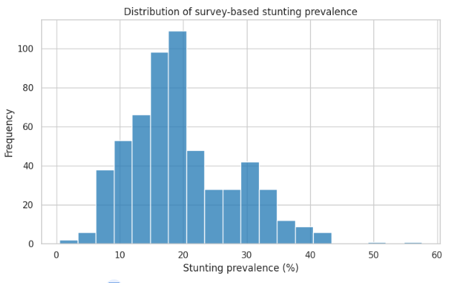

The histogram illustrates the distribution and variation of recorded stunting prevalence values. The spread of the observations indicates that prevalence varies across the years and subgroups represented in the dataset. Because the records represent different population categories, the distribution should not be interpreted as the distribution of individual children's measurements.
Figure 2. Year versus stunting prevalence.
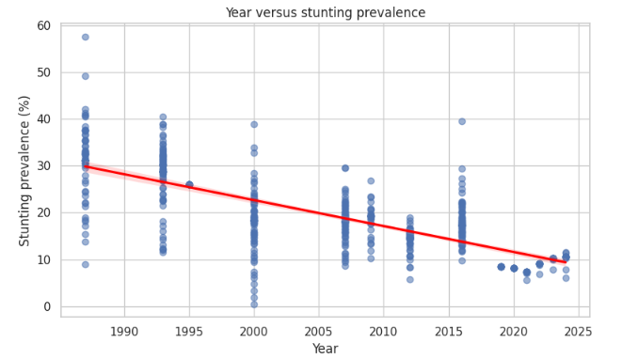
The scatter plot shows a negative association between year and prevalence. The Pearson correlation between year and numerical prevalence is approximately −0.729 in the cleaned subset. This indicates a strong negative linear association across the selected records. However, it does not demonstrate that prevalence decreased continuously in every year or that time alone caused the observed differences.
Figure 3. Stunting prevalence by sex.
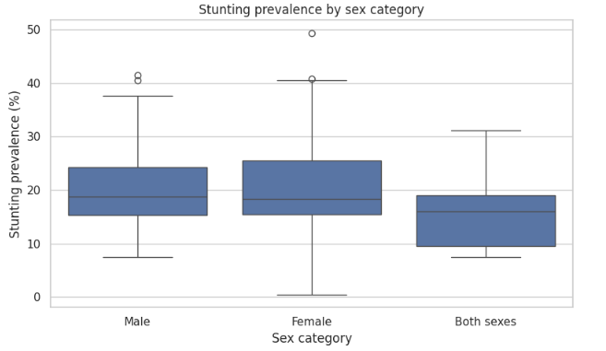
The category comparison provides a visual representation of variation among sex-related observations. Differences in the plotted values are descriptive and should not be interpreted as statistically significant without considering the results of the corresponding statistical test.
Figure 4. Correlation heatmap.
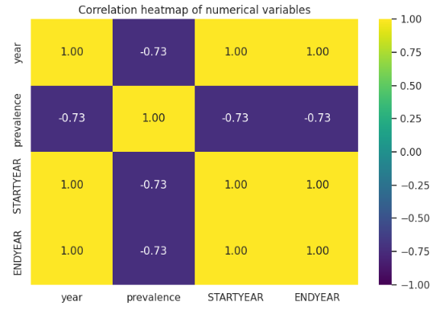
The heatmap illustrates correlations among numerical variables included in the analysis. The negative association between year and prevalence is consistent with the scatter plot. STARTYEAR and ENDYEAR were excluded from the machine-learning predictors because they are redundant with year for this subset.

3.2 Hypothesis Testing
Test | H₀ | Statistic | p-value | Conclusion
Welch t-test | Rural mean = Urban mean | t = 1.627 | 0.1212 | Fail to reject H₀
One-way ANOVA | Male = Female = Both sexes | F = 2.065 | 0.1288 | Fail to reject H₀
Both p-values exceed the significance level of 0.05. Therefore, the analyses do not provide sufficient statistical evidence of a rural–urban difference or a difference among the three sex categories in the selected observations.
These findings do not prove that the population means are equal. The tests also have limitations because the observations may span different years, and the Both sexes category is an aggregate rather than an independent demographic group. The ANOVA result should therefore be treated as an exploratory comparison, not as definitive evidence about sex-based differences in the population.

3.3 Machine Learning Evaluation
The reported evaluation results are presented below.
Model | MAE | RMSE | R²
Linear Regression | 3.703 | 5.027 | 0.584
Random Forest | 3.293 | 5.706 | 0.464
Based on the evaluation results, Linear Regression achieves a better overall fit, with lower RMSE and higher R², while Random Forest has a slightly lower MAE. Generally, lower MAE and RMSE values and a higher R² value indicate better model performance. These results suggest that year trends and encoded categories provide useful predictive information. However, this analysis is intended for coursework purposes only and should not be used for clinical decision-making.

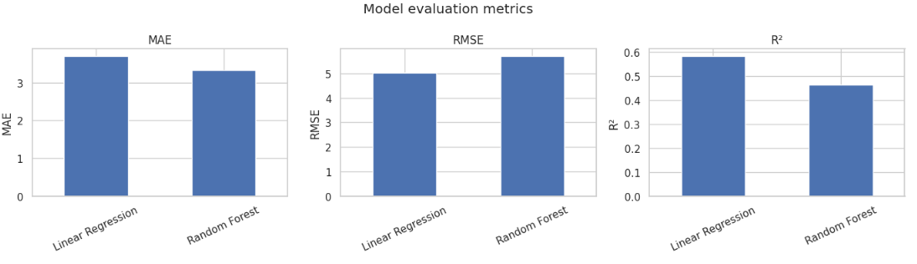
The comparison charts present the three evaluation metrics (MAE, RMSE, and R²) for both Linear Regression and Random Forest.

4. Limitations and Future Improvements
Several limitations should be considered when interpreting the findings:
- The selected dataset contains observations for different demographic and socioeconomic subgroups, rather than a single homogeneous time series.
- The random train-test split may allow related observations from the same years or categories to occur in both sets.
- The statistical tests compare recorded subgroup observations and do not necessarily establish population-level differences.
- Correlation between year and prevalence does not establish causation.
- Model evaluation on one split may not generalize to unseen years, subgroups, or future national estimates.
Future work should consider a more clearly defined prediction target, such as national-level prevalence by year, if sufficient consistent observations are available. For forecasting, chronological validation should be used so that earlier observations train the model and later observations test it. For subgroup prediction, validation should account for repeated observations and the structure of the data. Additional relevant health and socioeconomic indicators may also improve the analysis if their definitions, coverage, and availability are consistent.

- Conclusion
This project demonstrates a data analysis and machine learning workflow using real-world WHO Sri Lanka health indicators. The selected survey-based stunting indicator provided 575 records after duplicate removal, with no missing values in the numerical target field.
Exploratory analysis identified a strong negative association between year and recorded stunting prevalence. Neither the rural–urban Welch's t-test nor the sex-category ANOVA was statistically significant at the 5% significance level.
In the reported machine-learning comparison, Linear Regression performed better in terms of RMSE and R², while Random Forest achieved a lower MAE. These results provide a useful initial comparison of regression methods but should not be interpreted as proof of reliable future forecasting without further validation.
Overall, the project illustrates the importance of data cleaning, visualization, statistical testing, model evaluation, and critical interpretation when analyzing public health data. The findings are intended for academic coursework and exploratory analysis, not clinical decision-making.

6. References
Humanitarian Data Exchange. (n.d.). WHO data for Sri Lanka. https://data.humdata.org/dataset/who-data-for-lka
World Health Organization. (n.d.). Global Health Observatory. https://www.who.int/data/gho/
World Health Organization. (n.d.). Sri Lanka: Global Health Observatory country data. https://www.who.int/data/gho/data/countries/country-details/gho/sri-lanka

