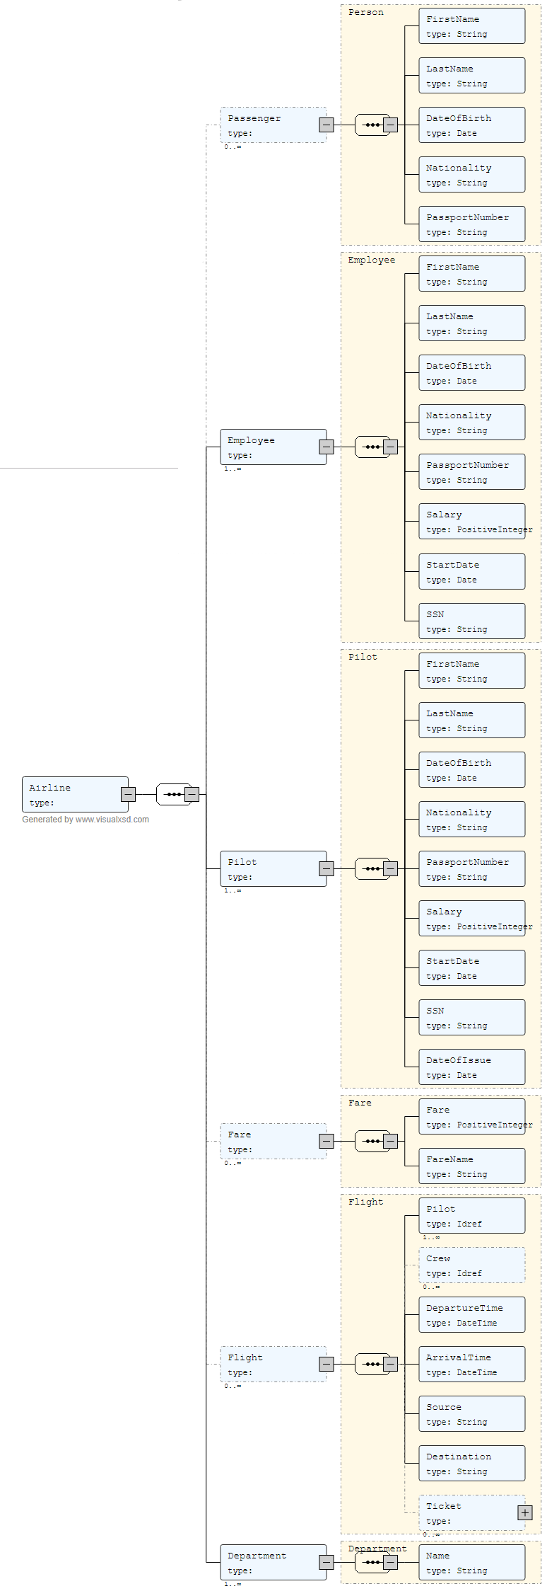

Airport XML Database and Schema Design

Coursework-2 Database Management Systems (F28DM)

By: Ismail Marashi and Ishaq Marashy

**Work Distribution**

1. Ishaq:

* Learning XSLT & XPATHS then relaying that information to Ismail.
* Majority of the data entry and XML.
* Advise corrections to XSD schema and finding errors.

1. Ismail:

* Learning XSD & designing the schema relaying that information to Ishaq.
* some of the data entry and XML.

1. Independent Work:
   * Both group members made two XPATHS (Extras done by Ishaq)
   * Both group members designed their own XSLT’s
   * Both group members designed their own XSLT’s displaying all the data in the XML (although it is not required)

**XSD Database Schema Overview**

This is the summery of all the XSD features used in the database design (More comments in the XSD file):

* Keys:
  + Person(ID), Employee(ID), Pilot(ID), Department(Code), Fare(FareType), Flight(FlightCode).
* Key references:
  + Employee(Supervisor), Employee (DepartmentID), Department(Manager), Flight(Pilot), Flight(Crew), Ticket(FareType).
* Complex datatypes:
  + Person, Employee, Pilot, Ticket, Fare, Flight, Department.
    - Extensions: Person is extended by employee, and employee is extended by pilot.
* Parent/Child relationships:
  + Airport is the root.
  + Airport is the parent of:
    - Passenger, Employee, Pilot, Ticket, Fare, Flight, Department.
      * Flight is the parent of ticket.
* Datatype definitions:
  + SSN: Uses regular expressions to restrict string input to XXX-XX-XXXX format.
  + Name: Limits inputs to include characters a to Z in addition to special characters with a size from 2-50.
  + Salary: Restricts input to a positive integer between 1000-1000000.

**XML Overview**

References the airport root node and enters data into the database for the following tables:

* Passenger (of type person which contains)
  + ID attribute of type ID
  + FirstName element of type name
  + LastName element of type name
  + DateOfBirth element of type date
  + Nationality element of type name
  + PassportNumber element of type String
* Employee (extends person and adds)
  + Supervisor attribute of type IDREF
  + DepartmentID attribute of type IDREF
  + Salary element of type integer
  + StartDate element of type date
  + SSN of type SSN
* Pilot (extends Employee and adds)
  + CertificateNumber attribute of type integer
  + DateOfIssue element of type date
* Department
  + Code attribute of type IDREF
  + Manager attribute of type IDREF
  + Name element of type name
* Ticket
  + SeatNumber element of type Integer
  + FareType attribute of type IDREF
  + PassengerID attribute of type IDREF
* Fare
  + FareType attribute of type ID
  + Fare element of type Integer
  + FareName element of type String
* Flight
  + FlightCode attribute as ID
  + Pilot element as IDREF
  + Crew element as IDREF
  + DepartureTime element as dateTime
  + ArrivalTime element as dateTime
  + Source element as name
  + Destination element as name
  + Ticket element as Ticket

**XPATHS**

* **All people of a certain faretype**
  + //Passenger[@ID=//Ticket[@FareType= "_24"]/@PassengerID]

<?xml version="1.0" encoding="UTF-8"?>

<result>

<Passenger ID="_1">

<FirstName>Dorris</FirstName>

<LastName>Christiansen</LastName>

<DateOfBirth>1980-08-17</DateOfBirth>

<Nationality>Portugal</Nationality>

<PassportNumber>815</PassportNumber>

</Passenger>

<Passenger ID="_3">

<FirstName>Lonzo</FirstName>

<LastName>Schmeler</LastName>

<DateOfBirth>2003-10-28</DateOfBirth>

<Nationality>Jordan</Nationality>

<PassportNumber>274</PassportNumber>

</Passenger>

<Passenger ID="_36">

<FirstName>Gerard</FirstName>

<LastName>Gibson</LastName>

<DateOfBirth>2017-12-30</DateOfBirth>

<Nationality>Singapore</Nationality>

<PassportNumber>859</PassportNumber>

</Passenger>

</result>

* **Number of people in a flight**
  + count(//Passenger[@ID=//Flight[@FlightCode="F1"]/Ticket/@PassengerID])

5

* **All people on a certain flight**
  + //Passenger[@ID=//Flight[@FlightCode="F1"]/Ticket/@PassengerID]

<?xml version="1.0" encoding="UTF-8"?>

<result>

<Passenger ID="_1">

<FirstName>Dorris</FirstName>

<LastName>Christiansen</LastName>

<DateOfBirth>1980-08-17</DateOfBirth>

<Nationality>Portugal</Nationality>

<PassportNumber>815</PassportNumber>

</Passenger>

<Passenger ID="_2">

<FirstName>Alvera</FirstName>

<LastName>Ziemann</LastName>

<DateOfBirth>2006-01-25</DateOfBirth>

<Nationality>Bolivia</Nationality>

<PassportNumber>441</PassportNumber>

</Passenger>

<Passenger ID="_3">

<FirstName>Lonzo</FirstName>

<LastName>Schmeler</LastName>

<DateOfBirth>2003-10-28</DateOfBirth>

<Nationality>Jordan</Nationality>

<PassportNumber>274</PassportNumber>

</Passenger>

<Passenger ID="_4">

<FirstName>Elijah</FirstName>

<LastName>Walter</LastName>

<DateOfBirth>2003-09-02</DateOfBirth>

<Nationality>Wake Island</Nationality>

<PassportNumber>79</PassportNumber>

</Passenger>

<Passenger ID="_6">

<FirstName>Destany</FirstName>

<LastName>Upton</LastName>

<DateOfBirth>2017-11-08</DateOfBirth>

<Nationality>Sierra Leone</Nationality>

<PassportNumber>119</PassportNumber>

</Passenger>

</result>

* **People supervised by id 9**
  + //Employee[@Supervisor="_9"]

<?xml version="1.0" encoding="UTF-8"?>

<result>

<Employee DepartmentID="_13" ID="_37" Supervisor="_9">

<FirstName>Colton</FirstName>

<LastName>Considine</LastName>

<DateOfBirth>1990-07-06</DateOfBirth>

<Nationality>Bangladesh</Nationality>

<PassportNumber>759</PassportNumber>

<Salary>281223</Salary>

<StartDate>2007-02-17</StartDate>

<SSN>164-55-4210</SSN>

</Employee>

<Employee DepartmentID="_13" ID="_39" Supervisor="_9">

<FirstName>Bridget</FirstName>

<LastName>Lockman</LastName>

<DateOfBirth>1995-05-03</DateOfBirth>

<Nationality>Nigeria</Nationality>

<PassportNumber>247</PassportNumber>

<Salary>210315</Salary>

<StartDate>1998-03-12</StartDate>

<SSN>226-06-0050</SSN>

</Employee>

<Employee DepartmentID="_13" ID="_40" Supervisor="_9">

<FirstName>Wilson</FirstName>

<LastName>Abbott</LastName>

<DateOfBirth>1991-11-18</DateOfBirth>

<Nationality>Pakistan</Nationality>

<PassportNumber>291</PassportNumber>

<Salary>21697</Salary>

<StartDate>2005-06-11</StartDate>

<SSN>290-90-0602</SSN>

</Employee>

<Employee DepartmentID="_13" ID="_41" Supervisor="_9">

<FirstName>Ruby</FirstName>

<LastName>Kessler</LastName>

<DateOfBirth>1996-06-07</DateOfBirth>

<Nationality>Malaysia</Nationality>

<PassportNumber>405</PassportNumber>

<Salary>473205</Salary>

<StartDate>1992-01-20</StartDate>

<SSN>300-93-0009</SSN>

</Employee>

<Employee DepartmentID="_13" ID="_5" Supervisor="_9">

<FirstName>Rhoda</FirstName>

<LastName>Kohler</LastName>

<DateOfBirth>1984-07-12</DateOfBirth>

<Nationality>Yemen</Nationality>

<PassportNumber>227</PassportNumber>

<Salary>47774</Salary>

<StartDate>2014-02-24</StartDate>

<SSN>120-10-0007</SSN>

</Employee>

</result>

* **People in a department**
  + //Employee[@DepartmentID="_13"]

<?xml version="1.0" encoding="UTF-8"?>

<result>

<Employee DepartmentID="_13" ID="_37" Supervisor="_9">

<FirstName>Colton</FirstName>

<LastName>Considine</LastName>

<DateOfBirth>1990-07-06</DateOfBirth>

<Nationality>Bangladesh</Nationality>

<PassportNumber>759</PassportNumber>

<Salary>281223</Salary>

<StartDate>2007-02-17</StartDate>

<SSN>164-55-4210</SSN>

</Employee>

<Employee DepartmentID="_13" ID="_39" Supervisor="_9">

<FirstName>Bridget</FirstName>

<LastName>Lockman</LastName>

<DateOfBirth>1995-05-03</DateOfBirth>

<Nationality>Nigeria</Nationality>

<PassportNumber>247</PassportNumber>

<Salary>210315</Salary>

<StartDate>1998-03-12</StartDate>

<SSN>226-06-0050</SSN>

</Employee>

<Employee DepartmentID="_13" ID="_40" Supervisor="_9">

<FirstName>Wilson</FirstName>

<LastName>Abbott</LastName>

<DateOfBirth>1991-11-18</DateOfBirth>

<Nationality>Pakistan</Nationality>

<PassportNumber>291</PassportNumber>

<Salary>21697</Salary>

<StartDate>2005-06-11</StartDate>

<SSN>290-90-0602</SSN>

</Employee>

<Employee DepartmentID="_13" ID="_41" Supervisor="_9">

<FirstName>Ruby</FirstName>

<LastName>Kessler</LastName>

<DateOfBirth>1996-06-07</DateOfBirth>

<Nationality>Malaysia</Nationality>

<PassportNumber>405</PassportNumber>

<Salary>473205</Salary>

<StartDate>1992-01-20</StartDate>

<SSN>300-93-0009</SSN>

</Employee>

<Employee DepartmentID="_13" ID="_5" Supervisor="_9">

<FirstName>Rhoda</FirstName>

<LastName>Kohler</LastName>

<DateOfBirth>1984-07-12</DateOfBirth>

<Nationality>Yemen</Nationality>

<PassportNumber>227</PassportNumber>

<Salary>47774</Salary>

<StartDate>2014-02-24</StartDate>

<SSN>120-10-0007</SSN>

</Employee>

</result>

* **All people who manage departments**
  + //Employee[@ID=//Department/@Manager]|//Pilot[@ID=//Department/@Manager]

<?xml version="1.0" encoding="UTF-8"?>

<result>

<Pilot CertificateNumber="81" DepartmentID="_14" ID="_8" Supervisor="_8">

<FirstName>Gustave</FirstName>

<LastName>Kohler</LastName>

<DateOfBirth>2013-07-11</DateOfBirth>

<Nationality>Denmark</Nationality>

<PassportNumber>921</PassportNumber>

<Salary>949854</Salary>

<StartDate>2003-11-28</StartDate>

<SSN>000-27-0000</SSN>

<DateOfIssue>1996-10-31</DateOfIssue>

</Pilot>

<Pilot CertificateNumber="41" DepartmentID="_14" ID="_7" Supervisor="_8">

<FirstName>Grace</FirstName>

<LastName>Sanford</LastName>

<DateOfBirth>1980-12-04</DateOfBirth>

<Nationality>Indonesia</Nationality>

<PassportNumber>297</PassportNumber>

<Salary>222837</Salary>

<StartDate>2007-07-04</StartDate>

<SSN>000-58-2000</SSN>

<DateOfIssue>1995-10-31</DateOfIssue>

</Pilot>

</result>

**XML Validation:**

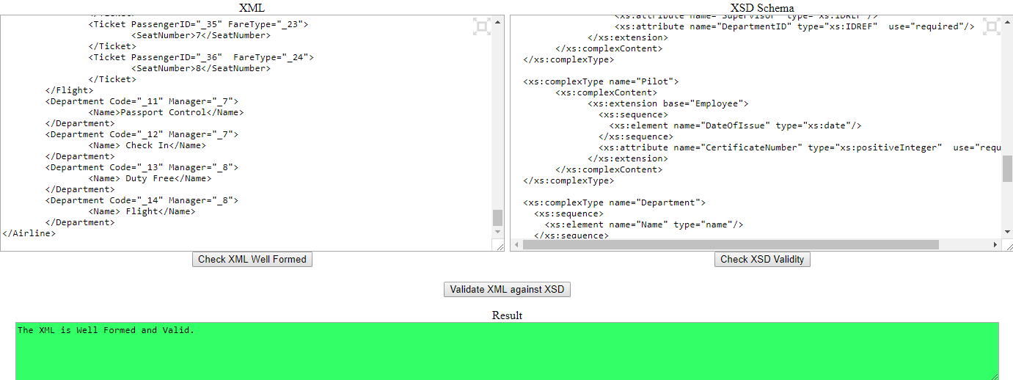Site Used: <http://www.utilities-online.info/xsdvalidation/>

**Site to Generate Graph on the Frontpage:** <http://visualxsd.com/Home/LoadSavedSchema/224af58eb2d54b0ddecd81ccf5c541fba67f986d>