Q1:

#include<stdio.h>

#include<math.h>

int main()

{

int data,min,max;

printf("entre the max value\n");

scanf("%d",&max);

int index,n,count,index1=0;

int my_array[100],loc;

for(data=2;data<=max;data++)

{

count=0;

for(index=1;index<=data;index++)

{

if(data%index==0)

{

count++;

}

}

if(count<3)

{

my_array[index1++]=data;

}

}

printf("enter the nth location of prime no.\n");

scanf("%d",&loc);

printf("prime no. in possition is %d\n",my_array[loc-1]);

}

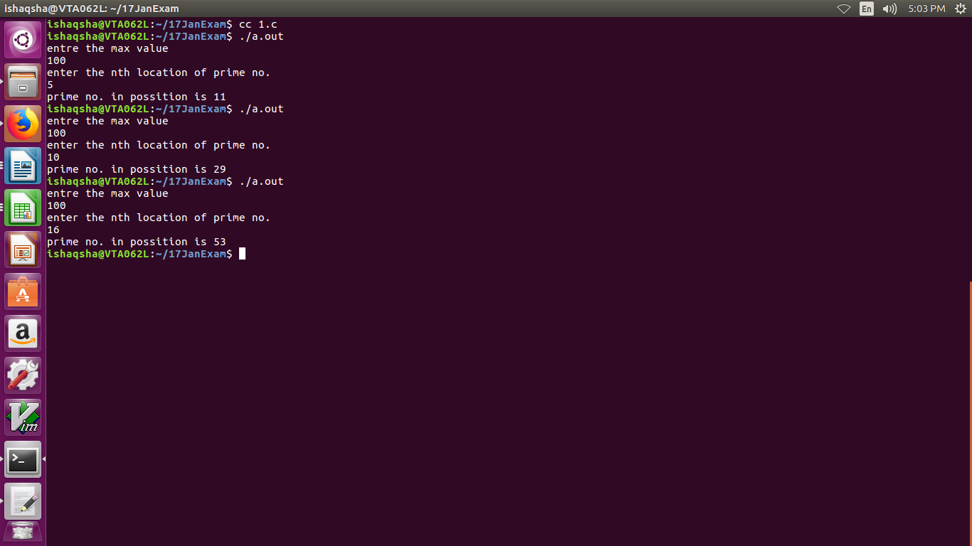

Q 3:

#include<stdio.h>

int main()

{

int first=0,second=1;

int result,i,num;

int my_array[100];

my_array[0]=first;

my_array[1]=second;

int max,count=0,cnt=0;

printf("enter a value whwer you want upto fiboinici\n");

scanf("%d",&max);

for(i=2;i<20;i++)

{

result=first+second:

first=second;

second=result;

my_array[i]=result;

}

for(i=0;i<max;i++)

{

printf("%d ",my_array[i]);

}

printf("\n");

printf("enter the num for checking prime no.\n");

scanf("%d",&num);

for(i=1;i<=num;i++)

{

if(num%i==0)

{

count++;

}

}

if(count<3)

{

printf("i am a prime n.\n");

for(i=0;i<max;i++)

{

if( my_array[i]==num)

{

cnt++;

}

}

}

if(cnt==1)

{

printf("number %d is a Fibonacci prime\n",num );

}

else

{

printf("number %d is not a Fibonacci prime\n",num );

}

}

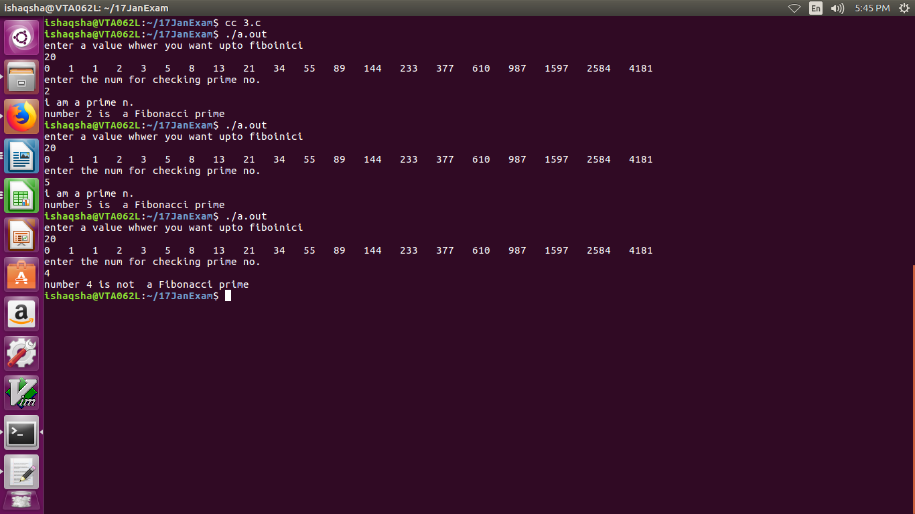

Q4

#include <stdio.h>

#include <string.h>

#define MAX 100

char Non_Repeat(char arr1[])

{

int index,index1,size,counter=0;

size =strlen(arr1);

for(index=0; index<size; index++)

{

counter=0;

for(index1=0; index1<size; index1++)

{

if(arr1[index]==arr1[index1])

{

counter++;

}

}

if(counter==1)

{

return arr1[index];

}

}

return 0;

}

int main()

{

char my_arr[MAX];

char ch;

printf("Enter String: ");

scanf("%s",my_arr);

ch = Non_Repeat(my_arr);

if(ch==0)

printf("First non-repeating character in string %s is -1\n",my_arr);

else

printf("First non-repeating character in string %s is %c\n",my_arr,ch);

}

