**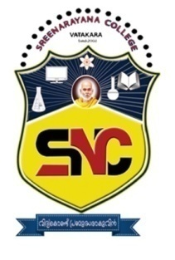 *Affiliated to University of Calicut***

SREE NARAYANA COLLEGE VATAKARA

Run by**: SNDP** Union Development & Welfare Society, Vatakara

Sree Narayana College , Vatakara was established by the SNDP Union Development and Welfare Society,Vatakara in memory and to pay obeisance to the great social reformer, Sree Narayana Gurudevan. The college started functioning on 08th August, 2003 in a rented building at Narayana Nagar, Vatakara. The college was shifted to S.N. Hills, Keezhal on 28th February 2011.

The college campus is refreshingly green and scenically beautiful with thick foliage. It offers course in Arts, Science, Commerce & Management disciplines at undergraduate and Post graduate levels. The college has completed eighteen years of its glorious service. It is today one of the biggest post graduate self-financing colleges under the University of Calicut.

As part of the choice Based Credit and Semester System at the graduate level, elective courses, complementary courses and skill based courses are offered to develop their potentialities in various faculties. The college bring together should academic achievement with extensive and vibrant co-curricular programs that includes fine arts, sports and leadership training programs.

The institution strives to fulfill the mission of Gurudevan to provide educational opportunities to all aspiring youth to excel in life by developing academic excellence, fostering values, creating civic enlightenment through education and endeavors to build a humane, intellectually accomplished, morally awakened and socially committed fraternity of young men and women. The college continuously strives to internalize and institutionalize excellence by improving the quality of its services and upgrading the infrastructural facilities. The college ensures the holistic development of its students, thereby making them intellectually, socially, physically and spiritually balanced human beings. Ragging is totally banned inside the campus and it is not entertained even for fun.

The college has a team of highly experienced and dedicated faculty comprising of more than twenty eminent Professors. Our students have secured commendable academic achievements over the years. Our aim is to inculcate the love of knowledge in our students

**#MESSAGE FROM THE MANAGER**

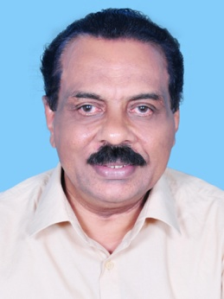

Manager

**Sri.P.M. Raveendran**

President, SNDP Union Devolopment

And Welfare Society Vatakara

SNDP Yogam is the biggest social organization in kerala. As a part of their social service, the Yogam is running agood number of aided and unaided colleges, Higher Secondary Schools,High Schools, UP and LP Schools,In order to provide higher education facilities to the weaker sections of the society, the Union started an Arts and ScienceCollege named after the Jagat Guru Sri Narayana as Sree Narayana College, Vatakara. The College was started in 2003 with two UG Courses. Slowly but steadily we have developed this college to a first grade college with 14 UG and 5 PG Courses. Now it is Placed as the biggest and the best unaided college in and around Vatakara. I hope that this institution progresses further to a Centre of Academic Excellence within a few years. We have a plan named ‘Vision 2024’ for the allroun development of the institution. The Management is fully committed to achive this goal.

**#DEAR PARENTS AND STUDENTS,**

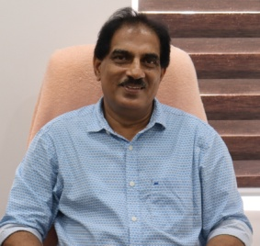

Principal

**Dr. M.K.RADHAKRISHNAN**

**PhD, MBA**

Sree Narayana College, Vatakara was established in 2003 and within this short span of time has placed itself at the very top among the self financing colleges affiliated to the University of Calicut. Located on asunny hilltop, in a verdant surrounding, Sree Naryana College with its will laid out buildings, presents a picture of scenic beauty, refreshing to the sight and mind.

The college is administered by SNDP Union Development and Welfare Society. It offers a total of 14 UG courses and 5 PG courses in Arts,Science, Psychology,Commerce and Management Studies. Though we began humbly, the college has seen steady expansion in this period. We have rendered yeoman service in the academic field of vatakara.

Inspired by the values of Sree Narayana Guru, the institution relentlessly strives to provide aspiring youth with opportunities to excel in life through developing academic and related skills. We have a vibrant NSS unit and students are given ample avenues to exhibit their co-curricular skills, their sporting and athletic prowess. Fine Arts, Leadership Training Programmes and placement cell are all hallmarks of this institution.

The environment of the college ensures the holistic development of the students, making them intellectually, physically and spiritually balanced humanbeings and fine citizens. As our aim is to inculcate the love of knowledge in our students we can boast of high academic achievements over the years. Even during the difficult time of Covid19, we resume our academic process through electronic media. I wish the institution will prosper in all dimension in order to cater the academic needs of the community in and around Vatakara, fostering the slogan of great saint Sree Narayana Guru “Enlighten through education”

**PROGRAMMES OF STUDY**

**\* UNDER GRADUATE**

1.B.Sc Physics Core

(Mathematics,Chemistry- (Comple.)

2.B.Sc Chemistry Core

(Mathematics,Physics- (Comple.)

3.B.Sc Statistics Core

(Mathematics,Computer Science - (Comple.)

4.B.Sc Mathematics Core

(Statistics- Computer Science (Comple.)

5.B.Sc Psychology Core

(Human Psychology, Statistics- (Comple.)

6.B.Sc Computer Science Core

(Mathematics, Statistics-(Comple.)

7.B.Sc Botany Core

(Zoology, Chemistry-(Comple.)

8.B.Sc Botany Core

(Botany,Chemistry-(Comple.)

9.B.C.A (Bachelor of Computer Application)

10.BA Functional English

11.B.B.A (Bachelor of Businesss Administration)

12.B.Com Computer Application

13.B.Com Finance

14.B.Com Co-operation

**\* POST GRADUATE**

1.M.Sc Physics

2.M.Sc Chemistry

3.M.Sc Clinical Psychology

4.M.Com. Finance

5.M.A English

**\*HIGHLIGHTS**

Highly qualified, dedicated and experienced faculty/ Well equipped laboratories/ Computer Lab with advanced computing systems and networking/ Well stocked Library/ English language Laboratory/ Training and placement cell/ soft skill development facility/ Industry visits/ Womens cell/ NSS/ Health Club/ Bhoomithra sena Club/ Legal literacy programme/ Alumini association/ Periodical test and model examinations/ College Union/ Film Club/ UGC Grievance Cell/ Tutorial System/ PTA/ College bus service/ Canteen/ Ragging free campus/ Committed and development oriented management/ Verdant Campus/ One of our student was selected as best NSS Volonteer under Calicut University/ Newly completed building for English department & Library

**\*ADMISSION 2023-2024**

50% of total seats in UG and PG will be filled up by the Calicut University through CAP (Centralised Admission Process) and 50% seatsof Management Quota by the College Management. Students seeking admission in Management Quota also should register in CAP. Registration for Management Quota seats has already started. Application forms are available from the SNDP Union Office. Vatakara. SC/ ST/ OBC/ OEC/ EWS Reservation as per ruels will be given.

**\*OUR RESULTS**

We have been producing very good result through out these years The college has producing more than 90% in all PG Programs for the last few years. The college bagged many ranks in university examinationsof M.Sc Physics and M.Sc Clinical Psychology.

**\*VISITING FACULTIES**

Highly qualified, experienced and dedicated faculty is our unique feature. Classes are conducted under the supervision of the following eminent Professors.

**# COMMERCE & MANAGEMENT STUDIES**

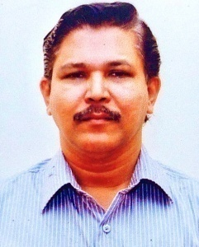

**Prof, Dr: K. VENUGOPALAN**

**(Head of the Department)**

Former HOD, PG Dept. of Commerce & Management Studies, Govt. College Madappally

**Dr.Udayakumar.O.K :** Former Principal Govt. College Madappally

**Dr.** **Abdul Assis Coroth :** Former HOD, PG Dept. of Commerce Govt. College Madappally

**Dr. T.Lalitha Devi :** Former Faculty, Avinashalingam University for Women, Coimbathore

**# PHYSICS**

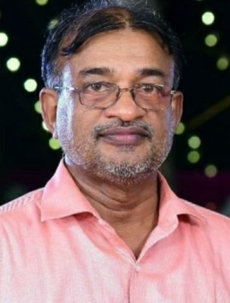

**Prof. M.P. NARAYANAN**

**(Head of the department)**

Former HOD, PG Dept. of Physics, Sir Syed College, Thaliparamba

**Prof. Abdullakutty.V.P :** Former HOD, Dept. of Physics, Sir Syed College, Thaliparamba

**Prof. M.C. Thomas :** Former HOD, Dept. of Physics, Nirmalagiri College, Koothuparamba

**Dr. Udayanandan :** Former Associate Professor of Physics, N.A.S College, Kanhangad

**#CHEMISTRY**

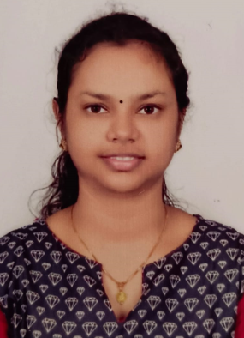

**ROJA.P**

**(Head of the Department)**

**Prof. P.V.RAVEENDRAN :** Former Professor of chemistry, Govt.College, Madappally.

Former Member PG&UG Board of Studies in Chemistry, University of Calicut.

Former Member academic council University of Calicut.

Former Chairman Board of Question Paper setters university of Kannur.

**Dr.K.PRADEEP KUMAR**: Former Principal, PRNSS.College ,Mattanur.

Research Guide of Kannur University.

Two Ph.D students successfully completed their Ph.D and were aworded

Ph.D in chemistry from kannur university.

Published 11 research papers in National /International Journals.

Former member of syndicate in Kannur University.

Former member of Academic Council in kannur University.

**# MATHEMATICS**

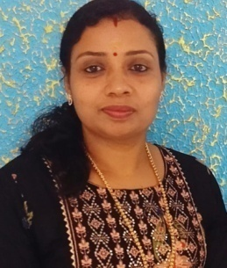

**NISHA.E**

**(Head of the Department)**

**Prof. M.V. Sathian :** Former Prof. Dept. of Mathematics, Govt. Arts & Science

College,Calicut

**#STATISTICS**

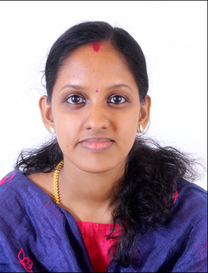

**TEENA .N**

**(Head of the Department)**

**#COMPUTER SCIENCE** / **BCA**

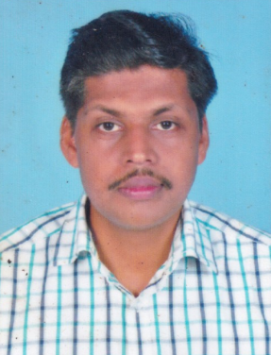

**PAVITHRAN.M.T**

**(Head of the Department)**

**#BOTANY**

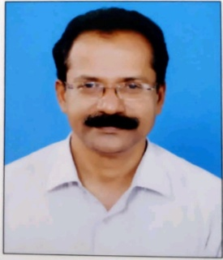

**Prof. P.T.JOSE**

**(Head of the Department)**

M.Sc, Bed

Former HOD and Associate professor : Department of Botany, Nirmalagiri College, Kuthuparamba

Teaching interests : TAXONOMY,GENETICS

**#ZOOLOGY**

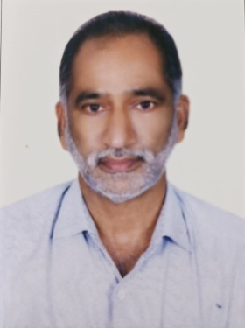

**Dr.Aravindan Tharemmal**

**(Head of the Department)**

M.Sc, Ph.D, NET

Former Head, Department of Zoology, Sree Narayana College. Kannur.

Former Course DirectorDepartment of Molecular Biology, Kannur University.

Former Co-ordinator, IGNOU Study Centre, Sree Narayana College, Kannur.

Teaching experience: 26 years

**Dr. K. Anil**(M.Sc,M.Phill, Ph.D): Visiting faculty

Former Head, Department of Zoology, Sree Narayana College Kannur

**#PSYCHOLOGY**

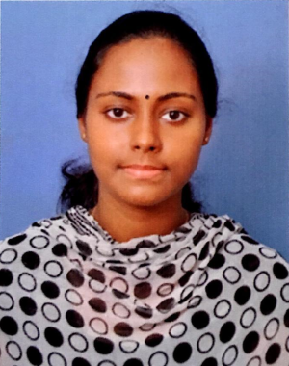

**HARSHA MANOLI**

**(Head of the Department)**

**#ENGLISH**

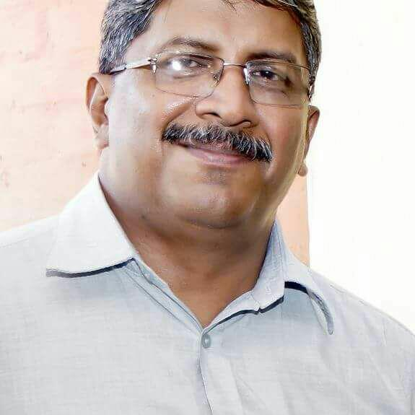

**Prof.Sudhir Kumar T**

**(Head of the Department)**

Former HOD,PG Dept.of English Govt. College, Madappally

**Prof. Achuthanandan :** Asst. professor, Journalism

**#PHYSICAL EDUCATION**

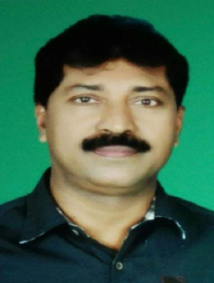

**Sri. Abdul Majeed.T.H**

**(Head of the Department)**

**#NSS**

The aim of the National Service Scheme is education through community service. It offers the youth a wonderful opportunity to help the poor and the downtrooden. It creates a strong social awareness among the students and imparts personality development to its members through study and work, camps, social service activities and other useful and productive work. The volunteers enrolled info N.S.S after the screening process have to undergo a minimum of 240 hours work in two consecutive academic years. This college has one NSS unit. For this compulsory special camping programme for 7 days during X’mas holidays will be there. Besides this activities like cleaning the college campus and its surroundings, gardening etc, are taken up by the NSS volunteers.

**#BHOO MITHRA SENA CLUB**

Dr. Vinjusha.N, Dept of Botany is the convenor of Bhoomithrasena Club. Sri. Sourav.M.P (B.Com Finance) is the secretary of the club. Environmental protection is the main motto of the club. The club functions with the collaboration of Directorate of environment and climate change, Kerala.

The other active clubs functioning in the college comprises of Film Society, Blood donors club, Tourism club and Red Ribbon Club.

**#COLLEGE FITNESS PROGRAMME**

University of Calicut started College Fitness programme during the year 2018 onwards. First year students are eligible to join the fitness programme. Marks are awarded to the students who passed the tests conducted by the department of physical education.