Multi-Agent Healthcare Research System with Retrieval-Augmented Generation
Mohamed Isharak M, Madhavan N, Padmapriyan M
Department of Computer Science and Business Systems
[Your College Name], Affiliated to Anna University, Chennai, India
{email1, email2, email3}@[yourcollege].edu.in
Abstract—The exponential growth of biomedical literature has outpaced the ability of researchers to manually search, evaluate, and synthesize scientific evidence. Existing tools address isolated parts of the research lifecycle — PubMed-style databases for discovery, reference managers for citations, manuscript editors for writing, and code-hosting platforms for version history — but no single environment unifies these functions for biomedical research specifically. Recent Retrieval-Augmented Generation (RAG) systems for medicine, such as MedRAG and Medical Graph-RAG, improve question answering over medical corpora but stop short of full research-workflow support: they do not validate evidence across multiple sources, detect contradictory findings, or provide version-controlled collaborative workspaces. This paper proposes a Multi-Agent Healthcare Research System that combines RAG-based semantic retrieval with a coordinated set of specialized agents — including retrieval, evidence-analysis, literature-review, writing, citation, and knowledge-graph agents — under a central orchestrator. The system further provides Git-like version control for research artifacts and a collaborative workspace for research teams. We describe the system architecture, the data flow across modules, the responsibilities of each agent, and an evaluation methodology for assessing retrieval accuracy, evidence-classification quality, and research-workflow efficiency relative to existing single-purpose tools. The proposed system aims to reduce tool fragmentation in biomedical research and improve the traceability and reproducibility of AI-assisted literature review.
Keywords—Retrieval-Augmented Generation; Multi-Agent Systems; Biomedical Literature Retrieval; Evidence Validation; Medical Informatics; Collaborative Research Platforms; Version Control.

I. INTRODUCTION
The volume of biomedical literature published each year continues to grow at a pace that makes exhaustive manual review impractical even for specialist teams. Researchers routinely move across a fragmented set of tools during a single project: a literature database to search for papers, a reference manager to organize citations, a writing platform to draft manuscripts, and a version-control system to track changes to code, data, or documents. This fragmentation increases manual effort, introduces inconsistency between tools, and makes it difficult to trace how a conclusion in a manuscript was derived from the underlying evidence.
Retrieval-Augmented Generation (RAG) has recently been applied to biomedical question answering, allowing large language models to ground their responses in retrieved literature rather than relying solely on parametric knowledge. Systems such as MedRAG and Medical Graph-RAG demonstrate that RAG can improve the accuracy and traceability of AI-generated answers in medicine. However, these systems are designed primarily as question-answering interfaces; they do not manage the surrounding research workflow — organizing notes and datasets, tracking revisions, coordinating collaborators, or reconciling contradictory findings across multiple papers.
This paper proposes a Multi-Agent Healthcare Research System that extends RAG-based retrieval with a coordinated set of specialized agents and an integrated research workspace. The specific contributions of this work are:
• A multi-agent architecture in which a central orchestrator delegates retrieval, evidence analysis, literature review, scientific writing, citation management, and knowledge-graph construction to dedicated agents.
• An evidence-classification pipeline that labels retrieved findings as supporting, neutral, or contradictory with respect to a research query, rather than returning a single synthesized answer.
• Git-like version control applied to research artifacts — notes, hypotheses, manuscripts, and datasets — alongside real-time collaboration features for research teams.
The remainder of this paper is organized as follows. Section II reviews related work in medical RAG systems. Section III states the problem addressed by this work. Section IV describes the proposed system architecture and the role of each agent. Section V presents the data flow and activity model. Section VI outlines the evaluation methodology. Section VII maps the system to relevant Sustainable Development Goals, and Section VIII concludes with directions for future work.
II. RELATED WORK
Amugongo et al. [1] present a systematic review of RAG applications in healthcare, concluding that RAG substantially reduces hallucination in clinical question answering compared to purely generative approaches, but note that most surveyed systems are narrow in scope and are not integrated into broader research workflows.
Zhao et al. [4] introduce MedRAG, a medical large language model that combines retrieval with knowledge-graph-elicited reasoning to produce citation-backed answers for a healthcare copilot. While MedRAG improves answer accuracy and grounding, it is designed as a conversational assistant rather than a research-management platform, and offers no support for collaboration or version history.
Wu et al. [5] propose Medical Graph-RAG, which combines a knowledge graph with retrieval to improve contextual understanding for medical large language models. This approach improves retrieval relevance but requires a complex graph-construction pipeline and, like MedRAG, does not address collaborative research management.
Liu et al. [2] survey the use of RAG and large language models across biomedicine more broadly, highlighting improvements in literature retrieval and research assistance, but similarly identify the absence of version control or an end-to-end research workflow as an open gap. Table I summarizes these systems against the gap addressed by the proposed system.
TABLE I
Comparison of Related Medical RAG Systems
Ref. | Author (Year) | Approach | Key Limitation Addressed by Proposed System
[1] | Amugongo et al. (2025) | Systematic review of RAG applications in healthcare | No integrated, end-to-end research workspace
[4] | Zhao et al. (2025) – MedRAG | Medical LLM with retrieval-augmented generation | Limited collaboration and research-project management
[5] | Wu et al. (2024) – Medical Graph-RAG | Knowledge graph combined with RAG | Complex to deploy; no collaborative or version-control features
[2] | Liu et al. (2025) | Biomedical LLM with semantic retrieval | No version control or full research workflow support

Across this body of work, a consistent pattern emerges: retrieval and question-answering quality has improved substantially, but no reviewed system provides evidence validation across multiple contradictory sources, research-specific version control, or a collaborative workspace within the same platform. This is the gap the proposed system targets.
III. PROBLEM STATEMENT
Existing research tools are fragmented across separate platforms for literature search, reference management, collaboration, manuscript writing, and version control, which increases manual effort and reduces reproducibility. Current medical RAG systems provide AI-assisted question answering but generally lack support for evidence validation, contradiction detection across sources, collaborative research management, version-controlled documentation, and AI-assisted scientific writing within a single environment. There is a need for an integrated, AI-powered research environment that combines semantic literature retrieval, evidence-based reasoning, collaborative project management, and structured knowledge organization to improve the efficiency, accuracy, and reproducibility of biomedical research.
IV. PROPOSED SYSTEM ARCHITECTURE
The proposed platform is organized into four layers: a user layer, a research-workspace layer, a multi-agent AI layer, and a medical RAG engine, backed by shared backend services. Fig. 1 illustrates the overall architecture.
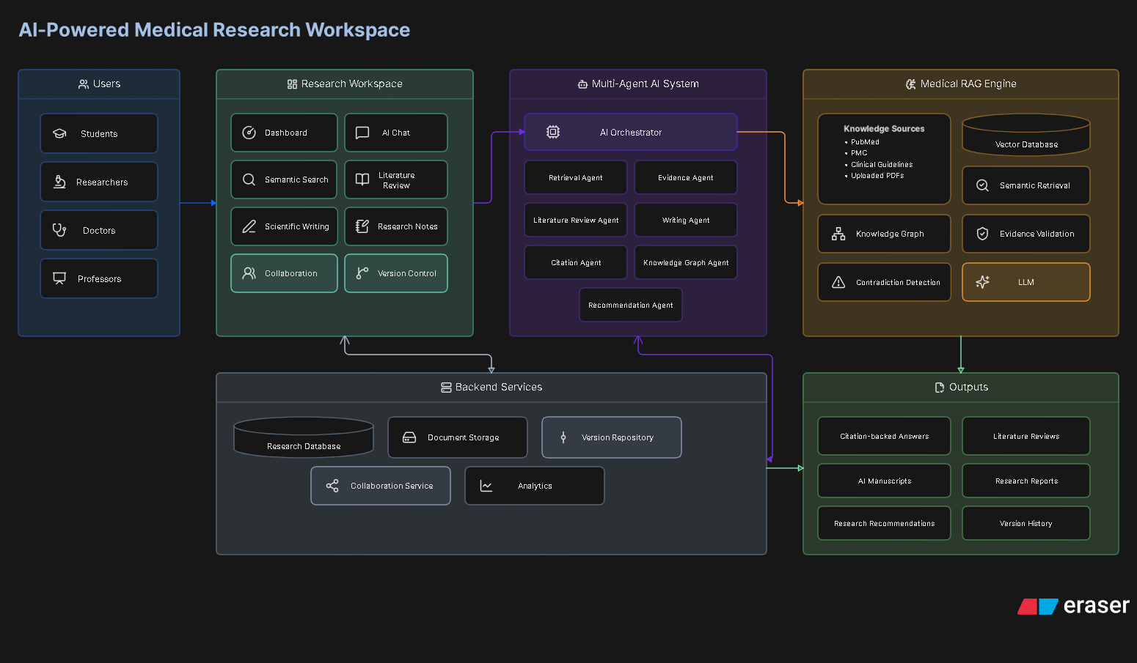
Fig. 1. System architecture of the proposed Multi-Agent Healthcare Research System.
A. User Layer
The platform serves students, researchers, doctors, and professors through a common workspace interface, each accessing the same underlying retrieval and evidence-analysis capabilities at different levels of depth.
B. Research Workspace Layer
This layer exposes the researcher-facing functions: a dashboard, an AI chat interface, semantic search, literature-review generation, scientific-writing assistance, research notes, collaboration tools, and version control, all operating on a shared research-database backend.
C. Multi-Agent AI Layer
A central AI Orchestrator coordinates seven specialized agents: a Retrieval Agent that queries biomedical sources; an Evidence Agent that classifies findings as supporting, neutral, or contradictory; a Literature Review Agent that synthesizes multi-paper summaries; a Writing Agent that assists with manuscript drafting; a Citation Agent that manages reference formatting and provenance; a Knowledge Graph Agent that maintains relationships between diseases, drugs, genes, and treatments; and a Recommendation Agent that surfaces related work and research gaps. Decomposing the workflow into specialized agents, rather than a single monolithic prompt, allows each stage — retrieval, validation, synthesis, and writing — to be independently evaluated, monitored, and improved.
D. Medical RAG Engine
The RAG engine indexes knowledge sources including PubMed, PMC, clinical guidelines, and user-uploaded documents into a vector database for semantic retrieval. It performs evidence validation and contradiction detection over retrieved passages before an LLM generates a citation-backed response, which is returned to the orchestrator for downstream use by the writing, citation, and literature-review agents.
E. Backend Services
A shared backend provides the research database, document storage, a version repository, a collaboration service, and analytics, which are consumed by both the workspace layer and the multi-agent layer, and produce the platform's outputs: citation-backed answers, literature reviews, AI-assisted manuscripts, research reports, recommendations, and version history.
F. Modules
Table II maps the architecture onto six functional modules delivered to the end user.
TABLE II
System Modules
Module | Function
Research Discovery & AI Assistant | Retrieval Agent queries PubMed, PMC, bioRxiv and clinical guideline sources; answers natural-language questions with citation-backed responses generated by the RAG engine.
Evidence Analysis & Literature Review | Evidence Agent and Literature Review Agent summarize papers, compare findings across sources, flag supporting / neutral / contradictory evidence, and draft literature reviews.
Research Workspace & Collaboration | Supports shared projects, annotations, discussion threads and progress tracking for research teams.
Dataset & Research Asset Management | Centralized storage for datasets, manuscripts, medical images, and experiment logs.
Version Control & Knowledge Graph | Git-like revision history for research artifacts, maintained by a dedicated Knowledge Graph Agent that also visualizes relationships between diseases, drugs, genes and treatments.
Secure Knowledge Repository | Encrypted, role-based storage for institutional documents and organizational knowledge, indexed for semantic search.

V. DATA FLOW AND ACTIVITY MODEL
Fig. 2 shows the context-level data flow between researchers, medical students, the platform, and its two primary stores: medical knowledge sources and the project database. Researchers submit search, project-management, and collaboration requests and receive AI-generated answers, literature reviews, and knowledge graphs in return; medical students receive study material, summaries, and generated MCQs, and can search and generate notes through the same interface.
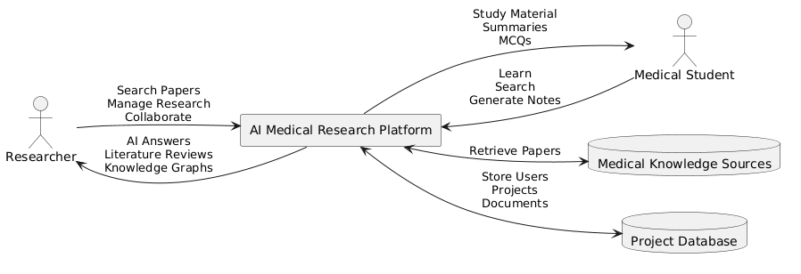
Fig. 2. Context-level data flow diagram.
Fig. 3 shows the corresponding user activity model. After authentication, a user opens or creates a research project, enters a query, and the system retrieves relevant papers and generates an AI summary through RAG before displaying evidence and citations. The user may optionally save the results to the project, which triggers a new version in the version-control layer, and may then collaborate with team members through comments before logging out.
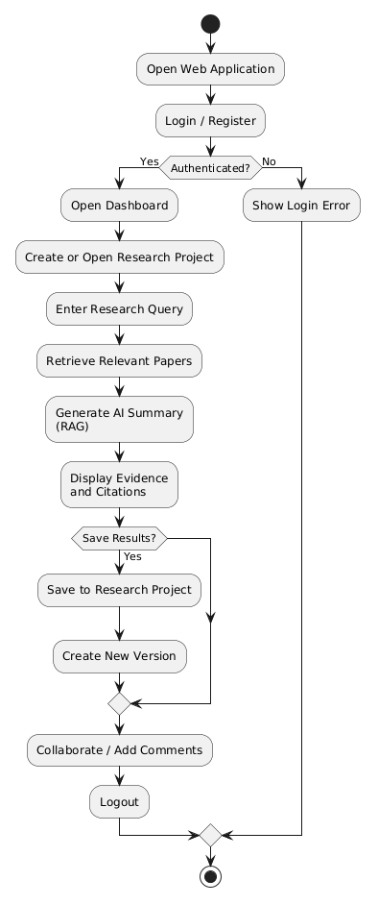
Fig. 3. Activity diagram of a typical research session.
VI. EVALUATION METHODOLOGY
Because the contribution of this work is centered on the retrieval-and-evidence pipeline rather than the workspace UI, evaluation is proposed along three axes.
A. Retrieval Quality
Precision, recall, and mean reciprocal rank of retrieved passages will be measured against a held-out set of biomedical queries with known relevant documents, and compared against a standard RAG baseline without the multi-agent evidence layer.
B. Evidence Classification Accuracy
The Evidence Agent's supporting / neutral / contradictory labels will be evaluated against a manually annotated subset of paper pairs, reporting precision, recall, and F1 per class.
C. Workflow Efficiency
Task-completion time for representative research tasks (e.g., producing a literature review on a given topic) will be compared between the proposed platform and the existing multi-tool baseline (PubMed + Zotero/Mendeley + Overleaf + GitHub) described in the related work.
[Insert experimental results here — retrieval precision/recall/MRR, evidence-classification F1, and task-completion time figures, once testing is complete. Do not submit this paper with placeholder or invented numbers in this section.]
VII. SUSTAINABLE DEVELOPMENT GOALS MAPPING
The proposed system contributes to several United Nations Sustainable Development Goals. By accelerating access to validated medical evidence, it supports SDG 3 (Good Health and Well-Being); by assisting students and researchers with literature comprehension and note generation, it supports SDG 4 (Quality Education); by advancing AI infrastructure for research, it supports SDG 9 (Industry, Innovation and Infrastructure); and by improving the traceability and reproducibility of research claims through version control, it supports SDG 16 (Peace, Justice and Strong Institutions).
VIII. CONCLUSION AND FUTURE WORK
This paper presented a Multi-Agent Healthcare Research System that integrates Retrieval-Augmented Generation, a coordinated set of specialized agents for evidence analysis and scientific writing, and Git-like version control within a single collaborative research workspace. The proposed architecture addresses a gap identified consistently across recent medical RAG literature: the absence of an integrated environment that combines citation-backed retrieval with evidence validation, contradiction detection, and reproducible, version-controlled collaboration. Future work includes completing the evaluation described in Section VI on a held-out biomedical query set, conducting a user study with research teams to assess collaboration features, and extending the Knowledge Graph Agent to support cross-paper hypothesis generation.
REFERENCES
[1] L. M. Amugongo et al., “Retrieval augmented generation for large language models in healthcare: a systematic review,” PLOS Digital Health, 2025.
[2] S. Liu et al., “RAG and large language models in biomedicine,” Journal of the American Medical Informatics Association, 2025.
[3] D. Baur et al., “Development and evaluation of a retrieval-augmented generation system for healthcare applications,” JMIR AI, 2025.
[4] X. Zhao et al., “MedRAG: knowledge graph-elicited reasoning for healthcare copilot,” 2025.
[5] J. Wu et al., “Medical graph RAG: towards safe medical large language models,” 2024.
[6] Y. H. Ke et al., “Retrieval-augmented generation for large language models in healthcare,” NPJ Digital Medicine, 2025.
[7] R. Yang et al., “Retrieval-augmented generation in medicine: a scoping review,” 2025.
[8] National Library of Medicine, “PubMed database,” [Online]. Available: https://pubmed.ncbi.nlm.nih.gov/
[9] National Library of Medicine, “PubMed Central (PMC),” [Online]. Available: https://www.ncbi.nlm.nih.gov/pmc/
[10] U.S. National Library of Medicine, “ClinicalTrials.gov,” [Online]. Available: https://clinicaltrials.gov/

