Reading the value of DHT11 Sensor via ESP32 Board using BLE Scanner(app)

Requirements:

- ESP32 Board
- DHT11 Sensor
- Jumper Wires
- Install Arduino IDE

Step 1: Connections ===>

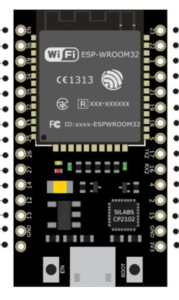
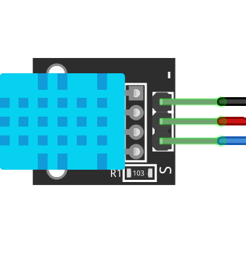

Step 2: In Arduino IDE :
Select Board – DOIT ESP32 DEVKIT

Step 3: Download the DHT11 library
Link: https://codeload.github.com/adafruit/DHT-sensor-library/zip/master

Step 4:

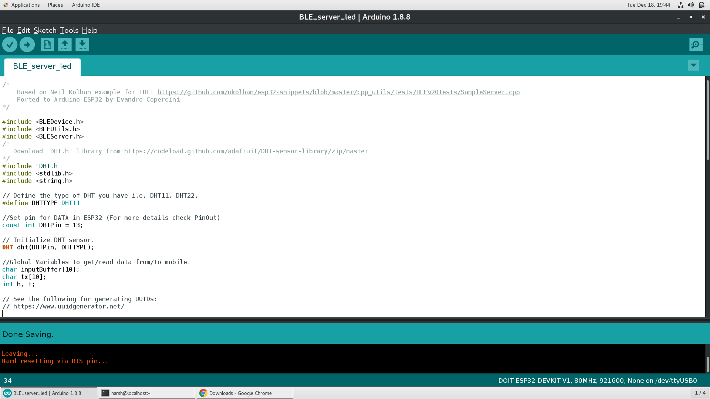

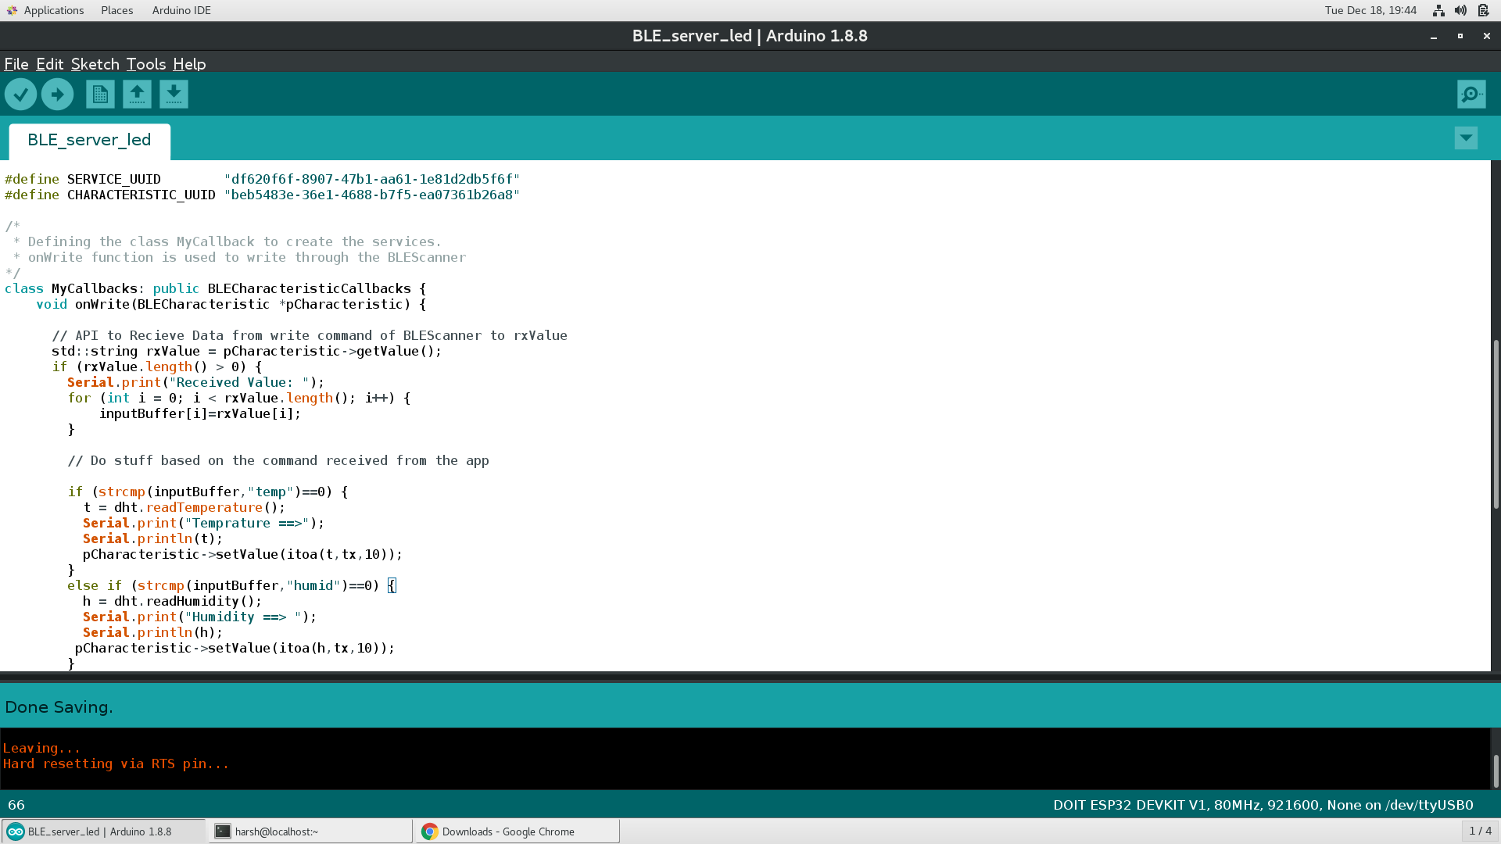

/*
* Defining the class MyCallback to create the services.
* onWrite function is used to write through the BLE Scanner
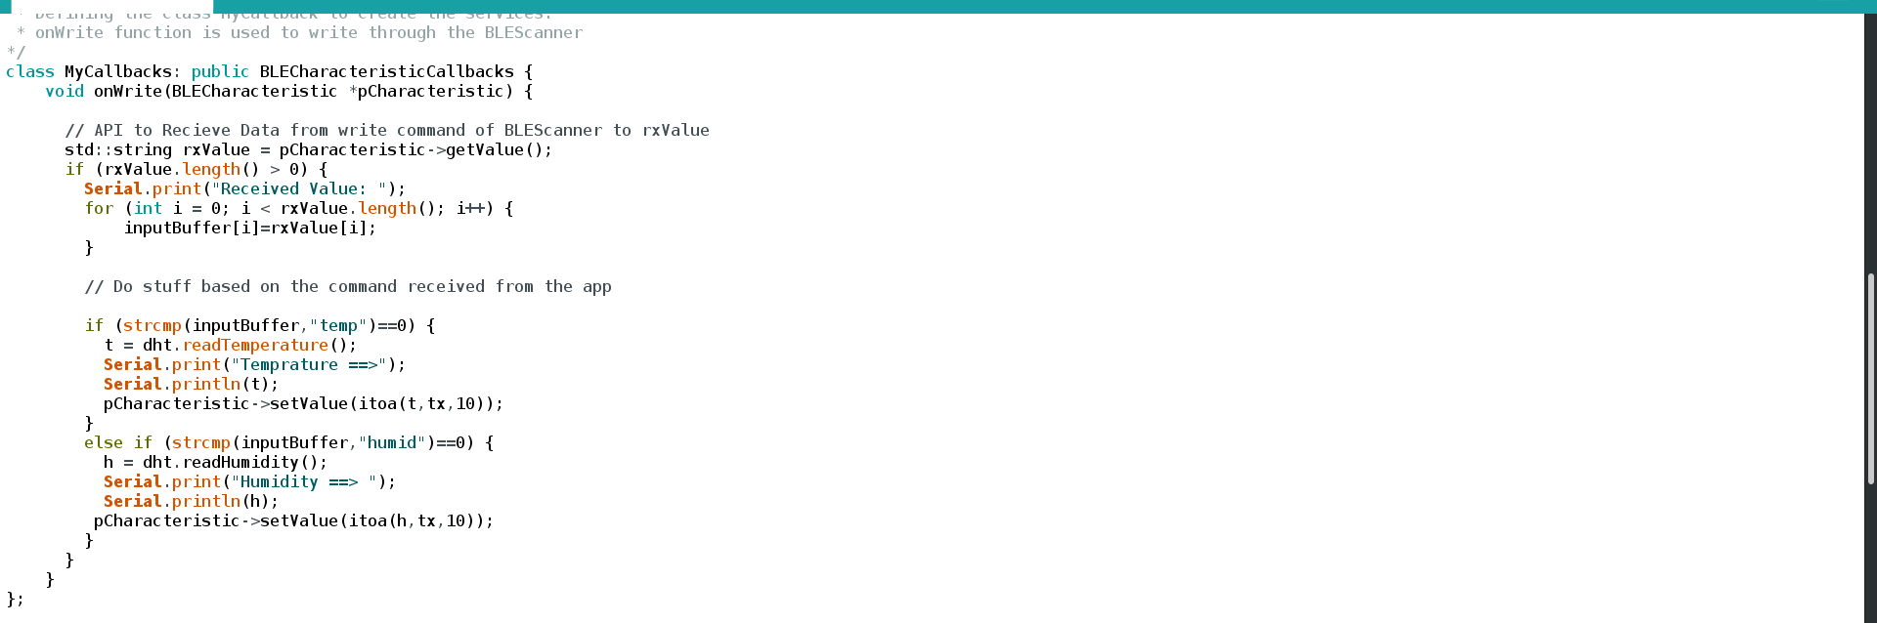
*/
// setCallbacks is an API used to create class object MyCallbacks()
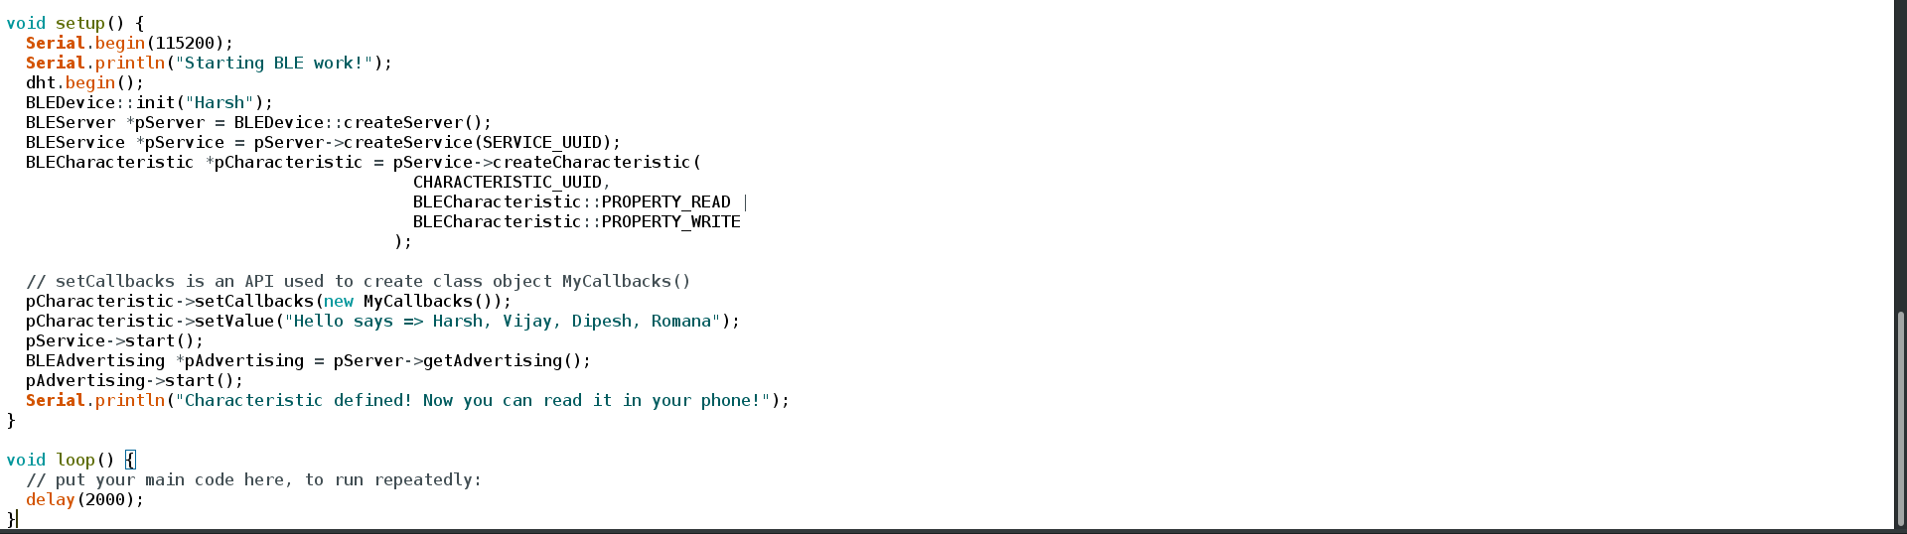

Now upload the code and open Serial Monitor.

Open BLE Scanner in phone and connect the bluetooth and follow the steps.
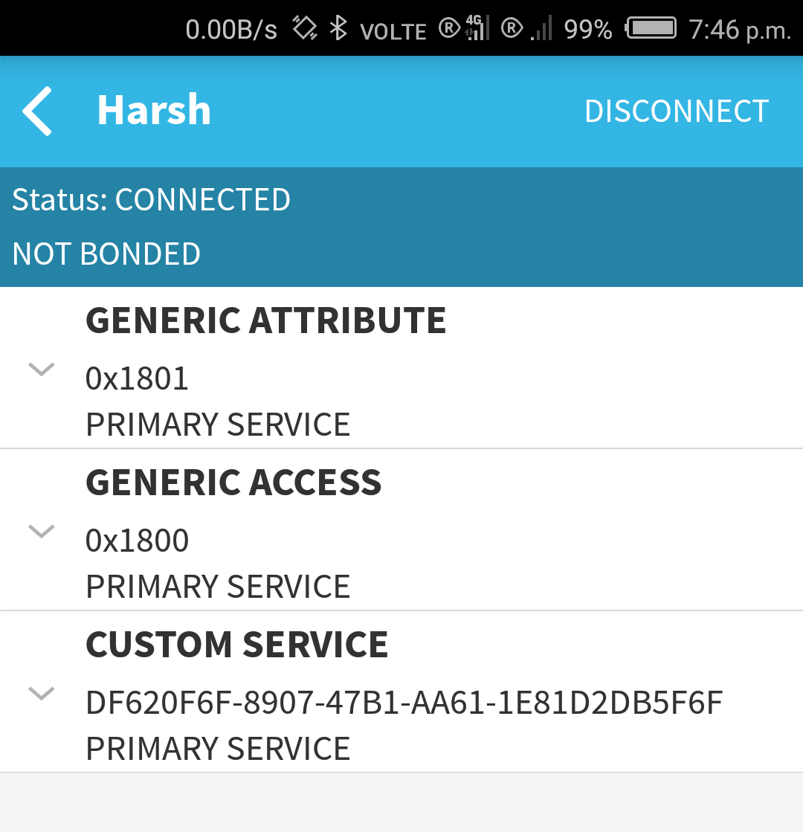
1.

2.
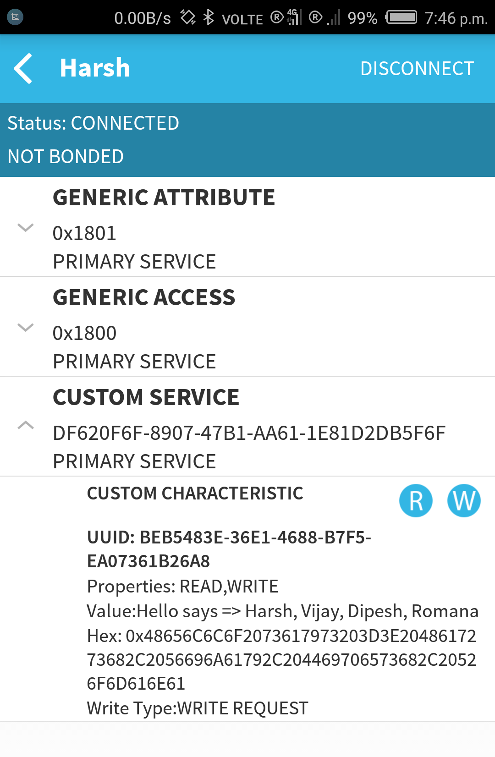
3.
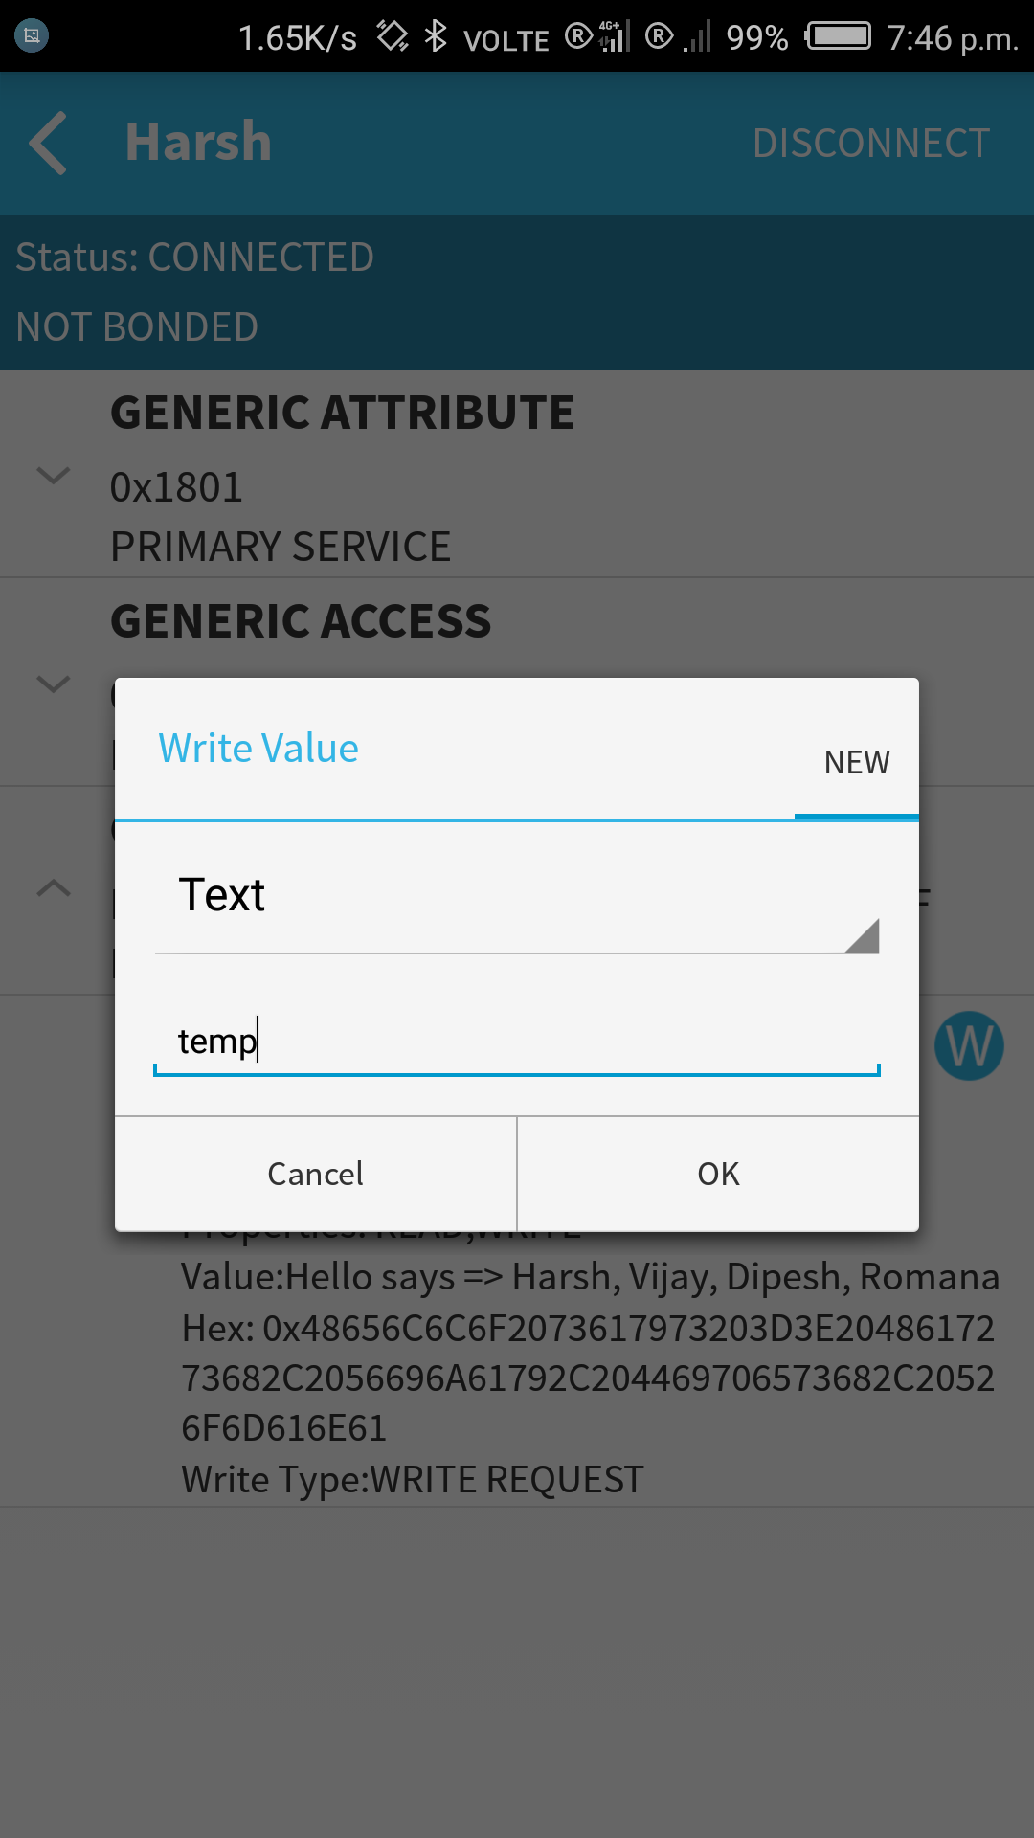

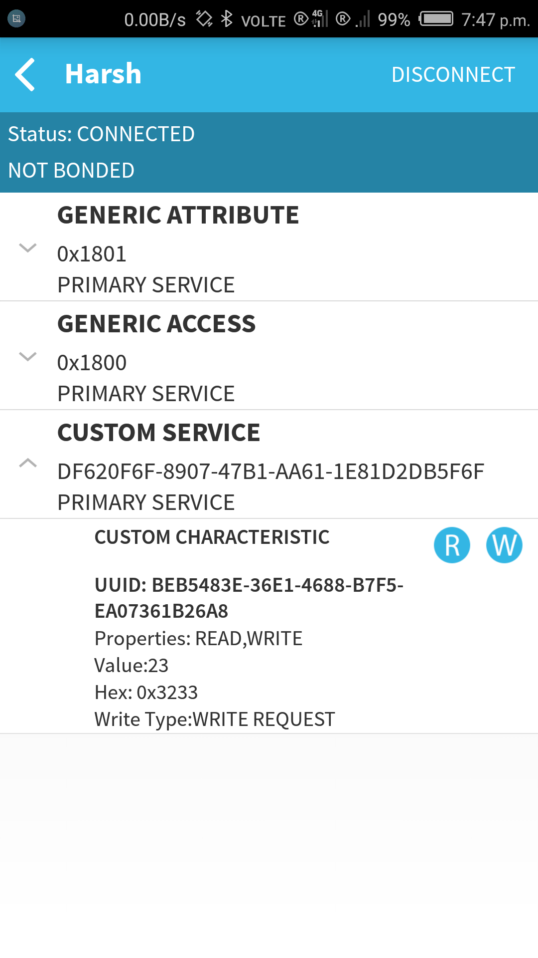

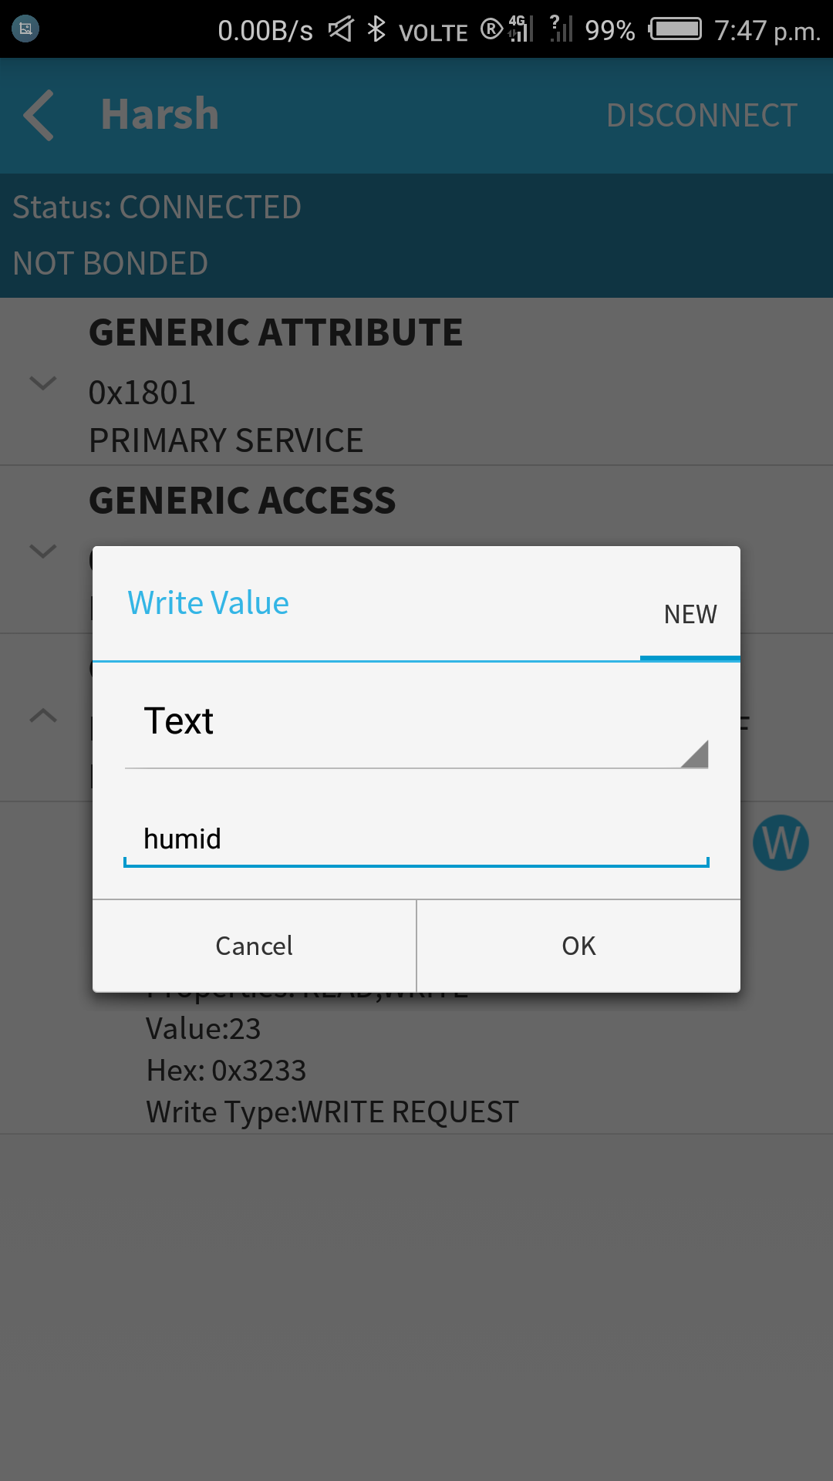
4.
5.

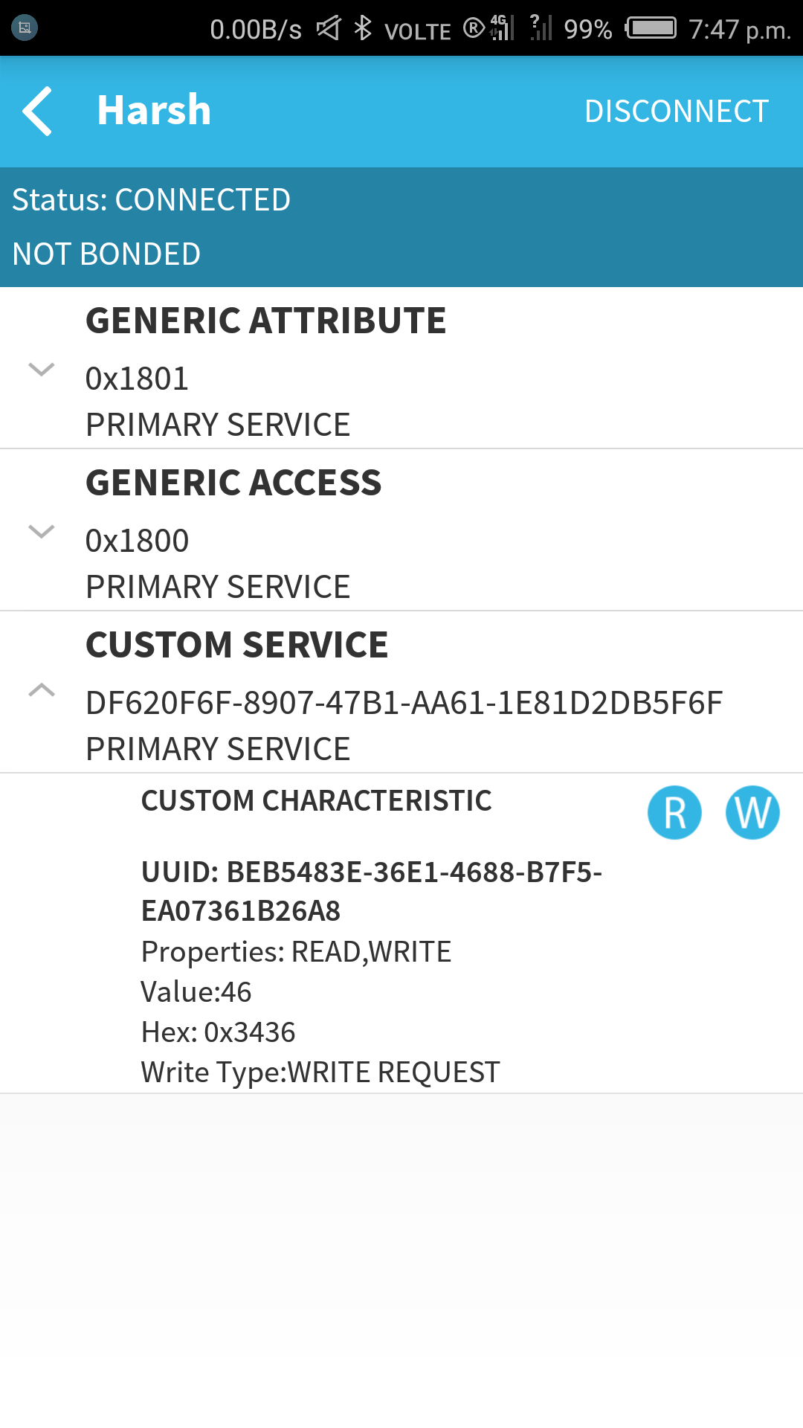
6.

