Dear Evaluator,

This is how I have approached to solve the given problem.

BillSubscription() method contains the logic of generating a bill for a particular period.

In this, the invoice start date is the subscription’s start date. The invoice end date depends on the logic that whether the subscription end date is given or not. If the subscription’s end date is given, then the invoice end date becomes the subscription’s end date. If the subscription’s end date is not given then the billing end date becomes the subscription’s end date.

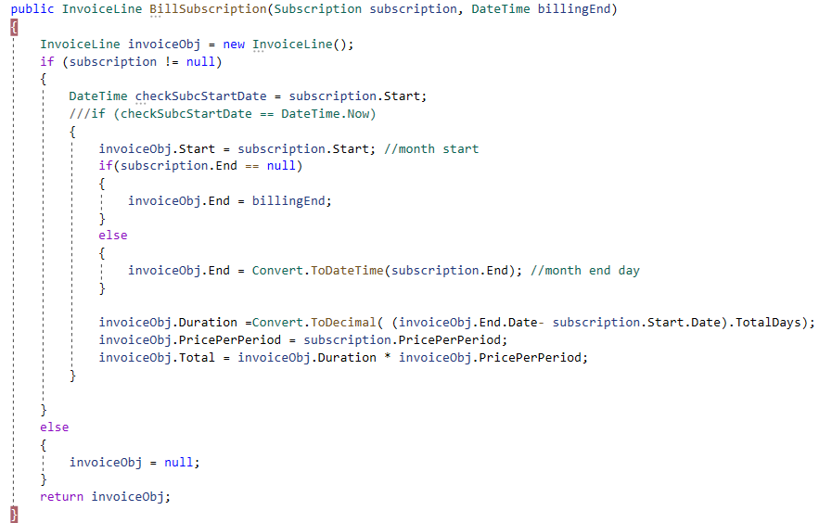

BillSubscriptionWithDiscount() method is used when there are discounts available.

The logic of overlapping days for a particular discount is checked.

Conditions are checked in the following sequence:

Condition1: check if there is any discount for the subscription and add value to the invoice list.

Condition2: The condition checks overlapping discounts and applies the highest discount value for the number of days that discount is valid. The second discount applies when the validity of overlapping higher discount ends. This means that the start date of the second discount begins when the previous higher discount expires.

Condition3: if there is no discount during the subscription period, then add value to the invoice without discount.

Here, is the output:

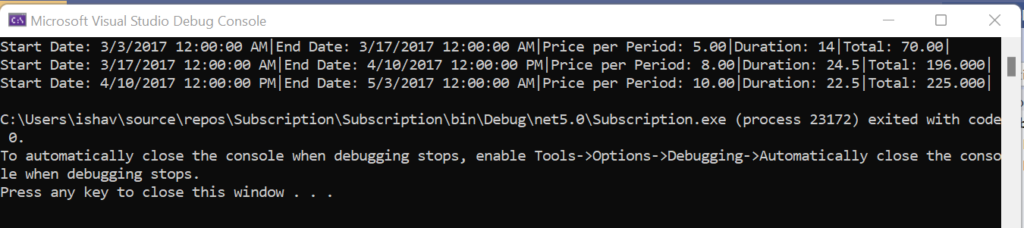

Of course, the code can be optimized further but I wanted to cover all the tasks asked in the challenge. Furthermore, optimization will need a little more time.

Let me know, should you have any question regarding the project.

Thank you for the reviewing project.

Regards

Vartika