1. SQL query to get the second highest salary from the Employee table.

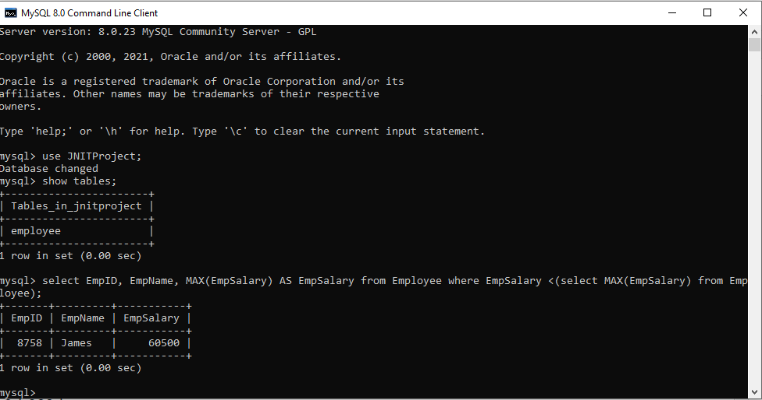

1. Suppose that a website contains two tables, the Customers table and the Orders table. Write a SQL query to find all customers who never order anything.



1. Write a SQL query for a report that provides the following information for each person in the Person table, regardless if there is an address for each of those people:

FirstName, LastName, City, State

