LAB ASSIGNMENT

Submitted for

EMBEDDED SYSTEM DESIGN (UCS704)

Submitted by:

# AAYUSH BANSAL 102103212

**4 CO8**

Submitted to:

# DR. DEEPSHIKHA TIWARI



Computer Science and Engineering Department Thapar Institute of Engineering and Technology, Patiala

# EXPERIMENT – 1 (Truth Table and Logic Gates)

**AIM: - To study and verify the truth table of various logic gates (AND, OR, NAND, NOR, XOR, XNOR, NOT).**

# AND GATE

CODE: -

module andGate; reg x;

reg y; wire z;

andComp uut (

.x(x),

.y(y),

.z(z)

);

initial begin x = 0;

y = 0;

#20 x = 1;

#20 y = 1;

#20 x = 0;

end

initial begin

$display("INPUT\tOUTPUT");

$monitor("x=%d,y=%d,z=%d \n",x,y,z);

end endmodule

module andComp( input x,

input y, output z

);

assign z = x&y; endmodule

OUTPUT: -

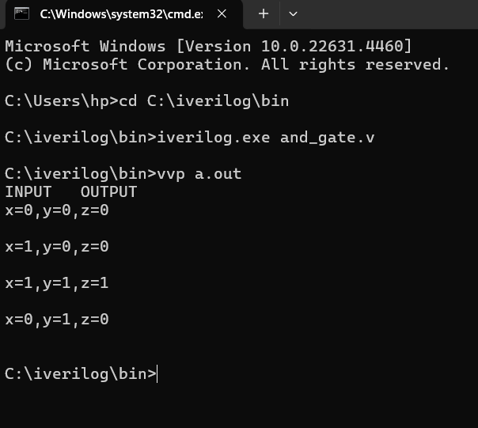

Fig 1.1 Output for AND gate

# OR GATE

CODE: -

module orGate; reg x;

reg y; wire z;

orComp uut (

.x(x),

.y(y),

.z(z)

);

initial begin x = 0;

y = 0;

#20 x = 1;

#20 y = 1;

#20 x = 0;

end

initial begin

$display("INPUT\tOUTPUT");

$monitor("x=%d,y=%d,z=%d \n",x,y,z); end

endmodule module orComp(

input x,

input y, output z

);

assign z = x|y; endmodule

OUTPUT: -

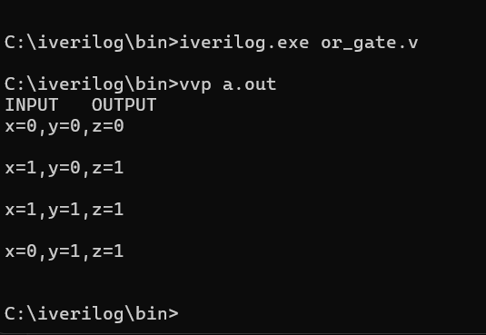

Fig 1.2 Output for OR gate

# NAND GATE

CODE: -

module nandGate; reg x;

reg y; wire z;

nandComp uut (

.x(x),

.y(y),

.z(z)

);

initial begin x = 0;

y = 0;

#20 x = 1;

#20 y = 1;

#20 x = 0;

end

initial begin

$display("INPUT\tOUTPUT");

$monitor("x=%d,y=%d,z=%d \n",x,y,z); end

endmodule

module nandComp( input x,

input y, output z

);

assign z = x~&y; endmodule

OUTPUT: -

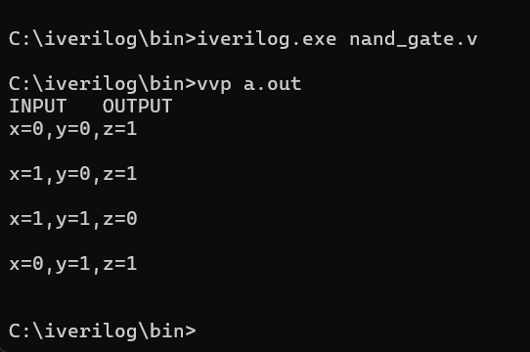

Fig 1.3 Output for NAND gate

# NOR GATE

CODE: -

module norGate; reg x;

reg y; wire z;

norComp uut (

.x(x),

.y(y),

.z(z)

);

initial begin x = 0;

y = 0;

#20 x = 1;

#20 y = 1;

#20 x = 0;

end

initial begin

$display("INPUT\tOUTPUT");

$monitor("x=%d,y=%d,z=%d \n",x,y,z); end

endmodule module norComp(

input x,

input y, output z

);

assign z = x~|y; endmodule

OUTPUT: -

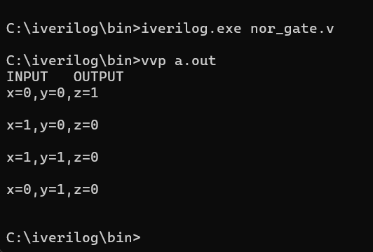

Fig 1.4 Output for NOR gate

# XOR GATE

CODE: -

module xorGate; reg x;

reg y; wire z;

xorComp uut (

.x(x),

.y(y),

.z(z)

);

initial begin x = 0;

y = 0;

#20 x = 1;

#20 y = 1;

#20 x = 0;

end

initial begin

$display("INPUT\tOUTPUT");

$monitor("x=%d,y=%d,z=%d \n",x,y,z); end

endmodule module xorComp(

input x,

input y, output z

);

assign z = x^y; endmodule

OUTPUT:-

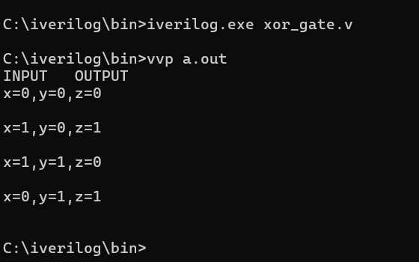

Fig 1.5 Output for XOR gate

# XNOR GATE

CODE: -

module xnorGate; reg x;

reg y; wire z;

xnorComp uut (

.x(x),

.y(y),

.z(z)

);

initial begin x = 0;

y = 0;

#20 x = 1;

#20 y = 1;

#20 x = 0;

end

initial begin

$display("INPUT\tOUTPUT");

$monitor("x=%d,y=%d,z=%d \n",x,y,z); end

endmodule module xnorComp(

input x,

input y, output z

);

assign z = x~^y; endmodule

OUTPUT:-

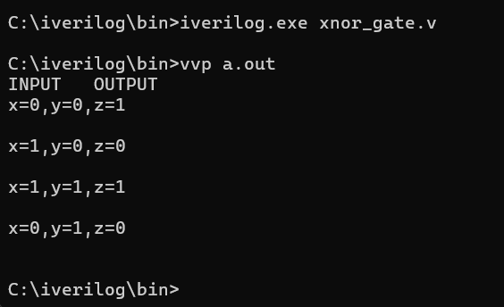

Fig 1.6 Output for XNOR gate

# NOT GATE

CODE: -

module notGate; reg x;

wire z; notComp uut (

.x(x),

.z(z)

);

initial begin x = 0;

#20 x = 1;

end

initial begin

$monitor("x=%d,z=%d \n",x,z); end

endmodule module notComp(

input x, output z

);

assign z = ~x; endmodule

OUTPUT: -

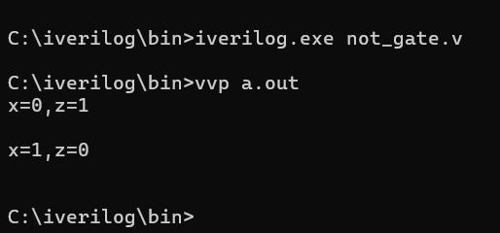

Fig 1.7 Output for NOT gate

# EXPERIMENT – 2 (HALF ADDER)

**AIM: - To design and verify a half adder using S= (x+y)(x’+y’) C= xy**

CODE: -

module halfAdder; reg x;

reg y; wire S; wire C;

halfAdderComp uut (

.x(x),

.y(y),

.S(S),

.C(C)

);

initial begin x = 0;

y = 0;

#20 y = 1;

#20 y = 0; x = 1;

#20 x = 1; y = 1;

end

initial begin

$display("INPUT\t\tOUTPUT");

$monitor("x=%d, y=%d \t S=%d, C=%d \n", x, y, S, C);

end endmodule

module halfAdderComp( input x,

input y, output S, output C

);

assign S = x ^ y; assign C = x & y;

endmodule

OUTPUT: -

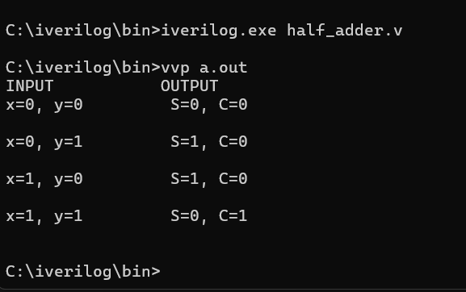

Fig 2 Output for HALF ADDER

# EXPERIMENT – 3 (FULL ADDER)

**AIM: - To design and verify a full adder using S = x’y’z+x’yz’+xy’z’+xyz C=xy+xz+yz**

CODE: -

module fullAdder; reg x;

reg y; reg Ci; wire S;

wire Cout; fullAdderComp uut (

.x(x),

.y(y),

.Ci(Ci),

.S(S),

.Cout(Cout)

);

initial begin x = 0;

y = 0; Ci=0;

#20 Ci=1;

#20 y = 1; Ci=0;

#20 Ci=1;

#20 y=0; x=1; Ci=0;

#20 Ci=1;

#20 x = 1; y=1; Ci=0;

#20 Ci=1;

end

initial begin

$display("Full Adder\n");

$display("X Y Ci\tS Cout");

$monitor("%d %d %d \t%d %d \n",x,y,Ci,S,Cout); end

endmodule

module fullAdderComp( input x,

input y, input Ci, output S, output Cout

);

assign S = x^y^Ci;

assign Cout = Ci&(x^y) | x&y;

endmodule

OUTPUT: -

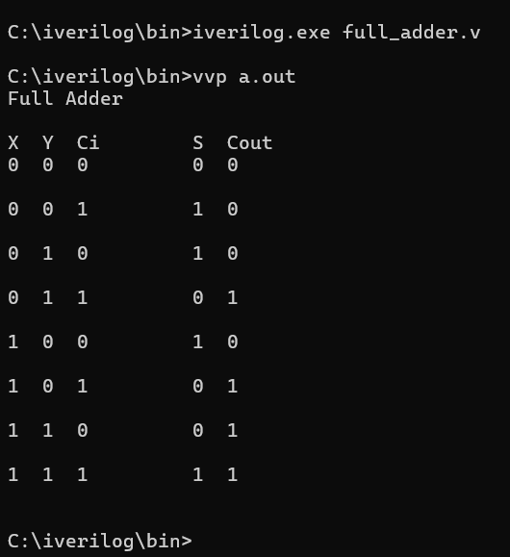

Fig 3 Output for FULL ADDER

# EXPERIMENT – 4 (Half Subtractor)

**AIM: - To design and verify a half subtractor using D = x’y +xy’ B=x’y**

CODE: -

module halfSub; reg x;

reg y; wire D; wire B;

halfSubComp uut (

.x(x),

.y(y),

.D(D),

.B(B)

);

initial begin x = 0;

y = 0;

#20 y = 1;

#20 y=0; x=1;

#20 x = 1; y=1;

end

initial begin

$display("Half Subtractor\n");

$display("X Y\tD B");

$monitor("%d %d\t%d %d \n",x,y,D,B); end

endmodule

module halfSubComp( input x,

input y, output D, output B

);

assign D = (~x&y)|(x&~y); assign B = ~x&y;

endmodule OUTPUT: -

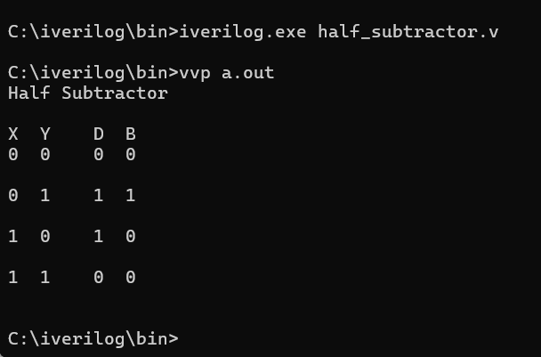

Fig 4 Output for HALF SUBTRACTOR

# EXPERIMENT – 5 (Number Converter)

**AIM: - Design a BCD to Excess 3 code converter using combinational circuits.**

CODE: -

module BCD2Ex3(A, B, C, D, W, X, Y, Z);

input A, B, C, D; output W, X, Y, Z;

assign W = A | (B&C) | (B&D);

assign X = (~B&C) | (~B & D) | (B & ~C & ~D); assign Y = ~( C ^ D);

assign Z = ~D; endmodule

module test; wire W, X,Y,Z;

reg A,B,C,D;

BCD2Ex3 object(A,B,C,D,W,X,Y,Z);

initial begin

$dumpfile("bcd.vcd");

$dumpvars(0,test);

$display (" A B C D | W X Y Z");

$monitor(" ",A, " ",B, " ",C, " ",D, " | ", W, " ",X, " ",Y, " ",Z); A = 0; B = 0; C = 0; D = 0;

#5 A = 0; B = 0; C = 0; D = 0;

#5 A = 0; B = 0; C = 0; D = 1;

#5 A = 0; B = 0; C = 1; D = 0;

#5 A = 0; B = 0; C = 1; D = 1;

#5 A = 0; B = 1; C = 0; D = 0;

#5 A = 0; B = 1; C = 0; D = 1;

#5 A = 0; B = 1; C = 1; D = 0;

#5 A = 0; B = 1; C = 1; D = 1;

#5 A = 1; B = 0; C = 0; D = 0;

#5 A = 1; B = 0; C = 0; D = 1;

end endmodule

OUTPUT: -

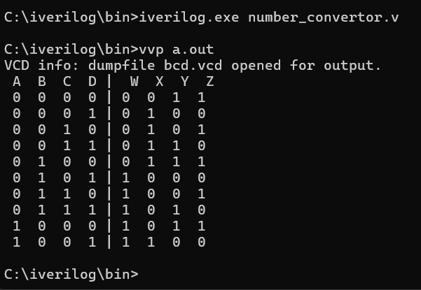

Fig 5 Output for NUMBER CONVERTOR

# EXPERIMENT – 6 (Multiplexer)

**AIM: - To design and implement a 4:1 multiplexer**

CODE: -

module mux(s1,s2,a,b,c,d,y); input s1,s2,a,b,c,d; output y;

assign y = ~s1&~s2&a | ~s1&s2&b | s1&~s2&c | s1&s2&d ; endmodule

module test;

reg a, b, c, d, s1, s2; wire y;

mux obj(s1,s2,a,b,c,d,y); initial begin

//$dumpfile("mux.vcd");

//$dumpvars( 0, test);

$display("S1\t S2\t A \t B \t C \t D | Y");

$monitor("%b \t %b \t %b \t %b \t %b \t %b | %b",s1,s2,a,b,c,d,y);

a=0; b=0; c=0; d=0; s1=0; s2=0;

#5 a=0; b=0; c=0; d=0; s1=0; s2=0; #5 a=0; b=0; c=0; d=1; s1=0; s2=1; #5 a=0; b=0; c=1; d=0; s1=1; s2=0; #5 a=0; b=0; c=1; d=1; s1=1; s2=1;

#5 a=0; b=1; c=0; d=0; s1=0; s2=0; #5 a=0; b=1; c=0; d=1; s1=0; s2=1; #5 a=0; b=1; c=1; d=0; s1=1; s2=0; #5 a=0; b=1; c=1; d=1; s1=1; s2=0; #5 a=1; b=0; c=0; d=0; s1=0; s2=1; #5 a=1; b=0; c=0; d=1; s1=0; s2=0;

#5 $finish;

end endmodule

OUTPUT: -

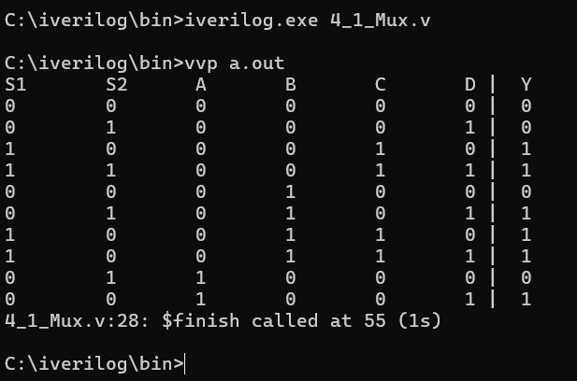

Fig 6 Output for 4:1 Multiplexer

# EXPERIMENT – 7 (Demultiplexer)

**AIM: - To design and implement a 1:4 demultiplexer.**

CODE: -

module demux(s1,s0,a,b,c,d,e,i); input s1,s0,e,i;

output a,b,c,d;

assign a =i&e&~s1&~s0; assign b =i&e&~s1&s0; assign c =i&e&s1&~s0; assign d =i&e&s1&s0;

endmodule module test;

reg s1, s0, e, i;

wire a, b, c, d;

demux obj(s1,s0,a,b,c,d,e,i); initial

begin

$display("e\ts1\ts0\td\tc\tb\ta");

$monitor("%b\t%b\t%b\t%b\t%b\t%b\t%b" ,e,s1,s0,d,c,b,a); i=1; e=0; s1=0; s0=0;

#10 i=1; e=1; s1=0; s0=0; #10 i=1; e=1; s1=0; s0=1; #10 i=1; e=1; s1=1; s0=0; #10 i=1; e=1; s1=1; s0=1;

end endmodule

OUTPUT: -

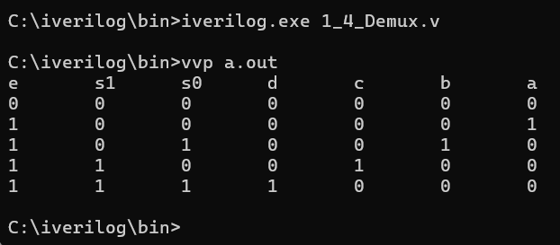

Fig 7 Output for 1:4 Demultiplexer

# EXPERIMENT – 8 (Decoder)

**AIM: - To design and verify a 2:4 decoder.**

CODE: -

module decoder(a,b,c,d,e,f,E); input a,b,E;

output c,d,e,f; assign c = E&a&b;

assign d = E&a&(~b); assign e = E&(~a)&b; assign f = E&(~a)&(~b);

endmodule module testbench;

reg a, b, E;

wire c,d,e,f;

decoder obj(a,b,c,d,e,f,E); initial begin

$display("Inputs | Outputs");

$display("E a b | c d e f");

$monitor("%b %b %b | %b %b %b %b",E,a,b,c,d,e,f); E=0 ; a=0; b=0;

#5 E=1; a=0; b=0; #5 E=1; a=0; b=1; #5 E=1; a=1; b=0; #5 E=1; a=1; b=1;

#5 $finish;

end endmodule

OUTPUT: -

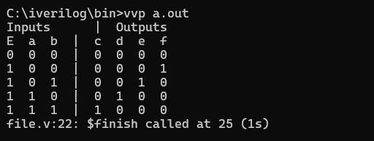

Fig 8 Output for 2:4 decoder.

# EXPERIMENT – 9 (Encoder)

**AIM: - To design and implement a 4:2 encoder.**

CODE: -

module Encoder42; reg i1;

reg i2;

reg i3; reg i4; wire o1; wire o2;

Encoder42Comp enc (

.i1(i1),

.i2(i2),

.i3(i3),

.i4(i4),

.o1(o1),

.o2(o2)

);

initial begin i1 = 0;

i2 = 0;

i3 = 0;

i4 = 0;

#20 i1 = 1;

#20 i1 = 0; i2 = 1;

#20 i2 = 0; i3 = 1;

#20 i3 = 0; i4 = 1;

end

initial begin

$display("4*2 Encoder\n");

$display("I4 I3 I2 I1\t\tO2 O1");

$monitor("%d %d %d %d\t\t%d %d", i4, i3, i2, i1, o2, o1); end

endmodule

module Encoder42Comp( input i1,

input i2, input i3, input i4, output o1, output o2

);

assign o1 = i3 | i4; assign o2 = i2 | i4;

endmodule

OUTPUT: -

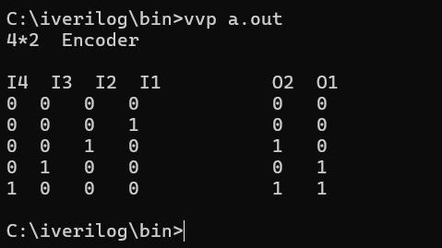

Fig 9 Output for 4:2 encoder.

# EXPERIMENT – 10 (Flip-Flops)

**AIM: - To design and verify the operation of D flip-flops using logic gates.**

module dff(d,clk,q,qn); input d,clk;

output q,qn; reg q,qn;

dffComp ff(q,qn,clk,d);

initial begin q=0; qn=1; end always @(posedge clk) begin

end endmodule

q = d; qn = !d;

module dffComp(q,qn,clk,d); input q,qn;

output clk,d; reg clk,d; initial begin

clk=0;

d=0; #9 d=1; #1 d=0; #1 d=1; #2 d=0; #1 d=1; #12 d=0;

#1 d=1; #2 d=0; #1 d=1; #1 d=0; #1 d=1; #1 d=0; # 7 d=1;

#8 $finish;

end

always begin

#4 clk=!clk;

end initial begin

$monitor("q=%d\tqn=%d\tclk=%d\td=%d\t",q,qn,clk,d); end

endmodule

OUTPUT: -

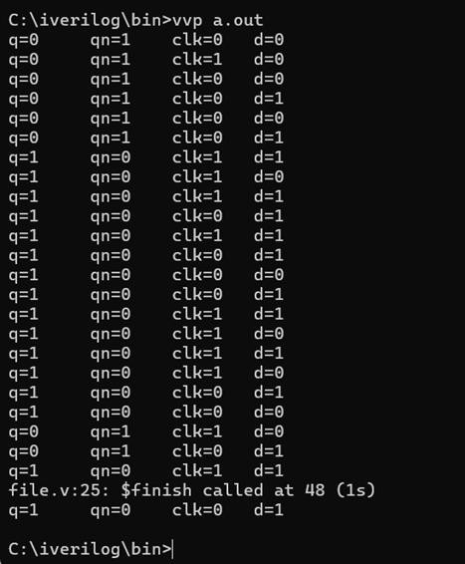

Fig 10 Output for D flip-flops

# EXPERIMENT – 11 (Flip-Flops)

**AIM: - To design and verify the operation of JK flip-flops using logic gates.**

module jkff(J, K, clk, q, qn); input J, K, clk;

output q, qn; reg q, qn; initial begin

q = 0;

qn = 1; end

always @(posedge clk) begin case ({J, K})

2'b00: q = q;

2'b01: q = 0;

2'b10: q = 1;

2'b11: q = ~q; endcase

qn = ~q; end

endmodule

module jkff_tb; reg J, K, clk; wire q, qn;

jkff uut (.J(J), .K(K), .clk(clk), .q(q), .qn(qn)); initial begin

clk = 0;

J = 0; K = 0; #10;

J = 0; K = 1; #10;

J = 1; K = 0; #10;

J = 1; K = 1; #10;

J = 1; K = 1; #10;

J = 0; K = 0; #10;

J = 1; K = 1; #10;

$finish; end

always #5 clk = ~clk; initial begin

$monitor("Time=%0d J=%b K=%b clk=%b q=%b qn=%b", $time, J, K, clk, q, qn);

end endmodule

OUTPUT: -

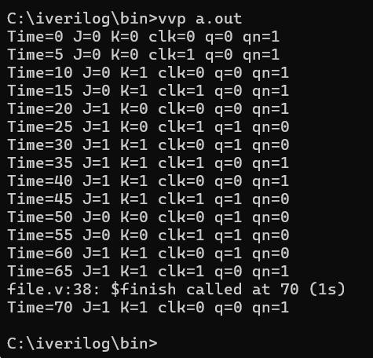

Fig 11 Output for JK flip-flops

# EXPERIMENT – 12 (Counter)

**AIM: - To verify the operation of asynchronous counter.**

CODE: -

module cntr4bit();

reg clock, reset, enable; wire [3:0] counter_out;

initial begin

$display ("time\t clk reset enable counter");

$monitor ("%g\t %b %b %b %b",

$time, clock, reset, enable, counter_out); clock = 1;

reset = 0;

enable = 0;

#5 reset = 1;

#10 reset = 0;

#10 enable = 1;

#100 enable = 0;

#30 enable=1;

#50 $finish; end

always begin

#5 clock = ~clock; end

cntr4bits cntr ( clock,

reset, enable, counter_out

);

endmodule

module cntr4bits (clock,reset,enable,counter_out); input clock ;

input reset ; input enable ;

output [3:0] counter_out ; wire clock ;

wire reset ; wire enable ;

reg [3:0] counter_out ; always @ (posedge clock) begin :Counter

if (reset == 1) begin counter_out = #1 4'b0000; end

else if (enable == 1) begin counter_out = #1 counter_out + 1; end

end endmodule

OUTPUT: -

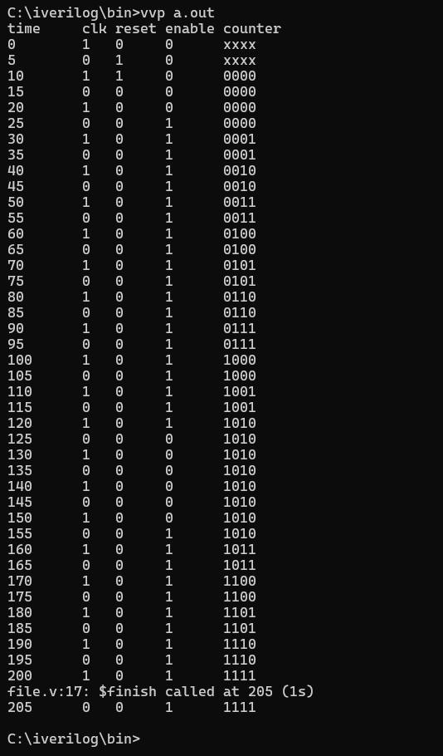

Fig 12 Output for asynchronous counter