23BCE1148
ISHAYU ROY
WEEK 3: USE CASE AND CLASS DIAGRAMS

a. USE CASE DIAGRAMS
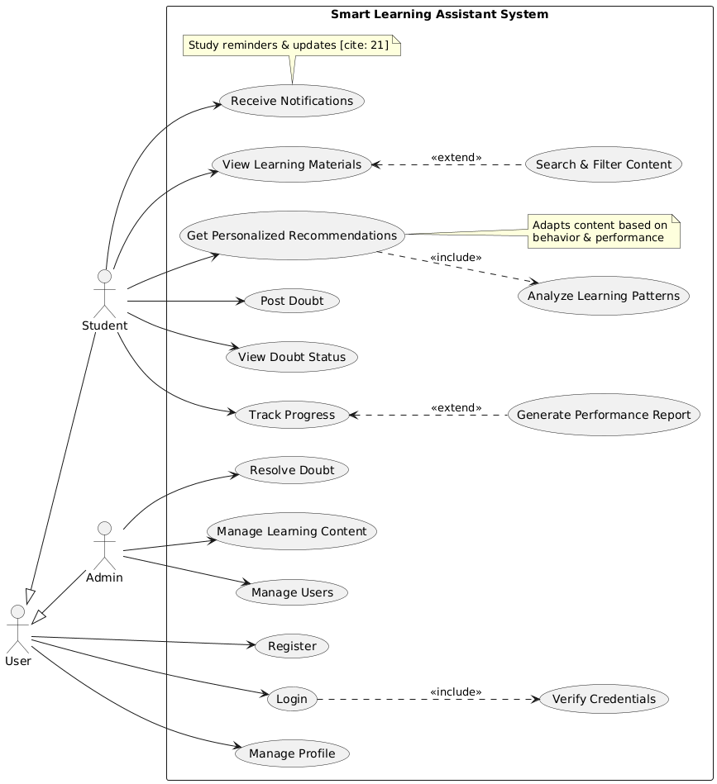

b. CLASS DIAGRAM

