**Step 1: Download and Install Windows 11**

1. **Go to the Windows 11 download page**: [Windows 11 Download](https://www.microsoft.com/software-download/windows11).
2. **Click on "Download Now"**.
3. **Follow the on-screen instructions** to create installation media (USB flash drive or DVD) or install directly if you’re upgrading.

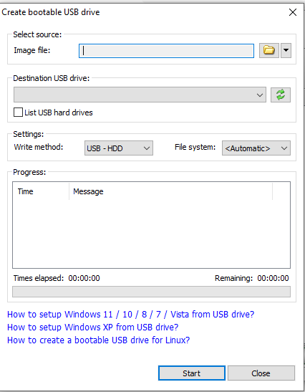

1. **Restart your computer** and boot from the installation media.
2. **Follow the installation prompts** to install Windows 11.

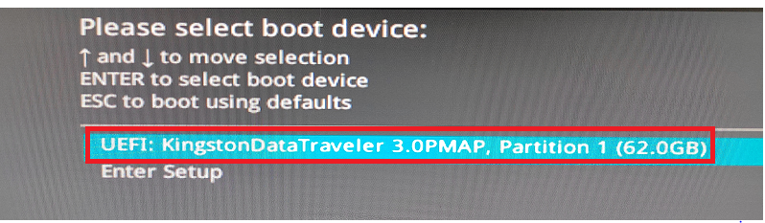

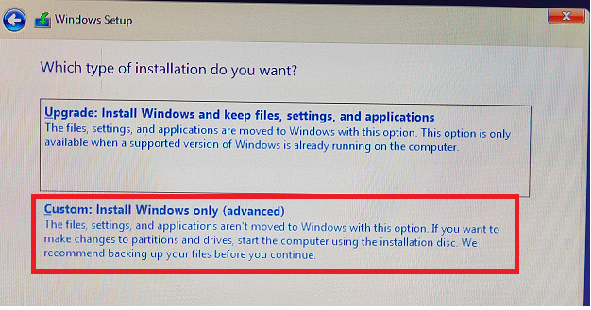

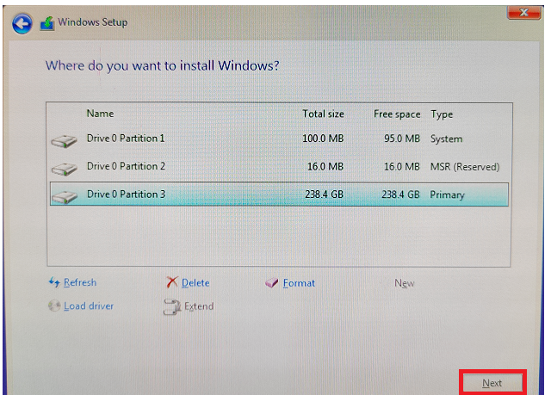

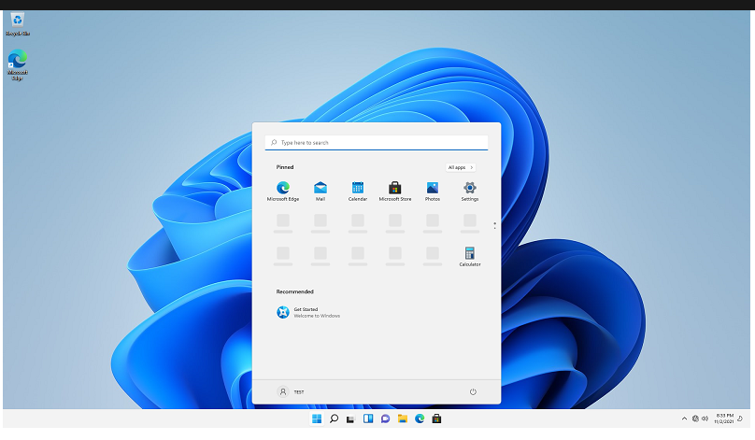

### Step 2: Install Visual Studio Code

1. **Go to the Visual Studio Code download page**: [Visual Studio Code Download](https://code.visualstudio.com/Download).
2. **Select the Windows download**.
3. **Run the downloaded installer** and follow the installation steps.
4. 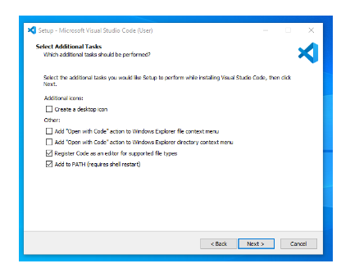

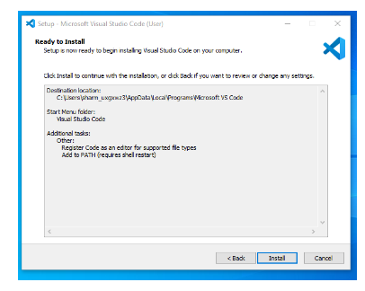

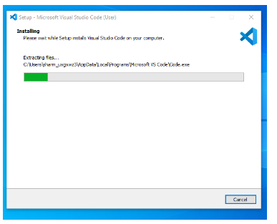

1. **Open Visual Studio Code** after installation completes
2. .

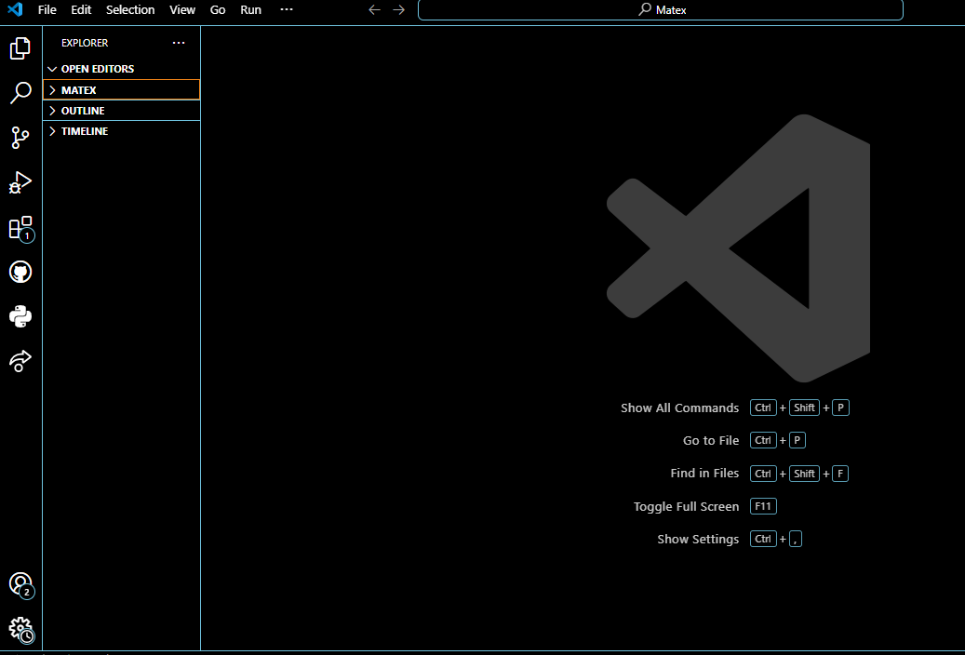

### task 3: Set Up Version Control System with Git and GitHub

1. **Download Git** from [Git for Windows](https://git-scm.com/download/win).
2. **Run the installer** and follow the setup instructions.
3. **Open Git Bash** (installed with Git) and configure Git with your name and email: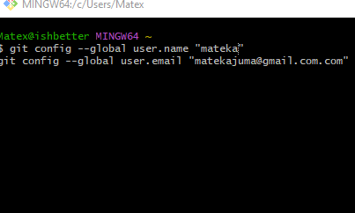
4. **Create a GitHub account** if you don't have one: [GitHub Sign Up](https://github.com).
5. **Create a new repository** on GitHub.

**By using mkdir my repository**

1. **Clone the repository** to your local machine:
2. 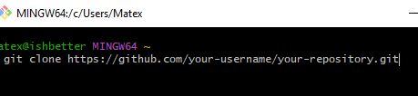

• **Navigate to your repository directory**:

**By using cd my repository**

• **Create a new file**, for example, README.md, and make your first comm

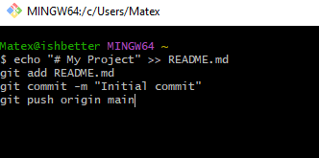

### task 4: Install Python

1. **Download Python** from [Python.org](https://www.python.org/downloads/).
2. **Run the installer** and make sure to check "Add Python to PATH".
3. **Verify the installation** by opening Command Prompt and typing:

.python –version

.pip --version

### Step 5: Install Package Managers

* **pip** is installed with Python. Verify by typing:

pip --version

Step 6: Configure MySQL Database

1. Download MySQL Installer

- Visit the [MySQL Downloads page](https://dev.mysql.com/downloads/windows/installer/5.7.html).

- Choose the appropriate installer (either the web or full version) and download it.

2. Run the Installer

- Open the downloaded MySQL Installer.

- Follow the setup wizard instructions.

3. Choose "Developer Default" Setup

- During the installation, select the "Developer Default" option. This setup installs MySQL Server, MySQL Workbench, and other necessary tools.

4. Configure MySQL Server

- The setup wizard will prompt you to configure the MySQL Server.

- Set the root password (make sure to remember it as you'll need it to access the database).

- You may be asked to configure other settings such as MySQL port (default is 3306) and user authentication methods.

5. Complete the Installation

- Continue following the prompts to complete the installation.

- Once the installation is finished, you can start MySQL Workbench to manage your databases.

By following these steps, you'll have MySQL Server installed and configured on your machine, ready to use for your development projects.