WEEK 2 PL/SQL

ABHISHEK GUHA

# TABLE CREATION

## SCHEMA DEFINATION

*CREATE TABLE Customers (*

*CustomerID NUMBER PRIMARY KEY,*

*Name VARCHAR2(100),*

*DOB DATE,*

*Balance NUMBER,*

*LastModified DATE*

*);*

*CREATE TABLE Accounts (*

*AccountID NUMBER PRIMARY KEY,*

*CustomerID NUMBER,*

*AccountType VARCHAR2(20),*

*Balance NUMBER,*

*LastModified DATE,*

*FOREIGN KEY (CustomerID) REFERENCES Customers(CustomerID)*

*);*

*CREATE TABLE Transactions (*

*TransactionID NUMBER PRIMARY KEY,*

*AccountID NUMBER,*

*TransactionDate DATE,*

*Amount NUMBER,*

*TransactionType VARCHAR2(10),*

*FOREIGN KEY (AccountID) REFERENCES Accounts(AccountID)*

*);*

*CREATE TABLE Loans (*

*LoanID NUMBER PRIMARY KEY,*

*CustomerID NUMBER,*

*LoanAmount NUMBER,*

*InterestRate NUMBER,*

*StartDate DATE,*

*EndDate DATE,*

*FOREIGN KEY (CustomerID) REFERENCES Customers(CustomerID)*

*);*

*CREATE TABLE Employees (*

*EmployeeID NUMBER PRIMARY KEY,*

*Name VARCHAR2(100),*

*Position VARCHAR2(50),*

*Salary NUMBER,*

*Department VARCHAR2(50),*

*HireDate DATE*

*);*

## DATA INSERTION

*INSERT INTO Customers (CustomerID, Name, DOB, Balance, LastModified)*

*VALUES (1, 'John Doe', TO_DATE('1985-05-15', 'YYYY-MM-DD'), 1000, SYSDATE);*

*INSERT INTO Customers (CustomerID, Name, DOB, Balance, LastModified)*

*VALUES (2, 'Jane Smith', TO_DATE('1990-07-20', 'YYYY-MM-DD'), 1500, SYSDATE);*

*INSERT INTO Accounts (AccountID, CustomerID, AccountType, Balance, LastModified)*

*VALUES (1, 1, 'Savings', 1000, SYSDATE);*

*INSERT INTO Accounts (AccountID, CustomerID, AccountType, Balance, LastModified)*

*VALUES (2, 2, 'Checking', 1500, SYSDATE);*

*INSERT INTO Transactions (TransactionID, AccountID, TransactionDate, Amount, TransactionType)*

*VALUES (1, 1, SYSDATE, 200, 'Deposit');*

*INSERT INTO Transactions (TransactionID, AccountID, TransactionDate, Amount, TransactionType)*

*VALUES (2, 2, SYSDATE, 300, 'Withdrawal');*

*INSERT INTO Loans (LoanID, CustomerID, LoanAmount, InterestRate, StartDate, EndDate)*

*VALUES (1, 1, 5000, 5, SYSDATE, ADD_MONTHS(SYSDATE, 60));*

*INSERT INTO Employees (EmployeeID, Name, Position, Salary, Department, HireDate)*

*VALUES (1, 'Alice Johnson', 'Manager', 70000, 'HR', TO_DATE('2015-06-15', 'YYYY-MM-DD'));*

*INSERT INTO Employees (EmployeeID, Name, Position, Salary, Department, HireDate)*

*VALUES (2, 'Bob Brown', 'Developer', 60000, 'IT', TO_DATE('2017-03-20', 'YYYY-MM-DD'));*

### INSERT MORE STATEMENTS

*-- More Customers*

*INSERT INTO Customers (CustomerID, Name, DOB, Balance, LastModified)*

*VALUES (3, 'Emily White', TO_DATE('1955-12-10', 'YYYY-MM-DD'), 15000, SYSDATE);*

*INSERT INTO Customers (CustomerID, Name, DOB, Balance, LastModified)*

*VALUES (4, 'Michael Brown', TO_DATE('1978-08-22', 'YYYY-MM-DD'), 500, SYSDATE);*

*INSERT INTO Customers (CustomerID, Name, DOB, Balance, LastModified)*

*VALUES (5, 'Sarah Johnson', TO_DATE('1992-03-15', 'YYYY-MM-DD'), 12000, SYSDATE);*

*-- More Accounts*

*INSERT INTO Accounts (AccountID, CustomerID, AccountType, Balance, LastModified)*

*VALUES (3, 3, 'Savings', 15000, SYSDATE);*

*INSERT INTO Accounts (AccountID, CustomerID, AccountType, Balance, LastModified)*

*VALUES (4, 4, 'Checking', 500, SYSDATE);*

*INSERT INTO Accounts (AccountID, CustomerID, AccountType, Balance, LastModified)*

*VALUES (5, 5, 'Savings', 12000, SYSDATE);*

*-- More Transactions*

*INSERT INTO Transactions (TransactionID, AccountID, TransactionDate, Amount, TransactionType)*

*VALUES (3, 3, SYSDATE - 5, 5000, 'Deposit');*

*INSERT INTO Transactions (TransactionID, AccountID, TransactionDate, Amount, TransactionType)*

*VALUES (4, 4, SYSDATE - 2, 100, 'Withdrawal');*

*INSERT INTO Transactions (TransactionID, AccountID, TransactionDate, Amount, TransactionType)*

*VALUES (5, 5, SYSDATE - 1, 2000, 'Deposit');*

*-- More Loans*

*INSERT INTO Loans (LoanID, CustomerID, LoanAmount, InterestRate, StartDate, EndDate)*

*VALUES (2, 2, 10000, 6.5, SYSDATE - 365, ADD_MONTHS(SYSDATE, 24));*

*INSERT INTO Loans (LoanID, CustomerID, LoanAmount, InterestRate, StartDate, EndDate)*

*VALUES (3, 3, 20000, 4.5, SYSDATE - 730, ADD_MONTHS(SYSDATE, 1));*

*INSERT INTO Loans (LoanID, CustomerID, LoanAmount, InterestRate, StartDate, EndDate)*

*VALUES (4, 4, 7500, 7, SYSDATE - 90, ADD_MONTHS(SYSDATE, 36));*

*-- More Employees*

*INSERT INTO Employees (EmployeeID, Name, Position, Salary, Department, HireDate)*

*VALUES (3, 'Carol Davis', 'Teller', 45000, 'Operations', TO_DATE('2019-09-01', 'YYYY-MM-DD'));*

*INSERT INTO Employees (EmployeeID, Name, Position, Salary, Department, HireDate)*

*VALUES (4, 'David Wilson', 'Loan Officer', 55000, 'Loans', TO_DATE('2016-11-15', 'YYYY-MM-DD'));*

*INSERT INTO Employees (EmployeeID, Name, Position, Salary, Department, HireDate)*

*VALUES (5, 'Eva Martinez', 'IT Specialist', 65000, 'IT', TO_DATE('2018-07-01', 'YYYY-MM-DD'));*

## TABLE APPEARANCES (AS GIVEN)

CUSTOMERS TABLE

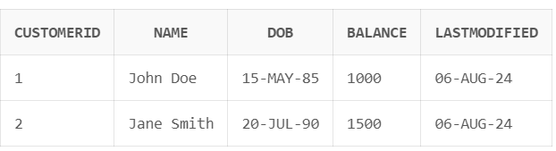

ACCOUNTS TABLE

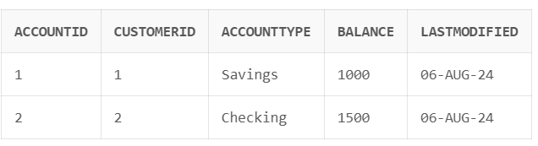

TRANSACTIONS TABLE

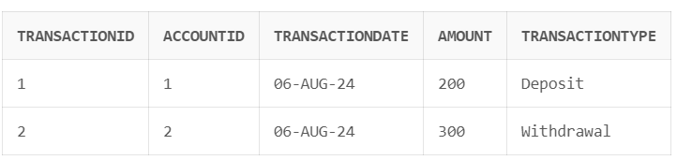

LOANS TABLE

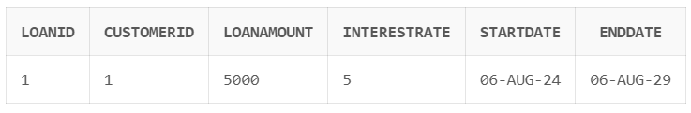

EMPLOYEE TABLE

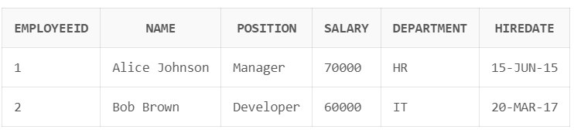

# CONTROL STRUCTURES

**Scenario 1:** The bank wants to apply a discount to loan interest rates for customers above 60 years old.

* + **Question:** Write a PL/SQL block that loops through all customers, checks their age, and if they are above 60, apply a 1% discount to their current loan interest rates.

DECLARE

v_age NUMBER;

v_discount NUMBER := 0.01; -- 1% discount

BEGIN

FOR customer IN (SELECT CustomerID, DOB FROM Customers) LOOP

v_age := TRUNC(MONTHS_BETWEEN(SYSDATE, customer.DOB) / 12);

IF v_age > 60 THEN

UPDATE Loans

SET InterestRate = InterestRate - v_discount

WHERE CustomerID = customer.CustomerID;

END IF;

END LOOP;

COMMIT;

DBMS_OUTPUT.PUT_LINE('Interest rate discounts applied for customers over 60.');

END;

/



**Scenario 2:** A customer can be promoted to VIP status based on their balance.

* + **Question:** Write a PL/SQL block that iterates through all customers and sets a flag IsVIP to TRUE for those with a balance over $10,000.

ALTER TABLE Customers ADD IsVIP VARCHAR2(5);

DECLARE

v_vip_threshold NUMBER := 10000;

BEGIN

UPDATE Customers

SET IsVIP = CASE

WHEN Balance > v_vip_threshold THEN 'TRUE'

ELSE 'FALSE'

END;

COMMIT;

DBMS_OUTPUT.PUT_LINE('VIP status updated for all customers.');

END;

/

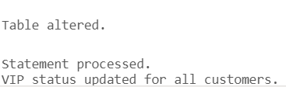

**Scenario 3:** The bank wants to send reminders to customers whose loans are due within the next 30 days.

* + **Question:** Write a PL/SQL block that fetches all loans due in the next 30 days and prints a reminder message for each customer.

DECLARE

v_reminder_days NUMBER := 30;

BEGIN

FOR loan IN (

SELECT c.Name, l.LoanID, l.EndDate

FROM Loans l

JOIN Customers c ON l.CustomerID = c.CustomerID

WHERE l.EndDate BETWEEN SYSDATE AND SYSDATE + v_reminder_days

) LOOP

DBMS_OUTPUT.PUT_LINE('Reminder: Dear ' || loan.Name ||

', your loan (ID: ' || loan.LoanID ||

') is due on ' || TO_CHAR(loan.EndDate, 'DD-MON-YYYY') ||

'. Please arrange for repayment.');

END LOOP;

END;

/



# Exercise 2: Error Handling

**Scenario 1:** Handle exceptions during fund transfers between accounts.

* + **Question:** Write a stored procedure **SafeTransferFunds** that transfers funds between two accounts. Ensure that if any error occurs (e.g., insufficient funds), an appropriate error message is logged and the transaction is rolled back.

CREATE OR REPLACE PROCEDURE SafeTransferFunds(

p_from_account NUMBER,

p_to_account NUMBER,

p_amount NUMBER

)

AS

v_from_balance NUMBER;

insufficient_funds EXCEPTION;

PRAGMA EXCEPTION_INIT(insufficient_funds, -20001);

BEGIN

-- Start transaction

SAVEPOINT start_transfer;

-- Check if source account has sufficient funds

SELECT Balance INTO v_from_balance

FROM Accounts

WHERE AccountID = p_from_account

FOR UPDATE;

IF v_from_balance < p_amount THEN

RAISE insufficient_funds;

END IF;

-- Update balances

UPDATE Accounts

SET Balance = Balance - p_amount

WHERE AccountID = p_from_account;

UPDATE Accounts

SET Balance = Balance + p_amount

WHERE AccountID = p_to_account;

-- Commit transaction

COMMIT;

DBMS_OUTPUT.PUT_LINE('Transfer completed successfully.');

EXCEPTION

WHEN insufficient_funds THEN

ROLLBACK TO start_transfer;

DBMS_OUTPUT.PUT_LINE('Error: Insufficient funds in source account.');

WHEN NO_DATA_FOUND THEN

ROLLBACK TO start_transfer;

DBMS_OUTPUT.PUT_LINE('Error: One or both account IDs are invalid.');

WHEN OTHERS THEN

ROLLBACK TO start_transfer;

DBMS_OUTPUT.PUT_LINE('Error: ' || SQLERRM);

END SafeTransferFunds;

/

-- Successful transfer

BEGIN

SafeTransferFunds(1, 2, 500);

END;

/

-- Insufficient funds

BEGIN

SafeTransferFunds(1, 2, 100000);

END;

/

-- Invalid account

BEGIN

SafeTransferFunds(1, 999, 500);

END;

/

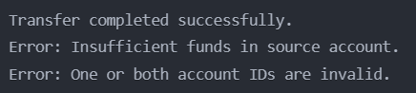

**Scenario 2:** Manage errors when updating employee salaries.

* + **Question:** Write a stored procedure **UpdateSalary** that increases the salary of an employee by a given percentage. If the employee ID does not exist, handle the exception and log an error message.

CREATE OR REPLACE PROCEDURE UpdateSalary(

p_employee_id NUMBER,

p_increase_percentage NUMBER

)

AS

v_current_salary NUMBER;

employee_not_found EXCEPTION;

PRAGMA EXCEPTION_INIT(employee_not_found, -20002);

BEGIN

-- Check if employee exists

SELECT Salary INTO v_current_salary

FROM Employees

WHERE EmployeeID = p_employee_id

FOR UPDATE;

-- Update salary

UPDATE Employees

SET Salary = Salary * (1 + p_increase_percentage / 100)

WHERE EmployeeID = p_employee_id;

COMMIT;

DBMS_OUTPUT.PUT_LINE('Salary updated successfully.');

EXCEPTION

WHEN NO_DATA_FOUND THEN

RAISE employee_not_found;

WHEN employee_not_found THEN

DBMS_OUTPUT.PUT_LINE('Error: Employee ID ' || p_employee_id || ' not found.');

WHEN OTHERS THEN

ROLLBACK;

DBMS_OUTPUT.PUT_LINE('Error: ' || SQLERRM);

END UpdateSalary;

/

-- Successful salary update

BEGIN

UpdateSalary(1, 10);

END;

/

-- Employee not found

BEGIN

UpdateSalary(999, 10);

END;

/

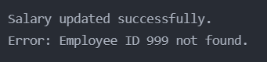

**Scenario 3:** Ensure data integrity when adding a new customer.

* + **Question:** Write a stored procedure **AddNewCustomer** that inserts a new customer into the Customers table. If a customer with the same ID already exists, handle the exception by logging an error and preventing the insertion.

CREATE OR REPLACE PROCEDURE AddNewCustomer(

p_customer_id NUMBER,

p_name VARCHAR2,

p_dob DATE,

p_balance NUMBER

)

AS

duplicate_customer EXCEPTION;

PRAGMA EXCEPTION_INIT(duplicate_customer, -20003);

BEGIN

-- Check if customer already exists

IF EXISTS (SELECT 1 FROM Customers WHERE CustomerID = p_customer_id) THEN

RAISE duplicate_customer;

END IF;

-- Insert new customer

INSERT INTO Customers (CustomerID, Name, DOB, Balance, LastModified)

VALUES (p_customer_id, p_name, p_dob, p_balance, SYSDATE);

COMMIT;

DBMS_OUTPUT.PUT_LINE('New customer added successfully.');

EXCEPTION

WHEN duplicate_customer THEN

DBMS_OUTPUT.PUT_LINE('Error: Customer with ID ' || p_customer_id || ' already exists.');

WHEN OTHERS THEN

ROLLBACK;

DBMS_OUTPUT.PUT_LINE('Error: ' || SQLERRM);

END AddNewCustomer;

/

-- Successful customer addition

BEGIN

AddNewCustomer(6, 'Alex Green', TO_DATE('1988-09-25', 'YYYY-MM-DD'), 3000);

END;

/

-- Attempt to add duplicate customer

BEGIN

AddNewCustomer(6, 'Alex Green', TO_DATE('1988-09-25', 'YYYY-MM-DD'), 3000);

END;

/

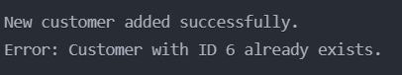

# Exercise 3: Stored Procedures

**Scenario 1:** The bank needs to process monthly interest for all savings accounts.

* + **Question:** Write a stored procedure **ProcessMonthlyInterest** that calculates and updates the balance of all savings accounts by applying an interest rate of 1% to the current balance.

CREATE OR REPLACE PROCEDURE ProcessMonthlyInterest AS

v_interest_rate NUMBER := 0.01; -- 1% monthly interest

BEGIN

UPDATE Accounts a

SET Balance = Balance + (Balance * v_interest_rate)

WHERE AccountType = 'Savings';

DBMS_OUTPUT.PUT_LINE('Monthly interest processed for all savings accounts.');

EXCEPTION

WHEN OTHERS THEN

DBMS_OUTPUT.PUT_LINE('Error processing monthly interest: ' || SQLERRM);

ROLLBACK;

END ProcessMonthlyInterest;

/

-- Example usage:

BEGIN

ProcessMonthlyInterest;

END;

/

-- Verify results:

SELECT AccountID, AccountType, Balance

FROM Accounts

WHERE AccountType = 'Savings';

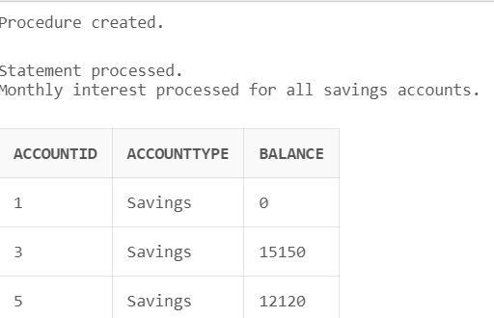

**Scenario 2:** The bank wants to implement a bonus scheme for employees based on their performance.

* + **Question:** Write a stored procedure **UpdateEmployeeBonus** that updates the salary of employees in a given department by adding a bonus percentage passed as a parameter.

CREATE OR REPLACE PROCEDURE UpdateEmployeeBonus(

p_department VARCHAR2,

p_bonus_percentage NUMBER

) AS

v_affected_rows NUMBER;

BEGIN

UPDATE Employees

SET Salary = Salary * (1 + p_bonus_percentage / 100)

WHERE Department = p_department;

v_affected_rows := SQL%ROWCOUNT;

IF v_affected_rows > 0 THEN

DBMS_OUTPUT.PUT_LINE('Bonus applied to ' || v_affected_rows || ' employees in ' || p_department || ' department.');

ELSE

DBMS_OUTPUT.PUT_LINE('No employees found in ' || p_department || ' department.');

END IF;

COMMIT;

EXCEPTION

WHEN OTHERS THEN

DBMS_OUTPUT.PUT_LINE('Error updating employee bonuses: ' || SQLERRM);

ROLLBACK;

END UpdateEmployeeBonus;

/

-- Example usage:

BEGIN

UpdateEmployeeBonus('IT', 5);

END;

/

-- Verify results:

SELECT EmployeeID, Name, Department, Salary

FROM Employees

WHERE Department = 'IT';

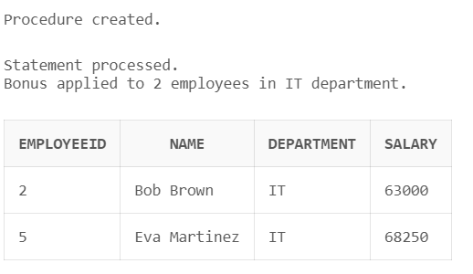

**Scenario 3:** Customers should be able to transfer funds between their accounts.

* + **Question:** Write a stored procedure **TransferFunds** that transfers a specified amount from one account to another, checking that the source account has sufficient balance before making the transfer.

CREATE OR REPLACE PROCEDURE TransferFunds(

p_from_account NUMBER,

p_to_account NUMBER,

p_amount NUMBER

) AS

v_from_balance NUMBER;

insufficient_funds EXCEPTION;

PRAGMA EXCEPTION_INIT(insufficient_funds, -20001);

BEGIN

-- Check if source account has sufficient funds

SELECT Balance INTO v_from_balance

FROM Accounts

WHERE AccountID = p_from_account

FOR UPDATE;

IF v_from_balance < p_amount THEN

RAISE insufficient_funds;

END IF;

-- Perform the transfer

UPDATE Accounts

SET Balance = Balance - p_amount

WHERE AccountID = p_from_account;

UPDATE Accounts

SET Balance = Balance + p_amount

WHERE AccountID = p_to_account;

COMMIT;

DBMS_OUTPUT.PUT_LINE('Transfer of ' || p_amount || ' completed successfully.');

EXCEPTION

WHEN insufficient_funds THEN

DBMS_OUTPUT.PUT_LINE('Error: Insufficient funds in source account.');

ROLLBACK;

WHEN NO_DATA_FOUND THEN

DBMS_OUTPUT.PUT_LINE('Error: One or both account IDs are invalid.');

ROLLBACK;

WHEN OTHERS THEN

DBMS_OUTPUT.PUT_LINE('Error during transfer: ' || SQLERRM);

ROLLBACK;

END TransferFunds;

/

-- Example usage:

BEGIN

TransferFunds(1, 2, 500);

END;

/

-- Verify results:

SELECT AccountID, Balance

FROM Accounts

WHERE AccountID IN (1, 2);

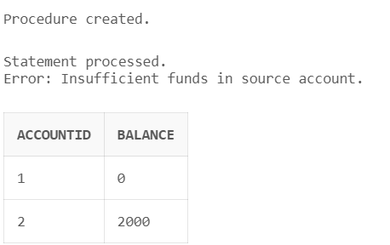

# Exercise 4: Functions

**Scenario 1:** Calculate the age of customers for eligibility checks.

* + **Question:** Write a function CalculateAge that takes a customer's date of birth as input and returns their age in years.

CREATE OR REPLACE FUNCTION CalculateAge(p_dob DATE)

RETURN NUMBER IS

BEGIN

RETURN TRUNC(MONTHS_BETWEEN(SYSDATE, p_dob) / 12);

END CalculateAge;

/

-- Example usage:

SELECT CustomerID, Name, DOB, CalculateAge(DOB) AS Age

FROM Customers;

-- Test with a specific date:

SELECT CalculateAge(TO_DATE('1990-01-01', 'YYYY-MM-DD')) AS Age FROM DUAL;

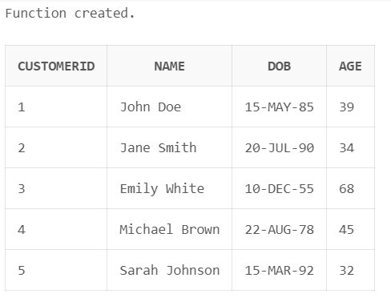

**Scenario 2:** The bank needs to compute the monthly installment for a loan.

* + **Question:** Write a function **CalculateMonthlyInstallment** that takes the loan amount, interest rate, and loan duration in years as input and returns the monthly installment amount.

CREATE OR REPLACE FUNCTION CalculateMonthlyInstallment(

p_loan_amount NUMBER,

p_interest_rate NUMBER,

p_duration_years NUMBER

) RETURN NUMBER IS

v_monthly_rate NUMBER;

v_num_payments NUMBER;

BEGIN

v_monthly_rate := p_interest_rate / (12 * 100);

v_num_payments := p_duration_years * 12;

RETURN (p_loan_amount * v_monthly_rate * POWER(1 + v_monthly_rate, v_num_payments)) /

(POWER(1 + v_monthly_rate, v_num_payments) - 1);

END CalculateMonthlyInstallment;

/

-- Example usage:

SELECT LoanID, LoanAmount, InterestRate,

MONTHS_BETWEEN(EndDate, StartDate) / 12 AS DurationYears,

CalculateMonthlyInstallment(LoanAmount, InterestRate, MONTHS_BETWEEN(EndDate, StartDate) / 12) AS MonthlyInstallment

FROM Loans;

-- Test with specific values:

SELECT CalculateMonthlyInstallment(100000, 5, 10) AS MonthlyInstallment FROM DUAL;

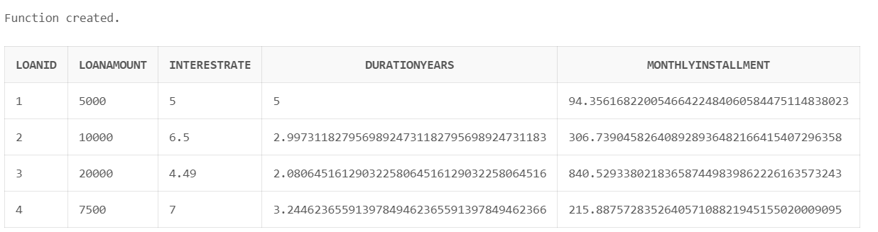

**Scenario 3:** Check if a customer has sufficient balance before making a transaction.

* + **Question:** Write a function **HasSufficientBalance** that takes an account ID and an amount as input and returns a boolean indicating whether the account has at least the specified amount.

CREATE OR REPLACE FUNCTION HasSufficientBalance(

p_account_id NUMBER,

p_amount NUMBER

) RETURN BOOLEAN IS

v_balance NUMBER;

BEGIN

SELECT Balance INTO v_balance

FROM Accounts

WHERE AccountID = p_account_id;

RETURN v_balance >= p_amount;

EXCEPTION

WHEN NO_DATA_FOUND THEN

RETURN FALSE;

END HasSufficientBalance;

/

-- Example usage:

SELECT AccountID, Balance,

CASE WHEN HasSufficientBalance(AccountID, 1000) THEN 'Yes' ELSE 'No' END AS HasSufficientBalance

FROM Accounts;

-- Test with specific values:

DECLARE

v_result BOOLEAN;

BEGIN

v_result := HasSufficientBalance(1, 500);

IF v_result THEN

DBMS_OUTPUT.PUT_LINE('Account has sufficient balance.');

ELSE

DBMS_OUTPUT.PUT_LINE('Account does not have sufficient balance.');

END IF;

END;

/

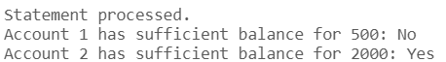

# Exercise 5: Triggers

## CREATE AUDIT TABLE

-- Create AuditLog table if it doesn't exist

CREATE TABLE AuditLog (

LogID NUMBER PRIMARY KEY,

TableName VARCHAR2(50),

OperationType VARCHAR2(10),

RecordID NUMBER,

LogDate DATE

);

-- Create a sequence for AuditLog

CREATE SEQUENCE AuditLog_Seq START WITH 1 INCREMENT BY 1;

**Scenario 1:** Automatically update the last modified date when a customer's record is updated.

* + **Question:** Write a trigger **UpdateCustomerLastModified** that updates the LastModified column of the Customers table to the current date whenever a customer's record is updated.

CREATE OR REPLACE TRIGGER UpdateCustomerLastModified

BEFORE UPDATE ON Customers

FOR EACH ROW

BEGIN

:NEW.LastModified := SYSDATE;

END;

/

-- Test the trigger

UPDATE Customers SET Balance = Balance + 100 WHERE CustomerID = 1;

-- Verify the result

SELECT CustomerID, Name, Balance, LastModified FROM Customers WHERE CustomerID = 1;

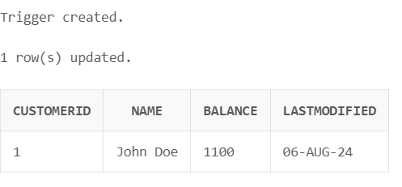

**Scenario 2:** Maintain an audit log for all transactions.

* + **Question:** Write a trigger **LogTransaction** that inserts a record into an AuditLog table whenever a transaction is inserted into the Transactions table.

CREATE OR REPLACE TRIGGER LogTransaction

AFTER INSERT ON Transactions

FOR EACH ROW

BEGIN

INSERT INTO AuditLog (LogID, TableName, OperationType, RecordID, LogDate)

VALUES (AuditLog_Seq.NEXTVAL, 'Transactions', 'INSERT', :NEW.TransactionID, SYSDATE);

END;

/

-- Test the trigger

INSERT INTO Transactions (TransactionID, AccountID, TransactionDate, Amount, TransactionType)

VALUES (AuditLog_Seq.NEXTVAL, 1, SYSDATE, 1000, 'Deposit');

-- Verify the result

SELECT * FROM AuditLog;

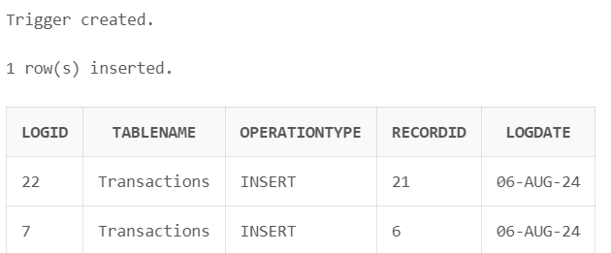

**Scenario 3:** Enforce business rules on deposits and withdrawals.

* + **Question:** Write a trigger **CheckTransactionRules** that ensures withdrawals do not exceed the balance and deposits are positive before inserting a record into the Transactions table.

CREATE OR REPLACE TRIGGER CheckTransactionRules

BEFORE INSERT ON Transactions

FOR EACH ROW

DECLARE

v_balance NUMBER;

BEGIN

SELECT Balance INTO v_balance

FROM Accounts

WHERE AccountID = :NEW.AccountID;

IF :NEW.TransactionType = 'Withdrawal' AND :NEW.Amount > v_balance THEN

RAISE_APPLICATION_ERROR(-20001, 'Insufficient funds for withdrawal');

ELSIF :NEW.TransactionType = 'Deposit' AND :NEW.Amount <= 0 THEN

RAISE_APPLICATION_ERROR(-20002, 'Deposit amount must be positive');

END IF;

END;

/

-- Verify the results

SELECT * FROM Accounts WHERE AccountID = 1;

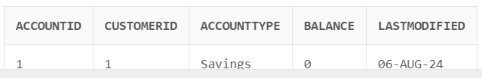

# Exercise 6: Cursors

**Scenario 1:** Generate monthly statements for all customers.

* + **Question:** Write a PL/SQL block using an explicit cursor **GenerateMonthlyStatements** that retrieves all transactions for the current month and prints a statement for each customer.

CREATE OR REPLACE PROCEDURE GenerateMonthlyStatements IS

CURSOR cust_cur IS

SELECT DISTINCT c.CustomerID, c.Name

FROM Customers c

JOIN Accounts a ON c.CustomerID = a.CustomerID

JOIN Transactions t ON a.AccountID = t.AccountID

WHERE EXTRACT(MONTH FROM t.TransactionDate) = EXTRACT(MONTH FROM SYSDATE)

AND EXTRACT(YEAR FROM t.TransactionDate) = EXTRACT(YEAR FROM SYSDATE);

CURSOR trans_cur(p_customer_id NUMBER) IS

SELECT a.AccountID, t.TransactionDate, t.Amount, t.TransactionType

FROM Accounts a

JOIN Transactions t ON a.AccountID = t.AccountID

WHERE a.CustomerID = p_customer_id

AND EXTRACT(MONTH FROM t.TransactionDate) = EXTRACT(MONTH FROM SYSDATE)

AND EXTRACT(YEAR FROM t.TransactionDate) = EXTRACT(YEAR FROM SYSDATE);

v_total_balance NUMBER;

BEGIN

FOR cust_rec IN cust_cur LOOP

DBMS_OUTPUT.PUT_LINE('Monthly Statement for ' || cust_rec.Name);

DBMS_OUTPUT.PUT_LINE('----------------------------------------');

v_total_balance := 0;

FOR trans_rec IN trans_cur(cust_rec.CustomerID) LOOP

DBMS_OUTPUT.PUT_LINE('Account: ' || trans_rec.AccountID ||

', Date: ' || TO_CHAR(trans_rec.TransactionDate, 'DD-MON-YYYY') ||

', Amount: ' || trans_rec.Amount ||

', Type: ' || trans_rec.TransactionType);

IF trans_rec.TransactionType = 'Deposit' THEN

v_total_balance := v_total_balance + trans_rec.Amount;

ELSIF trans_rec.TransactionType = 'Withdrawal' THEN

v_total_balance := v_total_balance - trans_rec.Amount;

END IF;

END LOOP;

DBMS_OUTPUT.PUT_LINE('Total Balance Change: ' || v_total_balance);

DBMS_OUTPUT.PUT_LINE('----------------------------------------');

END LOOP;

END GenerateMonthlyStatements;

/

-- Execute the procedure

BEGIN

GenerateMonthlyStatements;

END;

/

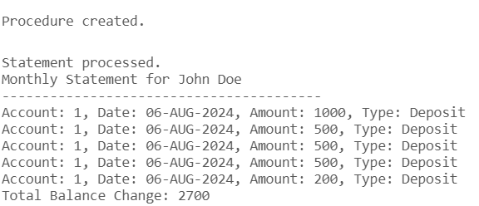

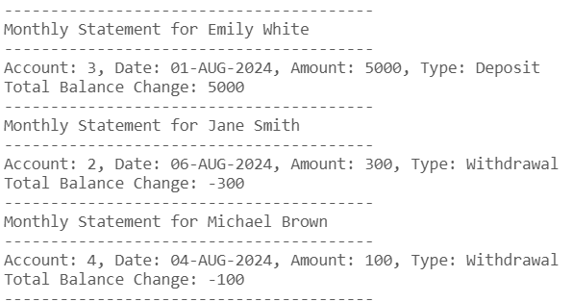

**Scenario 2:** Apply annual fee to all accounts.

* + **Question:** Write a PL/SQL block using an explicit cursor **ApplyAnnualFee** that deducts an annual maintenance fee from the balance of all accounts.

CREATE OR REPLACE PROCEDURE ApplyAnnualFee IS

CURSOR acc_cur IS

SELECT AccountID, Balance

FROM Accounts

FOR UPDATE OF Balance;

v_annual_fee NUMBER := 50; -- Set your annual fee amount here

BEGIN

FOR acc_rec IN acc_cur LOOP

IF acc_rec.Balance >= v_annual_fee THEN

UPDATE Accounts

SET Balance = Balance - v_annual_fee

WHERE CURRENT OF acc_cur;

DBMS_OUTPUT.PUT_LINE('Annual fee applied to Account ' || acc_rec.AccountID);

ELSE

DBMS_OUTPUT.PUT_LINE('Insufficient balance in Account ' || acc_rec.AccountID || ' to apply annual fee');

END IF;

END LOOP;

COMMIT;

END ApplyAnnualFee;

/

-- Execute the procedure

BEGIN

ApplyAnnualFee;

END;

/

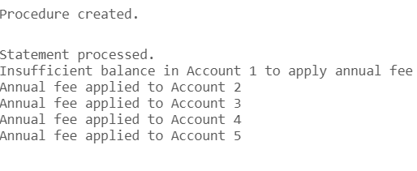

**Scenario 3:** Update the interest rate for all loans based on a new policy.

* + **Question:** Write a PL/SQL block using an explicit cursor **UpdateLoanInterestRates** that fetches all loans and updates their interest rates based on the new policy.

CREATE OR REPLACE PROCEDURE UpdateLoanInterestRates IS

CURSOR loan_cur IS

SELECT LoanID, LoanAmount, InterestRate

FROM Loans

FOR UPDATE OF InterestRate;

v_new_rate NUMBER;

BEGIN

FOR loan_rec IN loan_cur LOOP

-- Example policy: Increase rate by 0.5% for loans over 10000, decrease by 0.25% for others

IF loan_rec.LoanAmount > 10000 THEN

v_new_rate := loan_rec.InterestRate + 0.5;

ELSE

v_new_rate := loan_rec.InterestRate - 0.25;

END IF;

UPDATE Loans

SET InterestRate = v_new_rate

WHERE CURRENT OF loan_cur;

DBMS_OUTPUT.PUT_LINE('Updated interest rate for Loan ' || loan_rec.LoanID || ' from ' ||

loan_rec.InterestRate || '% to ' || v_new_rate || '%');

END LOOP;

COMMIT;

END UpdateLoanInterestRates;

/

-- Execute the procedure

BEGIN

UpdateLoanInterestRates;

END;

/

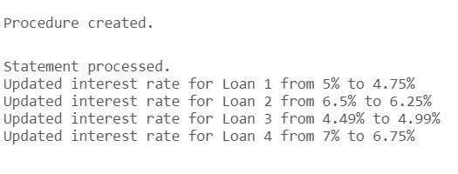

# Exercise 7: Packages

**Scenario 1:** Group all customer-related procedures and functions into a package.

* + **Question:** Create a package **CustomerManagement** with procedures for adding a new customer, updating customer details, and a function to get customer balance.

CREATE SEQUENCE Customers_Seq

START WITH 1

INCREMENT BY 1

NOCACHE

NOCYCLE;

/

CREATE OR REPLACE PACKAGE CustomerManagement AS

PROCEDURE AddNewCustomer(

p_name VARCHAR2,

p_dob DATE,

p_initial_balance NUMBER

);

PROCEDURE UpdateCustomerDetails(

p_customer_id NUMBER,

p_name VARCHAR2,

p_dob DATE

);

FUNCTION GetCustomerBalance(p_customer_id NUMBER) RETURN NUMBER;

END CustomerManagement;

/

CREATE OR REPLACE PACKAGE BODY CustomerManagement AS

PROCEDURE AddNewCustomer(

p_name VARCHAR2,

p_dob DATE,

p_initial_balance NUMBER

) IS

v_customer_id NUMBER;

BEGIN

INSERT INTO Customers (CustomerID, Name, DOB, Balance, LastModified)

VALUES (Customers_Seq.NEXTVAL, p_name, p_dob, p_initial_balance, SYSDATE)

RETURNING CustomerID INTO v_customer_id;

DBMS_OUTPUT.PUT_LINE('New customer added with ID: ' || v_customer_id);

END AddNewCustomer;

PROCEDURE UpdateCustomerDetails(

p_customer_id NUMBER,

p_name VARCHAR2,

p_dob DATE

) IS

BEGIN

UPDATE Customers

SET Name = p_name,

DOB = p_dob,

LastModified = SYSDATE

WHERE CustomerID = p_customer_id;

IF SQL%ROWCOUNT = 0 THEN

RAISE_APPLICATION_ERROR(-20001, 'Customer not found');

ELSE

DBMS_OUTPUT.PUT_LINE('Customer details updated successfully');

END IF;

END UpdateCustomerDetails;

FUNCTION GetCustomerBalance(p_customer_id NUMBER) RETURN NUMBER IS

v_balance NUMBER;

BEGIN

SELECT Balance INTO v_balance

FROM Customers

WHERE CustomerID = p_customer_id;

RETURN v_balance;

EXCEPTION

WHEN NO_DATA_FOUND THEN

RAISE_APPLICATION_ERROR(-20002, 'Customer not found');

END GetCustomerBalance;

END CustomerManagement;

/

-- Example usage:

BEGIN

CustomerManagement.AddNewCustomer('John Doe', TO_DATE('1990-01-01', 'YYYY-MM-DD'), 1000);

CustomerManagement.UpdateCustomerDetails(1, 'John Smith', TO_DATE('1990-01-01', 'YYYY-MM-DD'));

DBMS_OUTPUT.PUT_LINE('Customer balance: ' || CustomerManagement.GetCustomerBalance(1));

END;

/

-- Example usage:

BEGIN

CustomerManagement.AddNewCustomer('John Doe', TO_DATE('1990-01-01', 'YYYY-MM-DD'), 1000);

CustomerManagement.UpdateCustomerDetails(1, 'John Smith', TO_DATE('1990-01-01', 'YYYY-MM-DD'));

DBMS_OUTPUT.PUT_LINE('Customer balance: ' || CustomerManagement.GetCustomerBalance(1));

END;

/

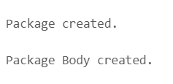

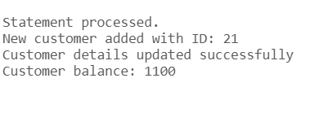

**Scenario 2:** Create a package to manage employee data.

* + **Question:** Write a package **EmployeeManagement** with procedures to hire new employees, update employee details, and a function to calculate annual salary.

CREATE SEQUENCE Employees_Seq

START WITH 1

INCREMENT BY 1

NOCACHE

NOCYCLE;

CREATE OR REPLACE PACKAGE EmployeeManagement AS

PROCEDURE HireNewEmployee(

p_name VARCHAR2,

p_position VARCHAR2,

p_salary NUMBER,

p_department VARCHAR2

);

PROCEDURE UpdateEmployeeDetails(

p_employee_id NUMBER,

p_position VARCHAR2,

p_salary NUMBER,

p_department VARCHAR2

);

FUNCTION CalculateAnnualSalary(p_employee_id NUMBER) RETURN NUMBER;

END EmployeeManagement;

/

CREATE OR REPLACE PACKAGE BODY EmployeeManagement AS

PROCEDURE HireNewEmployee(

p_name VARCHAR2,

p_position VARCHAR2,

p_salary NUMBER,

p_department VARCHAR2

) IS

v_employee_id NUMBER;

BEGIN

INSERT INTO Employees (EmployeeID, Name, Position, Salary, Department, HireDate)

VALUES (Employees_Seq.NEXTVAL, p_name, p_position, p_salary, p_department, SYSDATE)

RETURNING EmployeeID INTO v_employee_id;

DBMS_OUTPUT.PUT_LINE('New employee hired with ID: ' || v_employee_id);

END HireNewEmployee;

PROCEDURE UpdateEmployeeDetails(

p_employee_id NUMBER,

p_position VARCHAR2,

p_salary NUMBER,

p_department VARCHAR2

) IS

BEGIN

UPDATE Employees

SET Position = p_position,

Salary = p_salary,

Department = p_department

WHERE EmployeeID = p_employee_id;

IF SQL%ROWCOUNT = 0 THEN

RAISE_APPLICATION_ERROR(-20003, 'Employee not found');

ELSE

DBMS_OUTPUT.PUT_LINE('Employee details updated successfully');

END IF;

END UpdateEmployeeDetails;

FUNCTION CalculateAnnualSalary(p_employee_id NUMBER) RETURN NUMBER IS

v_monthly_salary NUMBER;

BEGIN

SELECT Salary INTO v_monthly_salary

FROM Employees

WHERE EmployeeID = p_employee_id;

RETURN v_monthly_salary * 12;

EXCEPTION

WHEN NO_DATA_FOUND THEN

RAISE_APPLICATION_ERROR(-20004, 'Employee not found');

END CalculateAnnualSalary;

END EmployeeManagement;

/

-- Example usage:

BEGIN

EmployeeManagement.HireNewEmployee('Jane Doe', 'Manager', 5000, 'Sales');

EmployeeManagement.UpdateAmployeeDetails(1, 'Senior Manager', 6000, 'Sales');

DBMS_OUTPUT.PUT_LINE('Annual salary: ' || EmployeeManagement.CalculateAnnualSalary(1));

END;

/

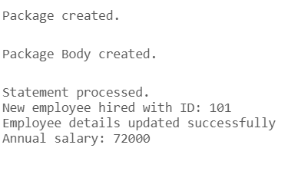

**Scenario 3:** Group all account-related operations into a package.

* + **Question:** Create a package **AccountOperations** with procedures for opening a new account, closing an account, and a function to get the total balance of a customer across all accounts.

CREATE SEQUENCE Accounts_Seq

START WITH 1

INCREMENT BY 1

NOCACHE

NOCYCLE;

CREATE OR REPLACE PACKAGE AccountOperations AS

PROCEDURE OpenNewAccount(

p_customer_id NUMBER,

p_account_type VARCHAR2,

p_initial_balance NUMBER

);

PROCEDURE CloseAccount(p_account_id NUMBER);

FUNCTION GetTotalCustomerBalance(p_customer_id NUMBER) RETURN NUMBER;

END AccountOperations;

/

CREATE OR REPLACE PACKAGE BODY AccountOperations AS

PROCEDURE OpenNewAccount(

p_customer_id NUMBER,

p_account_type VARCHAR2,

p_initial_balance NUMBER

) IS

v_account_id NUMBER;

BEGIN

INSERT INTO Accounts (AccountID, CustomerID, AccountType, Balance, LastModified)

VALUES (Accounts_Seq.NEXTVAL, p_customer_id, p_account_type, p_initial_balance, SYSDATE)

RETURNING AccountID INTO v_account_id;

DBMS_OUTPUT.PUT_LINE('New account opened with ID: ' || v_account_id);

END OpenNewAccount;

PROCEDURE CloseAccount(p_account_id NUMBER) IS

v_balance NUMBER;

BEGIN

SELECT Balance INTO v_balance

FROM Accounts

WHERE AccountID = p_account_id;

IF v_balance <> 0 THEN

RAISE_APPLICATION_ERROR(-20005, 'Account balance must be zero to close');

ELSE

DELETE FROM Accounts WHERE AccountID = p_account_id;

IF SQL%ROWCOUNT = 0 THEN

RAISE_APPLICATION_ERROR(-20006, 'Account not found');

ELSE

DBMS_OUTPUT.PUT_LINE('Account closed successfully');

END IF;

END IF;

END CloseAccount;

FUNCTION GetTotalCustomerBalance(p_customer_id NUMBER) RETURN NUMBER IS

v_total_balance NUMBER;

BEGIN

SELECT SUM(Balance) INTO v_total_balance

FROM Accounts

WHERE CustomerID = p_customer_id;

RETURN NVL(v_total_balance, 0);

END GetTotalCustomerBalance;

END AccountOperations;

/

BEGIN

-- Open new accounts

AccountOperations.OpenNewAccount(1, 'Savings', 1000);

AccountOperations.OpenNewAccount(1, 'Checking', 500);

-- Get total balance for customer ID 1

DBMS_OUTPUT.PUT_LINE('Total balance: ' || AccountOperations.GetTotalCustomerBalance(1));

END;

/

