# AMD Stock:

## Analysis of Returns:

The distribution of returns on AMD stock is fairly normal with a couple outliers on the right end tail, however the behavior appears to be normal.

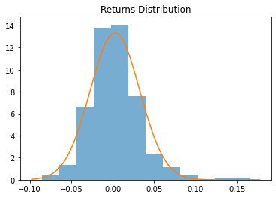

Normality Test? QQPlot? Comparison to KDE?

## One Step Predictions

By running Monte Carlo Simulations on geometric Brownian models, thousands of one-day predictions can be estimated. In this scenario, 10,000 simulations were run with the resulting simulation mean as 85.808, and simulation standard deviation as 3.174. This produced the following density plot:

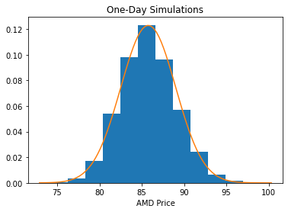

As seen in the figure, the resulting density plot for one-day predictions fits a normal distribution very well. Because of the normal behavior, the probability of the true AMD price at time t=1 can be calculated from the normal probability density function.

|  |  |  |  |
| --- | --- | --- | --- |
| Actual (t=1) | Predicted (Avg) | PDF | CDF |
| $85.07 | $85.79 | 0.1211 | 0.4109 |

In layman’s terms this means that there was a 12.11% chance of the price of an AMD share to hit its true price of $85.31, and that out of all simulated prices, 41.09% of those are less than the true price of AMD on that day.

## Extended One Step Predictions:

The one-step predictions can be applied over a set period of time to determine how well it forecasts future values of price. In the research paper **[INSERT RESEARCH CITATION]**, it was determined that a training set of 60 days produced the best predictions based on the mean squared value. That experiment is repeated, but with the addition of the mean absolute percentage error as another criterion of forecasting accuracy. Generating 10,000 simulations from training sets of 30 to 100 days resulted in the following expected MSE and MAPE when tested against the next seven business days:

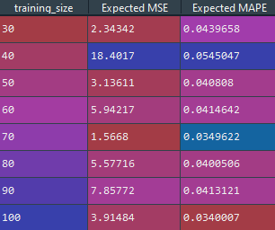

The expected MSE at 70 days is the lowest amongst the training sets, while the expected MAPE is the second lowest (with 100 days having the lowest). However, comparing the 70-day training set to the 100-day training set, the expected MSE is less than half. Thus, the optimal training size for this scenario should be 70 days. In comparison to the research paper, the results were close with the paper concluding a 60-day optimal training set.

Another interesting methodology that the same research paper conducts is examining the experimental probability of predicting the correct direction of the price change. To perform this experiment, 10,000 one-day simulations will be generated for training sizes from 30 to 100. The resulting experimental prices will be subtracted by the true *s(t-1)* price, and the direction will be checked against the true price change direction of *s(t)-s(t-1)*. The following probabilities were calculated:

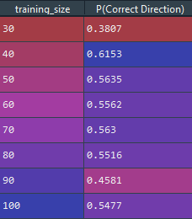

In comparison to the paper’s results of 100 days being the most accurate training size when it comes to predicting the correct direction of the price change, this scenario results in a training size of 40 being the most accurate.

## Sample 30 Business Day Forecasts:

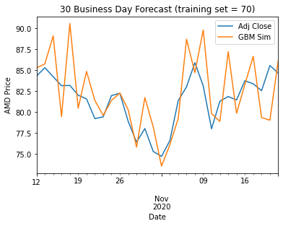

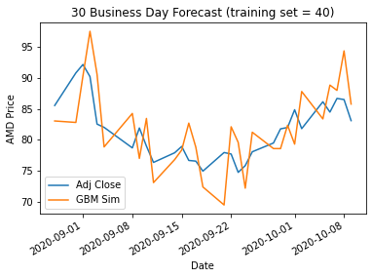

# S&P500 ETF (SPY):

## Analysis of Returns:

The distribution of returns on SPY ETF is actually a bit skewed to the left. However, it does still hold a general normal shape.

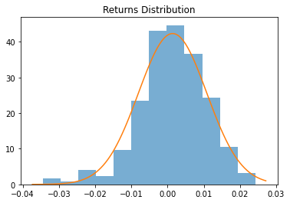

# Bitcoin (BTC):

## Analysis of Returns:

While the general shape and the QQ plot can be interpreted as generally normal, the normal distribution does not cover the peaks of the returns enough. Kernel density estimation can be employed to create a distribution that would capture this behavior better.

