CHAPTER 5: IMPLEMENTATION, CODING AND TESTING

5.1 Implementation and coding

5.1.1 Introduction
This chapter describes the implementation and testing of the System for Personal Computer Checks Using QR Codes developed for UTB Rubavu Campus. This phase focused on transforming the proposed design into a fully functional web-based application.
The implementation phase explains how the system was developed using the selected technologies and tools. It covers frontend development, backend development with PHP and PDO, MySQL database integration, session-based authentication, QR code generation, and local deployment using XAMPP. The testing section explains how the system was evaluated to ensure that it operated correctly, securely, and efficiently according to the defined requirements.

5.1.2 Description of implementation Tools and technology
The System for Personal Computer Checks Using QR Codes was developed using web technologies suitable for building a reliable campus gate-checking application. The system followed a three-tier client–server architecture, where the presentation layer (HTML, Bootstrap, and JavaScript) communicates with the application layer (PHP with PDO), which then interacts with the MySQL database. The technologies used in the development of the system are summarized in the table below.
Table 6: Technology used
Technology used | Description
HTML5 (Frontend) | Used to structure web pages including the landing page, login page, admin dashboard, gate-officer dashboard, registration forms, and report pages.
CSS3 (Frontend) | Used to style and format the web pages to improve appearance, layout, and readability.
Bootstrap 4 | Used to create responsive and consistent interfaces across devices and browsers.
JavaScript (Frontend) | Used to enhance client-side interaction, form behaviour, and dynamic page features.
PHP with PDO (Backend) | Used as the server-side language to process requests, enforce business rules, and interact securely with the database.
MySQL | Used as the relational database management system to store users, computer records, and activity logs.
TCPDF / QR libraries | Used to generate printable QR codes linked to registered computer serial numbers.
XAMPP | Used as the local development and hosting environment (Apache, MySQL, and PHP).
phpMyAdmin | Used to create, import, and manage the computer_records database.
Visual Studio Code / Cursor | Used as the primary code editor for development and debugging.

These technologies were selected because they provide flexibility, cross-platform compatibility, secure database access through prepared statements, and an efficient development workflow for academic and institutional web systems.

5.1.3 Screen Shots
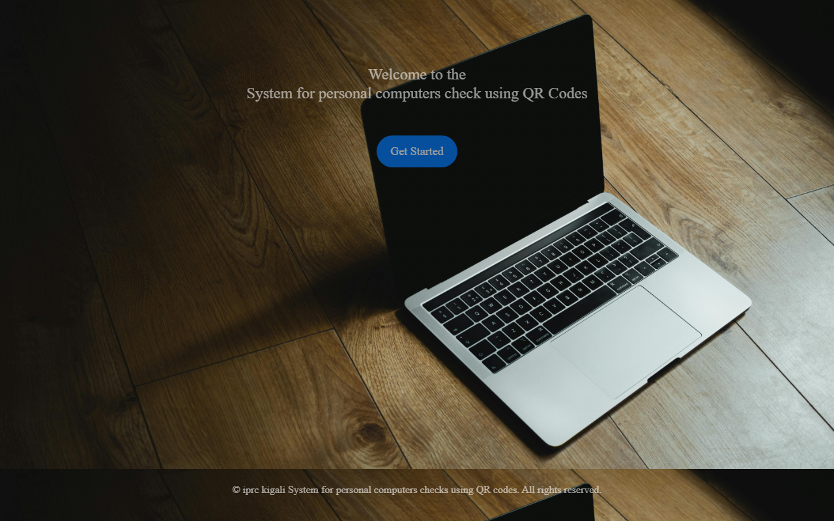
Figure 10: Home Page Interface
This figure presents the Home Page of the System for Personal Computer Checks Using QR Codes. It serves as the main entry point for authorized campus users and provides a clear welcome message together with a “Get Started” button that directs users to the login page.
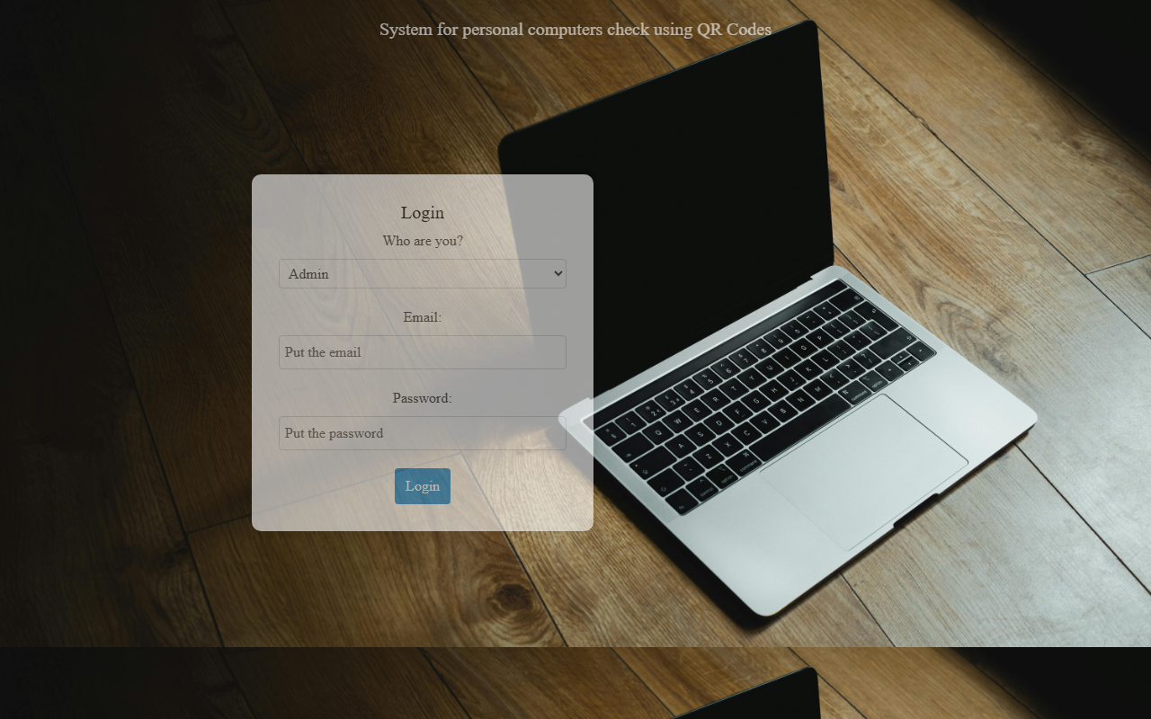
Figure 11: Login Page
This figure illustrates the Login page, where users select their role (Admin or Gate Officer), enter their email address and password, and authenticate into the system. Role selection ensures that each user is redirected to the appropriate dashboard after a successful login.
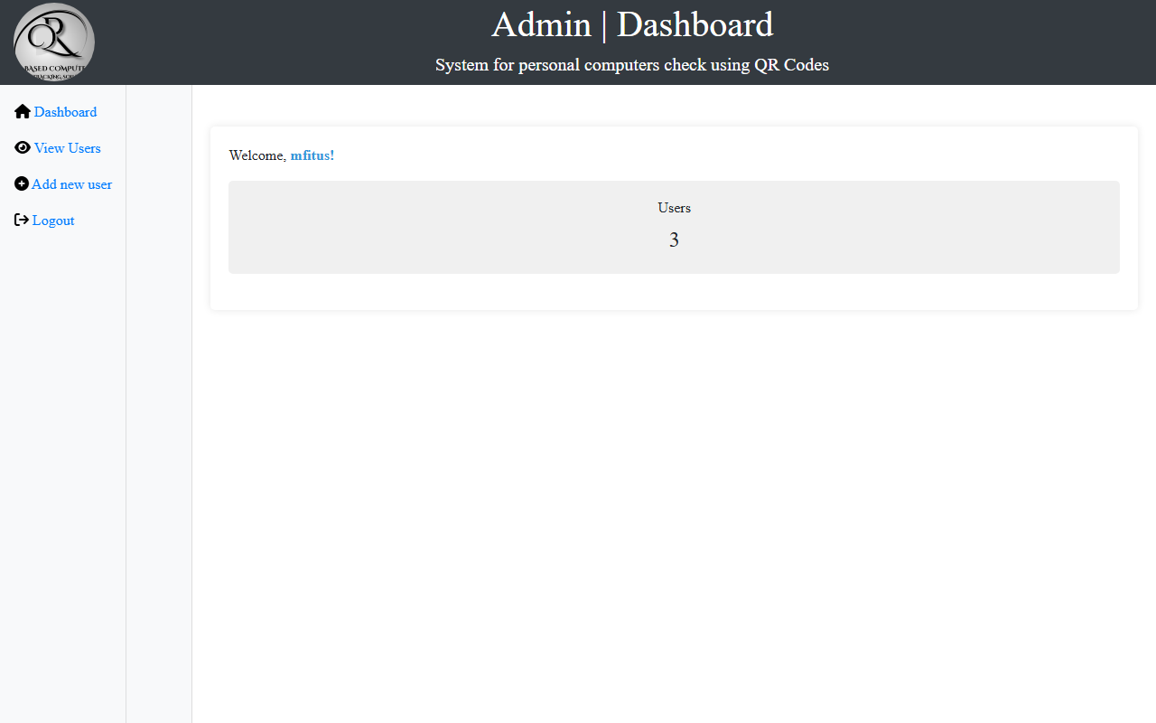
Figure 12: Admin Dashboard
This figure presents the Admin Dashboard. From this interface, administrators can manage system users, including adding, viewing, updating, and deleting accounts. The dashboard acts as the central control panel for system administration at UTB Rubavu Campus.
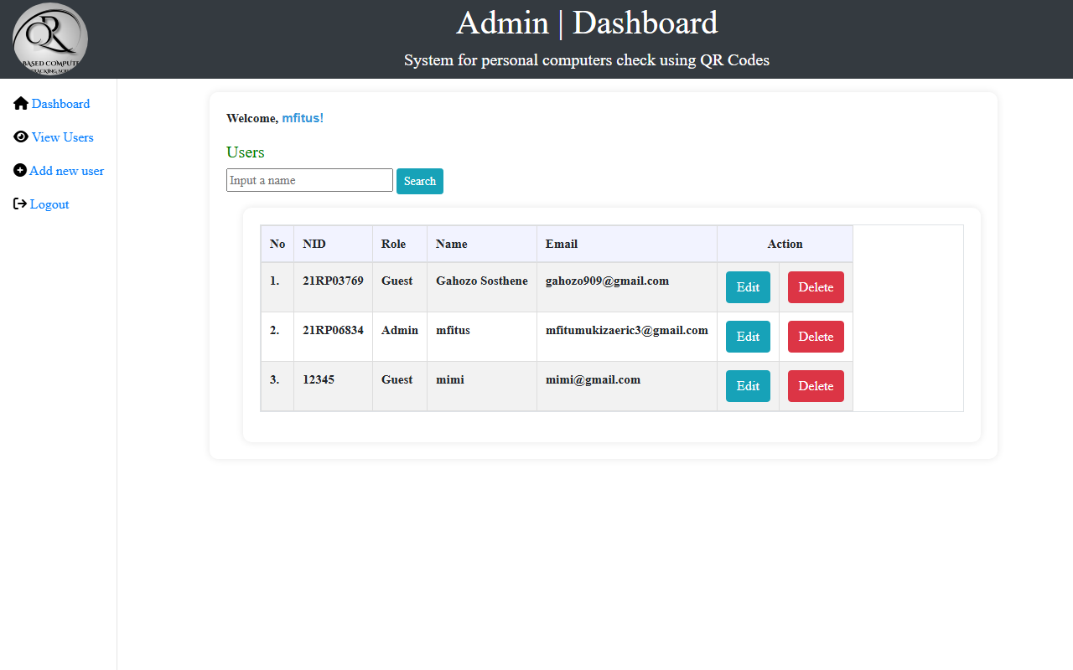
Figure 13: View Users Page
This figure shows the View Users page, which lists registered system accounts with their roles, identification numbers, names, and email addresses. It enables administrators to monitor who has access to the platform and to maintain accurate user records.
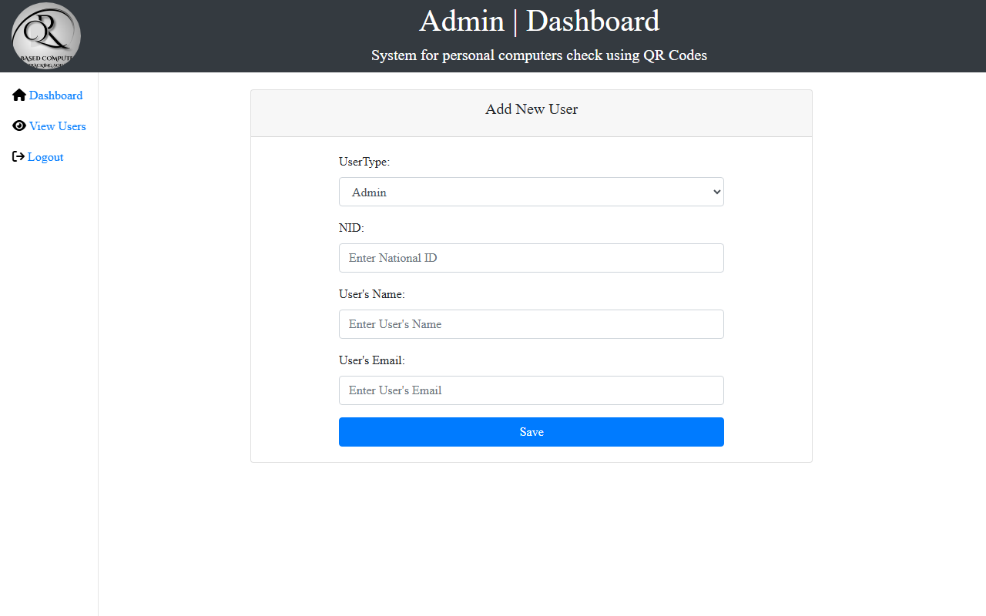
Figure 14: Add Users Page
This figure illustrates the Add Users interface. Administrators can register new Admin or Gate Officer accounts by capturing user type, national/staff identification number, full name, and email. Passwords are stored in hashed form for security.
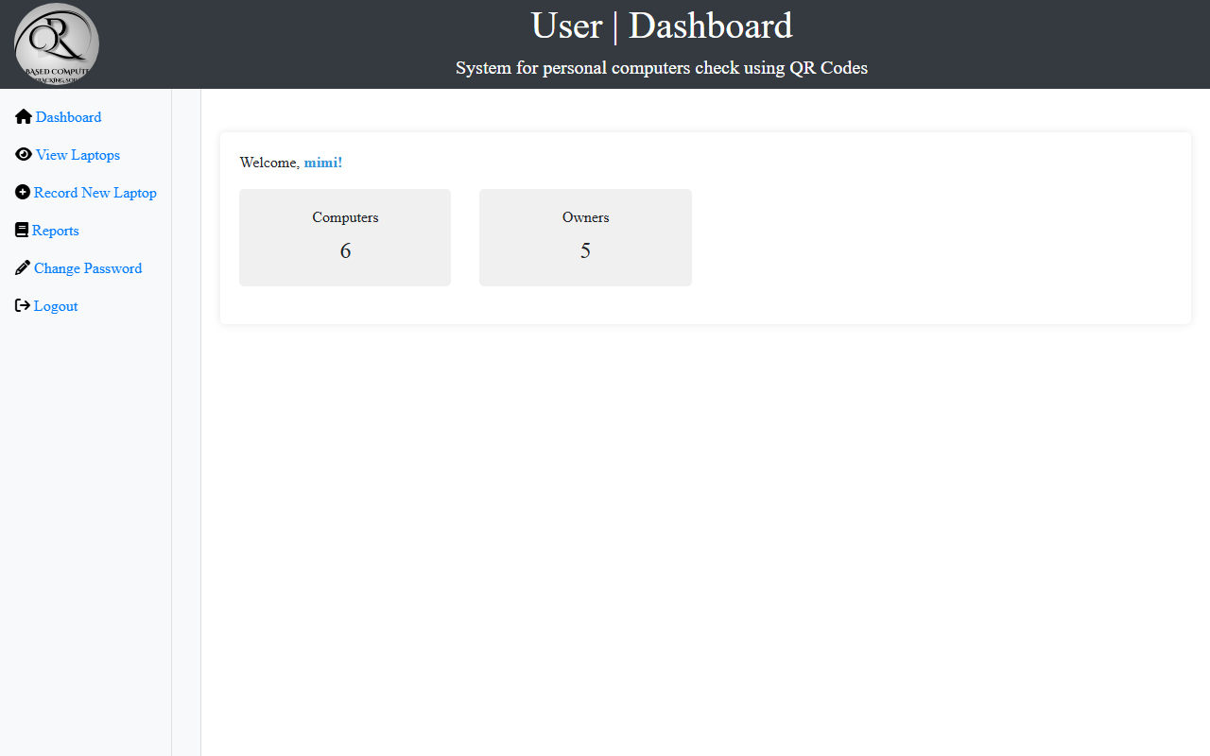
Figure 15: Gate Officer Dashboard
This figure presents the Gate Officer (Guest) Dashboard. From this panel, gate staff can access computer registration, laptop viewing, QR-related operations, password change, and reporting features used during daily entry and exit checks.
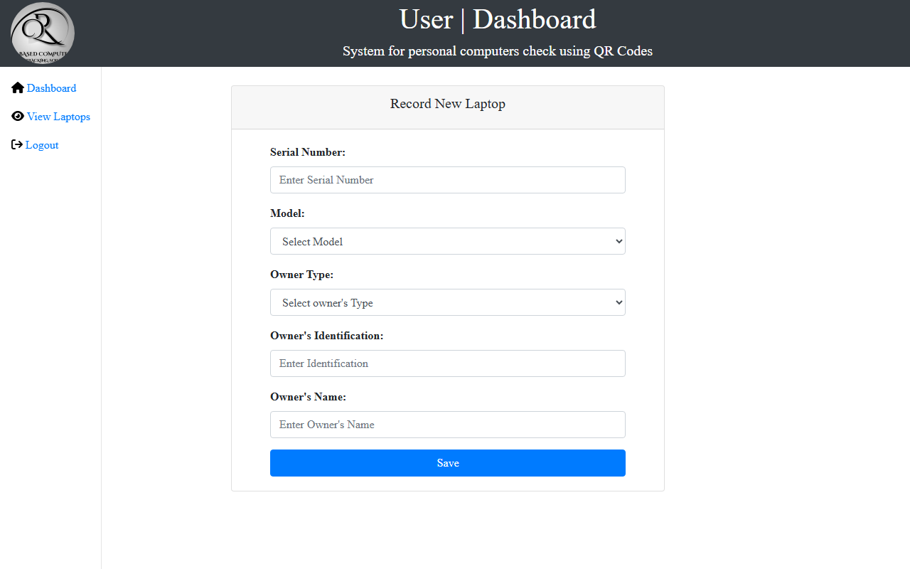
Figure 16: Record Computers Page
This figure shows the Record Computers page used to register a personal computer at the gate. Gate officers capture the serial number, model, owner type, owner number, and owner name. After successful registration, a QR code can be generated for the device.
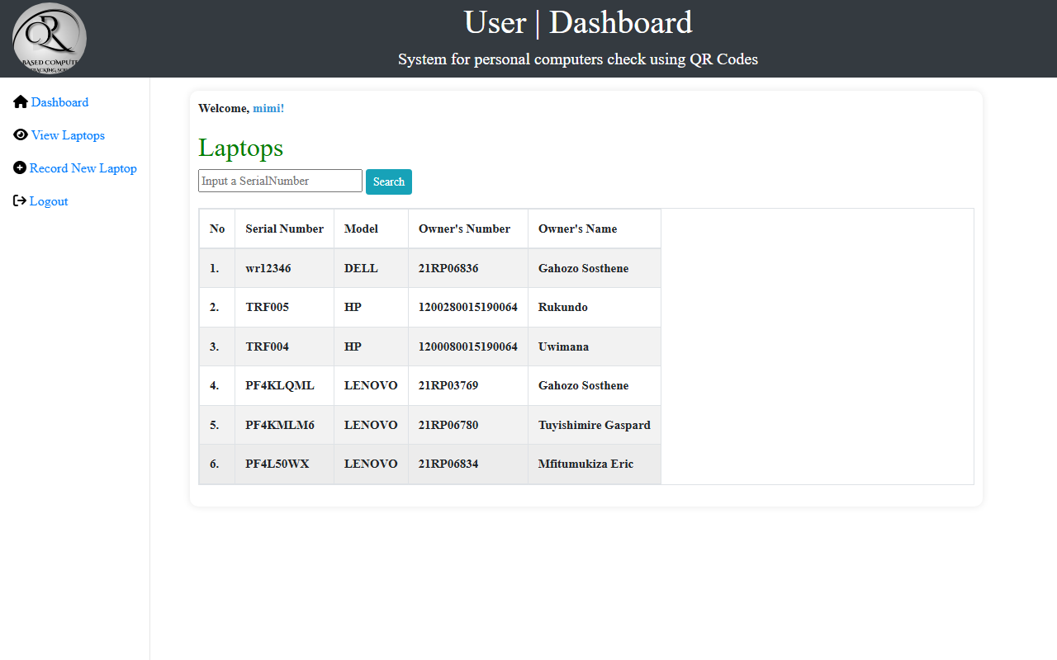
Figure 17: View Laptops / Registered Computers Page
This figure illustrates the View Laptops page, which displays registered computer records stored in the database. Gate officers can review device details and use the information during verification and QR-code generation activities.
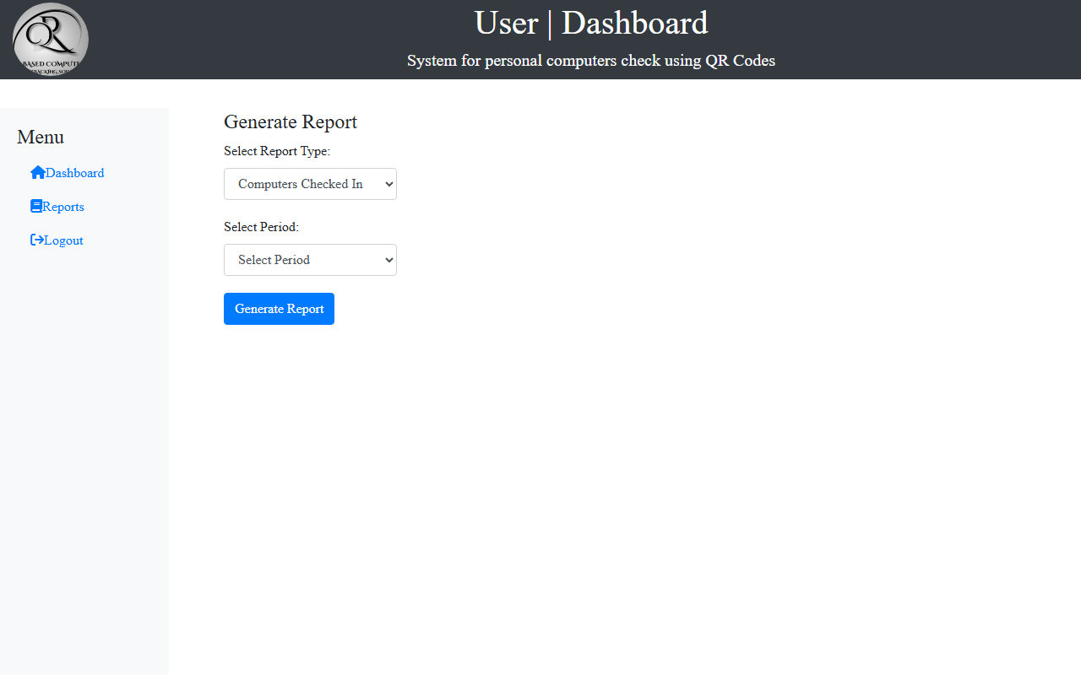
Figure 18: Reports Module
This figure presents the Reports module. It enables authorized users to review logged check-in and check-out activity and to generate printable reports for accountability and management purposes at the campus gate.
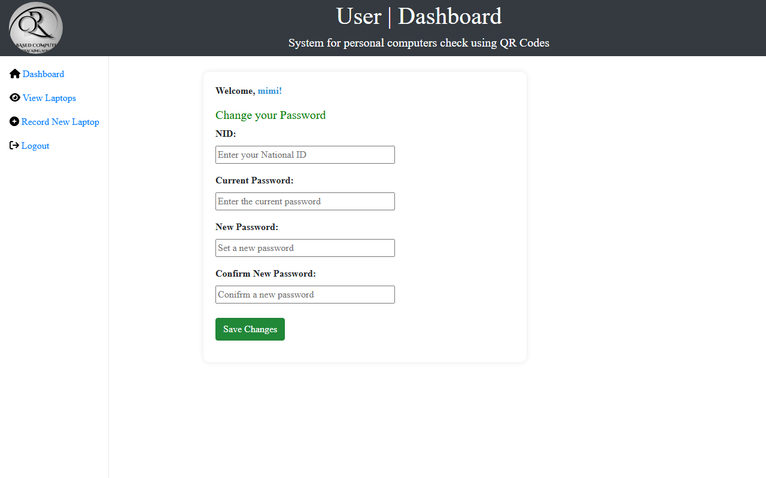
Figure 19: Change Password Page
This figure shows the Change Password page, which allows authenticated users to update their login credentials. This feature supports account security and controlled access to system modules.

5.1.4 Source Codes
The System for Personal Computer Checks Using QR Codes was implemented as a PHP web application hosted under the Apache document root. The main project folder contains presentation pages, backend scripts, database connection logic, and libraries used for QR code generation.
PROJECT FOLDER STRUCTURE
The application folder structure is summarized below:
QR/
├── index.php # Landing / home page
├── login.php # Authentication page
├── logout.php # Session termination
├── connection.php # MySQL PDO connection
├── admin-dashboard.php # Administrator home
├── user-dashboard.php # Gate officer home
├── add-users.php # Create system users
├── view-users.php # List / manage users
├── update-users.php # Edit user accounts
├── delete-users.php # Remove user accounts
├── record-computers.php # Register devices
├── view-laptops.php # List registered devices
├── getBarcode.php # QR display helper
├── log_form.php / submit_log.php # Check-in/out logging
├── report.php / generate_report.php
├── change-password.php
├── styles.css
├── img/ # Interface images
├── icons/ # Icon assets
├── tcpdf/ # PDF / barcode library
└── phpqr/ # QR generation support
Sample database connection file (connection.php):
<?php
try {
$pdo = new PDO(
"mysql:host=localhost;dbname=computer_records;",
'root',
'',
[PDO::ATTR_ERRMODE => PDO::ERRMODE_EXCEPTION]
);
} catch (PDOException $e) {
die('Connection failed: ' . $e->getMessage());
}
?>
Sample authentication logic (login.php):
<?php
session_start();
include 'connection.php';
function authenticateUser($email, $password, $user_type, $pdo) {
$query = "SELECT * FROM users WHERE email = :email AND user_type = :user_type";
$stmt = $pdo->prepare($query);
$stmt->bindParam(':email', $email);
$stmt->bindParam(':user_type', $user_type);
$stmt->execute();
$row = $stmt->fetch(PDO::FETCH_ASSOC);
if ($row && password_verify($password, $row['password'])) {
return $row;
}
return false;
}
if ($_SERVER['REQUEST_METHOD'] === 'POST') {
$user = authenticateUser($_POST['email'], $_POST['password'], $_POST['user_type'], $pdo);
if ($user) {
$_SESSION['user_type'] = $user['user_type'];
$_SESSION['email'] = $user['email'];
if ($user['user_type'] === 'Admin') {
header('Location: admin-dashboard.php');
} else {
header('Location: user-dashboard.php');
}
exit();
}
$error = "Invalid user_type, username or password";
}
?>
Sample computer registration logic (record-computers.php):
<?php
require_once 'connection.php';
if (isset($_POST['submit'])) {
$sn = $_POST['sn'];
$model = $_POST['model'];
$type = $_POST['type'];
$owno = $_POST['owno'];
$owname = $_POST['owname'];
$sql_check = "SELECT COUNT(*) FROM computer_info WHERE sn = :sn";
$stmt_check = $pdo->prepare($sql_check);
$stmt_check->bindParam(':sn', $sn);
$stmt_check->execute();
if ($stmt_check->fetchColumn() > 0) {
$Error = "Error: Computer's S/N already exists.";
} else {
$stmt = $pdo->prepare(
"INSERT INTO computer_info (sn, model, type, owno, owname) VALUES (?,?,?,?,?)"
);
$stmt->execute([$sn, $model, $type, $owno, $owname]);
$message = "Computer was recorded successfully!";
}
}
?>
Sample check-in / check-out logging logic (submit_log.php):
<?php
require_once 'connection.php';
if ($_SERVER['REQUEST_METHOD'] == 'POST') {
$stmt = $pdo->prepare(
"INSERT INTO logs (sn, model, type, owno, owname, action, comment)
VALUES (?,?,?,?,?,?,?)"
);
$stmt->execute([
$_POST['sn'], $_POST['model'], $_POST['type'],
$_POST['owno'], $_POST['owname'], $_POST['action'], $_POST['comment']
]);
echo "Log recorded successfully for " . htmlspecialchars($_POST['sn']);
}
?>
FRONTEND SAMPLE
The frontend of the System for Personal Computer Checks Using QR Codes was developed using HTML, CSS, Bootstrap, and JavaScript. A simplified landing-page structure is shown below.
<!DOCTYPE html>
<html lang="en">
<head>
<meta charset="UTF-8">
<meta name="viewport" content="width=device-width, initial-scale=1.0">
<title>Landing Page</title>
<link rel="stylesheet"
href="https://stackpath.bootstrapcdn.com/bootstrap/4.5.2/css/bootstrap.min.css">
</head>
<body>
<div class="container">
<h4>Welcome to the System for personal computers
check using QR Codes</h4>
<a href="login.php" class="btn btn-lg">Get Started</a>
</div>
</body>
</html>

5.2 Testing

5.2.1 Introduction
System testing is the process of evaluating a complete and integrated system to ensure that it meets the specified requirements. Testing involves executing the system to identify errors, defects, or inconsistencies and verifying that all components function as expected.
The System for Personal Computer Checks Using QR Codes underwent several types of testing to ensure reliability, usability, security, and performance before final demonstration and local deployment at UTB Rubavu Campus.

5.2.2 Objective of Testing
The primary objectives of system testing in this project were:
- 1. To identify and correct errors during development.
- 2. To ensure that all functional requirements are implemented correctly.
- 3. To verify that the system meets administrator and gate-officer expectations.
- 4. To confirm that the system operates securely and efficiently.
- 5. To ensure compatibility across different browsers and devices.
- 6. To validate that the system performs according to the System Requirement Specification (SRS).
Testing ensured that the platform supports accurate device registration, QR-based verification, secure authentication, and reliable activity logging at the campus gate.

5.2.3 Unit testing outputs
Unit testing was conducted to verify individual components of the system. PHP scripts and database operations were tested independently to ensure correct responses. Unit testing included:
- 1. Testing the PDO database connection to confirm successful access to the computer_records database.
- 2. Testing user authentication with valid and invalid credentials for Admin and Gate Officer roles.
- 3. Testing INSERT operations when registering a new computer record.
- 4. Testing duplicate serial-number prevention during computer registration.
- 5. Testing QR code generation for a registered serial number.
- 6. Testing INSERT operations into the logs table for check-in and check-out actions.
- 7. Testing password hashing and password update operations.
Each function was tested independently before integrating with other components.

5.2.4 Validation testing outputs
Validation testing ensured that the system behaved according to user expectations. Input fields were validated to prevent incorrect data submission. This included:
- 1. Ensuring required fields are completed before form submission on login, user registration, and computer registration forms.
- 2. Validating email format on the login and user creation forms.
- 3. Preventing unauthorized access to admin and gate-officer dashboards through session checks.
- 4. Displaying appropriate error messages for invalid login credentials.
- 5. Rejecting duplicate computer serial numbers during registration.
Validation confirmed that the system performs intended operations correctly and reduces the risk of incomplete or inconsistent data entry.

5.2.5 Integration Testing Outputs
Integration testing was conducted to verify that frontend pages, PHP backend scripts, and the MySQL database work together properly. This included:
- 1. Testing login form submission and redirection to the correct dashboard based on user role.
- 2. Testing computer registration forms and immediate storage of records in the Computer_info table.
- 3. Testing QR code generation linked to newly registered device serial numbers.
- 4. Testing check-in/check-out logging and storage of actions in the Logs table.
- 5. Testing report generation from stored log and device data.
- 6. Testing admin user-management operations (add, view, update, and delete) against the Users table.
This testing ensured smooth communication between the presentation, application, and database layers of the system.

5.2.6 Functional and system testing Results
Functional testing verified that each feature operates according to system requirements. All core functionalities were tested, including:
- 1. Accessing the home page and navigating to login
- 2. Admin and Gate Officer authentication
- 3. Adding, viewing, updating, and deleting users
- 4. Recording personal computers at entry
- 5. Viewing registered laptop/computer records
- 6. Generating and displaying QR codes
- 7. Logging check-in and check-out actions
- 8. Generating activity reports
- 9. Changing user passwords
- 10. Logging out and terminating sessions securely
The system responded correctly to user inputs and displayed accurate results. No major functional defects were identified after final testing.

5.2.7 Acceptance Testing Report
Acceptance testing was conducted to determine whether the system meets the needs of end users at UTB Rubavu Campus. The platform was tested by simulating real gate operations such as registering a device on entry, generating a QR code, and recording verification actions on exit.
Administrators tested dashboard functionality, including adding, editing, and deleting user accounts. Gate officers tested computer registration, QR-related operations, and reporting. Feedback confirmed that the system is usable, responsive under the local XAMPP environment, and meets the intended objectives of improving personal computer checks through QR codes at the campus gate.

