CHAPTER FOUR: SYSTEM ANALYSIS AND DESIGN

4.1 Introduction
This chapter presents the analysis and design of the proposed System for Personal Computer Checks Using QR Codes, developed for UTB Rubavu Campus. It discusses the analysis of the existing manual gate-recording system, the requirements identified for the new system, and the design of the proposed solution. The chapter also includes system modelling tools such as Use Case Diagrams, Data Flow Diagrams (DFDs), a Data Dictionary, Entity Relationship Diagrams (ERDs), database normalization, and the overall system architecture.

4.2 Data analysis and presentation
This section presents and analyses information gathered through observation of, and documentation review at, the UTB Rubavu Campus gate. The areas examined included the availability of records on laptops and personal computers entering and leaving the institution, the tools used to capture this information, the process followed by gate staff when verifying a returning device, and the challenges encountered in retrieving previously recorded data. The presentation methods used in this analysis include descriptive tables, process narratives, and diagrams (use case diagrams and flowcharts) illustrating how the current gate-checking process operates.

4.3 Interpretation of findings/results
The analysis of the existing gate-checking process revealed that device records are captured on paper in notebooks, which are frequently kept apart and sometimes managed by different personnel. This makes it difficult to locate a specific record when a device is due to exit, increases the risk of losing or damaging data, and leaves the process prone to human error and duplication. The findings indicate a clear need for a centralized, electronic system that can register devices at entry, generate a unique identifier for each device, and allow gate staff to verify a device quickly and accurately at exit using that identifier.

4.4 Summary of proposed system
The proposed System for Personal Computer Checks Using QR Codes was designed to replace the manual, paper-based recording process at UTB Rubavu Campus with an electronic, QR-code-based verification process. The system was implemented using HTML, Bootstrap, JavaScript, and PHP (with PDO) as the main development technologies, XAMPP as the local server environment, and MySQL as the database management system for data storage and management.
The study resulted in the development of a system capable of registering personal computers at the point of entry, generating a scannable QR code for each registered device, and enabling gate staff to verify a device's identity at exit by scanning its QR code against the stored record.

4.5 Description of existing system
The current system used at UTB Rubavu Campus is a manual, paper-based process in which notebooks are used to keep track of laptops and personal computers entering the institution. As described in the project background, this approach is outdated and exposes recorded data to risk of damage and loss. Records are also not easily kept or retrieved without consuming significant physical storage space, and the process is prone to errors and duplication.
When a student or guest returns to exit the campus, the gate worker must go back through the paper records to check whether the device being taken out matches one that was recorded on entry. Figure 1 below shows the use case diagram of the existing system, illustrating how students, guests, and gate workers interact with the paper-based process.
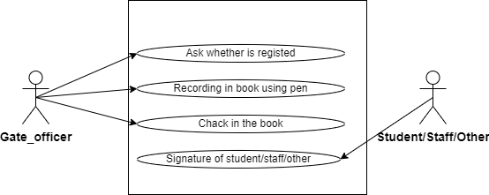
Figure 1: Use Case diagram of the existing system
Figure 2 presents a flowchart of the existing system. A flowchart provides a step-by-step visual representation of a process or workflow; here it outlines the major steps involved in the current manual gate-checking operation, from recording a device on entry to verifying and releasing it on exit.
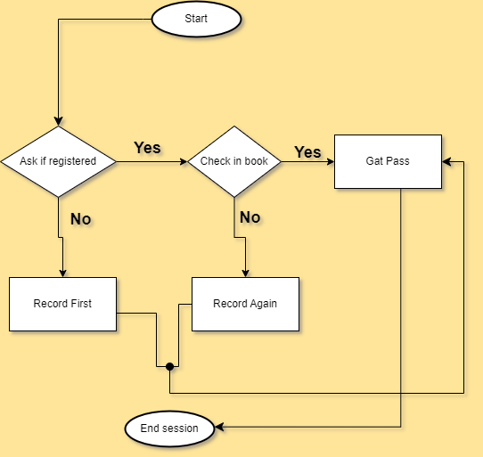
Figure 2: Flow chart of the existing system

4.5.1 Problem with the existing system
The analysis of the existing system revealed several challenges that affect effective device tracking at the campus gate:
- Finding a previously registered device and its owner among scattered notebooks is difficult and time-consuming.
- Recorded data is easily lost because entries are kept in different books, often managed apart and by different people.
- The unorganized, mixed record-keeping process increases the likelihood of unexpected errors and inconsistencies.
- Paper records are vulnerable to physical damage and take up significant storage space.
- Verifying a device at exit relies entirely on manual cross-checking, which is slow and error-prone.
These problems reduce the reliability of gate security checks and negatively affect the efficiency of the entry and exit process for students, staff, and guests.

4.6 Description of the new system
The proposed system is a web-based System for Personal Computer Checks Using QR Codes, designed to centralize the recording and verification of personal computers entering and leaving UTB Rubavu Campus. The system provides gate staff and administrators with a single point of access to device records, allowing devices to be registered on entry, matched against a generated QR code, and verified on exit by scanning that code.
The system allows authorized users to register a device and its owner's details, generate a unique QR code for that device, scan the QR code at exit to confirm a match, and maintain a log of all actions performed for accountability and reporting purposes.

4.6.1 Modules description
The proposed system consists of the following modules:

4.6.1.1 User Management Module
This module manages user accounts and access control, with the following functions:
- User login and logout
- Password management
- User profile management
- Role assignment (Administrator, Gate Officer)
This ensures secure access to the system and allows different users to perform only the activities they are authorized to carry out.

4.6.1.2 Computer Registration Module
This module manages the registration of personal computers and their owners as they enter the institution. It includes:
- Register a computer's serial number and model
- Capture owner's name and contact/owner number
- Record the date the device was registered
- Edit or update a device record
This module provides an accurate, centralized record of every device entering the campus, replacing the paper notebooks used in the existing system.

4.6.1.3 QR Code Generation and Verification Module
This module generates and verifies the QR code associated with each registered device. Its functions include:
- Generate a unique QR code linked to a device's record on registration
- Print the generated QR code for the device or its owner
- Scan a QR code at the exit gate using a smartphone camera or scanner app
- Match scanned data against the stored device record to confirm identity
This module is central to the system, as it replaces manual cross-checking with an automated, reliable verification step at the gate.

4.6.1.4 Logs and Reporting Module
This module records every action performed on a device record and supports reporting for management purposes. Its functions include:
- Log each registration, verification, and exit action with a timestamp
- Record comments or remarks on an action
- Generate reports on devices registered, verified, or flagged over a given period
This module supports accountability at the gate and provides administrators with insight into device movement and system usage.

4.6.2 System configurations and technology
This section outlines the hardware and software requirements needed to develop and operate the System for Personal Computer Checks Using QR Codes.
Table 1: Hardware specification
Item | Requirement
Computer | Required to run the system at the gate
Printer | Required for printing the generated QR codes
Smartphone | Required for scanning QR codes, using a QR-code scanner app or a built-in camera

Table 2: Software specification
Software | Purpose
MySQL | Free, open-source Relational Database Management System (RDBMS) using SQL, used to insert, select, delete, and update captured information
XAMPP | Free, open-source cross-platform web server solution used to host the system locally
PHP (with PDO) | Backend development
JavaScript | Client-side interaction on the backend/frontend
HTML | Defines the content/structure of the system's pages
Bootstrap | CSS framework responsible for responsive design and browser compatibility on the front end

4.7 Illustration of new system
This project focused on understanding what the System for Personal Computer Checks Using QR Codes must do and how it should solve the problems identified in the existing manual gate-checking process. At this stage, emphasis was placed on identifying user needs, system inputs and outputs, data flow, and overall system behaviour.
System design follows system analysis and explains how the proposed system was built to meet the identified requirements. This includes defining the structure of the system, breaking it into smaller components, and deciding how these components interact with one another. The design phase translates the system requirements into a form that can be implemented using the chosen technologies.

4.7.1 Functional Diagram
A functional diagram is used to represent the main functions of the System for Personal Computer Checks Using QR Codes and how users interact with them. It shows the sequence of actions performed by the system and the relationships between different system functions.
In this project, the functional diagram illustrates how gate officers and administrators interact with the platform. Gate officers register devices on entry, generate and print QR codes, and scan codes at exit to verify a match. Administrators manage user accounts, review logs, and generate reports on device activity.
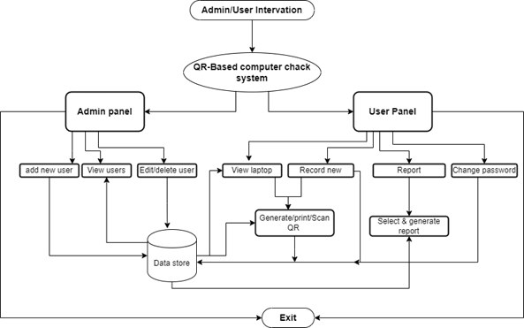
Figure 3: Functional Diagram

4.7.1.1 Data Flow Diagram
A Data Flow Diagram (DFD) is a graphical representation of how data moves through a system. It shows where data comes from, how it is processed, where it is stored, and where it goes. It does not represent control flow, loops, or decision rules; those are better captured in a flowchart. It is a useful tool for communicating with users, managers, and other personnel, and for analysing both existing and proposed systems. [8]

4.7.1.1.1 DFD Level 0
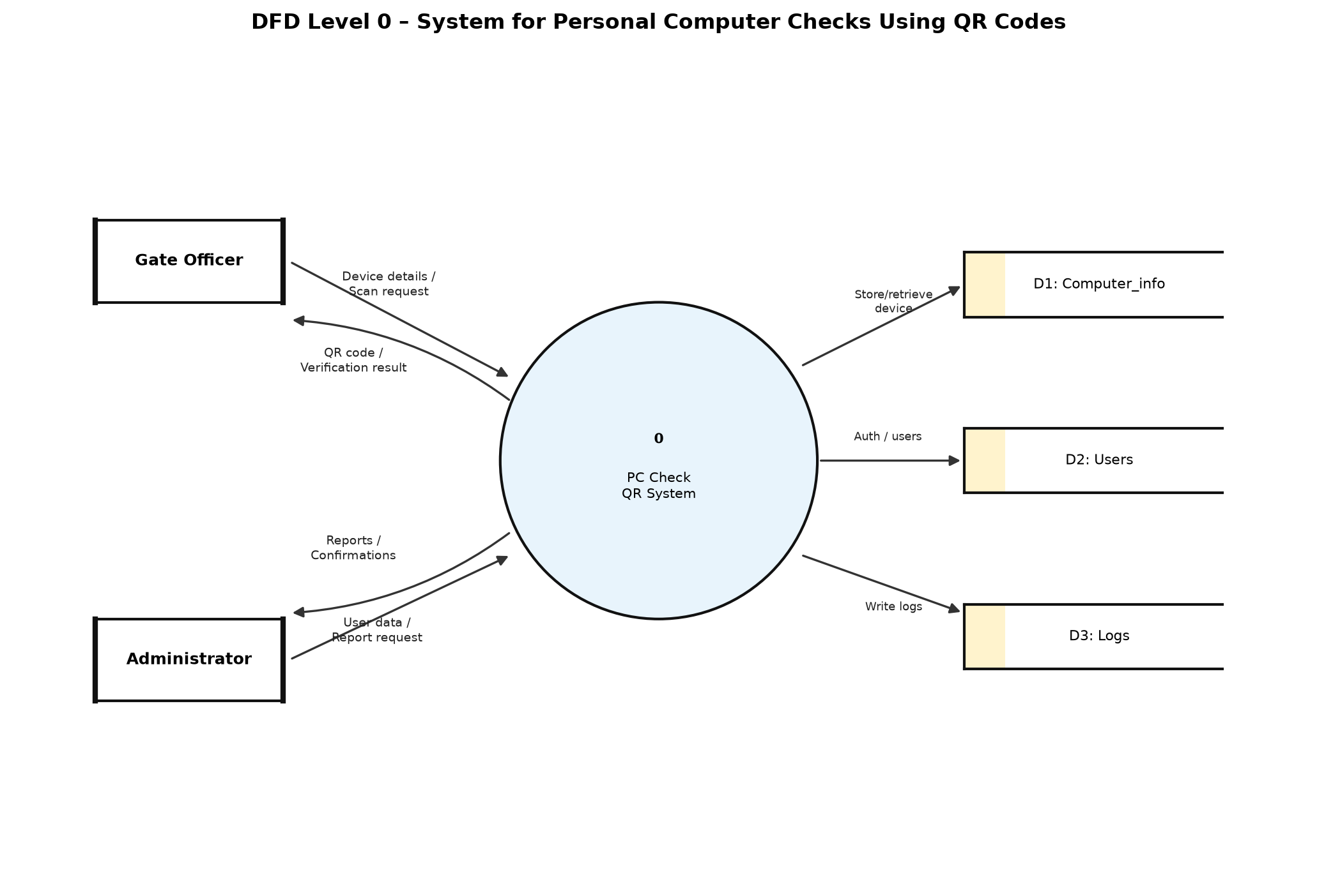
Figure 4: DFD Level 0
The diagram above represents the Data Flow Diagram (DFD) Level 0 for the System for Personal Computer Checks Using QR Codes. It provides a high-level view of how data flows within the system and how different users interact with it. At this level, the entire system is represented as a single process.
There are two main external entities involved in the system: the Gate Officer and the Administrator. Gate officers interact with the system to register devices, generate QR codes, and verify devices at exit. Administrators interact with the system to manage users, review device logs, and generate reports.
The data flow in this DFD illustrates the exchange of information between users and the main system process, including device registration details, generated QR-code data, scan/verification requests, and the responses generated by the system. The DFD Level 0 helps in understanding the overall system boundaries and the general flow of data from input to output.

4.7.1.1.2 DFD Level 1
A DFD Level 1 provides a more detailed view of how data flows within a system by expanding the single process shown in DFD Level 0 into multiple sub-processes, data stores, and data flows.
In the System for Personal Computer Checks Using QR Codes, the DFD Level 1 breaks the system down into core processes such as registering a device, generating a QR code, scanning and verifying a device at exit, logging actions, and administrator authentication. The DFD Level 1 consists of four main components:
- External Entities: users or systems outside the platform that interact with it — in this system, Gate Officers and Administrators.
- Processes: system activities that transform input data into output, such as registering a device, generating a QR code, and verifying a scanned code.
- Data Flows: show how data moves between external entities, processes, and data stores in a specific direction.
- Data Stores: locations where data is stored for later use, such as the Computer_info, Users, and Logs tables.
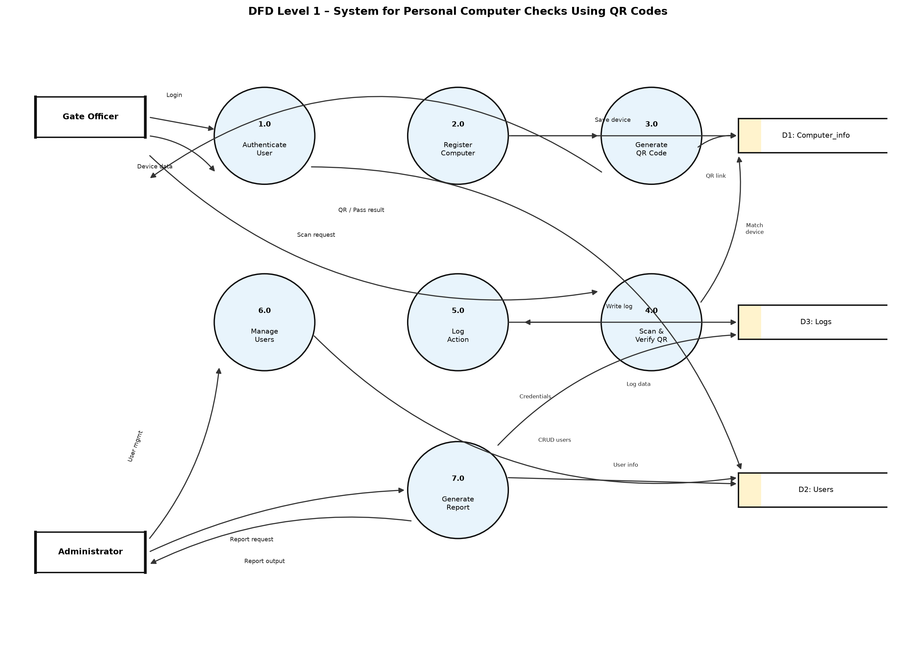
Figure 5: DFD Level 1
The diagram above illustrates how data will flow throughout the System for Personal Computer Checks Using QR Codes, from device registration through to verification at exit, and how gate officers and administrators interact with the system's internal processes.
Additionally, Figure 6 below is a flowchart which illustrates how UTB Rubavu Campus will use the System for Personal Computer Checks Using QR Codes in operation. It shows clearly how information flows within the system, and how users and administrators interact with it.
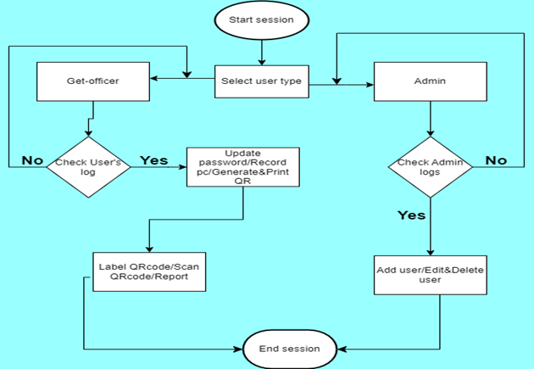
Figure 6: Flow chart of the new system

4.7.2 Use Case
A Use Case Diagram is a UML diagram that illustrates the interactions between actors and a system, showing the services (use cases) the system provides and who uses them. Figure 7 below shows the use case diagram for the System for Personal Computer Checks Using QR Codes, depicting the interactions between gate officers, administrators, and the system.
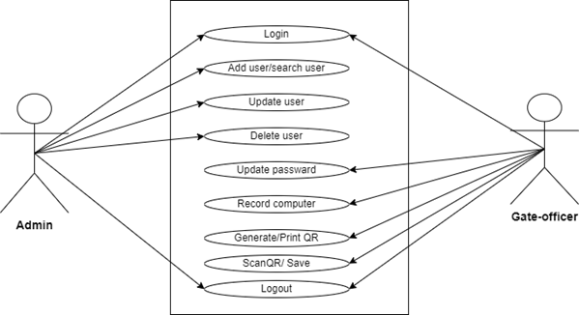
Figure 7: Use case diagram of the proposed system

4.7.3 Normalization
Normalization is the process of organizing data in a database to reduce data redundancy (duplication) and improve data integrity. It involves dividing large tables into smaller, related tables and defining relationships between them. Its objectives are to eliminate data redundancy, avoid data inconsistency, improve data integrity, simplify database maintenance, and reduce update, insertion, and deletion anomalies. The Computer_info, Users, and Logs tables of the proposed system were assessed against the following normal forms.

4.7.3.1 First Normal Form (1NF)
A table is in 1NF if each column contains atomic (indivisible) values, there are no repeating groups or multivalued attributes, and each record is unique. The Computer_info, Users, and Logs tables satisfy 1NF, as each field (for example sn, model, owno, owname, and date) holds a single, indivisible value, and each record is uniquely identified by a primary key (id or log_id).

4.7.3.2 Second Normal Form (2NF)
A table is in 2NF if it is already in 1NF and all non-key attributes are fully dependent on the entire primary key. Since each of the three tables uses a single-column primary key (id or log_id) rather than a composite key, every non-key attribute is fully dependent on that key, satisfying 2NF.

4.7.3.3 Third Normal Form (3NF)
A table is in 3NF if it is already in 2NF and there are no transitive dependencies, meaning non-key attributes should not depend on other non-key attributes. In the proposed design, attributes such as owname and owno depend directly on the device record identified by id, and not on any other non-key attribute, satisfying 3NF.

4.7.3.4 Boyce-Codd Normal Form (BCNF)
BCNF is a stronger version of 3NF: a table is in BCNF if, for every functional dependency, the determinant is a candidate key. BCNF eliminates certain anomalies that may still exist in 3NF. The Computer_info, Users, and Logs tables were reviewed and found to meet this condition, since sn and nid, which could otherwise determine other attributes, are themselves defined as unique keys.

4.7.4 Data Dictionary
A data dictionary, also called a metadata repository, is a centralized description of the data used in a system. It explains what each piece of data means, how it is stored, how it is used, and how it relates to other data. A data dictionary is important because it helps developers, system administrators, and system users understand the database structure and maintain consistency across the system.
Since the System for Personal Computer Checks Using QR Codes uses a database to store device, user, and activity-log information, the data dictionary below describes the main entities used in the system and their attributes. The entities include: Computer_info, Users, and Logs.
Table 3: Computer_info table
Field | Meaning | Data Type | Size | Description / Function
id | Device identification | Int | 50 | Primary key, uniquely identifies each registered computer
sn | Serial number | varchar | 20 | Unique identifier printed/encoded on the device's QR code
model | Device model | varchar | 30 | Stores the model details of the computer
owno | Owner's number | varchar | 30 | Stores the owner's contact number
owname | Owner's name | varchar | 30 | Stores the name of the device owner
date | Date of record | Date | — | Stores the date the device was registered

Table 4: Users table
Field | Meaning | Data Type | Size | Description / Function
id | User identification | Int | 10 | Primary key, uniquely identifies each system user
user_type | Role | varchar | 30 | Stores the user's role (Administrator, Gate Officer)
nid | User's number | varchar | 20 | Unique national/staff identification number
names | Names | varchar | 50 | Stores the full name of the user
email | Email | varchar | 60 | Used for login and user identification
password | Password | varchar | 200 | Stores the user's hashed password

Table 5: Logs table
Field | Meaning | Data Type | Size | Description / Function
log_id | Log identification | Int | 11 | Primary key, uniquely identifies each log entry
sn | Serial number | varchar | 20 | References the device's serial number
model | Model | varchar | 40 | Stores the model of the device involved in the action
owno | Owner number | varchar | 20 | Stores the owner's contact number
owname | Owner names | varchar | 80 | Stores the name of the device owner
action | Action done | varchar | 50 | Stores the action performed (e.g., registered, verified, exited)
comment | Short comment | varchar | 100 | Stores any remark made by the gate officer
date | Current time | timestamp | — | Stores the date and time the action occurred

4.7.5 Entity Relationship Diagram
An Entity Relationship Diagram (ERD) is a graphical representation that shows how data is organized in a database and how different entities are related. It helps in designing the database structure by identifying the main entities, their attributes, and the relationships between them.
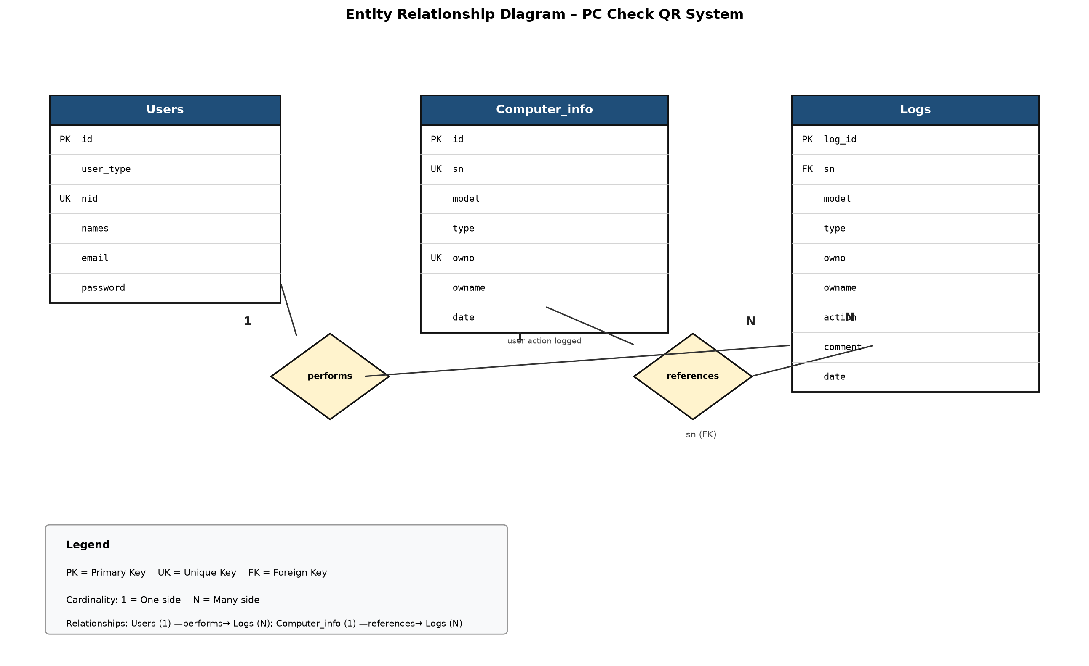
Figure 8: Entity Relationship Diagram
The diagram above represents the ER model of the System for Personal Computer Checks Using QR Codes. It describes the main entities involved in the system — Users, Computer_info, and Logs — along with their relationships, such as a user performing an action that is recorded in the logs, and a log entry referencing the device it relates to. The ERD provides a clear understanding of how device and user information is stored and linked within the database, supporting efficient data management and consistent implementation of backend operations.

4.8 Architecture design of the new system

4.8.1 System Architecture
The proposed System for Personal Computer Checks Using QR Codes for UTB Rubavu Campus adopts a Three-Tier Architecture consisting of the Presentation Layer, Application Layer, and Database Layer. This architecture promotes scalability, maintainability, security, and efficient data management.
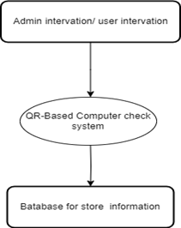
Figure 9: Three-Tier System Architecture
1. Presentation Layer (Client Layer)
This is the user interface through which gate officers and administrators interact with the system. It provides web pages for registering devices, generating and printing QR codes, and reviewing logs and reports. Technologies used are HTML, Bootstrap, and JavaScript, supporting the following functions:
- User registration and login
- Registering a personal computer at entry
- Generating and printing a device's QR code
- Scanning and verifying a QR code at exit
- Viewing logs and reports
2. Application Layer (Business Logic Layer)
This layer processes requests from users and applies business rules before interacting with the database. The technology used is PHP with PDO, and its functions include:
- User authentication and authorization
- Device registration and record management
- QR code generation and verification logic
- Logging of actions performed at the gate
- Report generation
- Data validation
3. Database Layer (Data Layer)
This layer stores and manages all system data. The technology used is the MySQL Database Management System, hosted locally through XAMPP, which stores data such as user accounts, registered computers, and activity logs.

