
UNIVERSITY OF TOURISM, TECHNOLOGY AND BUSINESS STUDIES


P.O.BOX: 350 Kigali – Rwanda

TOURISM PROMOTION PLATFORM OF GABON
A CASE STUDY: OGOOUE MARITIME PROVINCE

Submitted by:

xxx (28…..)
&
yyy (23…….)

Under the supervision and Guidance of Mr. DUSABE Yves

A dissertation submitted to:

Department of Business Information Technology in partial fulfillment of the requirements for the award of the Bachelor’s Degree in Business Information Technology.

July, 2026

DECLARATION
This research study is our original work and has not been presented to any other Institution. No part of this research should be reproduced without the authors’ consent or that of University of Tourism, Technology, and Business studies.

Student’s Name: Student’s Name: Ahadi Bashali CÉCILE
Signature: ……………………… Signature:………………………………

DEDICATION
This thesis is respectfully dedicated to the Almighty God, whose endless grace, wisdom, strength, and guidance have enabled us to complete this academic journey successfully.
We dedicate this work to our beloved parents and families for their unconditional love, continuous encouragement, sacrifices, prayers, and unwavering support throughout our education. Their belief in our abilities has been our greatest source of motivation.
We also dedicate this work to our lecturers and academic mentors whose knowledge, guidance, and dedication have greatly contributed to our personal and professional growth.
Finally, this thesis is dedicated to our friends, classmates, and all future researchers who may find this work useful in advancing knowledge and improving computer asset management systems through modern technologies such as QR codes

ACKNOWLEDGEMENT
Throughout the process of preparing and completing this project, we have received many assistances and guidance from various parties. Without these individuals who are willing to share their experiences and time to help us, we may not have completed the project on time or in better quality. Thus, in this section, we would like to express our heartfelt gratitude to all of these individuals who had supported us.
Firstly, we would like to thank the Almighty God who has granted better life to us, we thank our supervisor Mr. DUSABE Yves, we thank Lecturer Noah Nambale who has guided us on how to prepare high quality arrangement and implementation of the project. They had also inspired us with their ideas on how to further enhance the application, which is being developed.
Next, we would also like to thank our family members who have constantly provided us financial and mental support especially during hard times. Without their encouragement, we may not be able to withstand the stress being faced and eventually become demotivated.
Besides, we would also like to express our appreciation to friends who are willingly to spend their time for being models of our project.
Finally, yet importantly, we would also like to thank the department of Information Technology for providing facilities such as computer labs and internet connection, which had facilitated our progress toward finishing the project.
May the Almighty God bless you all!

LIST OF SYMBOLS, ACRONYMS AND ABBREVIATIONS
DBMS : Database Management System
DFD : Data Flow Diagram
ICT : Information and Communication Technology
IT : Information Technology
PC : Personal Computer
PDO : PHP Data Objects
PHP : Hypertext Preprocessor
QR : Quick Response
SDLC : Software Development Life Cycle.
UTB : University of Tourism, Technology and Business Studies
XAMPP : Cross-Platform Apache MySQL PHP and Perl.

LIST OF FIGURES
Figure 1: Use Case diagram of the existing system 21
Figure 2: Flow chart of the existing system 22
Figure 3: Functional Diagram 26
Figure 4: DFD Level 0 26
Figure 5: DFD Level 1 28
Figure 6: Flow chart of the new system 29
Figure 7: Use case diagram of the proposed system 29
Figure 8: Entity Relationship Diagram 33
Figure 9: Three-Tier System Architecture 34
Figure 10: Home Page Interface 37
Figure 11: Login Page 38
Figure 12: Admin Dashboard 38
Figure 13: View Users Page 39
Figure 14: Add Users Page 39
Figure 15: Gate Officer Dashboard 40
Figure 16: Record Computers Page 40
Figure 17: View Laptops / Registered Computers Page 41
Figure 18: Reports Module 42
Figure 19: Change Password Page 42

LIST OF TABLES
Table 1: Hardware specification 24
Table 2: Software specification 24
Table 3: Computer_info table 31
Table 4: Users table 31
Table 5: Logs table 32
Table 6: Technology used 36

TABLE OF CONTENTS
DECLARATION ii
ABSTRACT xiii
Key Terms xiii
CHAPTER ONE: GENERAL INTRODUCTION 1
1.1 Introduction 1
1.2 Background of the Study 2
1.3 Problem Statement 3
1.4 Objectives 4
1.4.1 General Objective 4
1.4.2 Specific Objectives 5
1.4.3 Research Questions 5
1.5 Significance of the Study 6
1.5.1 For Security Officers 6
1.5.2 For the Institution 6
1.5.3 For Students and Staff 6
1.5.4 For Researchers and Future Developers 6
1.6 Scope of the Project 7
1.7 Organization of the Project 8
CHAPTER TWO: LITERATURE REVIEW 10
2.0 Introduction 10
2.1 Definition of Key Concepts 10
2.1.1 Computer 10
2.1.2 Computer Asset Management 10
2.1.3 Quick Response (QR) Code 10
2.1.4 QR Code Scanner 11
2.1.5 Database Management System (DBMS) 11
2.1.6 Information System 11
2.1.7 Monitoring 11
2.1.8 Security 11
2.1.9 Reporting System 11
2.1.10 Entity 12
2.1.11 Primary Key 12
2.1.12 Foreign Key 12
2.2 Literature Review 12
2.2.1 QR Code-Based Computer Monitoring Systems 12
2.2.2 Computer Asset Management Systems 12
2.2.3 Database Systems for Asset Management 12
2.2.4 Reporting Systems 13
2.2.5 Existing Manual Computer Checking Systems 13
2.3 Conceptual Model of the Study 13
2.4 Summary of the Chapter 14
CHAPTER THREE: RESEARCH METHODOLOGY 15
3.0 Introduction 15
3.1 Research Design 15
3.2 Population and Sample Selection 15
3.3 Data Collection Tools 16
3.3.1 Observation 16
3.3.2 Interviews 16
3.3.3 Documentation 16
3.4 Data Collection 16
3.4.1 Primary Data 17
3.4.2 Secondary Data 17
3.5 Data Analysis 17
3.5.1 Editing 17
3.5.2 Coding 17
3.5.3 Requirement Analysis 17
3.6 System Development Methodology 18
3.6.1 Requirement Analysis 18
3.6.2 System Design 18
3.6.3 System Development 18
3.6.4 System Testing 18
3.6.5 System Deployment and Maintenance 18
3.7 Validity and Reliability 18
3.7.1 Validity 18
3.7.2 Reliability 19
3.8 Ethical Considerations 19
CHAPTER FOUR: SYSTEM ANALYSIS AND DESIGN 20
4.1 Introduction 20
4.2 Data analysis and presentation 20
4.3 Interpretation of findings/results 20
4.4 Summary of proposed system 20
4.5 Description of existing system 21
4.5.1 Problem with the existing system 22
4.6 Description of the new system 22
4.6.1 Modules description 23
4.6.1.1 User Management Module 23
4.6.1.2 Computer Registration Module 23
4.6.1.3 QR Code Generation and Verification Module 23
4.6.1.4 Logs and Reporting Module 24
4.6.2 System configurations and technology 24
4.7 Illustration of new system 25
4.7.1 Functional Diagram 25
4.7.1.1 Data Flow Diagram 26
4.7.1.1.1 DFD Level 0 26
4.7.1.1.2 DFD Level 1 27
4.7.2 Use Case 29
4.7.3 Normalization 30
4.7.3.1 First Normal Form (1NF) 30
4.7.3.2 Second Normal Form (2NF) 30
4.7.3.3 Third Normal Form (3NF) 30
4.7.3.4 Boyce-Codd Normal Form (BCNF) 30
4.7.4 Data Dictionary 30
4.7.5 Entity Relationship Diagram 33
4.8 Architecture design of the new system 34
4.8.1 System Architecture 34
CHAPTER FIVE: IMPLEMENTATION, CODING AND TESTING 36
5.1 Implementation and coding 36
5.1.1 Introduction 36
5.1.2 Description of implementation Tools and technology 36
5.1.3 Screen Shots 37
5.1.4 Source Codes 42
5.2 Testing 46
5.2.1 Introduction 46
5.2.2 Objective of Testing 46
5.2.3 Unit testing outputs 46
5.2.4 Validation testing outputs 47
5.2.5 Integration Testing Outputs 47
5.2.6 Functional and system testing Results 48
5.2.7 Acceptance Testing Report 48
CHAPTER SIX: CONCLUSION AND RECOMMENDATIONS 49
6.1 Conclusion 49
6.2 Recommendations 49
REFERENCES 52
APPENDICES 53

ABSTRACT
In our daily life in different institutions or companies they use to record different electronic devices that are brought inside manually, our main focus is personal computers (laptops). This kind of recording becomes difficult in different ways and that’s why we have chosen to develop system that will be helpful in such daily activity done different times.
Computer checking, within the context of monitoring computers entering and exiting an institution using QR codes, involves the systematic monitoring of computer assets through digital means. In this scenario, each computer is assigned a unique QR code containing comprehensive information about the device, such as its model, serial number, and assigned user.
The decision to implement a computer checking system utilizing QR codes within the institution stems from the recognized need for improved, maximize security, inventory management and asset monitoring processes. Historically, the institution may have encountered challenges related to the manual checking of computer assets, including discrepancies in inventory records, difficulty in locating specific devices, and delays in responding to maintenance or service requests.

Key Terms
- Automated system: A system that uses technology to perform tasks without human intervention. In the context of this project, an automated system refers to the QR code-based monitoring system that records the entry and exit of computers.
- Computer checking: The process of verifying and recording the movement of computers into and out of a specific location. This involves monitoring personal computers as they enter and exit an institution to ensure accurate monitoring and security.
- QR codes: Quick Response (QR) codes are a type of matrix barcode that can store a significant amount of information and can be read quickly by a scanner.
  - Each computer is assigned a unique QR code containing details like model, serial number, and assigned user for monitoring purposes.
- Laptops: Portable personal computers with a screen and alphanumeric keyboard, designed for mobile use. Laptops are a specific type of personal computer that will be checked using the QR code system.

- Institutional Asset Management: The process of managing and maintaining an institution's physical assets, ensuring they are used efficiently and maintained properly. The QR code monitoring system assists in managing the institution's assets, particularly computers, by providing accurate monitoring and maintenance records.

CHAPTER ONE: GENERAL INTRODUCTION

1.1 Introduction
System for personal computers checks using QR codes is an automated system that operates in UTB Rubavu Campus on the Main Gate. This system helps in monitoring and recording: The computers coming inside the UTB Rubavu Campus and the computers going out of UTB Rubavu Campus.
Although there are systems in place at many businesses and organizations to regulate and oversee the security of the equipment that workers bring to work each day, our attention is directed toward technology like laptops and phones.
This material management strategy is used to determine theft, which may lead to issues for the institution if someone took something that wasn't rightfully theirs. Following completion, each device's attributes are documented, and upon entry or exit, the user can view the data they are gathering and the data that will be recorded. These days, with all the technological breakthroughs, there are a lot more ways to use technology, such QR codes, scanners, and other tools.
QR code (abbreviated from Quick Response Code) is the trademark for a type of matrix barcode (or two-dimensional bar code) first designed for the automotive industry in Japan. Bar codes are optical machine-readable labels attached to items that record information related to the item. It was initially patented; however, its patent holder has chosen not to exercise those rights. Recently, the QR Code system has become popular outside the automotive industry due to its fast readability and greater storage capacity compared to standard UPC barcodes. The code consists of black modules (square dots) arranged in a square grid on a white background. The information encoded may be made up of four standardized types ("modes") of data (numeric, alphanumeric, byte / binary, Kanji) or, through supported extensions, virtually any type of data A QR code, as shown in Figures is read by an imaging device, such as a camera, and formatted algorithmically by underlying software using Reed-Solomon error correction until the image can be appropriately interpreted. Data is then extracted from patterns present in both horizontal and vertical components of the image.

1.2 Background of the Study
Normally in UTB Rubavu Campus on the Main Gates, they use to record computers coming inside every day and verify it when it goes outside. The way used is concerning manual system which uses pens and books.
Computer refers to the electronic device that receives data, process them, give the output and store the information. Monitoring can have more meanings in accordance with the domain, but here we refer it as a process of checking the personal computers which entering and exiting an institution.
Computer monitoring, within the context of monitoring computers entering and exiting in UTB Rubavu Campus using QR codes, involves the systematic monitoring of computer assets through digital means. In this scenario, each computer is assigned a unique QR code containing comprehensive information about the device, such as its make, model, serial number, and assigned user.
The decision to implement a computer monitoring system utilizing QR codes within the UTB Rubavu Campus stems from the recognized need for improved inventory and security management and asset monitoring processes.
This system will automate the process of recording and monitoring computers as they enter and exit the institution. Each computer will be assigned a unique QR code that, when scanned, will automatically update the inventory database with relevant details such as the time of entry or exit, and the identity of the user. This automation will significantly reduce the time and effort required for manual record-keeping, minimize human errors, and provide real-time updates on the status and location of each device.

1.3 Problem Statement
Historically, UTB Rubavu Campus had encountered challenges related to the manual checking of computer assets that pose several challenges such as time-consuming data entry processes lead to inefficiencies, manual errors in recording computer details result in inaccuracies, difficulty in accessing real-time information about computer assets, lack of a standardized system for identifying and monitoring computers, limited ability to retrieve detailed information about computers quickly.
To address these challenges, we proposed the development of "System for personal computers checks using QR codes" that streamlines the process of recording, monitoring, and keep logs for each computer entering or leaving the institution.

1.4 Objectives

1.4.1 General Objective
The general objective of this project is to enhance the efficiency and accuracy of computer asset management at UTB Rubavu Campus by implementing System for personal computers checks using QR codes. This system the recording of personal computers entering and exiting the
institution, thereby improving inventory management, reducing discrepancies, and facilitating timely maintenance and service responses.

1.4.2 Specific Objectives
Our proposed solution is to develop a system for personal computers checks using QR-codes that addresses the challenges mentioned above. The specific objectives involve the following key components:
      - To record computer’s information such as serial number, model, and the owner’s information into a centralized database.
      - To generate a unique QR code for each computer, containing all relevant information of it.
      - To print and attach the generated QR code to the computers respectively.
      - To allow users to scan the QR code using a mobile device or dedicated scanner, instantly retrieving detailed information about the computer, and keep logs.

1.4.3 Research Questions
- How can a QR code-based system improve the efficiency of recording and monitoring personal computers entering and leaving UTB Rubavu Campus?
- To what extent does the implementation of a QR code-based computer checking system reduce errors and enhance the security of computer asset management compared to the existing manual system?
- How effective is the proposed QR code-based system in providing accurate, real-time tracking and reporting of personal computers within the institution?
held in the centralized system, maintaining accuracy and security. The scope of this project covers the entire lifecycle of the QR code system, from data collection and QR code generation to practical application and verification, thereby enhancing the efficiency and reliability of computer asset management at the institution.

1.5 Significance of the Study
This study is significant to various stakeholders involved in computer asset management and institutional security. The proposed System for Personal Computers Checks Using QR Codes is expected to improve the efficiency, accuracy, and security of monitoring personal computers entering and leaving the institution.

1.5.1 For Security Officers
Firstly, this study will benefit security officers by providing a fast and efficient method of verifying and monitoring personal computers through QR code scanning. The system eliminates the need for manual record-keeping, reduces human errors, and enables security personnel to retrieve computer information instantly. This will improve access control and enhance the overall security of the institution.

1.5.2 For the Institution
Secondly, the study will benefit the institution by introducing a centralized computer asset management system that securely stores and manages computer records. The system will improve inventory management, facilitate real-time monitoring of computers entering and leaving the campus, and reduce the risk of theft, data loss, and inaccurate records. It will also support better decision-making through reliable and accessible records.

1.5.3 For Students and Staff
Thirdly, the study will benefit students and staff by ensuring that their personal computers are accurately identified and securely monitored while entering and exiting the institution. The QR code-based verification process will reduce delays at the main gate, increase confidence in the institution's security procedures, and provide a reliable method for confirming ownership of computer devices.

1.5.4 For Researchers and Future Developers
Finally, this study will contribute to the academic community and future researchers by providing knowledge on the application of QR code technology in computer asset management and institutional security. It will serve as a valuable reference for future studies related to asset tracking systems, QR code applications, inventory management, and the development of secure digital monitoring systems in educational institutions and other organizations.
1.6 Scope of the Project
The research work is focused on developing and implementing a system for personal computers checks using QR codes for computer asset management at UTB Rubavu Campus. The primary goal is to generate QR codes for each computer, which can be scanned to display and verify the hidden information.
This project involves several key activities. First, it includes recording of computer’s information, such as serial number, model, and the owner’s information, which are stored in a centralized database. Next, unique QR codes are generated for each computer, encapsulating all relevant information about the device. These QR codes are then printed and fixed to the respective computers.
Furthermore, the project enables users to scan the QR codes using mobile devices or dedicated scanners to instantly retrieve and verify detailed information about the computers. This scanning process ensures that the information displayed matches the data

1.7 Organization of the Project
This project is divided into six chapters where chapter one is General Introduction; it gives the general description of the work, it includes an introduction, the background of the study, Statement of the problem, the objectives of the work, scope of the project and the significant of the project.
Finally, there’s chapter six which concerns to the Conclusion and Recommendations related to the objectives and their results of the project.

CHAPTER TWO: LITERATURE REVIEW

2.0 Introduction
This chapter reviews the existing literature related to computer asset management systems, Quick Response (QR) code technology, database management systems, and information systems used for monitoring institutional assets. The review provides theoretical and empirical knowledge that supports the design and implementation of the proposed QR code-based computer checking system. The chapter is organized according to the objectives of the study and covers key concepts, related literature, the conceptual model, and a summary of the chapter.

2.1 Definition of Key Concepts

2.1.1 Computer
A computer is an electronic device that accepts data as input, processes it according to predefined instructions, stores it, and produces meaningful information as output. Personal computers, commonly referred to as laptops, are portable computing devices widely used in educational institutions and organizations for academic and administrative activities.

2.1.2 Computer Asset Management
Computer asset management refers to the systematic process of recording, monitoring, maintaining, and controlling computer equipment throughout its lifecycle. Effective asset management helps organizations reduce losses, improve accountability, and maintain accurate inventory records.

2.1.3 Quick Response (QR) Code
A Quick Response (QR) code is a two-dimensional barcode capable of storing large amounts of information that can be accessed quickly using smartphones or dedicated scanners. , QR codes enable fast identification, verification, and retrieval of information, making them suitable for inventory management and asset tracking.

2.1.4 QR Code Scanner
A QR code scanner is a software application or hardware device capable of reading and decoding information stored within QR codes. Modern smartphones normally include built-in QR code scanning functionality through their camera applications.

2.1.5 Database Management System (DBMS)
A Database Management System (DBMS) is software used to create, manage, retrieve, and manipulate data efficiently. [9] It provides secure storage of organizational information while minimizing redundancy and supporting fast retrieval of records.

2.1.6 Information System
An information system is a collection of interconnected components, including hardware, software, databases, people, and procedures, that work together to collect, process, store, and distribute information for decision-making and organizational operations.

2.1.7 Monitoring
Monitoring is the continuous observation and recording of activities or assets to ensure proper control, accountability, and security. In this study, monitoring refers to recording and verifying personal computers entering and leaving the institution.

2.1.8 Security
Security refers to the protection of organizational assets against unauthorized access, theft, misuse, or loss. In educational institutions, security measures are essential for safeguarding computers and other valuable equipment.

2.1.9 Reporting System
A reporting system is a software component that generates structured reports from stored data to assist users and management in monitoring operations and making informed decisions.

2.1.10 Entity
An entity is any real-world object such as a user, computer, or security officer about which information is stored in a database.

2.1.11 Primary Key
A primary key is a unique identifier assigned to every record in a database table to distinguish it from other records.

2.1.12 Foreign Key
A foreign key is an attribute that establishes a relationship between two database tables by referencing the primary key of another table.

2.2 Literature Review

2.2.1 QR Code-Based Computer Monitoring Systems
QR code technology has become one of the most widely adopted identification technologies due to its simplicity, low implementation cost, and high storage capacity. [3], [4] Researchers have demonstrated that QR codes improve asset identification by allowing instant retrieval of equipment information using smartphones or dedicated scanners. Educational institutions increasingly utilize QR codes to automate inventory management, reduce manual errors, and improve security.

2.2.2 Computer Asset Management Systems
Computer asset management systems are designed to monitor organizational computer resources throughout their operational lifecycle. [5], [7] These systems maintain information such as serial numbers, computer models, ownership details, maintenance history, and movement logs. Automated asset management significantly improves inventory accuracy compared to manual record-keeping methods.

2.2.3 Database Systems for Asset Management
Modern asset management systems depend on centralized databases to store and retrieve information efficiently. Relational databases such as MySQL and PostgreSQL provide secure storage, eliminate data redundancy, and support real-time access to computer records. Database systems also simplify report generation and improve data consistency.

2.2.4 Reporting Systems
Reporting systems transform stored operational data into meaningful reports that assist administrators in monitoring institutional assets. [10] Computer monitoring systems generate daily, weekly, monthly, and annual reports, enabling institutions to identify missing devices, monitor computer movement, and support decision-making.

2.2.5 Existing Manual Computer Checking Systems
Many educational institutions continue to rely on manual recording methods using books and paper registers to record computers entering and leaving campus. [7] Although simple to implement, manual systems suffer from numerous limitations including slow processing, data redundancy, human error, poor record retrieval, and increased security risks. These shortcomings justify the need for an automated QR code-based solution.

2.3 Conceptual Model of the Study
The proposed study is based on an Information System model consisting of three major components.
Input
- Computer information
- Owner information
- User credentials
- QR code requests
Process
- Computer registration
- QR code generation
- QR code scanning
- Data verification
- Log recording
- Database storage
- Report generation
Output
- Generated QR codes
- Verified computer information
- Entry and exit logs
- Daily, weekly, monthly, and annual reports
- Improved computer security and monitoring
The conceptual model demonstrates how computer information flows from registration through processing into meaningful reports that support institutional security and computer asset management. [10]

2.4 Summary of the Chapter
This chapter reviewed literature related to computer asset management, QR code technology, database management systems, reporting systems, and computerized monitoring systems. The review established that QR code technology provides an effective solution for improving the efficiency, accuracy, and security of computer asset management compared with traditional manual methods. The literature further highlighted the importance of centralized databases and automated reporting in supporting institutional decision-making. These findings provide the theoretical foundation for developing the proposed System for Personal Computers Checks Using QR Codes.

CHAPTER THREE: RESEARCH METHODOLOGY

3.0 Introduction
This chapter describes the methodology used to conduct the study and develop the proposed System for Personal Computers Checks Using QR Codes at UTB Rubavu Campus. It presents the research design, target population, data collection tools and methods, data analysis procedures, system development methodology, validity and reliability of the study, and ethical considerations. The purpose of this chapter is to explain how information was collected, analyzed, and utilized in designing and implementing the proposed system.

3.1 Research Design
This study adopted a mixed-methods research design by combining qualitative and quantitative research approaches. The qualitative approach was used to understand the challenges faced by security officers and users in monitoring personal computers entering and leaving the institution. The quantitative approach was used to analyze structured information collected during observation and documentation to determine the functional and non-functional requirements of the proposed system.
In addition, the study adopted the System Development Life Cycle (SDLC) using the Prototyping Model. The prototype enabled users to evaluate the proposed system during development, allowing continuous improvement through user feedback until the final system satisfied institutional requirements.

3.2 Population and Sample Selection
The target population for this study consisted of stakeholders involved in the computer checking process at UTB Rubavu Campus. These included:
- Security officers responsible for monitoring computers at the institution's gates.
- Students who regularly enter and leave the institution with personal computers.
- Academic and administrative staff.
- The Information Technology (IT) department responsible for managing institutional information systems.
The respondents were selected purposively because they are directly involved in the current computer checking process and possess the necessary information required for the study.

3.3 Data Collection Tools
The study employed the following data collection tools.

3.3.1 Observation
Observation was conducted at the main gate of UTB Rubavu Campus to understand how security officers currently record personal computers entering and leaving the institution. The researcher observed that the existing manual recording process consumed considerable time, was prone to human error, and made retrieval of records difficult. The observation provided valuable information for identifying system requirements.

3.3.2 Interviews
Interviews were conducted with security officers and selected institutional staff to gather first-hand information regarding the challenges encountered while using the existing manual computer checking system. The interviews revealed problems such as delays during verification, difficulty retrieving records, and risks associated with inaccurate manual recording.

3.3.3 Documentation
Document analysis was used to collect secondary information from books, journal articles, institutional reports, previous research projects, software engineering textbooks, and online resources related to QR code technology, computer asset management, and information systems. This technique provided theoretical support for the development of the proposed system.

3.4 Data Collection
Data were collected in two categories to ensure that sufficient information was obtained for system development.

3.4.1 Primary Data
Primary data were collected directly from respondents through observation and interviews. This information provided practical insights into the existing computer checking procedures, user requirements, operational challenges, and expectations regarding the proposed system.

3.4.2 Secondary Data
Secondary data were obtained through books, scholarly journals, conference papers, institutional documents, software development manuals, and reliable online resources. These sources provided theoretical knowledge, technological background, and best practices for QR code-based asset management systems.

3.5 Data Analysis
The collected data were analyzed systematically to identify system requirements and support decision-making during system development.

3.5.1 Editing
The collected information was carefully reviewed to identify and correct inconsistencies, omissions, and errors before analysis. This ensured completeness and accuracy of the collected data.

3.5.2 Coding
Relevant information obtained from interviews and observations was categorized according to research objectives and system requirements. Coding simplified data organization and facilitated interpretation during system analysis.

3.5.3 Requirement Analysis
After editing and coding, the researcher analyzed both functional and non-functional requirements of the proposed system. Functional requirements included computer registration, QR code generation, QR code scanning, report generation, and user management. Non-functional requirements included security, usability, reliability, performance, and maintainability.

3.6 System Development Methodology
The proposed system was developed using the Prototyping Model of the System Development Life Cycle (SDLC). The methodology consisted of the following phases:

3.6.1 Requirement Analysis
During this phase, information was gathered from stakeholders through observation, interviews, and documentation to identify user needs and system requirements.

3.6.2 System Design
The system architecture, database structure, user interfaces, data flow diagrams, use case diagrams, and entity relationship diagrams were designed before implementation.

3.6.3 System Development
The system was implemented using PHP, HTML, CSS, Bootstrap, JavaScript, and MySQL. QR code generation libraries were integrated to generate unique QR codes for each registered computer.

3.6.4 System Testing
The developed system underwent Unit Testing, Integration Testing, and User Acceptance Testing (UAT) to verify correctness, functionality, performance, and usability.

3.6.5 System Deployment and Maintenance
After successful testing, the system was deployed for use within UTB Rubavu Campus. Regular maintenance activities, including software updates, bug fixing, and system monitoring, were planned to ensure continuous and reliable operation.

3.7 Validity and Reliability

3.7.1 Validity
Validity refers to the extent to which the research instruments accurately measured the intended information. To ensure validity, the observation checklist and interview questions were reviewed by the project supervisor and refined before data collection. The collected data were also compared with existing institutional practices to ensure consistency.

3.7.2 Reliability
Reliability refers to the consistency of the research findings. Standardized observation procedures and structured interview questions were used to ensure that data collected from different respondents remained consistent and dependable.

3.8 Ethical Considerations
Ethical principles were observed throughout the study. Participation was voluntary, and respondents were informed about the purpose of the research before data collection. Confidentiality and anonymity of participants were maintained by ensuring that personal information was not disclosed without consent. All information collected was used strictly for academic purposes, and all referenced materials were properly cited to avoid plagiarism.

CHAPTER FOUR: SYSTEM ANALYSIS AND DESIGN

4.1 Introduction
This chapter presents the analysis and design of the proposed System for Personal Computer Checks Using QR Codes, developed for UTB Rubavu Campus. It discusses the analysis of the existing manual gate-recording system, the requirements identified for the new system, and the design of the proposed solution. The chapter also includes system modelling tools such as Use Case Diagrams, Data Flow Diagrams (DFDs), a Data Dictionary, Entity Relationship Diagrams (ERDs), database normalization, and the overall system architecture.

4.2 Data analysis and presentation
This section presents and analyses information gathered through observation of, and documentation review at, the UTB Rubavu Campus gate. The areas examined included the availability of records on laptops and personal computers entering and leaving the institution, the tools used to capture this information, the process followed by gate staff when verifying a returning device, and the challenges encountered in retrieving previously recorded data. The presentation methods used in this analysis include descriptive tables, process narratives, and diagrams (use case diagrams and flowcharts) illustrating how the current gate-checking process operates.

4.3 Interpretation of findings/results
The analysis of the existing gate-checking process revealed that device records are captured on paper in notebooks, which are frequently kept apart and sometimes managed by different personnel. This makes it difficult to locate a specific record when a device is due to exit, increases the risk of losing or damaging data, and leaves the process prone to human error and duplication. The findings indicate a clear need for a centralized, electronic system that can register devices at entry, generate a unique identifier for each device, and allow gate staff to verify a device quickly and accurately at exit using that identifier.

4.4 Summary of proposed system
The proposed System for Personal Computer Checks Using QR Codes was designed to replace the manual, paper-based recording process at UTB Rubavu Campus with an electronic, QR-code-based verification process. The system was implemented using HTML, Bootstrap, JavaScript, and PHP (with PDO) as the main development technologies, XAMPP as the local server environment, and MySQL as the database management system for data storage and management.
The study resulted in the development of a system capable of registering personal computers at the point of entry, generating a scannable QR code for each registered device, and enabling gate staff to verify a device's identity at exit by scanning its QR code against the stored record.

4.5 Description of existing system
The current system used at UTB Rubavu Campus is a manual, paper-based process in which notebooks are used to keep track of laptops and personal computers entering the institution. As described in the project background, this approach is outdated and exposes recorded data to risk of damage and loss. Records are also not easily kept or retrieved without consuming significant physical storage space, and the process is prone to errors and duplication.
When a student or guest returns to exit the campus, the gate worker must go back through the paper records to check whether the device being taken out matches one that was recorded on entry. Figure 1 below shows the use case diagram of the existing system, illustrating how students, guests, and gate workers interact with the paper-based process.
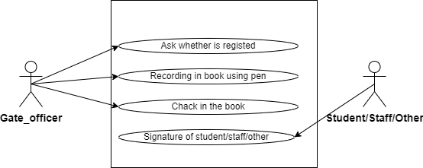
Figure 1: Use Case diagram of the existing system
Figure 2 presents a flowchart of the existing system. A flowchart provides a step-by-step visual representation of a process or workflow; here it outlines the major steps involved in the current manual gate-checking operation, from recording a device on entry to verifying and releasing it on exit.
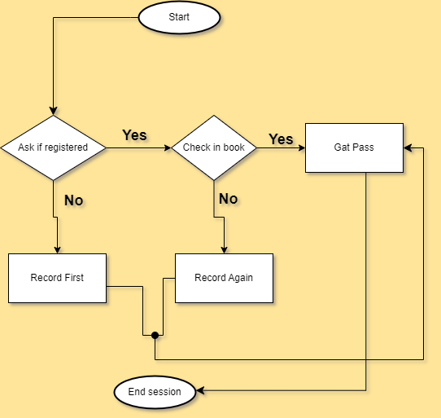
Figure 2: Flow chart of the existing system

4.5.1 Problem with the existing system
The analysis of the existing system revealed several challenges that affect effective device tracking at the campus gate:
- Finding a previously registered device and its owner among scattered notebooks is difficult and time-consuming.
- Recorded data is easily lost because entries are kept in different books, often managed apart and by different people.
- The unorganized, mixed record-keeping process increases the likelihood of unexpected errors and inconsistencies.
- Paper records are vulnerable to physical damage and take up significant storage space.
- Verifying a device at exit relies entirely on manual cross-checking, which is slow and error-prone.
These problems reduce the reliability of gate security checks and negatively affect the efficiency of the entry and exit process for students, staff, and guests.

4.6 Description of the new system
The proposed system is a web-based System for Personal Computer Checks Using QR Codes, designed to centralize the recording and verification of personal computers entering and leaving UTB Rubavu Campus. The system provides gate staff and administrators with a single point of access to device records, allowing devices to be registered on entry, matched against a generated QR code, and verified on exit by scanning that code.
The system allows authorized users to register a device and its owner's details, generate a unique QR code for that device, scan the QR code at exit to confirm a match, and maintain a log of all actions performed for accountability and reporting purposes.

4.6.1 Modules description
The proposed system consists of the following modules:

4.6.1.1 User Management Module
This module manages user accounts and access control, with the following functions:
- User login and logout
- Password management
- User profile management
- Role assignment (Administrator, Gate Officer)
This ensures secure access to the system and allows different users to perform only the activities they are authorized to carry out.

4.6.1.2 Computer Registration Module
This module manages the registration of personal computers and their owners as they enter the institution. It includes:
- Register a computer's serial number and model
- Capture owner's name and contact/owner number
- Record the date the device was registered
- Edit or update a device record
This module provides an accurate, centralized record of every device entering the campus, replacing the paper notebooks used in the existing system.

4.6.1.3 QR Code Generation and Verification Module
This module generates and verifies the QR code associated with each registered device. Its functions include:
- Generate a unique QR code linked to a device's record on registration
- Print the generated QR code for the device or its owner
- Scan a QR code at the exit gate using a smartphone camera or scanner app
- Match scanned data against the stored device record to confirm identity
This module is central to the system, as it replaces manual cross-checking with an automated, reliable verification step at the gate.

4.6.1.4 Logs and Reporting Module
This module records every action performed on a device record and supports reporting for management purposes. Its functions include:
- Log each registration, verification, and exit action with a timestamp
- Record comments or remarks on an action
- Generate reports on devices registered, verified, or flagged over a given period
This module supports accountability at the gate and provides administrators with insight into device movement and system usage.

4.6.2 System configurations and technology
This section outlines the hardware and software requirements needed to develop and operate the System for Personal Computer Checks Using QR Codes.
Table 1: Hardware specification
Item | Requirement
Computer | Required to run the system at the gate
Printer | Required for printing the generated QR codes
Smartphone | Required for scanning QR codes, using a QR-code scanner app or a built-in camera

Table 2: Software specification
Software | Purpose
MySQL | Free, open-source Relational Database Management System (RDBMS) using SQL, used to insert, select, delete, and update captured information
XAMPP | Free, open-source cross-platform web server solution used to host the system locally
PHP (with PDO) | Backend development
JavaScript | Client-side interaction on the backend/frontend
HTML | Defines the content/structure of the system's pages
Bootstrap | CSS framework responsible for responsive design and browser compatibility on the front end

4.7 Illustration of new system
This project focused on understanding what the System for Personal Computer Checks Using QR Codes must do and how it should solve the problems identified in the existing manual gate-checking process. At this stage, emphasis was placed on identifying user needs, system inputs and outputs, data flow, and overall system behavior.
System design follows system analysis and explains how the proposed system was built to meet the identified requirements. This includes defining the structure of the system, breaking it into smaller components, and deciding how these components interact with one another. The design phase translates the system requirements into a form that can be implemented using the chosen technologies.

4.7.1 Functional Diagram
A functional diagram is used to represent the main functions of the System for Personal Computer Checks Using QR Codes and how users interact with them. It shows the sequence of actions performed by the system and the relationships between different system functions.
In this project, the functional diagram illustrates how gate officers and administrators interact with the platform. Gate officers register devices on entry, generate and print QR codes, and scan codes at exit to verify a match. Administrators manage user accounts, review logs, and generate reports on device activity.
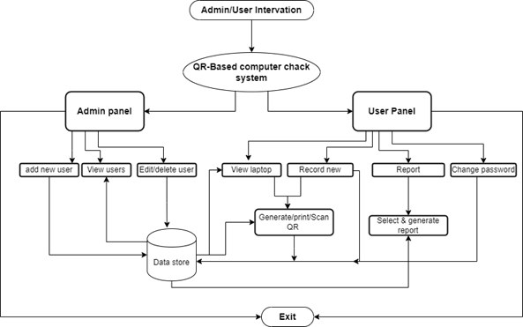
Figure 3: Functional Diagram

4.7.1.1 Data Flow Diagram
A Data Flow Diagram (DFD) is a graphical representation of how data moves through a system. It shows where data comes from, how it is processed, where it is stored, and where it goes. It does not represent control flow, loops, or decision rules; those are better captured in a flowchart. It is a useful tool for communicating with users, managers, and other personnel, and for analyzing both existing and proposed systems.

4.7.1.1.1 DFD Level 0
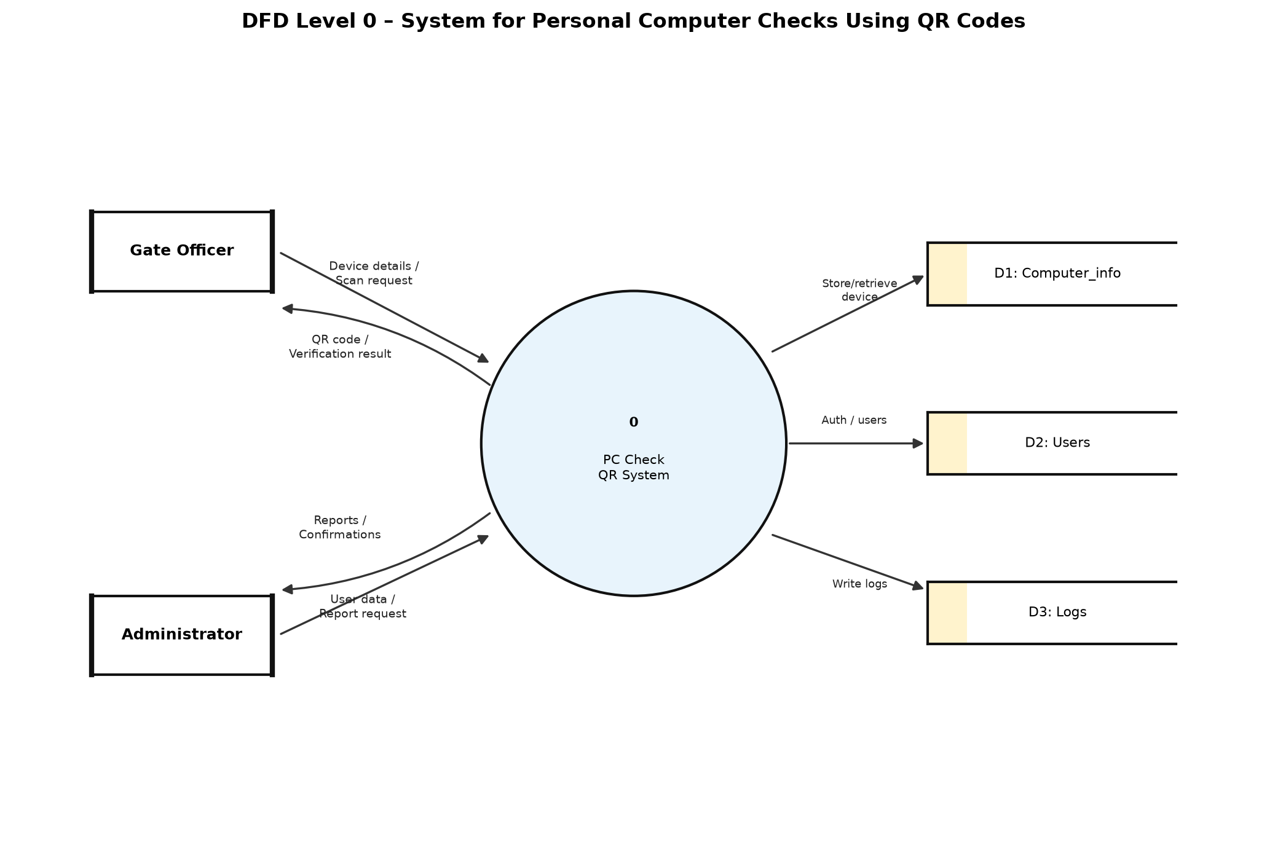
Figure 4: DFD Level 0
The diagram above represents the Data Flow Diagram (DFD) Level 0 for the System for Personal Computer Checks Using QR Codes. It provides a high-level view of how data flows within the system and how different users interact with it. At this level, the entire system is represented as a single process.
There are two main external entities involved in the system: the Gate Officer and the Administrator. Gate officers interact with the system to register devices, generate QR codes, and verify devices at exit. Administrators interact with the system to manage users, review device logs, and generate reports.
The data flow in this DFD illustrates the exchange of information between users and the main system process, including device registration details, generated QR-code data, scan/verification requests, and the responses generated by the system. The DFD Level 0 helps in understanding the overall system boundaries and the general flow of data from input to output.

4.7.1.1.2 DFD Level 1
A DFD Level 1 provides a more detailed view of how data flows within a system by expanding the single process shown in DFD Level 0 into multiple sub-processes, data stores, and data flows.
In the System for Personal Computer Checks Using QR Codes, the DFD Level 1 breaks the system down into core processes such as registering a device, generating a QR code, scanning and verifying a device at exit, logging actions, and administrator authentication. The DFD Level 1 consists of four main components:
- External Entities: users or systems outside the platform that interact with it — in this system, Gate Officers and Administrators.
- Processes: system activities that transform input data into output, such as registering a device, generating a QR code, and verifying a scanned code.
- Data Flows: show how data moves between external entities, processes, and data stores in a specific direction.
- Data Stores: locations where data is stored for later use, such as the Computer_info, Users, and Logs tables.
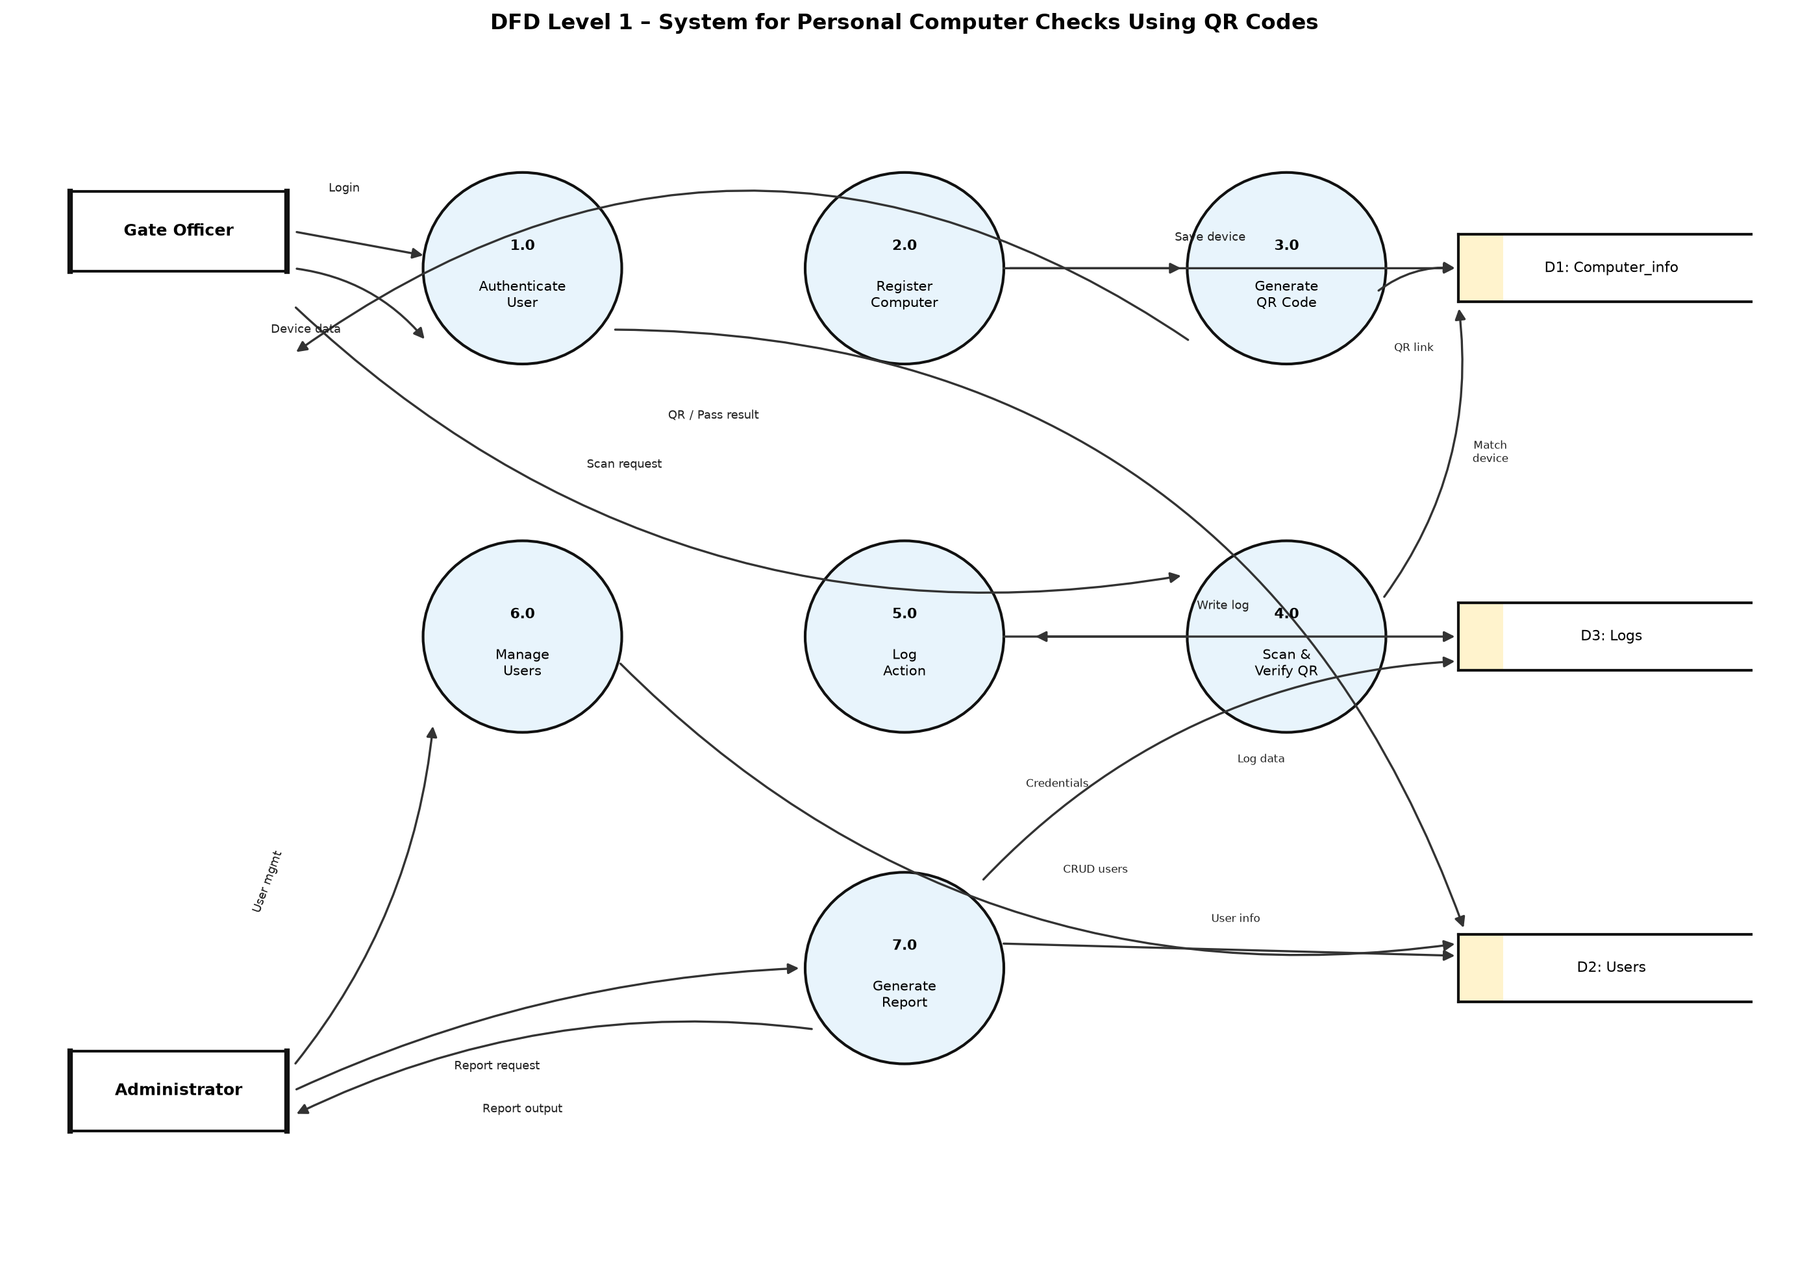
Figure 5: DFD Level 1
The diagram above illustrates how data will flow throughout the System for Personal Computer Checks Using QR Codes, from device registration through to verification at exit, and how gate officers and administrators interact with the system's internal processes.
Additionally, Figure 6 below is a flowchart which illustrates how UTB Rubavu Campus will use the System for Personal Computer Checks Using QR Codes in operation. It shows clearly how information flows within the system, and how users and administrators interact with it.
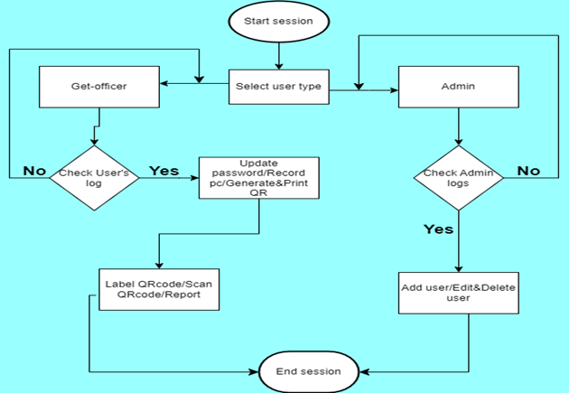
Figure 6: Flow chart of the new system

4.7.2 Use Case
A Use Case Diagram is a UML diagram that illustrates the interactions between actors and a system, showing the services (use cases) the system provides and who uses them. Figure 7 below shows the use case diagram for the System for Personal Computer Checks Using QR Codes, depicting the interactions between gate officers, administrators, and the system.
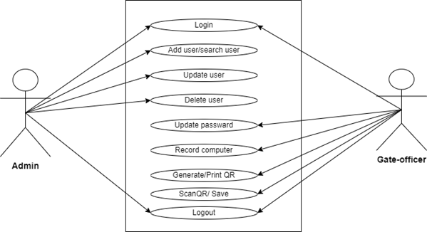
Figure 7: Use case diagram of the proposed system

4.7.3 Normalization
Normalization is the process of organizing data in a database to reduce data redundancy (duplication) and improve data integrity. [9], [11] It involves dividing large tables into smaller, related tables and defining relationships between them. Its objectives are to eliminate data redundancy, avoid data inconsistency, improve data integrity, simplify database maintenance, and reduce update, insertion, and deletion anomalies. The Computer_info, Users, and Logs tables of the proposed system were assessed against the following normal forms.

4.7.3.1 First Normal Form (1NF)
A table is in 1NF if each column contains atomic (indivisible) values, there are no repeating groups or multivalued attributes, and each record is unique. The Computer_info, Users, and Logs tables satisfy 1NF, as each field (for example sn, model, owno, owname, and date) holds a single, indivisible value, and each record is uniquely identified by a primary key (id or log_id).

4.7.3.2 Second Normal Form (2NF)
A table is in 2NF if it is already in 1NF and all non-key attributes are fully dependent on the entire primary key. Since each of the three tables uses a single-column primary key (id or log_id) rather than a composite key, every non-key attribute is fully dependent on that key, satisfying 2NF.

4.7.3.3 Third Normal Form (3NF)
A table is in 3NF if it is already in 2NF and there are no transitive dependencies, meaning non-key attributes should not depend on other non-key attributes. In the proposed design, attributes such as own me and own depend directly on the device record identified by id, and not on any other non-key attribute, satisfying 3NF.

4.7.3.4 Boyce-Coded Normal Form (BCNF)
BCNF is a stronger version of 3NF: a table is in BCNF if, for every functional dependency, the determinant is a candidate key. BCNF eliminates certain anomalies that may still exist in 3NF. The Computer info, Users, and Logs tables were reviewed and found to meet this condition, since sn and nid, which could otherwise determine other attributes, are themselves defined as unique keys.

4.7.4 Data Dictionary
A data dictionary, also called a metadata repository, is a centralized description of the data used in a system. It explains what each piece of data means, how it is stored, how it is used, and how it relates to other data. A data dictionary is important because it helps developers, system administrators, and system users understand the database structure and maintain consistency across the system.
Since the System for Personal Computer Checks Using QR Codes uses a database to store device, user, and activity-log information, the data dictionary below describes the main entities used in the system and their attributes. The entities include: Computer_info, Users, and Logs.
Table 3: Computer_info table
Field | Meaning | Data Type | Size | Description / Function
id | Device identification | Int | 50 | Primary key, uniquely identifies each registered computer
sn | Serial number | varchar | 20 | Unique identifier printed/encoded on the device's QR code
model | Device model | varchar | 30 | Stores the model details of the computer
owno | Owner's number | varchar | 30 | Stores the owner's contact number
owname | Owner's name | varchar | 30 | Stores the name of the device owner
date | Date of record | Date | — | Stores the date the device was registered

Table 4: Users table
Field | Meaning | Data Type | Size | Description / Function
id | User identification | Int | 10 | Primary key, uniquely identifies each system user
user_type | Role | varchar | 30 | Stores the user's role (Administrator, Gate Officer)
nid | User's number | varchar | 20 | Unique national/staff identification number
names | Names | varchar | 50 | Stores the full name of the user
email | Email | varchar | 60 | Used for login and user identification
password | Password | varchar | 200 | Stores the user's hashed password

Table 5: Logs table
Field | Meaning | Data Type | Size | Description / Function
log_id | Log identification | Int | 11 | Primary key, uniquely identifies each log entry
sn | Serial number | varchar | 20 | References the device's serial number
model | Model | varchar | 40 | Stores the model of the device involved in the action
owno | Owner number | varchar | 20 | Stores the owner's contact number
owname | Owner names | varchar | 80 | Stores the name of the device owner
action | Action done | varchar | 50 | Stores the action performed (e.g., registered, verified, exited)
comment | Short comment | varchar | 100 | Stores any remark made by the gate officer
date | Current time | timestamp | — | Stores the date and time the action occurred

4.7.5 Entity Relationship Diagram
An Entity Relationship Diagram (ERD) is a graphical representation that shows how data is organized in a database and how different entities are related. It helps in designing the database structure by identifying the main entities, their attributes, and the relationships between them.
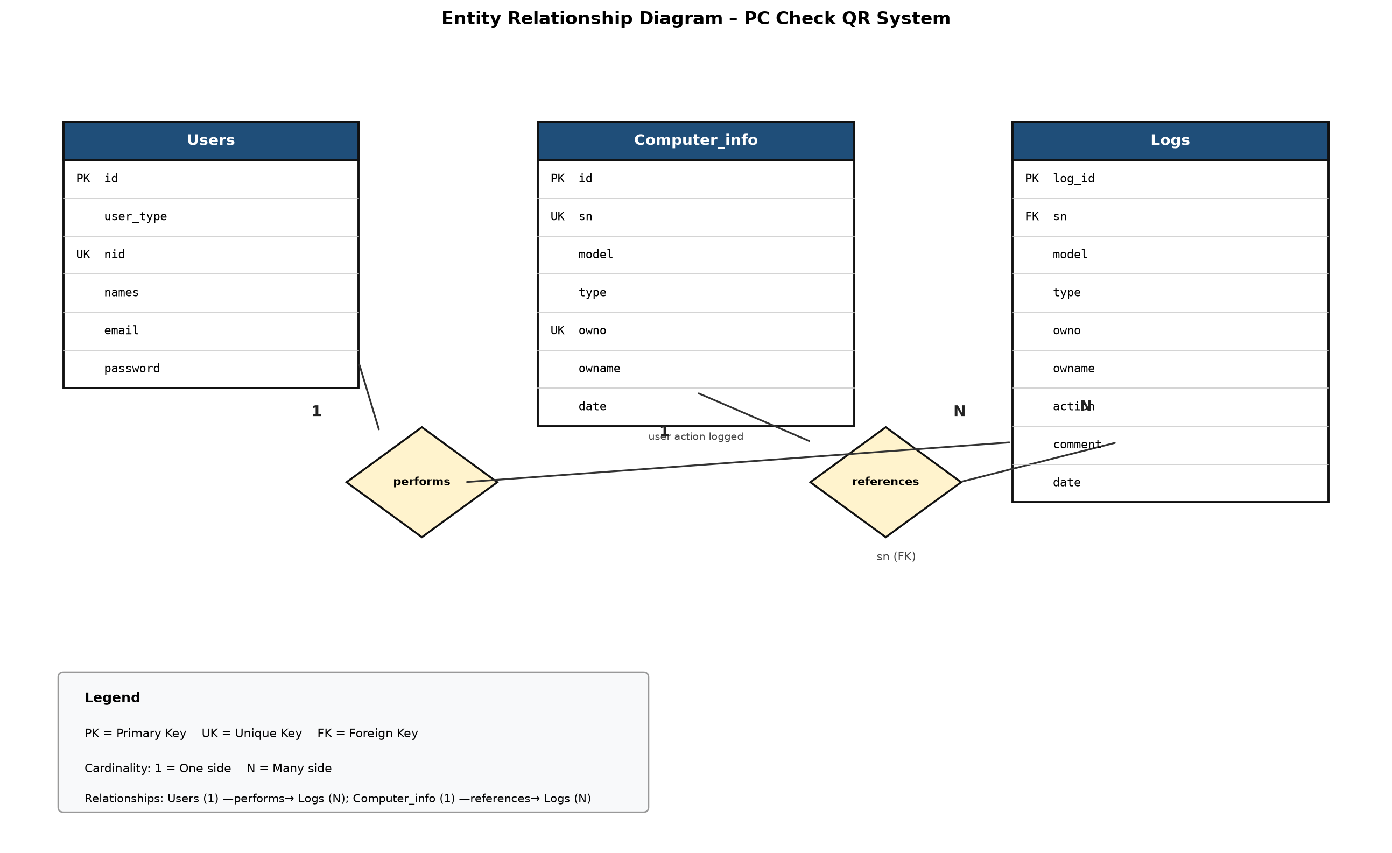
Figure 8: Entity Relationship Diagram
The diagram above represents the ER model of the System for Personal Computer Checks Using QR Codes. It describes the main entities involved in the system — Users, Computer_info, and Logs — along with their relationships, such as a user performing an action that is recorded in the logs, and a log entry referencing the device it relates to. The ERD provides a clear understanding of how device and user information is stored and linked within the database, supporting efficient data management and consistent implementation of backend operations.

4.8 Architecture design of the new system

4.8.1 System Architecture
The proposed System for Personal Computer Checks Using QR Codes for UTB Rubavu Campus adopts a Three-Tier Architecture consisting of the Presentation Layer, Application Layer, and Database Layer. This architecture promotes scalability, maintainability, security, and efficient data management.
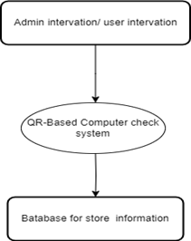
Figure 9: Three-Tier System Architecture
1. Presentation Layer (Client Layer)
This is the user interface through which gate officers and administrators interact with the system. It provides web pages for registering devices, generating and printing QR codes, and reviewing logs and reports. Technologies used are HTML, Bootstrap, and JavaScript, supporting the following functions:
- User registration and login
- Registering a personal computer at entry
- Generating and printing a device's QR code
- Scanning and verifying a QR code at exit
- Viewing logs and reports
2. Application Layer (Business Logic Layer)
This layer processes requests from users and applies business rules before interacting with the database. The technology used is PHP with PDO, and its functions include:
- User authentication and authorization
- Device registration and record management
- QR code generation and verification logic
- Logging of actions performed at the gate
- Report generation
- Data validation
3. Database Layer (Data Layer)
This layer stores and manages all system data. The technology used is the MySQL Database Management System, hosted locally through XAMPP, which stores data such as user accounts, registered computers, and activity logs.

CHAPTER FIVE: IMPLEMENTATION, CODING AND TESTING

5.1 Implementation and coding

5.1.1 Introduction
This chapter describes the implementation and testing of the System for Personal Computer Checks Using QR Codes developed for UTB Rubavu Campus. This phase focused on transforming the proposed design into a fully functional web-based application.
The implementation phase explains how the system was developed using the selected technologies and tools. It covers frontend development, backend development with PHP and PDO, MySQL database integration, session-based authentication, QR code generation, and local deployment using XAMPP. The testing section explains how the system was evaluated to ensure that it operated correctly, securely, and efficiently according to the defined requirements.

5.1.2 Description of implementation Tools and technology
The System for Personal Computer Checks Using QR Codes was developed using web technologies suitable for building a reliable campus gate-checking application. The system followed a three-tier client–server architecture, where the presentation layer (HTML, Bootstrap, and JavaScript) communicates with the application layer (PHP with PDO), which then interacts with the MySQL database. The technologies used in the development of the system are summarized in the table below.
Table 6: Technology used
Technology used | Description
HTML5 (Frontend) | Used to structure web pages including the landing page, login page, admin dashboard, gate-officer dashboard, registration forms, and report pages.
CSS3 (Frontend) | Used to style and format the web pages to improve appearance, layout, and readability.
Bootstrap 4 | Used to create responsive and consistent interfaces across devices and browsers.
JavaScript (Frontend) | Used to enhance client-side interaction, form behaviour, and dynamic page features.
PHP with PDO (Backend) | Used as the server-side language to process requests, enforce business rules, and interact securely with the database.
MySQL | Used as the relational database management system to store users, computer records, and activity logs.
TCPDF / QR libraries | Used to generate printable QR codes linked to registered computer serial numbers.
XAMPP | Used as the local development and hosting environment (Apache, MySQL, and PHP).
phpMyAdmin | Used to create, import, and manage the computer_records database.
Visual Studio Code / Cursor | Used as the primary code editor for development and debugging.

These technologies were selected because they provide flexibility, cross-platform compatibility, secure database access through prepared statements, and an efficient development workflow for academic and institutional web systems.

5.1.3 Screen Shots
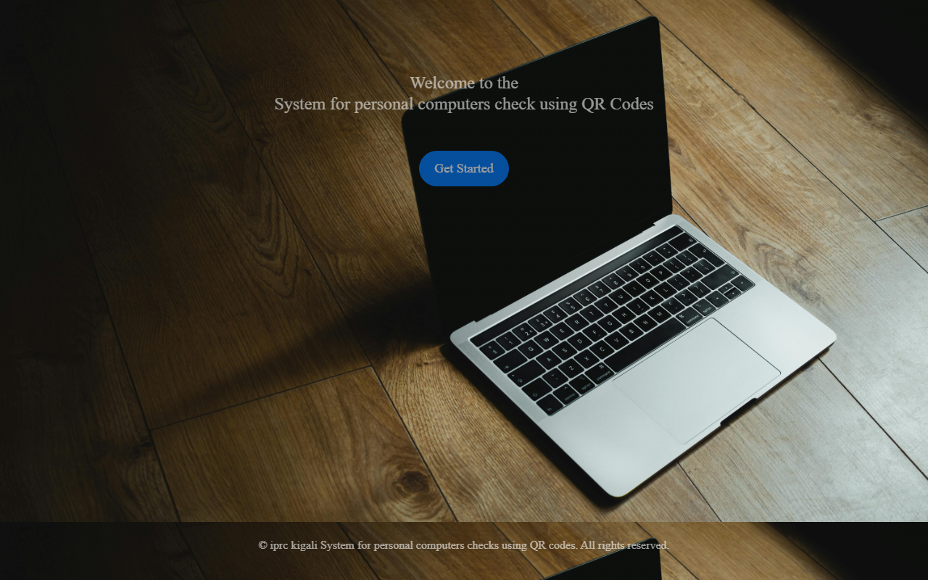
Figure 10: Home Page Interface
This figure presents the Home Page of the System for Personal Computer Checks Using QR Codes. It serves as the main entry point for authorized campus users and provides a clear welcome message together with a “Get Started” button that directs users to the login page.
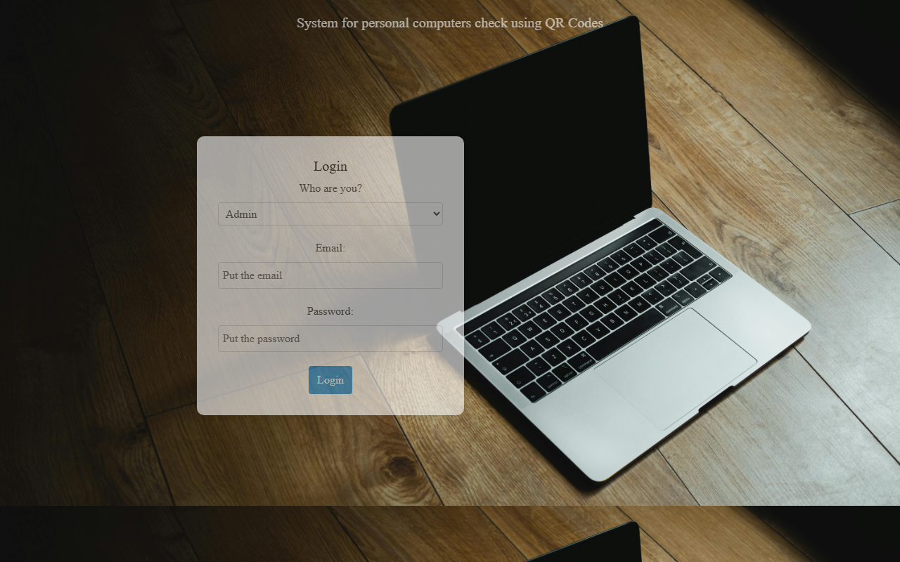
Figure 11: Login Page
This figure illustrates the Login page, where users select their role (Admin or Gate Officer), enter their email address and password, and authenticate into the system. Role selection ensures that each user is redirected to the appropriate dashboard after a successful login.
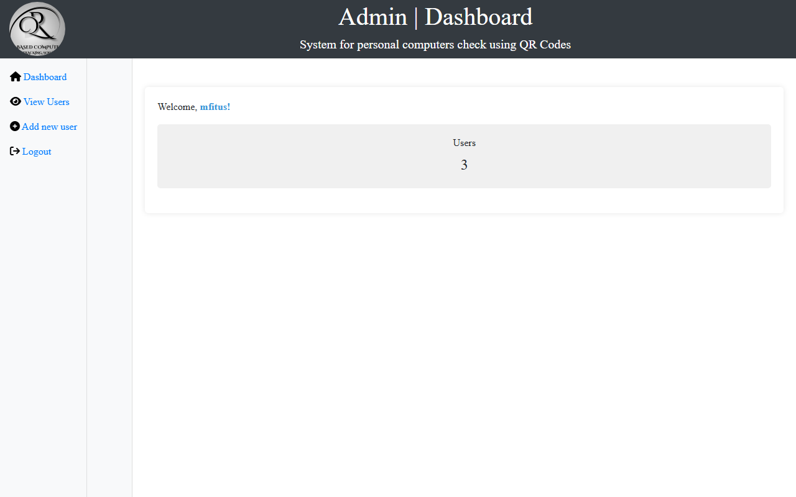
Figure 12: Admin Dashboard
This figure presents the Admin Dashboard. From this interface, administrators can manage system users, including adding, viewing, updating, and deleting accounts. The dashboard acts as the central control panel for system administration at UTB Rubavu Campus.
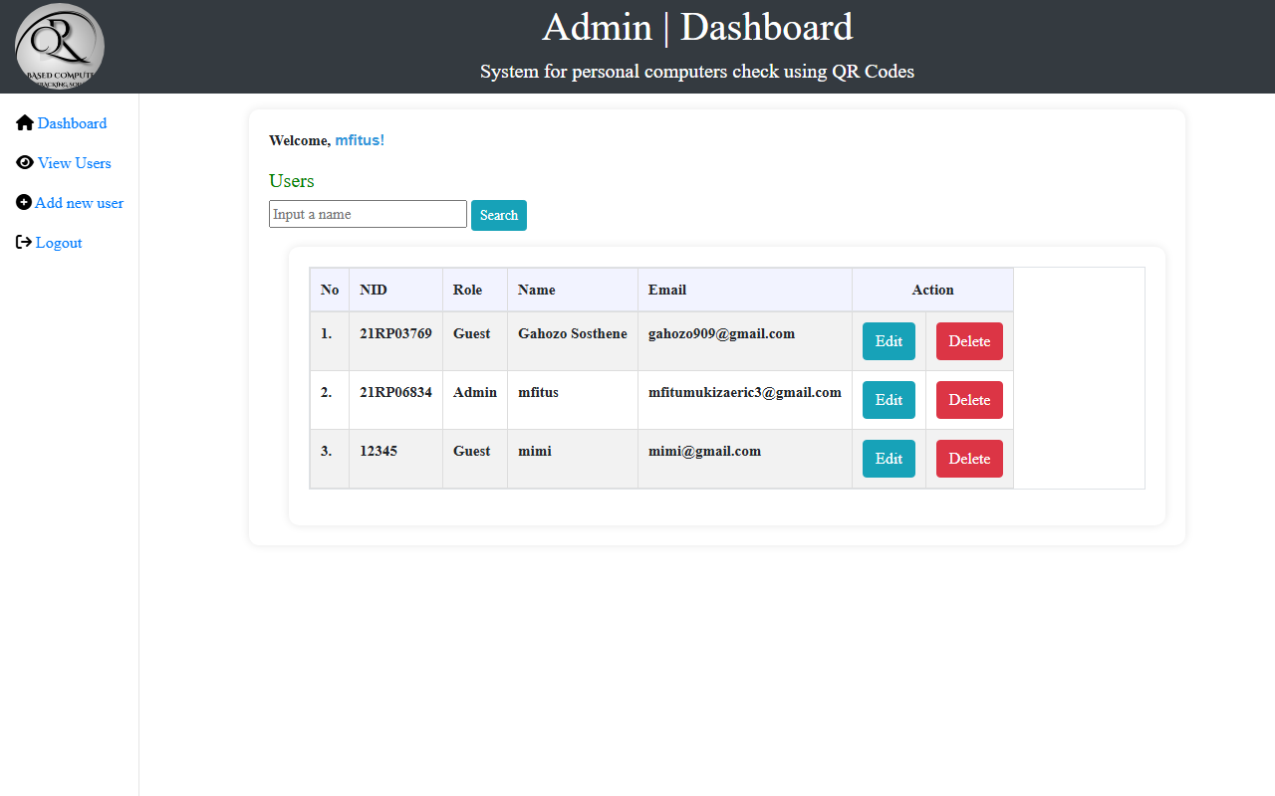
Figure 13: View Users Page
This figure shows the View Users page, which lists registered system accounts with their roles, identification numbers, names, and email addresses. It enables administrators to monitor who has access to the platform and to maintain accurate user records.
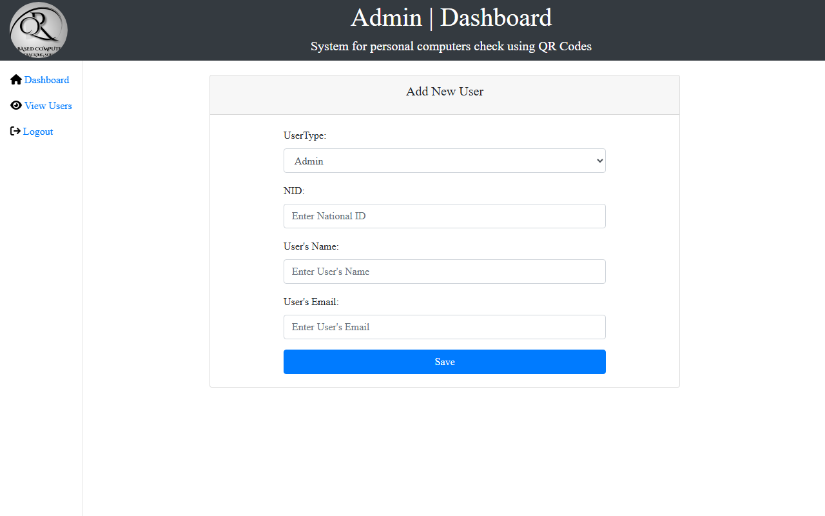
Figure 14: Add Users Page
This figure illustrates the Add Users interface. Administrators can register new Admin or Gate Officer accounts by capturing user type, national/staff identification number, full name, and email. Passwords are stored in hashed form for security.
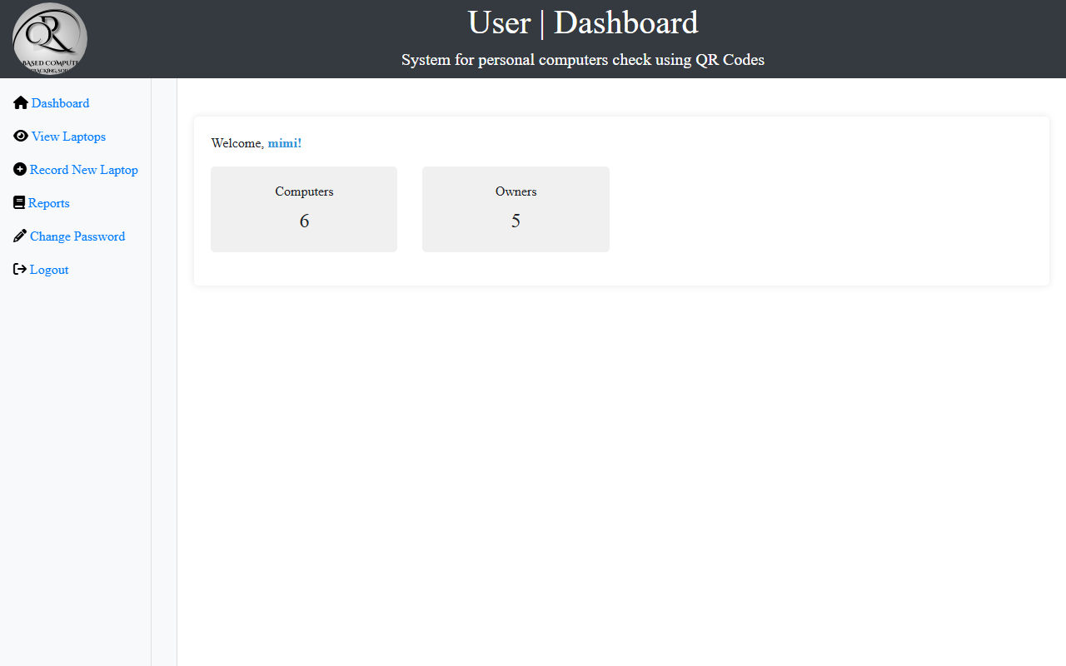
Figure 15: Gate Officer Dashboard
This figure presents the Gate Officer (Guest) Dashboard. From this panel, gate staff can access computer registration, laptop viewing, QR-related operations, password change, and reporting features used during daily entry and exit checks.
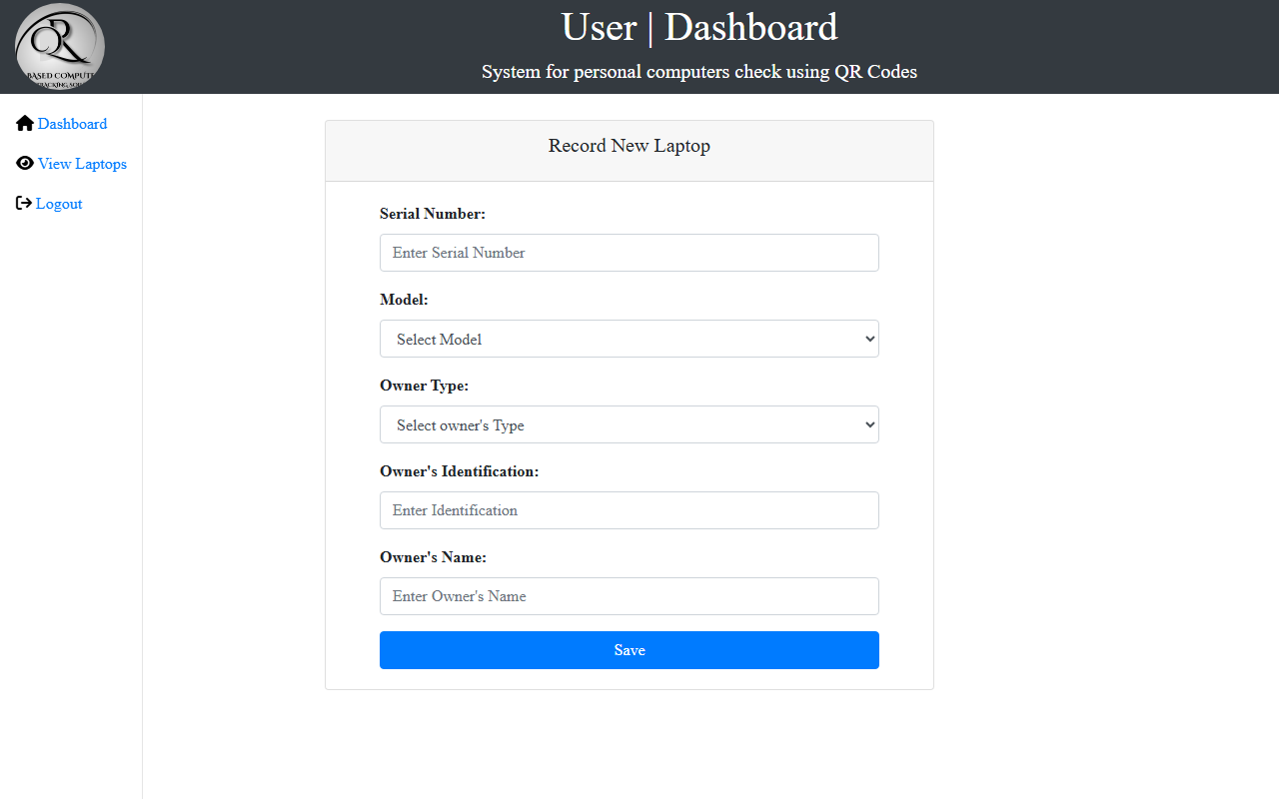
Figure 16: Record Computers Page
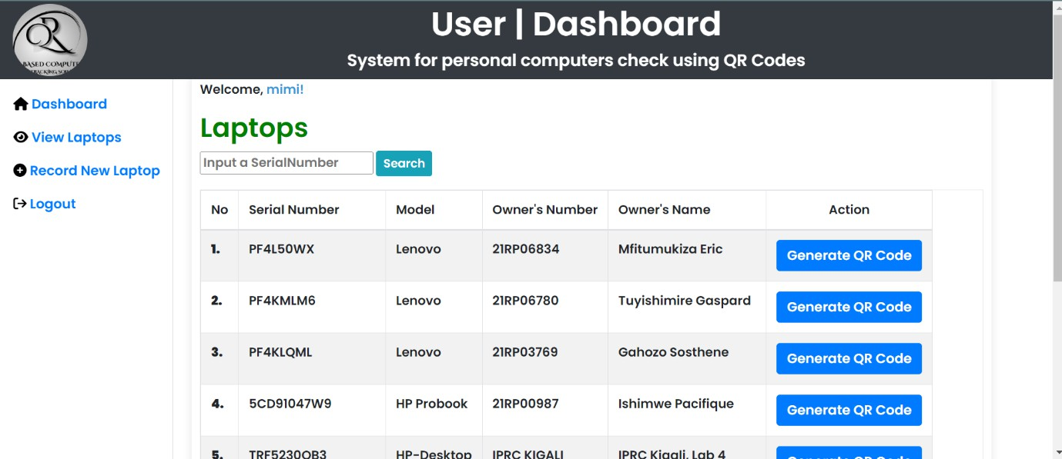
This figure shows the Record Computers page used to register a personal computer at the gate. Gate officers capture the serial number, model, owner type, owner number, and owner name. After successful registration, a QR code can be generated for the device.

Figure 17: View Laptops / Registered Computers Page
This figure illustrates the View Laptops page, which displays registered computer records stored in the database. Gate officers can review device details and use the information during verification and QR-code generation activities.
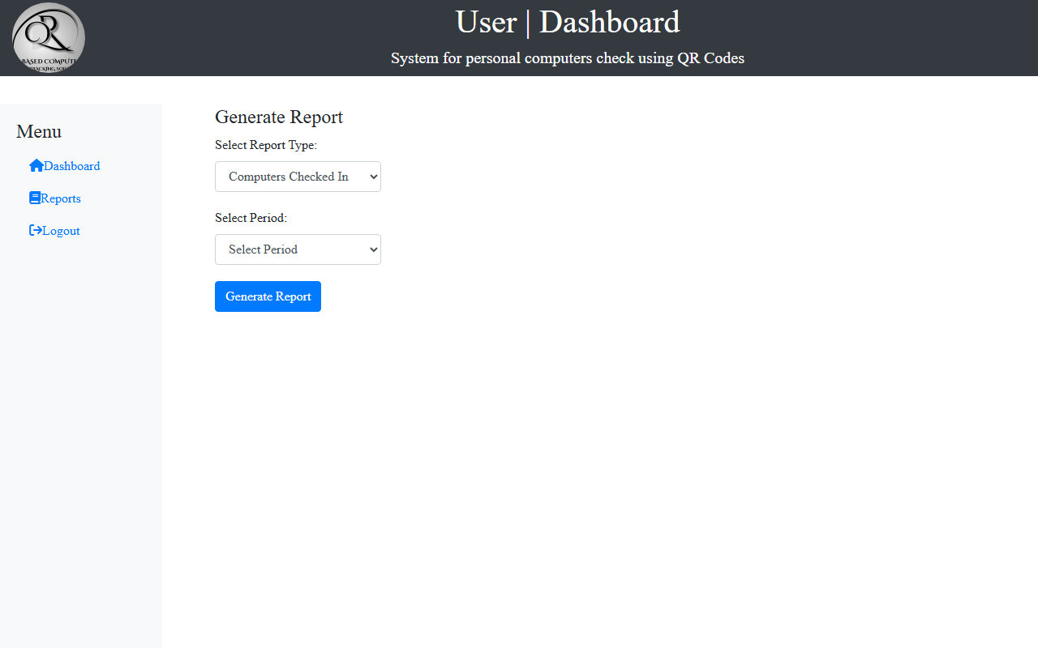
Figure 18: Reports Module
This figure presents the Reports module. It enables authorized users to review logged check-in and check-out activity and to generate printable reports for accountability and management purposes at the campus gate.
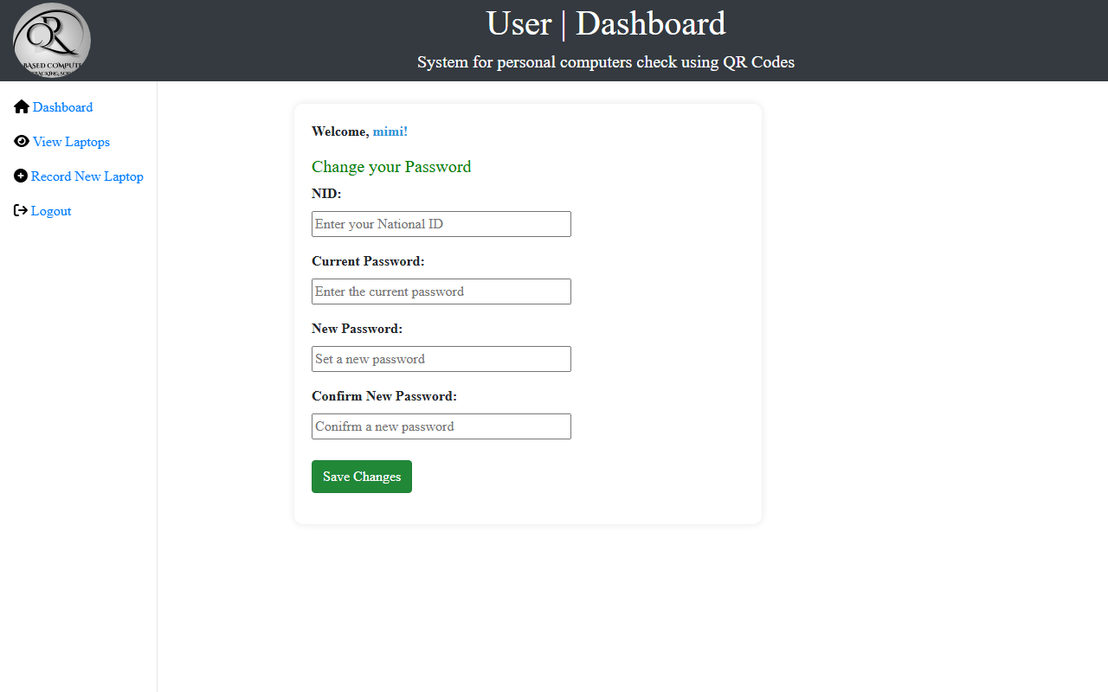
Figure 19: Change Password Page
This figure shows the Change Password page, which allows authenticated users to update their login credentials. This feature supports account security and controlled access to system modules.

5.1.4 Source Codes
The System for Personal Computer Checks Using QR Codes was implemented as a PHP web application hosted under the Apache document root. The main project folder contains presentation pages, backend scripts, database connection logic, and libraries used for QR code generation.
PROJECT FOLDER STRUCTURE
The application folder structure is summarized below:
QR/
├── index.php # Landing / home page
├── login.php # Authentication page
├── logout.php # Session termination
├── connection.php # MySQL PDO connection
├── admin-dashboard.php # Administrator home
├── user-dashboard.php # Gate officer home
├── add-users.php # Create system users
├── view-users.php # List / manage users
├── update-users.php # Edit user accounts
├── delete-users.php # Remove user accounts
├── record-computers.php # Register devices
├── view-laptops.php # List registered devices
├── getBarcode.php # QR display helper
├── log_form.php / submit_log.php # Check-in/out logging
├── report.php / generate_report.php
├── change-password.php
├── styles.css
├── img/ # Interface images
├── icons/ # Icon assets
├── tcpdf/ # PDF / barcode library
└── phpqr/ # QR generation support
Sample database connection file (connection.php):
<?php
try {
$pdo = new PDO(
"mysql:host=localhost;dbname=computer_records;",
'root',
'',
[PDO::ATTR_ERRMODE => PDO::ERRMODE_EXCEPTION]
);
} catch (PDOException $e) {
die('Connection failed: ' . $e->getMessage());
}
?>
Sample authentication logic (login.php):
<?php
session_start();
include 'connection.php';
function authenticateUser($email, $password, $user_type, $pdo) {
$query = "SELECT * FROM users WHERE email = :email AND user_type = :user_type";
$stmt = $pdo->prepare($query);
$stmt->bindParam(':email', $email);
$stmt->bindParam(':user_type', $user_type);
$stmt->execute();
$row = $stmt->fetch(PDO::FETCH_ASSOC);
if ($row && password_verify($password, $row['password'])) {
return $row;
}
return false;
}
if ($_SERVER['REQUEST_METHOD'] === 'POST') {
$user = authenticateUser($_POST['email'], $_POST['password'], $_POST['user_type'], $pdo);
if ($user) {
$_SESSION['user_type'] = $user['user_type'];
$_SESSION['email'] = $user['email'];
if ($user['user_type'] === 'Admin') {
header('Location: admin-dashboard.php');
} else {
header('Location: user-dashboard.php');
}
exit();
}
$error = "Invalid user_type, username or password";
}
?>
Sample computer registration logic (record-computers.php):
<?php
require_once 'connection.php';
if (isset($_POST['submit'])) {
$sn = $_POST['sn'];
$model = $_POST['model'];
$type = $_POST['type'];
$owno = $_POST['owno'];
$owname = $_POST['owname'];
$sql_check = "SELECT COUNT(*) FROM computer_info WHERE sn = :sn";
$stmt_check = $pdo->prepare($sql_check);
$stmt_check->bindParam(':sn', $sn);
$stmt_check->execute();
if ($stmt_check->fetchColumn() > 0) {
$Error = "Error: Computer's S/N already exists.";
} else {
$stmt = $pdo->prepare(
"INSERT INTO computer_info (sn, model, type, owno, owname) VALUES (?,?,?,?,?)"
);
$stmt->execute([$sn, $model, $type, $owno, $owname]);
$message = "Computer was recorded successfully!";
}
}
?>
Sample check-in / check-out logging logic (submit_log.php):
<?php
require_once 'connection.php';
if ($_SERVER['REQUEST_METHOD'] == 'POST') {
$stmt = $pdo->prepare(
"INSERT INTO logs (sn, model, type, owno, owname, action, comment)
VALUES (?,?,?,?,?,?,?)"
);
$stmt->execute([
$_POST['sn'], $_POST['model'], $_POST['type'],
$_POST['owno'], $_POST['owname'], $_POST['action'], $_POST['comment']
]);
echo "Log recorded successfully for " . htmlspecialchars($_POST['sn']);
}
?>
FRONTEND SAMPLE
The frontend of the System for Personal Computer Checks Using QR Codes was developed using HTML, CSS, Bootstrap, and JavaScript. A simplified landing-page structure is shown below.
<!DOCTYPE html>
<html lang="en">
<head>
<meta charset="UTF-8">
<meta name="viewport" content="width=device-width, initial-scale=1.0">
<title>Landing Page</title>
<link rel="stylesheet"
href="https://stackpath.bootstrapcdn.com/bootstrap/4.5.2/css/bootstrap.min.css">
</head>
<body>
<div class="container">
<h4>Welcome to the System for personal computers
check using QR Codes</h4>
<a href="login.php" class="btn btn-lg">Get Started</a>
</div>
</body>
</html>

5.2 Testing

5.2.1 Introduction
System testing is the process of evaluating a complete and integrated system to ensure that it meets the specified requirements. Testing involves executing the system to identify errors, defects, or inconsistencies and verifying that all components function as expected.
The System for Personal Computer Checks Using QR Codes underwent several types of testing to ensure reliability, usability, security, and performance before final demonstration and local deployment at UTB Rubavu Campus.

5.2.2 Objective of Testing
The primary objectives of system testing in this project were:
- 1. To identify and correct errors during development.
- 2. To ensure that all functional requirements are implemented correctly.
- 3. To verify that the system meets administrator and gate-officer expectations.
- 4. To confirm that the system operates securely and efficiently.
- 5. To ensure compatibility across different browsers and devices.
- 6. To validate that the system performs according to the System Requirement Specification (SRS).
Testing ensured that the platform supports accurate device registration, QR-based verification, secure authentication, and reliable activity logging at the campus gate.

5.2.3 Unit testing outputs
Unit testing was conducted to verify individual components of the system. PHP scripts and database operations were tested independently to ensure correct responses. Unit testing included:
- 1. Testing the PDO database connection to confirm successful access to the computer_records database.
- 2. Testing user authentication with valid and invalid credentials for Admin and Gate Officer roles.
- 3. Testing INSERT operations when registering a new computer record.
- 4. Testing duplicate serial-number prevention during computer registration.
- 5. Testing QR code generation for a registered serial number.
- 6. Testing INSERT operations into the logs table for check-in and check-out actions.
- 7. Testing password hashing and password update operations.
Each function was tested independently before integrating with other components.

5.2.4 Validation testing outputs
Validation testing ensured that the system behaved according to user expectations. Input fields were validated to prevent incorrect data submission. This included:
- 1. Ensuring required fields are completed before form submission on login, user registration, and computer registration forms.
- 2. Validating email format on the login and user creation forms.
- 3. Preventing unauthorized access to admin and gate-officer dashboards through session checks.
- 4. Displaying appropriate error messages for invalid login credentials.
- 5. Rejecting duplicate computer serial numbers during registration.
Validation confirmed that the system performs intended operations correctly and reduces the risk of incomplete or inconsistent data entry.

5.2.5 Integration Testing Outputs
Integration testing was conducted to verify that frontend pages, PHP backend scripts, and the MySQL database work together properly. This included:
- 1. Testing login form submission and redirection to the correct dashboard based on user role.
- 2. Testing computer registration forms and immediate storage of records in the Computer_info table.
- 3. Testing QR code generation linked to newly registered device serial numbers.
- 4. Testing check-in/check-out logging and storage of actions in the Logs table.
- 5. Testing report generation from stored log and device data.
- 6. Testing admin user-management operations (add, view, update, and delete) against the Users table.
This testing ensured smooth communication between the presentation, application, and database layers of the system.

5.2.6 Functional and system testing Results
Functional testing verified that each feature operates according to system requirements. All core functionalities were tested, including:
- 1. Accessing the home page and navigating to login
- 2. Admin and Gate Officer authentication
- 3. Adding, viewing, updating, and deleting users
- 4. Recording personal computers at entry
- 5. Viewing registered laptop/computer records
- 6. Generating and displaying QR codes
- 7. Logging check-in and check-out actions
- 8. Generating activity reports
- 9. Changing user passwords
- 10. Logging out and terminating sessions securely
The system responded correctly to user inputs and displayed accurate results. No major functional defects were identified after final testing.

5.2.7 Acceptance Testing Report
Acceptance testing was conducted to determine whether the system meets the needs of end users at UTB Rubavu Campus. The platform was tested by simulating real gate operations such as registering a device on entry, generating a QR code, and recording verification actions on exit.
Administrators tested dashboard functionality, including adding, editing, and deleting user accounts. Gate officers tested computer registration, QR-related operations, and reporting. Feedback confirmed that the system is usable, responsive under the local XAMPP environment, and meets the intended objectives of improving personal computer checks through QR codes at the campus gate.

CHAPTER SIX: CONCLUSION AND RECOMMENDATIONS

6.1 Conclusion
The implementation of a system for personal computers checks using QR codes at UTB Rubavu Campus represents a significant advancement in inventory management and asset monitoring processes. Throughout this study, we have identified key challenges associated with manual monitoring methods, such as discrepancies in inventory records, difficulty in locating specific devices, and delays in responding to maintenance or service requests. By integrating a digital solution, we have demonstrated that these issues can be effectively mitigated.
Our mixed-methods research approach has provided a comprehensive evaluation of the system's effectiveness. Quantitative data collected from system usage logs indicated a notable reduction in monitoring errors and improvements in the efficiency of recording computer entries and exits. Qualitative feedback from users highlighted the system's ease of use and the positive impact on overall user satisfaction.
Despite the initial setup costs and the need for technical and user training, the long-term benefits of the QR code-based system are evident. The automation of inventory management not only enhances accuracy and efficiency but also allows for real-time updates and better allocation of resources for maintenance and service tasks.

6.2 Recommendations
Based on the findings of this study, we propose the following recommendations for UTB Rubavu Campus and other institutions considering the implementation of a system for personal computers checks using QR codes:
    - Initial Setup Cost: The system requires significant initial investment in hardware devices such as computer, QR code printer, QR code scanner. Without these mentioned items, a system should not run
    - Technical Issues: The system also can face the delay in generating QR code regarding the performance of computer it is running on. And it can delay in loading pages regarding the bandwidth of the network that it is running on.
    - System Dependence: Reliance on the system means that any downtime or failure can significantly impact the institution's operations. Furthermore, logs can’t be recorded without internet.

    - Comprehensive Training Programs: Ensure that all users especially get security officers, receive thorough training on the operation and benefits of the QR code checking system. This will facilitate smoother adoption and minimize resistance to change.
    - Regular System Maintenance and Updates: Establish a routine schedule for system maintenance to ensure that all hardware (QR code scanners) and software components are functioning optimally. Regular updates will also help in addressing any emerging issues or integrating new features.
    - Scalability Planning: As the institution grows and the number of tracked devices increases, ensure that the system is scalable. Plan for potential expansions and upgrades to accommodate a larger inventory without compromising performance.
    - Integration with other Existing Systems operating in different institutions: Where possible, integrate the system for personal computers checks using QR codes with other existing management systems within the other institutions to streamline processes and improve overall efficiency.
By adopting these recommendations, UTB Rubavu Campus can maximize the benefits of the system for personal computers checks using QR codes, ensuring a more efficient, accurate, and user-friendly approach to inventory management. This system not only addresses current challenges but also sets a foundation for future advancements in asset monitoring and institutional management.

REFERENCES
[1] Wikipedia, "Data Dictionary," 2024. [Online]. Available: https://en.wikipedia.org/wiki/Data_dictionary
[2] F. Almasalha, "QR code based applications," Jan. 2014. [Online].
[3] M.-J. Tsai, "QR code beautification by instance segmentation (IS-QR)," Digital Signal Processing, 2024.
[4] S. Tiwari, "An Introduction To QR Code Technology," in Proc. 2016 Int. Conf. Information Technology (InCITe), 2016.
[5] S. Pati, A Novel QR Code Based Smart Attendance Tracking System. Kolkata, India: Dept. of ECE, 2020.
[6] Malwarebytes, "QR Codes: How they work and how to stay safe," 2024. [Online]. Available: https://www.malwarebytes.com/
[7] M. Innocent and U. Jeannine, Gate Check Management System. Kigali, Rwanda, 2020, p. 11.
[8] GeeksforGeeks, "What is DFD (Data Flow Diagram)?," 2024. [Online]. Available: https://www.geeksforgeeks.org/what-is-dfd/
[9] R. Elmasri and S. B. Navathe, Fundamentals of Database Systems, 7th ed. Pearson, 2016.
[10] I. Sommerville, Software Engineering, 10th ed. Pearson, 2016.
[11] T. Connolly and C. Begg, Database Systems: A Practical Approach to Design, Implementation, and Management, 6th ed. Pearson, 2015.
[12] PHP Group, "PHP Data Objects (PDO)," PHP Manual, 2024. [Online]. Available: https://www.php.net/manual/en/book.pdo.php

APPENDICES
Below are some codes that makes up a test-qr.php, a page that enables us to generate a QR Code
<!DOCTYPE html>
<html lang="en">
<head> <meta charset="UTF-8">
<meta name="viewport" content="width=device-width, initial-scale=1.0">
<title>Computers Gatepass Solution | QR Code Generator</title>
<style>
@media print { title{
display: none;
}
nav {
display: none;
}
input{
display: none;
}
button{
display: none;
}
}
</style>

</head>
<body onload="window.print();">
<?php
// Include the database connection file require_once 'connection.php';
// Fetch a serial number from the database
$stmt = $pdo->prepare("SELECT sn, model, owno, owname FROM computer_info WHERE sn=?");
$stmt->execute([$_GET['sn']]);
$row = $stmt->fetch(PDO::FETCH_ASSOC);
$serialNumber = $row['sn'];
$model = $row['model'];
$ownerNumber = $row['owno'];
$ownerName = $row['owname'];
// Generate QR Code with URL
// $url = "http://schoolgate.com/log_form.php?sn=" . urlencode($serialNumber) . "&model=" . urlencode($model) . "&owno=" . urlencode($ownerNumber) . "&owname=" . urlencode($ownerName);
$url = "https://c1b9-197-243-40-122.ngrok-free.app/log_form.php?sn=" . urlencode($serialNumber) . "&model=" . urlencode($model) . "&owno=" . urlencode($ownerNumber) . "&owname=" . urlencode($ownerName);
?>
<img src="tcpdf/examples/barcodes/getMyBarcode.php?details=<?= urlencode($url) ?>" height="110" width="110" />
</body>
</html>

