**South-West State University**

The Department of International Relations and State Management

**GRADUATE QUALIFICATION WORK**

**IN THE BACHELOR'S PROGRAM**

41.03.05 International relations,

World politics and international business

(code, name of the EP HE: direction of training, orientation (profile))

**Preventive Diplomacy for Conflict Prevention in Africa**

(topic name)

**Diploma work**

(type of GQW: thesis or thesis project)

Author of the GQW ______________ G. Milicent Mbire

(signature, date) (initials, last name)

Group MO-02B

Head of GQW ______________ E.А. Sentishcheva

(signature, date) (initials, last name)

Norm Control ______________ V.M. Kuzmina

(signature, date) (initials, last name)

Consultant for the section

in a foreign language ______________ E.А. Sentishcheva

(signature, date) (initials, last name)

GQW approved for protection:

Head of the Department ______________ M. A. Parkhomchuk

(signature, date) (initials, last name)

Kursk 2024

**Ministry of Education and Science of Russia**

**South-West State University**

The Department of International Relations and State Management

I APPROVE:

Head of the department of SWSU

M. A. Parkhomchuk

"____"____________20___

**THE TASK FOR THE GRADUATE QUALIFICATION WORK**

**BACHELOR'S DEGREE PROGRAM**

Student  G. Milicent Mbire cipher 19-07-0085 group MO-02b

(last name, initials)

1. The Topic «Preventive diplomacy for conflict prevention in Africa» is approved by the order of Rector of SWSU from «18» 03 2024 No. 1295-с.

2. Deadline for submitting the FQW to the defense « » ___________ 20____

3.Initial data: educational and scientific literature of domestic and foreign authors, periodicals, statistical data, and analytical information published on the official websites of the governmental organizations, Internet resources of international financial, political and cultural organizations.

4. The content of the work (sections):

4.1 Introduction

4.2 Theoretical and legal foundations of the concept study of preventive diplomacy in politics.

4.3 Analysis of the application of preventive diplomacy for conflict prevention in Africa.

4.4 Prospects for cooperation between States within the framework of the concept of preventive diplomacy for conflict prevention in Africa.

4.5 Выводи

4.6 Conclusion

4.7 List of references

5. List of graphic material: not provided

Head of the GQW E.A. Sentishcheva

(signature, date) (initials, last name)

The task was accepted by  G. Milicent Mbire

(signature, date) (initials, last name)

**РЕФЕРАТ**

Выпускная квалификационная работа представлена на 81 страницах, содержит 8 таблиц, 11 рисунков, 58 источников литературы.

Ключевые слова: превентивная дипломатия, предотвращение конфликтов, Африка, мир и безопасность, дипломатическое вмешательство, тематические исследования, вызовы, региональные организации.

Объектом исследования в работе является превентивная дипломатия для предотвращения конфликтов в Африке.

Предметом исследования являются теоретические основы концепции превентивной дипломатии для предотвращения конфликтов в Африке.

Цель состоит в том, чтобы изучить влияние развития превентивной дипломатии на предотвращение конфликтов в Африке.

В работе были получены следующие результаты: изучены теоретические и правовые основы исследования концепции превентивной дипломатии в политике, проведен анализ применения превентивной дипломатии для предотвращения конфликтов в Африке, проведена оценка взаимодействия мирового сообщества по предотвращению конфликтов в Африке, были обозначены проблемы превентивной дипломатии для предотвращения конфликтов в Африке, выделены пути совершенствования превентивной дипломатии для представления конфликтов в Африке.

В ходе исследования были использованы методы синтеза и анализа изучаемого материала, а также анализ журналистских материалов о влиянии превентивной дипломатии на освещение конфликтов в Африке

**ABSTRACT**

The final qualification work is presented on 81 pages, contains 8 tables, 11 figures, 58 sources of references.

Key words: Preventive diplomacy, conflict prevention, Africa, peace and security, diplomatic intervention, case studies, challenges, regional organizations.

The object of research in the work is the preventive diplomacy for conflict prevention in Africa.

The object of the study is preventive diplomacy for conflict prevention in Africa.

The subject of the study is the theoretical foundations of the concept of preventive diplomacy for conflict prevention in Africa.

The goal is to study the impact of the development of preventive diplomacy for conflict prevention in Africa.

The following results were obtained in the work: the theoretical and legal foundations of the concept study of preventive diplomacy in politics were studied, an analysis of the application of preventive diplomacy for conflict prevention in Africa was performed, an assessment of the interaction of the world community on conflict prevention in Africa was carried out, problems of preventive diplomacy for conflict prevention in Africa were outlined, ways to improve preventive diplomacy for conflict presentation in Africa were highlighted.

In the course of the study, the methods of synthesis and analysis of the material under study were used, as well as the analysis of journalistic material on the impact of preventive diplomacy for conflict presentation in Africa.

**CONTENT**

|  |  |
| --- | --- |
| Introduction | 06 |
| 1. Theoretical and legal foundations of the concept study of preventive diplomacy in politics. | 08 |
| 1.1 Theoretical foundations of the study of preventive diplomacy at the present stage. | 08 |
| 1.2 Stages of the formation of the preventive diplomacy concept. | 13 |
| 1.3 Tools of preventive diplomacy in world politics. | 23 |
| 2. Analysis of the application of preventive diplomacy for conflict prevention in Africa. | 27 |
| 2.1 Cooperation of States within the framework of the concept of preventive diplomacy. | 27 |
| 2.2 Assessment of the interaction of the world community on conflict prevention in Africa. | 35 |
| 2.3 Problems of preventive diplomacy for conflict prevention in Africa. | 48 |
| 3. Prospects for cooperation between States within the framework of the concept of preventive diplomacy for conflict prevention in Africa. | 52 |
| 3.1 Improving the policy of States within the framework of preventive diplomacy. | 52 |
| 3.2 Promising preventive diplomacy programs for conflict prevention in Africa. | 56 |
| 3.3 Forecast of the development of preventive diplomacy for conflict prevention in Africa. | 61 |
| 4 Выводи | 65 |
| Conclusion | 74 |
| References | 76 |

|  |
| --- |
|  |

**INTRODUCTION**

In recent decades, the African continent has been plagued by persistent and devastating conflicts, stemming from factors such as political instability, ethnic tensions, resource competition, and historical grievances. These conflicts pose significant challenges to peace, stability, and socio-economic development. The consequences of these conflicts have been devastating, leading to loss of life, displacement of populations, and hindering socioeconomic development.

The imperative to address these conflicts and prevent their escalation has underscored the critical role of preventive diplomacy. By engaging in dialogue, mediation, and early intervention, preventive diplomacy can help mitigate tensions and create an environment conducive to sustainable peace and development

The concept of preventive diplomacy, encompassing proactive diplomatic interventions aimed at forestalling the outbreak, recurrence, or escalation of conflicts, has gained prominence in the discourse on conflict prevention. In the African context, where diverse historical, political, and socio-economic factors contribute to the complexity of conflicts, preventive diplomacy emerges as a pivotal tool in promoting sustainable peace and security, by proactively identifying and addressing the root causes of potential conflicts.

The object of the study is preventive diplomacy for conflict prevention in Africa.

The subject of the study is the influence of preventive diplomacy in Africa.

The goal is to study the impact of preventive diplomacy in resolving conflict in Africa.

Tasks that are defined in the study:

1. To study the theoretical foundations of the study of preventive diplomacy at the present stage.
2. To show stages of the formation of the preventive diplomacy concept.
3. To consider the tools of preventive diplomacy in world politics.
4. To study the cooperation of States within the framework of the concept of preventive diplomacy.
5. To assess the interaction of the world community on conflict prevention in Africa.
6. To reveal the problems of preventive diplomacy for conflict prevention in Africa.
7. To study ways of improving the policy of States within the framework of preventive diplomacy.
8. To analyze promising preventive diplomacy programs for conflict prevention in Africa.
9. To create and reveal a forecast of the development of preventive diplomacy for conflict prevention in Africa.

The theoretical basis of the study: By delving into the theoretical underpinnings of preventive diplomacy and its applicability in the African context, this study endeavors to elucidate the fundamental principles and strategic imperatives that underpin effective conflict prevention. Moreover, through an analysis of case studies, including the South Sudan conflict and preventive diplomacy efforts in the Democratic Republic of Congo, this study seeks to underscore the practical significance of preventive diplomacy in addressing complex and protracted conflicts in Africa. The study includes the great works of Ramsbotham O., Woodhouse T., Miall H., John Paul Lederach, Kaldor M., Galtung Johan, Burton John, Baylis J., Smith S., Owens, Brower C. H., Chalk P., Morgenthau H. J., and many more.

Methods of analysis. A single interdisciplinary systematic approach based on a combination of different types of analysis was used in the study of the research object. Quantitative and qualitative tasks were solved with the help of statistical, graphical methods, the method of grouping, ranking, systematization of data, expert.

**1 Theoretical and legal foundations of the concept study of preventive diplomacy in politics**

**1.1 Theoretical foundations of the study of preventive diplomacy at the present stage**

Preventive diplomacy, a pivotal concept in political science and international relations, is underpinned by robust theoretical and legal foundations that shape its principles and application in addressing conflicts. At the present stage, the theoretical foundations of preventive diplomacy have evolved to incorporate a multidisciplinary approach, drawing on insights from various fields such as conflict resolution, international relations, and peace studies.

This section of the paper provides a concise overview of the theoretical and legal frameworks essential to the study of preventive diplomacy in politics.

The most important principles for implementing preventive diplomacy are: daily consultations and consensus; activities that build trust; volunteerism; and recognition of universally recognized principles of international law [1].

**Theoretical Foundations:** Preventive diplomacy is based on various conflict resolution theories, including the work of scholars such as Ramsbotham, Woodhouse, and Miall [2]. Their seminal work offers valuable insights into the theoretical underpinnings of preventive diplomacy. Their analysis of conflict prevention and resolution theories provides a comprehensive understanding of the conceptual framework that guides diplomatic interventions aimed at preventing the outbreak or escalation of conflicts.

Complexity Theory and Adaptive Systems: The application of complexity theory and the understanding of conflicts as adaptive systems have gained prominence in shaping the theoretical foundations of preventive diplomacy. This perspective, as discussed by scholars like John Paul Lederach [3], emphasizes the dynamic and interconnected nature of conflicts, necessitating flexible and adaptive diplomatic approaches for effective prevention.

Human Security and Conflict Prevention: The theoretical linkage between human security and conflict prevention, as articulated by scholars such as Mary Kaldor in “Human Security” [4]. Human Security: Reflections on Globalization and Intervention) has enriched the theoretical foundations of preventive diplomacy. This approach underscores the imperative of addressing human vulnerabilities and insecurities as a means of preventing conflicts, thereby emphasizing the human-centered nature of preventive diplomacy.

Furthermore, Johan Galtung's influential work on structural theory of conflict [5] emphasizes the role of structural inequalities, such as economic disparities and unequal power relations, in fueling potential conflicts. Preventive diplomacy draws from this theory by recognizing the importance of addressing underlying structural issues to prevent conflicts from arising.

Not to mention John Burton's Human Needs Theory [6] which posits that conflicts often stem from unmet human needs, such as security, identity, and recognition. Preventive diplomacy incorporates this theory by advocating for early intervention to address these fundamental human needs and prevent them from escalating into violent confrontations.

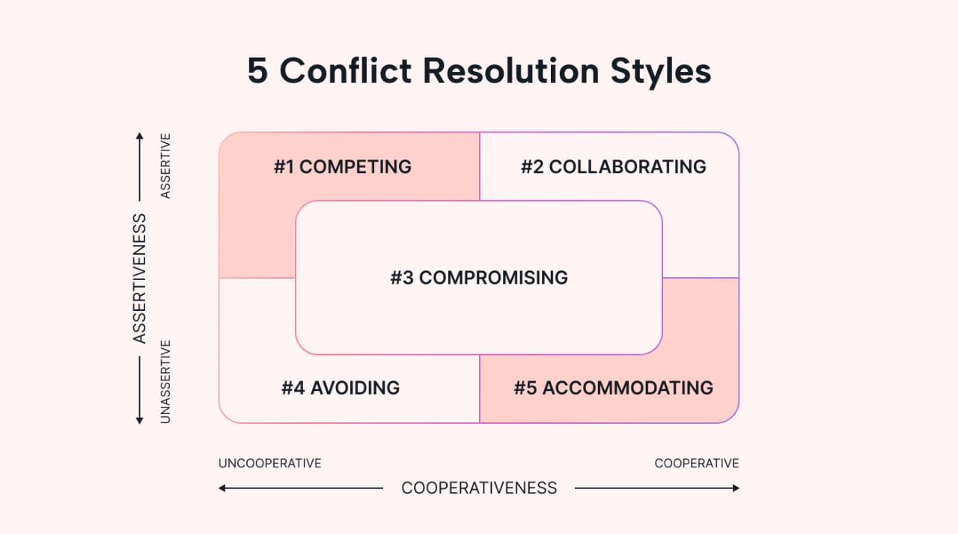

Figure 1 – Conflict Resolution [7]

Moreover, the application of international relations theories, as expounded in works such as "The Globalization of World Politics" by Baylis, Smith, and Owens [8], provides valuable insights into the role of preventive diplomacy in international politics. Last but not list:

Peace-building and Sustaining Peace: The integration of peace-building frameworks and the concept of sustaining peace within the theoretical foundations of preventive diplomacy, as discussed by the United Nations [9] in various reports and resolutions, underscores the long-term and comprehensive nature of preventive diplomacy. This approach emphasizes the need for sustained engagement to address root causes of conflicts and build resilient societies.

The integration of realism, liberalism, and constructivism in understanding diplomatic interventions enhances the theoretical understanding of preventive diplomacy within the broader context of international relations.

Liberalism: Belief in cooperation and peaceful conflict resolution.

- Preventive diplomacy aligns with the idea of promoting democracy, human rights, and economic interdependence as ways to create a more peaceful world order.

- Emphasizes institutions like the United Nations and regional organizations as platforms for dialogue and conflict prevention.

Realism: Focuses on power politics and national interest.

- Preventive diplomacy can be seen as a tool to maintain the balance of power and prevent conflicts that could disrupt the international order.

- Realists might emphasize preventive measures like arms control and alliances to deter aggression.

Constructivism: Highlights the importance of shared ideas, norms, and identities in shaping international relations.

-Preventive diplomacy can be seen as a way to promote a culture of peace and build trust between states.

- Constructivists emphasize the role of confidence-building measures and informal diplomacy in preventing conflict.

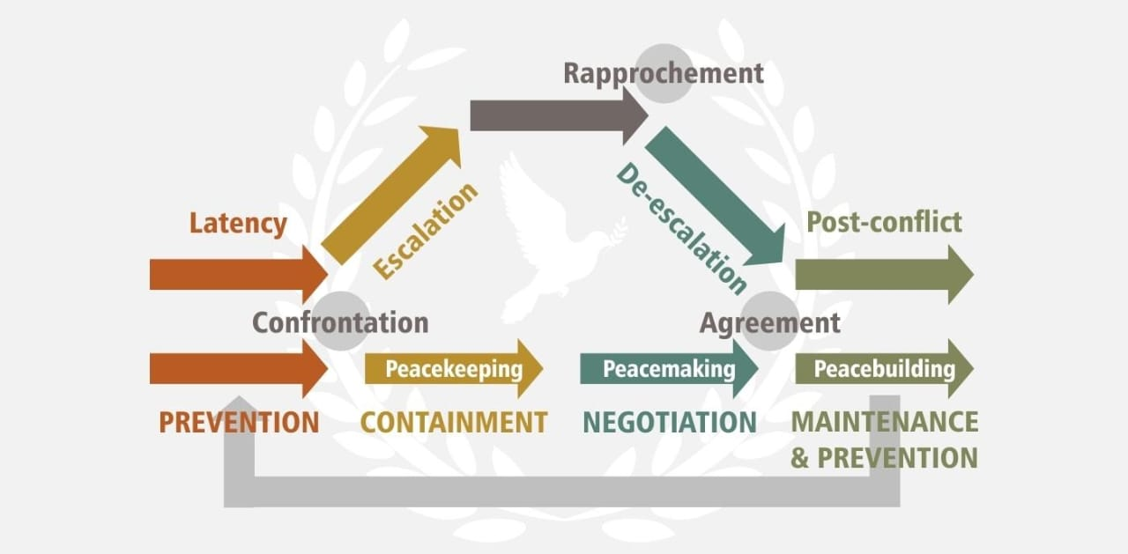

Figure 2 － The phases of conflict and comprehensive peace-building

The concept of preventive diplomacy is also closely related to peace-building and conflict prevention theories. It draws on the idea that sustainable peace can only be achieved by addressing root causes of potential conflict and promoting positive peace through inclusive and participatory processes.

The legal foundations of preventive diplomacy are anchored in the provisions of the United Nations Charter, which emphasize the peaceful settlement of disputes and the role of the UN in preventive diplomacy. Key articles such as 1, 2, and chapter VI of the UN Charter [10]. Which state:

**Article 1** of the United Nations Charter emphasizes the primary purpose of the United Nations, which is to maintain international peace and security. It underlines the commitment to take effective collective measures for the prevention and removal of threats to peace, and for the suppression of acts of aggression or other breaches of the peace.

**Article 2** outlines the principles upon which the United Nations is founded. It includes principles such as the sovereign equality of all its members, the requirement to fulfill obligations under international law, and the promotion of friendly relations among nations based on respect for the principle of equal rights and self-determination of peoples.

Chapter VI of the United Nations Charter focuses on the peaceful settlement of disputes. It outlines the various mechanisms and procedures available for the pacific resolution of conflicts, with the overarching aim of preventing the escalation of disputes into armed conflicts.

Article 33 of Chapter VI provides a framework for the pacific settlement of disputes. It outlines various peaceful means of resolving disputes, including negotiation, inquiry, mediation, conciliation, arbitration, and judicial settlement as the mechanisms to be utilized by parties involved in a dispute. This article emphasizes the importance of utilizing these peaceful means to prevent the escalation of conflicts and maintain international peace and security

Article 34 provides the UN Security Council with the authority to investigate any dispute, or any situation which might lead to international friction or dispute, in order to determine whether the continuance of the dispute or situation is likely to endanger the maintenance of international peace and security.

Article 36 empowers the Security Council to recommend appropriate procedures or methods of adjustment to settle the dispute.

Article 37 stipulates that should the parties to a dispute fail to reach a peaceful settlement through regional agencies or arrangements, the Security Council may take further action to settle the dispute.

Chapter VI of the UN Charter plays a pivotal role in preventive diplomacy by providing a framework for the proactive resolution of disputes before they escalate into armed conflicts. By emphasizing negotiation, mediation, and other peaceful means of settlement, Chapter VI provides a legal basis for the practice of preventive diplomacy, aligning with the UN's commitment to maintaining international peace and security.

Through the principles and mechanisms outlined in Chapter VI, the UN Charter establishes the legal foundation for preventive diplomacy, enabling diplomatic efforts to address potential sources of conflict and promote peaceful resolution before situations escalate into full-blown crises or wars.

These articles collectively form the legal foundation of the United Nations and provide the basis for the organization's commitment to preventing conflicts, promoting peaceful relations among nations, and utilizing diplomatic means to resolve disputes and prevent the outbreak of wars.

Additionally, international legal principles and norms, as elucidated in Ian Brownlie's "Principles of Public International Law" [11], provide a critical framework for understanding the legal dimensions of preventive diplomacy. The prohibition of the threat or use of force and the duty to prevent the occurrence of conflicts are pivotal legal principles that underpin the practice of preventive diplomacy.

Moreover, regional legal instruments, such as the African Union's Constitutive Act [12], contain provisions related to conflict prevention, peace, and security. These regional instruments contribute to the legal foundations of preventive diplomacy, particularly within the African context.

The synthesis of theoretical insights from conflict resolution, international relations theories, and diplomatic studies with the legal principles enshrined in international and regional legal instruments forms the bedrock of the theoretical and legal foundations of preventive diplomacy in politics. This comprehensive understanding of the theoretical and legal underpinnings is instrumental in shaping the conceptual framework and practical application of preventive diplomacy in addressing conflicts and promoting sustainable peace and security.

**1.2 Stages of the formation of the preventive diplomacy concept**

The concept of preventive diplomacy has evolved through distinct stages, shaped by historical events, international crises, and scholarly contributions. Understanding the developmental stages of this concept provides insights into its evolution and the strategies employed to prevent conflicts before they escalate

**Early Diplomatic Practices and Antecedents: which are also known as the Early雏形 (chú xíng) (prototypes). For centuries, leaders have employed various methods to prevent conflicts, such as mediation, alliances, and diplomacy. These efforts can be seen as early forms of preventive diplomacy, even though the term itself wasn't used.**

The origins of preventive diplomacy can be traced back to early diplomatic practices aimed at averting conflicts through mediation, arbitration, and negotiation. Notable antecedents include the Congress of Vienna in 1815, where major European powers engaged in diplomatic efforts to prevent future conflicts following the Napoleonic Wars. Other examples of early prototypes of preventive diplomacy include:

- The Treaty of Westphalia (1648): This treaty ended the Thirty Years' War and established the principle of state sovereignty. It is considered one of the first modern treaties to incorporate preventive diplomacy principles, as it aimed to prevent future religious conflicts in Europe.

- The Concert of Europe (1815-1822): This alliance of European powers was formed after the Napoleonic Wars to maintain peace and stability in Europe. The Concert of Europe used various methods of preventive diplomacy, including mediation and diplomacy, to resolve disputes and prevent conflicts from escalating.

- The Monroe Doctrine (1823): This U.S. policy declared that the Americas were off-limits to further European colonization. The Monroe Doctrine is seen as an early example of preventive diplomacy, as it aimed to prevent European powers from intervening in the Americas and sparking conflict.

- The Pan-American Union (1890-1948): This organization was founded to promote cooperation and solidarity among the countries of the Americas. The Pan-American Union used various methods of preventive diplomacy, including mediation and arbitration, to resolve disputes and prevent conflicts between its member states.

- The League of Nations (1919-1946): The League of Nations was established after World War I to promote international peace and security. The League's Covenant included provisions for collective security, aimed at deterring aggression through collective action. The League also established various tools for preventive diplomacy, such as good offices, fact-finding missions, and preventive deployments.

These are just a few examples of early prototypes of preventive diplomacy. Many other examples can be found throughout history, demonstrating the long-standing tradition of using diplomatic methods to prevent conflicts.

**League of Nations and Interwar Period (1919-1946):** The establishment of the League of Nations after World War I marked a significant shift towards a more systematic approach to preventing conflicts. The League's Covenant included provisions for collective security, aimed at deterring aggression through collective action. The League's efforts to resolve disputes through arbitration and mediation, as enshrined in the Covenant of the League of Nations, laid the groundwork for preventive diplomacy as a formalized approach to conflict prevention [13].

The League of Nations, though not the first attempt at preventing conflict, marked a significant leap in establishing a systematic approach to global peace and security. Here's a breakdown of its role in the evolution of preventive diplomacy:

- Collective Security: The League's Covenant, its founding document, emphasized collective security. This meant member states would collectively deter aggression by any nation. This principle aimed to discourage countries from starting conflicts knowing they'd face the combined might of the League.

- Dispute Settlement: The League provided a platform for peaceful resolution of international disputes. Member states could bring their grievances before the League Council or the Assembly, where mediation and arbitration could be employed to find solutions.

- Early Warning and Action: The League established mechanisms for early detection of potential conflicts. They deployed fact-finding missions to investigate tensions and sent commissions to regions on the brink of war. This early intervention aimed to address issues before they escalated.

Table 1 － Limitations of the League included

|  |  |
| --- | --- |
| Lack of Enforcement Power: | The League lacked its own military force to enforce its decisions. It relied on member states to contribute troops for collective action, which proved unreliable. |
| Great Power Politics: | Major powers like the US never joined, weakening the League's authority. Additionally, internal political considerations often trumped collective security concerns, leading to inaction in crucial moments. |
| Focus on Europe: | The League primarily focused on European issues, neglecting other regions where conflicts were brewing. This limited its effectiveness as a truly global organization. |

Despite these limitations, the League of Nations laid the groundwork for future efforts in preventive diplomacy. It pioneered methods for international cooperation, dispute settlement, and early intervention. These ideas were later adopted and strengthened by the United Nations, which continues to play a central role in preventing conflicts today.

**United Nations and Formalization of Preventive Diplomacy (1945-present): The establishment of the United Nations marked a pivotal stage in the formalization of preventive diplomacy as a core component of international peacemaking efforts. The UN Charter, particularly Articles 1, 2, and 33, provided the legal basis for preventive diplomacy, emphasizing the peaceful settlement of disputes and the** prevention of conflicts through diplomatic means [14]. **The United Nations (UN) has been a driving force in advancing the concept of preventive diplomacy since its inception in 1945. Here's how the UN has built upon the League of Nations' foundation and expanded the use of preventive diplomacy:**

**- Stronger Charter: The UN Charter explicitly authorizes the organization to take measures to "maintain international peace and security" (Article 1). This broader mandate compared to the League's Covenant gives the UN more legitimacy and flexibility in deploying preventive measures.**

**- Expanded Tools: The UN toolbox for preventive diplomacy is more comprehensive than the League's. It includes:**

**- Good Offices: The UN Secretary-General or a special representative can act as a neutral intermediary to facilitate dialogue and negotiation between conflicting parties.**

**- Fact-Finding Missions: The UN can send teams to investigate tensions on the ground and report their findings, promoting transparency and awareness.**

**- Preventive Deployments: The UN can deploy peacekeeping missions or unarmed observers to deter violence and build confidence in areas at risk of conflict.**

**- Early Warning Systems: The UN monitors potential threats to peace and security through various means, including political analysis and intelligence gathering.**

**- Focus on Conflict Prevention: The UN goes beyond just resolving disputes. It actively works to prevent conflicts from arising in the first place. This includes addressing root causes like poverty, inequality, and human rights abuses.**

**- Regional Engagement: The UN works closely with regional organizations like the African Union and the Organization for Security and Co-operation in Europe (OSCE) to tailor preventive diplomacy efforts to specific regional contexts.**

**Challenges faced by the United Nations and the formalization of preventive diplomacy and the ways forward:**

**- Political Will: The effectiveness of preventive diplomacy hinges on the political will of member states to cooperate and take collective action.**

**- Resource Constraints: The UN often faces resource limitations, hindering its ability to deploy preventive measures effectively in all conflict zones.**

**- Sovereignty Concerns: Some countries are wary of UN intervention, viewing it as an infringement on their sovereignty.**

**Despite these challenges, the UN remains a vital actor in preventive diplomacy. Its efforts have helped to prevent numerous conflicts and promote peace and stability in various regions. As the world faces new and evolving security threats, the UN will likely continue to adapt and refine its preventive diplomacy strategies.**

**Cold War and Evolution of Diplomatic Practices (1947-1991):** The Cold War era witnessed the evolution of diplomatic practices geared towards preventing the escalation of tensions between the superpowers, contributing to the development of preventive diplomacy strategies.

Scholarly works during this period, such as Hans Morgenthau's “Politics Among Nations” [15], offered insights into the role of diplomacy in managing international crises and preventing conflicts. The Cold War Era (1947-1991) saw a unique application of preventive diplomacy, largely driven by the fear of a full-scale war between the two superpowers, the United States and the Soviet Union. Here's how preventive diplomacy played out in this tense geopolitical climate:

- Focus on Containment: The US doctrine of containment aimed to prevent the spread of communism around the world. This strategy included diplomatic measures to bolster allied governments and counter Soviet influence in strategic regions.

- Proxy Wars: While the superpowers never directly confronted each other militarily, they supported opposing sides in numerous regional conflicts. These proxy wars were a way to indirectly fight each other without risking a devastating escalation.

- Nuclear Deterrence: The development and stockpiling of nuclear weapons by both sides created a situation of Mutually Assured Destruction (MAD). This common threat served as a powerful deterrent, preventing a direct military confrontation between the US and USSR.

- Détente: Periods of relaxation in tensions, known as détente, also played a role in preventive diplomacy. Arms control talks and diplomatic channels were established to manage tensions and reduce the risk of accidental war.

Limitations of Cold War Era Preventive Diplomacy:

- Superpower Rivalry: The underlying ideological conflict between the US and USSR often overshadowed efforts at cooperation in preventive measures.

- Proxy Wars: Despite preventing a direct superpower clash, proxy wars caused widespread death and destruction in numerous regions.

- Limited Scope: Preventive diplomacy mainly focused on containing the spread of communism rather than addressing broader global issues.

Despite these limitations, the Cold War era marked a significant application of preventive diplomacy on a global scale. The ever-present threat of nuclear war forced the US and USSR to develop methods to manage tensions and prevent a catastrophic conflict. These experiences continue to inform preventive diplomacy efforts in the 21st century.

**Post-Cold War Era and Expansion of Preventive Diplomacy (1991- present):** The post-Cold War era witnessed an expansion of preventive diplomacy efforts, with the UN increasingly engaging in conflict prevention and mediation in various regions. Notable instances include the Brahimi Report of 2000 [16], which underscored the importance of preventive diplomacy and conflict prevention as essential components of the UN's peace and security agenda

The end of the Cold War ushered in a new era for preventive diplomacy, marked by both opportunities and challenges. Here's a breakdown of how preventive diplomacy has evolved in the post-Cold War era:

- Reduced Bipolarity: With the collapse of the Soviet Union, the bipolar world order dissolved. This created more space for the UN and regional organizations to take a more active role in preventive diplomacy.

- Focus on Broader Issues: The post-Cold War era saw preventive diplomacy efforts addressing a wider range of conflict drivers beyond ideological rivalry. This includes issues like ethnic tensions, resource scarcity, and human rights abuses.

- Early Warning and Prevention: Early warning systems and conflict prevention strategies received greater emphasis. The goal became to identify potential conflicts in their early stages and address root causes before they escalate.

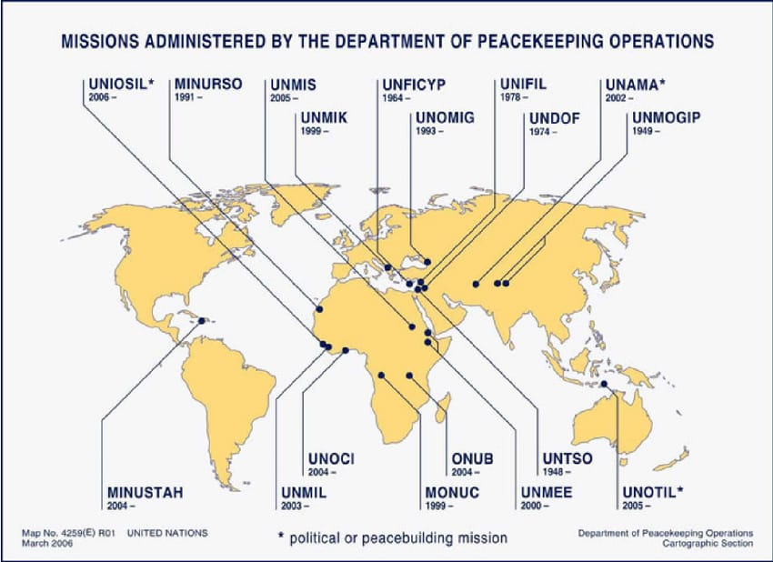

Figure 3 － UN peacekeeping operations March as of 2006

The following are examples of how the post-Cold War era witnessed an expansion of preventive diplomacy efforts, with the UN increasingly engaging in conflict prevention and mediation in various regions and the challenges they faced:

- The UN has deployed peacekeeping missions to various regions to deter violence and promote peace-building, such as in Cambodia and Namibia.

- Regional organizations like the African Union have played a crucial role in mediating conflicts and promoting dialogue within their member states.

- Civil society organizations (CSOs) have become increasingly involved in preventive diplomacy, working on the ground to build trust and address grievances within communities.

Table 2 － Challenges and The Way Forward: **Post-Cold War Era and Expansion of Preventive Diplomacy**

|  |  |
| --- | --- |
| Challenges | The Way Forward |
| Resource Constraints:  The UN and regional organizations often face budget limitations, hindering their ability to deploy comprehensive preventive measures effectively across multiple conflict zones. | Strengthening Early Warning Systems:  Investing in early warning mechanisms and conflict analysis to identify potential threats at an early stage. |
| Political Will:  Effective preventive diplomacy requires cooperation and commitment from member states. However, national interests and political agendas can sometimes obstruct collective action. | Enhancing Collaboration:  Fostering stronger collaboration between the UN, regional organizations, and CSOs to leverage expertise and resources for effective preventive action. |
| Sovereignty Concerns:  Some countries remain wary of external intervention, viewing it as an infringement on their sovereignty, making them less receptive to preventive diplomacy efforts. | Addressing Root Causes:  Addressing the underlying social, economic, and political issues that fuel conflict through development initiatives and promoting good governance. |

The post-Cold War era offers a more complex landscape for preventive diplomacy. While opportunities have expanded, new challenges have emerged. As the world faces evolving security threats, adapting and refining preventive diplomacy strategies will remain essential for promoting lasting peace and stability.

**Contemporary Approaches and Multidimensional Prevention:** Contemporary approaches to preventive diplomacy encompass multidimensional strategies, including early warning systems, mediation, peace-building, and addressing structural causes of conflicts. Scholarly works by authors such as Oliver P. Richmond in “A Theory of International Relations” [17], have contributed to the understanding of preventive diplomacy within the context of broader peace-building efforts.

The concept of preventive diplomacy has evolved significantly in recent years. Here's a look at some key contemporary approaches and the emphasis on multidimensional prevention.

Table 3 － Contemporary Approaches

|  |  |
| --- | --- |
| Focus on Human Security | Preventive diplomacy now prioritizes human security, safeguarding individuals from threats like violence, poverty, and discrimination. This approach goes beyond traditional state security concerns. |
| Peace-building Integration | Preventive diplomacy is increasingly integrated with peace-building efforts. This means addressing the root causes of conflict alongside preventing its outbreak. |
| Technology and Innovation | New technologies like social media monitoring and data analysis are being used to identify potential conflicts and track hate speech online. |
| Inclusive Processes | There's a growing emphasis on including women, youth, and civil society organizations in preventive diplomacy efforts. These groups often have valuable insights into local dynamics and can contribute to more sustainable peace. |

Table 4 － Multidimensional Prevention

|  |  |
| --- | --- |
| Addressing Underlying Causes | Moving beyond immediate triggers, preventive diplomacy now delves deeper to address factors like poverty, inequality, lack of access to resources, and human rights violations that contribute to conflict |
| Combining Tools and Strategies | A multidimensional approach utilizes various tools and strategies, such as diplomacy, mediation, development assistance, and promoting good governance. |
| Tailored Solutions | There's a recognition that "one-size-fits-all" solutions don't work. Preventive measures are tailored to the specific context and needs of each situation. |
| Focus on Prevention Throughout Conflict Cycle | The emphasis is on prevention throughout the conflict cycle, not just before the outbreak of violence. This includes post-conflict peace-building to prevent relapse. |

Table 5 － Benefits and Challenges of Multidimensional Prevention

|  |  |
| --- | --- |
| Benefits | Challenges |
| More Sustainable Peace:  By addressing the root causes of conflict, multidimensional prevention aims to create more durable peace agreements that are less likely to break down. | Resource Constraints:  The implementation of comprehensive preventive measures require significant human and financial resources, which can be scarce. |
| Reduced Human Cost:  By preventing conflicts in the first place, the human cost in terms of lives lost and displaced populations can be significantly reduced. | Political Will:  Effective multidimensional prevention requires sustained political will from national governments and international organizations. |
| Cost-Effectiveness:  Investing in prevention is often seen as more cost-effective in the long run than responding to full-blown conflicts | Complexities on the Ground:  Addressing underlying causes often involves complex social, economic, and political issues that are difficult to tackle. |

As conflicts become increasingly complex, so must preventive diplomacy. By continuing to adapt and embrace multidimensional approaches, preventive diplomacy can play a crucial role in promoting a more peaceful and stable world.

The formation of the preventive diplomacy concept has traversed distinct historical stages, from its early diplomatic antecedents to its formalization within the framework of international organizations such as the League of Nations and the United Nations. The evolving nature of preventive diplomacy reflects a response to the changing dynamics of global conflicts and the imperative of proactive diplomatic interventions in preventing the outbreak and escalation of hostilities.

**1.3 Tools of preventive diplomacy in world politics.**

Preventive diplomacy in world politics encompasses a diverse array of strategies and tools aimed at averting conflicts, mitigating tensions, and promoting peaceful resolutions in international relations. These tools are essential components of proactive diplomatic efforts to prevent the escalation of disputes and address underlying grievances before they lead to violent confrontations.

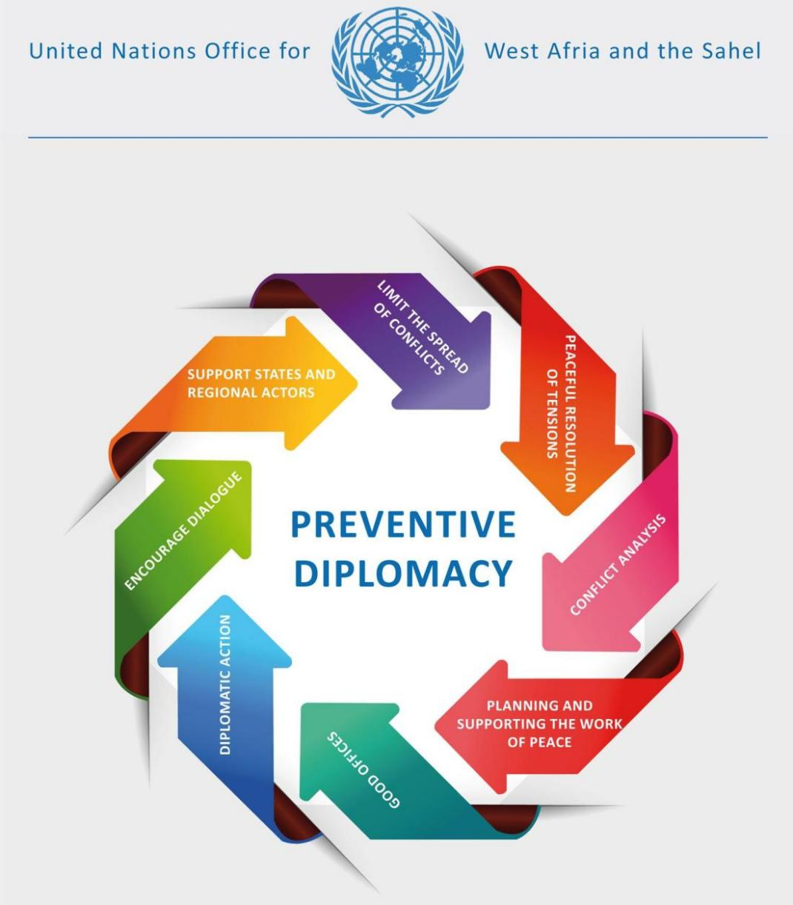

Figure 4 － Preventive Diplomacy: A tool for confronting crisis [18]

From early warning systems and mediation techniques to peace-building initiatives and diplomatic negotiations, the toolbox for preventive diplomacy offers a multifaceted approach to conflict prevention in various contexts and situations.

Below is a comprehensive list of tools for preventive diplomacy in world politics, encompassing a diverse range of strategies aimed at preventing conflicts and promoting peaceful resolutions in international relations:

Table 6 － Strategies aimed at preventing conflicts and promoting peaceful resolutions in international relations

|  |  |
| --- | --- |
| **Early Warning Systems** | Early warning systems utilize data analysis, risk assessment, and monitoring mechanisms to identify potential conflict triggers and emerging threats, enabling proactive diplomatic interventions to prevent escalation [19]. |
| **Mediation and Arbitration** | Mediation involves the intervention of a neutral third party to facilitate dialogue and negotiation between conflicting parties, aiming to reach mutually acceptable agreements and prevent the outbreak of hostilities [20]. |
| **Track II Diplomacy** | Track II diplomacy involves unofficial, non-governmental efforts to facilitate dialogue and bridge differences between conflicting parties, often complementing official diplomatic initiatives [21]. |
| **Confidence-Building Measures** | Confidence-building measures aim to reduce tensions and build trust between conflicting parties through transparency, communication, and the establishment of mutually beneficial agreements, thereby preventing conflicts [22]. |
| **Preventive Deployments and Peacekeeping** | Preventive deployments of peacekeeping forces, under the authorization of international organizations, serve to prevent the outbreak of violence, protect civilians, and create conditions conducive to peaceful resolution of disputes [23]. |
| **Economic and Development Initiatives** | Economic and development initiatives, such as poverty alleviation programs, infrastructure development, and trade agreements, contribute to addressing underlying socio-economic grievances, reducing tensions, and preventing conflicts [24]. |
| **Diplomatic Negotiations and Treaties** | Diplomatic negotiations and the formulation of treaties serve as fundamental tools for conflict prevention, as they provide avenues for peaceful resolution of disputes through formal agreements and compromises [25]. |
| **Early Diplomatic Engagement** | Early diplomatic engagement involves proactive interaction with conflicting parties to address grievances, de-escalate tensions, and prevent the emergence of hostilities through dialogue and confidence-building measures [26]. |
| **Humanitarian Assistance and Disaster Relief** | Humanitarian assistance and disaster relief efforts contribute to preventing conflicts by addressing humanitarian crises, providing essential aid, and mitigating the impact of natural disasters or emergencies that could lead to conflict [27]. |
| **Cross-Cultural Dialogue and Reconciliation** | Cross-cultural dialogue and reconciliation initiatives promote mutual understanding, address historical grievances, and foster peaceful coexistence, thus preventing conflicts rooted in cultural or ethnic tensions [28]. |

This comprehensive list of tools for preventive diplomacy in world politics encompasses a diverse array of strategies and approaches, supported by authoritative references that underpin their relevance in international relations and conflict prevention.

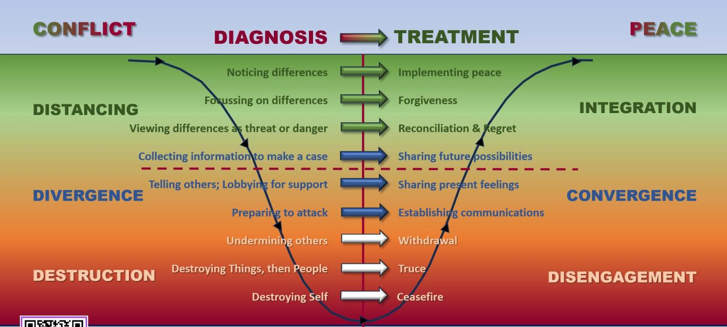

Figure 5 － Diplomacy: Treating for Peace, a strategy for preventive conflict [29]

Understanding how conflicts work is fairly important, we encounter many kinds of conflicts in different settings throughout our lives. Some are personal, involving the inner critic. Others are interpersonal, where we disagree with one another for some reason. Conflicts may also involve groups or organisations we belong to, while others are commercial, legal, or political matters, some of which are played out globally. How well we manage those conflicts, de-escalating them as they arise, often determines the level of success we can achieve.

Conflicts can quickly escalate when something is said or done which causes offence, or which doesn’t meet our expectations. De-escalation is a skill involving many aspects, but its foundation is the intention we bring to the task. Having a clear intention to achieve some form of ‘Win:Win’ outcome is usually the best way to secure an acceptable resolution of a conflict.

The ‘Conflict Curve’ was developed by [Michael S. Lund](https://independent.academia.edu/MichaelLund3) in his book [Preventing violent conflicts, A Strategy for preventive diplomacy](https://www.amazon.com.au/gp/product/1878379526/ref=dbs_a_def_rwt_hsch_vapi_taft_p1_i0)(US Institute for Peace Press 1996). It describes the steps and stages usually involved in the escalation of conflict and those required for de-escalation. While originally framed in the context of global tensions, the principles offered can be scaled down for use in organisational and personal conflicts.

Conflicts can quickly escalate when something is said or done which causes offence, or which doesn’t meet our expectations. De-escalation is a skill involving many aspects, but its foundation is the intention we bring to the task. Having a clear intention to achieve some form of ‘Win:Win’ outcome is usually the best way to secure an acceptable resolution of a conflict.

The ‘Conflict Curve’ was developed by [Michael S. Lund](https://independent.academia.edu/MichaelLund3) in his book [Preventing violent conflicts, A Strategy for preventive diplomacy](https://www.amazon.com.au/gp/product/1878379526/ref=dbs_a_def_rwt_hsch_vapi_taft_p1_i0)(US Institute for Peace Press 1996). It describes the steps and stages usually involved in the escalation of conflict and those required for de-escalation. While originally framed in the context of global tensions, the principles offered can be scaled down for use in organisational and personal conflicts.

The use of graded peace-making measures or treatments characterises the adjacent conflict states as part of a continuum of pathological behaviours. The more serious the conflict, the more dramatic the diplomatic treatment that would be required to interrupt or reverse escalation.

The diplomatic measures suggested in the ‘Treating for Peace’ chart (i.e. the inverted Conflict Curve) can be adapted for use at the personal, group, or organisational level in any setting.

**2 Analysis of the application of preventive diplomacy for conflict prevention in Africa**

**2.1 Cooperation of States within the framework of the concept of preventive diplomacy**

The concept of preventive diplomacy, rooted in the proactive management of conflicts to prevent their escalation into full-blown crises, relies heavily on the cooperation of states on a global scale. As the international community faces diverse and complex challenges, the cooperative engagement of states within the framework of preventive diplomacy is crucial for fostering global stability and mitigating potential conflicts.

Multilateral Diplomacy: A Cornerstone of Conflict Prevention: Multilateral diplomacy serves as a cornerstone of conflict prevention, providing a platform for international cooperation and concerted efforts to avert potential conflicts. In the context of preventive diplomacy, multilateralism involves the engagement of multiple states, international organizations, and other stakeholders in collaborative endeavors aimed at addressing emerging threats to peace and security. This section delves into the critical role of multilateral diplomacy in conflict prevention and its impact on fostering global stability.

The United Nations and Multilateral Diplomacy: The United Nations (UN) stands as a preeminent example of multilateral diplomacy in action, offering a forum for member states to engage in dialogue, negotiation, and collective decision-making to address diverse global challenges. The UN Charter underscores the commitment to the peaceful resolution of disputes and the prevention of the scourge of war, laying the foundation for the practice of preventive diplomacy within the multilateral framework.

The Security Council, as the primary organ responsible for the maintenance of international peace and security, plays a central role in multilateral conflict prevention efforts. Through its mandate to identify potential threats to peace and recommend measures to address such threats, the Security Council serves as a focal point for multilateral diplomacy aimed at preventing conflicts from escalating [30]. Multilateral diplomacy offers several distinct advantages in the context of conflict prevention

Table 7 － Advantages of Multilateral Diplomacy in Conflict Prevention

|  |  |
| --- | --- |
| Inclusivity: | By involving a wide array of stakeholders, including states, international organizations, and non-state actors, multilateral diplomacy ensures a diverse range of perspectives and resources are brought to bear on conflict prevention efforts. |
| Normative Framework: | Multilateral organizations often establish normative frameworks and mechanisms for conflict prevention, providing a set of agreed-upon principles, rules, and procedures that guide the collective response to potential conflicts [31]. |
| Resource Pooling: | Through multilateral platforms, states can pool resources, expertise, and capabilities to enhance the effectiveness of preventive diplomacy initiatives, particularly in regions facing heightened risks of conflict [32]. |

Despite its advantages, multilateral diplomacy faces challenges in the realm of conflict prevention:

- Diverse Interests: Balancing the diverse national interests and policy priorities of member states within multilateral forums can present challenges in formulating cohesive strategies for conflict prevention.

- Decision-Making Processes: The consensus-based decision-making processes within multilateral organizations may impede swift and decisive action in response to emerging conflicts, particularly in cases where member states hold divergent views.

- Resource Constraints: Multilateral efforts in conflict prevention may be constrained by resource limitations, necessitating innovative approaches to maximize the impact of available resources.

Multilateral diplomacy stands as a vital instrument in conflict prevention, leveraging cooperation among states and international organizations to address potential sources of conflict. The inclusive, normative, and resource-sharing aspects of multilateral diplomacy contribute to its efficacy in preventing conflicts and fostering global stability. However, the challenges of navigating diverse interests and decision-making processes underscore the complexity of multilateral conflict prevention efforts. Nevertheless, the enduring commitment to multilateralism and collaborative engagement remains essential in advancing the principles of preventive diplomacy and promoting sustainable peace and security on a global scale.

Regional Alliances and Collaborative Initiatives: Strengthening Preventive Diplomacy: Regional alliances and collaborative initiatives play a crucial role in the framework of preventive diplomacy, contributing to conflict prevention, peace-building, and stability within specific geographic regions.

Role of Regional Alliances in Conflict Prevention: Regional alliances, such as the European Union [33], African Union [34] , Association of Southeast Asian Nations (ASEAN) [35], and Organization of American States (OAS) [36], among others, have increasingly taken on proactive roles in conflict prevention within their respective regions. These alliances serve as platforms for member states to engage in dialogue, cooperative security measures, and joint initiatives aimed at averting potential conflicts and addressing existing sources of instability.

Regional alliances offer several advantages in the context of preventive diplomacy:

1. Regional Expertise: These alliances often possess in-depth understanding of regional dynamics, cultural nuances, and historical contexts, enabling them to tailor conflict prevention strategies to the specific challenges within their regions.
2. Proximity and Accessibility: Proximity to the affected areas allows regional alliances to swiftly mobilize resources and interventions, facilitating timely responses to emerging conflicts.
3. Cultural and Linguistic Affinity: Shared cultural and linguistic affinities among member states can enhance communication and understanding, contributing to more effective preventive diplomacy efforts.

Collaborative initiatives within regional alliances encompass a wide range of activities aimed at preventing conflicts and fostering stability:

1. Early Warning Systems: Regional alliances often establish early warning systems to detect potential sources of conflict, enabling timely interventions and preventive measures.
2. Peace-building and Mediation Efforts: Collaborative peace-building and mediation initiatives seek to address underlying grievances, facilitate dialogue, and promote reconciliation among conflicting parties.
3. Capacity-Building Programs: Regional alliances engage in capacity-building efforts to enhance the conflict prevention and resolution capabilities of member states, promoting sustainable peace and security within the region.

Despite their advantages, regional alliances and collaborative initiatives encounter certain challenges in the realm of preventive diplomacy:

- Diverse Interests and Priorities: Balancing the diverse national interests and policy priorities of member states within regional alliances can present challenges in formulating cohesive strategies for conflict prevention.

- Resource Constraints: Limited resources and varying capacities among member states may impede the effectiveness of collaborative initiatives in conflict prevention.

Regional alliances and collaborative initiatives play a pivotal role in preventive diplomacy, leveraging regional expertise, proximity, and collaborative efforts to address potential conflicts and promote stability within specific geographic contexts. While challenges exist, the unique advantages of regional alliances in conflict prevention underscore their significance in fostering regional and global security. The sustained engagement of regional alliances in preventive diplomacy remains essential in advancing the principles of conflict prevention and contributing to enduring peace and stability in diverse regions across the globe.

Shared Intelligence and Early Warning Systems: Enhancing Preventive Diplomacy:

Shared intelligence and early warning systems play a critical role in the framework of preventive diplomacy, providing crucial information and insights that enable states and international organizations to anticipate, prevent, and mitigate potential conflicts [37].

Importance of Shared Intelligence in Conflict Prevention: Shared intelligence involves the exchange of information, analysis, and assessments among states, intelligence agencies, and international partners [38]. This collaborative approach to intelligence gathering and analysis enhances the collective understanding of evolving security threats, potential conflict triggers, and destabilizing factors, thereby enabling proactive measures to prevent conflicts from escalating.

Advantages of Shared Intelligence in Preventive Diplomacy: Shared intelligence offers several advantages in the context of conflict prevention:

- Comprehensive Threat Assessment: Collaborative intelligence sharing facilitates a more comprehensive assessment of potential threats, drawing on diverse sources of information and expertise.

- Early Identification of Risks: Timely sharing of intelligence allows for the early identification of emerging risks and warning signs, enabling preemptive diplomatic and security interventions.

- Enhanced Situational Awareness: Access to shared intelligence enhances the situational awareness of states and international organizations, empowering them to make informed decisions and formulate targeted preventive strategies.

- Early Warning Systems for Conflict Prevention: Early warning systems are designed to detect and analyze indicators of potential conflict, enabling timely responses and preventive action [39]. These systems often incorporate various sources of information, including political, socioeconomic, and security-related data, to identify patterns and trends that may signal the risk of conflict escalation.

Collaborative initiatives in early warning systems encompass a range of activities aimed at enhancing conflict prevention efforts:

– Data Sharing and Analysis: States and international organizations collaborate in sharing relevant data and conducting joint analysis to identify potential conflict triggers and hotspots.

– Capacity-Building and Training: Capacity-building programs focus on equipping stakeholders with the skills and tools necessary to effectively utilize early warning systems and act on the information obtained.

– Policy Coordination and Response Planning: Collaborative efforts involve the development of coordinated policies and response plans based on the insights gleaned from early warning systems, enabling proactive measures to avert potential conflicts.

While shared intelligence and early warning systems offer substantial benefits, they encounter certain challenges in the realm of preventive diplomacy:

－ Data Sharing Concerns: Sensitivity regarding the sharing of intelligence and information among states can impede seamless collaboration and hinder the effectiveness of early warning systems.

－ Analytical Capacity: Variations in the analytical capacity and methodologies of participating entities may impact the quality and reliability of shared intelligence and early warning assessments.

Shared intelligence and early warning systems serve as indispensable tools in preventive diplomacy, empowering states and international organizations to anticipate and address potential conflicts before they escalate [40].

The advantages of collaborative intelligence sharing and early warning systems in enhancing threat assessment and situational awareness underscore their significance in conflict prevention. Overcoming challenges through enhanced collaboration and information sharing remains crucial in advancing the effectiveness of shared intelligence and early warning systems in fostering global peace and security.

Strengthening Preventive Diplomacy through Cooperative Capacity-Building and Training Programs: The cooperative engagement of states in capacity-building and training programs is instrumental in strengthening the preventive diplomacy capabilities of nations, particularly in conflict-affected regions. By sharing expertise, resources, and best practices, states can enhance their diplomatic and mediation capacities, contributing to more effective preventive diplomacy efforts.

Empowering Diplomatic and Mediation Capacities: Cooperative capacity-building and training programs are designed to empower states with the skills, knowledge, and resources necessary to effectively engage in preventive diplomacy and mediation. These programs focus on enhancing the capabilities of diplomats, mediators, and relevant stakeholders in conflict resolution, negotiation, and peace-building, thereby equipping them to address and manage conflicts proactively.

Cooperative capacity-building and training programs offer several distinct advantages in the context of preventive diplomacy:

1. Knowledge Sharing: Through cooperative programs, states can share best practices, lessons learned, and specialized knowledge in conflict resolution and preventive diplomacy, enriching the collective expertise of participating nations.
2. Resource Pooling: Collaborative initiatives enable the pooling of resources, expertise, and training facilities, maximizing the impact of capacity-building efforts and ensuring broader access to critical training opportunities.
3. Cultural and Contextual Understanding: By engaging in cooperative programs, states can enhance their understanding of diverse cultural and contextual factors that influence conflict dynamics, fostering more nuanced and effective diplomatic interventions.

Cooperative capacity-building and training programs in preventive diplomacy encompass various focus areas, including:

- Negotiation and Mediation Skills: Training programs focus on honing the negotiation and mediation skills of diplomats and mediators, preparing them to engage in constructive dialogue and conflict resolution processes.

- Conflict Analysis and Early Warning: Capacity-building efforts emphasize the development of analytical capabilities for conflict assessment, early warning system utilization, and the identification of potential conflict triggers.

- Peace-building and Reconciliation: Programs address strategies for promoting peace-building, reconciliation, and the sustainable resolution of conflicts, equipping participants with tools for long-term stability.

Despite their advantages, cooperative capacity-building and training programs encounter certain challenges, such as:

- Sustainability: Ensuring the sustainability of capacity-building efforts and the long-term retention of trained personnel within governmental and diplomatic structures.

- Adaptation to Local Contexts: Tailoring training programs to the specific cultural, social, and political contexts of participating nations to ensure relevance and applicability.

Cooperative capacity-building and training programs play a vital role in strengthening the preventive diplomacy capabilities of states, particularly in conflict-affected regions. The advantages of knowledge sharing, resource pooling, and contextual understanding underscore the significance of collaborative initiatives in enhancing diplomatic and mediation capacities. Overcoming challenges through sustained engagement and tailored training approaches remains essential in advancing the effectiveness of cooperative capacity-building and training programs in fostering peace and stability in conflict-affected regions.

By fostering a culture of collaboration and mutual support in capacity-building and training, states can contribute to the advancement of preventive diplomacy efforts and the promotion of sustainable peace and security on a global scale.

**2.2 Assessment of the interaction of the world community on conflict prevention in Africa**

The interaction of the world community on conflict prevention in Africa has been marked by a mix of cooperative efforts, challenges, and notable achievements. International organizations, regional alliances, and individual states have engaged in various initiatives aimed at preventing and resolving conflicts across the continent. Here's an assessment of the world community's interaction on conflict prevention in Africa:

United Nations: The United Nations has played a pivotal role in conflict prevention in Africa through its peacekeeping missions, diplomatic interventions, and support for regional peace initiatives. Notable examples include the UN mission in the Central African Republic (MINUSCA) and the UN-African Union hybrid mission in Darfur (UNAMID).

United Nations Multidimensional Integrated Stabilization Mission in the Central African Republic (MINUSCA): The United Nations Multidimensional Integrated Stabilization Mission in the Central African Republic (MINUSCA) is a peacekeeping mission mandated to protect civilians and support transition processes in the Central African Republic (CAR). Established in 2014, MINUSCA's mission encompasses addressing security, humanitarian, human rights, and political crises in the CAR and its regional implications. The mission is authorized under Chapter VII of the UN Charter and is tasked with various responsibilities, including supporting the transition process, facilitating humanitarian assistance, promoting and protecting human rights, and supporting justice and the rule of law. MINUSCA subsumed the UN Integrated Peace-building Office in the Central African Republic (BINUCA) upon its establishment and took over the authority of the African-led International Support Mission in the Central African Republic (MISCA) in 2014.

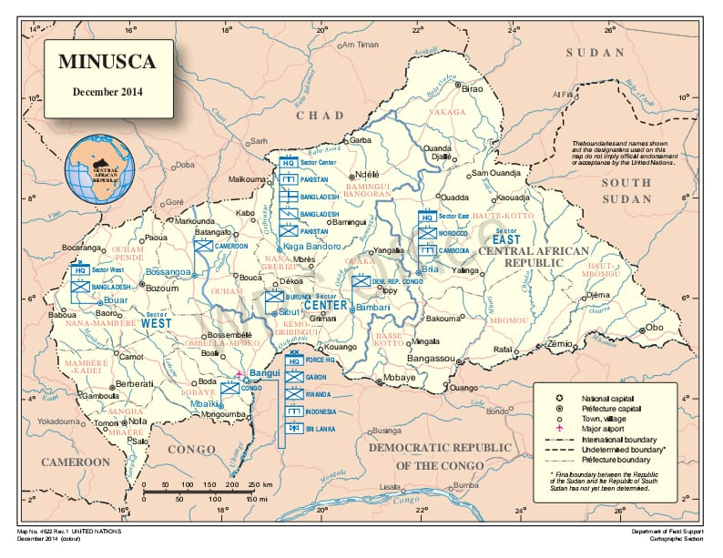

Figure 6 － The United Nations Multidimensional Integrated Stabilization Mission in the Central African Republic (MINUSCA) 2014

MINUSCA was initially authorized to comprise up to 10,000 military personnel, including military observers and staff officers, as well as 1,800 police personnel and corrections officers [41]. The mission is funded through a separate account approved annually by the UN General Assembly, with an approved budget of $1,116,738,700 for the period of July 2021 to June 2022.

The Central African Republic has been plagued by decades of instability and conflict, with a resurgence of violence in 2012 leading to widespread humanitarian crises and internal displacement. The conflict escalated into a sectarian crisis, resulting in inter-communal clashes and the displacement of millions, requiring significant humanitarian aid and support. The UN Security Council authorized an AU-led International Support Mission to the CAR (MISCA) and French-backed peacekeeping force (Operation Sangaris) to address the escalating violence. However, the security needs on the ground exceeded the capabilities of the deployed international troops, leading to ongoing violence and human rights violations .

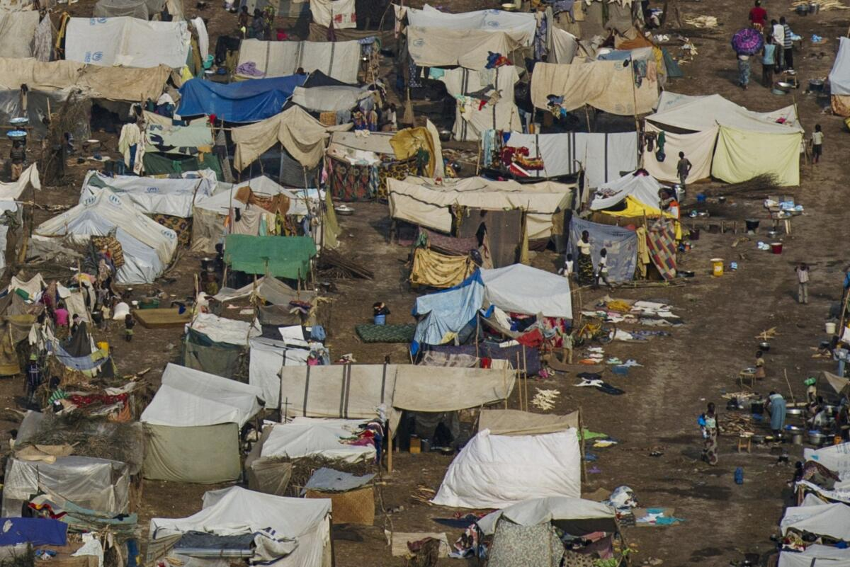

Figure 7 － Civilians massacred amid sectarian chaos: A refugee camp near the airport in Bangui (2012)

MINUSCA's mandate includes the protection of civilians, support for the extension of State authority, facilitation of the peace process, delivery of humanitarian assistance, and protection of UN personnel and installations. The mission is also tasked with promoting and protecting human rights, including the timely publication of human rights reports. MINUSCA's role extends to advancing a multi-year strategic vision aimed at creating the political, security, and institutional conditions conducive to national reconciliation and durable peace in the CAR [42].

In a significant development, the UN Security Council adopted Resolution 2709 (2023) to extend the mandate of MINUSCA until 15 November 2024. The resolution maintains MINUSCA's troop levels and identifies priority tasks, including the protection of civilians, support for the extension of State authority, and the facilitation of the peace process, among others. This extension underscores the ongoing commitment of the international community to support stability and peace-building efforts in the CAR through the mission.

MINUSCA's role in the Central African Republic remains crucial in addressing the multifaceted crises and contributing to the stabilization and reconstruction of the country. The mission's efforts are instrumental in protecting civilians, promoting human rights, and supporting the peace process, reflecting the collaborative engagement of the international community in conflict prevention and peace-building in the region.

The United Nations-African Union Hybrid Mission in Darfur (UNAMID) was a joint peacekeeping mission established to address the conflict in the Darfur region of Sudan. UNAMID was deployed in 2007 with the primary mandate of protecting civilians, facilitating the delivery of humanitarian assistance, and supporting the peace process in Darfur. The mission was a unique collaboration between the United Nations and the African Union, reflecting a joint commitment to addressing the complex crisis in the region.

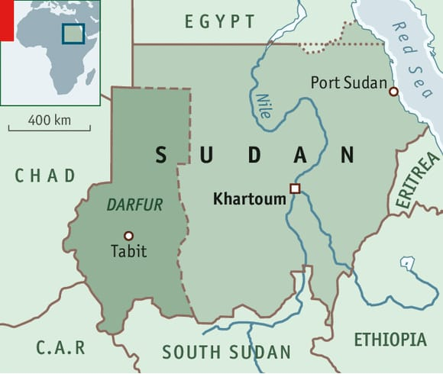

Figure 8 － The United Nations-African Union Hybrid Mission in Darfur (UNAMID)

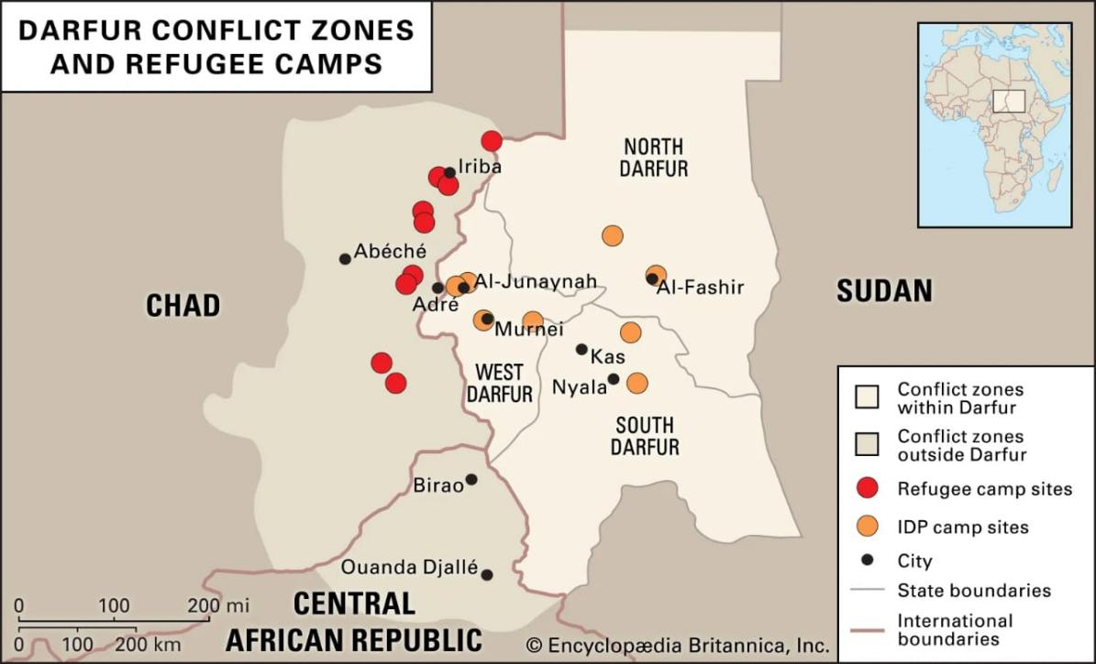

Figure 9 － Darfur-related conflict zones and campsites for refugees and internally displaced peoples (IDPs) in Sudan, the Central African Republic, and Chad, 2008 [43]

UNAMID's mandate was authorized under Chapter VII of the UN Charter and involved a range of tasks, including:

1. Protecting civilians under imminent threat of physical violence:
2. Facilitating the delivery of humanitarian aid and ensuring the safety of humanitarian personnel
3. Supporting the implementation of the Darfur peace agreements
4. Contributing to the promotion of human rights and the rule of law
5. Monitoring and reporting on the security situation in Darfur
6. Assisting in the mediation of local conflicts and contributing to the establishment of conditions conducive to the voluntary return of internally displaced persons and refugees to their homes

At its peak, UNAMID was one of the largest peacekeeping missions, with a significant deployment of military, police, and civilian personnel. Contingents from various contributing countries, both from the African Union and non-African countries, participated in the mission's operations.

UNAMID was deployed in the context of the protracted conflict in Darfur, which had resulted in widespread violence, displacement, and humanitarian crises. The mission aimed to provide protection to civilians affected by the conflict and support efforts to achieve a durable peace in the region. Over the years, UNAMID faced challenges related to the security environment, logistical constraints, and the complex nature of the conflict dynamics in Darfur.

UNAMID's presence significantly contributed to the protection of civilians and the delivery of humanitarian aid in Darfur. The mission also played a role in supporting the peace process and facilitating dialogue among various stakeholders. In 2020, UNAMID began its drawdown and eventual exit from Darfur, marking a transition in the international community's approach to addressing the conflict in the region.

The legacy of UNAMID reflects the collaborative efforts of the United Nations and the African Union in addressing complex and challenging conflicts. While the mission faced operational and political challenges, it remains an important example of international and regional cooperation in peacekeeping and conflict resolution efforts.

African Union (AU): The AU has been actively involved in conflict prevention and resolution through its Peace and Security Council (PSC) in various countries, including Somalia, South Sudan, and Mali. The PSC, as the AU's principal peace and security organ, plays a crucial role in addressing conflicts and promoting peace across the continent. Here are the key ways in which the AU, through its Peace and Security Council, has been involved in conflict prevention and resolution in these countries:

1. Somalia: The AU, through its Peace and Security Council, has been extensively involved in conflict prevention and resolution in Somalia.

Peace Support Operations: The AU Mission in Somalia (AMISOM) has been a significant AU-led peace support operation aimed at stabilizing Somalia and countering the threat of armed groups.

Mediation and Dialogue: The AU has facilitated mediation efforts and dialogue among various Somali stakeholders to foster reconciliation and political stability.

Support for Peace-building: The AU has supported efforts to build peace and strengthen governance structures in Somalia, contributing to stability and the restoration of state authority.

1. South Sudan: The AU's Peace and Security Council has been actively engaged in conflict prevention and resolution in South Sudan:

Mediation and Peace Agreements: The AU has facilitated mediation efforts and played a key role in brokering peace agreements, including the 2015 Agreement on the Resolution of the Conflict in South Sudan (ARCSS).

Peace Support Operations: The AU has been involved in discussions related to peace support operations and has advocated for predictable, adequate, and sustainable support for peace operations in South Sudan.

Support for Constitutional Order: The AU has supported efforts to restore constitutional order and stability in South Sudan, emphasizing the need for effective conflict resolution mechanisms.

1. Mali: The AU, through its Peace and Security Council, has been engaged in conflict prevention and resolution in Mali:

Support for Peace Initiatives: The AU has supported peace initiatives and efforts to address the conflict in Mali, including the restoration of constitutional order and the promotion of dialogue among stakeholders.

Peacekeeping and Peace-building: The AU has supported peacekeeping and peace-building efforts in Mali, emphasizing the need for sustainable strategies to address the security challenges in the country.

Advocacy for Predictable Financing: The AU has advocated for predictable, flexible, and sustainable financing for peace support operations in Mali, highlighting the importance of addressing funding shortfalls and operational challenges.

The African Union's Peace and Security Council has been instrumental in conflict prevention and resolution in Somalia, South Sudan, and Mali through its mediation, peace support operations, advocacy for sustainable financing, and support for peace-building initiatives. The AU's engagement reflects its commitment to addressing conflicts and promoting peace and stability in these countries, demonstrating the organization's role as a key actor in peace and security efforts on the African continent.

Somalia : The international community, including the UN and the AU, has been engaged in supporting conflict prevention and state-building efforts in Somalia. The AU Mission in Somalia (AMISOM) has been instrumental in stabilizing the country and supporting the Somali government's efforts to combat extremist groups like Al-Shabaab.

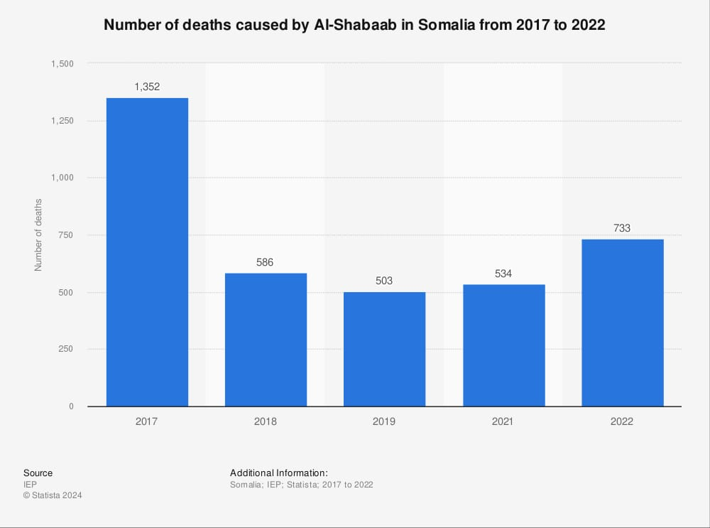

Figure 10 － Number of deaths caused by Al-Shabaab in Somalia from 2017 to 2022

The African Union Mission in Somalia (AMISOM) is a major peace support operation deployed by the African Union in Somalia. Established in 2007, AMISOM's primary objective is to support the Federal Government of Somalia in its efforts to stabilize the country, counter the threat posed by armed extremist groups, and create a secure environment conducive to the delivery of humanitarian aid and the re-establishment of effective governance.

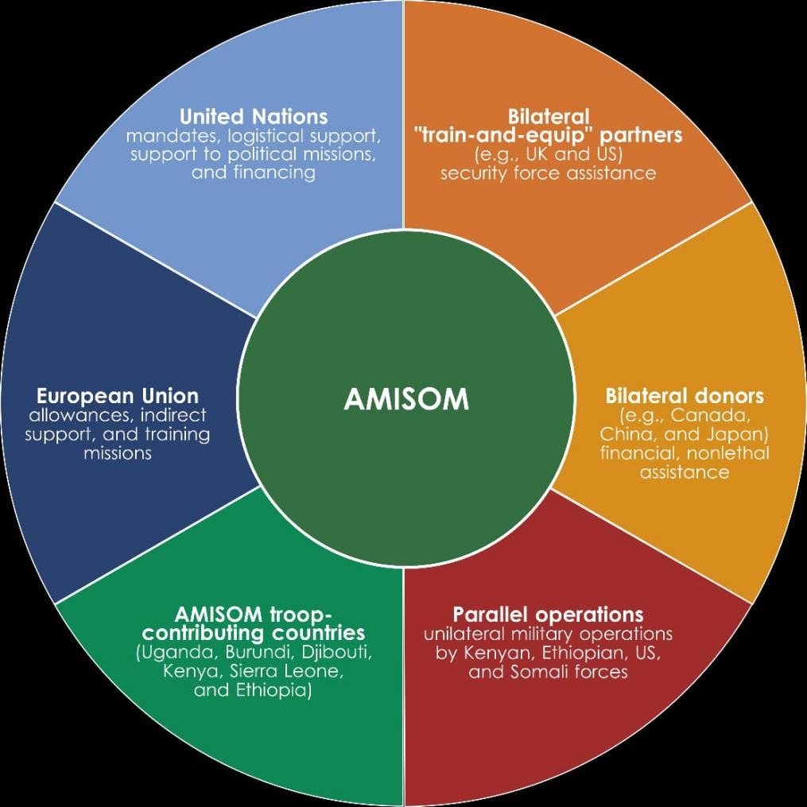

Figure 11 － The AMISOM model

AMISOM's mandate, authorized by the United Nations Security Council, includes a range of tasks such as:

1.Supporting the Federal Government of Somalia in the implementation of its National Security Stabilization Plan

2. Reducing the threat posed by Al-Shabaab and other armed opposition groups [44].

3. Protecting the Somali people and key infrastructure

4. Facilitating the delivery of humanitarian assistance

5. Supporting the implementation of the Somali Transition Plan, which involves the gradual handover of security responsibilities to Somali security forces

6. Contributing to the creation of conditions for long-term stabilization and reconstruction

AMISOM is composed of military contingents contributed by several African countries. These troops operate in coordination with Somali national security forces and are supported by international partners.

Challenges and Achievements

Over the years, AMISOM has faced challenges related to the complex security environment in Somalia, including asymmetric warfare tactics employed by extremist groups. The mission has also made significant contributions to the stabilization of key urban centers, the protection of civilians, and the training and capacity-building of Somali security forces.

In recent years, discussions and plans for the gradual draw down and eventual exit of AMISOM have been underway, reflecting a transition towards greater reliance on Somali security forces to take over security responsibilities. This transition involves a comprehensive approach to capacity-building, institutional reforms, and the strengthening of the Somali security sector.

The African Union Mission in Somalia (AMISOM) represents a significant African-led peace support operation aimed at addressing the complex security challenges in Somalia. The mission's efforts have been instrumental in supporting the Somali government and its security forces in countering the threat of armed extremist groups and contributing to the stabilization and reconstruction of the country. AMISOM's role reflects the commitment of the African Union and its member states to addressing security challenges on the African continent and promoting peace and stability in Somalia.

Additionally, several international and regional actors have collaborated on conflict prevention initiatives in the Great Lakes region of Africa. The Great Lakes region, which encompasses countries such as the Democratic Republic of the Congo (DRC), Burundi, Rwanda, and Uganda, has been plagued by conflicts, violence, and instability. Collaboration among international and regional actors has been essential in addressing the complex challenges facing the region. Some of the key actors involved in conflict prevention initiatives in the Great Lakes region include:

International Actor:

1. United Nations (UN): The UN has been actively engaged in conflict prevention and resolution efforts in the Great Lakes region through its peacekeeping operations, political mediation, and support for humanitarian assistance and development initiatives.
2. African Union (AU): The AU has played a pivotal role in promoting peace and security in the Great Lakes region through its Peace and Security Council and by deploying peace support operations in conflict-affected areas.
3. European Union (EU): The EU has provided significant financial and diplomatic support for conflict prevention and peace-building initiatives in the Great Lakes region. This support has included funding for peace and security programs, development assistance, and capacity-building efforts.
4. United States and Other Western Countries: Various Western countries, including the United States, have been actively involved in conflict prevention and resolution efforts in the Great Lakes region, providing diplomatic support, financial assistance, and technical expertise.
5. International Financial Institutions: Entities such as the World Bank and the International Monetary Fund (IMF) have supported development and economic recovery programs in the Great Lakes region, contributing to conflict prevention and stability.

Regional Actors:

1. Economic Community of the Great Lakes Countries (CEPGL): CEPGL, comprising Burundi, the DRC, and Rwanda, has been involved in regional cooperation and conflict prevention initiatives to promote peace, security, and economic development in the Great Lakes region.
2. International Conference on the Great Lakes Region (ICGLR): ICGLR, a regional organization consisting of 12 member states, has been actively engaged in conflict prevention, peace-building, and the promotion of good governance and human rights in the Great Lakes region.
3. East African Community (EAC): The EAC, which includes Burundi, Rwanda, Uganda, and Tanzania, has contributed to regional stability and security in the Great Lakes region through collaboration on conflict prevention, peace-building, and economic integration.
4. Economic Community of West African States (ECOWAS): Formed in 1975, ECOWAS has been instrumental in intervening in crises, notably in Liberia through the deployment of the ECOMOG force to secure a cease-fire and monitor peace. Its successful interventions in Liberia and Sierra Leone demonstrate the potential of sub-regional organizations in managing conflicts effectively [45].
5. Intergovernmental Authority on Development (IGAD) and Southern African Development Community (SADC): Both IGAD and SADC have played increasingly important roles in preventive diplomacy, showcasing the effectiveness of sub-regional entities in addressing conflicts within their respective geographical areas.

Challenges and support needs for regional actors: Predictable, reliable, and sustainable financing of African Union peacekeeping operations is critical, considering the continent's challenges such as terrorism, insurgencies, and climate change. The international community, including the UN, has recognized the necessity of empowering African Union peace operations.

The roles of regional groups are indispensable but require adequate human and financial resources to be effective. The Security Council is urged to consider a bolstered African Union toolkit for deploying peacekeeping missions promptly when needed [46].

This overview of the role of regional organizations in preventive diplomacy in Africa underscores the complexity of the landscape in which these entities operate. Their efforts, in collaboration with international bodies like the UN, are essential in the pursuit of peace and stability across the continent, albeit faced with challenges that necessitate a coordinated, well-resourced approach.

The collaboration between international and regional actors in conflict prevention initiatives in the Great Lakes region underscores the importance of a comprehensive and coordinated approach to addressing the complex challenges of peace and security. By working together, these actors have sought to promote stability, reconciliation, and sustainable development in the region, reflecting a shared commitment to fostering peace and prosperity in the Great Lakes region of Africa.

Table 8 － The challenges and achievements the collaboration between international and regional actors

|  |  |
| --- | --- |
| Challenges | Achievements |
| Resource Constraints:  Limited resources and funding have posed challenges to sustained conflict prevention efforts in Africa, impacting the effectiveness of peacekeeping missions and capacity-building programs. | Diplomatic Engagements:  The world community's diplomatic engagements have contributed to the prevention and resolution of conflicts in Africa, leading to peace agreements and political transitions in countries such as South Sudan and Liberia. |
| Complexity of Conflicts:  The multifaceted nature of conflicts in Africa, often involving historical, ethnic, and political dimensions, has posed challenges to effective preventive diplomacy and mediation. | Regional Initiatives:  Collaborative efforts by regional organizations, with the support of the international community, have led to successful conflict prevention and peace-building outcomes in certain African countries, demonstrating the impact of coordinated actions. |

The world community's interaction on conflict prevention in Africa has been characterized by diverse engagements, reflecting a commitment to addressing the complex challenges facing the continent. While significant achievements have been made, ongoing cooperation and sustained support are essential for advancing effective conflict prevention efforts and fostering lasting peace and stability in Africa.

**2.3 Problems of preventive diplomacy for conflict prevention in Africa.**

Preventive diplomacy stands as a cornerstone for mitigating violence and averting the escalation of disputes into armed conflicts in Africa, embodying diplomatic efforts taken at the earliest stage to preempt disputes and conflicts. Its role within the United Nations system underscores a collective resolve to address the root causes of political instability and ethnic conflict across the continent, emphasizing early intervention, robust partnerships, and multilateral engagement for effective crisis identification and prevention [47]. This strategic approach not only targets the immediate triggers of violence but also aims to strengthen infrastructures for peace through sustainable, evidence-based research and preventive action, outlining a comprehensive framework for African conflict prevention strategies.

Challenges, however, mar the path of preventive diplomacy in Africa, from ensuring the cooperation and consent of conflicting parties to navigating a crowded field of international and regional organizations, each engaged in efforts to prevent civil war and violent conflicts. The dynamic interplay between the African Union, regional organizations, and the UN's diplomacy initiatives highlights the critical need for enhanced coordination, flexibility, and the leveraging of diplomatic efforts for peace processes. The forthcoming sections delve into these obstacles, examining case studies and innovative approaches that leverage the strengths of preventive diplomacy in Africa, aiming to halt the cycle of intrastate conflicts and pave the way toward lasting peace and stability on the continent [48].

Preventive diplomacy in Africa faces a myriad of challenges that hinder its effectiveness in conflict prevention and resolution. These challenges can be broadly categorized into institutional limitations, geopolitical dynamics, and resource constraints.

Institutional Limitations: Institutional limitations include:

－ Structural Challenges: The United Nations, a key player in preventive diplomacy, grapples with inherent structural issues, including inadequate early warning systems and financial constraints, which limit its operational capacity [49].

－ Sovereignty and Internal Affairs: The principle of state sovereignty significantly restricts the UN's capabilities, particularly at the pre-conflict stages, making it challenging to intervene in internal matters of states [50].

－ Access to Information: Limited access to intelligence and fact-finding missions impairs the organization's ability to carry out early warning and risk assessment, often resulting in delayed responses to emerging conflicts.

－ Reaction Time and Approach: The UN's often slow reaction to early warnings and the Secretary-General's preference for a regionally-led, state-centric approach have further impacted its effectiveness in preventive diplomacy.

1. Geopolitical Dynamics: Geopolitical dynamics include:

－ Emergence of New Actors: The rise of new global and regional actors and African disillusionment with perceived Western influence complicate the landscape of preventive diplomacy [51].

－ Security Council Reform: The lack of reform within the Security Council and the absence of permanent African representation contribute to a perceived loss of legitimacy, undermining the UN's authority in the region.

－ Regional Organization Challenges: Regional organizations, crucial to the facilitation of dialogue and mediation, face their own set of challenges, including adapting to the continuously changing conflict landscape, internal rules and regulations, lack of political will, resources, and perceptions of impartiality and neutrality.

1. Resource Constraints: Resource constraints include:

－ Economic Pressures: The global economic crisis has exerted new pressures on resources allocated for preventive diplomacy, affecting its crisis-response capacity.

－ Timing of Intervention: The timing of intervention poses a significant challenge, as intervening too early or too late can drastically affect the success of mediation efforts [52].

In light of these challenges, it is evident that preventive diplomacy in Africa operates within a complex and often constrained environment. Efforts to enhance its effectiveness must address these multifaceted challenges, from institutional reform and improved early warning systems to increased resources and better coordination among international and regional actors.

The effectiveness of preventive diplomacy in Africa is exemplified through various case studies that underscore the importance of early intervention, consent of the parties involved, and international cooperation. Below are summaries of notable instances where preventive diplomacy has played a crucial role in conflict prevention and resolution:

Guinea (2008-2010): The political crisis in Guinea highlighted the UN's capacity to employ preventive diplomacy effectively. The consent of conflict parties to UN intervention and the high level of international cooperation were pivotal in navigating the country away from large-scale violence.

Lebanon (2011-2017): During the Syria crisis, preventive diplomacy in Lebanon demonstrated the UN's ability to facilitate dialogue and maintain stability in a highly volatile region. The success factors included effective use of international leverage and good internal UN coordination.

Sudan (2010-2011) and South Sudan (2011): The African Union's mediation efforts in the Sudan-South Sudan conflict, leading to the Comprehensive Peace Agreement and eventually South Sudan's independence, showcase the potential of regional organizations in preventive diplomacy. The AU's approach included regular high-level meetings, technical support, and election monitoring, emphasizing the significance of sustained international and regional cooperation.

These case studies, supported by the research project 'Capturing UN Preventive Diplomacy Success', provide a comprehensive understanding of the mechanisms and factors contributing to the success of preventive diplomacy in Africa. They highlight the significance of early intervention, consent, cooperation, and the strategic use of international leverage, alongside the crucial role of skilled envoys and internal coordination, in preventing conflicts and sustaining peace.

Emerging Challenges and Global Actors: New challenges such as cyber threats, climate change, economic inequality, rights reversals, discrimination, global human rights backslides, food security, and migration contribute to global instability, necessitating a comprehensive approach to preventive diplomacy that addresses these multifaceted issues.

The emergence of China as a significant influence in Africa shifts the continent's power dynamics, affecting political decisions and highlighting the impact of new global actors on preventive diplomacy.

The EU's commitment to defending multilateralism and a rules-based international order emphasizes the role of preventive diplomacy in advancing democracy, human rights, and the rule of law, showcasing the importance of international efforts in conflict prevention.

These dynamics illustrate the complex interplay between regional organizations, international actors, and emerging global challenges in preventive diplomacy efforts in Africa. Addressing these factors requires a coordinated, multifaceted approach that leverages the strengths of all stakeholders involved in the pursuit of peace and stability.

**3 Prospects for cooperation between States within the framework of the concept of preventive diplomacy for conflict prevention in Africa**

**3.1 Improving the policy of States within the framework of preventive diplomacy**

Preventive diplomacy stands as a cornerstone in the preservation of international peace and security. In this section, we delves into the critical role of preventive diplomacy within the contemporary geopolitical landscape, assessing current state policies [53], and presenting strategies for their enhancement. By integrating robust early warning mechanisms, bolstering diplomatic capacities, and fostering multilateral cooperation, states can effectively prevent conflicts and mitigate potential crises.

Preventive diplomacy, defined as proactive diplomatic action aimed at preventing conflicts before they escalate, has become increasingly indispensable in an interconnected world fraught with geopolitical tensions. In light of the devastating human and economic costs associated with armed conflicts, the importance of preventive measures cannot be overstated. However, despite recognition of its significance, current state policies often fall short in effectively employing preventive diplomacy. This study seeks to address this gap by exploring avenues for improving state policies within the framework of preventive diplomacy.

The Role of Early Warning Mechanisms (Systems): Early warning systems serve as the bedrock of preventive diplomacy, offering timely insights into emerging conflicts and enabling proactive responses. However, existing mechanisms often suffer from inadequacies such as limited coverage and lack of coordination. To address these shortcomings, there is a need for the development and enhancement of early warning systems at both national and international levels. By harnessing advanced technologies and fostering collaboration between governmental and non-governmental actors, states can bolster their capacity to identify and address potential conflicts before they escalate.

Utilize Advanced Technology: Invest in advanced technology for early warning systems, including data analytics, artificial intelligence, and satellite imagery to detect potential conflicts and tensions at an early stage.

Enhance Information Sharing: Establish mechanisms for efficient and timely sharing of intelligence and information among states, international organizations, and relevant non-state actors to facilitate collective and coordinated responses to emerging threats.

Community Engagement: Foster community engagement and grassroots networks to gather local insights and early indicators of potential conflicts, thereby complementing formal early warning systems.

Strengthening Diplomatic Capacities (Negotiation): Diplomatic prowess plays a pivotal role in conflict prevention, yet many states lack the requisite diplomatic capacities to effectively engage in preventive diplomacy. Investing in diplomatic training and skill-building initiatives is essential to address this deficit. By equipping diplomats with the necessary knowledge, skills, and resources, states can enhance their ability to engage in proactive diplomatic efforts and mediate conflicts before they spiral out of control. Moreover, fostering a culture of dialogue and negotiation within diplomatic circles is crucial in promoting peaceful resolution of disputes.

Proactive Mediation: Encourage the proactive engagement of neutral third-party mediators in potential conflict zones to facilitate dialogue and negotiation before tensions escalate.

Capacity Building: Invest in capacity building for diplomats and negotiation experts to enhance their skills in conflict resolution, mediation, and negotiation techniques.

Inclusive Diplomacy: Emphasize the importance of inclusive and participatory diplomatic processes that involve all relevant stakeholders, including marginalized communities and non-state actors, to ensure the legitimacy and sustainability of negotiated settlements.

Fostering Multilateral Cooperation: Multilateral cooperation serves as a linchpin in the effectiveness of preventive diplomacy, as many conflicts today transcend national borders and require collective action for resolution. While existing multilateral frameworks and institutions provide valuable platforms for cooperation, they often face challenges such as political divisions and resource constraints. To enhance multilateral cooperation in conflict prevention, states must prioritize dialogue, collaboration, and information-sharing among themselves and with international organizations. By leveraging the diverse expertise and resources of various stakeholders, states can develop comprehensive strategies to address the root causes of conflicts and promote sustainable peace.

International Cooperation:

Joint Early Warning Mechanisms: Establish joint early warning and response mechanisms with neighboring states and regional organizations to address cross-border tensions and conflicts.

Peace-building Initiatives: Support and contribute to international peace-building initiatives, including peacekeeping missions, post-conflict reconstruction efforts, and capacity building for conflict-affected regions [54].

Role of Non-State Actors:

－ Engage Civil Society: Foster meaningful engagement with civil society organizations, including NGOs, religious leaders, and community-based groups, to leverage their local knowledge, networks, and influence in conflict prevention and peace-building.

－ Private Sector Involvement: Encourage the private sector to invest in conflict-sensitive development projects, job creation, and economic opportunities in potential conflict areas to address underlying grievances and promote stability.

－ Track II Diplomacy: Promote track II diplomacy by involving academic institutions, think tanks, and influential individuals in informal dialogue processes to explore creative and alternative approaches to conflict resolution.

Case studies illustrating successful multilateral cooperation in conflict prevention:

- The Oslo Accords: The negotiations leading to the Oslo Accords between Israel and the Palestine Liberation Organization (PLO) in the 1990s exemplify successful multilateral cooperation facilitated by diplomatic mediation. Despite numerous obstacles and deep-seated mistrust between the parties, the involvement of international mediators and the commitment to dialogue ultimately led to a breakthrough agreement that laid the groundwork for future peace negotiations.

- The Iran Nuclear Deal: The Joint Comprehensive Plan of Action (JCPOA), commonly known as the Iran Nuclear Deal, demonstrates the effectiveness of multilateral cooperation in preventing the proliferation of nuclear weapons.

Through extensive negotiations involving the United States, European Union, Russia, China, and Iran, a comprehensive agreement was reached to limit Iran's nuclear program in exchange for sanctions relief. Despite subsequent challenges to the agreement, the JCPOA stands as a testament to the power of multilateral diplomacy in addressing complex security challenges.

Preventive diplomacy remains a vital tool in maintaining international peace and security in an increasingly volatile world. By enhancing state policies through the integration of early warning mechanisms, strengthening diplomatic capacities, and fostering multilateral cooperation, states can better prevent conflicts and mitigate potential crises. However, realizing the full potential of preventive diplomacy requires sustained commitment and cooperation from all stakeholders. As such, it is imperative for states to prioritize conflict prevention through proactive diplomatic efforts and collective action, thereby paving the way for a more peaceful and stable world.

**3.2 Promising preventive diplomacy programs for conflict prevention in Africa**

Preventive diplomacy programs play a crucial role in averting potential conflicts in Africa.

Good Offices, Special Envoys, and Mediators: Envoys and formal mediators have been instrumental in effective preventive diplomacy in Africa. For instance, Kofi Annan in Kenya, Haile Menkerios in Zimbabwe and Sudan, and other mediators have played key roles in preventing crises. These individuals play crucial roles in facilitating communication and negotiation between parties.

－ Special Envoys: Special envoys are appointed by governments or international organizations to represent them in specific diplomatic missions or negotiations. They are typically tasked with addressing sensitive or high-stakes issues that require a diplomatic solution. Special envoys often have significant expertise in the region or subject matter they are dealing with, and they can act as a direct line of communication between the appointing authority and the parties involved.

－ Mediators: Mediators are neutral third parties who facilitate negotiations between conflicting parties to help them reach a mutually acceptable agreement. They do not represent any specific government or organization, and their primary role is to assist the conflicting parties in finding common ground and reaching a peaceful resolution. Mediators use various conflict resolution techniques to foster dialogue and encourage compromise.

－ Roles and Responsibilities: Good office, special envoys, and mediators all share the common goal of promoting dialogue, understanding, and peaceful conflict resolution.

- They often work behind the scenes to build trust, facilitate communication, and explore potential solutions to complex issues.

- These roles require individuals with strong diplomatic skills, cultural sensitivity, and the ability to navigate complex political landscapes.

Examples: Historically, special envoys and mediators have played pivotal roles in resolving conflicts around the world, such as in the Middle East peace process and negotiations, as well as in diplomatic efforts to address humanitarian crises and political standoffs.

Preventive diplomacy programs for conflict prevention in Africa:

UN Peacekeeping Operations: The UN has maintained a significant peacekeeping presence in Africa, focusing on conflict-affected states to prevent relapse into violence. However, the UN's record in preventive diplomacy within existing missions has been mixed, with missed opportunities and insufficient efforts to prevent mass violence.

United Nations (UN) peacekeeping operations are deployed to help countries torn by conflict create the conditions for lasting peace. These operations are a vital tool in the maintenance of international peace and security.

UN peacekeeping operations aim to: Monitor and observe peace processes in post-conflict areas:

- Implement peace agreements.

- Protect civilians.

- Assist in disarmament, demobilization, and reintegration of former combatants.

- Support the organization of elections.

- Promote human rights.

- Aid in the delivery of humanitarian assistance.

UN peacekeeping is guided by the principles of: Consent of the parties involved

- Impartiality.

- Non-use of force except in self-defense and defense of the mandate.

- Defense of the mandate.

The structure of UN peacekeeping operations typically includes: Military components:

- Police components.

- Civilian personnel, including human rights officers, electoral staff, and experts in various fields.

Some notable UN peacekeeping missions include: United Nations Peacekeeping Force in Cyprus (UNFICYP).

- United Nations Interim Force in Lebanon (UNIFIL).

- United Nations Mission in South Sudan (UNMISS).

- United Nations Organization Stabilization Mission in the Democratic Republic of the Congo (MONUSCO).

- United Nations Multidimensional Integrated Stabilization Mission in Mali (MINUSMA).

Economic Community Monitoring Group (ECOMOG): ECOMOG has exemplified the potential of multilateral intervention for humanitarian assistance, especially in internal security situations. It has served as a model for the possibilities and challenges of regional peacekeeping in Africa [55].

ECOMOG was a multinational armed force established by the Economic Community of West African States (ECOWAS) in 1990. It was created to intervene in the civil wars and conflicts in West Africa, with a primary focus on restoring peace and stability in the region.

ECOMOG was formed in response to the civil wars in Liberia and later in Sierra Leone. Its primary purpose was to enforce peace agreements, provide humanitarian assistance, and support the maintenance of law and order in member states facing internal conflicts.

ECOMOG's first major deployment was during the Liberian Civil War, where it played a significant role in the peace process and the eventual departure of the warring factions from power. It was also involved in the Sierra Leone Civil War, contributing to the restoration of peace in the country.

ECOMOG consisted of military contingents from ECOWAS member states, with Nigeria being the primary contributor of troops and resources. The force comprised infantry, engineering, medical, and support units, and was supported by both air and naval components.

ECOMOG faced challenges such as inadequate funding, logistical constraints, and the complexity of the conflicts it was deployed to address.

There were also criticisms of its effectiveness and allegations of human rights abuses during some of its operations.

ECOMOG's interventions had a significant impact on the resolution of conflicts in West Africa, contributing to the restoration of peace and stability in the region.

It paved the way for subsequent peacekeeping efforts and the development of regional security mechanisms within ECOWAS.

ECOMOG was a regional peacekeeping force established by ECOWAS to address conflicts in West Africa, and its contributions have had a lasting impact on the region's security and stability.

African Union (AU) Mediation Efforts: The AU has been actively involved in mediating conflicts in Africa, working cooperatively with the UN to maintain consensus and assist parties in navigating through critical phases of conflict resolution.

Regional Powers and Organizations: The UN Security Council and Secretariat have increasingly delegated the lead role in managing conflicts in Africa to regional powers or organizations. This shift has impacted the UN's role in conflict prevention on the continent.

As far as future prospects are concerned, unfortunately, the UN has lost ground in conflict prevention on the African continent, with a trend of deferring the lead role in managing conflicts to regional powers or organizations. Understanding the UN's new position and its causes will be essential for effective preventive diplomacy in Africa.

These preventive diplomacy programs and efforts have played a significant role in conflict prevention in Africa, with both successes and challenges. Understanding the evolving dynamics and challenges will be essential for improving future prospects of conflict prevention in the region.

Envisioning the future scenarios for preventive diplomacy in Africa involves considering the aforementioned trends and developments. Several scenarios can be envisaged:

－ Enhanced Early Warning Capabilities: With the integration of advanced technology, future preventive diplomacy efforts in Africa may benefit from enhanced early warning capabilities, allowing for proactive and targeted interventions in potential conflict situations.

－ Multi-Stakeholder Collaboration: Future scenarios could see a greater emphasis on multi-stakeholder collaboration, involving not only state actors but also non-state actors such as local community leaders, civil society organizations, and international partners. This inclusive approach could lead to more effective and sustainable conflict prevention outcomes.

－ Institutional Strengthening: Forecasted developments suggest that preventive diplomacy programs in Africa may focus on institutional strengthening, particularly within the AU and regional organizations. This could involve enhancing the capacity of mediation and peace-building institutions, as well as the development of standardized conflict analysis frameworks.

The forecasted advancements in preventive diplomacy for conflict prevention in Africa offer promising prospects for mitigating and averting conflicts on the continent. The integration of technology, regional coordination, engagement with non-state actors, and capacity building are expected to shape the future of preventive diplomacy in Africa. By recognizing and preparing for these potential developments, stakeholders can work towards a more peaceful and stable Africa.

**3.3 Forecast of the development of preventive diplomacy for conflict prevention in Africa**

The African continent has been confronted by a myriad of conflicts, often fueled by deep-seated political, ethnic, and socio-economic factors. In response to these challenges, preventive diplomacy has emerged as a critical tool for addressing and mitigating the risk of conflicts in Africa. This section aims to forecast the development of preventive diplomacy for conflict prevention in Africa, taking into account current trends, challenges, and potential future scenarios.

Current Landscape of Preventive Diplomacy in Africa: As of the present, preventive diplomacy in Africa faces significant hurdles, including issues related to sovereignty and non-interference, resource constraints, the complexity of conflicts, involvement of non-state actors [56], political will and leadership, and regional and international coordination. These challenges underscore the complexities and limitations faced in the practice of preventive diplomacy in the region.

The current landscape involves efforts to address the region's complex security challenges through various initiatives and frameworks. The New Agenda for Peace (NAP) and the African Union's (AU) Peace and Security Architecture (APSA) are central to these efforts. Here's an overview of the preventive diplomacy landscape in Africa:

New Agenda for Peace (NAP) is a policy paper developed to frame discussions during the Summit for the Future expected to take place in September 2024 [57]. It emphasizes the need to strengthen international multilateral security cooperation to deliver peace as a global public good and advances 12 proposals in five priority areas necessary to address insecurity globally, which are also pertinent to the African continent.

NAP recognizes the peculiarities of Africa’s insecurity and exclusively mentions Africa and the AU, acknowledging the continent's unique security challenges and the need for a new approach to address them.

African Union's Peace and Security Architecture (APSA) plays a pivotal role in addressing Africa's security challenges and is being reviewed to adapt to the continent’s contemporary security challenges and develop a strategy to promote community responses to conflicts.

NAP recommends that member states and regional organizations develop cross-regional prevention strategies, which aligns with the AU's efforts to promote community responses to conflicts on the continent.

There are quite a number of forecasted trends in preventive diplomacy, the list includes:

－ Enhanced Regional and International Coordination: With an increasing recognition of the need for coordinated efforts in conflict prevention, a forecasted trend involves enhanced regional and international coordination among African states, regional organizations, and global actors. This may lead to the development of more cohesive and unified preventive diplomacy strategies.

－ Integration of Technology and Early Warning Systems: There is a forecasted integration of advanced technology and early warning systems in preventive diplomacy efforts. This may involve the use of data analytics, artificial intelligence, and other technological tools to enhance the early detection of potential conflict triggers and improve the proactive response to emerging threats.

－ Inclusive Engagement with Non-State Actors: Future trends in preventive diplomacy may see a greater emphasis on inclusive engagement with non-state actors, including rebel groups [58], militias, and community-based organizations. This shift may involve innovative approaches to dialogue and negotiation with these diverse and fragmented actors, recognizing their influence on conflict dynamics.

－ Capacity Building and Resource Mobilization: A forecasted trend involves increased efforts in capacity building and resource mobilization for preventive diplomacy in Africa. This may include initiatives to enhance diplomatic expertise, establish effective early warning systems, and secure the necessary financial resources to support proactive conflict prevention measures.

Forecasted trends in preventive diplomacy are crucial for addressing emerging challenges and fostering international peace and security. Here are additional anticipated trends:

Importance of Conflict Prevention: The UN Secretary-General's policy brief, A New Agenda for Peace, underscores the need for member states to prioritize and invest in conflict prevention. This emphasizes the importance of boosting preventive diplomacy by making greater use of the UN and its good offices capacities, and building or repairing regional security architectures.

National Prevention Strategies: There is a call for all UN member states to develop national prevention strategies grounded in sustainable development and inclusive of all components of society. These strategies should aim to prevent not only conflict but also violence committed by extremist groups, criminal groups, and armed gangs, as well as gender-based and domestic violence.

International Cooperation: The draft Pact of the Future document under negotiation includes a section on international peace and security that incorporates ideas from the Secretary-General’s A New Agenda for Peace.

Strengthening cooperation across the UN system and empowering women and youth are highlighted as key elements in comprehensive approaches to conflict prevention.

Challenges and Cost-Effectiveness: The challenges faced by states in preventing conflict and its recurrence, including risk multipliers such as climate change, pandemics, and food insecurity, are recognized.

Prevention is considered more cost-effective compared to responding once conflict erupts, and comprehensive approaches are deemed necessary for effective prevention.

These trends highlight the increasing recognition of the importance of preventive diplomacy and the need for comprehensive and collaborative approaches to address the evolving challenges in conflict prevention.

Based on current trends and forecasted developments, several future scenarios for preventive diplomacy in Africa can be envisaged:

Scenario 1: Enhanced Effectiveness - If the forecasted trends materialize, there is the potential for enhanced effectiveness in preventive diplomacy efforts, leading to a reduction in the outbreak and escalation of conflicts across the continent.

Scenario 2: Continued Challenges - Despite forecasted developments, persistent challenges such as political resistance, resource constraints, and complex conflict dynamics may continue to pose obstacles to the successful implementation of preventive diplomacy in Africa.

The development of preventive diplomacy for conflict prevention in Africa is poised to undergo significant changes in the coming years. By forecasting trends and potential future scenarios, it becomes possible to anticipate the trajectory of preventive diplomacy and proactively address the challenges and opportunities that lie ahead. Through concerted efforts to enhance coordination, integrate technology, engage non-state actors, and mobilize resources, the practice of preventive diplomacy in Africa can evolve to better address the complex and multifaceted conflicts that continue to impact the continent.

**Выводи**

Превентивная дипломатия в Африке является важным инструментом смягчения последствий конфликтов до их эскалации, и её эффективность имеет далеко идущие последствия для стабильности и развития континента. Данная работа направлена на всесторонний анализ превентивной дипломатии для предотвращения конфликтов в Африке, изучение её исторического контекста, текущей практики, проблем и перспектив на будущее. Углубляясь в эту важнейшую тему, представляется целесообразным проанализировать различные подходы международных организаций, стран и отдельных личностей, которые вкладывают средства в укрепление мира и безопасности в Африке.

Исторический контекст превентивной дипломатии в Африке связан с борьбой континента с повторяющимися конфликтами, начиная от межгосударственных войн и заканчивая внутренними распрями и терроризмом. Постколониальная эпоха была свидетелем многочисленных конфликтов, часто усугублявшихся политическими, социально-экономическими и этническими факторами. В ответ международное сообщество, региональные организации и африканские государства все активнее используют превентивную дипломатию в качестве активного подхода к предотвращению конфликтов и укреплению мира.

Современная практика превентивной дипломатии в Африке включает в себя разнообразные практики и инициативы. Африканский союз (АС), региональные экономические сообщества и отдельные государства создали системы раннего предупреждения, механизмы посредничества и миротворческие миссии для урегулирования потенциальных конфликтов. Однако сохраняются значительные проблемы, в том числе ограниченные ресурсы, политическая воля и институциональный потенциал. Более того, сложность современных конфликтов, в которые вовлечены негосударственные субъекты и транснациональная динамика, создает серьезные препятствия для эффективной превентивной дипломатии.

Заглядывая в будущее, можно отметить многообещающие достижения в области превентивной дипломатии для предотвращения конфликтов в Африке. К ним относятся интеграция передовых технологий раннего предупреждения и анализа конфликтов, усиление региональной координации и сотрудничества, расширение взаимодействия с негосударственными субъектами и наращивание потенциала в области дипломатии и миростроительства. Прогнозирование этих событий дает ценную информацию о потенциальных стратегиях и мерах вмешательства, которые могут способствовать более эффективному предотвращению конфликтов на континенте.

Превентивная дипломатия в целях предотвращения конфликтов в Африке остается важнейшим мероприятием, учитывая сложные проблемы в области безопасности на континенте. Анализируя исторический контекст, текущую практику, вызовы и перспективы на будущее, этот тезис подчеркивает важность активной и всеобъемлющей дипломатии для укрепления мира и стабильности. Решение проблем и использование прогнозируемых тенденций в области превентивной дипломатии могут способствовать установлению более мирного и безопасного климата в Африке, способствуя тем самым социально-экономическому развитию и процветанию её населения.

Исторический контекст превентивной дипломатии в Африке берет свое начало в борьбе континента с повторяющимися конфликтами, начиная от межгосударственных войн и заканчивая внутренними распрями и терроризмом. С момента обретения независимости от колониального господства в середине 20-го века многие африканские страны сталкивались с различными формами конфликтов, часто вызванных политическими, этническими и социально-экономическими факторами. В ответ на эти вызовы появилась превентивная дипломатия как активный подход к урегулированию и предотвращению конфликтов до того, как они перерастут в полномасштабные кризисы.

В первые годы независимости Африка пережила волну межгосударственных конфликтов, когда новообразованные государства столкнулись с территориальными спорами, напряженностью на границах и борьбой за региональное влияние. Организация африканского единства (ОАЕ), предшественница Африканского союза (АС), была создана в 1963 году с главной целью укрепления единства и солидарности между африканскими государствами и урегулирования конфликтов мирными средствами, заложив основу для превентивной дипломатии на континенте.

С началом холодной войны вмешательство внешних держав в конфликты в Африке еще больше осложнило ситуацию с безопасностью в регионе. Соперничество между Соединенными Штатами и Советским Союзом часто подпитывало или обостряло существующую напряженность, что приводило к опосредованным войнам и политической нестабильности в ряде африканских стран. Этот период подчеркнул необходимость региональных и международных дипломатических усилий по предотвращению конфликтов и содействию их мирному урегулированию.

В эпоху после окончания холодной войны Африка продолжала сталкиваться с внутренними конфликтами, включая гражданские войны, этническое насилие и борьбу за власть и ресурсы. Сохранение этих конфликтов привело к растущему признанию важности превентивной дипломатии в устранении коренных причин нестабильности и предотвращении эскалации насилия. Следовательно, Африканский союз, региональные организации и отдельные африканские государства все чаще прибегают к превентивной дипломатии как средству предотвращения конфликтов и содействия миру и стабильности.

Исторический контекст превентивной дипломатии в Африке отражает непрерывную эволюцию в ответ на меняющийся характер конфликтов и динамику международных отношений. В нем подчеркиваются усилия континента по разработке дипломатических механизмов и рамок для предотвращения потенциальных источников нестабильности и управления ими, в конечном счете направленные на создание более мирной и процветающей Африки.

Исторический контекст создает основу для понимания современного состояния превентивной дипломатии в Африке и дает представление о вызовах, возможностях и будущих перспективах предотвращения конфликтов на континенте.

Современная практика превентивной дипломатии в целях предотвращения конфликтов в Африке.

Совет Безопасности Организации Объединенных Наций (СБ ООН) стремится расширить свое участие в предотвращении путем рассмотрения различных инициатив, таких как использование Специальной рабочей группы по предотвращению и разрешению конфликтов в Африке и расширение географии деятельности рабочей группы за пределы Африки. Кроме того, было предложено расширить использование миссий по установлению фактов или выездных миссий для выявления потенциальных конфликтных ситуаций, которые могут угрожать международному миру и безопасности.

Были предприняты усилия по улучшению взаимодействия между Советом Безопасности ООН, Комиссией по миростроительству (КМС), международными финансовыми институтами и другими соответствующими заинтересованными сторонами в целях устранения коренных причин конфликтов и разработки стратегий предотвращения.

Совету Безопасности ООН рекомендуется уделять больше внимания миростроительству и опираться на рекомендации КМС в ходе своих обсуждений и продления мандата, тем самым поддерживая усилия по структурному предотвращению.

Среди проблемы превентивной дипломатии в предотвращении конфликтов в Африке можно выделить следующие:

1. Вмешательство во внутренние дела государств. Совет Безопасности ООН столкнулся с трудностями в эффективном осуществлении мер по предотвращению, в частности, из-за опасений по поводу вмешательства во внутренние дела государств, которое препятствует эффективному урегулированию внутригосударственных конфликтов.

2. Геополитическая динамика. Новая геополитическая динамика усложнила превентивную деятельность Совета, создавая проблемы в урегулировании конфликтов и их предотвращении.

3. Координация и согласованность политики. Существуют проблемы, связанные с координацией всеобъемлющей стратегии и достижением согласованности политики, особенно при оказании технической поддержки правительствам принимающих стран в условиях повышенного риска.

4. Инициирующие события для превентивной дипломатии. Превентивная дипломатия часто мобилизуется в ответ на инициирующие события (вспышки насилия или кризисы) взамен активных заблаговременных действий до данных событий.

В работе подчеркивается важность инструментов превентивной дипломатии, таких как услуги, специальные посланники и посредники в урегулировании конфликтов и содействии установлению мира, а также приводятся конкретные примеры, иллюстрирующие их влияние на недавнюю эффективную превентивную дипломатию в Африке.

Приводя примеры успешной превентивной дипломатии, такие как Кофи Аннан в Кении и Хайле Менкериос в Зимбабве и Судане, также нельзя не отметить ограниченный успех этих усилий. Отсутствие согласованности международной политики и должной осмотрительности при выполнении Глобального политического соглашения в Зимбабве вызывает сомнения в эффективности превентивной дипломатии в достижении прочных демократических преобразований. Кроме того, результаты подчеркивают важность согласованности политики и механизмов координации для обеспечения того, чтобы усилия по превентивной дипломатии привели к устойчивому предотвращению кризисов.

В работе изучены проблемы, связанные с превентивной дипломатией, включая необходимость во всеобъемлющей стратегии и согласованности политики, а также риск применения чрезмерно технического подхода без учета всеобъемлющей политической стратегии в условиях повышенного риска. Результатом изученного материала можно назвать необходимость того, чтобы ООН заблаговременно выявляла нестабильные выборы, проводила обстоятельный политический анализ и применяла превентивную дипломатию.

ООН выступает в качестве главного органа по предотвращению конфликтов и управлению ими в Африке, при этом особое внимание уделено вызовам, с которыми сталкиваются новые глобальные игроки и геополитическая динамика. Подчеркивается необходимость того, чтобы ООН укрепила свой аналитический потенциал, сформировала круг сторонников превентивной дипломатии и новаторски подошла к вопросу о непропорциональном акценте на выборах как естественном завершении мирного процесса. В работе также рассматривается глубокое влияние восстаний в Северной Африке, особенно в Ливии, на роль ООН и ее отношения с развивающимися экономиками.

Критический анализ усилий по превентивной дипломатии в Африке акцентирует необходимость того, чтобы ООН переосмыслила и подтвердила свою ценность и обязанности в области мира и безопасности. В работе содержится призыв к улучшению стратегического диалога и координации с ключевыми региональными субъектами, а также к укреплению аналитического потенциала ООН и ее готовности объединять различные стороны для обеспечения согласованности политики. Также рассматривается важность изучения процессов демократизации и содействия устойчивому демократическому управлению в государствах, затронутых конфликтами.

Анализ усилий по превентивной дипломатии в Африке дает ценную информацию о проблемах, возможностях и необходимых мерах по адаптации для эффективного предотвращения конфликтов. В работе представлена динамика развития превентивной дипломатии, подчеркивается необходимость активных и всеобъемлющих подходов к устранению коренных причин конфликтов и содействию прочному миру и стабильности в Африке.

Среди прогнозируемых перспективных достижений в области превентивной дипломатии для предотвращения конфликтов в Африке можно выделить следующие.

1. Интеграция передовых технологий.

Ожидается, что использование передовых технологий, включая анализ данных и системы раннего предупреждения, сыграет ключевую роль в активизации усилий по превентивной дипломатии в Африке. Это позволит своевременно выявлять потенциальные конфликты и облегчит целенаправленное дипломатическое вмешательство. Интеграция технологий может внести значительный вклад в активное предотвращение конфликтов и управление ими, обеспечивая преимущество в устранении возникающих угроз и рисков.

2. Региональная координация и сотрудничество.

Растет понимание необходимости усиления региональной координации в области превентивной дипломатии. Ожидается, что укрепление сотрудничества между Африканским союзом (АС), региональными экономическими сообществами и отдельными африканскими государствами будет способствовать более согласованному и всеобъемлющему подходу к предотвращению конфликтов. Укрепляя региональное сотрудничество, усилия по превентивной дипломатии могут использовать коллективный опыт и ресурсы для эффективного урегулирования конфликтов.

3. Взаимодействие с негосударственными субъектами.

Будущие события предполагают большее внимание к привлечению негосударственных субъектов к усилиям по предотвращению конфликтов и расширению их возможностей. Организации гражданского общества, лидеры общин и массовые движения все чаще признаются в качестве важных заинтересованных сторон в превентивной дипломатии. Использование их местных знаний и связей может повысить эффективность инициатив по предотвращению конфликтов, способствуя устойчивым усилиям по миростроительству.

Представляется целесообразным предположить, что в ближайшие годы большое внимание будет уделяться наращиванию потенциала африканских государств и региональных организаций в области анализа конфликтов, посредничества и миростроительства. Это будет включать подготовку дипломатов, посредников и миротворцев для эффективного участия в превентивной дипломатии и разрешении конфликтов. Ожидается, что благодаря повышению квалификации и возможностей заинтересованных сторон, участвующих в предотвращении конфликтов, улучшатся перспективы успешной превентивной дипломатии.

4. Расширенные возможности раннего предупреждения.

Благодаря внедрению передовых технологий будущие усилия по превентивной дипломатии в Африке могут выиграть от расширения возможностей раннего предупреждения. Это позволит принимать упреждающие и целенаправленные меры в потенциальных конфликтных ситуациях, сводя к минимуму риск эскалации и способствуя разработке своевременных и эффективных стратегий предотвращения конфликтов.

5. Сотрудничество с участием многих заинтересованных сторон.

В будущих сценариях может быть уделено больше внимания сотрудничеству с участием многих заинтересованных сторон, включая не только государственных субъектов, но и негосударственных субъектов, таких как лидеры местных сообществ, организации гражданского общества и международные партнеры. Такой инклюзивный подход мог бы привести к более эффективным и устойчивым результатам в предотвращении конфликтов, опираясь на разнообразный опыт и точки зрения различных заинтересованных сторон.

6. Институциональное укрепление.

Программы превентивной дипломатии в Африке могут быть направлены на институциональное укрепление, особенно в рамках Африканского союза и региональных организаций. Это может включать в себя укрепление потенциала институтов посредничества и миростроительства, а также разработку стандартных систем анализа конфликтов. Благодаря укреплению институционального потенциала усилия по превентивной дипломатии могут стать более действенными и эффективными в преодолении сложной динамики конфликта.

Эти многообещающие достижения в области превентивной дипломатии для предотвращения конфликтов в Африке открывают ценные перспективы для смягчения и предотвращения конфликтов на континенте. Осознавая эти потенциальные достижения и готовясь к ним, заинтересованные стороны могут работать над созданием более мирной и стабильной Африки.

**Conclusion**

Africa has a complex conflict landscape, but preventive diplomacy offers a powerful tool for stemming violence before it erupts. Preventive diplomacy aims to identify and address the root causes of conflict before tensions escalate. This includes fostering dialogue, promoting good governance, and strengthening regional institutions. The UN, particularly its regional offices, plays a vital role. However, African regional organizations like ECOWAS are increasingly taking the lead, reflecting a shift towards African solutions for African problems.

The effectiveness of preventive diplomacy hinges on early action, sustained engagement, and addressing deep-seated issues like poverty, inequality, ethnic tension, governance issues, youth bulge, and resource scarcity. Additionally, navigating the political complexities of the continent and securing resources for long-term initiatives can be difficult.

Despite challenges, preventive diplomacy offers a cost-effective and sustainable approach compared to reactive conflict resolution. Investing in early warning systems, strengthening civil society, and promoting inclusive political processes are crucial for success. By working collaboratively, the UN, regional actors, and African states can leverage preventive diplomacy as a shield to safeguard peace across the continent. Additionally, facilitating resource-sharing agreements, promoting sustainable development practices, and addressing environmental degradation to reduce competition over land, water, and minerals lessens resource scarcity,

By implementing these expanded measures like, ensuring sustainability, utilizing technology, and strengthening regional capacity, preventive diplomacy can become a more robust shield against conflict in Africa. It requires not just international support but also a strong commitment from African nations themselves to prioritize peaceful solutions and address the root causes of instability. Through proactive engagement and a collaborative approach, Africa can move towards a future where dialogue and diplomacy prevail over violence.

Due to preventive diplomacy, Africa has transformed in many ways including:

Reduced Violence: Preventive diplomacy has fostered dialogue and compromise, leading to a decrease in armed conflicts and the human suffering they inflict.

Strengthened Institutions: Regional organizations like ECOWAS have grown more adept at conflict prevention and mediation, fostering a sense of African ownership over peacebuilding efforts.

Empowered Civil Society: Local NGOs and peacebuilding organizations play a more prominent role, promoting tolerance and peaceful conflict resolution at the grassroots level and,

Sustainable Development: By addressing resource scarcity and governance issues, preventive diplomacy lays the groundwork for economic growth and poverty reduction, further mitigating conflict triggers.

Africa's future is intertwined with the success of preventive diplomacy. By building on the progress made and addressing ongoing challenges, Africa can solidify a future where dialogue and diplomacy are the primary tools for navigating differences. Preventive diplomacy is not a magic bullet, but it offers a cost-effective and sustainable path towards a more peaceful and prosperous Africa. As Nelson Mandela aptly stated, "If you want peace, you must talk to your enemies, because they are the ones with whom you will have to make peace." Preventive diplomacy embodies this spirit, fostering dialogue and creating a future where peace prevails across the continent.

Summing it up, preventive diplomacy is not a magic bullet, but it is an essential strategy for a more peaceful Africa. By addressing the underlying causes of conflict and fostering a culture of dialogue, Africa can build a more secure and stable future.

**References**

1. Assefa, Hizkias: Preventive Diplomacy in Africa: A Critical Analysis of the OAU Conflict Management and Resolution Mechanisms. – Text. Direct // African Journal on Conflict Resolution. // 2003. // No. 1. – Pp. 71-92.
2. Ramsbotham Oliver. Contemporary Conflict Resolution: Textbook, 4th ed. / Woodhouse, T. – Miall, H., 2016. – Text: direct
3. Lederach, J. P. The Moral Imagination: The Art and Soul of Building Peace / John Paul L. – Text: direct // The Moral Imagination. // 2005. // Pp. 31-40
4. Kaldor, M. Reflections on Globalization and Intervention / Mary Kaldor. – Text: direct // Human security. – 2007. – Pp. 110- 113.
5. Galtung, Johan. Peace, Violence, and Imperialism. – Text: direct // Journal of Peace Research. – 1969. – No 6. – vol. 6. – Pp. 167-191
6. Burton, John. Conflict Resolution as a Political Philosophy. – Text: direct // Conflict Resolution Quarterly. – 2000. – No. 3. – vol. 17. – Pp. 261-282.
7. Thomas-Kilmann model. // Quality gurus: [Website]. – URL: https://www.qualitygurus.com/conflict-resolution-thomas-kilmann-model/ (accessed: 04.04.2024) – Text: electronic.
8. Baylis, J. The Globalization of World Politics: An Introduction to International Relations / Smith, S. – Owens, P. – Oxford University Press. – 2017. – Pp. 99-220
9. United Nations. Various reports and resolutions on peace-building and sustaining peace. – Text: direct // General Assembly Security Council. – 2020. – Pp. 5-22.
10. United Nations. Charter of the United Nations. // UN Charter. [Website]. – URL: www.un.org/en/sections/un-charter/chapter-vi/index.html. / (access: 04.04.2024) – Text: electronic.
11. Brownlie, Ian. Principles of Public International Law. – Text: direct // Oxford University Press. – 2008. – Pp.507-537
12. African Union. Constitutive Act of the African Union. // Constitutive Act. [Website]. – URL: http://au.int/en/constititive-act / (access: 04.04.2024) – Text: electronic.
13. Jennifer Brower. The global threat of new and reemerging infectious diseases: reconciling U.S. national security and public health policy / Peter Chalk. Text: direct // Rand Corporation. – 2003. – Pp 1– 146.
14. Charter of the United Nations. // UN Charter. [Website]. – URL: www.un.org/en/sections/un-charter/chapter-vi/index.html. / (access: 04.04.2024). – Text: electronic.
15. Morgenthau, H. J. The struggle for power and peace. /Kenneth W. T.Text: direct // Politics among nations. – 1948.
16. Lakhdar Brahimi. Report of the Panel on United Nations Peace Operations. Text: direct // United Nations Peacekeeping. – 21.09.2000.
17. Oliver P. Richmond. Peace and War: A Theory of International Relations. Text: Peace in International Relations. – 2009. – 2nd ed. – Pp 247-270.
18. United Nations Office for West Africa and the Sahel. // Global Journal. [Website]. – URL: <https://globalejournal.org/global-e/march-2018/preventive-diplomacy-tool-confronting-migration-crisis.> / (access: 05.04.2024) – Text: electronic.
19. Gurr, T. R. People versus states: Minorities at risk in the new century / T.R Gurr. – Text: direct // US Institute of Peace Press. – 2000. – Vol. 4.
20. Bercovitch, J. International conflict mediation: New approaches and findings/ Gartner, S. S. – Text: direct // Routledge. – 2006. – 1st ed
21. Crocker, C. A. Turbulent peace: The challenges of managing international conflict / Hampson, F. O., Aall, P.– Text: direct // Turbulent peace. – 2001.
22. Zartman, I. W. International mediation in civil wars / Touval, S. – Text: direct // Bargaining with bullets. – 2007
23. Diehl, P. F. A taxonomic analysis with implications / Drunkman, D. – Wall, J. – Text: direct // International peacekeeping. – 1998
24. Collier, P. Greed and grievance in civil war / Hoeffler, A. – Text: direct // Oxford Economics Papers. – 2004. – Vol. 56. – No. 4. – Pp. 563-595
25. Zartman, I. W. Negotiation and conflict management. – Text: direct // Essays on theory and practice. – 2008. – Pp. 2-14
26. Boulden, J. Terrorism and the UN: Before and after September 11/ Weiss, T. G. – Text: direct // Indiana University Press. – .2004. – Pp. 55-240
27. Slim, H.,. Protection: An ALNAP guide for humanitarian agencies/ Bonwick, A. – Text: direct // Active Learning Network for Accountability and Performance in humanitarian action. – 2005
28. Lederach, J. P. Building peace: Sustainable reconciliation in divided societies. – Text: direct // United States Institute of Peace Press. – Washington, DC. – 1997. – Pp. 87-97
29. Lund, M.S. Preventing Violent Conflicts: A strategy for preventive diplomacy, USIP Press. – 1996. // Aquatix Pharma. [Website]. – URL: <https://www.slideshare.net/aquatixpharma/the-role-of-diplomacy-its-effects-in-multicultural-conflict-management.> (access: 05.04.2024) – Text: electronic.
30. United Nations Security Council: About the Security Council. – Electronic text // United Nations. [Website] – URL: <https://www.un.org/securitycouncil/>. (access: 05.04.2024)
31. Boulden, J. Multilateral Diplomacy and the United Nations Today: Reality and Relevance. – Text: direct // International Studies Perspectives. – 2015 – Pp353-371.
32. Beigbeder, Y. The United Nations and the Maintenance of International Peace and Security. – Text: direct // Indiana University Press. – Bloomington. – 2006.
33. European External Action Service. – 2021 // Conflict Prevention, Peace-building and Mediation. [Website] – URL: <https://eeas.europa.eu/topics/conflict-prevention-peace-building-and-mediation_en>. (access: 04.04.2024) – Text: electronic. – Text: electronic.
34. African Union Peace and Security Department // African Union. [Website] – URL: <https://au.int/en/department/psc>. (access: 10.04.2024) – Text: electronic.
35. Conflict Prevention. // Association of Southeast Asian Nations [Website] – URL: <https://asean.org/conflict-prevention/>. (access: 10.04.2024) – Text: electronic.
36. Conflict Prevention. // Organization of American States. [Website] – URL: <http://www.oas.org/en/topics/peace/>. (access: 04.04.2024) – Text: electronic.
37. Early Warning and Preventive Diplomacy. – Electronic text // United Nations. [Website] – URL: <https://peacemaker.un.org/early-warning-and-preventive-diplomacy>. (access: 10.04.2024)
38. Early Warning and Conflict Prevention. // International Crisis Group. [Website] – URL: <https://www.crisisgroup.org/early-warning-and-conflict-prevention>. (access: 14.04.2024) – Text: electronic.
39. Early Warning Early Action. // United Nations Office for the Coordination of Humanitarian Affairs. [Website]. – URL: <https://www.unocha.org/early-warning-early-action>. (access:14.04.2024) – Text: electronic.
40. Early Warning and Preventive Action. // Global Partnership for the Prevention of Armed Conflict. [Website]. – URL: <https://www.gppac.net/our-work/early-warning-preventive-action>. (access: 04.04.2024) – Text: electronic.
41. United Nations Security Council Resolution 2149. // MINUSCA. [Website]. – URL: <https://minusca.unmissions.org/en/about>. (access: 14.04.2024) – Text: electronic.
42. UN Security Council Resolution 2709. // UN Press. [Website]. – URL: <https://press.un.org/en/2023/sc15493.doc.htm>. (access:04.04.2024) – Text: electronic.
43. Darfur-related conflict zones and campsites for refugees and internally displaced peoples (IDPs) in Sudan, the Central African Republic, and Chad. – 2008. // Britannica. [Website]. – URL: <https://www.britannica.com/place/Sudan/Conflict-in-Darfur>. (access: 14.04.2024) – Text: electronic.
44. Opiyo, Ododa. ‘US should strike hard to wipe out Al Shabaab’. // ACCORD. [Website]. – URL: <https://www.accord.org.za/ajcr-issues/the-challenges-of-preventive-diplomacy/.> (access: 14.04.2024) – Text: electronic.
45. Waging War to Keep the Peace: The ECOMOG Intervention and Human Rights. // Human Right Watch. [Website]. – URL: <https://www.hrw.org/reports/1993/liberia/.> (access:04.04.2024) – Text: electronic.
46. Speakers in Security Council Call for Expanding UN-AU Partnership to Tackle Rising Violence, Humanitarian Crises across Africa. // UN. [Website]. – URL: <https://press.un.org/en/2023/sc15438.doc.htm>. (access: 14.04.2024) – Text: electronic.
47. Preventive Diplomacy. // UN. [Website]. – URL: <https://peacemaker.un.org/sites/peacemaker.un.org/files/SGReport_PreventiveDiplomacy_S2011552%28english%29_1.pdf>. (access: 14.04.2024) – Text: electronic.
48. Capturing United Nations Preventive Diplomacy Success: How and Why Does It Work? // United Nations University. [Website]. – URL: <https://kroc.nd.edu/assets/279569/un_preventive_diplomacy_policy_paper_and_case_studies.pdf>. (access: 14.04.2024) – Text: electronic.
49. African Journal on Conflict Resolution / vol.12 – No. 1 – 2012. // African Journals Online. [Website]. – URL: <https://www.ajol.info/index.php/ajcr/article/view/78701>. (access: 14.04.2024) – Text: electronic.
50. Ododa J. Opiyo. The challenges of preventive diplomacy: The United Nations’ post-Cold War experiences in Africa. // ajol journals. [Website]. – URL: <https://www.ajol.info/index.php/ajcr/article/view/78701/69040.> (access: 04.04.2024) – Text: electronic.
51. Preventive Diplomacy in Africa: Adapting to New Realities. – Electronic text // Crisis Group. [Website]. – URL: <https://www.crisisgroup.org/africa/preventive-diplomacy-africa-adapting-new-realities.> (access: 14.04.2024) – Text: electronic.
52. Perspectives of the UN & RO on preventive and quiet diplomacy, dialogue facilitation and mediation. // UN. [Website]. – URL: <https://peacemaker.un.org/sites/peacemaker.un.org/files/PerspectivesonPreventiveandQuietDiplomacy_OSCE2011_0.pdf>. (access: 14.04.2024) – Text: electronic.
53. Boulden, J: Routledge Handbook of Diplomacy and Statecraft. – Text: direct // Routledge. – 2016.
54. Boutros-Ghali, B. An Agenda for Peace: Preventive diplomacy, peacemaking and peace-keeping. – Text: direct // United Nations.– 1992. – Vol. 1.
55. Preventive Diplomacy and Peacekeeping in Sub-Sahara Africa. // USAWC strategy research project. [Website]. – URL: <https://apps.dtic.mil/sti/tr/pdf/ADA326560.pdf>. (access: 04.04.2024) – Text: electronic.
56. Assefa, Hizkias: Preventive Diplomacy in Africa: A Critical Analysis of the OAU Conflict Management and Resolution Mechanisms. – Text. Direct // African Journal on Conflict Resolution. – 2003. – No. 1. – Pp. 71-92.
57. What opportunities does the New Agenda for Peace offer Africa. // PSC Report. [Website]. – URL: <https://issafrica.org/pscreport/psc-insights/what-opportunities-does-the-new-agenda-for-peace-offer-africa>. (access: 14.04.2024) – Text: electronic.
58. Ackermann, Alice. Preventing violent conflict in Africa. – Text: direct // Journal of Peace Research. – 2003. – vol. 40. – no. 1. – pp. 67-83.