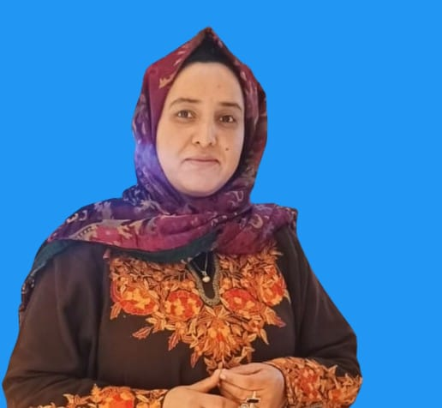 |  | EDUCATION
Bachelor of Science(B.Sc.)
Govt. Degree College Nawakadal, Srinagar

Bachelor of Education(B.Ed.)
University of Kashmir,Dargah Hazratbal,Srinagar
Tahira Farooq  Pre-Primary Teacher  Profile  A warm, caring, and dedicated early childhood educator with a strong passion for nurturing young learners during their foundational years. Seeking a position as a Pre-Primary Teacher where I can create a safe, joyful, and engaging classroom environment that supports holistic child development, encourages curiosity, and builds strong emotional, social, and learning foundations through child-centric and play-based teaching methods.  CONTACT  PHONE:  6006100573  Residence: Kawoosa Khalisa,Narbal-193401  EMAIL:  Ishfaq25malik@gmail.com |  | WORK EXPERIENCE

Head Teacher

Al Rashid Institute of Education
Duration: 3 Years
- Academic supervision of early-grade classes
- Coordination and mentoring of teaching staff
- Curriculum planning and implementation for pre-primary and primary sections
- Effective parent-teacher communication
- Ensuring discipline and maintaining quality education standards

General Line Teacher

Iqra International
Duration: 2 Years
- Teaching foundational concepts to young learners
- Activity-based, child-centric teaching approaches
- Classroom management and positive student engagement
- Supporting emotional and social development of children
 |  | SKILLS
- Early childhood teaching techniques
- Child psychology and care
- Creative and play-based learning strategies
- Strong communication and interpersonal skills
- Patience, empathy, and leadership abilities

