Kloudstack eSIM
New Feature & Workflow Documentation

1. Kloud Wallet & Loyalty Cashback

What is it?
Kloud Wallet is a customer rewards feature that allows users to earn cashback when they purchase eligible Kloud eSIM plans. The cashback is automatically added to their wallet and can be used toward future purchases.
How does it benefit customers?
- Customers receive a reward after making eligible purchases.
- Higher spending unlocks higher cashback rates.
- Wallet credits can reduce the cost of future eSIM purchases.
- Customers can track their wallet balance and reward history.
Loyalty Tiers
Tier | Required Spend | Cashback
🥉 Bronze | $0+ | 2%
🥈 Silver | $50+ | 4%
🥇 Gold | $150+ | 6%
💎 Platinum | $500+ | 8%

Customer Workflow
- Login — The customer logs into their Kloud eSIM account.
- Check Wallet — Their current wallet balance and loyalty tier are displayed.
- Choose an eSIM — The customer selects the required destination and data plan.
- Checkout — Available wallet balance can be used toward the purchase.
- Earn Cashback — After a qualifying purchase, cashback is added according to the customer's loyalty tier.
- Use Rewards — The customer can use the accumulated wallet balance on a future purchase.
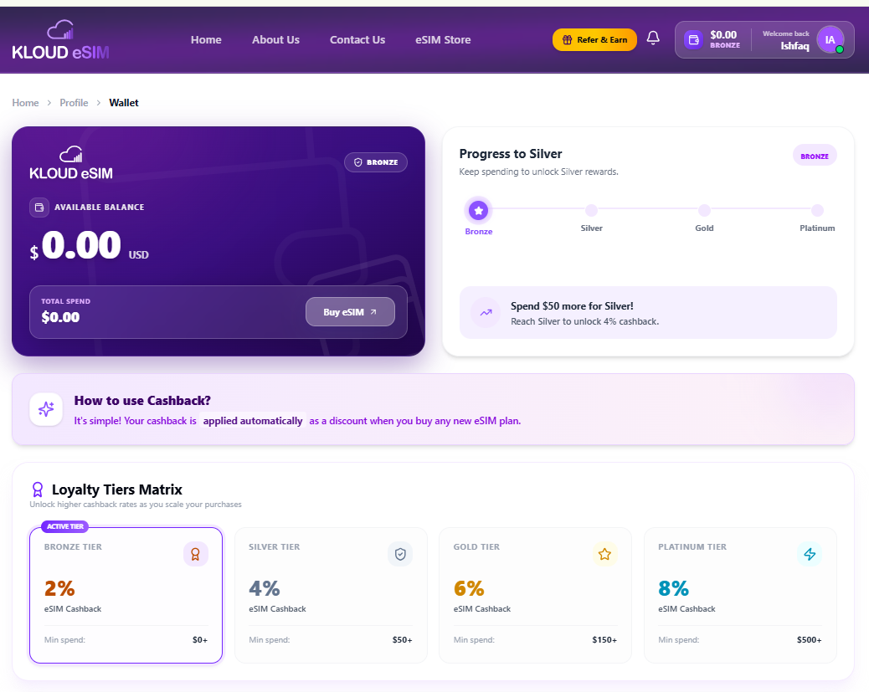

2. Referral Program — Give $5, Get $5

What is it?
The Referral Program allows existing customers to invite friends to Kloud eSIM. When a referred friend completes a qualifying first purchase, the friend receives a $5 discount, while the referring customer receives $5 Kloud Credits.
How it benefits customers
- Friends receive an immediate discount.
- Existing customers earn Kloud Credits.
- Customers can share their referral link, code or QR code.
- Referral progress can be tracked from the referral dashboard.
Referral Workflow
Customer → Share → Friend Registers → First Purchase → $5 Discount → $5 Kloud Credits
- Customer opens the Referral section.
- Customer copies their unique referral link/code or QR code.
- The friend opens the referral link and creates an account.
- The friend makes a qualifying first eSIM purchase.
- The friend receives the $5 discount.
- The referring customer receives $5 Kloud Credits.
- The referral status is updated in the dashboard.
